Practicum Certifier



Playbook

Contents
Practicum Certifier 1
Playbook 1
Overview 3
Qualifications 3
Practicum Certifiers’ Schedule 3
Practicum Duration for Certifiers 3
Attendance Code Words 3
Certifier Practicum Cancelations 4
Equipment and Technical Requirements 4
Emergency Assistance: 6
Prior to Practicum 6
Call Info 6
Attendance Code Words 6
Print a List of Practicum Registrants 6
Blank CoachVille Practicum Scoring Sheets 7
Determine Who Coaches First 7
Day of Practicum 7
Hours Requirements 7
How Students can Register for a Practicum 8
Breaks 8
Practicum Schedule Breakdown Samples 8
Introduction 10
Core Competencies Question and Answer 10
Debrief 10
It all about playing better next time! 10
Maintain a safe environment and maintain the student’s self esteem 10
Possible questions or ideas for debrief 11
Match the verbal and written feedback on score sheet 11
Preliminary verbal assessment 11
If the student most likely has not passed 11
Suggested Debrief 30 Minute Breakdown: 12
After the Practicum 12
Complete the CoachVille Practicum Scoring Sheet 12
Score Sheet Naming Convention 12
Practicum Recordings for the Purpose of Scoring 13
Escalation Procedures 13
Escalation - What if a participant does not agree with the Practicum Score? 13
Compensation and How to Get Paid 13
Stipend 13
How to Get Paid 13
Invoicing Instructions 13
Payment Cycle 14
Practicum Processes For Students 14
CoachVille Practicum Certifier Agreement 15
Agreement Addendum 16

Overview

Practicum Participation is an immersive experience with a group of three to five participants where they will coach, be coached and observe the coaching of their colleagues under the guidance of a Certified Coach. All those observing can participate by taking notes about where they saw specific examples of excellence in coaching and why, as well as where they saw potential missed opportunities or alternative paths.

Practicums accelerate student learning because we know that learning comes from doing the coaching itself (with feedback). Adults learn best in context - we learn how to swim by swimming, how to lead by leading, and how to coach by coaching. In the practicum, the Practicum Certifier provides immediate verbal feedback as to the strengths and opportunities for improvement. Afterwards, a written assessment is provided as to whether their coaching was at ACC, PCC, or MCC level with specific feedback on how to improve. This assessment becomes part of the student’s record - a requirement for graduation.

The Practicum Certifier creates a safe environment for learning that transforms the students mindset from: “I am uncomfortable receiving feedback; I avoid it at all costs” to: “I love feedback; it helps me focus my energy on how to coach better.” The Practicum Certifier helps students get comfortable with coaching while others are observing. They help the student see that participating in a practicum is a gateway to mastery that magnifies focus and accelerates the learning process.

Qualifications
It is an ICF requirement that Practicum Certifiers have a PCC or MCC. We are always on the lookout for Practicum Certifiers, so refer your qualified colleagues to us if they have an interest!

Practicum Certifiers’ Schedule

Planning is essential. CoachVille schedules six months of practicums at a time, with a lead time of three months. For example, the June through December schedule for practicum certifiers will require commitments from the certifiers no later than March 1.

Practicum Duration for Certifiers
Practicums are a 5-hour commitment if there are 5 students. If there are fewer students, it may be shorter. If it is shorter than 4.75 hours, the certifier must inform the students that they will need to make up an hour as an observer.

Attendance Code Words
Practicum certifiers are required to give out four pairs (total of eight) code words for attendance. This breaks down to a pair of code words given out for every 1.25 hours of a practicum. A five-hour practicum requires four pairs of attendance code words. One pair of attendance code words is given for every 1.25 hours (75 minutes).

See the table below for a sample breakdown of when to give code words for a five-hour practicum.

Sample Five-Student Practicum (5 hours)
Minutes | Accum | Description
8 | 0:00 - 0:08 | Brief Introduction and Overview
 |  | 1st word of 1st set of code words
25 | 0:08 - 0:33 | Coaching Session 1
30 | 0:33 - 1:03 | Coaching Session 1 debrief and verbal preliminary assessment
3 | 1:03 - 1:06 | Break
25 | 1:06 - 1:31 | Coaching Session 2
 |  | 2nd word of 1st set of Attendance Codes
30 | 1:31 - 2:01 | Coaching Session 2 debrief and verbal preliminary assessment
3 | 2:01 - 2:04 | Break
25 | 2:04 - 2:29 | Coaching Session 3
 |  | 2nd set of Attendance Codes
30 | 2: 29 - 2:59 | Coaching Session 3 debrief and verbal preliminary assessment
3 |  | Break
25 | 2:59 - 3:27 | Coaching Session 4
 |  | 3rd set of Attendance Codes
30 | 3:27 - 3:57 | Coaching Session 4 debrief and verbal preliminary assessment
3 |  | Break
25 | 3:57 - 4:25 | Coaching Session 5
30 | 4:25 - 4:55 | Coaching Session 5 debrief and verbal preliminary assessment
5 | 4:55 - 5:00 | Wrap Up
 |  | 4th set of Attendance Codes

Certifier Practicum Cancelations
If you are unable to meet your agreement to lead a scheduled practicum, you must give a
3-week notice to Deanna generalmanager@coachville.com and copy Linda Drake at lindadrake@coachville.com.

In addition, you must find someone qualified to replace you. Do not attempt to reschedule the published date or time of a practicum without contacting Deanna generalmanager@coachville.com.

Equipment and Technical Requirements
Practicum Certifiers must demonstrate that they have the right tools and equipment to facilitate a virtual class over the phone and using MaestroConference.

Computer and Internet Access: Practicum Certifiers must have access to a computer with the Mozilla Firefox browser with a high-speed internet connection in order to operate the MaestroConference conductor’s interface. A desktop or laptop computer is required.

Do not use netbooks (half-sized laptops) or iPads. A netbook’s video monitor and keyboard are too small to quickly and easily select callers to turn microphones on or off, or move callers into a new room in MaestroConference. In addition, iPads will not work because they do not run Flash which is required to run MaestroConference.

Headset with microphone: A headset and microphone that provides clear and distinct sound quality so the students clearly hear the instructor’s voice is required. If the headset is battery powered, it must last through 5 hours of class.

Do not use your computer’s built-in microphone and speakers. This causes echoes and poor quality sound.

Use of Skype: Practicum certifiers should use Skype to call into class only in emergencies. International Practicum certifiers must demonstrate a solid internet connection with clear audio quality prior to instructing their first class.

Phone Line: A phone is required. A landline provides the highest voice quality. If a cell phone is used, we recommend having a second battery available for swapping, or a second phone in order to last through 5 hours of class time. A headset with microphone is required. Do not use your computer’s microphone and speakers – it will cause echoes or feedback.

Backup Plan: Be prepared with a backup plan in the event of equipment failure.
- What will you do if your phone battery dies? (Another phone line? Another battery?)
- What will you do if the electricity goes out? (Uninterruptible Power Supply (UPS)? Another location? Depend on an assistant to take over?)
- What will you do if your high-speed internet connection dies? (WiFi Hotspot? Secondary connection? Depend on an assistant?)
- What will you do if your computer dies? (Backup computer? Borrow a computer? Rely on an assistant?)
- What will you do if your headset battery dies? (Alternate headset? Use the handset?)

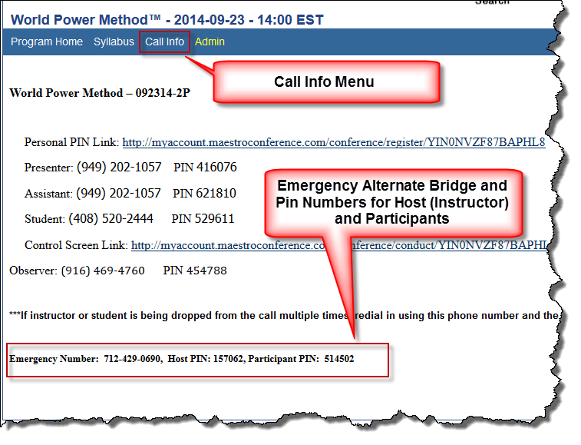Emergency Assistance:
Who to call: If you experience any problem that prevents you from connecting to class, CALL LINDA DRAKE IMMEDIATELY AT (626) 260-2837 for immediate assistance. She will contact Deanna Stull or Dave Buck if necessary.

If there are technical difficulties with MaestroConference check for an email from one of the leadership team regarding a site-wide outage and instructions on what to do.
Figure 1 Emergency Bridge Numbers

Emergency Bridge Numbers: Every class has emergency alternate bridge telephone numbers located on the Call Info menu of your class (see Figure 1). If you need to use the emergency alternate bridge numbers, email your students immediately with the emergency bridge number and pin, and instruct them to meet you on the alternate bridge line. Do your best to deliver an extraordinary class in spite of the challenges.

Prior to Practicum

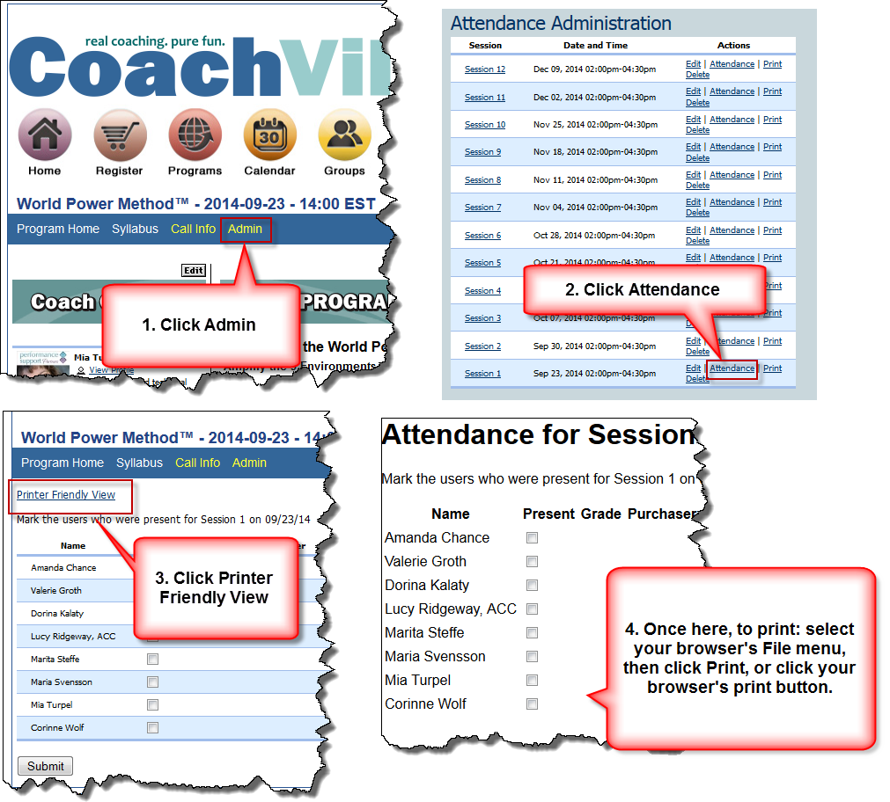Call Info
Figure 2 Print List of Practicum Registrants
The MaestroConference bridge and pin numbers are located on the yellow Call Info menu of the practicum program. This menu is visible to the practicum leaders only (not students). Write down the bridge and pin numbers. This is important in the event of a power outage or internet outage, where you can still call in, but you are unable to access the CoachVille site for the information.

Attendance Code Words
The practicum differs from most classes because they have four sets of code words. These attendance codes are located in the syllabus and only visible to the practicum leaders. Write them down and announce them to the students every 1.25 hours.

Print a List of Practicum Registrants
To view and print the list of registrants, access the class by clicking the Programs button, click the appropriate Practicum link, then click the Admin menu.

- Click Admin (see Error! Reference source not found.)
- Scroll down to Attendance Administration and click Attendance for the desired session.
- Click Printer Friendly View in the upper left corner.
- Use your browser’s print feature to print by clicking File and then Print.

Tip: For tech savvy users, download a CSV file, and import into Excel. To do this click Admin, click Registrants under Section Administration, and then click CSV. Save to your computer, and then open in Excel.

Blank CoachVille Practicum Scoring Sheets
Click to download the latest CoachVille Practicum Scoring Sheets:
CoachVille Practicum Scoring Sheet-Word Version or CoachVille Scoring Sheet - PDF

Determine Who Coaches First

To make the session flow smoothly, we suggest you plan before the start of the practicum the sequence of “who is coaching who” so you do not have to determine this after the start of the session. Below is a sample worksheet to assist.

List Registrants:
Student A Name:
Student B Name:
Student C Name:
Student D Name:
Student E Name:

List Registrant Names in the designated places below:
Order | Role of Coach | Role of Player
1 | Student A | Student B
2 | Student B | Student C
3 | Student C | Student D
4 | Student D | Student E
5 | Student E | Student A

Day of Practicum

Hours Requirements
A student is required to attend for five hours. If there are less than five people scheduled for the practicum and it lasts less than the five required hours, the participants MUST make up the time. They must be told to schedule a Coaching Practicum Observer to make up the required time.

Although there may only be three students, the practicum can still be five hours by expanding the coaching time from 25 to 30 minutes, and expanding each debrief opportunity. You could add an interactive core competency review at the beginning. It is up to you. The key is that the student must make up the missing hours by taking a Practicum Observer, and it is your responsibility to let them know.

How Students can Register for a Practicum
A Complete Program student can self-register through the Registration center. Any other student must contact Linda Drake via email at lindadrake@coachville.com or via phone at (626) 260-2837. They must tell her which practicum they wish to attend and she will register the student assuming there are available seats. The majority of practicums are scheduled for a Friday, Saturday or Sunday, and the available practicums are listed in the Registration center.

Breaks
Give brief stretch/bathroom breaks in between sessions.

Practicum Schedule Breakdown Samples
Below are examples of three-student, four-student and five-student practicums designed to last the required five hours.

Sample Five-Student Practicum (5 hours)
Minutes | Accum | Description
8 | 0:00 - 0:08 | Brief Introduction and Overview
 |  | 1st word of 1st set of code words
25 | 0:08 - 0:33 | Coaching Session 1
30 | 0:33 - 1:03 | Coaching Session 1 debrief and verbal preliminary assessment
3 | 1:03 - 1:06 | Break
25 | 1:06 - 1:31 | Coaching Session 2
 |  | 2nd word of 1st set of Attendance Codes
30 | 1:31 - 2:01 | Coaching Session 2 debrief and verbal preliminary assessment
3 | 2:01 - 2:04 | Break
25 | 2:04 - 2:29 | Coaching Session 3
 |  | 2nd set of Attendance Codes
30 | 2: 29 - 2:59 | Coaching Session 3 debrief and verbal preliminary assessment
3 |  | Break
25 | 2:59 - 3:27 | Coaching Session 4
 |  | 3rd set of Attendance Codes
30 | 3:27 - 3:57 | Coaching Session 4 debrief and verbal preliminary assessment
3 |  | Break
25 | 3:57 - 4:25 | Coaching Session 5
30 | 4:25 - 4:55 | Coaching Session 5 debrief and verbal preliminary assessment
5 | 4:55 - 5:00 | Wrap Up
 |  | 4th set of Attendance Codes

Sample Four-Student Practicum (5 Hours)*
*Note: If Practicum is less than 4.75 hours, student must make up one hour in another practicum.

Minutes | Accum | Description
7 | 0:00 - 0:07 | Brief Introduction and Overview
30 | 0:07 - 0:37 | Coaching Session 1
40 | 0:37 - 1:17 | Coaching Session 1 debrief and verbal preliminary assessment
 |  | 1st set of Attendance Codes
3 | 1:17 - 1:20 | Break
30 | 1:20 - 1:50 | Coaching Session 2
40 | 1:50 - 2:30 | Coaching Session 2 debrief and verbal preliminary assessment
 |  | 2nd set of Attendance Codes
3 | 2:30 - 2:33 | Break
30 | 2:33 – 3:03 | Coaching Session 3
40 | 3:03 – 3:43 | Coaching Session 3 debrief and verbal preliminary assessment
 |  | 3rd set of Attendance Codes
3 | 3:43 – 3:46 | Break
30 | 3:46 - 4:16 | Coaching Session 4
40 | 4:16 – 4:56 | Coaching Session 4 debrief and verbal preliminary assessment
4 | 4:56 - 5:00 | Wrap Up
 |  | 4th set of Attendance Codes

Sample Three-Student Practicum (5 Hours)
Minutes | Accum | Description
10 | 0:00 - 0:10 | Brief Introduction and Overview
30 | 0:10 - 0:40 | Interactive Core Competency Review
30 | 0:40 - 1:10 | Coaching Session 1
 |  | 1st set of Attendance Codes
3 | 1:10 - 1:13 | Break
50 | 1:13 - 2:03 | Coaching Session 1 debrief and verbal preliminary assessment
30 | 2:03 - 2:33 | Coaching Session 2
 |  | 2nd set of Attendance Codes
3 | 2:33 - 2:36 | Break
50 | 2:36 – 3:26 | Coaching Session 2 debrief and verbal preliminary assessment
30 | 3:26 – 3:56 | Coaching Session 3
 |  | 3rd set of Attendance Codes
3 | 3:56 – 3:59 | Break
50 | 3:59 – 4:49 | Coaching Session 3 debrief and verbal preliminary assessment
11 | 4:49 – 5:00 | Wrap Up
 |  | 4th set of Attendance Codes

Introduction
- Introduce yourself and welcome the participants and observers.
- Explain the purpose of the practicum. Include that it is an immersive opportunity to get direct and immediate feedback on your coaching strengths and improvement opportunities in order to quickly move you toward coaching mastery.
- Explain that learning also occurs from observing the other coaches with their coaching styles, and hearing their debrief sessions.
- Explain the timing format of the class, that the five participants will both play the role of coach once, and also the role of player, and the other sessions they will observe. Each coach will get 25 minutes to 30 minutes to coach depending on the number of students, and there will be a 30-50 minute debrief, where the practicum certifier will share observations on strengths and opportunities to improve.
- Welcome the observers and invite them along with the participants to use the CoachVille score sheet to help them learn to identify the proficiencies and competencies in pursuit of mastery. Let the observers know that they will remain on mute, and they may have an opportunity in the debrief to share an observation.

Core Competencies Question and Answer
If there are less than five students attending the practicum, you may choose to start with an interactive question and answer review session on the core competencies, or spend more time on each debrief. A couple of ways to facilitate a core competency question and answer session are:
- Ask everyone to pick one item from the score sheet that they want to work on, and why.
- Ask for questions and challenges.

Debrief

It all about playing better next time!
Emphasize that the feedback on strengths and opportunities for improvement are in the spirit of pursuit of mastery and playing better. While receiving feedback can be a little unnerving, getting direct and immediate feedback is a way to rapidly accelerate coaching skills toward mastery.

Maintain a safe environment and maintain the student’s self esteem
Use your coaching skills as a certifier, and use the coaching proficiency, “Respect the client’s humanity.” Adults have something real to lose – their self-esteem. Self-esteem and ego are on the line when they coach in front of peers, and other observers. Bad experiences in traditional education, feelings about authority and the preoccupation with what is happening in their life all affect their practicum experience. They need to understand that all feedback is in the spirit of playing better next time, and in the pursuit of mastery in coaching!

CoachVille is about the spirit of play, and positive emotions greatly improve learning. Feelings determine both the quality and quantity of one’s learning. Negative feelings inhibit learning. Positive feelings accelerate it. Learning that is stressful, painful, and dreary can’t hold a candle to learning that is joyful, relaxed, and engaging. You can make a real difference by being authentic and inspiring, encouraging, and honoring them for their courage in stepping out of their comfort zones in the spirit of learning to coach better.

Keep a positive and playful, warm environment. Keep the focus on it being an immersive learning environment. Acknowledge them for their courage to be here in the spotlight for the purpose of learning and going out in the world to play even better next time. A little sensitivity goes a LONG way toward keeping a warm and safe environment for learning.

Possible questions or ideas for debrief
- Ask the coach how they thought it went. What did they think went well? What didn’t go so well? What other paths could they have taken?
- What’s the big question that they wanted to ask but didn’t? Why?
- If they say, “I didn’t have time” ask them, “What didn’t you have time for?”
- Share what you saw as their strengths.
- Share what you saw as other pathways they might have taken.
- Ask them, what would you have done differently?
- Where was the missed opportunity?
- Share one or two things that if they could practice and improve upon would have the greatest impact on their coaching.
- Ask the observers to share what strengths, what other pathways they might have taken, or what questions they had about the approach the coach took during the session to get more viewpoints

Match the verbal and written feedback on score sheet
It is the expectation of the student that the verbal preliminary assessment of passing, ACC, or PCC be congruent or match their written score. What you say verbally to them in assessing the proficiency level of their coaching should be congruent or match with the score sheet so that when they receive their written scores, it should not be a complete surprise, it should be generally what they expected based on the verbal feedback they were given.

Preliminary verbal assessment
The student is excited to hear what the preliminary assessment. Be truthful. If you are certain it is a solid ACC, or PCC, then let them know. If you are uncertain, let them know you will make your decision after reviewing your notes and doing a thorough assessment. Your verbal preliminary assessment should be congruent or match with your written assessment. Don’t tell them it’s a solid ACC, and then send them a score sheet that indicates they have not passed.

If the student most likely has not passed
If the student has most likely not passed, it is critical that you practice the coaching proficiency of “respect their humanity” and are kind in your delivery. Students participating in the practicum game should be acknowledged for their courage in playing big. The paradox of play is that you never really lose. You are either winning or learning! When you are not sitting on the bench and really playing big by participating in a practicum, you never lose because the pursuit of mastery is a process and a journey. When you play big, you go through the repeated process of RACE: Results, Actions, Challenges, Evaluation in the pursuit of mastery. Remind them their goal should be to learn and grow with each practicum.

Suggested Debrief 30 Minute Breakdown:

Minutes | Description
5 Minutes | Congratulations! Acknowledge their courage. Remind them that this is a safe place for learning. Ask them how they think they did. Let them share.
15 Minutes | Share your observations on their strengths, pathways taken and not taken, and their greatest opportunities for improvement. (See section
8 Minutes | Invite the observers to share an observation on what they say the coach did well, what other pathways they might have taken, or questions on why the coach chose a particular path.
2 Minutes | If very sure of assessment, give the coach a verbal assessment of ACC, PCC, MCC. If not sure, let them know you are not sure and need to review your notes and will let them know in your written assessment. Avoid embarrassing student if they did badly – do not say ‘you failed’ or ‘you did not pass’ in front of entire audience.

After the Practicum
Click here to download the latest CoachVille Practicum Scoring Sheets by clicking here.

Complete the CoachVille Practicum Scoring Sheet
Complete the student assessments using the CoachVille Practicum Scoring Sheets as soon as possible but no later than 3 weeks after the practicum date. Send the completed assessments directly to each individual participant and copy Linda Drake at lindadrake@coachville.com and generalmanager@coachville.com.

Please include clear specific examples that reflect the select scores in each session. The more examples and feedback you can provide, the more impact you can have on the learning and progress of the student.

Click to download the latest CoachVille Practicum Scoring Sheets:
CoachVille Practicum Scoring Sheet-Word Version or .CoachVille Scoring Sheet- PDF

Score Sheet Naming Convention
When naming the score sheet file for each student, use the following naming convention:

Year, Month Day - Practicum – Student Name – Who coaches who (first names)

Example:

2014 Sept 12 – Practicum – Mia Turpel – Mia coaches Lucy

Practicum Recordings for the Purpose of Scoring
If a certifier feels they need to listen to a coaching session again in order to do a fair and thorough assessment, they may request the download link from Linda Drake. All recordings are confidential for the use of scoring only, and may not be shared with anyone else.

Escalation Procedures

Escalation - What if a participant does not agree with the Practicum Score?
If the participant does not agree with the practicum score, escalate by notifying Deanna Stull at generalmanager@coachville.com and copying Linda Drake at lindadrake@coachville.com.

Deanna Stull and the Certifier will review the score sheet one-on-one with the student. Afterward, a determination is made whether the score is valid . The certifier notifies the participant of the outcome via email with a copy to Deanna Stull.

If warranted, and the issue is still not resolved, Deanna will listen to the recording, as well as Dave Buck, if necessary. A determination will be made and the Participant and Certifier will be notified.

Compensation and How to Get Paid

Stipend
The Practicum Certifier receives a stipend of $75 per student which covers the practicum time and verbal assessment, the written assessment and score sheet, and miscellaneous other communication such as emails before class. For a full practicum of five students, that is $75 per student times 5 students for a total of $375.

This is a contract position. CoachVille will send you an IRS 1099-MISC form at the end of the year for tax purposes. You are responsible for reporting this taxable income and we recommend you consult your CPA or accountant.

How to Get Paid
After completion of the practicums and submission of written assessments, send an email with an invoice attached preferably in PDF format via email to Deanna Stull at generalmanager@coachville.com.

Invoicing Instructions
Your invoice should include the following information:
- Your name
- Your company name
  - Indicate whether check should be made payable to you individually (i.e. Jane Doe) or payable to your company name (i.e. ABC Coaching).
- Your street address, city, state and zip
- Your Social Security number or your Employer Identification Number (EIN) number (if we don’t already have it)
- The total billing amount broken down by each course. Include:
  - The course name (i.e. Practicum)
  - The practicum date including the year (i.e. Sep 6, 2014).
  - The number of students
  - The total dollar amount ($75 x 5 students = $375)

Example:
Practicum Sep 6, 2014 (5 x $75 = $375)

- Name the invoice file using the following naming convention: Name_Practicum_Date

Example:
Jane_Doe_Practicum_Sep_12_2014

- Send the invoice as an attachment to an email to generalmanager@coachville.com.
- Submit all invoices to CoachVille NO LATER THAN 30 days after the completion of the practicum.

Please ensure all necessary information is included to avoid a delay in payment.

Payment Cycle
Please allow 60 days for payment on invoices received by CoachVille before the 15th of the month and 90 days after the 15th of the month.

Examples:

Example 1: CoachVille receives invoice before the 15th, on October 5. Allowing 60 days, payment by check arrives within 60 days by December 5.

Example 2: CoachVille receives invoice after the 15th on October 16. It misses monthly payment processing cycle, and is processed the following month in November. Your stipend payment by check arrives by January 16.

IMPORTANT: Instructors must submit all invoices to CoachVille within 30 days after class end.

Practicum Processes For Students
Practicum certifiers should be prepared to answer frequently asked questions from students regarding practicum processes. Please read the Student Coaching Practicum Playbook for detailed information on the student registration/cancellation and additional processes for practicums to help you answer the questions they may have, and feel free to share it with students.

CoachVille Practicum Certifier Agreement
Position of Practicum Certifier with CoachVille – The Center for Coaching Mastery

I, ( your name ), have read the Practicum Certifier Playbook and understand the expectations and requirements for the position of Practicum Certifier and agree to abide by them.

I accept and commit to the position of Practicum Certifier for a year <enter year date range>. The specific dates and times for each practicum are listed on an addendum to this agreement that is signed each quarter.

Attendance and Timeliness:
I agree to lead all sessions, and dial-in 10 minutes prior to each practicum.

Stipend
I understand that the Practicum Certifier receives a stipend of $75 per student which covers the practicum time and verbal assessment, the written assessment and score sheet, and miscellaneous other communication such as emails before class. Example: A practicum of five students, that is $75 per student times five students for a total of $375.

How to Get Paid

I understand that after completion of the practicums and submission of written assessments, I send an email with an invoice attached preferably in PDF format via email to Deanna Stull at generalmanager@coachville.com to get paid. I understand that detailed instructions are in the Practicum Certifier Playbook.

This is a contract position. CoachVille will send you an IRS 1099-MISC form at the end of the year for tax purposes. You are responsible for reporting this taxable income and we recommend you consult your CPA or accountant.

Equipment
Instructors must demonstrate that they have the right tools and equipment to facilitate a virtual class over the phone and using MaestroConference as described in the Instructor and Assistant Instructor Playbook.

Please sign and return this agreement to generalmanager@coachville.com.

Instructor Name |  | Date
Deanna Stull, General Manager |  | Date

Agreement Addendum
Fall 2014 Practicums

Will Lead | Date | Time
Yes/No | Saturday, September 20, 2014 | 12PM-5PM
Yes/No | Friday, September 26, 2014 | 8AM-1PM
Yes/No | Saturday, October 11, 2014 | 9AM – 2PM
Yes/No | Friday, October 17, 2014 | 8AM-1PM
Yes/No | Saturday, October 18, 2014 | 12PM-5PM
Yes/No | Friday, November 14, 2014 | 1PM-6PM
Yes/No | Friday, November 14, 2014 | 8AM-1PM
Yes/No | Sunday, November 16, 2014 | 1PM-6PM
Yes/No | Friday, December 12, 2014 | 1PM-6PM
Yes/No | Sunday, December 14, 2014 | 1PM-6PM

Instructions: Select either Instructor or Assistant Instructor, and sign below.

___ I agree to lead the practicums marked “Yes” above following the guidelines in my Practicum Certifier Playbook.

Name |  | Date
Deanna Stull, General Manager |  | Date

150112 v1.02
140916 V1.01

