In Class Coaching Practice (Dyad) Guide

How to get the Most from Your Dyad Practice Sessions

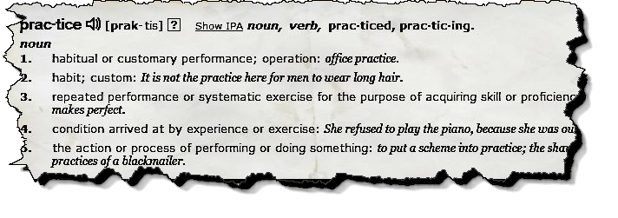What is a Dyad?
The individuals that are paired throughout the length of the course to practice the coaching skills or concepts learned in class are referred to as dyads. Simply put, they are practice partners.

CoachVille uses the DTMOPP (Desire, Theory, Method, Observe, Practice, and Perform) learning method. The “practice” part of this method is your dyad practice sessions. The instructor discusses a coaching method, theory or idea and then conducts a brief coaching demonstration or plays a coaching recording. After a class discussion of this demonstration, next is your dyad practice session.

The MaestroConference system is used to create dyad ‘break-outs’ for these practice sessions. These ‘break-outs’ are virtual conference rooms where you and your dyad practice partner take turns coaching — practicing the concepts just learned (and experiencing them) in a supportive environment.

The instructor will tell you how much time you have for each dyad and will prompt you when to start. Typically each dyad practice session is 40 to 50 minutes (20-25 minutes for each partner). You will be automatically connected with your partner – just wait a moment and say ‘hello’ and start coaching!

Who is my dyad partner?
Dyad partners are assigned during the first class. Most of the time you will have the same dyad partner for the entire course, but adjustments may be made due to absence or additions to class.

In your first practice session exchange phone numbers and email addresses. You can then connect with your partner outside of class to practice coaching techniques.

What should I do as the coach during my dyad?
Dive immediately into the coaching session focusing your intention on using the method being taught in the class, and on the skills you just learned. This is your opportunity to practice under guidance so use your time well.

Practice artful interruption to refocus your client when they go into ‘story’ mode. Ask them for permission to interrupt, and ask them if they can get to the heart of their story in a few sentences. This is referred to as “laser-speak.” For example: “Jane, may I interrupt for a minute? What you have to say is important to me, AND can you get to the heart of your story in just a few sentences?”

Ask “What” and “How” questions, and minimize “Yes” or “No” questions. No tipping (unsolicited advice) or problem solving. Don’t ask, “Have you tried _____.” Instead ask, “What have you tried already?”

What are some hints and tips to be the player during the dyad?
Bring something real that matters to you as your focus for being coached. As described previously, use “laser speak” — a way of speaking that is concise, specific and that gets to the point or the heart of the matter quickly in a few sentences. It allows for quicker, cleaner communication and opens up more time to cover the important things to make progress quickly.

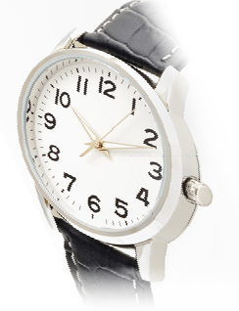If you are stumped on what your coaching focus should be, try asking yourself these questions: What is the greatest challenge I have had this week? What have I complained about most this week (indicates a toleration)? Where do I feel stuck? If you still do not know what you want or what direction you are moving, than bring your desire to figure this out to your session.

Manage your time! All participants need equal time to practice as a coach. The instructor will announce when it is time to switch partners, and when it is near time to finish the dyad practice and wrap up. Remember: We don’t expect you to do a complete coaching session in 20 minutes. Limit your coaching focus to the technique or method you just learned. Your instructor will then dissolve the dyad break-outs and return everyone to the “main conference room.”

After your practice session is complete, be prepared to share your challenges and perspectives as a coach and player with the class.

What if I need help?
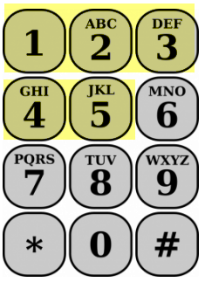Your instructor will be “walking” through the virtual dyad rooms listening to you practicing with your partner and may briefly interrupt to provide feedback to help you hone your coaching skills.

Raise your hand to get help or have a question answered by pressing a number from 1 to 5 on your telephone keypad. Both partners raise hands for a quicker response.

What if I want a different dyad partner?
The purpose for practice dyads is to have a safe space to make mistakes, learn and grow in the pursuit of mastery in coaching. Not every partnership or breakout will result in great coaching sessions, but instead they result in great learning opportunities.

We rarely change practice partners. If you feel like you need a different dyad practice partner, consider the reason you want a change. If you are frustrated or challenged with your partner, staying with your current partner could be an opportunity to learn and grow as a coach. Ask yourself, "Who is the universe asking me to become by giving me this practice partner?"

For additional perspectives and tips, listen to the Best of Thomas Recording: “Why Clients Can Be Frustrating.” In this recording, Thomas Leonard and Dave Buck facilitate a discussion about the sources of frustration a simple three-step method to grow past it and evolve yourself.
150331 V2.0

