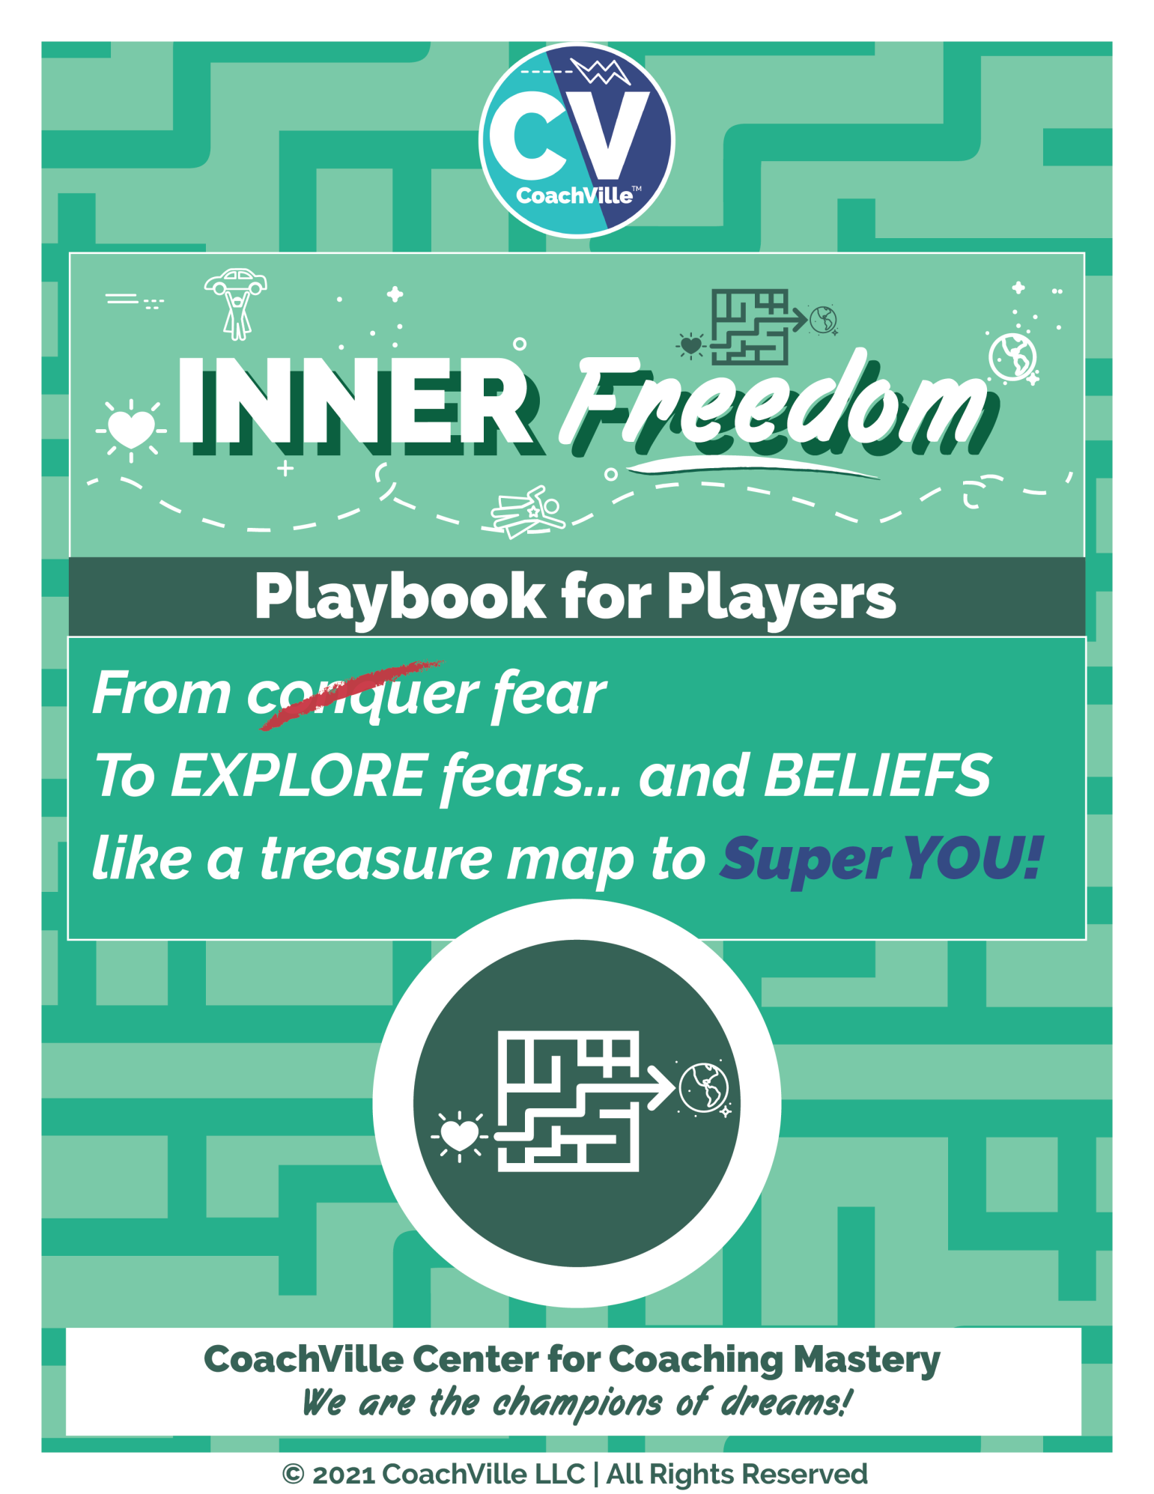

Welcome!

Hello there! Coach Dave here with you.
I am the co-creator – with my amazing team of coaches at CoachVille – of the Inner Freedom Method that your coach will use to guide you in pursuit of your BIG dream.
While your coach is your Guide on the adventure, I will be your “Bonus Companion” with this playbook and a series of audio that I recorded to help you make the most of every session with your coach. Time is precious!
Our vision at CoachVille…
Everyone, everywhere with the courage to play BIG for their dreams, has a GREAT Coach!
Your coach is…
The champion of your dreams
The promoter of your playfulness
The unleasher of your superpowers
The true heart of coaching is playing together to play better. Just as a basketball coach helps you play basketball better or a violin coach helps you play violin better, a Life Coach will help you play life better.
The Inner Freedom Method is a unique and powerful method of Life Coaching. You probably recognize the experience when you really want to do something but it feels like there is something within you holding you back. This is a very common experience.
While many personal growth programs talk about conquering fear we are going to do something VERY different! We are going to explore your fears – along with doubts, resistance and beliefs – like a treasure map to your Superpowers. It is going to be an awesome adventure!
When you have your superpowers and the inner freedom to use them, activities that used to seem hard, or even impossible, suddenly feel easy and in the flow of life! YES!!
To explain this little book using a metaphor:
The Introduction is like a travel brochure for an adventure to climb Mt. Kilimanjaro; hopefully it gets you energized to go!
Then each chapter is like a chapter from a Lonely Planet Guide to the territory so that you can really make the most of your experience.
I know I LOVED my Lonely Planet Guide during my month in Bolivia!
Our motto:
The world is a playground… so we are GOING OUT TO PLAY… Together.

Coach Dave Buck and the CoachVille Team!

Table of Contents

Welcome! 2
Table of Contents 3
An introduction to Playing Life with an Inner Freedom Coach 4
Possibilities for your BIG Dream 8
The 4 ways to Play Life. The 4 things we desire! 9
The FEAR of Social Play 11
We were born to play but then we were trained to work. 14
Get Your Human Nature Back! 18
Your Fears Are a Treasure Map to Your Superpowers 21
Introduction to the Inner Freedom Method 26
How to use the playbook, weekly audio & playsheets 30
Session #01) Play With Fear 32
Session #02) Pivotal Moments 41
Session #03 Feel the Energy 51
Session #04 Memory Pops 56
Session #05 Superpower Potential 63
Session #06 Find the Perfection 73

An introduction to Playing Life with an Inner Freedom Coach

The Practical… The Problems … The Purposeful
As your bonus companion on your adventure with your Inner Freedom Coach, my role is to prepare you for each leg of the journey so that you can really LOVE it and thrive.
In this introduction I have a few provocative ideas to share with you… that will shift how you see yourself, the world around you and your opportunity to thrive in a joyful way. AWWW Yeah.
So the first thing I want to do is share with you a few of the “real world” benefits of playing with an Inner Freedom Coach in the form of practical benefits, problems solved and bigger purpose and aspirations.
The Practical
- If your dream or purpose feels fuzzy or lost, it will come into focus and gain energy.
- Positive actions that used to seem hard, will start to feel easy.
- Your life will start to feel like a fun, growth-oriented adventure… MOST DAYS
- You will have more fulfilling experiences with people you enjoy; in ALL aspects of your life!
- You will gain awareness of where your doubts and fears are coming from… and you will feel more and more FREE!
- You will greatly expand your “body awareness” and “emotional awareness” which will increase your intuition, inner knowing and self-trust. << THIS IS A BIG ONE!
- You will feel more ALIVE… and feel like your life is more vibrant than it used to be!
The Problems
Coaching is NOT an intervention for problems! It is about playing better for your dream.
However… as you play better with your Inner Freedom coach, many of life’s common problems will lessen or disappear completely.
- You will experience LESS anxiety.
- You will experience LESS self-doubt.
- You will experience LESS procrastination on important actions.
- You will experience LESS negative self-talk;
- You will experience LESS limiting beliefs; and the idea of self-sabotage will disappear.
- You will experience LESS frustration, isolation and overwhelm! (A LOT LESS)
- OFTEN… You will experience LESS of unwanted addictions.

You have to admit… this will be awesome!
The Purposeful… and Aspirational
- You will gain influence. You will begin to see yourself as powerful and capable of having a profound positive impact in the lives of others and in the world!
- You will gain creativity. You will gain clarity on the YOUnique qualities that you have within you that you can use to co-create the results and experiences you desire.
- You will make changes. You will feel more confident in taking risks that can bring about positive rewards for your dream.
- You will gain Visibility. You will feel more courage in being seen and owning your value.
- You will develop the ability to tap into your body wisdom to make bold choices.
- You will develop the ability to tap into the Supermind for needed insights and possibilities… and then ACT on them.
- You will feel like your energy is flowing and aligned with your dream and greater purpose.
- Last but not least… you will stop the futile exercise of trying to conquer fear and you will learn how to EXPLORE fear – specifically social fear – which will lead to an extraordinary boost in your FREEDOM. INNER FREEDOM!
- As you practice exploring the FEAR you experience in social situations, you will rediscover your lost playfulness and YOUnique capabilities. AKA Your Superpowers!
AWWWW Yeah!

What coaching is
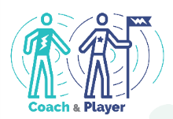
Before you start your adventure with your Inner Life Coach, I want to share with you a few thoughts about life coaching because there is a lot of confusion about this.
Here is our definition of coaching:
Coaching Is…
1. A profound personal relationship
2. Wherein the coach guides the player
3. In pursuit of playing better for their dreams
4. Through perceptive observations
5. And co-creative conversations

Some folks have gotten the idea that coaches talk with you to help you solve your own problems. Others think that coaches tell you what tasks to do and hold you accountable.
Life Coaching is not about problems or tasks because life is not about problems and tasks. Life is for playing for our dreams and Coaching is about playing together to play better; also known as practice.
Let’s go a little deeper into each of the elements.
1. A profound personal relationship
Coaching is a personal relationship. Your coach will care about you as a person and you will care about your coach. It is very different than the ideas we got about Industrial Age Professional that was robotic and impersonal.
Coaching is profound because it goes beneath the surface of life’s circumstances into feelings, emotions, beliefs, desires, possibilities, fears, visions, ideas… the important stuff.
2. Wherein the coach guides the player
Coaching is NOT hierarchical… which is an important detail we will explore in a moment.
Guiding another person on an adventure is a real artform. It is not the same as directing or controlling; but it is more than a passive companion.
Think about the guide on a hero’s journey like Star Wars Obi Wan Kenobi to Luke Skywalker. They are on the adventure together, they are both actively involved. Obi Wan is sharing observations with Luke BUT… Luke makes his own choices about what to do.
Another way to think of this is the Olympic Coach. They are in the Training Center with the athlete every day sharing the dream together. Olympic athletes deeply thank their coach when they win a medal; they could not have done it alone.
3. In pursuit of playing better for their dreams
Playing better is the essence and the purpose of what ALL coaching is about.
Playfulness is an awesome Human Superpower. Helping you restore and maximize your playfulness is a big part of Life Coaching. I will get into that much deeper in a few moments because the idea of play may be scrambling your mind right now.
To ease into the exploration here are a few ideas to help you understand what I mean by PLAY and playfulness:
- Curious and Creative
- Resourceful and Resilient
- Explore and Experiment
- Fun! (usually, but not always)
The 3 Frameworks of Play
There are 3 areas of life where we see play all the time. One way to get into playing for your dream is to identify with one or more of these and re-imagine your dream with this framework.
1) Performance Art: You have talents, a “voice” or perspective and something to say or share. You practice A LOT to refine both your skills and your message. You use your talents to co-create experiences with your audience.
2) Game / Athletics: The urge to compete drives you to hone your skills to perform at a high level. You enjoy the thrill of victory and embrace the difficulty of defeat. You enjoy the camaraderie of your team mates and the competitors. The definition of compete from the ancient Greek language is actually quite inspiring.
To Compete: to seek the best in oneself in the company of others likewise engaged.
3) Epic Quest: You have been “called” to adventure. There is something you MUST do even though it means leaving behind the comfortable of your well known surroundings and place in the world. You face great challenges in pursuit of your mission. If you are successful, you reap some great reward which you can bring back to your tribe for all to enjoy.
Your Dreams
This is another topic we will talk about A LOT in this playbook and with your coach. Your Dream is your vision for who you want to become and what you want to experience in the world.
In the next section we will get into the details of The Dream.
4. Through perceptive observations
We are ALL yearning to be seen by someone who knows what they are looking at!
Your coach is going to observe you as you adventure together and share with you what they see in a judgment-free way!
We all have blind spots in our thoughts and actions because we can’t see ourselves very clearly…a trusted outside observer can really accelerate our growth.
This is the way life is meant to be played; we are meant to co-create life with others.
5. And co-creative conversations
Talking together is a big part of how coaching happens.
The key in Life Coaching and Life Playing is to co-create a safe space for deep and provocative conversations.
This brings me to one of my favorite things to share with new Life Players!
The ancient power of co-creation!
In the ancient Aramaic Language there was a power phrase: Abera Ca Dabera – It means: “I create as I speak”. You have probably heard of it being used in the context of a magic trick but it is much more practical than that! When two people are talking together in deep conversation with purpose, permission and presence – as happens in a Life Coaching relationship – it can take on a life all its own. With your words you can speak your dream into existence and create the new version of YOU needed to fulfill your dream. This is the “magic” of co-creating that makes coaching such a powerful force in the world!
With focus and determination you can experience this transformational power with your Inner Freedom Life Coach!

Possibilities for your BIG Dream
The first thing your coach is going to talk with you about is your Dream; because going for your Dream is what playing life is all about. An important point here is that playing life with a Life Coach is MUCH different than going it alone. So I am encouraging you to think bigger than you might normally allow yourself to think.

Why Dream… rather than objectives or goals?
- Your Dream includes your imagination.
- Your Dream includes your vision.
- Your Dream includes your heart’s desires.
- Your Dream includes how you want to contribute to life.
- Your Dream includes who you want to become.
- Your Dream includes the experiences you want to co-create.
- Your Dream includes the spirit of play.
- Your Dream includes a sense of wonder and mystery.
Often we don’t think too much about our dreams, we just focus on what we can control by ourselves. This is how we were trained to think in the Industrial Culture. (We will get to this in a moment) This approach tends to keep us pretty small; which is OK sometimes. But truly life can be MORE.
You may be very clear on your Dream and already in pursuit. Or you may be a little fuzzy about the details but just know you are ready for more. Wherever you find yourself now is the perfect place to start your adventure. The purpose of this little section is to spark your imagination for what your BIG Dream can be.
Our mantra is: The world is a playground. Let’s Play Together.
Here is a “starter” list of the endeavors that people dream of playing better. This will spark your imagination for the many possibilities you have with your Inner Freedom Life Coach!
Aspects of Life you can play better with a Life Coach
- small business ownership,
- career development & transition into something joyful & meaningful
- business growth through team play,
- leading a worthy cause
- growing a vibrant community or tribe
- spiritual quest through community participation,
- financial freedom through value creation,
- corporate management and/or leadership of a great team
- artistic expression and performance
- health and wellness through engagement
- personal growth through self-expression and participation (this includes co-creating relationships and partnerships)
How you will grow as you play for your dreams…
- You will express your superpowers, energy and creativity
- You will enjoy the company of people on your growing Dream Team
- You will grow your skills and capabilities
- You will experience personal transformation; to become, believe and belong
- You will grow in status within a community
- You will change your world or THE world in a positive way
You will LOVE playing for a Dream that is engaging, supportive, challenging, purposeful and fulfilling.

The 4 ways to Play Life. The 4 things we desire!
A BIG difference between playing with a coach and working in isolation is well… a focus on play… specifically Social Play.
These are the four things EVERYONE playing big in the world wants more of; wants to do better or bigger in their own unique way to make a positive impact; to matter.
By adding activities in these four areas into your plan each week, your coach will be able to guide you toward the experiences you desire, the impact you desire and personal transformation AT THE SAME TIME!.
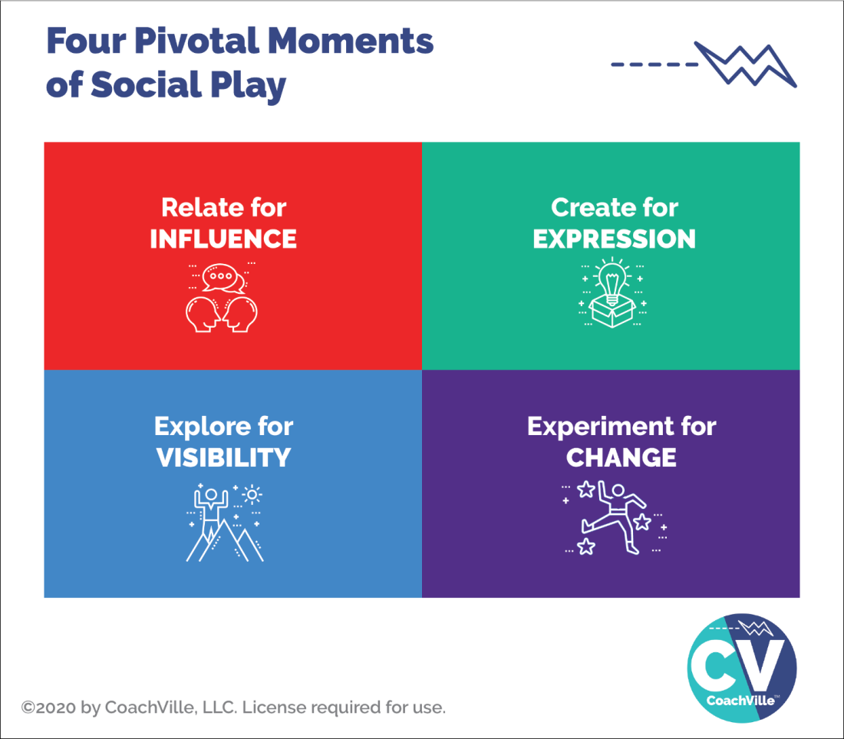
Here is an important insight to consider: Anything that you cannot control but you can influence is an opportunity to play and play better with a coach!
So I want you to wonder… to dream… of what you would do if you were able to increase your influence in the world around you.
These are the four essential activities of the Connected Age of Play.
We call them pivotal moments of social play.
- Relate, Create, Explore and Experiment
- A pivotal moment is a coach-able moment that you can improve through practice.
- Social play means that it involves co-creating the experience with one or more other people rather than completing a task in isolation; as was the norm in the Industrial Age of Control.
And here is another BIG point: YOU have unique superpowers within you that your coach will help you unleash to become AWESOME in each of these 4 types of social play.
The Four “Things” people playing life want more of…
Entrepreneurs, leaders of teams and organizations, people with a cause, people with an idea… anyone who aims to move beyond the status quo of life wants these four things:
- Influence
- Visibility
- Expression
- Change.
That means YOU!

Relate for Influence
Relate means talking to other people! This is pretty much what we do all the time in life. It becomes playful where there is an opportunity for positive influence like when you are asking someone to do something with you and they might say “yes”, but they might say “no”.

Create for Expression (AKA to Share)
Creating is when you make a thing or you design an experience that you aim to share with others; for examples: writing, recording, designing, planning. The sharing part is all about participation and contribution. This is very much in line with the “Life is Performance Art” concept.

Explore for Visibility (AKA to See and Be Seen)
Exploring is when you go into a new territory; you are stepping into the unknown (hopefully with a sense of wonder) It can be a physical place, a social media platform or even a new idea. You explore to see and experience new people and new places; and also to BE SEEN by new people.

Experiment for Change (AKA to Try New Ways)
Experimenting is any time you do something that you have not done before OR you do something that you have done in a new way. Often when we experiment we have an idea or a hope of what will happen but we don’t actually know. A key to success is to start with an intention, be open to new possibilities AND keep track of what happens; and most important is to not look at any outcome as a failure but as learning.
Hopefully you are getting energized about playing for your Dream!

The BIG Picture…
Inner Freedom is a transformational method of Life Coaching where you practice pivotal moments of social play that lead to influence, visibility, expression and change!
You will experience this fully over the next few months and you just might be inspired to take a “coach and play” approach to many of your future pursuits in life!

The FEAR of Social Play
Now you might be thinking: “Yes, these social play actions and results are exactly what I want!
“But when I think about it:
- Asking for what I want or need is pretty hard for me.
- Sharing what I create can be a real struggle.
- I know I need to “get out there” and be more visible, but it’s not easy.
- Trying new things often feels too risky so I stick with what I always do.”
EXACTLY.
These feelings are the opposite of Inner Freedom.
These four social play activities will bring up seven really intense FEARS!
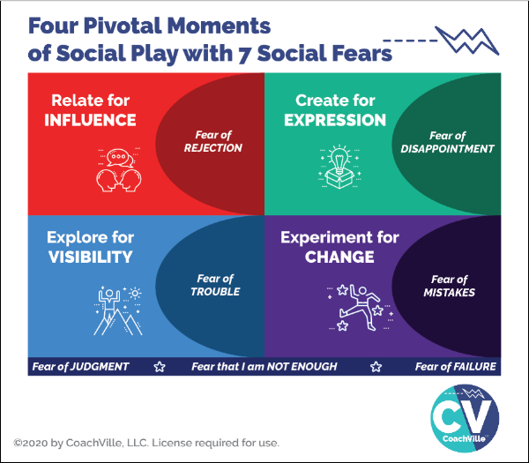
While all of us with a BIG Dream to contribute our unique value and voice to others want these four experiences… we are all also navigating through these seven intense fears; mostly on a non-conscious level and mostly with a variety of not-so-effective methods! (Hah! That is an understatement).
- Fear of Rejection
- Fear of Trouble
- Fear of Disappointment
- Fear of Mistakes
- Fear of Judgment
- Fear of Failure
- Fear that I am NOT ENOUGH (The “BIG Kahuna” Fear)

Relate for Influence = Fear of Rejection
To play for impact in the world – even with just a few people - you need to cultivate a high level of ease with approaching people and talking with them. And then you need to invite them to a next step. This is where the fear of rejection comes in. BIG TIME.

Create for Expression = Fear of Disappointment
Playing BIG for your dream will include creating and sharing experiences (or content) in a variety of forms. Also every time you have an opportunity to speak in front of people you are creating and sharing an experience. The fear that we might disappoint someone or BE disappointed by someone’s reaction to what we create can be a BIG block to creating and sharing.

Create and share is the essence of the idea that life can be played like performance art!

Explore for Visibility = Fear of Trouble
Exploring for visibility is often described as: “I need to get out there”. And for many people this is a BIG struggle; this is because the Fear of Trouble is VERY REAL.
In order to contribute your gifts to others you need to find people (customers, colleagues or partners) to participate in what you are creating. You need to “get out in the world” either physically or virtually.
The world of people is an amazing but potentially “dangerous” place; at least at an emotional level. The potential for trouble in the unknown is why most people stay where they are and spend their time with the same people. However, it is almost impossible to pursue your dream this way.

Experiment for Change = Fear of Mistakes
As coaches and entrepreneurs we are change-makers! But at the same time we are often crippled by the fear of mistakes.
This is a big remnant of the Industrial Age mindset that everything you need to do: a) there is a right way to do it b) you should be able to do it the right way every time and never make mistakes.
Of course this is nonsense! But the residue of this mindset from school and jobs keeps us locked into a perfection trap. This makes it sooo hard to experiment and find our unique way to do everything our Dream needs us to do.

Fear of Judgment ~ Fear of Failure ~ Fear that I am not enough
These fears are basically accumulations of the four fears of playfulness. They are deep artifacts of the Industrial Age of Control and they impact our thoughts and feelings in a profound way.
Here is a BIG idea: these social FEARS – and the beliefs that form around them - are not inherent to us, we absorb them from the culture through our life experiences.
If you aim to play for your Dream at a high level you need to embrace and explore these fears with profound curiosity. This is what I mean by explore your fears like a treasure map. The treasure is your playfulness and unique superpowers - for Influence, Visibility, Expression and Change - that are deep within you waiting to be activated.
BIG POINT regarding the power of coaching: it is almost impossible to explore social fear by playing alone. But together we can do it!
More about that in a few chapters.
So by playing with your Inner Freedom Life Coach, who is a very capable guide of the Human Journey… out in the social world… through these intense fears… you can become very capable in Pivotal Moments of Social Play in pursuit of your BIG Dreams.
YES!
That’s why you are here with us.
The BIG question you might be wondering…
How / where did I get all of these fears?
How did I become so fearful of activities that seem so natural and essential?
This is the question of the century! (quite literally)
Let’s talk about how this happened to all of us.

We were born to play but then we were trained to work.
I believe that the idea of playing life is the most natural, effective and joyful way to live. I also believe that the Human Spirit of Play is the most untapped resource in the world today. It has the power to transform lives, relationships, families, communities, businesses and the sustainability of life on the planet. Yeah… it’s that BIG.
But all of us were trained in the Industrial Age to look at everything as work; as something that needs to be controlled. School was work, jobs and business are work, and we also work on our relatonships and even our golf game! UGH!! In the Industrial Age you were trained to work in isolation rather than play in the world.
The essence of Industrial Age work is control.
The essence of Connected Age play is co-creation.
In his TED Talk Steve Kiel says that: “the opposite of play is not work. The opposite of play is depression”. Remember all those problems I mentioned at the beginning? They start when we stop playing. And we stop playing because we were made to feel shame for being playful at school, often at home and then at work.
What we are talking about here is our approach to life: we can work on it in an attempt to control it or we can play and co-create with it.
Hint: playing is more fun, less stressful and WAY more effective!!
Play is a better way!
The “Industrial Age” – which became mainstream around 1880 – made work the central theme and approach to life for most humans.
Many historians say that the Human focus on work and control began when humans started farming food and domesticating animals. At that point they became tied to the daily grind of working on the same plot of land every day. Whereas our hunter-gatherer ancestors lived every day as a free spirited adventure; albeit with additional risks.
But in 2010 something BIG happened… suddenly almost every human had a super computer in their hands and with it the ability to connect with anyone in the world in an instant. I call this the dawning of the Connected Age.
I believe that as the Connected Age unfolds there is an opportunity for playfulness to become the central theme and approach to life. We can restore the free-spirited playfulness that is our Human Heritage and combine it with the security of well-organized shelter and food production that our ancestors lacked.
WOW! SO GOOD.
I made a little chart to help us go a little deeper and recognize the differences between The Industrial Age of Control and The Connected Age of Play.
The important thing to notice is how the Industrial Age of Control culture created a HUGE need for Inner Freedom Life Coaching!
Life Coaching subverts hierarchical control because noone is in charge. It is a co-creation by equal partners with different roles.
We Free Each Other!!

{Chart starts on the next page}

The Transformation from worker to player
 | 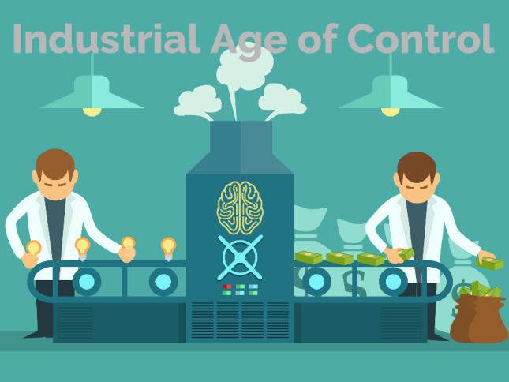 | 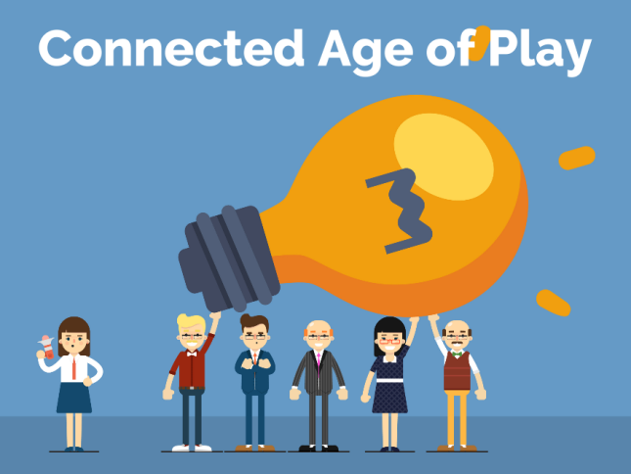
Time frame | 1880 – ~2030 | ~2010 - ????
The Framework | Everything – schools, businesses, communities - is run by authoritarian control like a military operation. | Most things are run like a talented performance art or athletic team co-creating inspiring experiences.
The Approach | Innocent teachers, managers and business owners become unwitting henchmen for the dehumanizing top-down hierarchy.  The 3 C’s  Command  Tell them what to do  Control  Show them how to do it  Compliance  Make sure they do it right | Inspired Life Coaches and coach-approach teachers, entrepreneurs and leaders play to unleash the best of Human Nature.  The 3 B’s  Become  The urge to Become through play  Believe  The ability to Believe in a dream  Belong  The need to Belong with a dream team
The Power | In the “system” | In the YOUnique Superpowers  of Individual Players in  an uplifting environment
Where we  learn | In School.  Sitting silently at a desk  memorizing the right answers  working alone completing tasks  preparing for the test | Life (and Online)…  Learning from the world  co-creating, sharing, connecting  playing games with global friends  pursuing the next level
Memes | Do it right the first time  or don’t do it at all;  (at school)Do your own work  if you help your neighbor  you are a cheater | After you fail, play again  Together we play better  Get to the next level
You are a | Worker / servant  Consumer | Player  Co-Creator / Investor
You have a | Job  with a Manager / Boss  (enjoyment unlikely) | Dream / Purpose  with a Coach  (enjoyment assumed)
What you do | Complete tasks  Fix problems | Co-Create Results and Experiences  Express Superpowers to add value
Why? | To earn a living | To live your dream and GROW
The Feeling? | Suppressed & Traumatized  Dreams squashed  Playfulness shamed  Unique voice and power silenced | Rewarding and challenging experiences and opportunities to contribute make every day a fulfilling adventure
The Path to Success... | Do it right  Don’t make mistakes  Fit in by being like the others  Don’t try to be special  Mind your own business | Play big to make a difference  Risk failure, learn fast and grow  Find a place / group that embraces ALL of who YOU are  Own your value.
You buy… | Things - More is better  Things will make you happy (NOT)  Entertainment to  “get away” from meaningless  or repetitive work | Things that inspire you  and tools for creation;  Experiences that expand your skills and awareness;  Coaching to play better  and pursue your Dream
You aim to | Save some money for retirement;  then you can enjoy life. | Co-Create a freedom-filled lifestyle  economic freedom  creative freedom  emotional freedom  spiritual freedom  location freedom

I know this chart paints a pretty bleak picture of our current culture in the left column. You may be an optimistic person and think: “it’s not that bad”. I understand. I am an optimistic – make the best of any situation – kind of person myself. However… for most people in the world it IS bad. AND we have normalized it so that we have become numb to it. AND most importantly we have been taught that we are powerless to change it.
I have been a professional Life Coach for almost 25 years for over 1,000 amazing individuals. I can tell you: even folks who are optimistic, investing in themselves and aiming big are boxed in by Industrialized social fears. They have no idea what their REAL powers are and their capacity to engage in social play activities is severely stunted.
Meanwhile, the situations we face as a human family demand that we stop “making the best of it” and start reclaiming our Human Superpowers to make change! Especially when we consider that most of the trauma, pain and suffering that is happening… we are doing it to each other without even being aware of it!
Together we can change the experience of life for the better… for everyone.

Get Your Human Nature Back!
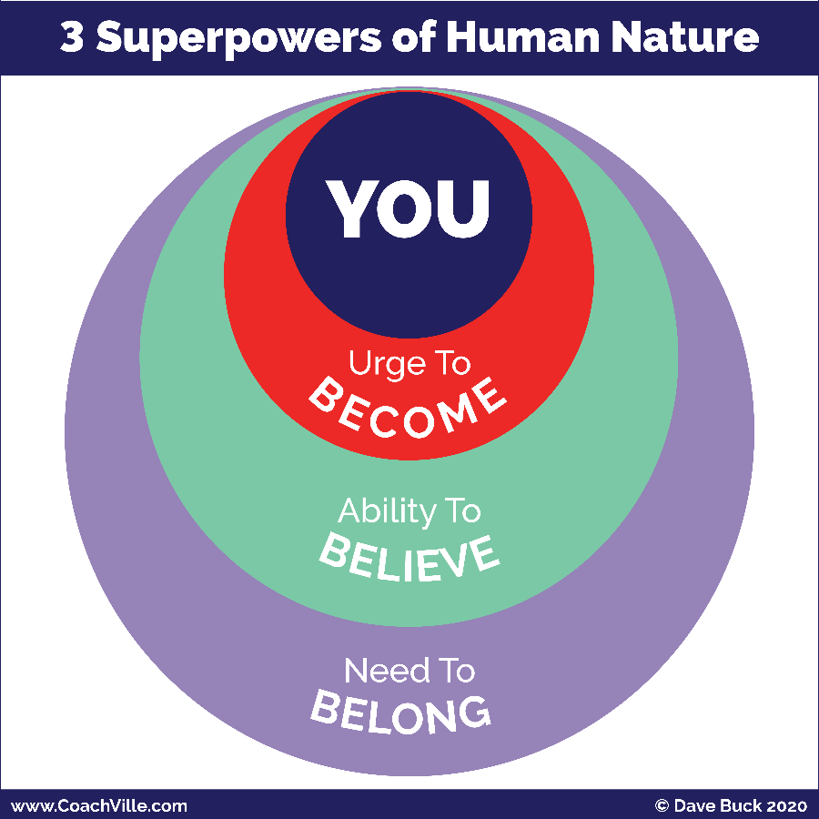
There are three Superpowers of Human Nature that you need to unleash in order to play BIG for your Dream: Become – Belong – Believe.
You saw this in the chart about the Connected Age of Play.
1) The Urge to Become. All humans have an inner urge to become the next version of themselves; to grow and expand. We become by playing. If we stop playing we stop becoming and stay the way we are.
2) The Need to Belong. This is the strongest of all human needs. It operates mostly on a non-conscious level and drives almost everything in the human experience. We Humans always seek belonging and status within the environment we are in.
3) The Ability to Believe. Humans are believers. The ability to believe is the catalyst of all human civilization.
All of our beliefs – about how life works, who we are and what is possible for us – come from navigating between our urge to become and our need to belong. In other words, we get our beliefs from our interactions with the world around us.
Some of our beliefs are conscious and we think and talk of them often. Most of our beliefs settle into a non-conscious level within us and have a non-stop profound impact of what we do and don’t do on a moment-to-moment basis. A big benefit of having a Life Coach is that by observing you they can bring your non-conscious beliefs into awareness so you can explore them.

To create change we need to unleash all three superpowers!
- We need to PLAY to become the next version of ourselves.
- We need to find or create a new environment of profound belonging where we are supported and challenged to become the next version of ourselves; where we feel safe to be our Superpower selves!
- We need to believe in our own dream. Then we need to explore our beliefs and choose the ones that we need to uplevel in order to live our new dream.
This is the essence of the Inner Freedom Method!
This is where you REALLY need a great Life Coach! We are not meant to unleash our Human Nature Superpowers alone.

Life Coaching Starts Here
When you think of signing on with a Life Coach there is a purpose behind it.
You want to:
- Accomplish something
- Experience something
- Get better at something
- Change something
You probably don’t think: “Oh, I need help unleashing my Human Superpowers!”
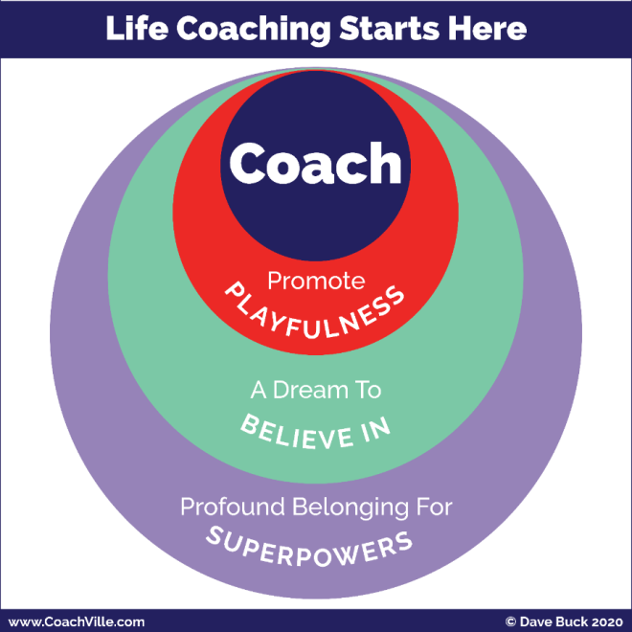
LOL
True. However, to get that “something” you want, that is exactly what we need to do.
And not only will it energize the path to the “something”, it will also open doors to amazing new possibilities!
In this little diagram called: “Life Coaching Starts Here” you will recognize the structure but the words have changed.
Promote Playfulness
The Urge to Become… Promote Playfulness
This is essential because coaching and playing go hand in glove since the purpose of coaching is playing better. So you and your coach will co-create ways for you to PLAY life in pursuit of your dream.
A Dream to Believe In
The Ability to Believe… Believe in your Dream
Life coaching is about living our dreams! So your coach will want to focus in on what your dream is. Don’t worry if it is not clear. You can start with even the smallest inkling and grow it into a BIG Dream.
Profound Belonging for Superpowers
The Need to Belong… co-create a place of profound belonging for YOU and your Superpowers.
Your coach will start be creating a “safe space” – a judgment free space – for you to express your dreams and practice being Super YOU!
As your confidence grows from your time with your coach you will begin to bring Super YOU and your Dreams out into the world so they can find where they BELONG!

We Free Each Other… The Global Life Coaching Movement
By signing on with an Inner Freedom Life Coach you are participating in one of the most important movements happening in the world today!

Our shared dream is to uplift the human family one person at a time:
From the tyranny of hierarchical control
Into the egalitarian joy of connected play

All around the world Professional Life Coaches as well as Coach-Approach leaders, managers and entrepreneurs are uplifting the Human Family – one person at a time - out of the dehumanizing Industrial Age of Control and into the Connected Age of Play by unleashing the Superpowers of Human Nature. (whew… that is a doozy of a sentence!)
Why do I say that the Industrial Age of Control is dehumanizing?
Because we Humans HATE being controlled!
We hate it. It is completely unnatural to our human nature to be controlled. Humans are born to be free!
At the same time, we are also born to be connected. We naturally care for each other and for the collective.
True freedom is the awareness and ability to be fully oneself AND care for the collective at the same time.
Essentially, Life Coaching this is about freedom!
- Freedom to be your playful self and continue to grow and become a new version of you easily and naturally.
- Freedom to express ALL of who you are and contribute your value to others and enjoy the rewards.
- Freedom to pursue your own dream with a team of people who share your dream.
- Freedom to co-create belonging with people who enjoy ALL of YOU and who you are becoming and what you are contributing.
Every person who “gets free” in this way then passes freedom on to everyone around them; co-creating a ripple effect of good.
A key point here is that we don’t get free by struggling alone! Freedom is social. We only get free together… we must free each other by stopping the status quo habits of Industrial Control and sharing the rebellious joy of Connected Play.
I am super excited to have you on our team as an Inner Freedom Player!!!
Free people, free people!

Your Fears Are a Treasure Map to Your Superpowers
This is a major theme of the Inner Freedom coaching program that you saw on the cover page so I just want to illuminate it a little bit here. We will be swimming in it full on once the coaching starts.
Here is the BIG AWARENESS: Growing up in the Industrial Age of Control you absorbed A LOT OF SOCIAL FEAR!!!
And the ways we were taught to “deal with” our fears were misguided.
AKA The don’t work at all.

From: Conquer Fear; Fear is a weakness that I must squash or overcome.
To: Explore Fear; Fear is my friend that is trying to keep me safe.
This is a very different way to look at fear than what you are used to. In the Industrial Age the idea was to make everything a simple task where nothing would ever go wrong and everything was under control. In this life you only experience the fear of shame for doing something wrong; any other fear must be squashed immediately so you can carry on doing your work in isolation.
The thing is, life is not that simple. I refer to this Industrial Mindset as the “Delusion of Control”. When you start playing for your dream out in the world of people, you realize that you can’t control it (or them) and you WILL experience fear… A LOT!
Then in the 80’s and 90’s the “Self-Help” movement really took off and continues today. While there are some good ideas in there, there was a LOT of nonsense about how you need to conquer your fear. And you can do it yourself with a self-help program.
The problem with the self-help movement is that it is based in the Industrial Culture of Isolation and working alone; somehow with the right information you can do everything yourself.
My experience has been that we can’t get free of social fears by working alone… it is impossible. So these programs lead most people to deeper feelings of shame and despair.
Here is the clue: Humans are not meant to do great things alone!!! We are social animals. We are here to co-create life together.
So the key is to change your relationship to fear.
If you attempt to conquer fear, it will defeat your dream.
If you honor and befriend fear, it will guide you to it.
Here is the next BIG idea to consider that will be a recurring theme in the Inner Freedom experience: In the Industrial Culture, the experiences you learned to fear the most were when you expressed your YOUnique power and playfulness.
What happened to most of us: We got in trouble for being ourselves!
Your fears aim to keep you out of “trouble” so the thing you fear the most is your own power!
These dehumanizing experiences put our power and playfulness into the shadows of our inner being. This is what we refer to as the treasure map.
I know this may sound strange, so I am asking you to trust me on this one and then be curious and open. We will explore this possibility all throughout the program. The good news is that your Inner Freedom Coach knows how to guide you on the treasure hunt!
So when you feel fear, DON’T FREAK OUT, and don’t ignore it! Make a note about the situation and share it with your coach. Then the adventure continues.
The Treasure Map
I call it a treasure map because it is not a like a road map with easy-to-read signs. It is an adventure with lots of challenges and quirky clues.
TO Your Superpowers
A Superpower = A unique ability that you can practice
until it is capable of making a BIG IMPACT on people or situations.
Again, the key is to stay open and curious and your coach will guide you on the Inner Adventure to discover the power that is hiding behind that shadow of fear.
This includes the Human Nature Superpowers we have talked about a few times AND your YOUnique abilities that have gone missing because of dehumanizing Industrial Age trauma.
There is a lot more to YOU than you are aware of right now.

There is more to life than meets the eye!
Another way of saying this is: there is more to life than what we can control.
A LOT MORE!
This is a BIG idea that I want to share with you to give you the bigger picture of Life Coaching and playing for your dreams.
We call it “Energy”; or Energy Alignment.
Here is a little diagram to show the elevation of Life Coaching from the Industrial Mindset focus on Control to the Connected Play mindset focus on playing with energy.
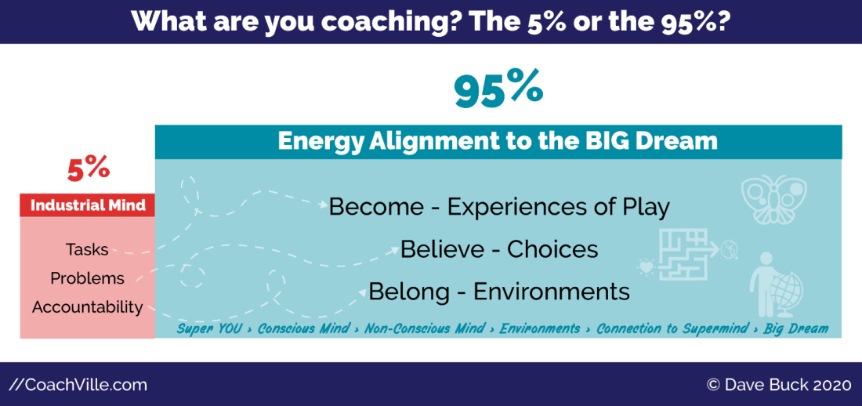
Life Coaching has come a LONG way in the past 25 years… and at CoachVille we have been a really big part of that evolution.
In the early days of Life Coaching – in the 1990’s – we were greatly influenced by the culture of the Industrial Age. So as a result Life Coaching got tangled up in concepts like tasks, problems and accountability.
But in the grand scheme of life, completing tasks, fixing problems and holding accountability is only a small fraction of what it takes to live a joyful life of freedom and co-creation!
You may have wondered:
Why is the life I imagine so difficult to realize?
The answer is: The energy is not aligned!
And most Industrial Age “success” training ignores Energy Alignment.
One way of thinking about this is in concepts you already recognize: attitude, intuition, attraction and synchronicity.
Energy Alignment makes these ideas very practical while adding the sense of mystery and wonder.
Your Inner Freedom Coach will be focused on guiding you to your BIG Dream through:
- becoming the next version of you through playful practice and the freedom to BE your powerful self,
- upleveling your non-conscious beliefs and choices and exploring your fears of your own power
- leveraging the need to belong by upgrading your environments to embrace your power.
When you develop in these areas you seem to make the right moves at the right time without a lot of wasted effort. And good things and opportunities just seem to come to you.
Yes, here we see yet another variation on the Become – Believe – Belong theme. It’s everywhere because your awesome Human Nature is everywhere!
The idea is to play for your dream and live in the flow of energy RATHER than holding you accountable for an endless list of tasks and problems.
WOOO HOOOOO!

The Energy Alignment Game Overview
Let’s explore Energy Alignment a little deeper because it is woven throughout the Inner Freedom Coaching Experience.
I am going to share with you the picture and a brief overview to energize you and spark your curiosity. We will go into each of the elements as we move along on our Inner Freedom adventure together. (Something to look forward to ;-)
You don’t need to “worry” about understanding this; it will happen naturally as your coach guides you using the Inner Freedom Method.
The “Game” is to align all aspects of YOU with your BIG Dream to create a state of flow.
Energy Alignment Game
SO MUCH FUN!! Learning about this concept was one of the big moments of my life.
This definitely goes in the realm of play; as in something that you cannot control but you can influence with skill, strategy, imagination and playful effort.
One little note: There are MANY MANY ways to play with Energy so this is not intended to be a definitive guide.
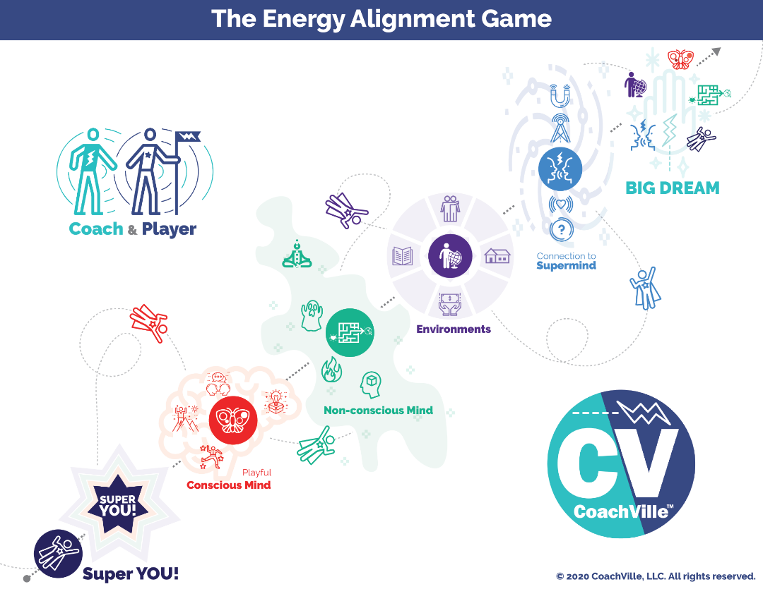
Your BIG Dream
This is your vision of what you aim to accomplish, experience, express or co-create in the world. Your Dream comes from your hearts desires but is often sparked by what you see – or don’t see – in the world around you.
Often our hearts dreams are a little mysterious; even to the one who has the dream.
Most BIG Dreams include an essence of contribution.
Next we will go to the lower left to explore all of the energies that we can align with your dream.
Super YOU
There is a next-level version of YOU that you must express fully and become in order to fulfill this big dream.
One of the reasons your Heart has dreams is so that you can discover and express more of your abilities.
Playful Conscious Mind
There is a playful version of your focused thoughts and deliberate actions that you need to use in an intentional way to uplevel your skills to align with the new dream. Your playful conscious mind responds to the urge to become the next version YOU. Play is all about becoming. In the model hopefully you recognize the 4 symbols for the Pivotal Moments of Social Play that we explored earlier.
Non-Conscious Mind
Whoa, this is a big one. Your non-conscious mind is the power source of belief and desire within you. It is like an energetic bridge between the urge to become in your playful conscious mind and the need to belong in the environment around you. You will need to expand your body awareness; where your intuition and inner knowing live.
You will need to uplevel your relationship with fear from enemy to friend and a treasure map to your Superpowers. Your dream will need you to tap into your hearts desires for focus and fuel. You will need to cultivate belief in a whole new set of possibilities to align with your dream.
The non-conscious Mind is the main focus of the Inner Freedom Method coaching… whew! We need it.
Environment
Your non-conscious mind - which is super focused on belonging - is in constant connection with your environment. You will need to uplevel many aspects of the world around you so that the powers of belonging, believing and becoming align with your dream. And as you unleash your Superpowers, you will need to find or cultivate an environment where it is safe for you to express them. Inner Freedom will give you the courage to make those changes.
Connection to the Super Mind
There is a timeless web of human consciousness that we are all connected to. Through big questions, gratitude and intentional thoughts your dream can become a magnet for the insights, inklings, spontaneous awareness, opportunities and synchronicities that you need to live your dream. But be prepared, the Super Mind plays rough so you need to expect a tumble or two.
The pursuit of Flow
Your dream is calling you out into the world to discover a bigger contribution and more fulfilling joyful life. As you endeavor to align every part of your energy to the BIG Dream, it begins to FEEL – feel is the key word – more natural. This is called getting into the flow. It is not the ultra-safe under control routine. It is engaging, yet safe enough that the potential rewards seem worthy of the potential risks. This is when pursuing your BIG Dream feels less and less stressful and more and more fun!
That is what we are playing for!

Introduction to the Inner Freedom Method
The Inner Freedom Method is a precise sequence of guided exploration conversations, practice experiences, visualizations and body awareness experiences.
You cannot do the Inner Freedom by yourself; it is NOT a self-help method. The Inner Freedom Method is a co-created experience that requires two people. (There is a way to do a modified version in a small group as well)
In Session 1 you and your coach will explore your BIG Dream for it’s possibilities as well as any “fear adjacent” experiences that you are aware of. From that point forward, each session your coach will guide the exploration of a “pivotal moment” of social play that you want to explore to unleash your power.
I will get into the details of the life-changing concept of a “Pivotal Moment” in Chapter 1 of this playbook and in the audio series. (Something else to look forward to!)
There are 9 Steps in the Inner Freedom Method. You will experience them at different times during your 12 sessions.
Here are the 12 Sessions of the Inner Freedom Method Coaching Adventure:
#1) Play With Fear
#2) Pivotal Moments and Judgment-Free Awareness
#3) Feel the Energy and Body Beliefs
#4) Memory Pops
#5) Explore the Superpower Potential
#6) Find the Perfection
#7) Flow of Gratitude
#8) Make Your Mind the Ally of Your Dream
#9) Intentional Co-Creation
#10 Upgrade Your Environments
#11 The New Super YOU!
#12 Celebrations

The Inner Freedom Method Model
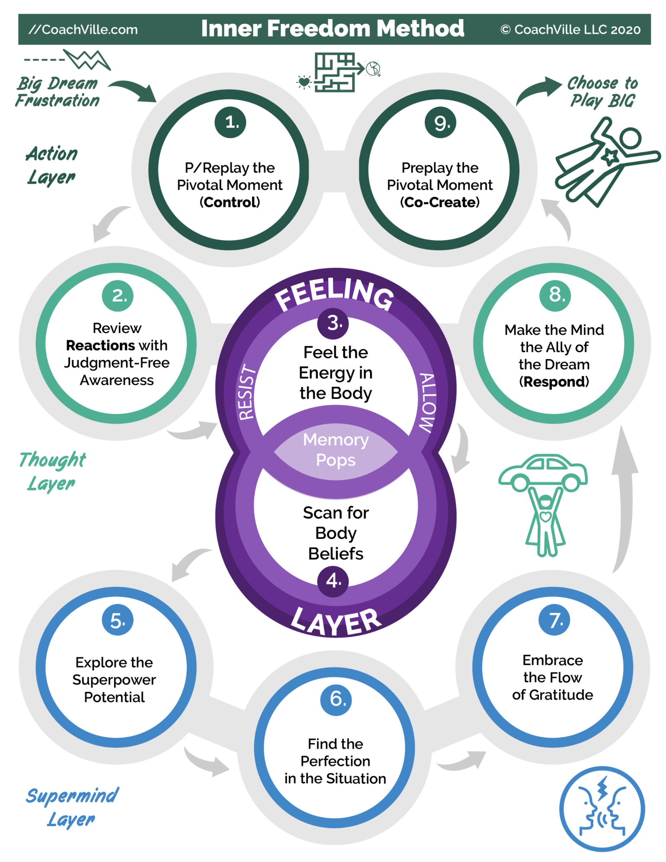

The Inner Freedom Program Adventure Log
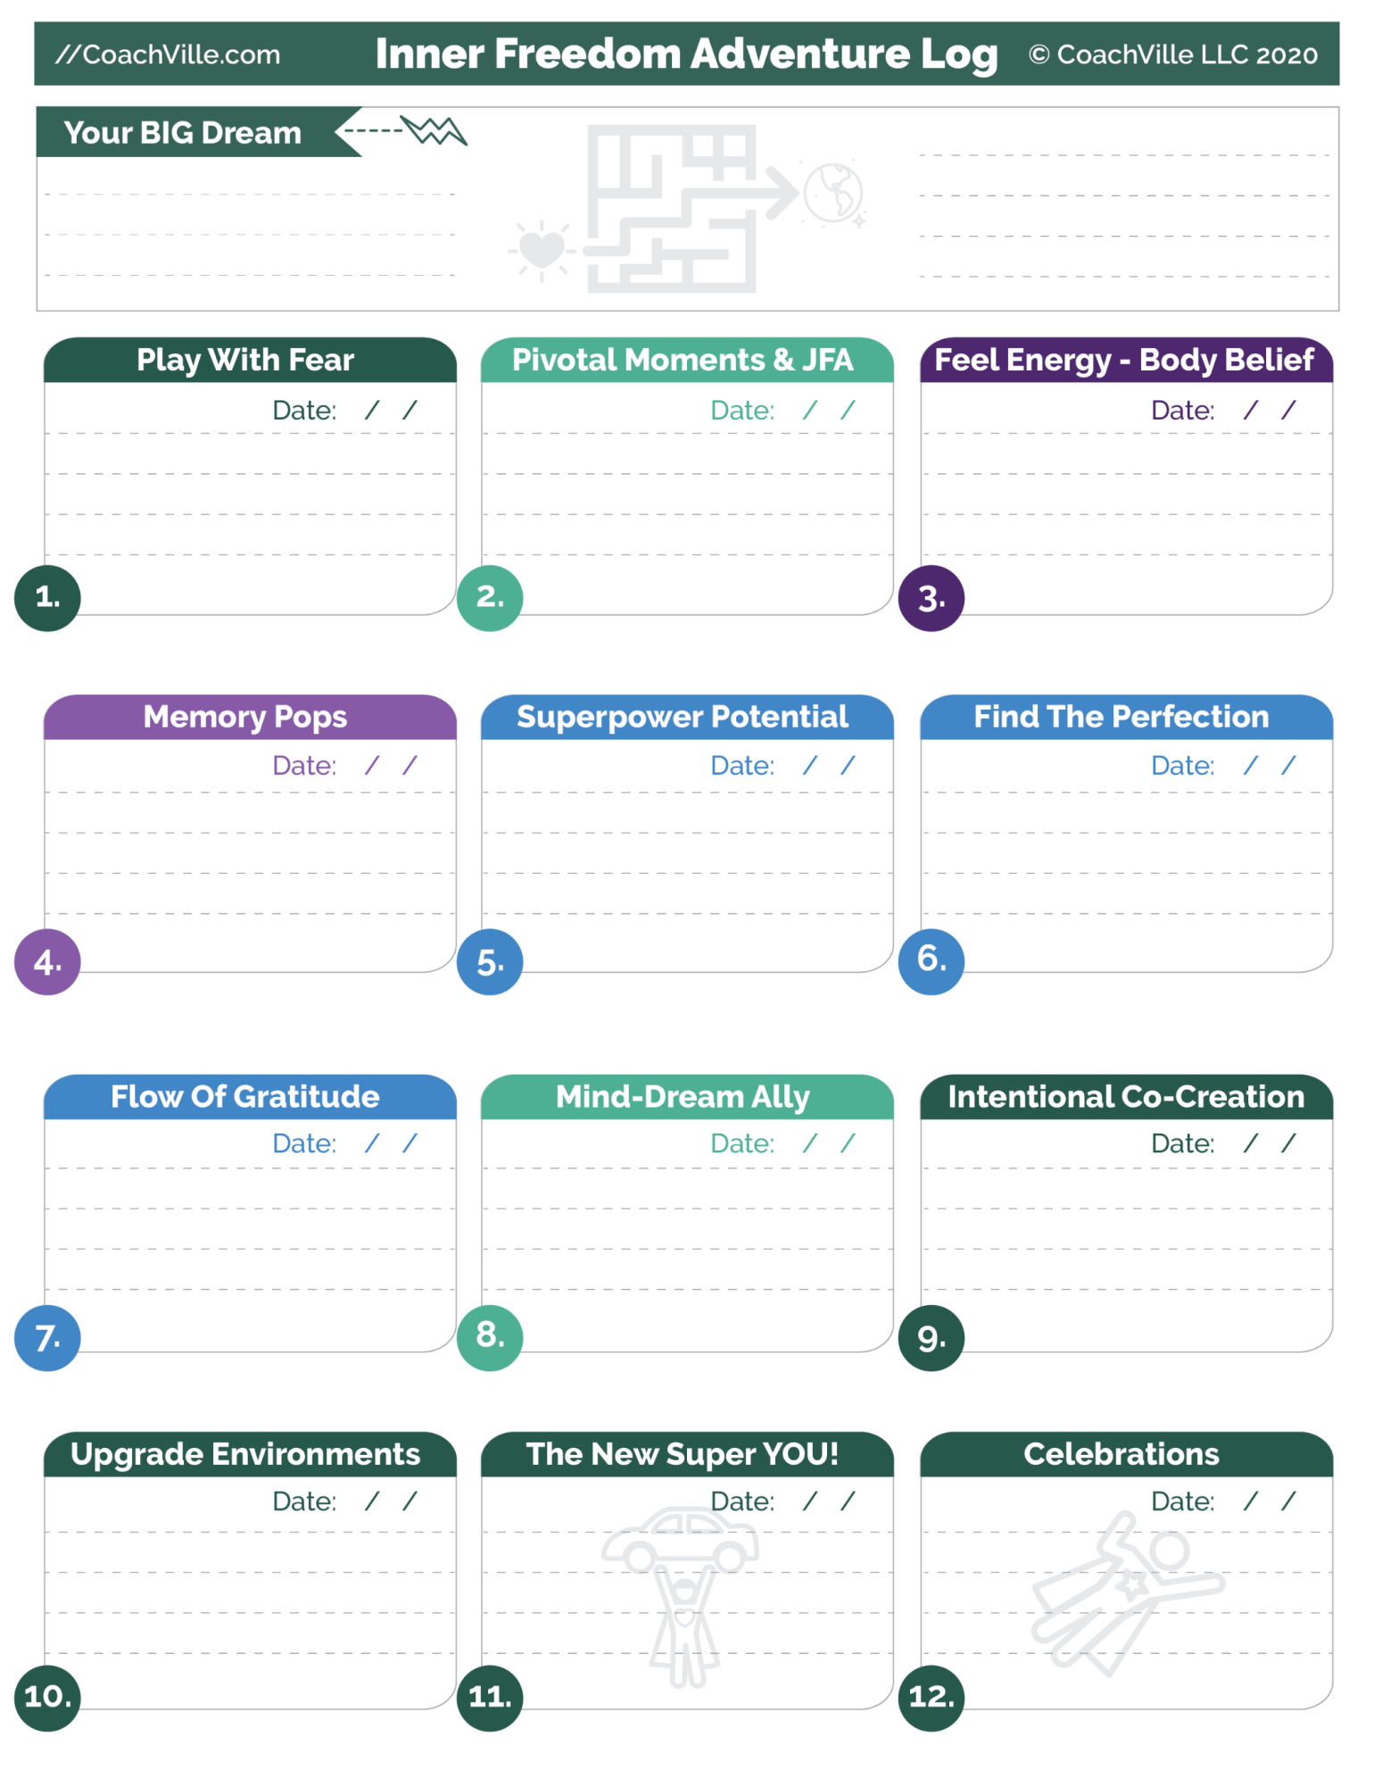

Let’s Play!
Whoa! We have come a long way together already and our adventure is just beginning.
Look out world… here we come!
If you have already signed on with your Inner Freedom Coach, that is AWESOME
Below are a few quick instructions to help you get fully prepared.
If you haven’t signed on yet but now you really want to,
CALL THE COACH WHO SENT YOU THIS!!!

How to use the playbook, weekly audio & playsheets
Your coach and I are co-creating team play for transformation. For YOU and your dream!!
This playbook and the playsheets and the audio are designed to help you get the most out of your coaching experience. Because all of the key ideas are explained here, you and your coach can dive right into co-creating and practicing together; rather than your coach using precious time explaining these concepts.
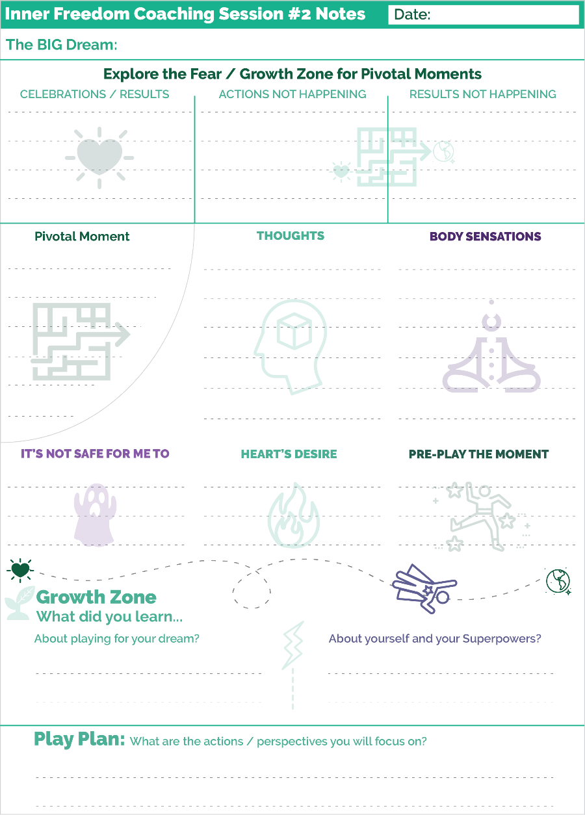
IMPORTANT: Here is a separate PDF with just the playsheets that you can use to print.
How to prep for each session
1) Read the chapter in this playbook corresponding to the session
2) Listen to the Player Prep Audio (there is a link at the top of each chapter)
3) Print the Coaching Notes sheet for the session (or print the whole pack now).
Listen to the Player Prep Audio
Listen to the “player prep” audio a time or two prior to your coaching session. This will help to create an “immersion experience” for your dream. We have all had hundreds of thousands of “repetitions” about working on tasks in isolation… so it will take quite a few reps before you can fluidly PLAY Together for your dream. But together… we will do it.
Coaching Session Notes
An example of the Coaching Notes for Session 2 is on the previous page. I am using Session 2 as the example because it is the one that is most similar to the others.
Use these sheets to write a few key word notes during each coaching session. The sheets are set up with words and symbols to follow the flow of the session; like creating a mind map. Writing a few notes will help you remember different parts of the experience and then capture your growth from the session.
Remember, a coaching session is not school! There won’t be a test. You don’t need copious notes. Write a few key words for each segment; again, like a mind map.
After Each Session
1) Write the date and a few high level key word notes on the Inner Freedom Adventure Log (seen on page 28)
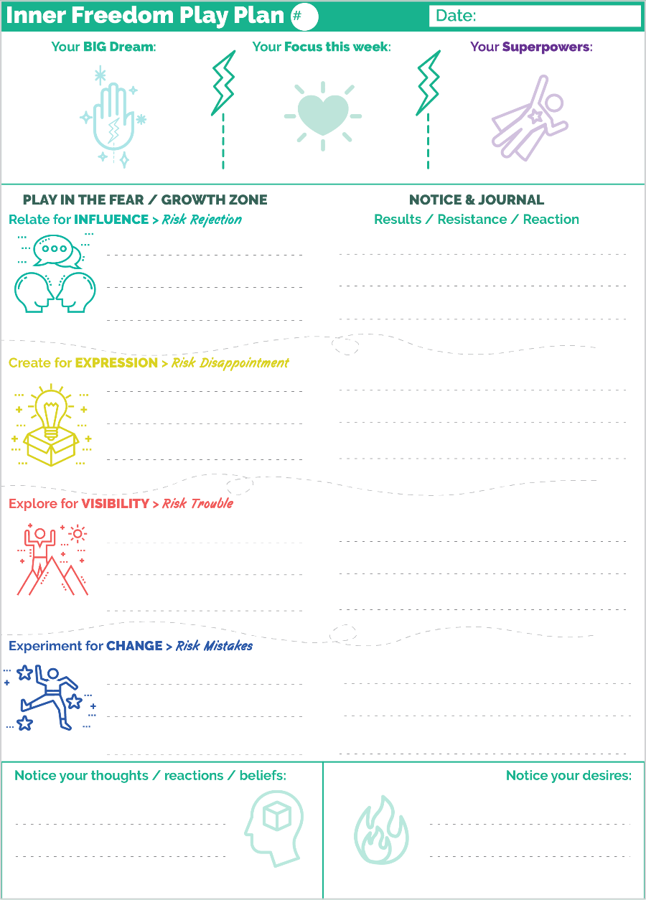
2) Print the Play Plan Playsheet to write out your play plan. Keep the sheet in view in between coaching sessions so you remember to play!
3) Write a few notes about your experiences of playing the items on your play plan.
The Inner Freedom Adventure Log
After each coaching session write the date in the section you just did and then write a few big picture phrases that capture the essence of the session. Use this one page to create a visual display of your progress through the program.
Play Plan for the week
A mini version of the sheet is on the right.
There is a page to write a few key social actions that you intend to play with during the week. Fill this in shortly after your coaching session. This is not your big task list!!
It is a play plan with a few items of Social Play to focus on; write the action on the left side of the page.
THEN as you play your week (or resist playing), write in a few key words about your experiences and what you are learning on the right side of the page.
This will help you prepare for your next coaching session.

Session #01) Play With Fear
Listen to this audio to prepare for Session 1.
In this first session with your Inner Freedom Coach you are going to explore first your BIG Dream. Then you will get into the details of some of the Actions, Challenges and Results that are part of playing for the dream. Finally you will explore a few experiences that are caused by fear and doubt. We will get into all of that in a moment.
But first, there are a few ideas that I want to share with you.
Play with Fear has two meanings:
1) to approach fear in a playful way.
2) to play EVEN THOUGH you are experiencing fear.
To put this notion of fear into perspective, let’s explore the Human Journey…

The Human Journey with a Coach
It used to be called the Hero’s Journey. We believe that EVERY human can choose to live a hero’s life by playing for a BIG Dream to contribute to others by expressing their superpowers! So we call it the Human Journey.
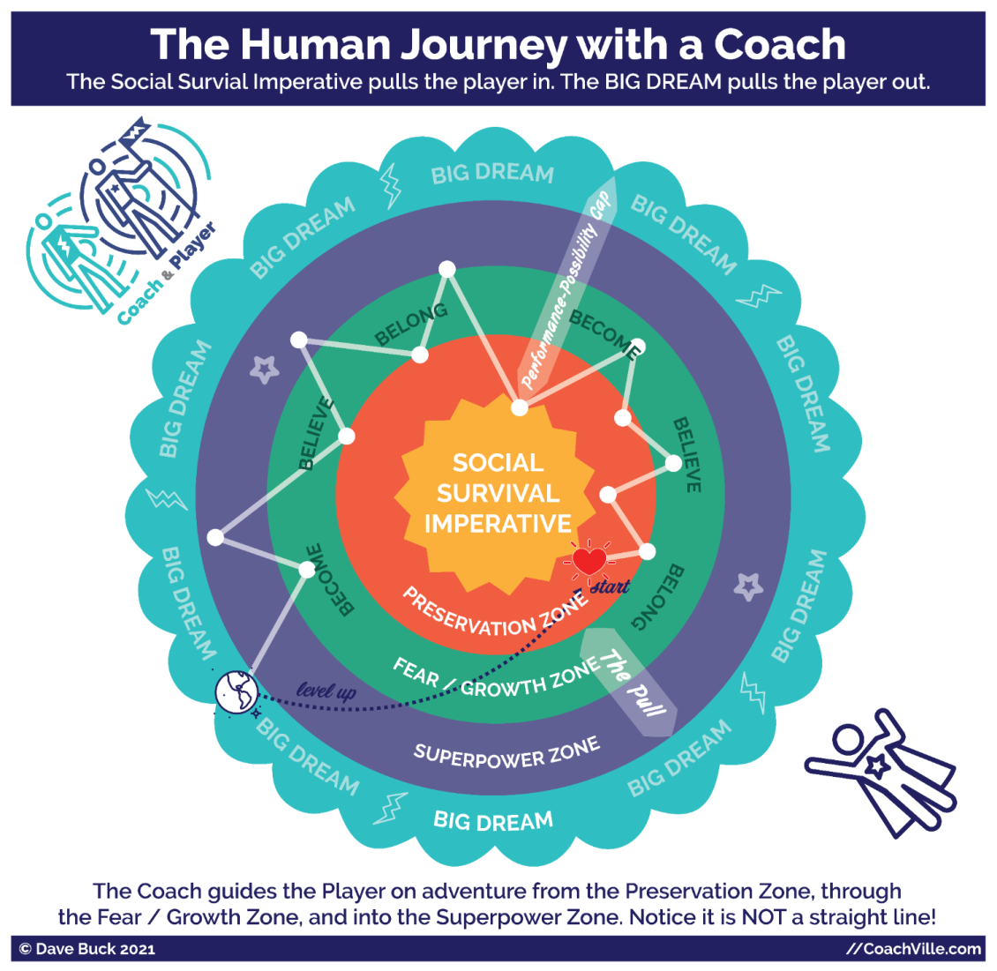
One of the key ideas about Inner Freedom Coaching is called: your social fears are a treasure map to your Superpowers. This diagram shows this idea of travelling with your coach starting in the Preservation Zone, through the Fear / Growth Zone into the Superpower Zone to reach your BIG Dream. Let’s walk through it.

There is a “play safe” version of your life that is available to you now in the Preservation Zone. In this life you preserve who you are and where you are. You avoid any social risks. This is how most people live. But this is NOT how you live when you have an Inner Freedom Life Coach!
The outer ring is your BIG Dream! The adventure is to get your heart’s desire out into the world. It is your heart is calling you to adventure! This is where the experiences and results that you imagine happen with regularity. You are in the flow of life contributing your unique value to the world in a way that is fulfilling for you. AND after some time you will be in the Preservation Zone at your new level and it will be time to pursue your next BIG Dream!
The Growth/Fear Zone is the unknown. This is where you will face challenges that you cannot overcome as the current version of you. You will need to become the next version of you, uplevel your beliefs and establish a new environment of belonging. This is where you face social risks in pursuit of social rewards. In the Fear/Growth Zone you see the 3 B’s of Human Nature: Become, Believe, Belong that we explored in the Introduction.
The Superpower Zone is where you discover the powers and playfulness within you that have been hidden in the shadows that you will NEED to live your dream. You have Superpowers for influence, expression, visibility and change that you have not yet tapped into. OR you may be using them, but now you are being called to raise your level of mastery.
Your coach will be with your guide every step of the way on the adventure.
Notice the “Performance Possibility Gap” (in the upper right). . This is the gap between the sum total of who you are and what you can do now AND who you must become to fulfill your dream. You have a vision of yourself playing life at a higher level of impact. This is a good thing!
Also notice “The Pull” (in the lower right). . We will speak about this often. This is the natural tug within all of us between the need to preserve “what is” by playing safe and the desire to pursue our heart’s Dream by playing BIG. The experience of “The Pull” will ALWAYS be there!
The Inner Freedom Method is ALL about exploring The Pull!

Your Superpowers

Your coach is on a mission to unleash your Superpowers by exploring your social fears! It helps to know what a Superpower is AND to have some examples of phrases that can be used to describe them. When you are discovering something within yourself that has been hidden in a shadow it can be really difficult to put it into words.
A superpower is a unique ability that you practice and refine through coaching until it is capable of BIG Impact on other people and situations.
We all have the Superpowers of Human Nature:
- Urge to Become
- Ability to Believe
- Need to Belong
In addition, we all have a combination of innate energies and abilities that are unique to us as individuals.
There are so many amazing abilities that only some humans are awesome at! It’s so fun. This is why we are born for Team Play!
Your Inner Freedom Coach is interested in ALL of your abilities – both common and unique – and will guide you toward expressing ALL of “who you are” to live your dream.
There is an aspect of our human abilities that has been mostly overlooked for a long, long time: the abilities to co-create change. This is because the forces of the hierarchical control status quo don’t want us to even know that we have these abilities.
These are the abilities that can be discovered, honed and refined with a Life Coach. These are the Superpowers that you can cultivate to uplift the Human Family into Freedom.
They are the Superpowers for Change!
We have a list of 64 “Superpowers for Change” to spark your imagination. As you explore the list you may see one that resonates as how you want to relate for influence, explore for visibility or create to express ideas or experiences and experiment for change.
Look it over and go with your gut to choose a few that seem to overlap these two criteria:
- Who is my Dream asking me to become?
- Do I feel this Superpower inside me?
The Super YOU page is something I created that is loosely based on the ancient I-Ching (Book of Changes). I have learned a lot from several rebellious translators of the I-Ching in co-creating this list. It uses language that is “playful” and meant to spark your imagination.
Feel free to change words or combine a few of them to create the “superpower phrases” that really FEEL like YOU!
The more you discover and unleash your superpowers the more alive you will feel.
AND it might feel pretty scary sometimes… we will get to that later.
MOST IMPORTANT: Have fun, use your imagination while you look over the list of energies and abilities and imagine yourself possessing them and using them.
For our purposes right now, just select a few and write them in the box. This is just a place to begin.
Reality check
Most people that I have coached had some awareness of a few things that they were good at doing. And some had an idea about their “strengths” or something similar from doing a self-assessment test. These inklings and readouts are valuable. But most had no idea about their Superpowers for Change! As we will explore together in Chapter 4, over the course of our lives often our Superpowers go into the shadows to hide until we are ready to embrace the risks involved with using them. NOW is the time.
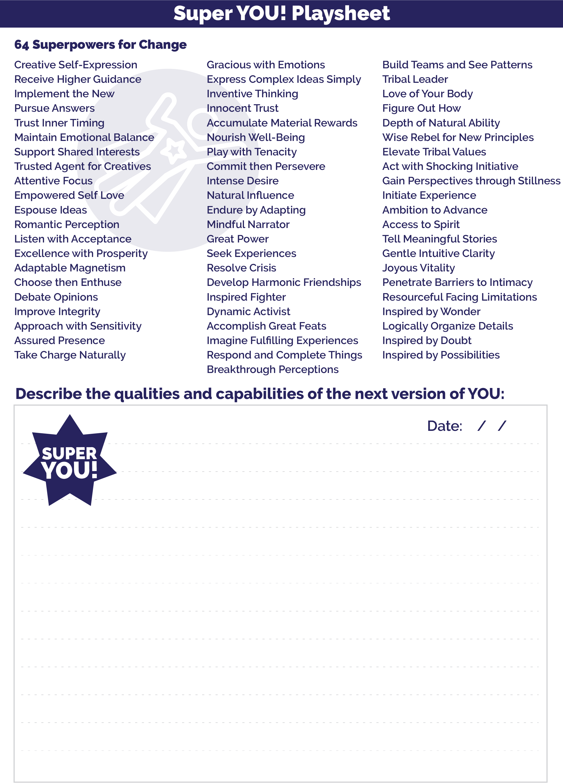
4 Pivotal Moments of Social Play and Social Fear
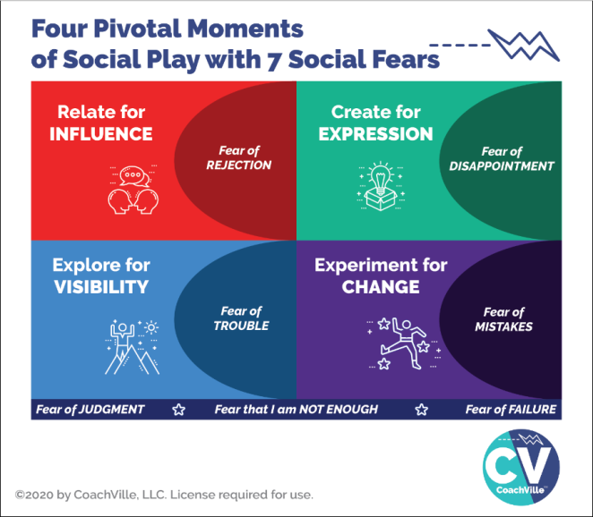
I want to quickly call back something we covered in the Introduction: the 4 Pivotal Moments of Social Play AND 7 Social Fears.
In this session your coach is going to explore with you your BIG Dream and some of the actions you are taking or want to take. Consider actions where you can expand your influence or visibility. Consider ideas and experiences that you would love to create and share with others. What would you LOVE to change in your world or THE world?
Allow yourself to dream of being an influential person in your world.
And when your coach asks you about what you are avoiding or resisting… allow yourself to acknowledge activities that you currently wouldn’t even try because you have some of the social fears described on this diagram.

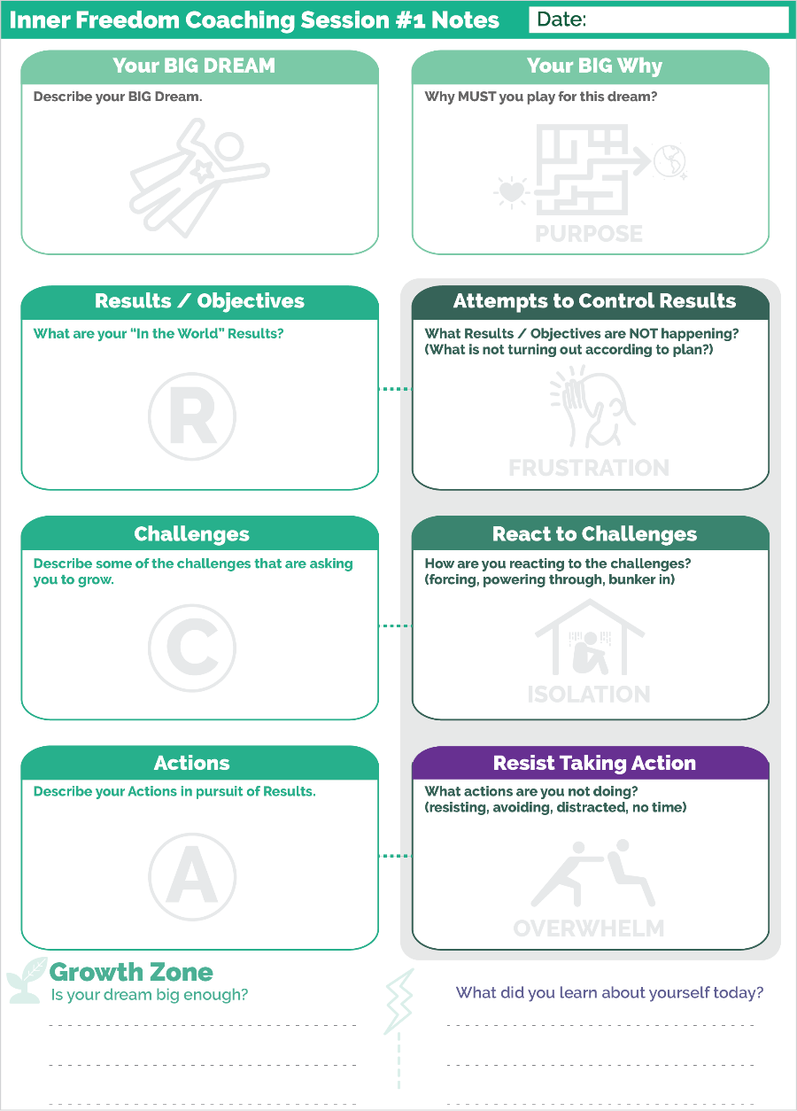
Prepare for Session 01 - Play With Fear
The purpose of this first session with your coach is to sketch out the starting point for your adventure together. As you saw in the Human Journey Diagram there is a Performance Possibility Gap that you desire to cross.
Here is a big point: in the Industrial Age the goal was to be a perfect task completion machine; you were never supposed to have a Gap or at least never admit it.
This is different! Here, the Gap is the start of the fun. Make it big and energizing and remember that you won’t be going alone.
Your BIG Dream
All coaching begins when you have a BIG dream and choose a coach to guide you on the adventure. As the “player” you must have a vision of experiencing something beyond what you are doing today; you must have a desire to become the next version of YOU!
We use the word Dream rather than objective or goal for a few reasons. First these are Industrial Words. Second we want you to tap into your imagination, your heart, your playfulness and your desire; among other things.
You may be very clear about your BIG Dream. However, if you are like most people, your dream starts out a bit “fuzzy”. If that is you, please don’t let that stop you. Start with whatever clarity you have and know that your dream can come into clarity over the next several weeks with your coach. AND it is absolutely OK to change your dream half way through the adventure.

Remember the power phrase that I introduced you to in the Introduction: Abera Ca Dabera; I create as I speak. Your Dream will get clearer and more energized every time you speak about it with your coach AND the other folks on your Dream Team.
Here are a few thoughts to help you hone in on your dream right now.
- Focus on something that you CAN do right now. It is great if you also have a “some day” dream, but your coach can only guide you toward a dream you can pursue now.
- If you have a “some day” dream that is not possible now, choose a dream that will develop you in a way that moves you toward your “some day”.
- Choose something that will pull you out into the world of other people; even if that is virtually rather than face-to-face. Something that you can do by working in isolation is not a BIG enough dream for playing with a coach.
- Choose something that will ask you to GROW; something that will take on a life of its own and “ask” you to become the next version of YOU.
Your BIG Why
The BIG why is about tapping into your deep desires for your life. What are the driving forces behind this dream for you? What is the impact you REALLY want to have on your world and the people in your life?
Results / Objectives
Co-creating results with the world is what makes playing for your dream the so exhilarating. The results are what happen when you perform the action with skill and focused intent. In a playable Dream, when the desired results are achieved on a regular basis they accumulate into the desired Tangible Outcomes of the dream. Your impact on the world will ripple out into the world for good.
Actions
Every playable Dream has actions that happen over and over again as you play; like shooting the ball toward the basket in basketball. When actions are taken to co-create desired results WHILE holding a vision of excellence, they grow into a new level of Mastery. Again remember that you want to focus on relating, creating, exploring and experimenting rather than completing routine tasks.
Challenges
Any dream worth playing for is full of interesting challenges; some anticipated, some unexpected! The challenges are what get in the way between actions and results. The key for you and your coach is to find the sweet spot between easy and hard. If the dream is too easy it is not inspiring. If it is too hard (not attainable) then apathy sets in. It is through facing challenges that you become the person you desire to be.
Attempts to Control Results ~ Frustration
(what is not turning out according to plan)
Frustration is a very common experience for folks who go for their BIG Dreams in life. LOT’s of the time, things don’t go as planned. The key is to share what is not turning out without judging it. Often when we experience frustration we are attempting to control something that we can’t control; but we can influence by playing better.
React to Challenges ~ Isolation
(forcing, powering through, bunker in)
In the Industrial Age a challenge meant that you were doing something wrong. That is not how we view it in Connected Play. However, since we grew up in the Industrial Age where we were trained to work in isolation, when things don’t go our way often our first instinct is to “bunker in” and work harder to figure it out before anyone finds out.
Reacting in this case is referring to your thoughts and how you perceive your self and your situation when things go wrong.
Resist Taking Action ~ Overwhelm
(resisting, avoiding, distracted, no time)
This is the one that is often easiest to notice. However, again since in the Industrial Age we were trained to be perfect, when we don’t do something we needed to have a good excuse. Or we needed to say that we were just too busy to do it. Being busy or overwhelmed is the go-to reason for almost everything we resist or avoid.
If there is an action that would really move your dream forward and you are not doing it, then that is something to recognize and call it what it is. This will open up a wide pathway for personal growth with the Inner Freedom Method!

Growth Zone
When we play together we grow; all the time. But since most of us have been in the Industrial Status Quo for a while we lose our awareness of growth. Your Coach is going to ask you about growth in every session. Get used to it! With your attention on you and your coach’s attention on YOU, you can recognize your own growth and start to feel really alive again. FUN!!!
No Shame in the Game
When your coach asks you about the activities you are resisting etc., the most important thing you can do is to talk about these experiences in a straight forward, open, curious, judgment-free way. Every BIG Dream will give you a fair share of troubles and sleepless nights. This does not mean that you are doing it wrong! In fact, it probably means you are ready for the kind of breakthroughs that Inner Freedom Coaching can create with you.
Watch out for “Spiritual Bypass”
Spiritual Bypass is a term that refers to a situation where you try too hard to maintain a positive attitude or stay in a place of gratitude – which in general are valuable practices. But when you try too hard you can go blind to the real challenges around you and within you and lose your determination to co-create change.
Connecting a Few Dots…
One last thing about the Coaching Notes sheet and Coaching Session #1
When you have a desired result, and you attempt to control the result (rather than co-create), it can lead to frustration.
When you face a challenge, and you react to the challenge (rather than respond), it can lead to isolation.
When you intend to take an action, and you resist the action (rather than allow it), it can lead to overwhelm.
Whew! There are so many growth opportunities. We will explore them along the way.

How to use the weekly Play Plan Playsheet every week.
I shared this with you in the Introduction. But since it is such an important part of the growth process I want to share a few extra thoughts about how to use these sheets each week.
AFTER each coaching session…
The top of the page sets your intention for the week. This is super important and empowering!
In the left section write a phrase or two to describe your BIG Dream. This may change and evolve as you play; or you may write the same thing every week. Either way… writing it out each week and looking at this page often will keep it close to you. The palm with the lightning bolt is the symbol for the mystical power of your dream.
In the middle section write your focus of for the week . This can be a theme or a specific action. The symbol is the illuminated heart! This is from the Inner Freedom symbol for getting your hearts desires through the maze and out into the world. Giving a theme to your week will keep your energy vibrating at a high level.
In the right box write a few of your Superpowers that you aim to play with this week. This may be a little sparse in the early weeks. But you will add more as you become aware of them. Remember this is your intention. By writing a few power phrases in there and then reviewing the sheet every day, you will be amazed at how often you will feel the urge to use your Superpowers!!
Then there is a section for each of the 4 ways to play in the FEAR / Growth Zone. Write a few action items in each section. (at least one) Remember this is not a task list; this is a play plan. You have intentions for actions and results but you don’t know what will happen.
Write what does – or doesn’t happen – in the right column as you play the week. It is labeled “Results / Resistance / Reactions”.
Results – it is important to separate the action from the result. What happened “in the world” remember it was not automatic so notice the details.
Resist - Write in if you had a time or thought to do the action but didn’t do it. This is definitely not something you do with a task list!
Reactions – Notice your thoughts and body as you are doing the action and make a few notes if they are noteworthy.
This will give you a great summary that you can share with your coach.
The bottom section is for you to write a few notes about beliefs and desires that pop up for you as you play through the week. These are mostly non-conscious so you need to catch them when they pop up and write them down.
Remember, this is just the first week! So just play with it the best you can and know that you will gain confidence in this process over time.

Ready to go!
Allright!! That is all you need to know to jump in to Inner Freedom Coaching Session #1.
One last thing…
Coaching is a co-created experience. There is no right or wrong answer to questions or explorations.
The point of this playbook is for you to understand the concepts that will help you dive into the co-creation; this is where the real fun and big breakthroughs come from.
Be your full-on self; trust your Self and trust the experience.
It is going to be awesome, illuminating… and FUN!!
Enjoy it!

Session #02) Pivotal Moments
And Judgment-Free Awareness
Listen to this audio to prepare for Session 2.
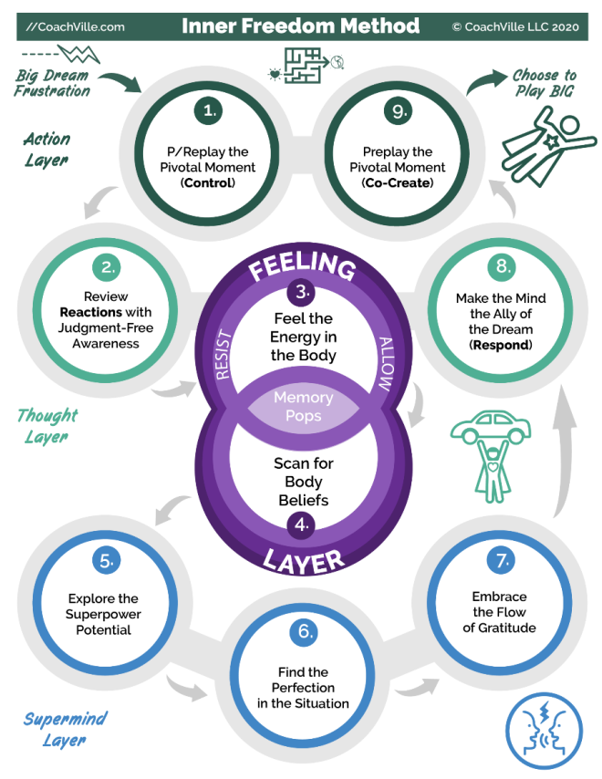
Your coach is going to use a short version of the Inner Freedom Method for the first few sessions. On the diagram of the method (Full size version on page 28) this will be steps: 1,2,3,4,8 and 9
Also I will share with you our Plan-Play-Grow technique so that you can get into the rhythm of playing with a coach.
Understanding the concept of the pivotal moment is essential to thriving with your Inner Freedom coach so we will get into this in detail. A pivotal moment is anytime you intend to make a play for your BIG Dream but it doesn’t turn out as you planned.
We will go over Steps #1 and 2 in detail in this chapter, Steps #3 and 4 in the next chapter.

Choosing a Pivotal Moment to play with
The first part of your coaching session each week will involve reviewing some of the events from your week of play. This weekly exploration serves several good purposes:
1) Your coach can celebrate with you the moments that went well and
2) Your coach can explore with you the moments that didn’t go so well.
From this exploration you and your coach will choose a moment to practice using the Inner Freedom Method.
A metaphor that really helps in understanding this aspect of Life Coaching is to imagine an athletic coach watching their team in a game. In a game there are MANY moments that happen. When the coach and the team gather for their next practice the coach will have selected a few pivotal moments from the game to focus on with the players. Then they will practice ways to play better in moments like that in the next games.
This is the same idea except you need to play the key role in noticing the pivotal moments because your coach isn’t watching you play. So what I aim to do in this chapter is share with you how to notice a pivotal moment when you are playing for your dream. In any week of play there will likely be several juicy pivotal moments to explore. Your coach will help you choose the ONE to focus on for the session.
Before we move onto the Steps of the Method, I want to share with you some BIG ideas about how to notice pivotal moments while you play for your dream.

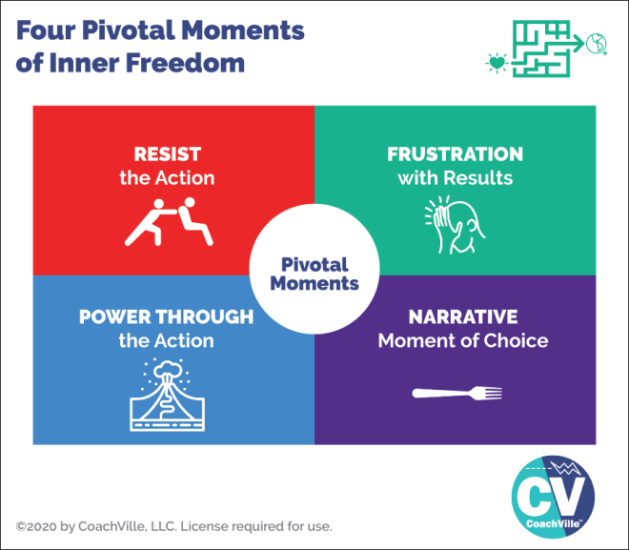
4 Pivotal Moments Of Inner Freedom
As you look at the model you might notice that it is similar to some of the ideas and images from the Playsheet for Session #1 when your coach was asking you about the actions that were not going so well in playing for your Dream. A VERY IMPORTANT point for this exercise is to maintain judgment-free awareness; be open and curious; no blame, no shame. (I am going to remind you about this every week; the Industrial Mindset is a beast)
The reason we are going into this in such detail is because MOST of the time these pivotal moments go by so fast that we don’t even notice them. There is a LOT going on, but it is happening at a non-conscious level so most of the time it passes by. BUT… now that you have an Inner Freedom Coach you need to learn how to pay attention to these moments.
Resist the Action
This is typically the easiest to recognize. This is when there is an action for your dream that you intend to do and even want to do but you just don’t seem to do it. You find yourself putting it off; sometime deliberately and oftentimes non-consciously by “getting busy”. If it is an action that is important for your dream and you are not doing it then you are resisting it; there is some kind of fear involved…plain and simple.
Power Through the Action
Powering through is very similar to resisting except that after resisting the action for some time you eventually do it. BUT typically you have to really gear yourself up to do it. Or you just get so annoyed with yourself for not doing it that you just do it to get it over with; not the best energy for an action that is part of living your dream! ;-)
The purpose of Inner Freedom is for you to get into your actions with an easy flow!
Frustration with Results
This is when you take the action but you don’t get the results that you desired. Remember with your BIG Dream we are talking about playful actions where you can’t control the outcome but you can influence it. So when you don’t get your desired results that is an opportunity to expand your influence.
This is situation where your energy may be impacting the outcome in a way that is not beneficial. But it is VERY difficult to notice your own energy while you are in the moment. A goal of your coach with Inner Freedom Method is create awareness of how your energy is flowing in the moment you take the action. When you shift your energy you often get better results.
Narrative Moment of Choice
This is a situation where there is a “story” involved about how or why something didn’t happen. Typically in a story like this there was a moment of choice to go one way or another. (the metaphorical fork road) In that moment you made a choice that pulled you toward the safety zone and away from your Dream.

Plan-Play-Grow Technique
To help you make the most out of your coaching experience I am going to share with you how to get into the rhythm of playing with a Life Coach. There is a coaching technique we use to create this rhythm called: Plan-Play-Grow. If you have ever had an athletic coach or a performance art coach then you will recognize this technique.
On a personal note, I first learned about this technique by observing my mom who was a piano and voice coach. Her music studio was right beneath my bedroom in the house, so I heard coaching happening every day after school. Even though I wasn’t tuned into the details I did notice one very dramatic thing: over time all of her students played a lot better! This is exactly how it happens… and it yields great results almost every time.
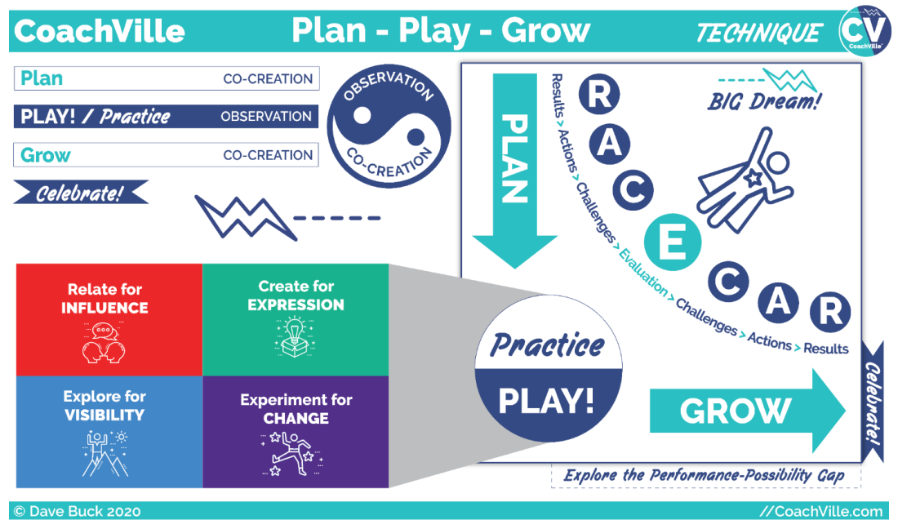
Let’s explore this model together.
We start in the upper left where you see Plan – Play / Practice – Grow – Celebrate. You also see the yin/yang symbol with the core of the coaching experience which is observation and co-creation. You may recognize those terms from the definition of coaching I shared with you.
Next, look at the right side of the diagram. You see the Plan – Play / Practice – Grow – Celebrate again but this time you also see what we call the RACECAR acronym: Results – Actions – Challenges – Evaluate. We will get into that in a few moments.
Also in the lower left you see a call out from the Practice / Play circle into the 4 primary activities of playing for our dreams; AKA Social Play. You saw this in the Playbook Introduction. (It’s all coming together!)
Whew! We have a lot to talk about here.
Let’s first get clear on the coaching rhythm because it will really help you get the most out of your sessions with your coach.
In the coaching session:
You and your coach will celebrate the notable experiences since your last session; especially moments of play where something good happened.
You and your coach will co-create a coaching PLAN for the session by first EVALUATING what happened when you played. You will also explore your insights. And you will share specifics about key playful actions and the results in the world.
You and your coach will PRACTICE together to co-create new awareness, new possibilities, new capabilities and new confidence. We will explore a variety of practice techniques in this Inner Freedom Coaching program.
You are your coach will capture your GROWth from the session. (The Growth Zone in the Coaching Notes Play Sheet) The intention of a good coaching session is that you grow during the session… and then continue to grow as you play in the world.
Make a few notes on you’re the coaching notes sheet as you talk together.
You and your coach will co-create your play PLAN for the upcoming time frame; focusing on the 4 types of actions to play BIG for your dream.
You will write out the most important items on your Play Plan Playsheet.
Then…YOU go out in the world to play:
You PLAY for your Dream aiming to co-create RESULTS and experiences by taking the 4 types of ACTIONS and facing CHALLENGES along the way.
You notice your GROWth opportunities as you play.
Make a few notes on your playsheet about what happens as you play (or avoid playing).
In the next coaching session:
You and your coach will CELEBRATE your RESULTS (and your challenges)
You and your coach will co-create a coaching PLAN for the session by first EVALUATING what happened when you played.
You and your coach will PRACTICE together.
You are your coach will capture your GROWth from the session.
You and your coach will co-create your play PLAN for the upcoming time frame.
YOU go out in the world to play:
The rhythm repeats from here.
When you get into this rhythm with your coach, you will be amazed at how quickly you feel your progress and good things start to happen. It really is fun.

Understand RACECAR
One of the most important shifts that your coach and I want to help you make is from Industrial Control to Connected Play.
Understanding the acronym RACECAR from the Plan-Play-Grow technique can help you make this shift.


R is for Results in the world
Probably the most challenging part of the shift is the focus from completing tasks to co-creating results in the world.
In the Industrial Age we were told to only focus on what we can control.
So we should only focus on completing our tasks and doing them right; mostly in isolation so that we don’t bother anyone. Since we can’t control what happens with other people we should not put our attention there.
In the Connected Age of Play it’s ALL about co-creating with others; we use our powers and energy to be a positive influence in the world; to make a positive impact.
We put our attention on the results that happen because that is the purpose of playing for our dream. In play you have to look beyond yourself… out into the world or people around you that you aim to influence or contribute to or be seen by or make changes with.
In play… there is NOTHING you can control. When we play for results sometimes they happen and sometimes they don’t. That is what makes it play. Practicing with a Coach to play better means getting the results we desire more often than we do right now.
Remember the results from our 4 pivotal moments of social play: influence, expression that contributes to others, visibility and change.
STOP getting people under control
Another quirky angle on Results from the Industrial Age of Control is that we SHOULD be able to control everyone and everything by following the manipulation instructions properly.
There are a lot of manipulation techniques in the Industrial Age because the whole focus is on getting everyone and every situation under control. This is very difficult of course because as I emphasized in the Introduction, we humans HATE being controlled!
So what happens most of the time is that our attempts to control are futile and frustrating. This is one of the reasons why there is so much chronic anxiety and depression in the Industrial Culture: people are in positions or roles where they are supposed to control other people and they are judged based on their ability to control others. This is SUPER stressful.
Letting go of the delusion of control is one of the most freeing benefits of shifting into the Connected Age of Playing for Influence as a co-creator.
This is a LOT of what Inner Freedom is about.

A is for Actions with your Superpowers
We all do a lot in a given day. The key here is to find moments when you can take the social play actions: relate, create, explore and experiment.
Since we are all used to going through our days completing tasks, it requires some intentional effort to get into play.
A) There are some actions that you are doing already that you can now approach playfully.
B) You can intentionally add playful actions into your day.
Playful actions are when you aim to be a positive influence on someone or co-create with them AND you pay attention to the result that happens (or doesn’t happen).
The performance-possibility Gap
The idea of the Performance-Possibility Gap is integral to coaching. You have a current level of facility with playful actions and your superpowers. And you and your coach share a vision that you can expand that facility.
You can co-create the results you desire more often.
You can PLAY better.
The key to getting into play mode is to drop the Industrial Age Control mindset that you have to do things perfectly every time. This “perfection trap” is antithetical to play. It literally makes it impossible to play and that was the intention; to get you to stop playing and become a compliant worker doing what you are told to do by the boss. Sad but true… we have been doing this to each other for a long time now.
But not anymore!!!
You can break free of the perfection trap and enjoy playing again.
The next step is to embrace challenges.

C is for Challenges with the Spirit of Play.
When I was describing results I wrote that sometimes they happen and sometimes they don’t. This is the nature of play.
Well, everything that contributes to the desired result NOT happening is a challenge.
There are several different types of challenges.
1) A challenge where you need to develop more skill and experience in what you are doing.
2) A challenge where you experience some doubt or fear related to what you are doing.
3) A challenge where there is something in the world – probably some force of the status quo – that doesn’t want you to achieve your desired result.
The key to being playful is to embrace challenges with the spirit of play.
There are some challenges that you are already aware of. And there will be plenty of challenges that you don’t even know about yet but will arrive as you play more and more.
Every challenge presents you with a growth opportunity. Growing and playing better is fun! Players embrace challenges. Great players LOOK for challenges.
When you are really passionate about the result you are playing for, the experience of a challenge can elicit your Superpowers. Somehow the challenge causes you to reach deeper into yourself and your real power comes through. This is why playing for dreams can lead to surprising discoveries within yourself.
A benefit of playing with a coach is that you can talk through what is happening when you play and identify the challenges you are facing. And then co-create a plan to play with them by expressing your superpowers.
There is nothing wrong.
Embracing challenges is another element of play that requires a shift from the Industrial Control mindset. When the focus is on following the instructions and keeping everything under control, a challenge usually meant that you were doing something wrong. IT meant that you were not perfect… oh the horrors!
Embracing challenges as fun growth opportunities – rather than something is wrong – will significantly reduce your stress and expand your joy.

E is for Evaluation with judgment-free awareness
I know that the experience of being evaluated can bring up a lot of bad memories. Starting with the dehumanizing and traumatizing testing we all suffered as children in school. Followed by the dreaded performance reviews many of us suffered in jobs. The purpose of the whole thing was to show you what you were doing wrong. UGH!
I am inviting you here to look at evaluation with a fresh perspective. YOU are not being evaluated. YOU – with your coach - are evaluating the results WITH judgment-free awareness. You are doing this to assess the impact you are having and look for ways to play better.
In this setting, evaluation is a co-created experienced aimed at helping you become MORE.
This is another situation where it will take a little practice to shift out of feeling that there is something wrong into seeing ways to grow.
You and your coach will do it together.
C-A-R is looking at it from the other direction
- You experience and embrace a challenge
- You take your playful actions
- In pursuit of your desired Results.
The idea of the RACECAR acronym is to look for results, actions, challenges and evaluation for growth opportunities in a fun and playful way.
Next let’s get into the Inner Freedom Method!

Step #1 P/Replay the Pivotal Moment

Once you choose a pivotal moment to play with the next few steps of the Inner Freedom Method are sort of like watching game film of the moment together. Looking at the moment together from an Energy Alignment perspective… you will explore the action, thoughts in the mind and physical sensations in the body. This is the first step in getting your hearts intentions through the maze and out into the world.
To start you will bring the moment into your imagination and play the scene out and describe what is happening to your coach so that you can “look” at it together.

Replay OR Pre-Play
Often you will replay the moment that happened in the past week.
However, you can also preplay a moment in the future.
This is an advantage that your imagination has over actual game film in an athletic coaching situation. Your imagination is so powerful that you can preplay a moment in your future with just as much detail as you can replay a moment in your past.


Step #2) Review Reactions with Judgment-Free Awareness
Our minds are truly amazing! And we are going to tap into this amazingness in Step #2 of the Inner Freedom Method.
While you imagine yourself in the scene of the Pivotal Moment (either replay or preplay) you can also notice the thoughts that are going through your mind in that scene. We refer to these thoughts as reactions because they frequently reveal how you are reacting to the situation; usually your non-conscious beliefs will aim to keep you safe by popping up thoughts that will keep you “in the box”. In Step #8 we will make a transformational leap from react to respond.
So, you are both in the scene and also the observer of your thoughts about the scene AT THE SAME TIME!
BIG WOW!
And your coach is there with you also observing as you describe the scene and then your thoughts.
The big breakthrough here is to notice your thoughts with judgment-free awareness.
This means that you are gentle, open and curious about every thought that you notice. No filter, no blame, no negative assessments, no ignoring some because they don’t seem relevant… just notice and share each thought; they are all relevant and valuable.
Your coach will help you make sense of it all as you move along.

Brief review of Steps 3,4,8,9
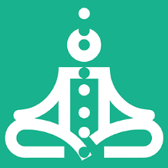
Your coach will do steps 3,4,8 and 9 with you for the first time in this session.
Steps 3 and 4 are where we explore what is happening in your body (The Feeling Layer) while you are in the scene. This may be a new experience for you so just go into it with curiosity. Feeling energy is something that gets better with practice… so this is just the beginning. Your coach will guide you so you can just relax and enjoy the adventure.
We will explore these two steps in detail in Chapter 3. It will be easier to explain after you have experienced it.
Step 8 is where you explore how your dream wants you to respond to the situation. This will reveal the opportunity to choose between your Dream and your Social Survival Imperative (Remember “the Pull”).
Then in Step 9 you use your imagination again to preplay the scene the way your dream wants it to go. It’s fun. This is the type of guided visualization that all of the top performers in Athletics, Performance Art and Life do with their coaches on a regular basis. It is powerful and it will lead to better and better play over time. YES!!

Prepare for Session 02 – Pivotal Moments
A mini version of the Coaching Notes Play Sheet for Session #2 is on the right.
The purpose of these sheets is to provide you with a basic structure where you can write in just a few key words along the way; like a mind map.
A coaching session is not school! You don’t need to write a lot down. It is a co-created experience so you need to be fully present and fully participating. Having the structure of the conversation on the page allows you to just write a few words in each section that you can review after the session.
The trick is for some parts of the coaching session you will be visualizing with your imagination and you will have your eyes closed; not an easy way to take notes! After each visualization write a few key words in to the relevant box.
Before the Session
For the start of your coaching session have your Play Plan Playsheet from the previous week in front of you. It should have your notes from your experiences of playing for your dream. Highlight a few moments you want to share with your coach.
The BIG Dream
Your Coach will ask you about this every week. Allow yourself to speak it from the heart each time. You may notice yourself describing it in a new way. Write down the key phrases at the top of your sheet.
Explore the Fear/Growth Zone for Pivotal Moments
Share with your coach the key moments from your week of play. Sharing is powerful. As you talk about it you may come to a new realization or understanding. Avoid the “task list read out” vibe. Share each one as a short story.
- Celebrations and Results
- Actions Not Happening
- Results Not Happening
Celebrate any experience that was noteworthy for you! Remember: A Result is when something happens in the world as a result of your actions.
Then with judgement-free awareness note anything you planned to do but did not; and when you took action but did not get your desired results. BE JUDGMENT FREE!!!!
Choose a Pivotal Moment to Practice
The next step will be to choose a pivotal moment from all the possible moments. You may know exactly which one to choose. If not your coach will help you choose one.
Write the essence of it on your play sheet.
Then your coach will guide you through the Method.
Thoughts – Share what comes up for you.
Body Sensations – This is an eyes closed exercise; after you do it write a few notes. As far as noticing body sensations, this may be new for you. Stay as open and receptive as you can.
It’s not safe for me to: - This will reveal a body belief / non-conscious belief.
Heart’s Desire – This will connect your dream to the moment you are exploring.
Pre-Play the moment – This is a powerful exercise to put your energy into a vision of the future.
Growth Zone
It is valuable to capture your growth oriented insights right as they happen. It is easy for them to disappear when you get back into your day.
Play Plan
You and your coach will co-create a few actions to focus on in the days ahead. This is just a start. You will develop a complete play plan each week and write it on a new Play Plan Play Sheet as soon as possible after the session.
The Value of the Play Sheets
You will remember all of the key points and create a compelling diary of the experience.
It is also very helpful to review the sheets from time to time to look for patterns. And it will be fun to review after the adventure is over to remember the key moments along the way.
Ready to go!
Again remember that your coaching session is a co-creation with your coach. It is not a test; it is not a counseling session to talk about your problems. It is an opportunity to explore new ways that you can play BIG for your dream. To prepare for the session all you need to do is refresh your memory of your pivotal moments from your week of play.

Session #03 Feel the Energy
And Scan for Body Beliefs
Listen to this audio to prepare for Session 3.
In this chapter we are going to deep dive into this experience that we call: “The Pull” ; the pull between your BIG Dream and your Social Survival Imperative. I have a model for this that will help you understand your pivotal moments.
Finally we will explore Inner Freedom Method Step #3 Feel the Energy and Step #4 Body Beliefs which are the heart of the Inner Freedom Method.

Speak Your Dream! (why we do this every week)
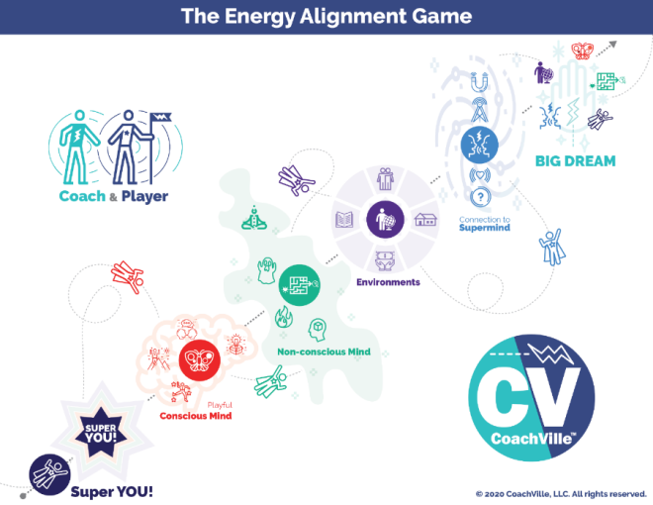
This is super important!
Remember the Energy Alignment Game I shared with you in the Introduction? On the right is a mini version of the model. (the full size one is on page 24)
You see your BIG DREAM in the upper right. The whole game is to align every aspect of YOU and your environment with your dream.
At the start of every session your coach is going to ask you to speak your dream. We do this for several reasons ranging from pragmatic to energetic.
On the practical side, your dream is the reason for having a Life Coach; it is what the coaching is all about… YOUR Dream! Speaking it out loud sets the tone for the session: it’s about playing for your dream. That’s it.
As you speak it each week you might say a different version or you might realize that it is evolving in some way. As you gain clarity it gets easier to align. Also, this way your coach can stay aligned with it as well.
From an energetic perspective speaking your dream with someone who shares the dream with you activates the connection to the Supermind. That is the cosmic looking blue area to the left of the BIG DREAM.
Often in a great coaching session amazing insights and ideas will just pop in to either the coach or the player; puzzles are solved, new possibilities are sparked. Speaking your dream opens up the channel for these powerful experiences.

Why we celebrate & what to celebrate
Celebrating is a powerful human experience. We love to celebrate and I feel we don’t do it enough in our daily lives. I notice in athletics and performance art there is lots of celebrating from the high five on the field or court to the ovation in the hall.
In the Industrial Age where everything was “allegedly” under control there was no reason to celebrate anything because everything that happened was supposed to happen; just do your job.
But playing for a dream is different! There is no control. And anytime you take the risk to play for influence, visibility, expression or change… this is something to celebrate; especially when what you are playing for happens!! But beyond the obvious celebration of positive results, you can celebrate the bold action no matter how it turns out. You can celebrate a big challenge for how it is asking you to grow.
Celebrate. It’s good for your soul. AND it deepens your connection to the Super Mind.

Keep looking for Pivotal Moments as you play
In the next segment we are going to go deeper into understanding the experience of a pivotal moment; it is called “The Pull”. This is when you notice that your dream is pulling you one way and your social survival imperative is pulling you another way.
You will notice it most easily through the four pivotal moment experiences: resist, power through, no results and moments of choice. The more you notice these moments, the faster you will grow!

The Pull!
Remember “the Pull” from the Human Journey with a Coach model we explored in Chapter 1? Well, now we are going to deep dive into this experience.
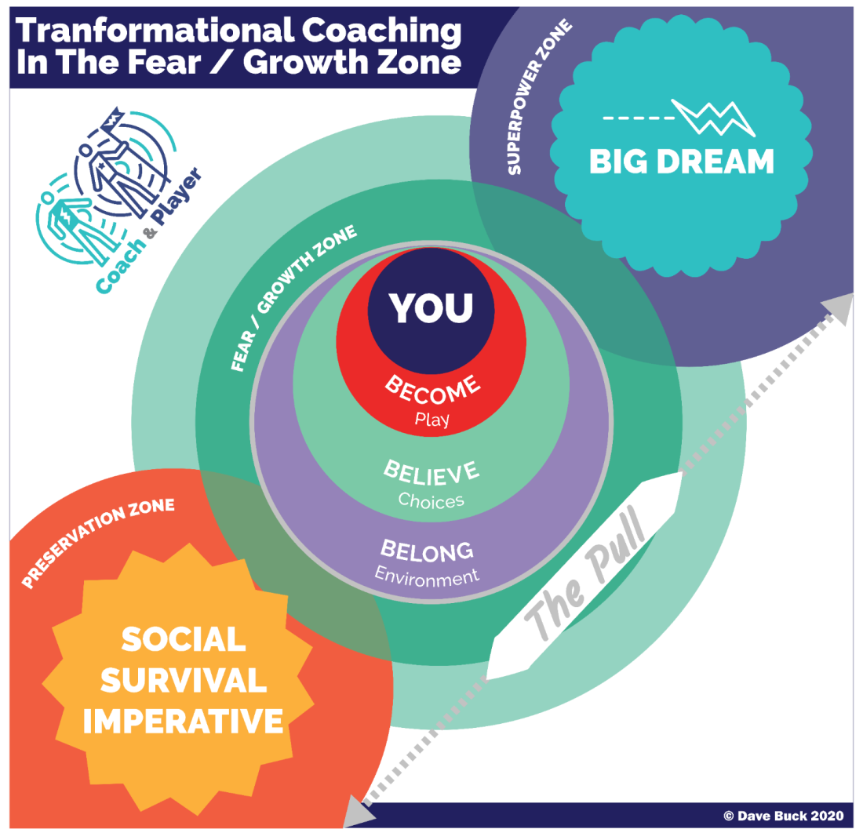
In the Human Journey with A Coach model we depicted your Big Dream as an outer circle pulling you out and the Social Survival Imperative as an Inner Circle pulling you in. Here we will dive deeper into this life experience that is at the heart of all Life Coaching.
There is wisdom in the creation of YOU. The dreams in your heart – including the one you are playing for now – are meant to require the playfulness and unique power that you were born to express. Yeah, the wisdom of creation!
These moments of choice between playing safe and playing BIG happen many times in an adventurous day of playing for our dreams. And as we have discussed they often happen at a mostly non-conscious level. You don’t really notice them.
What you may notice is that you had a brief thought to take an action for your dream… then you felt a little buzzing energy somewhere in your body… and you “decided” to check your email/Facebook/Distraction of Choice instead.
Hopefully you are thinking right now: “Oh crap! That happens all the time!” Yes, it does. AND this is why I say that the success of your dreams requires that you pay as much attention to your energy as you do to your activity.
Social FEAR is learned
Remember when you did the Inner Freedom Method with your coach, you were exploring energy in your body and your coach asked you to fill in the blank: It’s not safe for me to: (fill in the blank)? I want to share something with you.
I created this technique many years ago and have used it over a thousand times. One of the most common things people share is: It’s not safe to be me.
WOW. That is a really profound thing to say and hear. And truly this is how most of us feel deep within. This is an example of a self-preservation belief. In other words I will stop expressing my power so that I can maintain a sense of belonging with the people around me. We will get into this in great detail in Chapter 4.
Often the moments earlier in life when we tried to use our power to help or contribute or create and we “got in trouble” (or worse) are the moments that impacted us emotionally the most deeply. The Social Survival Imperative is based on the need to belong. It is one of our Human Nature Superpowers. The Preservation Zone is where we don’t take an action that will risk our current status of belonging.
FEAR is the way your SELF tries to protect you from events and situations that seem similar to an experience in your past when you experienced trouble or even trauma.
As a result, in the FEAR / Growth Zone we feel a strong PULL between our BIG Dream and the Social Survival Imperative. “The Pull” is a natural byproduct of playing BIG for our dreams because your Dream is “designed” to require your unique powers – the ones you got in trouble for earlier in life!
This is why it is so important that you don’t think of fear as an enemy or that if you are stopped by fear that means that you have “issues”. You don’t have “issues”! You have a BIG Dream and a strong Self Preservation instinct both pulling you in opposite directions.
I encourage you to stop saying things like “Self-limiting beliefs”.
“Self-limiting beliefs” make us sound foolish! Why would anyone limit themselves?
But this is not what is happening. These are self-preservation beliefs that are pulling against the actions of your BIG Dream. Self-preservation is essential for social survival and it is honorable. Your coach is aiming to empower you to cultivate the capacity to CHOOSE when to play safe and honor your self-preservation instinct and when to play BIG and honor your BIG Dream. No judgment; simply to power to choose.
Also in the Growth / Fear zone you have the three B’s of Human Nature: the urge to Become the next version of YOU, the need to uplevel a few Beliefs and the opportunity to co-create a new environment of profound Belonging for you and your dream. We will explore this in the upcoming Chapters.
The FEAR / GROWTH Zone impacts our choices in life at a mostly non-conscious level. That is why your coach uses the body awareness technique during the Inner Freedom Method. Through this guided visualization exercise you bring non-conscious fears and growth opportunities into conscious awareness so you can observe them. I encourage you to really dive in on these moments with your coach; this is how you unleash your greatest power.

Step #3) Feel the energy in the body
In the last session with your coach you experienced this part of the method. While you are playing the scene in your imagination, your coach asks you to scan your body for physical sensations. This may have been the first time anyone has guided you in a body awareness exercise.
When you look at the Inner Freedom Method model you see Step 3 is in the heart center of the model this is because feeling the energy in your body is the heart of the Inner Freedom Method.
A powerful way to understand this is to say that your body IS your non-conscious mind.
(via Candace Pert in the movie “What the Bleep” and her book: “Molecules of Emotion”)
A few things to know about feeling energy:
1) It is an essential life skill but somehow it is not often taught. It is awesome that you have an Inner Freedom Coach! Feeling energy is the gateway to your inner awareness, intuition, wisdom and freedom.
2) The goal of the exercise is to allow yourself to experience the energy. Just let it be there. The goal is NOT to get the energy to “release” although often it does.
3) When your coach asks you to close your eyes and scan your body from the top of your head to your waist, just be patient and notice.
4) The energy may feel like a buzzing sensation or heat or pressure or a whole host of other things.
5) The typical places where we feel energy like this is in the gut, solar plexus, heart, throat, jaw, behind the eyes and forehead. But it could show up anywhere from the waist up or even your whole body.
6) It can take a little practice to distinguish between feeling energy and some other agitation. For example: an energy in your gut vs. something that you ate agitating your stomach. You will know.
7) You may notice more than one sensation. In this situation your coach will ask you to choose the one that is most intense.
8) It is great to practice feeling energy when you are by yourself. AND the transformational potential is amazing when you are guided by a coach who is co-creating the experience with you.
9) If you don’t really notice any physical sensations after relaxing and breathing into it… that is OK! You are not doing it wrong. Even if you don’t notice a specific sensation, you are still breathing and scanning which gets you into your body.
I have done this method with MANY people and for lots of folks it takes some consistent practice before they started to notice subtle physical sensations. Stay with it; they will come into awareness when they are ready.
10) The main thing is just to trust the process! With practice it will become something that expands your awareness in a way that will serve you well for the rest of your life.

Step #4) Scan for Body Beliefs
After feeling the energy, your coach is going to explore the “body belief” with you. This is a powerful way to give voice – and words - to the wide variety of social fears that have settled into your non-conscious mind. You may recall the phrase your coach used in the last session:
It’s not safe for me to: {fill in the blank}
Just allow words to come through you rather than thinking of words. The point of doing this is to bring these Social FEARs into your awareness so that you can understand them. We also refer to these feelings as: self-preservation instincts. Their purpose is to keep you safe. Their purpose is to direct you away from any social risk activity that could jeopardize your current status of belonging. You could say it is a friendly ghost. (sort of like Casper, the cartoon character from the 40’s & 50’s ;-)
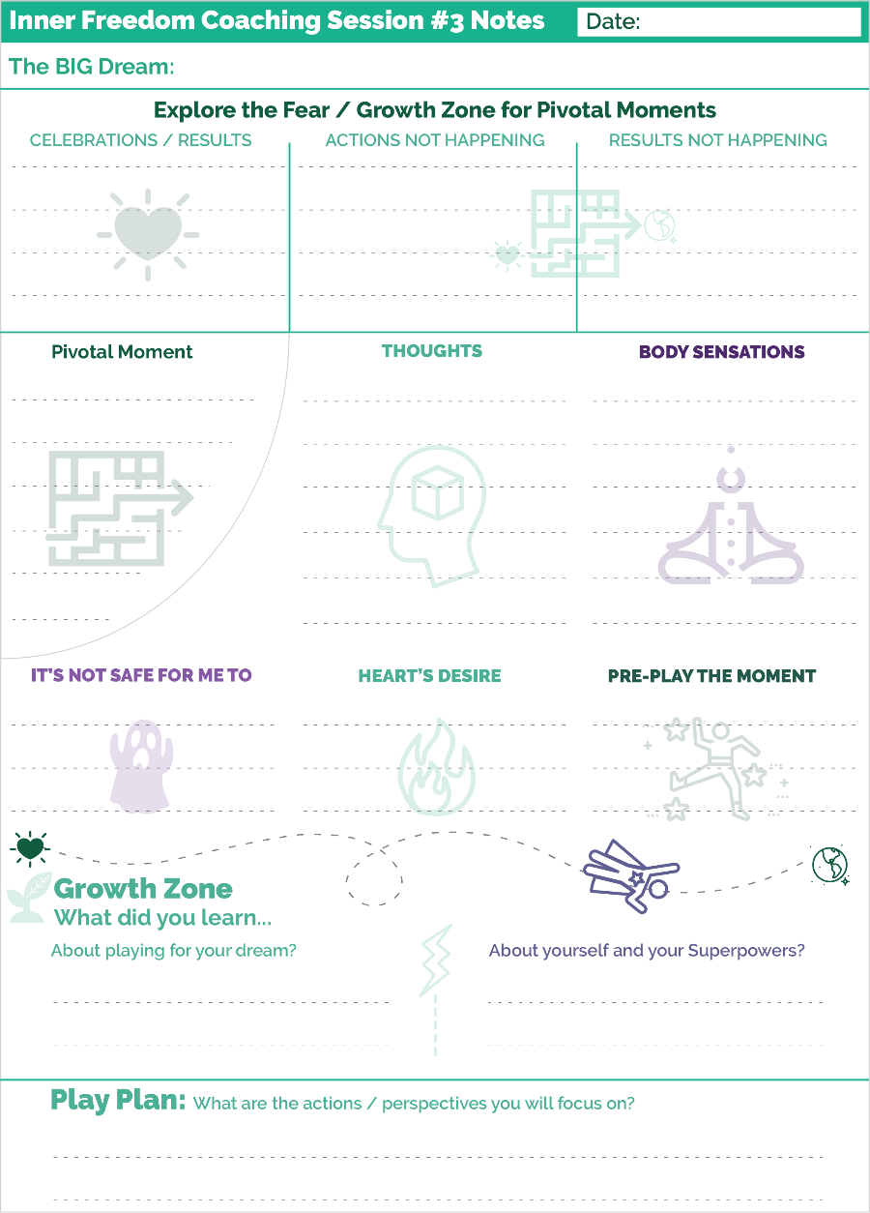
After you get a little practice with this process, these feelings and body belief phrases will provide clues on the treasure map that we will use to hunt for your superpowers! The thing we learned to fear the most is expressing our playfulness and unique power.

Prepare for Session 03 – Feel the Energy
A mini version of the Coaching Notes Play Sheet for Session #3 is on the right. You may notice that it is exactly the same as the sheet for Session #2.
The session will follow a similar structure as last week but will be a different experience because you will practice a different pivotal moment.
When I use these sheets as a player – yes, I am a player too – I find it interesting to look back at the pivotal moments, thoughts, body sensations and beliefs from each session. Over time it will give you clues on the treasure map. Fun!

Session #04 Memory Pops
Listen to this audio to prepare for Session 4.
I have lot’s of provocative goodies for you in this chapter! We are going to explore Memory Pops. A memory pop is when you are feeling energy in your body and a memory of an earlier moment in life pops into your mind; most of the time it was an emotionally charged moment. Before we do that though I am going to provide an explanation of how these emotionally charged moments got into your Non-Conscious Mind in the first place!
Then we will explore a few ideas about your non-conscious mind from the perspective of The Energy Alignment Game I shared with you in the Introduction.

Become-Belong-Believe
Remember this model from the Introduction. Next we are going to explore how most of us lost access to these 3 Superpowers of Human Nature.
These are the 3 Superpowers we all need to activate in order to Play for our dreams and make positive change within ourselves and out in the world around us.
Let’s do a quick recap:
1) The Urge to Become. All humans have an inner urge to become the next version of themselves; to grow and expand. We become by playing. If we stop playing we stop becoming and stay the way we are.
2) The Need to Belong. This is the strongest of all human needs. It operates mostly on a non-conscious level and drives almost everything in the human experience. We Humans always seek belonging and status within the environment we are in.
3) The Ability to Believe. Humans are believers. The ability to believe is the catalyst of all human civilization. All of our beliefs – about how life works, who we are and what is possible for us – come from navigating between our urge to become and our need to belong. In other words, we get our beliefs from our environments.
On the next page is a model that tells the story of how we lost our playfulness, human nature superpowers and unique powers in the Industrial Control Culture.
I have coached over 1,000 people and heard so many individual stories of how superpowers were lost during incidents at home, at school and at jobs.
While each of these stories are unique, in aggregate they reveal a few patterns.
I share this model with you for a few reasons:
1) To have compassion for your own process of re-discovering your powers and re-humanizing!
2) It will help you navigate the experience of memory pops that you are about to experience with your coach.

The story of you becoming Super YOU!
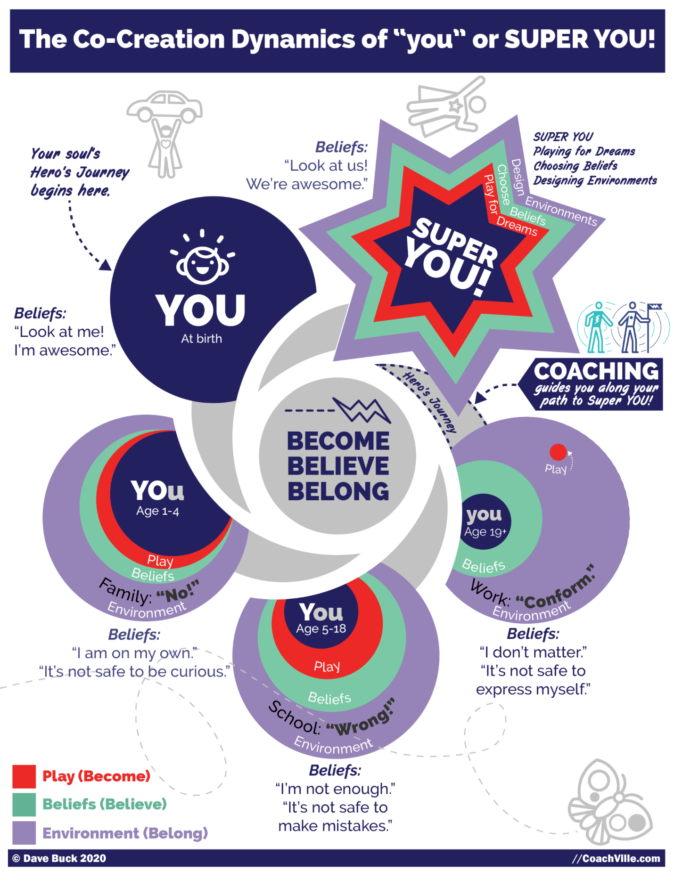
As a little person, your Urge to Become activates and you start to play. You play everything. As you play you grow… you become the next version of you day after day, month after month, year after year.
At the same time, as you play, your environment reacts to you and the Need to Belong kicks in… HARD. You naturally and automatically do whatever you feel you need to do to maintain belonging with the group (aka family) you are in.
When your environment reacts favorably to you, you come to believe that it is good and safe to do what you are doing and you do it more. If your environment reacts negatively to you, you come to believe that it is NOT safe to do what you are doing and you curtail it or stop completely.
The Capacity to Believe is extremely useful for learning how to get along in the world of people. You come to believe, for example, that people don’t like it when you throw a rock at your little sister; this belief is a good thing.
However, if for example, you are crawling around following your curiosity and a BIG person yells: “NO” and puts you into the isolation pen (for some reason it is called a “playpen”), you may come to believe that it is not safe to be curious; this is not such a good thing.
First at home, then in Industrial school and then in Industrial jobs, your Urge to Become through play moves you into life. And as you do this the environment reacts to you. When the reactions are unfavorable – which happened a lot in Industrial Hierarchical Control Culture - your need for belonging and status are threatened; this is called getting “in trouble”. As this happens you develop beliefs about yourself and life. Over time we come to believe a whole lot of things about ourselves that restrict access to our powers; the activities and expressions that we feel safe to do gets smaller and smaller.
As various aspects of YOU go into the “not safe to express” category in your beliefs, you become a smaller and smaller version of you. You come to FEAR your natural playfulness and your unique powers because at one time expressing them got you in trouble; AKA threatened your belonging.
Also notice in the diagram that as you move from home to school to jobs your playfulness gets smaller and smaller as does your access to your unique superpowers.
Fast forward to now and urge to play BIG for your Dream…
So, when you experience inner resistance or doubt or FEAR attempting to do the any of the needed activities of your dream – which are playful and need your unique superpowers – it is not because there is something wrong with you! It is simply because you are a human being who grew up in the Industrial Age and absorbed the Industrial Control Culture’s fear of play and unique personal power. These are the pivotal moments that you need to observe with judgment-free curiosity.
I believe that this process of losing our unique power as we grow up has been a part of the Human experience since the beginning of modern civilization. All of the Hero’s Journey stories include the pattern of going out into the world, facing new challenges and discovering lost inner powers.
However, I also believe that the fear of playfulness and uniqueness was extreme in the Industrial Age of Control so most of us have become very small versions of our potential.
I also believe strongly that since all of these “don’t do it” beliefs were established in social situations (AKA belonging) we need to explore and uplevel them in a socially safe space. This is why 1-1 personal coaching is such a powerful force for personal growth.


Memory Pops
Social risk actions evoke social fears. Actually merely thinking about a social risk action will evoke social fear. And you will feel that fear somewhere in your body.
In Step #3 Feel the Energy in the Body, your coach asks you to feel into a physical sensation in your body. After you do this, your coach is going to ask you if anything came up for you.
Often while you are feeling body energy a memory will pop into your mind; probably a memory of a situation from home, friends, school or work.
About Memory Pops
VERY IMPORTANT: when we are small LOTS of situations that seemed like trouble at the time are actually benign in the grand scheme of life. Also, common situations, like moving to a new home with your family, can create a lot of emotional situations even if there was no real trouble.
Another important point about memory pops is that very often they reveal situations that were not really troubling, they were just strange or intense. These types of moment can also put our powers into shadows as well.
In Step #4 Scan for Body Beliefs, your coach is going to ask you a question: It is not safe for me to {fill in the blank}. This is another situation where you are not trying to think of an answer; you just allow the words to bubble up. When the words come it will be illuminate the self-preservation instinct and “the Pull” we spoke about in Chapter 2.
Often when body belief words are bubbling up, additional memories will pop up that will illuminate the situation.
The power of Safe Space with your Coach
The final point I want to make about memory pops is to encourage you to BE UNAFRAID of your memories. Most memory pops are benign but revealing. The ones that are more intense you can feel safe exploring with your coach.
If the memory involves some “gory” details, you do not need to share them at all! Only share what you feel comfortable sharing. In fact the gory details are not needed for the method to work beautifully. Your coach only needs to know “the essence” of the situation to help guide you to freedom to reclaim your power.
You are not alone; that makes all the difference.
Talking About Memories Is Not “Therapy”
I need to bring this up because it often comes up around this topic: Talking about memories from your life is not Psychotherapy. Two humans talking together can talk about anything they choose to; you don’t need a “degree” to talk about memories.
Another important point here is that you and your coach are not just talking about memories. The memories that pop WHILE feeling energy in the body reveal clues that help you regain your power to play fully for your dreams. Everything we do in coaching is about playing for your dreams. That’s it.

The Treasure Map (in brief)
We will talk more about the concept that our fears are like a “treasure map” to our superpowers in the next chapter. The idea I want to share with you now is that every time in your life where you experienced some trouble (or trauma) when you were expressing your power or playfulness becomes an emotional memory that is stored in your body / Non-conscious Mind.
So there are hundreds or thousands of these emotionally intense memories in there that create the energy you feel when you contemplate a socially risky action to play for your dream. Each one has its own Body Belief / Fear; though they tend to have common themes.
In a safe space, these sensations reveal emotional memories that can provide clues on the treasure map that will lead to your lost Superpowers and Playfulness!

Your non-conscious mind is always ready.
(Energy Alignment Game)
Remember the Energy Alignment Game I shared with you in the Introduction.
Each week I will elaborate on one aspect of this “game” and connect it to what your Inner Freedom Coach is doing with you.
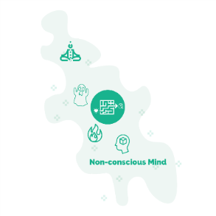
Your Non-conscious Mind is a big “blob” of everywhere power. Learning how to access, channel and align this power for your dream is an endless supply of fun!
In this model I am highlighting a few key elements:
Body Awareness: This is the ability to close your eyes, scan your body and notice the “energy”; often in the form of buzzing, pressure or tightness. This is also where insights and inner knowing come from. Another smart move is to care for your body so physical ailments are few and they are clearly distinguishable from Inner Knowing signals.
Fears: your fears aim to keep you safe. They are the “friendly ghost” that aims to scare you away from socially risky actions. With practice they can also guide you toward your lost unique superpowers and playfulness.
Desires: your hearts desires light your path when you learn to trust them and act on them. Your BIG Dream is one aspect of your hearts desires.
Beliefs: everything we believe we have absorbed from the world (and people) around us. While some of your beliefs are part of your conscious thinking process, most are embedded in your non-conscious where you are not aware of them. Your dream will require that you bring them into awareness and then uplevel a few and develop some new.
You will notice the symbol for the Inner Freedom Method (the heart energy finding a way through the maze out into the world) at the center of the Non-Conscious Mind Model. The Non-Conscious Mind IS the maze!
As you play for your BIG Dream your non-conscious energy, fears, desires and beliefs will come to light! You will have the opportunity to explore them in deep conversations with your Inner Freedom Coach; this is SOOO powerful. Then you and your Coach will co-create awareness of new choices and new possibilities. Power Up!

Tenacious Self Love!
I recommend you remove these phrases from your vocabulary
An important note: The experience of beliefs and fears limiting our ability to play big for our dream – which is a TOTALLY NATURAL HUMAN EXPERIENCE – has acquired a lot of blame and shame in the personal growth / self-help movement. This is not helpful! You have probably heard or said many of these things. I highly recommend you stop saying them about yourself or anyone else!
- You are sabotaging yourself,
- You can’t get out of your own way,
- You are a procrastinator,
- You have self-limiting beliefs,
- You have a gremlin inside of you
- Your EGO is causing your problems
- You need to crush your fear!
I flat out do NOT believe in self-sabotage nor any of these shaming concepts! You will not hear your coach use these judgmental phrases with you.
When you understand how these beliefs, doubts and fears got into you, it doesn’t seem right to shame them.
I believe in tenacious self-love! This is where we embrace our humanness with judgment-free awareness. We embrace all of our human experiences and see everything as included in our pursuit of our dreams.

The Freedom to Choose!
The big idea of Inner Freedom is the freedom to choose when you play BIG and when to play safe. It is not that one is good and one is bad as is always portrayed in the self-help world; BOTH are honorable! Your Big Dream is honorable. Your self-preservation beliefs, acquired through a lifetime of experiences, are honorable!
There is social risk and reward with almost every activity in your Dream. That is what play is all about! In any kind of play – but especially in sports - there are constant moments of choice where you evaluate risk and reward in the blink of an eye.
The big idea here is that if you are not aware that the choice is happening, the default choice is to play safe because your body and brain will prioritize safety over fulfillment.
As you continue to practice with your coach you will begin to sense your emerging freedom to choose how you want to play in any moment; and often playing BIG – and taking the risk – will be the clear and natural choice! That is when good things start happening for you... and the people you aim to contribute to.

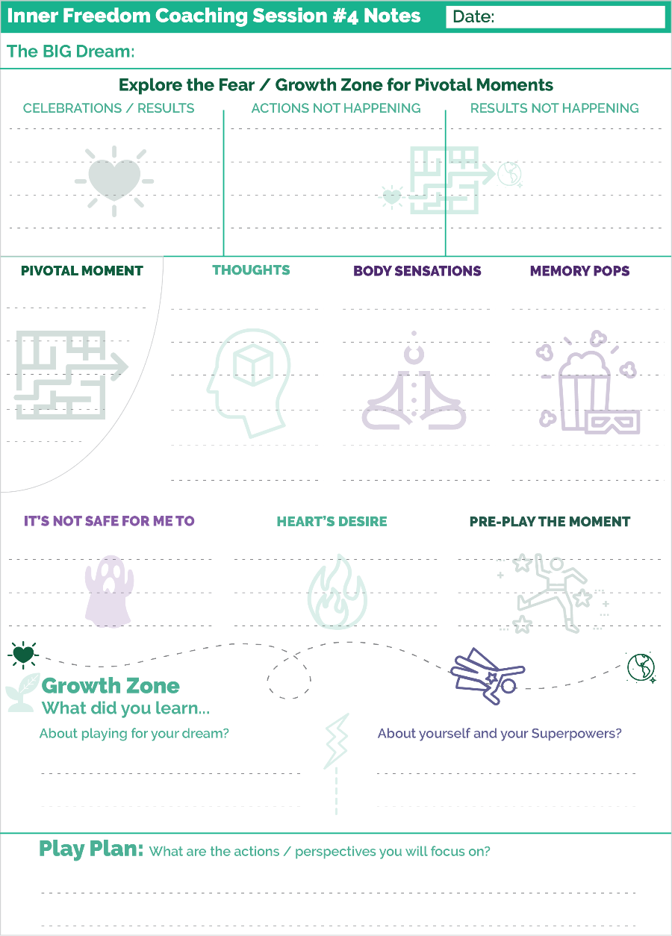
Prepare for Session #04 – Memory Pops
When you look at the playsheet you can see a new little section called Memory Pops with the popcorn icon.
Here are a few key points about the memory pop exercise.
ALLOW it, don’t force it.
One key that I can share with you about this exercise is to just allow a memory to emerge into your mind. You don’t need to force it or try to think of it. In fact, trying to think of something will block the flow.
Often times it will start as a vague image.
Often it will seem like the image “has no relevance” to the current situation. HAH. Never underestimate the power of your Non-conscious mind. Trust that whatever is popping up has value; it is part of the treasure map.
This is about gently allowing the non-conscious awareness of the earlier moment to move into your conscious mind and imagination. We all have had many emotional experiences where we experienced trouble while expressing our power; or where we were attempting to use our power to help a situation and it didn’t work. These are the types of memories that will pop up when we feel the energy related to the social risks of playing for our dream.
Another key to this part of the method is to avoid predicting what the memory will be. Many people I have coached have a few stories of really troubling life experiences that they remember from time to time. The memories that “Pop Up” during inner freedom are rarely those moments.
You have a lifetime of memories in your non-conscious mind; They are ALL potentially part of the treasure map. Just allow the image of the memory to emerge into your conscious mind… don’t force it.
With judgment-free awareness, you and your coach can explore these moment in a way that is illuminating and fun.
We will get deeper into these fun explorations in the next few sessions.

Session #05 Superpower Potential
Listen to this audio to prepare for Session 5.
In this chapter we are going to dive into 3 important topics.
1) Role Play a pivotal conversation. Ideas for conversations to role play.
2) How to explore your fears as a treasure map to your superpowers. (I know you have been wondering about this!)
3) Inner Freedom Step #5: Explore the Superpower Potential
Let’s go!!

Role Play the Pivotal Conversation
Coaching is about practicing moments to help you play better!
In Inner Freedom we practice together in 2 ways.
1) Playing with a moment using your imagination. This is called the Pivotal Moment Technique (we have been doing this in the last few sessions).
2) Playing with a conversation by role playing.
A Pivotal Conversation is one where you are relating for influence:
- You might face the fear of rejection
- You might face some inner resistance or hold something back;
- You fear you may lose your clarity of words.
- You doubt that you will be able to create the influence that you desire.
On the next page is the model for the Role Play Technique.

The Role Play Technique
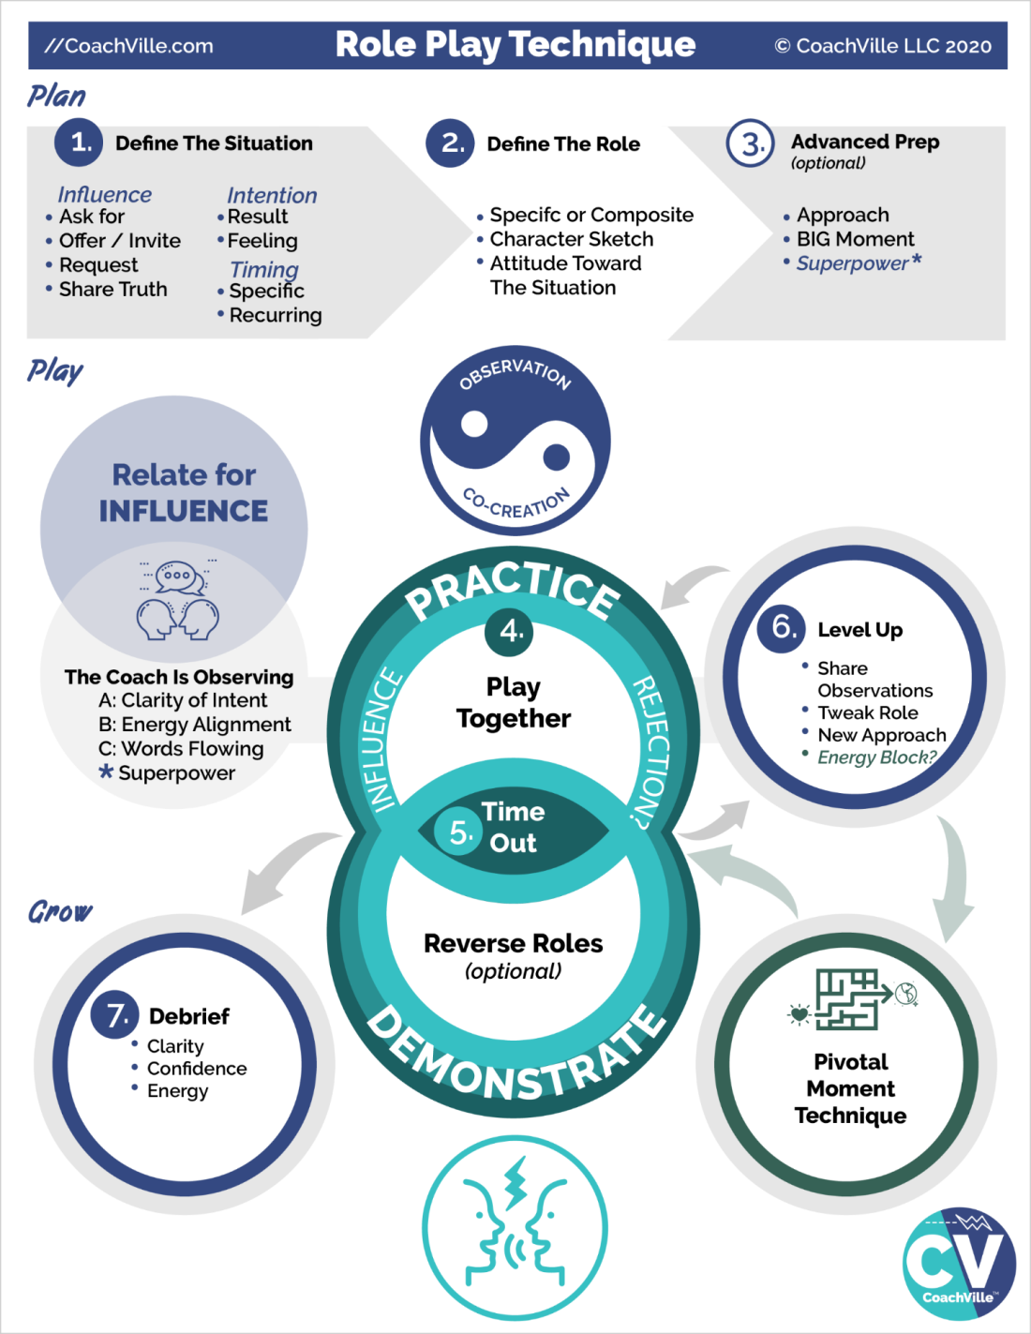
To do a great role play only takes a few minutes.
The role play is where the coach plays the role of the person the player needs to talk with. It could be a specific person. Or it could be a “typical” person for a recurring activity.
Observation ~ Co-Creation
This is on the model to remind you that this is the centerpiece of the coaching relationship and that Role Play is a great way to bring this framework to a coaching session.
Relate for Influence
Coach: while you are co-creating the scenario with your player and then practicing with your player you are also OBSERVING your player.
Your Coach is observing:
A) Clarity of Intent – your coach will listen for how clearly you are moving toward your intention.
B) Energy Alignment – while you are playing in the conversation your coach will pay attention to the feelings that they notice.
C) Words Flowing – The words that you speak are mostly effected by your clarity of intent and flow of energy. Yet, sometimes there are better ways to say things that your coach can suggest after a time out.
*) Superpower – This is a subtlety of advanced coaching. If you want to practice a particular Superpower for Influence – which is awesome – then your coach can notice when you use it or AVOID using it.
PLAN
In steps 1,2 and 3 you are sharing just a few details so that your coach can play the scene with a fair degree of authenticity. It is play so it does not need to be perfect or exactly accurate; just close enough for you to “get into the moment” with your coach.
1) Define the situation
What is the influence you are playing for?
- Ask for something
- Offer something they want them to accept
- Invite them to do something they want them to say yes
- Request for support; for an action; for a change
- Share a truth; something they want to say and want to be heard
What is the intention?
- What is the result you are playing for? What do you want the other person to do? How do you want the other person to feel?
- What is the situation? : Is this a one-time situation with a specific person or is this a recurring situation with a type of person.
- Usually there is something you want the other person to say “Yes” to and commit to an action.
2) Define the “Role”
Is this a specific person or composite of a typical person?
Character sketch: what are their essential qualities?
Attitude: what is their likely point of view about the situation?
Note: To play the role of another person, your coach will not change their voice. They can sound like themselves and still play the role.
3) Advanced Prep
If you have plenty of time you can explore these before jumping into practice.
What is your approach to the conversation? How are you going to authentically move them toward the “Yes” you are playing for?
In the conversation, what is the big moment? Your coach can steer the scene toward this moment.
PLAY
4) Play together
Just jump into the role and play. Don’t think about it too much or worry about if you are doing it right! Truly… the more you allow yourself to co-create in the flow, the better the practice will be.
5) Call time out!
Either the coach or the player can call time out to end the scene.
6) Level Up
Talk it over for a few moments.
A) Share observations. What did you FEEL is the most important thing to share because that is the part that will most impact your results; AND that you can explore using the Pivotal Moment technique.
B) Tell your coach if they need to tweak how they are playing the Role in any way?
C) New approach of experiment? Sometimes you will immediately know that you want to try it again a different way. Sometimes your coach will share a few ideas and co-create a new approach with you.
Pivotal Moment
This is what we are doing in this session. See… you are already receiving advanced coaching!!
Play Again
4) After exploring the energy with the Pivotal Moment technique you will jump back into the role play and play again… or a few more times.
Advanced Technique… Reverse Role Play
Reverse Role Play is where the coach plays the role of the player and the player plays the role of the person they are going to talk to.
This can be really powerful for 2 reasons.
1) It gives you – the coach - the opportunity to demonstrate a new way for the player to approach the situation; demonstrating new ways is a classic coaching move.
2) It gives your player the opportunity to put themselves into the perspective and mindset of the person they want to talk to. By “stepping into their shoes” and playing as them, they start to imagine new ways to approach them.
Grow
7) Debrief
Talking together about the role play and pivotal moment experience is an excellent opportunity to capture growth.
Look back on the practice and highlight the three ways to play better while relating for influence:
- Clarity of intent
- Confidence in how the words are flowing
- Energy alignment
It is powerful to experience growth in real time!

BIG LIST of Relate for Influence conversations to practice

The more you study the Dreams of life, like personal growth, business, leadership or romance, the more you realize that communication / relating is the primary activity. Playing for a dream is mostly about talking to other people and relating for influence!
Relating well has MANY underlying factors like clarity of intention, being present, really listening and sharing authentically.
So a BIG part of your coach using Role Play with you is helping you become a skilled relator for influence through practice. In most dreams there are MANY distinct conversations – where social reward and risk are involved - that you can identify, observe and then practice.
Each unique type of conversation is a different skill
The key to a good role play is to hone in on:
A) A very specific conversational skill
OR
B) A very specific conversation situation
Examples of distinct conversation (Skills):
- Make a request for support
- Ask for something
- Make an offer to do or share something
- Ask another person to change their behavior in a positive way
- Introduce yourself in a way that sparks deeper conversation
- Invite someone to an experience with you
- Invite someone to hire you for something AKA discuss the money!
Examples of specific conversation situations:
- I want to ask my boss for the opportunity to lead the next project.
  - I want to call Bill from the Chamber of Commerce and suggest that I give a talk at a meeting
  - I want to reach out to Sally and let her know that I want to be a part of the community leadership team.
There are so many possibilities!!!

Relate for Influence: Practice together to play better
Let’s make the connection between role playing a pivotal conversation and Social Play activity number 1: Relate for Influence.
When you raise your game in “pivotal conversations” a LOT of big things can happen for you. When someone agrees to hire you, buy from you, participate with you, join your team, advocate for you or support you in a big way, your dream can really take off.
Practicing pivotal conversations with your coach can really pay off for you because it can help you uplevel ALL of the elements that lead to a “yes”.
Here are the elements that lead to YES, in order of importance:
1) Clarity of intent
2) Alignment and flow of energy
3) Flow of your words + listening from the heart
4) Use your Superpowers for Influence (once you have them unleashed)
You might be surprised to see that “flow of words” is 3rd. YES they are ALL important. But in terms of influence the flow of words is less than clarity and alignment. You know this because you have had many big conversations in your life where you rehearsed the words in your head a hundred times but then in the moment those words didn’t come out the way you envisioned.
1) The first benefit of practicing with your coach is to clearly state your intent. Knowing exactly what you want in the conversation and why you want it is the most important thing. Your coach can help you gain this level of clarity.
2) The next one is alignment and flow of energy. This speaks to the 95% vs. 5% idea I shared with you in the Introduction. When you are talking with someone they feel your energy WAY more than they hear your words. Your energy is what moves them – or not - most of the time.
When you role play with your coach, the MAIN thing they are observing is your energy. And this is the big benefit of practicing with your Inner Freedom Coach. By using the method together you can uplevel your energy into alignment with your dream.
3) The words will flow. Sure there may be a few key phrases that you want to plan and practice. However, the path to success is to get the first three items elevated so that you can trust yourself to speak from the heart.
After a few experiences of practicing pivotal conversations with your coach and then playing for your dream out in the world… you will realize that having an Inner Freedom Coach is an amazing investment that pays dividends!
While you are speaking from the heart, you also need to listen from the heart. Being present and really hearing the other person will improve your heartfelt flow of words. This takes practice!! In deeper and more extensive role plays your coach can help you improve in this skill.
4) We all have a unique way of relating for influence. And as we have discussed often, many of our powers were squashed earlier in life… but especially when it comes to playing for yes. I have coached many people that have been shut down to the point where they are terrified to ask for anything. So this kind of situation is definitely an opportunity to explore for your lost power.
The great thing about role playing is that you can practice using your power in a safe space and build confidence to the point where you feel really good about being yourself and expressing what you really want or need to say.

Super YOU (Energy Alignment Game)
“A Superpower = A unique ability that you can practice
until it is capable of making a BIG IMPACT”

Inherent to the desire to pursue a BIG dream is the requirement to become the next version of you; which means developing your Superpowers. So Fun!!
The flying person wearing the star is the symbol of expressing unique power in the world to have a positive impact on situations and for the good of others.
This includes expanding your mastery of abilities that you have already expressed. AND it also includes discovering and unleashing aspects of you that have become hidden in shadows of fear while you adapted to the environments of your life so far.
This discovery process is baked into the wisdom of your BIG Dream!
You will identify your Superpower potential by exploring actions in the world required to play for your dream and noticing the fears that you experience. Using the Inner Freedom Method your coach can help you find the unique energies hidden behind your social fears.
Then, you will practice bringing Super YOU into the actions and situations of your dream. AND, during a role play you can practice the situation while specifically expressing one of your newly discovered superpowers.
SOOOOO GOOOOOOD!!!!


Step #5: Explore the Superpower Potential
Understanding the nature of the treasure map gives us a foundation to explore Inner Freedom Step #5. You are playing with a Pivotal Moment where you experience the Pull. You have the moment alive in your imagination; you notice your thoughts, you feel the energy in your body.
Often while feeling the energy or shortly after you will have a memory pop of an earlier event in your life. You now know how that emotionally intense memory got in you!!
Your coach will ask you to explore the body belief: It’s not safe for me to {fill in the blank}.
This gives language to the feeling. Just let the words pop up; don’t try to “think” of the words.
Step #5 is to explore both the memory pop and the self-preservation instinct to look for clues about the power or playfulness that you were expressing or trying to express in that moment.
Clues from the memory pop
- What was going on?
- What were you doing?
- Someone didn’t like your behavior or attitude; what didn’t they like?
- If you were trying really hard to help someone or improve a bad situation, what were you trying to do?
Don’t expect crystal clear answers from this exploration; though sometimes that will happen. Most of the time you will have a feeling about it and the clarity will come later.
In the next section I will introduce you to a more detailed version of the Superpower playsheet we used in Chapter 1. There are a lot of provocative words and phrases for Superpowers for change. Often by scanning this page after a session a phrase will jump out at you to articulate the power you were using or trying to use in that moment.
It’s fun!

Detailed Superpower Playsheet
In Chapter 1, I shared a playsheet with 64 Superpowers for change listed on it. I encouraged you to read it over and pick out a few Superpowers that you want to “become” in the next version of you.
Now that you know more about your dream, more about YOU and more about how came to fear your most unique powers…. Let’s take a deeper look at this list. On the next page is a more detailed version of the 64 Superpowers for Change; as I shared before, it is loosely based on the “I-Ching” (Book of Changes).
There are a few ways to use this chart.
1) Read it over a few times to look for the unique powers you are noticing within you AND your Dream needs you to develop them and express them NOW.
2) Look at it after each session to see if there is a Superpower that relates to the pivotal moment or memory pop you just explored; feel into the earlier experience. You were expressing SOMETHING. What was it? Look at this page of superpowers to find a phrase that resonates with you.
3) Read it over and while thinking of each of the 4 areas of Social Play:
- You have Relate for Influence Superpowers
- You have Create for Expression (to share) Superpowers
- You have Explore for Visibility Superpowers
- You have Experiment for Change Superpowers
Look for them on this page!
Feel free to mix and match words and phrases to create the phrase that really feels true for you.

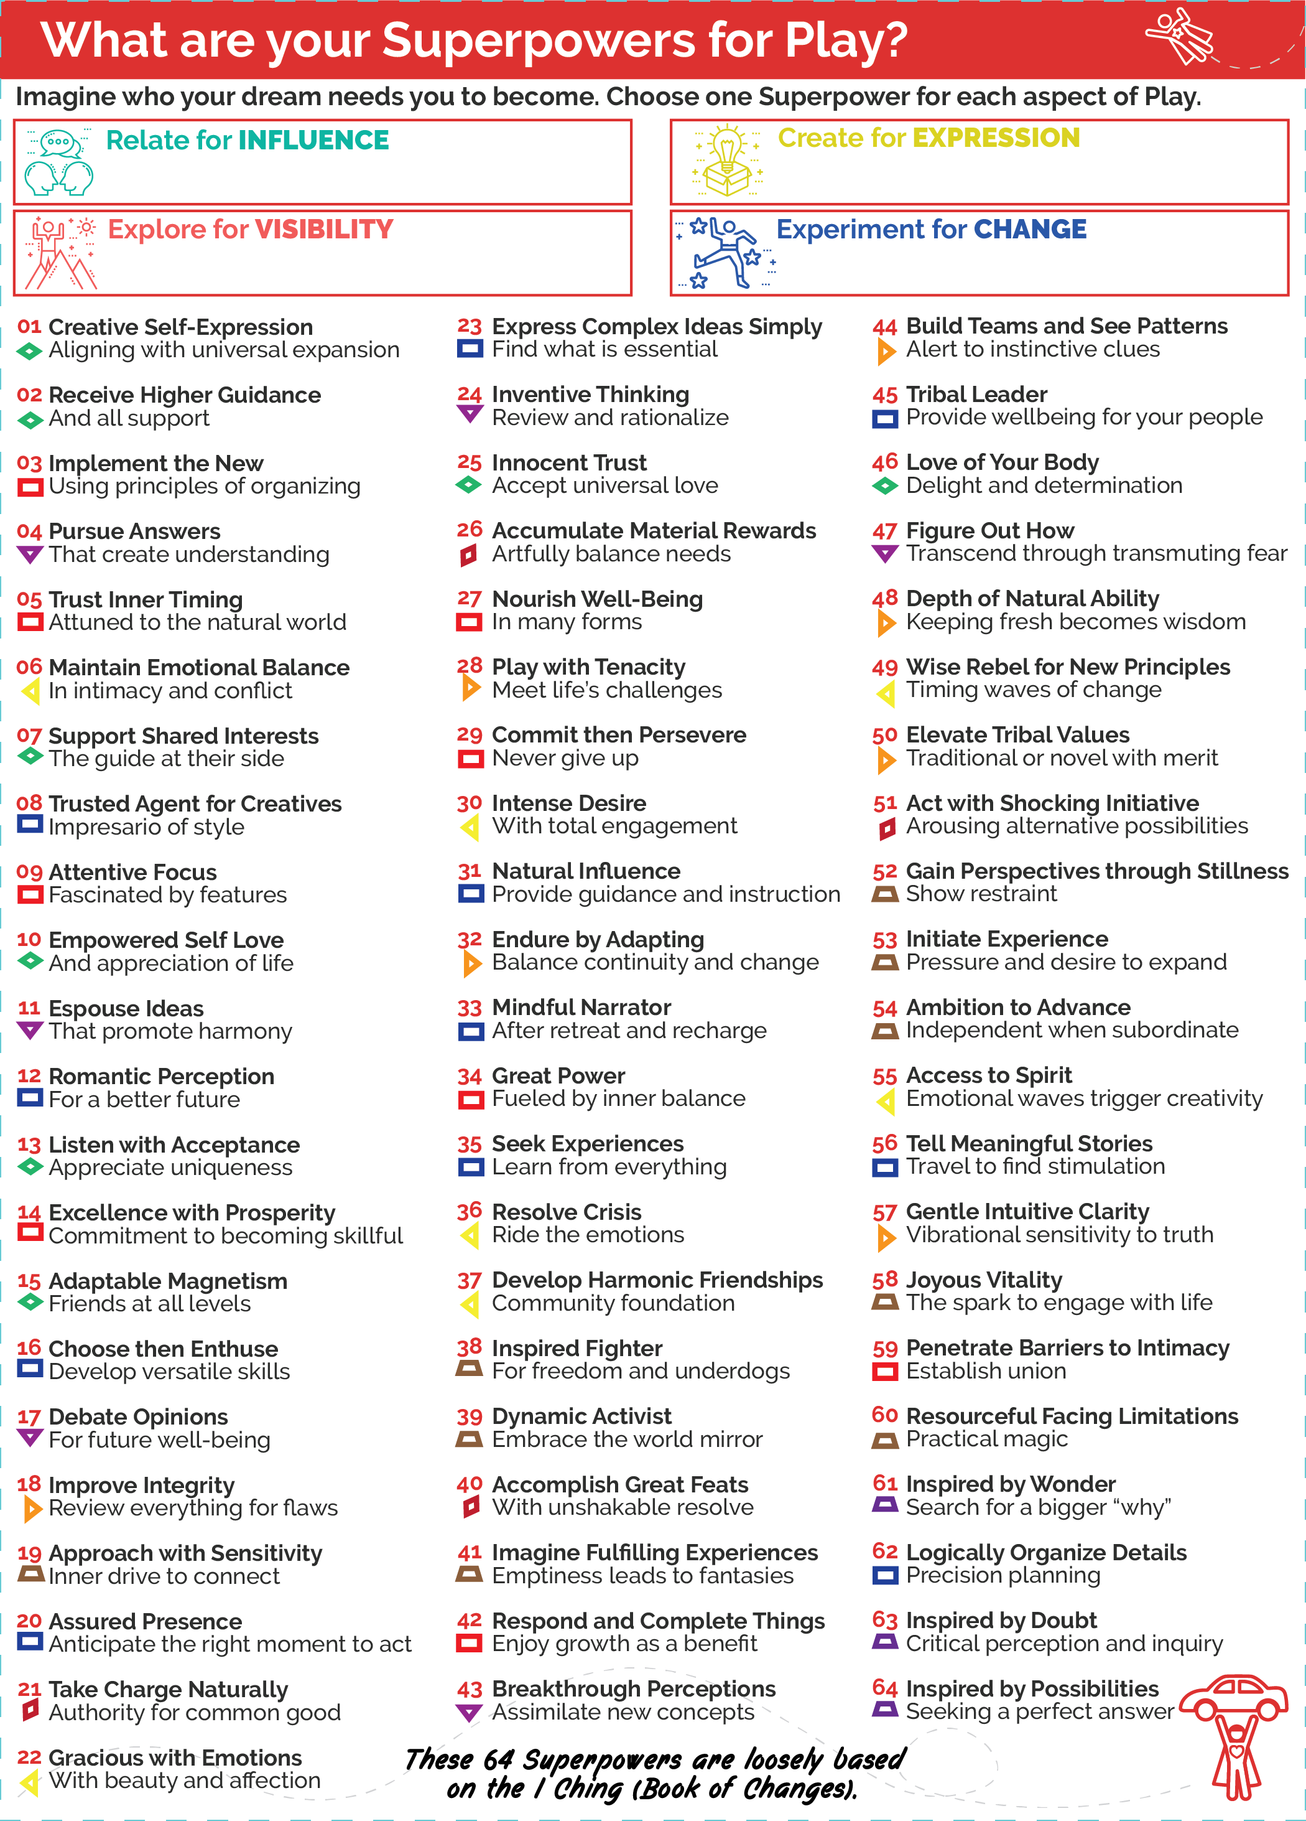

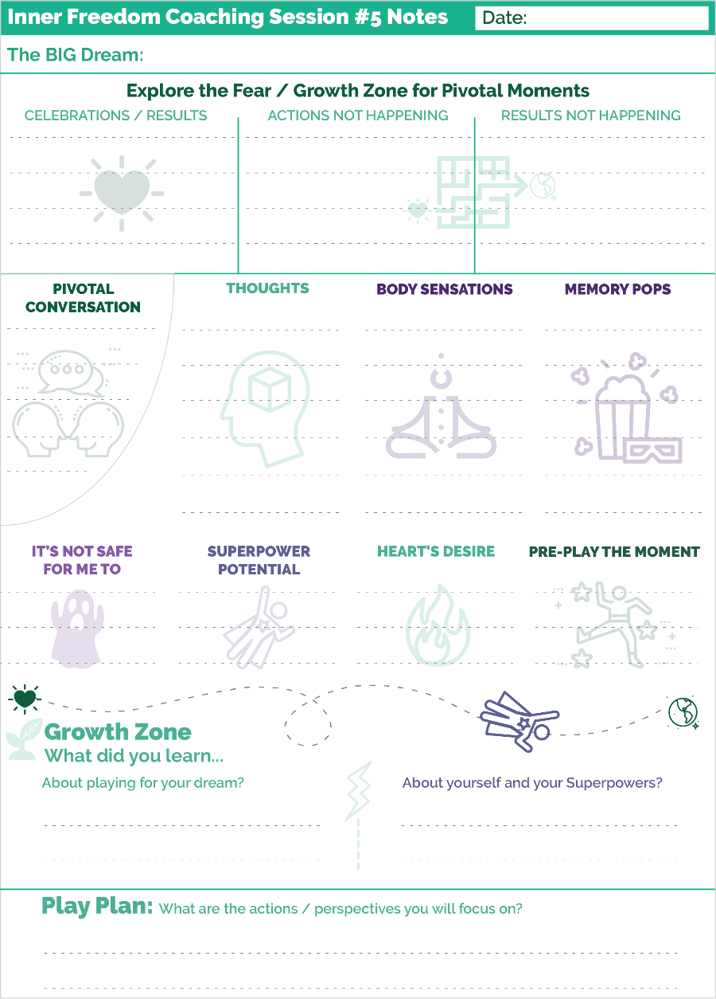
Prepare for Session #5 – Superpower Potential
Whew! This chapter had a lot to offer.
Let’s do a quick walk through of the Coaching Notes sheet and notice a few new elements from what we have seen so far.
1) Where the Pivotal Moment section usually is, we now see a Pivotal Conversation. This is a special subtopic of a Pivotal Moment where we start with a Role Play.
AWWW Yeah.
Here is how it works. Usually in Step #1 you play a moment in your imagination. Here you will play the moment with your coach in a role play. Then Steps #2, #3, #4 and #8 are the same as you have done before. For Step #9 rather than preplaying the scene in your imagination, you jump back into the role play conversation with your coach.
You will be amazed at how different it feels and sounds the second time!
And you will likely feel empowered to take the risk – whatever the conversation was – soon after the session.
2) You see a new section for Step #5: Explore Superpower Potential.
This will be a regular part of each coaching session moving forward. Now that you have some comfort level with the basic steps of the Inner Freedom Method it is time to start exploring the treasure map for your lost powers.
There are a few points I want to share here:
1) The main benefit of the Inner Freedom Method is that actions that seemed hard or scary for some reason just become easy. Often results that were not happening just start happening. This experience often comes down to you expressing your playfulness and power in a new way. You may not necessarily be able to NAME the power; it just happens.
2) I have shared with you a few tools to help you give names to these powers. It’s a fun exercise AND when you can name it, you can own it. You can practice it and use it intentionally.
3) When you are exploring a Pivotal Moment with your coach you may not be able to name the power while you are in the session. But if you scan the Superpower Playsheet after the session, something will jump out at you. Or you might find yourself expressing that power again naturally – now that it is unleashed – and after a few times you will be able to name what it is.
The most important thing is to keep playing. Enjoy your adventure. Enjoy your emerging freedom to express your power.

Session #06 Find the Perfection
And the Supermind Layer
Listen to this audio to prepare for Session 6.
In this chapter we start our transition into the deeper parts of the Inner Freedom method.
1) We will explore the Supermind Connection which is part of the Energy Alignment Game.
2) Your Fears are a Treasure Map to your Superpowers… the details.
3) Step #6 Find the Perfection in the Situation
4) A Coaching Proficiency called: Recognize the Perfection in Every Situation

Remember the Energy Alignment Game
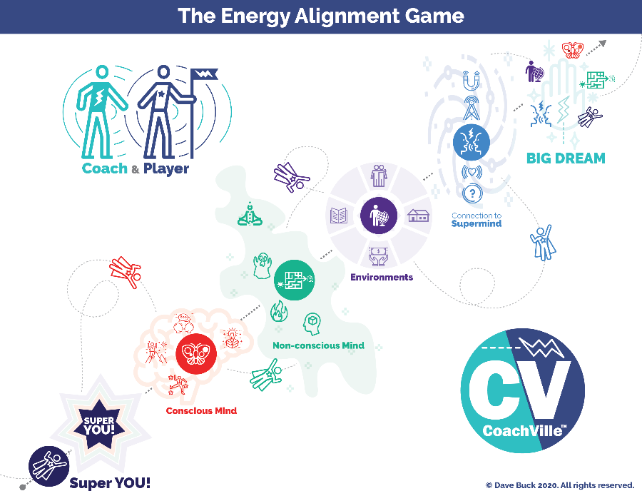
Over the 2nd half of the program we are going to continue to explore the Energy Alignment Game.
The BIG idea is this: the results we co-create in life are only partially caused by our actions; the energy behind our actions is mostly responsible for how results are co-created. Steps 1,2,3,4,8,9 that we have played with so far are focused on the Non-conscious Mind and Playful Conscious Mind.
In the Inner Freedom Method Steps 5, 6 and 7 are part of what we call the Supermind Layer where you strengthen your connection with Life Force Energy. (“Use the Force Luke”)
In these steps we also intensify our treasure hunt for Super YOU!
So let’s explore a few details about the Supermind Connection before we dive into Inner Freedom Step #6.

The Supermind Connection (Energy Alignment Game)
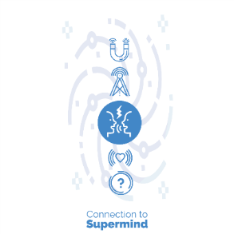
The Supermind is the web of Consciousness that we all have access to. It is sometimes referred to as “The Universe”, “The Field” or Life Force Energy.
This is another aspect of life that will provide an endless supply of insight and fun when you approach it with a sense of wonder.
The Supermind is responsible for spontaneous insights, synchronistic events and profound inspirations. The Supermind is essential to the coaching relationship!
When you think of someone who you haven’t spoken to in a while, and then shortly after they call you seemingly “out of the blue”, this is the Supermind in action.
When you are talking with your coach and a new idea “comes to you” while you are talking or your coach has an “inkling ” or “a flash” about your superpowers, this is the Supermind in action.
There are many ways to play in this realm to get into alignment with your BIG Dream.
The “?” symbol indicates living by BIG questions and staying open to “answers” as they come to you.
The emanating heart is the symbol for the well-known process of gratitude which is an essential practice for Supermind Connection.
The radio tower is the symbol of the power of thinking about and speaking your Dream and intentions; putting them “out there”.
The magnet is the symbol of attracting experiences that move you toward your dream as long as you stay open to the perfection of each situation. People and experiences are drawn to you by the magnetic power of your BIG Dream.
As your Supermind Connection gains strength it feels like you are co-creating with Life Force Energy. It feels like events are happening in favor of your dream; it feels like the Supermind WANTS your dream to happen as much as you do.
The AWESOME thing is that expanding your connection with The Supermind is baked in to the Inner Freedom Method that your coach is using! The talking faces with the lightning bolt is the symbol for our Coaching Relationship model at CoachVille.
When you share your dream with a coach it amplifies your connection to the Super Mind! This is why your coach asks you to speak your dream at the start of every session; sharing your dream with your Coach and your Dream Team amplifies your connection to the Supermind because we are all connected to it.
When your coach asks you a provocative question that sticks with you for a few days… and then insights start coming to you, this is the Supermind Connection in action.

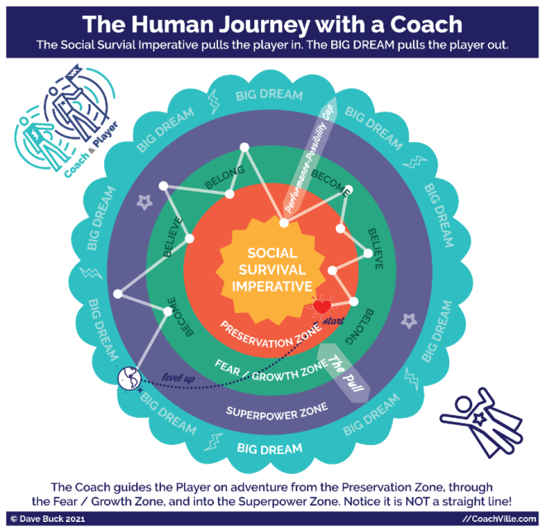
Your Fears are a Treasure map
Let’s go deeper into this idea that your fears are a treasure map to your playfulness and Superpowers.
I have been a Professional Life Coach for 24 years – that means people pay me to help them Play Life better. I have coached over 1,000 individuals. SOOO fun.
This Inner Freedom Method is based on what I have figured out while coaching amazing people who really want to be free and contribute value in the world; that’s who I coach.
Here is a brief recap of a few ideas:
I have learned that EVERYONE has a dream in their heart that will call them to adventure to contribute to the world. That is why you have a Life Coach right now!!!
AND everyone has absorbed a lot of Social FEARS from their environment throughout the course of their life time.
I have coached many people to reclaim and unleash their superpowers on our Human Journey together. A big insight I have developed is the idea that our fears are a treasure map to our superpowers.
It is a quirky concept. Here are a “baker’s dozen” ideas to help you understand it and embrace the adventure.
1) Your Superpowers = your voice, your value, your impact
A superpower is an energy or ability that you can practice to become capable of a big impact on people and situations. You are here to contribute your value and use your voice to uplift the Human Family in some unique way. There is a reason you are here. And that reason may evolve many times in your life time.
2) It’s a treasure map not a road map
The Industrial Age hyper focus on control and logic - there is a right way to do everything; there is a correct answer to every puzzle – has gotten us out of balance with life. Logic has its place; but most of life does not run on logic nor should it. There is not a step-by-step task list for most things you want to accomplish in life and there is definitely not one for recovering your Superpowers.
A treasure map is about looking for clues, reading mysterious signs, solving puzzles without enough information and trusting your inklings and intuition. When a challenge comes your way, there is probably a purpose for it. Look deeper. Pay attention to any sleeping dreams that you remember. Allow yourself space and time to just “Be” so that flashes of insight can come to you.
3) You have a LOT of energy and abilities and possibilities that you are not currently aware of
You were born with a host of energies and abilities. All of them have value for you to share with others and a few of these have Superpower potential; Aka the potential for BIG impact. The need to belong with family, friends, teachers, communities and then co-workers often causes us to hide our uniqueness. This is part of every human story! The purpose of your BIG Dream is to call you out into the bigger world to discover your power and find the people who want and need the WHOLE you… SUPER YOU!
4) You are allowed to change
You don’t need to be consistent. You don’t need to stay the way you have always been. These notions are artifacts of the Industrial Age mindset where everyone was supposed to be “like a machine”. You are not a machine. You are a Human and beyond being allowed to change… you are SUPPOSED to change as you gain wisdom from life’s challenges. You can evolve the way you see the world. You can change your perspective. Most likely, some people won’t like this. See Point #6
5) You CAN change / uplevel
You CAN change. You can become the next version of you. You can add capabilities and make more powerful use of the capabilities you are using already. However in order to add new capabilities you are going to have to PLAY… try new things… experiment… take risks. The reason most people stop changing is because they stop playing. People mostly stop playing because of the risks of social play: rejection, mistakes, trouble, disappointment… and failure. The key is to tap into your inner urge to become and allow yourself to play: relate, create, explore, experiment. Remember anything that you cannot control but you can influence is an opportunity for play.
6) Some people won’t like you becoming Super YOU…
You have to embrace the notion that some people that you care about don’t want you to change. Or if they do want you to change it is according to their standards; not the changes your dream needs.
Always remember there are two transformational power sources inside of you: the urge to become and the need to belong. If someone in your life doesn’t want you to change – take more social risks; become more powerful – the need to belong is going to pull you back. It’s going to hurt.
I have coached so many people who started into an adventure with the belief that their spouse/child/parent/friend supported them 100%, only to find out that this was contingent upon them not changing in any way. This created a lot of pull back.
So part of your adventure is going to include influencing the people in your life to get on board with your Dream and who YOU will become in the process. Be prepared to have lots of real conversations. Hint: you can role play these with your coach.
Also be prepared to find new people to play bigger roles in your life; people who ENCOURAGE you to become Super YOU and embrace who you are becoming. We call this your Dream Team.
A quirky related note…
I have coached players who were holding on to a version of themselves that a parent / friend/ teacher wanted them to be… even when that person was no longer in their life (or even on the Earth). That person from their life history wanted or needed my player to be a certain way… so they adapted to please them and maintain belonging with them. They found themselves staying that way to honor their memory. They had to find a new way to honor the memory and trust the calling of their dream.
7) You are wasting a LOT of energy holding your own power back
Have you ever been in a situation where you were looking after some young humans (say 2 -5 years old) and you were trying to contain them; to keep them “safe”… from everything? It takes a tremendous amount of energy to contain the playful energy of a 5 year old wielding their creative power! This is a great analogy for what is happening inside of you.
Your playful self is eager to take action to co-create your dream in the world. Meanwhile your preservation instincts are trying to keep you “safe”… from everything… by curtailing your playfulness and your unique creative power. Your inner self feels fear because you got “in trouble” for using that power when you were small. (Remember from Chapter 4)
Now you find yourself in an inner “tug of war” that is quite exhausting!; needing sugar and/or caffeine to power you through the day. Because safety and self-preservation are the default priority, your non-conscious energy is pumping up your mind with ways to distract your focus so that you don’t take any social risks; and to keep your power under control.
What your coach is doing with the Inner Freedom Method is to focus as much of YOU as possible onto your Dream so that it can attain equal footing with self-preservation.
As you become more at ease within your Self, you will recoup soooooo much energy; energy that you can use for your Dream!!
8) Moments when your unique power got you in trouble
Because the Industrial Age mindset got everyone so hyper focused on control our playfulness and self-expression got us into trouble a lot… at home, at school (for sure) and in jobs (double sure). (again from Chapter 4)
All of these moments hurt, but …
Your moments of unique creative self-expression
where you got in trouble for “being yourself”
are traumatic moments that hurt the most
and become your deepest fears.
These were intense experiences. But the good news is that these experiences leave clues in your non-conscious mind; clues that you can explore with your coach to find and restore the power that you lost!
9) Moments when your power failed you
Another pattern that I have seen in many players is this: an earlier moment when someone (or something) they cared about was suffering or in some kind of trouble. And they attempted to use their power to help them, but it didn’t work. They tried so hard, but they failed to have the impact they wanted to have.
These are also intense moments when our power can go into the shadows. But again, these experiences leave clues… they are on the treasure map… and you will find them when you adventure out to live your dream.
10) Where there is fear… there is desire.
If you make fear your enemy it will defeat your dream
If you make fear your friend it will guide you to it
You’ve heard the expression: “where there is smoke there is fire”.
This is exactly like that: where there is fear there is desire.
When you move into action for your dream and experience the pull back to safety… the pull of fear… this is a Pivotal Moment. This is a moment where you have the desire to use your power… so you feel the fear of using your power.
When you explore one of these “pull” / pivotal moments with your coach, you are following the treasure map together. Each time you will learn more and more about the fears you have absorbed, the desires urging you forward and the Superpower potential that is within you.
11) Follow your hunches and inklings about actions for your dream…
The more you focus on living your dream, the more you will experience inklings and intuitions about what you need to do. This is the Supermind in Action: when you THINK and IMAGINE your dream it activates the Supermind Connection and these inklings pop into your mind.
Follow these hunches and inklings… try new things and take social risks. Your dream is calling you into the world of people to contribute your voice and value. Expand your self!
Quite often these hunches will pull you into a Pivotal Moment where you experience fear. It can feel like logic trying to “talk you out of it”. Your Dream is not dependent upon logic nor control. It is dependent upon play and growth. Notice the fears that come up… be super curious… explore with your coach.
12) Trust Your SELF and Honor all parts of YOU
One of the big side effects of these earlier moments where we experience trouble while being ourselves… in addition to our power going into the shadows… we often lose trust in ourselves at the same time. This lack of self-trust leads to all sorts of dilemma, an underlying sense of anxiety and low self-worth being the most troubling.
A big step back to Super YOU is when you honor all parts of YOU… including your doubts and fears! Understand that you got them from your environment and they are based in the need to belong which is essential and honorable. Be curious and cultivate judgment free awareness toward everything you are feeling and experiencing.
Trust yourself first to notice and consider the actions you desire to take in pursuit of your dream. By practicing with your coach you will gain respect for your ability to play with your power AND to respond powerfully to the challenges that will inevitably arrive.
13) Expect a lot of back and forth; go and stop
Some days you will move powerfully into the Growth Zone toward your dream. Other days the FEAR feels big and the Social Survival Imperative pulls you back into the Preservation Zone.
The path through the Superpower Zone to your BIG Dream is not a straight path; not by a long shot. Expect to zig zag all over the treasure map!
AND… with your coach by your side you will make more and more moves into the Superpower Zone! AWWW Yeah! That’s how you live the dream. Thanks Coach!

Step #6 Find the Perfection in the Situation

Finding the perfection in a situation is a transformational process that can take many forms. The essence of it is this: Each experience serves a meaningful purpose in your life; and in addition is possibly providing some value in your ability to live your dream.
AND with really troublesome or traumatic experiences you may never be able to “see” the perfection and that is OK.
Finding the perfection in situations dramatically expands your connection to life which is a huge confidence booster… but it takes some practice. This is where your Life Coach comes in!
By the time we arrive at Step #6 in the Inner Freedom Method you and your coach are playing with 2 distinct and related moments. The first is the Pivotal Moment of Choice in the present that you are playing with. The second is an earlier moment in life that may have “popped” up while feeling the energy in your body.
As we move deeper into the method over the next few sessions your coach will explore both moments with you for “perfection”. The idea is that your BIG Dream is a magnet that draws experiences to you. Many of these experiences are awesome and fun while some seem really difficult or even troubling BUT they are exactly what you need to experience to step into your power and live your dream.
This perspective is often difficult to see on your own, and as I said before, with your Life Coach with you it becomes much easier and clearer.

Coaching Proficiency: Recognizes the Perfection in Every Situation
I love sharing ideas from our Coaching Programs with you as part of your experience of having an Inner Freedom Life Coach.
CoachVille founder Thomas Leonard (and the founder of professional Life Coaching) was really big on the idea of a Life Coach and Life Player (YOU!) looking together for perfection in situations. He wove it into almost every program he created and we have continued along that path.
From Thomas…
“One way of looking at life is to believe that everything happens for a perfectly good reason, even if we cannot always see or know that reason within our own lifetime. The point here is to look for and find how a player's event, problem, situation or trait is perfect, even if it's clearly not. Seeking to understand and recognizing perfection first, instead of offering tips, techniques and solutions as a knee-jerk reaction, is what the Great Coach does naturally.”
“Recognizing perfection doesn't mean that things are "ideal" or the way the player would have consciously chosen it. It does mean being able to identify different possible meanings, seeing multiple realities. You may need to transcend your own bias against the word ‘perfect’”.
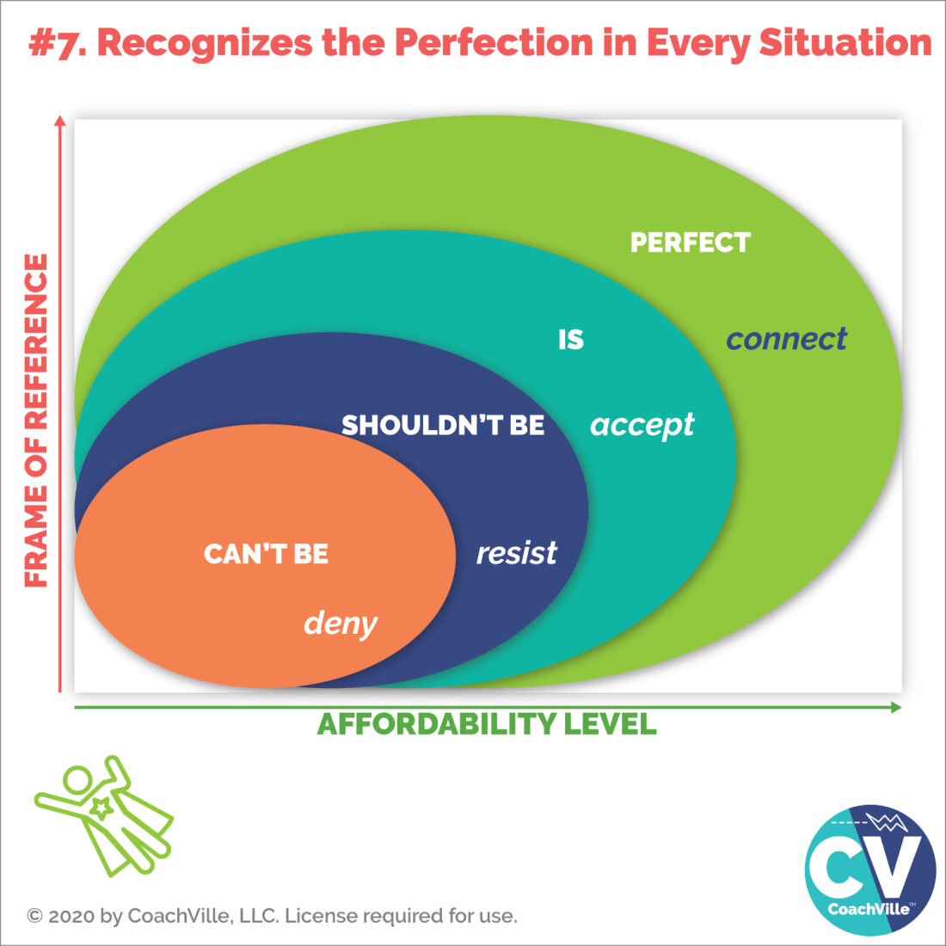
When you can recognize the perfection of the situation you feel a deep connection to life, the Supermind and to the meaning of your dream.
Here is a list that Thomas created to compliment the model above:

Things that don’t seem perfect, yet can be seen as perfect

- Failure
- Resistance
- Missed opportunity
- Frustration
- Confusion
- Dislocation
- Sliding backward
- Mistakes
- Financial loss
- Stress
- Difficult relationships
- Competitive threats

What Inner Freedom is
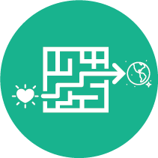
Now that we are half way through the experience, let’s do a quick recap on the Inner Freedom Method
Inner Freedom is the ability to choose when and how to get your hearts dream out into the world – through the maze of non-conscious beliefs and fears that are trying to keep you safe by avoiding social risk.
The symbol of the Inner Freedom Method is the heart moving through the maze toward the world.
This is a transformational experience:
From: fear, emotions and “limiting” beliefs are something you "power through"; the non-conscious mind is dark and mysterious and must be avoided.
To: you can play with fear and emotions; you can uplevel your beliefs; and the non-conscious mind is a vast resource of wisdom and power.
The BIG idea is that you can approach fear with the spirit of play and explore it with curiosity like a treasure map. This brings deep understanding to the self-preservation patterns that are creating conflict with your desire to play BIG for your dream.
With expanded awareness we can transform inner conflict into positive energy, joyful self-expression and deep confidence. This leads to the freedom to choose playful actions that require social risk and the ability to co-create your desired results and experiences with the world!

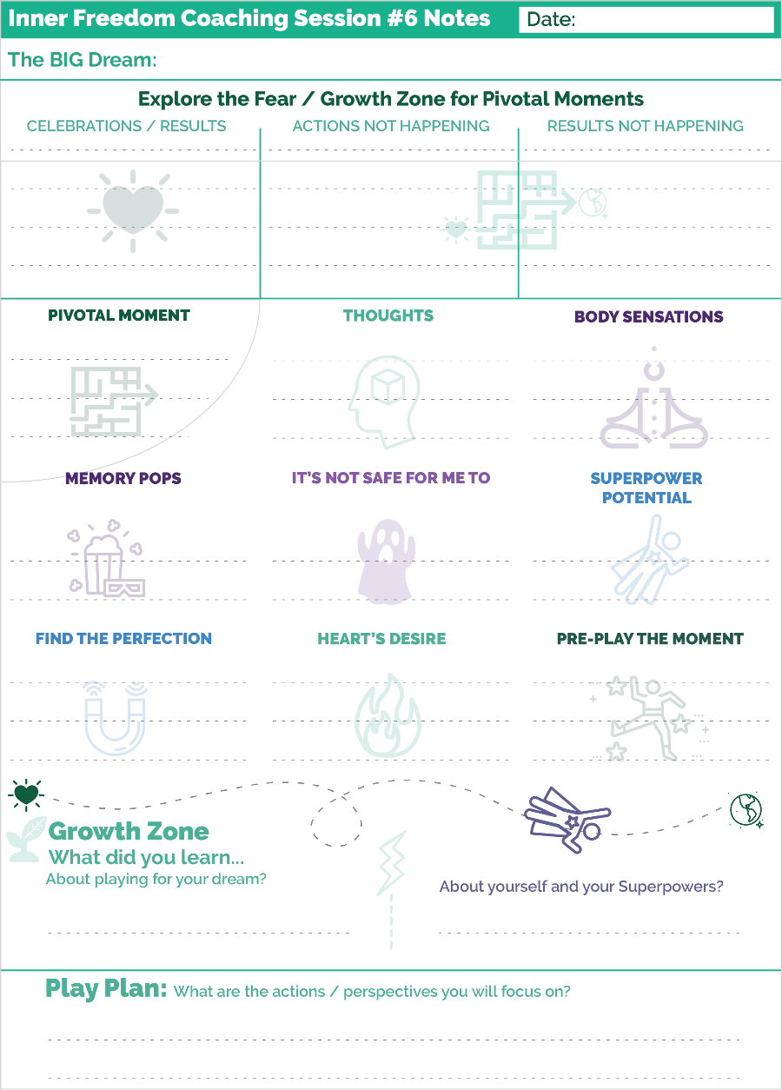
Prepare for Session #6 – Find the Perfection
How are you doing with noticing your pivotal moments?
Is it getting easier to hone in on the moment with the greatest upside potential for your dream?
These are usually the ones with the biggest growth opportunity.
Let’s have a look at the coaching notes playsheet for Session #6.
We start off the same way we do each session:
Sharing your current version of your BIG Dream.
Sharing celebrations and results
Exploring Actions and Results that are no happening.
Next we get into the Steps of the Method.
Notice the writing spots are getting smaller! This is because now there are 9 sections whereas before there were 8. In session #7 there will be 10.
There is a section for each step of the method. PLUS there is a section for Memory Pops. This is not a “Step” but when it happens you want to write it down.
Notice the Find the Perfection section – for Step #6 - is on the sheet now.
Then at the bottom are the sections for the Growth Zone and your Play Plan.
Remember that with your coach you will probably only talk about new items that came up in the session. Then you write up your complete Play Plan with all of the playful actions you are focused on for the week.
Ready to play…
For this session with your coach, choose a pivotal moment that you know has great potential to unleash your Superpowers! In other words, choose a moment where you are experiencing a lot of fear. ;-)

{To be continued…}

