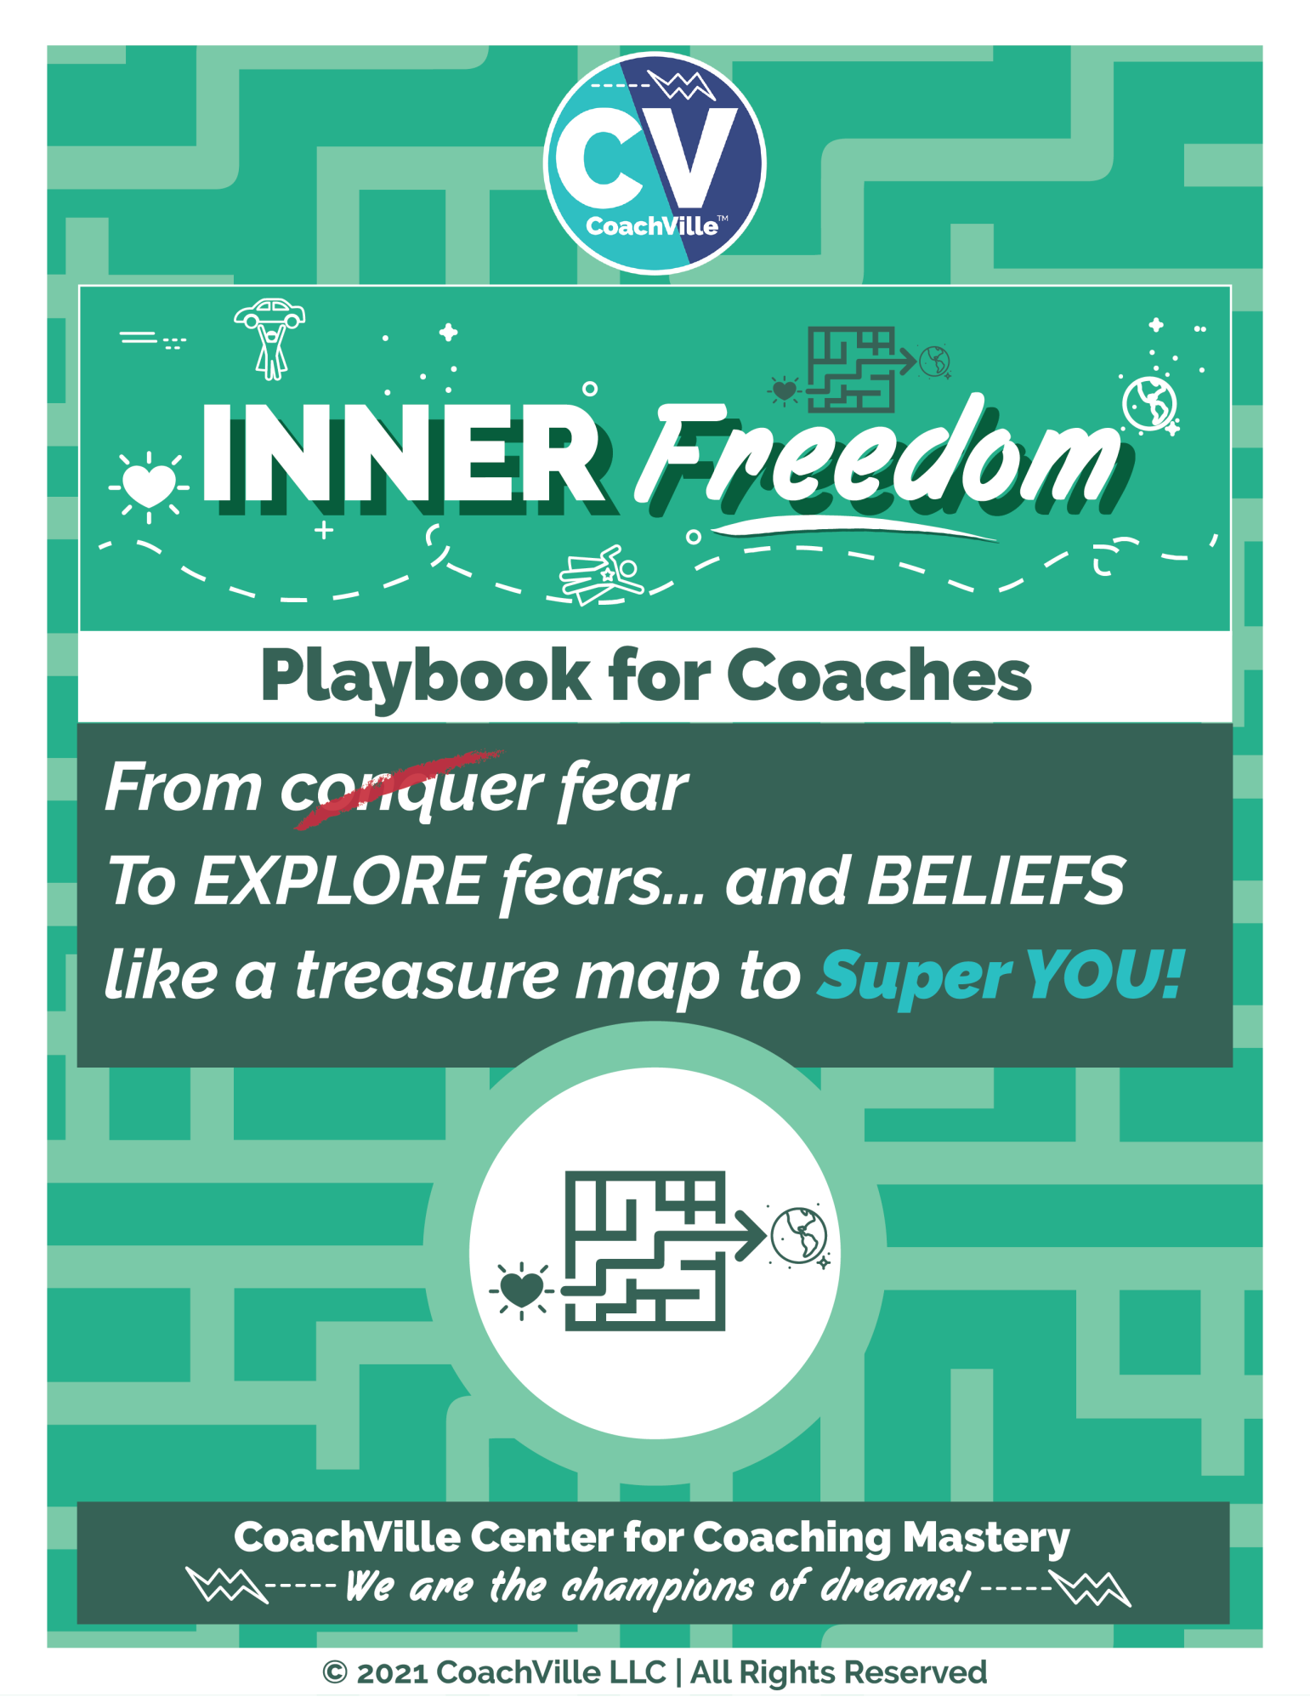
WE FREE EACH OTHER!
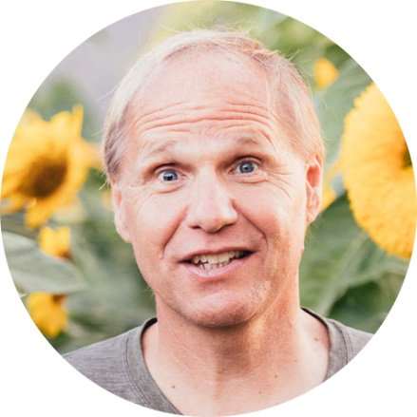
Welcome. On behalf of the entire CV Team, I want to welcome you to the Inner Freedom Method TM Coaching Program.
The themes of the program:
The Pursuit of Inner Freedom to get your Hearts Desires out into the world.
AND
Learn how to befriend fear and it will guide you like a treasure map to your playfulness and Superpowers!

The BIG IDEA that is the focus of this program is this: People playing a BIG Dream in life are often highly aware of exactly what to do, but they are unable to do it on a consistent basis because of the strong conflicting experience of FEAR.
The powerful truth is: You can PLAY with FEAR! This is the coaching opportunity that we will explore in this program.
And we will play with our fundamental coaching theory: The World is a Playground and Life is for Play!

The emphasis will be on PLAYING BIG in life and adopting a “PLAY Life framework” in your personal, business and career life. Specifically, you will design and play for your dream with actions that require you to play outside of your current self-preservation zone. This is a potentially transformational shift and we invite you to PLAY along with us.
Of course, there will be LOTS of coaching as well! As a part of our “Active learning” method you will collaborate with a coaching partner throughout the program. You will coach and be coached by the same person in all of the in-class coaching exercises. We believe this will allow you to go deeply into the coaching and experience a real coaching relationship.
The BIG BIG DREAM…
Life Coaching is a global freedom movement! When people are free to play big for their dreams they can think for themselves and care for the collective at the same time. This way of living is essential for us to uplift the Human Family.
Enjoy the program and remember… FREE PEOPLE, FREE PEOPLE!

Coach Dave Buck and the CV Team!

Table of Contents
Table of Contents 3
Introduction 4
Chapter 1 – Play BIG With Fear ~ The Inner Freedom Playsheet 59
Chapter 2 – The Pivotal Moment & JFA 85
Chapter 3 – Feel the Energy & Body Beliefs 94
Chapter 4 Memory Pops 103
Chapter 5 – Explore the Superpower 108
Chapter 6 – Find the Perfection in the Situation 117
Chapter 7 – The Flow of Gratitude 127
Chapter 8 – Make Your Mind the Ally of the Dream 134
Chapter 9 – #9 Preplay the Pivotal Moment + Intentional Co-Creation 142
Chapter 10 – The World Power Connection 147
Chapter 11 – The New YOU! 151
Chapter 12 – Celebration & Becoming precedes results 155

Introduction

Pre-Class Play Plan
{Add live links to the items}
It looks like a lot… but it will be fun to prepare for our adventure.
1) Read the Introduction (Wooo Hooo! You are doing that now!)
2) Get the Coaching Guide PDF; I recommend printing this and putting it in a binder.
3) Get the Playsheet Pack PDF; Follow the printing instructions.
4) Get the Player Playbook Introduction PDF
You can send this to your potential players
5) Get the Player Playbook PDF
You can send this to your players after they sign on with you
6) Listen to the Player Prep Audio for the Exploratory Session
7) Have conversations to recruit 3 players to coach during class.
This Introduction contains a detailed plan for doing this. Aim to have your 3 players signed on before class starts.
8) Get on the Game Card for this program:
On the Milestone Card Read the “how to play” Playbook (for first time students only)
9) On the program home page, read the “Dyad Guide” (for first time students only)
10) Give some thought to what your Inner Freedom Mission will be
11) Listen to the Player Prep Audio for Session 1
12) Listen to the Coaching Demonstration Session 1 Audio
13) Read Chapter 1 of this Playbook
14) Read the Coaching Guide for Session 1 a few times (at least once out loud)
You are READY for the first class!

The Game Card
Your REAL LIFE is PLAY!
Each week you will play a fun and challenging game
where you earn points for:
1) Read your class Playbook; Read the coaching guide several times out loud!
2) Participate in class and share about what you have learned in class conversations
4) Listen to the recorded coaching demonstrations
5) Complete Missions to coach your players and
6) Complete Missions to play BIG for your dream
7) Stay in contact with your class partner (player/coach)
8) Inspire your team mates And being inspired by them
Your personal “game card” will provide you with a visual display of what you need to do and what you have already accomplished. The public leaderboard will allow you to see how everyone else is doing. Then you can explore the game cards of your class mates for ideas and inspiration. And… when you share you will attempt to inspire them as well!
Note: Center for Coaching Mastery Students need a minimum of 150 points total on game cards to pass the class. At CoachVille we don’t give right/wrong answer tests… not our thing!

The Practical… The Problems … The Purposeful
As your Guide on your Inner Freedom adventure, my role is to prepare you for each leg of the journey so that you can really LOVE it and thrive as both a player and a coach.
In this introduction I have a few provocative ideas to share with you… that will shift how you see yourself, the world around you and your opportunity to thrive in a joyful way. AWWW Yeah.
So the first thing I want to do is share with you a few of the “real world” benefits of Inner Freedom Coaching in the form of practical benefits, problems solved and bigger purpose and aspirations.
The Practical
- If your dream or purpose feels fuzzy or lost, it will come into focus and gain energy.
- Positive actions that used to seem hard, will start to feel easy.
- Your life will start to feel like a fun, growth-oriented adventure… MOST DAYS
- You will have more fulfilling experiences with people you enjoy; in ALL aspects of your life!
- You will gain awareness of where your doubts and fears are coming from… and you will feel more and more FREE!
- You will greatly expand your “body awareness” and “emotional awareness” which will increase your intuition, inner knowing and self-trust. << THIS IS A BIG ONE!
- You will feel more ALIVE… and feel like your life is more vibrant than it used to be!
The Problems
Coaching is NOT an intervention for problems! It is about playing better for your dream.
However… as you play better with your Inner Freedom coach, many of life’s common problems will lessen or disappear completely.
- You will experience LESS anxiety.
- You will experience LESS self-doubt.
- You will experience LESS procrastination on important actions.
- You will experience LESS negative self-talk;
- You will experience LESS limiting beliefs; and the idea of self-sabotage will disappear.
- You will experience LESS frustration, isolation and overwhelm! (A LOT LESS)
- OFTEN… You will experience LESS of unwanted addictions.

You have to admit… this will be awesome!
The Purposeful… and Aspirational
- You will gain influence. You will begin to see yourself as powerful and capable of having a profound positive impact in the lives of others and in the world!
- You will gain creativity. You will gain clarity on the YOUnique qualities that you have within you that you can use to co-create the results and experiences you desire.
- You will make changes. You will feel more confident in taking risks that can bring about positive rewards for your dream.
- You will gain Visibility. You will feel more courage in being seen and owning your value.
- You will develop the ability to tap into your body wisdom to make bold choices.
- You will develop the ability to tap into the Supermind for needed insights and possibilities… and then ACT on them.
- You will feel like your energy is flowing and aligned with your dream and greater purpose.
- Last but not least… you will stop the futile exercise of trying to conquer fear and you will learn how to EXPLORE fear – specifically social fear – which will lead to an extraordinary boost in your FREEDOM. INNER FREEDOM!
- As you practice exploring the FEAR you experience in social situations, you will rediscover your lost playfulness and YOUnique capabilities. AKA Your Superpowers!
AWWWW Yeah!

What coaching is
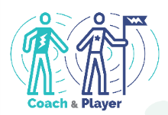
Before we start our coaching adventure, I want to share with you a few thoughts about life coaching because there is a lot of confusion about this.
Here is our definition of coaching:
Coaching Is…
1. A profound personal relationship
2. Wherein the coach guides the player
3. In pursuit of playing better for their dreams
4. Through perceptive observations
5. And co-creative conversations

Some folks have gotten the idea that coaches talk with you to help you solve your own problems. Others think that coaches tell you what tasks to do and hold you accountable.
Life Coaching is not about problems or tasks because life is not about problems and tasks. Life is for playing for our dreams and Coaching is about playing together to play better; also known as practice.
Let’s go a little deeper into each of the elements.
1. A profound personal relationship
Coaching is a personal relationship. Your coach will care about you as a person and you will care about your coach. It is very different than the ideas we got about Industrial Age Professional that was robotic and impersonal.
Coaching is profound because it goes beneath the surface of life into feelings, emotions, beliefs, desires, possibilities, fears, visions, ideas… the important stuff.
2. Wherein the coach guides the player
Coaching is NOT hierarchical… which is an important detail we will explore in a moment.
Guiding another person on an adventure is a real artform. It is not the same as directing or controlling; but it is more than a passive companion.
Think about the guide on a hero’s journey like Star Wars Obi Wan Kenobi to Luke Skywalker. They are on the adventure together, they are both actively involved. Obi Wan is sharing observations with Luke BUT… Luke makes his own choices about what to do.
Another way to think of this is the Olympic Coach. They are in the Training Center with the athlete every day sharing the dream together. Olympic athletes deeply thank their coach when they win a medal; they could not have done it alone.
3. In pursuit of playing better for their dreams
Playing better is the essence and the purpose of what ALL coaching is about.
Playfulness is an awesome Human Superpower. Helping you restore and maximize your playfulness is a big part of Life Coaching. I will get into that much deeper in a few moments because the idea of play may be scrambling your mind right now.
To ease into the exploration here are a few ideas to help you understand what I mean by PLAY and playfulness:
- Curious and Creative
- Resourceful and Resilient
- Explore and Experiment
- Fun! (usually, but not always)
The 3 Frameworks of Play
There are 3 areas of life where we see play all the time. One way to get into playing for your dream is to identify with one or more of these and re-imagine your dream with this framework.
1) Performance Art: You have talents, a “voice” or perspective and something to say or share. You practice A LOT to refine both your skills and your message. You use your talents to co-create experiences with your audience.
2) Game / Athletics: The urge to compete drives you to hone your skills to perform at a high level. You enjoy the thrill of victory and embrace the difficulty of defeat. You enjoy the camaraderie of your team mates and the competitors. The definition of compete from the ancient Greek language is actually quite inspiring.
To Compete: to seek the best in oneself in the company of others likewise engaged.
3) Epic Quest: You have been “called” to adventure. There is something you MUST do even though it means leaving behind the comfortable of your well known surroundings and place in the world. You face great challenges in pursuit of your mission. If you are successful, you reap some great reward which you can bring back to your tribe for all to enjoy.
Your Dreams
This is another topic we will talk about A LOT in this playbook and with your partner coach. Your Dream is your vision for who you want to become and what you want to experience in the world.
In the next section we will get into the details of The Dream.
4. Through perceptive observations
We are ALL yearning to be seen by someone who knows what they are looking at!
Your coach is going to observe you as you adventure together and share with you what they see in a judgment-free way!
We all have blind spots in our thoughts and actions because we can’t see ourselves very clearly…a trusted outside observer can really accelerate our growth.
This is the way life is meant to be played; we are meant to co-create life with others.
5. And co-creative conversations
Talking together is a big part of how coaching happens.
The key in Life Coaching and Life Playing is to co-create a safe space for deep and provocative conversations.
This brings me to one of my favorite things to share with new Life Players!
The ancient power of co-creation!
In the ancient Aramaic Language there was a power phrase: Abera Ca Dabera – It means: “I create as I speak”. You have probably heard of it being used in the context of a magic trick but it is much more practical than that! When two people are talking together in deep conversation with purpose, permission and presence – as happens in a Life Coaching relationship – it can take on a life all its own. With your words you can speak your dream into existence and create the new version of YOU needed to fulfill your dream. This is the “magic” of co-creating that makes coaching such a powerful force in the world!
With focus and determination you can experience this transformational power with your Inner Freedom Life Coach!

Possibilities for your BIG Dream
The first thing your partner coach is going to talk with you about (and you with your players as well) is your Dream; because going for your Dream is what playing life is all about. An important point here is that playing life with a Life Coach is MUCH different than going it alone. So I am encouraging you to think bigger than you might normally allow yourself to think.

Why Dream… rather than objectives or goals?
- Your Dream includes your imagination.
- Your Dream includes your vision.
- Your Dream includes your heart’s desires.
- Your Dream includes how you want to contribute to life.
- Your Dream includes who you want to become.
- Your Dream includes the experiences you want to co-create.
- Your Dream includes the spirit of play.
- Your Dream includes a sense of wonder and mystery.
Often we don’t think too much about our dreams, we just focus on what we can control by ourselves. This is how we were trained to think in the Industrial Culture. (We will get to this in a moment) This approach tends to keep us pretty small; which is OK sometimes. But truly life can be MORE.
You may be very clear on your Dream and already in pursuit. Or you may be a little fuzzy about the details but just know you are ready for more. Wherever you find yourself now is the perfect place to start your adventure. The purpose of this little section is to spark your imagination for what your BIG Dream can be.
Our mantra is: The world is a playground. Let’s Play Together.
Here is a “starter” list of the endeavors that people dream of playing better. This will spark your imagination for the many possibilities you have with your Inner Freedom Life Coach!
Aspects of Life you can play better with a Life Coach
- small business ownership,
- career development & transition into something joyful & meaningful
- business growth through team play,
- leading a worthy cause
- growing a vibrant community or tribe
- spiritual quest through community participation,
- financial freedom through value creation,
- corporate management and/or leadership of a great team
- artistic expression and performance
- health and wellness through engagement
- personal growth through self-expression and participation (this includes co-creating relationships and partnerships)
How you will grow as you play for your dreams…
- You will express your superpowers, energy and creativity
- You will enjoy the company of people on your growing Dream Team
- You will grow your skills and capabilities
- You will experience personal transformation; to become, believe and belong
- You will grow in status within a community
- You will change your world or THE world in a positive way
You will LOVE playing for a Dream that is engaging, supportive, challenging, purposeful and fulfilling.

The 4 ways to Play Life. The 4 things we desire!
A BIG difference between playing with a coach and working in isolation is well… a focus on play… specifically Social Play.
These are the four things EVERYONE playing big in the world wants more of; wants to do better or bigger in their own unique way to make a positive impact; to matter.
By adding activities in these four areas into your plan each week, your coach will be able to guide you toward the experiences you desire, the impact you desire and personal transformation AT THE SAME TIME!.
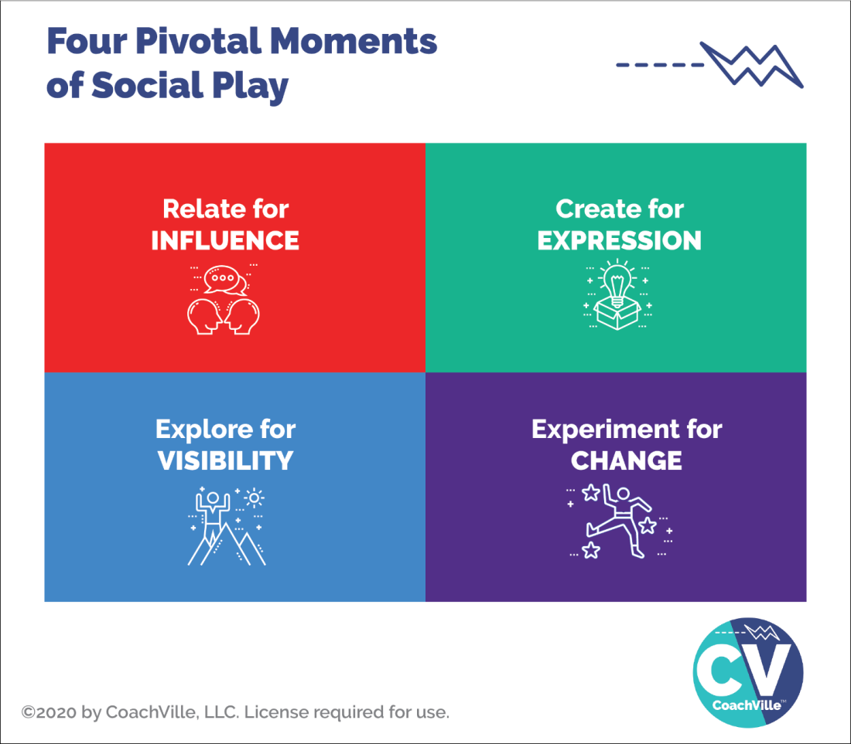
Here is an important insight to consider: Anything that you cannot control but you can influence is an opportunity to play and play better with a coach!
So I want you to wonder… to dream… of what you would do if you were able to increase your influence in the world around you.
These are the four essential activities of the Connected Age of Purpose.
We call them pivotal moments of social play.
- Relate, Create, Explore and Experiment
- A pivotal moment is a coach-able moment that you can improve through practice.
- Social play means that it involves co-creating the experience with one or more other people rather than completing a task in isolation; as was the norm in the Industrial Age of Control.
And here is another BIG point: Everyone has unique superpowers within them that can be unleashed to become AWESOME in each of these 4 types of social play.
The Four “Things” people playing life want more of…
Entrepreneurs, leaders of teams and organizations, people with a cause, people with an idea… anyone who aims to move beyond the status quo of life wants these four things:
- Influence
- Visibility
- Expression
- Change.
That means YOU!

Relate for Influence
Relate means talking to other people! This is pretty much what we do all the time in life. It becomes playful where there is an opportunity for positive influence like when you are asking someone to do something with you and they might say “yes”, but they might say “no”.

Create for Expression (AKA to Share)
Creating is when you make a thing or you design an experience that you aim to share with others; for examples: writing, recording, designing, planning. The sharing part is all about participation and contribution. This is very much in line with the “Life is Performance Art” concept.

Explore for Visibility (AKA to See and Be Seen)
Exploring is when you go into a new territory; you are stepping into the unknown (hopefully with a sense of wonder) It can be a physical place, a social media platform or even a new idea. You explore to see and experience new people and new places; and also to BE SEEN by new people.

Experiment for Change (AKA to Try New Ways)
Experimenting is any time you do something that you have not done before OR you do something that you have done in a new way. Often when we experiment we have an idea or a hope of what will happen but we don’t actually know. A key to success is to start with an intention, be open to new possibilities AND keep track of what happens; and most important is to not look at any outcome as a failure but as learning.
Hopefully you are getting energized about playing for your Dream!

The BIG Picture…
Inner Freedom is a transformational method of Life Coaching where you practice pivotal moments of social play that lead to influence, visibility, expression and change!
You will experience this fully over the next few months and you just might be inspired to take a “coach and play” approach to many of your future pursuits in life!

The FEAR of Social Play
Now you might be thinking: “Yes, these social play actions and results are exactly what I want!
“But when I think about it:
- Asking for what I want or need is pretty hard for me.
- Sharing what I create can be a real struggle.
- I know I need to “get out there” and be more visible, but it’s not easy.
- Trying new things often feels too risky so I stick with what I always do.”
EXACTLY.
These feelings are the opposite of Inner Freedom.
These four social play activities will bring up seven really intense FEARS!
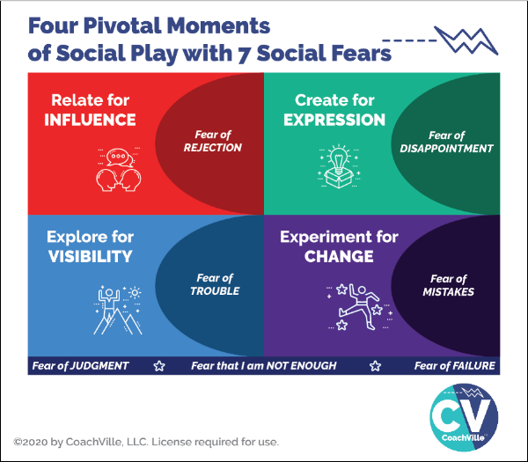
While all of us with a BIG Dream to contribute our unique value and voice to others want these four experiences… we are all also navigating through these seven intense fears; mostly on a non-conscious level and mostly with a variety of not-so-effective methods! (Hah! That is an understatement).
- Fear of Rejection
- Fear of Trouble
- Fear of Disappointment
- Fear of Mistakes
- Fear of Judgment
- Fear of Failure
- Fear that I am NOT ENOUGH (The “BIG Kahuna” Fear)

Relate for Influence = Fear of Rejection
To play for impact in the world – even with just a few people - you need to cultivate a high level of ease with approaching people and talking with them. And then you need to invite them to a next step. This is where the fear of rejection comes in. BIG TIME.

Create for Expression = Fear of Disappointment
Playing BIG for your dream will include creating and sharing experiences (or content) in a variety of forms. Also every time you have an opportunity to speak in front of people you are creating and sharing an experience. The fear that we might disappoint someone or BE disappointed by someone’s reaction to what we create can be a BIG block to creating and sharing.

Create and share is the essence of the idea that life can be played like performance art!

Explore for Visibility = Fear of Trouble
Exploring for visibility is often described as: “I need to get out there”. And for many people this is a BIG struggle; this is because the Fear of Trouble is VERY REAL.
In order to contribute your gifts to others you need to find people (customers, colleagues or partners) to participate in what you are creating. You need to “get out in the world” either physically or virtually.
The world of people is an amazing but potentially “dangerous” place; at least at an emotional level. The potential for trouble in the unknown is why most people stay where they are and spend their time with the same people. However, it is almost impossible to pursue your dream this way.

Experiment for Change = Fear of Mistakes
As coaches and entrepreneurs we are change-makers! But at the same time we are often crippled by the fear of mistakes.
This is a big remnant of the Industrial Age mindset that everything you need to do: a) there is a right way to do it b) you should be able to do it the right way every time and never make mistakes.
Of course this is nonsense! But the residue of this mindset from school and jobs keeps us locked into a perfection trap. This makes it sooo hard to experiment and find our unique way to do everything our Dream needs us to do.

Fear of Judgment ~ Fear of Failure ~ Fear that I am not enough
These fears are basically accumulations of the four fears of playfulness. They are deep artifacts of the Industrial Age of Control and they impact our thoughts and feelings in a profound way.
Here is a BIG idea: these social FEARS – and the beliefs that form around them - are not inherent to us, we absorb them from the culture through our life experiences.
If you aim to play for your Dream at a high level you need to embrace and explore these fears with profound curiosity. This is what I mean by explore your fears like a treasure map. The treasure is your playfulness and unique superpowers - for Influence, Visibility, Expression and Change - that are deep within you waiting to be activated.
BIG POINT regarding the power of coaching: it is almost impossible to explore social fear by playing alone. But together we can do it!
More about that in a few chapters.
So by playing with your Inner Freedom Life Coach, who is a very capable guide of the Human Journey… out in the social world… through these intense fears… you can become very capable in Pivotal Moments of Social Play in pursuit of your BIG Dreams.
YES!
That’s why you are here with us.
The BIG question you might be wondering…
How / where did I get all of these fears?
How did I become so fearful of activities that seem so natural and essential?
This is the question of the century! (quite literally)
Let’s talk about how this happened to all of us.

We were born to play but then we were trained to work.
I believe that the idea of playing life is the most natural, effective and joyful way to live. I also believe that the Human Spirit of Play is the most untapped resource in the world today. It has the power to transform lives, relationships, families, communities, businesses and the sustainability of life on the planet. Yeah… it’s that BIG.
But all of us were trained in the Industrial Age to look at everything as work; as something that needs to be controlled. School was work, jobs and business are work, and we also work on our relatonships and even our golf game! UGH!! In the Industrial Age you were trained to work in isolation rather than play in the world.
The essence of Industrial Age work is control.
The essence of Connected Age play is co-creation.
In his TED Talk Steve Kiel says that: “the opposite of play is not work. The opposite of play is depression”. Remember all those problems I mentioned at the beginning? They start when we stop playing. And we stop playing because we were made to feel shame for being playful at school, often at home and then at work.
What we are talking about here is our approach to life: we can work on it in an attempt to control it or we can play and co-create with it.
Hint: playing is more fun, less stressful and WAY more effective!!
Play is a better way!
The “Industrial Age” – which became mainstream around 1880 – made work the central theme and approach to life for most humans.
Many historians say that the Human focus on work and control began when humans started farming food and domesticating animals. At that point they became tied to the daily grind of working on the same plot of land every day. Whereas our hunter-gatherer ancestors lived every day as a free spirited adventure; albeit with additional risks.
But in 2010 something BIG happened… suddenly almost every human had a super computer in their hands and with it the ability to connect with anyone in the world in an instant. I call this the dawning of the Connected Age.
I believe that as the Connected Age unfolds there is an opportunity for playfulness to become the central theme and approach to life. We can restore the free-spirited playfulness that is our Human Heritage and combine it with the security of well-organized shelter and food production that our ancestors lacked.
WOW! SO GOOD.
I made a little chart to help us go a little deeper and recognize the differences between The Industrial Age of Control and The Connected Age of Play.
The important thing to notice is how the Industrial Age of Control culture created a HUGE need for Inner Freedom Life Coaching!

The Transformation from worker to player
 | 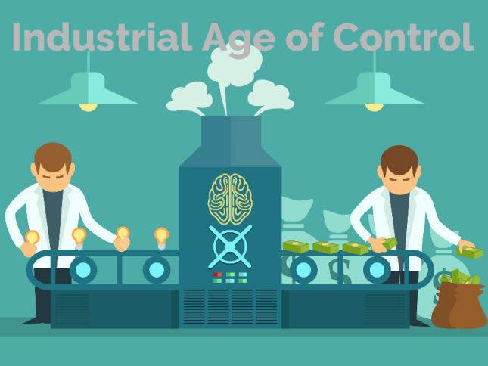 | 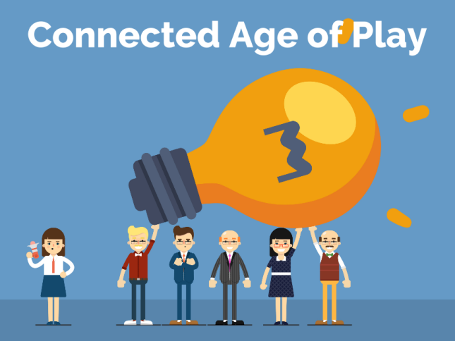
Time frame | 1880 – ~2030 | ~2010 - ????
The Framework | Everything – schools, businesses, communities - is run by authoritarian control like a military operation. | Most things are run like a talented performance art or athletic team co-creating inspiring experiences.
The Approach | Well intentioned teachers, managers and business owners become unwitting henchmen for the dehumanizing top-down hierarchy.  The 3 C’s  Command  Tell them what to do  Control  Show them how to do it  Compliance  Make sure they do it right | Inspired Life Coaches and coach-approach teachers, entrepreneurs and leaders play to unleash the best of Human Nature.  The 3 B’s  Become  The urge to Become through play  Believe  The ability to Believe in a dream  Belong  The need to Belong with a dream team
The Power | In the “system” | In the YOUnique Superpowers  of Individual Players in  an uplifting environment
Where we  learn | In School.  Sitting silently at a desk  memorizing the right answers  working alone completing tasks  preparing for the test | Life (and Online)…  Learning from the world  co-creating, sharing, connecting  playing games with global friends  pursuing the next level
Memes | Do it right the first time  or don’t do it at all;  (at school)Do your own work  if you help your neighbor  you are a cheater | After you fail, play again  Together we play better  Get to the next level
You are a | Worker / servant  Consumer | Player  Co-Creator / Investor
You have a | Job  with a Manager / Boss  (enjoyment unlikely) | Dream / Purpose  with a Coach  (enjoyment assumed)
What you do | Complete tasks  Fix problems | Co-Create Results and Experiences  Express Superpowers to add value
Why? | To earn a living | To live your dream and GROW
The Feeling? | Suppressed & Traumatized  Dreams squashed  Playfulness shamed  Unique voice and power silenced | Rewarding and challenging experiences and opportunities to contribute make every day a fulfilling adventure
The Path to Success... | Do it right  Don’t make mistakes  Fit in by being like the others  Don’t try to be special  Mind your own business | Play big to make a difference  Risk failure, learn fast and grow  Find a place / group that embraces ALL of who YOU are  Own your value.
You buy… | Things - More is better  Things will make you happy (NOT)  Entertainment to  “get away” from meaningless  or repetitive work | Things that inspire you  and tools for creation;  Experiences that expand your skills and awareness;  Coaching to play better  and pursue your Dream
You aim to | Save some money for retirement;  then you can enjoy life. | Co-Create a freedom-filled lifestyle  economic freedom  creative freedom  emotional freedom  spiritual freedom  location freedom

I know this chart paints a pretty bleak picture of our current culture in the left column. You may be an optimistic person and think: “it’s not that bad”. I understand. I am an optimistic – make the best of any situation – kind of person myself. However… for most people in the world it IS bad. AND we have normalized it so that we have become numb to it. AND most importantly we have been taught that we are powerless to change it.
I have been a professional Life Coach for almost 25 years for over 1,000 amazing individuals. I can tell you: even folks who are optimistic, investing in themselves and aiming big are boxed in by fears. They have no idea what their REAL powers are and their capacity to engage in social play activities is severely stunted.
Meanwhile, the situations we face as a human family demand that we stop “making the best of it” and start reclaiming our Human Superpowers to make change! Especially when we consider that most of the trauma, pain and suffering that is happening… we are doing it to each other without even being aware of it!
Together we can change the experience of life for the better… for everyone.

Get Your Human Nature Back!
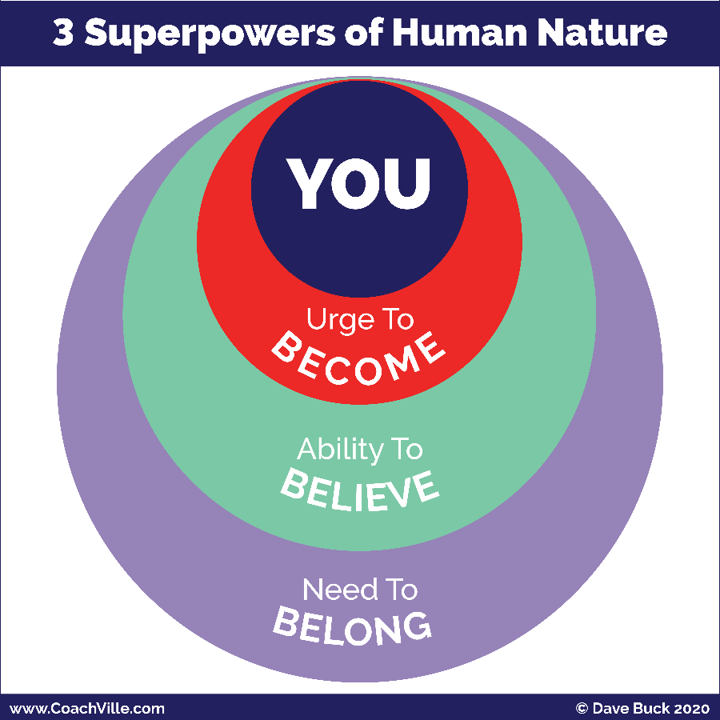
There are three Superpowers of Human Nature that you need to unleash in order to play BIG for your Dream: Become – Belong – Believe.
You saw this in the chart about the Connected Age of Play.
1) The Urge to Become. All humans have an inner urge to become the next version of themselves; to grow and expand. We become by playing. If we stop playing we stop becoming and stay the way we are.
2) The Need to Belong. This is the strongest of all human needs. It operates mostly on a non-conscious level and drives almost everything in the human experience. We Humans always seek belonging and status within the environment we are in.
3) The Ability to Believe. Humans are believers. The ability to believe is the catalyst of all human civilization.
All of our beliefs – about how life works, who we are and what is possible for us – come from navigating between our urge to become and our need to belong. In other words, we get our beliefs from our interactions with the world around us.
Some of our beliefs are conscious and we think and talk of them often. Most of our beliefs settle into a non-conscious level within us and have a non-stop profound impact of what we do and don’t do on a moment-to-moment basis.
To create change we need to unleash all three superpowers!
- We need to PLAY to become the next version of ourselves.
- We need to find or create a new environment of profound belonging where we are supported and challenged to become the next version of ourselves; where we feel safe to be our Superpower selves!
- We need to believe in our own dream. Then we need to explore our beliefs and choose the ones that we need to uplevel in order to live our new dream.
This is the essence of the Inner Freedom Method!
This is where you REALLY need a great Life Coach! We are not meant to unleash our Superpowers alone.

Life Coaching Starts Here
When when a player signs on with a Life Coach there is a purpose behind it.
They want to:
- Accomplish something
- Experience something
- Get better at something
- Change something
They probably don’t think: “Oh, I need help unleashing my Human Superpowers!”
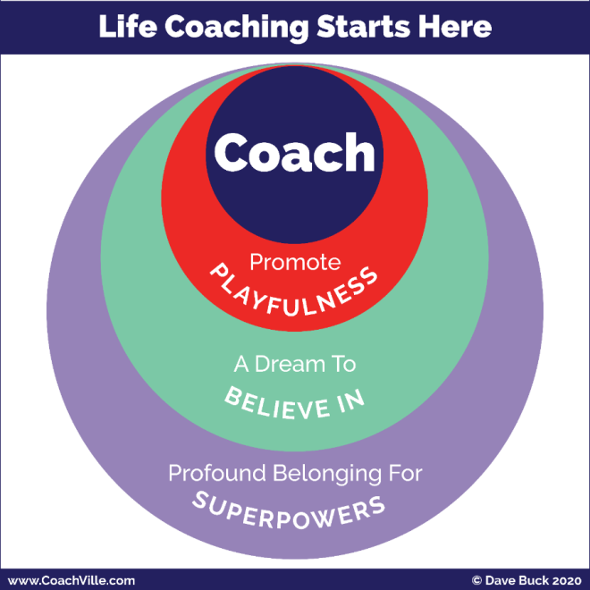
LOL
True. However, to get that “something” they want, that is exactly what we need to do.
And not only will it energize the path to the “something”, it will also open doors to amazing new possibilities!
In this little diagram called: “Life Coaching Starts Here” you will recognize the structure but the words have changed.
Promote Playfulness
The Urge to Become… Promote Playfulness
This is essential because coaching and playing go hand in glove since the purpose of coaching is playing better. So you will co-create ways for your player to PLAY life in pursuit of their dream.
A Dream to Believe In
The Ability to Believe… Believe in your Dream
Life coaching is about living our dreams! So you will focus in on what your player’s dream is. Don’t worry if it is not clear. You can start with even the smallest inkling and grow it into a BIG Dream.
Profound Belonging for Super YOU
The Need to Belong… co-create a place of profound belonging for YOU and your Superpowers.
You will start be creating a “safe space” – a judgment free space – for your player to express their dreams and practice being Super YOU!
As their confidence grows from your time you will begin to encourage your player to be Super YOU out into the world so they can find where they BELONG!

We Free Each Other… The Global Life Coaching Movement
By signing on to become an Inner Freedom Life Coach you are participating in one of the most important movements happening in the world today!
All around the world Professional Life Coaches as well as Coach-Approach leaders, managers and entrepreneurs are uplifting the Human Family – one person at a time - out of the dehumanizing Industrial Age of Control and into the Connected Age of Play by unleashing the Superpowers of Human Nature. (whew… that is a doozy of a sentence!)
Essentially, Life Coaching this is about freedom!
- Freedom to be your playful self and continue to grow and become a new version of you easily and naturally.
- Freedom to express ALL of who you are and contribute your value to others and enjoy the rewards.
- Freedom to pursue your own dream with a team of people who share your dream.
- Freedom to co-create belonging with people who enjoy ALL of YOU and who you are becoming and what you are contributing.
Every person who “gets free” in this way then passes freedom on to everyone around them; co-creating a ripple effect of good.
A key point here is that we don’t get free by struggling alone! Freedom is social. We only get free together… we must free each other by stopping the status quo habits of Industrial Control and sharing the rebellious joy of Connected Play.
I am super excited to have you on our team as an Inner Freedom Coach!!!
Free people, free people!

Our Fears Are a Treasure Map to Our Superpowers
I am addressing this section to you as a player… you will also guide this process as a coach.
This is a major theme of the Inner Freedom coaching program that you saw on the cover page so I just want to illuminate it a little bit here. We will be swimming in it full on once the coaching starts.
Here is the BIG AWARENESS: Growing up in the Industrial Age of Control you absorbed A LOT OF SOCIAL FEAR!!!
And the ways we were taught to “deal with” our fears were misguided.
AKA The don’t work at all.

From: Conquer Fear; Fear is a weakness that I must squash or overcome.
To: Explore Fear; Fear is my friend that is trying to keep me safe.
This is a very different way to look at fear than what you are used to. In the Industrial Age the idea was to make everything a simple task where nothing would ever go wrong and everything was under control. In this life you only experience the fear of shame for doing something wrong; any other fear must be squashed immediately so you can carry on doing your work in isolation.
The thing is, life is not that simple. I refer to this Industrial Mindset as the “Delusion of Control”. When you start playing for your dream out in the world of people, you realize that you can’t control it (or them) and you WILL experience fear… A LOT!
Then in the 80’s and 90’s the “Self-Help” movement really took off and continues today. While there are some good ideas in there, there was a LOT of nonsense about how you need to conquer your fear. And you can do it yourself with a self-help program.
The problem with the self-help movement is that it is based in the Industrial Culture of Isolation and working alone; somehow with the right information you can do everything yourself.
My experience has been that we can’t get free of social fears by working alone… it is impossible. So these programs lead most people to deeper feelings of shame and despair.
Here is the clue: Humans are not meant to do great things alone!!! We are social animals. We are here to co-create life together.
So the key is to change your relationship to fear.
If you attempt to conquer fear, it will defeat your dream.
If you honor and befriend fear, it will guide you to it.
Here is the next BIG idea to consider that will be a recurring theme in the Inner Freedom experience: In the Industrial Culture, the experiences you learned to fear the most were when you expressed your YOUnique power and playfulness.
What happened to most of us: We got in trouble for being ourselves!
Your fears aim to keep you out of “trouble” so the thing you fear the most is your own power!
These dehumanizing experiences put our power and playfulness into the shadows of our inner being. This is what we refer to as the treasure map.
I know this may sound strange, so I am asking you to trust me on this one and then be curious and open. We will explore this possibility all throughout the program. The good news is that your Inner Freedom Coach knows how to guide you on the treasure hunt!
So when you feel fear, DON’T FREAK OUT, and don’t ignore it! Make a note about the situation and share it with your coach. Then the adventure continues.
The Treasure Map
I call it a treasure map because it is not a like a road map with easy-to-read signs. It is an adventure with lots of challenges and quirky clues.
TO Your Superpowers
A Superpower = A unique ability that you can practice
until it is capable of making a BIG IMPACT on people or situations.
Again, the key is to stay open and curious and your coach will guide you on the Inner Adventure to discover the power that is hiding behind that shadow of fear.
This includes the Human Nature Superpowers we have talked about a few times AND your YOUnique abilities that have gone missing because of dehumanizing Industrial Age trauma.
There is a lot more to YOU than you are aware of right now.

There is more to life than meets the eye!
Another way of saying this is: there is more to life than what we can control.
A LOT MORE!
This is a BIG idea that I want to share with you to give you the bigger picture of Life Coaching and playing for your dreams.
We call it “Energy”; or Energy Alignment.
Here is a little diagram to show the elevation of Life Coaching from the Industrial Mindset focus on Control to the Connected Play mindset focus on playing with energy.
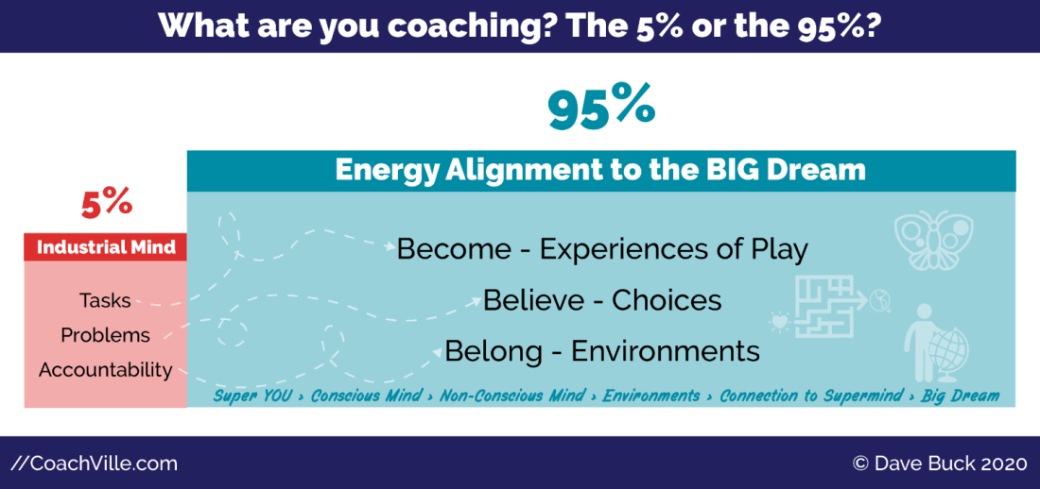
Life Coaching has come a LONG way in the past 25 years… and at CoachVille we have been a really big part of that evolution.
In the early days of Life Coaching – in the 1990’s – we were greatly influenced by the culture of the Industrial Age. So as a result Life Coaching got tangled up in concepts like tasks, problems and accountability.
But in the grand scheme of life, completing tasks, fixing problems and holding accountability is only a small fraction of what it takes to live a joyful life of freedom and co-creation!
You may have wondered:
Why is the life I imagine so difficult to realize?
The answer is: The energy is not aligned!
And most Industrial Age “success” training ignores Energy Alignment.
One way of thinking about this is in concepts you already recognize: attitude, intuition, attraction and synchronicity.
Energy Alignment makes these ideas very practical while adding the sense of mystery and wonder.
As an Inner Freedom Coach will be focused on guiding your players to their BIG Dream through:
- becoming the next version of you through playful practice and the freedom to BE your powerful self,
- upleveling their non-conscious beliefs and choices and exploring your fears of your own power
- leveraging the need to belong by upgrading thier environments to embrace their power.
When you develop in these areas you seem to make the right moves at the right time without a lot of wasted effort. And good things and opportunities just seem to come to you.
Yes, here we see yet another variation on the Become – Believe – Belong theme. It’s everywhere because your awesome Human Nature is everywhere!
The idea is to play for your dream and live in the flow of energy RATHER than holding you accountable for an endless list of tasks and problems.
WOOO HOOOOO!

The Energy Alignment Game Overview
Let’s explore Energy Alignment a little deeper because it is woven throughout the Inner Freedom Coaching Experience.
I am going to share with you the picture and a brief overview to energize you and spark your curiosity. We will go into each of the elements as we move along on our Inner Freedom adventure together. (Something to look forward to ;-)
You don’t need to “worry” about understanding this; it will happen naturally as your coach guides you using the Inner Freedom Method.
The “Game” is to align all aspects of YOU with your BIG Dream to create a state of flow.
Energy Alignment Game
SO MUCH FUN!! Learning about this concept was one of the big moments of my life.
This definitely goes in the realm of play; as in something that you cannot control but you can influence with skill, strategy, imagination and playful effort.
One little note: There are MANY MANY ways to play with Energy so this is not intended to be a definitive guide.
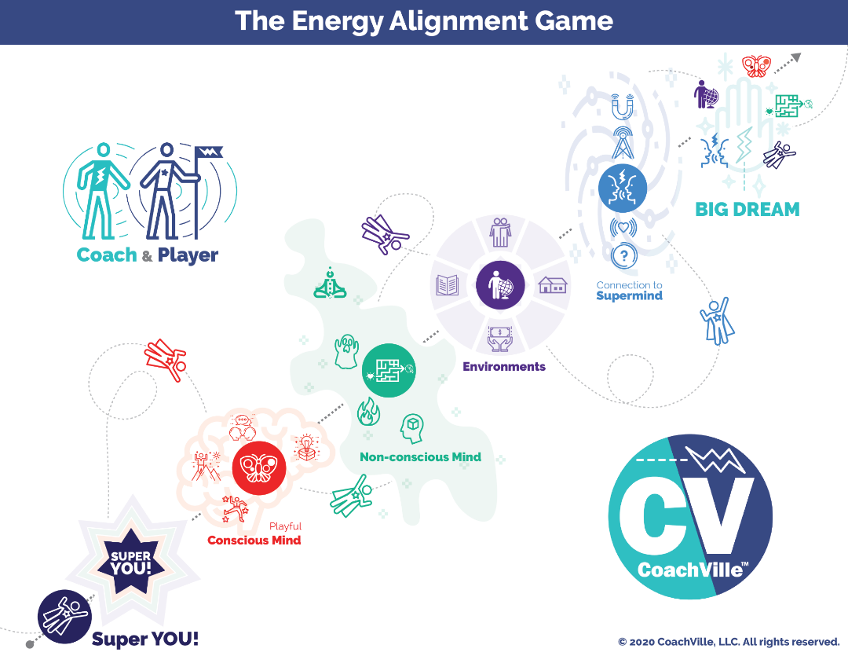
Your BIG Dream
This is your vision of what you aim to accomplish, experience, express or co-create in the world. Your Dream comes from your hearts desires but is often sparked by what you see – or don’t see – in the world around you.
Often our hearts dreams are a little mysterious; even to the one who has the dream.
Most BIG Dreams include an essence of contribution.
Next we will go to the lower left to explore all of the energies that we can align with your dream.
Super YOU
There is a next-level version of YOU that you must express fully and become in order to fulfill this big dream.
One of the reasons your Heart has dreams is so that you can discover and express more of your abilities.
Playful Conscious Mind
There is a playful version of your focused thoughts and deliberate actions that you need to use in an intentional way to uplevel your skills to align with the new dream. Your playful conscious mind responds to the urge to become the next version YOU. Play is all about becoming. In the model hopefully you recognize the 4 symbols for the Pivotal Moments of Social Play that we explored earlier.
Non-Conscious Mind
Whoa, this is a big one. Your non-conscious mind is the power source of belief and desire within you. It is like an energetic bridge between the urge to become in your playful conscious mind and the need to belong in the environment around you. You will need to expand your body awareness; where your intuition and inner knowing live.
You will need to uplevel your relationship with fear from enemy to friend and a treasure map to your Superpowers. Your dream will need you to tap into your hearts desires for focus and fuel. You will need to cultivate belief in a whole new set of possibilities to align with your dream.
The non-conscious Mind is the main focus of the Inner Freedom Method coaching… whew! We need it.
Environment
Your non-conscious mind - which is super focused on belonging - is in constant connection with your environment. You will need to uplevel many aspects of the world around you so that the powers of belonging, believing and becoming align with your dream. And as you unleash your Superpowers, you will need to find or cultivate an environment where it is safe for you to express them. Inner Freedom will give you the courage to make those changes.
Connection to the Super Mind
There is a timeless web of human consciousness that we are all connected to. Through big questions, gratitude and intentional thoughts your dream can become a magnet for the insights, inklings, spontaneous awareness, opportunities and synchronicities that you need to live your dream. But be prepared, the Super Mind plays rough so you need to expect a tumble or two.
The pursuit of Flow
Your dream is calling you out into the world to discover a bigger contribution and more fulfilling joyful life. As you endeavor to align every part of your energy to the BIG Dream, it begins to FEEL – feel is the key word – more natural. This is called getting into the flow. It is not the ultra-safe under control routine. It is engaging, yet safe enough that the potential rewards seem worthy of the potential risks. This is when pursuing your BIG Dream feels less and less stressful and more and more fun!
That is what we are playing for!

Introduction to the Inner Freedom Method
The Inner Freedom Method is a precise sequence of guided exploration conversations, practice experiences, visualizations and body awareness experiences.
You cannot do the Inner Freedom by yourself; it is NOT a self-help method. The Inner Freedom Method is a co-created experience that requires two people. (There is a way to do a modified version in a small group as well)
In Session 1 you and your player will explore their BIG Dream for it’s possibilities as well as any “fear adjacent” experiences that they are aware of. From that point forward, each session you will guide the exploration of a “pivotal moment” of social play that they want to explore to unleash their power.
I will get into the details of the life-changing concept of a “Pivotal Moment” in Chapter 1 of this playbook and in the audio series. (Something else to look forward to!)
Here are the 12 Sessions of the Inner Freedom Method Coaching Adventure:
#1) Play With Fear
#2) Pivotal Moments and Judgment-Free Awareness
#3) Feel the Energy and Body Beliefs
#4) Memory Pops
#5) Explore the Superpower Potential
#6) Find the Perfection
#7) Flow of Gratitude
#8) Make Your Mind the Ally of Your Dream
#9) Intentional Co-Creation
#10 Upgrade Your Environments
#11 The New Super YOU!
#12 Celebrations

Program Description
A 9-step Coaching Method to transform FEAR
into a treasure map leading to your hidden superpowers
The Inner Freedom ™ Method is a powerful 9-step method where you identify non-conscious patterns of fear and transform them into a powerful source of energy to fulfill your purpose to Play BIG for your Dream.

Your story as a player...
As you step into your vision to Play for your dream in a BIG WAY, you will often find yourself severely slowed or even “paralyzed” by the invisible force of FEAR! With the Inner Freedom Method you will create a personal transformation...
From: fear and emotions are something you conquer; the non-conscious mind is dark and mysterious and must be avoided.
To: you can befriend your fear and emotions; the non-conscious mind is a vast resource of wisdom and power.
With the Inner Freedom Method you learn how to approach fear with the spirit of play; to explore it with curiosity. This brings deep understanding to the self-preservation patterns that are creating conflict with your desire to play BIG. With expanded awareness we can transform inner conflict into positive energy, joyful self-expression and deep confidence. This leads to winning choices and winning results!
The BIG Question: How BIG do you CHOOSE to play in this amazing playground of your life?
With Inner Freedom it is truly your choice!

Your story as a Coach...
When you coach your player to play big in the outside world their “Inner World” will put up a LOT of resistance. Nearly every decision we make in social situations is instantaneously determined by patterns of feeling in the non-conscious mind; what to say, NOT say, what to do, must NEVER do. When we start playing big, we often notice how restricted we feel; and it's frustrating.
This is your opportunity for coach-able moments of transformation that lead to breakthrough results...
From: Motivate your players to overcome (power through) fear and control their emotions.
To: Guide your players to PLAY with fear and respond to their emotions.
When you bring the Inner Freedom Method to your coaching conversations your players will be amazed at the awareness that comes into focus. And they will be thrilled when freedom and RESULTS replace frustration! You will be a coaching hero! (always fun)
With the Inner Freedom Method you will be able to coach the biggest players in the most challenging and high impact dreams.
When the word gets out about what you can do, you will be in high demand.
The BIG questions: How BIG do you want to be as a coach?
Do you see yourself as a coach approach leader of influence with people who truly want to make a difference in your community? in the world?

The BIG Picture
Humans are emerging from the Industrial Age of Control into the Connected Age of Play. More and more of us are yearning to live more purposefully; to experience and express our uniqueness AND our connectedness. To do this, we MUST be highly aware of and leverage ALL aspects of the Human Experience: including purpose, desires, emotions and fear.
Together we must embrace the truth that PLAYING Life INCLUDES challenges and hardships that give us opportunities to grow more fully into ourselves and connect more deeply with others. We have a choice in how we play the moments of our lives. To be a coach in the world means living, loving and teaching these truths.

How to learn how to coach (the quick version)
Whoa! There is a lot to say about this topic. I will share just a few points for the purposes of helping you jump into the coaching class experience.
First, it takes over 100 hours of coaching for most people to go from bad to good; many more to go from good to great. This is a real conundrum because no one wants to be a “bad” coach for the person they are coaching; especially because most of the time when we start out we are coaching someone we know!
This is where the Coaching Guides come in! By following the Guides you will co-create a good – sometimes even great – coaching session way before you are good at it!
Coaching is a performance art. It is a LOT like learning to play music. When you first start learning there is a LOT going on. You are learning how to make sounds with the instrument, you are learning the techniques of the instrument and you are learning how to read and understand music; then after a lot of practice you figure out how to put these three things together with your personal artistry to create music that expresses you in a meaningful way.
When you learn an instrument, your desire is to make music; you have heard other people play and it sounded so beautiful. But when you play, it doesn’t sound like that! This is why there is music for a new player that facilitates them learning all of these things a few steps at time. And with a little practice they experience music that is fun to create and pleasing to listen to.
Following this metaphor, the Coaching Guides are like the “music for new coaches”. At the same time they are fun for experienced coaches who want to learn a new style of coaching.
Let’s explore this metaphor a little closer. We will use learning to play the piano as a quick and relatable example.
On a personal note: my mom was a piano and voice coach and her music studio was right below my bedroom in our home. So I heard this process happening every weekday for over 10 years!! It works… and it is truly amazing how people can transform through coaching.
To learn how to perform music on the piano there are a few distinct steps. But we generally learn simultaneously.
- Learn how to read the notes & chords on the paper
- Learn how to make sounds on the instrument
- Learn to practice and play a song
- Learn how to perform a song for an audience
Learn to perform piano | Learn to coach
1a) Learn how to read the notes on the paper | 1a) Learn the coaching skills / superpowers
1b) Learn how to read chords etc. | 1b) Learn the coaching proficiencies
2) Learn how to make sounds on the instrument | 2) Learn coaching techniques
3) Learn to practice and play a song | 3) Learn the steps of the Method and how to follow a Coaching Guide to create a complete coaching session; practice with a partner.
4) Learn how to perform a song | 4) Learn to co-create coaching sessions with a player

What most coach training programs do is steps 1a and 2; they skip steps 1b, 3 and 4.
This would be like teaching you how to read a sheet of sequential notes and play them on the piano (like the scales if you are familiar with music)
… then they say: “OK, go and make music for people!”
You would say: “WAIT! I don’t know any songs, how can I make music?”
The Coaching Guides are the songs!

Here is a little sample of a Coaching Guide
WELCOME (and permission to coach)
A) WELCOME
SAY: "I am really excited about coaching with you. I can't wait to see what we co-create together."
ASK: Do I have your permission to be your coach today? Are you ready to get started?
{wait for them to say, YES}
SAY: "OK. Let's go.

COACHING PLAN
B) DEEPEN THE DREAM
SAY: Today we are going to dive deeper into how you are playing for your Dream right now and then we are going to practice using judgment-free awareness to explore where FEAR is coming into your experiences.

ASK: We spoke about your BIG Dream in our exploratory conversation. Can you give me a recap of your Dream and update me with any additions you have thought of since we spoke last.
{listen and affirm their effort}

ASK: Do you have a name for this dream?
{listen and help them come up with a name for just a minute; it is not essential to have a name but it makes in more memorable and fun}

SAY: In Inner Freedom we talk about your BIG Dream as getting your heart’s desire out into the world. We want to create awareness of the driving force behind this dream for you.
ASK: Why is this DREAM really important to you right now?

{most people will orient either on themselves or the world around them; based on which one they focus on, ASK about the other}
ASK: What about for you personally?
OR
ASK: What about for the world?

A few notes about the Guides
There are headings for each section that follow a basic flow: Welcome & Celebration, Coaching Plan, Play Together, Growth Mode (Celebrate, Plan, Play, Grow)
You say the parts that start with ASK: or SAY:
The parts in {RED} offer instructions that are for you to read but not say.
NOTE: if you are color blind, the RED parts are always in {braces}
They will help you know what to listen for or offer a choice about where to go with the conversation.

HOW TO PRACTICE AND LEARN THEM DEEPLY
1) The BEST way to practice is to read each coaching guide OUT LOUD several times. You need to get the feel of the words in your mouth, in your ears and in your brain. After a few read through’s you will be able to follow the guide and put your attention on your player at the same time with ease!
2) Then in class you will practice with your coaching partner. This is your time to practice with another person. This time is for YOU to get the feel for the guide and how to observe another person as they respond to what you are exploring. This is your time to follow the Guide and NOT to worry too much about the special needs of your partner. They need to step up and be a player so that you can practice coaching.
3) Then the next step is to follow the Guides as you coach your practice players. Here you practice observing your player within the structure and content provided by the Coaching Guides.
Then… and this is the important part…
4) They will become a part of you and you will be able to perform them naturally.
5) Then… you will start to perform them with your own interpretations and styling (sort of like jazz piano)
6) You will create your own music; AKA coaching guides that you write for yourself that become your coaching methods!
Perceptive Observations
Another point about life coaching (actually ALL coaching) is that the MOST important thing that makes you good is the ability to observe your player at play and then share perceptive observations that help them gain awareness and play better. What the coaching guides allow you to do is take your mind off of figuring out what to talk about or what questions to ask and put it on listening deeply and observing your player.
Another aspect of the Coaching Guides is that they provide a pathway to “play jazz”; meaning they provide a basic structure that sounds good and then as your abilities improve you can improvise – add your personal flair and imagination – within the structure.
Practice bypassing your Industrial Mind!
A BIG thing most people need to UNLEARN when they start coaching is the Industrial Mindset pattern of looking for a problem to solve. Most people in a conversation have a desire to be helpful by looking for a problem that they can help solve with some advice. This is a habit you need to pay attention to and practice bypassing because coaching is NOT about solving problems; coaching is about playing better. Following the guides will really help with this! The Guides will coax you toward playing together to play better and away from Industrial Age problems and tasks.

What to do in a “Coaching” Conversation
Coaching is a conversation between a coach and a player. It is a very distinct conversation. However when we converse, we tend to fall into comfortable conversational patterns like: friend to friend; colleague to colleague; boss to employee; parent to child; counselor to “counselee” etc.
It is a very good idea to set a specific time frame for the coaching conversation. This can be anywhere from 20 minutes to one hour; 45 minutes is very common for professional coaching sessions, 30 minutes is common for coach approach leader sessions with a team member. Some coaches like to do an extended session for the first session of a new “season” where you are defining the dream and the objectives.
One thing that really frustrates people new to coaching “not knowing” what to talk about in a coaching session and this makes it very difficult to learn the Superpowers and Skills.
As explained above, we have solved this by providing clear coaching outlines (AKA Coaching Guides) for your coaching conversations. These outlines will guide you and your player through a sequence of inquiries, this way you can focus your attention on two things:
1) Using the superpowers and skills that you have studied. It is very effective.
2) OBSERVATION – you must cultivate your ability to put your attention on the other person and observe them on multiple levels. Not worrying about how to orchestrate the whole conversation will allow you to practice this.
In this program you will begin or continue your journey toward talking like a coach. To make the journey easier we have developed the Plan-Play-Grow Technique for structuring coaching conversations. We use this technique in every CoachVille Class.

How to do a great coaching practice session in class
1) You will both get to be Coach and Player. So choose who will be the coach and who will be the player in the first session
2) Get RIGHT INTO the coaching – skip the traditional small talk
3) When you are the Coach - Follow the Coaching Guide
Ask the questions and then BE CURIOUS to clarify what your player is sharing. Focus your attention on deeply observing your player.
4) When you are the Player DO NOT READ GUIDE – just be real, be yourself; tap into your desire to play for your dream.
A few more points for when you are the coach:
1) The questions are a guide so you can focus on being the coach within each question; rather than trying to think of what to ask next.
2) Follow the Guide! BUT don’t treat it as a task to cover all the questions before you run out of time.
You can think of it like an actor performing in a play. When you observe it, it looks natural. You don’t think: “Oh, they are only reciting lines.”
Or you can think of it as a singer performing a song. They are creating an experience for you. You don’t think: “Oh, they are only singing the notes on a page that someone else wrote”.
3) As you talk with your player about each question, allow your intuition to pop with insights and follow up questions. BUT don’t go too far down a “bunny trail”. Follow your intuition for a few minutes and then move to the next question.
4) Stay on track and stay loose at the same time.
5) HOLD YOUR TONGUE if you feel the urge to tip or fix the situation!
Tipping is for waiters and waitresses - NOT coaches
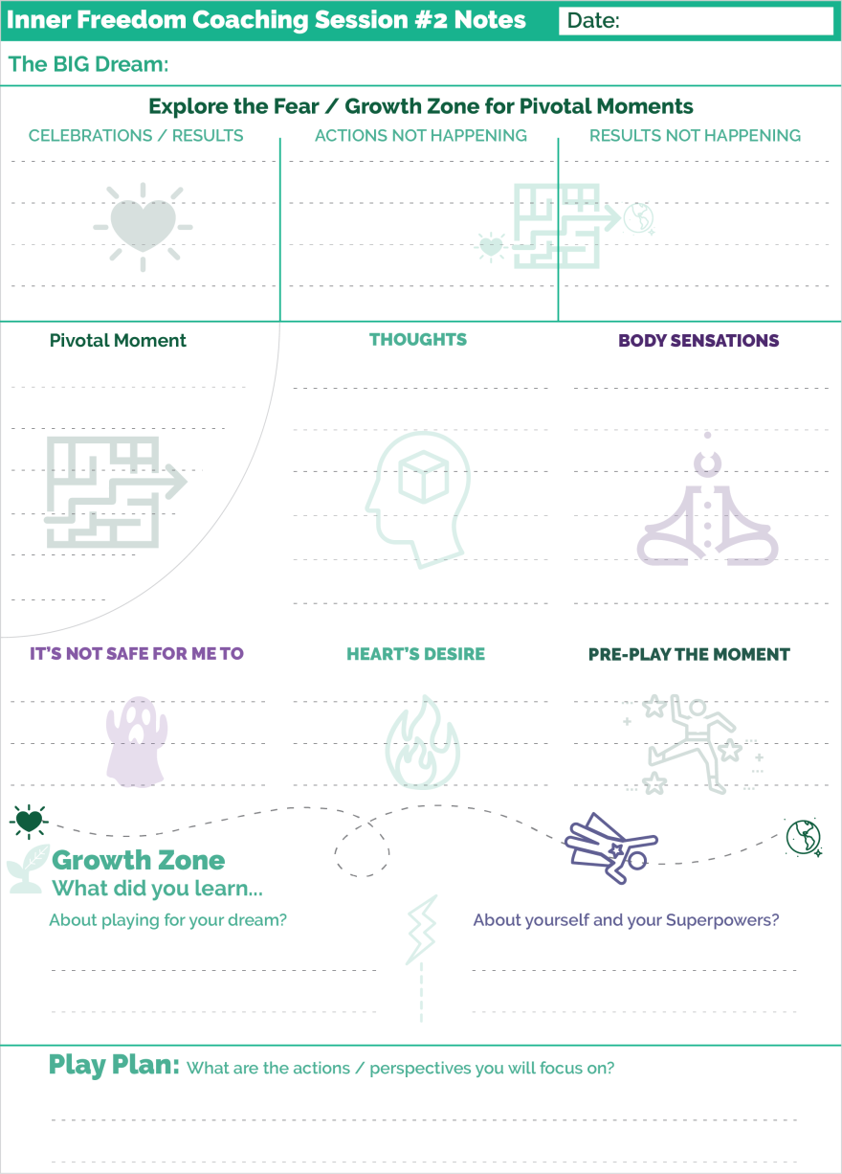
Tipping - is when your player shares something about their situation and you think you have a good, quick solution and share it.
"Did you ever try...”
There IS a time and place to share solutions and ideas. This will come when you are role playing together.
This is GREAT practice.

How to use the Play Sheets for taking notes
There is a PDF with the playsheets for the 12-week program.
Here is a quick overview of how to use these sheets for yourself and with your players.
In General
You do want to take a few notes during a coaching session… but not A LOT of notes.
You do NOT need to write down everything your player says like dictation; doing this detracts from your coaching presence.
It is a good idea to write a few keywords as the session goes along.
Weekly Playsheets
There is a sample on the right side of this page that has been miniaturized.
To facilitate this process we have created playsheets that follow the flow of each session with a place to write keywords. For each coaching session there is a 1-page playsheet that has a section for each part of the conversation.
I recommend that YOU recommend to your players to use these sheets for notes during the session. They too should focus on the conversation and take just a few keyword notes to facilitate the growth process.
The Inner Freedom Adventure Log
This is a 1-page overview to track the 12-session adventure. There is a place to write the date and a few keywords from each session.
Use these to track the whole experience and to always know which session you are on with each player.
The Weekly Play Plan
These are for the player. There is just one sheet that should be printed 11 copies.
They are designed for the player to make a play plan for each week, use as a visual reminder of the plan and then make notes as these actions become “pivotal moments”; aka coach-able moments.

How the Inner Freedom Method will make you a better coach
1) Your confidence as a coach will increase dramatically because you KNOW you have the tools to handle ANY challenging situation your player is in.
2) Your ability to find the "Pivotal moment" and shift the experience for your player from inner resistance to inner freedom will create extraordinary richness in every session. You will learn exactly what questions to ask and what to look for.
3) Understanding and using body awareness will allow you to help your players expand and tap into intuition and inner knowing
4) The ability to find the perfection in situations past and present is a most extraordinary booster to self-worth; which is something EVERYONE values greatly
5) Your players will FEEL more capable to play BIG in the world after every session with you.
6) You will become masterful in reading the dynamic of in/out of the self-preservation zone and know just how to keep your players on the growing edge.
7) You will have a deep understanding AND a solution for the common challenges people face today: overwhelm, frustration, isolation and even apathy! This will give you great confidence in coaching a player through challenging situations.
8) You will learn how to talk about FEAR and inner conflict as a catalyst for growth with your players.
9) You will expand your understanding of the dynamic balance between support and challenge which has the effect of boosting your players self-worth. This in turn will greatly enhance their ability to play for their Dream and get results.

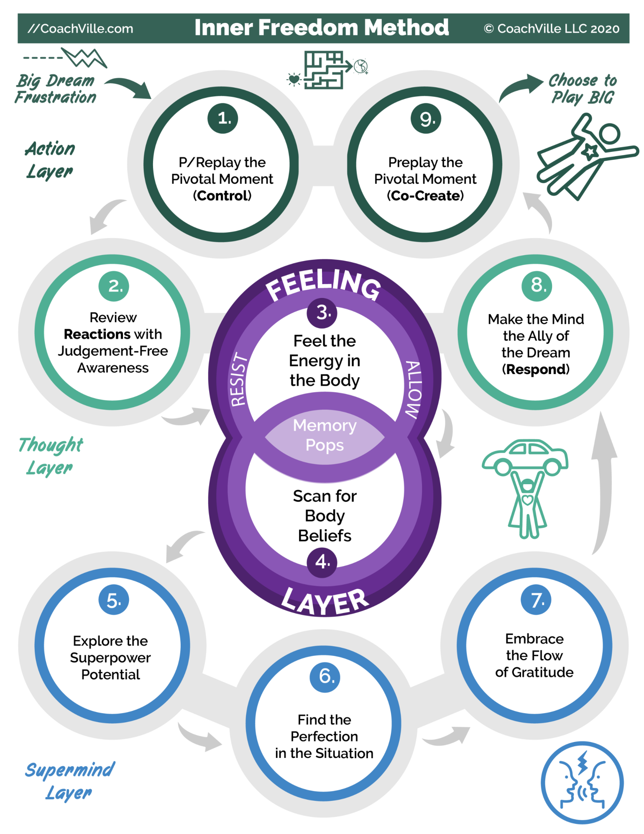

Inner Freedom and the CoachVille Curriculum
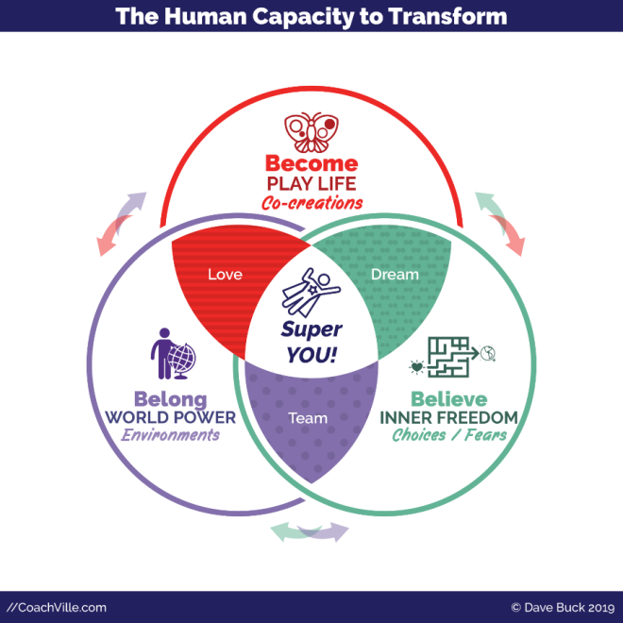
The Inner Freedom Method is part of a trilogy of methods designed to co-create transformation by unleashing the superpowers of Human Nature within the player.
(While the Industrial Culture works feverishly to control them!)
This little diagram maps the three methods to the three superpowers of Human Nature that we have explored a few times: Become – Believe – Belong.
The Inner Freedom Method is especially focused on exploring and unleashing the Ability to Believe. Specifically, the ability a person has to believe in their own dream and to choose the beliefs that align with that dream.
Or beliefs determine the choices we make in our days and our lives.
Many of the beliefs we absorbed in the Industrial Culture were intended to keep us in fear. Specifically to fear our playfulness and expressing our YOUnique powers. This is what is meant by the maze in the symbol for the program. Our beliefs, choices and fears become a tangled maze that we must explore in order to get our hearts desires out into the world. On the journey we rediscover our playfulness and unique Superpowers. FUN!

Inner Freedom Mission 1

Outline
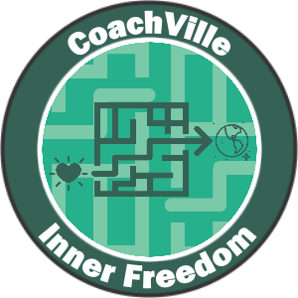
- You are on a mission to get your Hearts Desires out into the world. AKA Your BIG Dream
- Let’s go deeper into PLAY in the Connected Age:
Influence, Visibility, Creative Expression and Change
- Power Up: Name a few PLAY BIG Moves
- Game Action: Elicit support from your team
- BIG WIN: You get verbal support for your DREAM and your PLAY BIG Moves!
- Find the Fun!

“Inner Freedom Coaching Mantra #1:
“All growth happens over the edge of your self-preservation zone.”
- Coach Dave

1) Introduction: You are on a mission to get your Heart’s Desires out into the World!

Quick Summary:
BIG Idea: Get your Heart’s Desires through a FUN and challenging “Maze of FEARS and Body Beliefs” out into the World by PLAYING in pursuit of your BIG DREAM. Explore those FEARS and Body Beliefs like a treasure map to your lost superpowers! Fully immerse yourself in the Inner Freedom Method by experiencing it as a player.
3 Questions:
What is your current Purpose / BIG DREAM?
How/What would you LOVE to contribute to the world? (AKA your fellow humans)
What are your Hearts Desires?
These questions reveal your “mission” to PLAY BIG for your DREAM. The IMPORTANT point here is that you DO NOT need perfect clarity. You just need a place to start. The details will reveal themselves while you are on the adventure.
We PLAY LIFE by relating, creating, exploring and experimenting.
We will use the Pivotal Moments of Social Play framework to create a fun weekly play plan to get your Hearts Desires out into the world!
RELATE to be a positive INFLUENCE (also called Play for “YES”).
CREATE for self-EXPRESSION of things and experiences that you aim to share with people.
EXPLORE for VISIBILITY with new people, groups and places to see and be seen.
EXPERIMENT for CHANGE by trying new ways of doing things.
Influence, Expression, Visibility and Change… these are the four experiences that we are all playing for in the Connected Age of Purpose.
In the Inner Freedom program you will use the Plan-Play-Grow technique to create opportunities to play with the FEAR on the edge of your preservation zone; to play in the fear/growth zone and… the Superpower Zone!
You will learn later in the program why we use the term preservation zone rather than what is typically called the comfort zone.
Another way that we describe this is your Performance-Possibility Gap. As a player, you always look for the next level; for how you can play bigger and better.
Think about what a HUGE opportunity this is. YOU PROBABLY ALREADY KNOW WHAT YOUR PLAY MOVES ARE! The activities and results that if you played them with freedom, grace and energy every day – it could send your business / career / relationship into a state of awesomeness!
We are going to do this together! With the powerful assistance of your new Inner Freedom class partner and your Inner Freedom colleagues you will be able to take actions and get results that have eluded you in the past. Let’s DO IT!
Together we will co-create transformation:
From: fear and emotions are something you ignore or power through; the subconscious mind is dark and mysterious and must be avoided.
To: you can embrace and play with fear and emotions; the non-conscious mind and the Social Survival Imperative is “a bit of a maze” but it can become a vast resource of wisdom and your superpowers.
As you think about your PLAY MOVES, consider that playing BIG means to express yourself and create results that contribute to the lives of others. It’s not just about you doing something, it includes influencing or sharing with other people in a unique way.
Remember that you want to go for something that connects to your purpose so that it is meaningful and edgy; something that will inspire a combination of tenacity and vulnerability.
Even if you are not 100% sure what your PLAY MOVES are, dive into play. You only need an inkling about where to start. Got it? OK, you are ready.
Finally stay connected to these FUN ideas about the Inner Freedom Method:
- Get your Heart’s Desires out into the world
- FEAR is your Friend; You can PLAY with FEAR
- FEAR is like a treasure map that leads to your Superpowers
- Actions and results that seemed really hard, suddenly become easy and fun
- To go bigger out in the world,
you must go deeper into your SELF”.

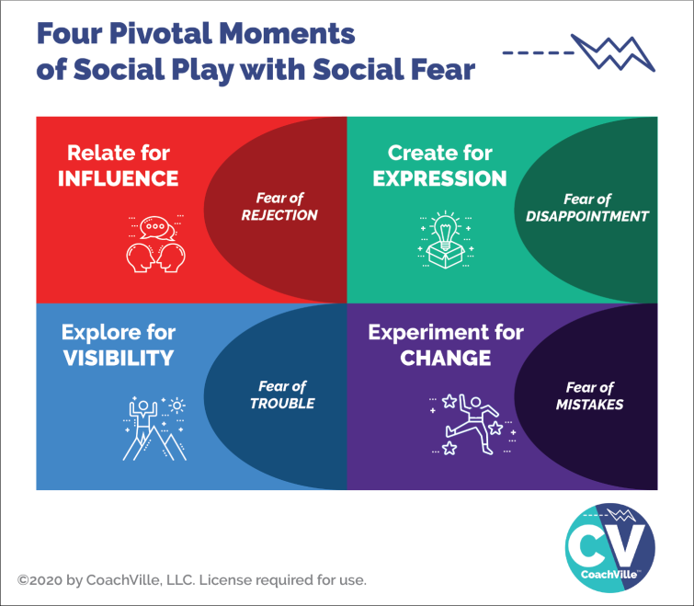
2) Let’s go deeper into PLAY: Relate, Create, Explore and Experiment
IMPORTANT: Choose Play Moves you can do at least a little bit most days. These activities will keep you on the edge of your preservation zone and give you lots of experiences to explore with your partner / coach.
This is important. The Inner Freedom Method is about what happens in your body and mind during pivotal moments when you choose to do something where you will experience some fear, doubt or uncertainty. You start the adventure when you CHOOSE to play BIG.
We will focus on relate for influence, create and share and explore to be seen type of activities in Inner Freedom. But you can add Experiment to try new ways to your Big Dream for sure.
There are 4 types of Play MOVES that we will focus on in Inner Freedom:
1) INFLUENCE: This is a Relating Action –> Resulting Influence (play for “YES”)
Here you take the relating action with the intention of producing a resulting positive influence on other people.
There are several skills that you can practice that often put us into a “state of resistance”:
Relating Action / Skill | Resulting Influence
The Social skill of networking and follow up: attend networking events and make a few Follow Up calls every day. | Play for “YES, I want to know more about what you do.” OR “YES, I will recommend you to someone”.
The Enrollment skill of recruiting clients for your business. Connect with potential clients. | Play for “YES, I would LOVE to be your player!”
The Leadership skill of sharing with a colleague about something important to you in order to enlist their support. | Play for “YES, I will support you”.

And there are many “specific” opportunities where you COULD play for “YES”.
Here are a few examples to spark your imagination
Follow up with a specific person who was curious about your coaching. | Play for “YES”.
Contact an influential person you know and invite them to an exploratory conversation… in pursuit of enrolling them as an advocate | Play for “YES”.
Contact an influential person you know and engage them in a conversation about introducing you to their tribe. | Play for “YES”.
Follow up with a person who you supported in the past who said they would support you in the future. | Play for “YES”
Reach out to a good colleague and ask them if you can share with them about what you are doing and how excited you are. | Play for “YES”

2) A “CREATE and Share” challenge based on completing the steps of a project.
Here you take action to CREATE a “thing” or “experience” and then share what you have created to get engagement or feedback. Usually it is the “sharing part” that creates the resistance.
Here are a few examples.
Project | Create and Share
20-Day Challenge to write a chunk of your book | Complete a few pages, share them AND request feedback.
20 Day Challenge to create a product | Complete a discreet step each day and as you complete each one share it and request feedback.
20 Day Challenge to create a new method; eg. A visibility method or enrollment method. | Complete a discreet step each day and as you complete each one share it and request feedback.
The skill of blogging or posting: write provocative articles / posts that spark engagement. | Play for “YES, I will write a comment about the value of your article”.

3) EXPLORE for Visibility: people, groups and places,
People: contacting someone that you have not met before (usually because someone you know referred you; OR because you saw them on a social network.
Groups: Participate in social networks by interacting with the posts of other people.
Places: Going somewhere that you have not gone before
The idea for Inner Freedom Exploring is to step out of your preservation zone into the transformation zone.
So… if you LOVE to go to new places… then that would not be a good choice for an Inner Freedom Play move.
4) Experiments for CHANGE: activities and ideas
Experimenting is about using your imagination to try new things that you might normally avoid because they give you a feeling of fear, doubt or uncertainty.
This is also about doing things where you do not have control of the outcome.

3) Power Up: Name your Hearts Desire and Potential PLAY Moves
Inner Freedom Power: OK. You got the basic idea from reading about the mission. Here are a few points to emphasize.
Choose something you REALLY WANT to do.
Yes it is scary in some way and
yes, you have been avoiding it in some way but
you KNOW it would be awesome if you could really do it with ease and create the results that you desire.
Whatever it is, do it in a way that requires participation by other people! Once you have your initial idea together for your Hearts Desire and your possible PLAY MOVES, update your game card!
 | A POWER UP is an activity where you listen, read or do an exercise and then share your insights and/or plans.
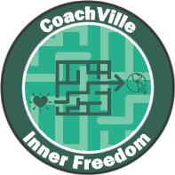 | Inner Freedom Mission #1:  Here are my Hearts Desires that I aim to get out into the world! Here are a few things I want to do to Relate/Influence, Create/Share and Explore outside of my preservation zone…
 | WHAT TO SHARE:  1) Share the name of your Dream  2) Influence: Share a few Influence Plays you are playing for. Are you playing for “Yes”?  3) Create and share: Share about anything that you are going to create and share with others (either a few specific people, a group or the World!)  4) Explore: Describe any new territories, frameworks, groups you are going to explore to see and be seen.  5) Experiment: Describe a few changes you want to make by doing new activities or doing current activities in a new way.

4) Game action: Enlist support for your Play BIG Moves
This is the Connected Age of Play. Your Hearts Desire is NOT a game of solitaire. AND even if your Hearts Desire and Play Moves might seem easy for someone else, it is a BIG DEAL for you, and that is all that matters.
Also, you may need to make a few changes in your daily routine to make space for your Play moves and that will require some support from the people in your life.
AND here is the other thing… sharing about your Hearts Desire and PLAY MOVES with your “team” is often on the edge of your preservation zone so it is good practice!
Your Team = family, friends, colleagues, advocates, customers.
You can find your own words but it can be helpful to share it in the context of the course.
Example: Say something like: “I am participating in a program called Inner Freedom where we create a mission to get our Heart’s Desire out into the world by playing over the edge of our preservation zone. Can I share mine with you?”
Go for it! And share about each conversation you have whether they like your PLAY BIG MOVES or not!
 | A GAME ACTION is an activity where you do something in the world and then share about what you did and what you learned.
Inner Freedom Mission #1
I just shared about my Hearts’ Desire and PLAY BIG MOVES with someone on my “team”. Here is what happened and what I learned...

WHAT TO SHARE: Share about the experience of sharing with someone on your TEAM. Share about anything you noticed about your thoughts or physical sensations before, during and after.
REMEMBER: if you got an acknowledgment of support then you will share about that on the BIG WIN tab so that we can celebrate YOU.

 | POSSIBILITY!! Whenever possible, share a photo of you in action!

After you share about the game action, a BIG WIN item will pop up on your game card (look on the Big Win tab). If you got an acknowledgment of support then you can ALSO share about that next.

5) BIG WIN: “Yes. I will support you!”
When someone on your team listens to you share about your Hearts Desire and PLAY MOVES and expresses their intention to support you… THAT IS A BIG WIN. Relish it.
So when this happens you will share in both the Game Action area AND the Big Win area for the same conversation.
 | A BIG WIN is when you get the desired result or experience from an action you take in the world. This is a BIG DEAL and we want to celebrate you!
Inner Freedom Mission #1
I just got an acknowledgement of support for my PLAY BIG MOVE from someone on my team! I am so grateful because…
 | WHAT TO SHARE: Share a few details about how you feel and what is possible now that you have this acknowledgement of support.
 | POSSIBILITY!! Whenever possible, share a photo of you in action celebrating with someone on your team!

6) Find the Fun!
Make the play plan your own!- When you play for your dream it is fun to customize the play plan for your personal desires; then bring the spirit of play to the PLAY MOVES of your dream.
Creativity is fun – Find a collection of fun ways to approach your PLAY MOVES. Challenge your mind to come up with a variety of fun alternatives – keep it fresh.
Collaboration is fun – Find ways to get other people involved with your PLAY MOVES. Playing with others is always more fun than playing solitaire and you tend to get better results as well (although it is more risky).
Fear is fun – It is exhilarating when you step out of your preservation zone and embrace the experience.
Transformations from worker to player
Industrial Work Mindset (the old way)… | Spirit of Play Mindset (the new way)…
Do what you are told to do. | It’s YOUR Game. Define your own key initiative and have fun going after it.
Do your own work! Bunker in to work in solitude. If you ask for help from others that is cheating. (we all learned this lesson in Industrial Age School) | Humans are collaborative creatures. We are at our best when we engage others in our initiatives. People love to contribute, play along and give feedback.
Do it the same way every time to make it routine and eliminate mistakes | Routine is the enemy of your brain! Challenge your mind to find creative ways to approach your initiative in a new way every day.

Coach Mission 1: Recruit 3 Players {update this}

Outline:
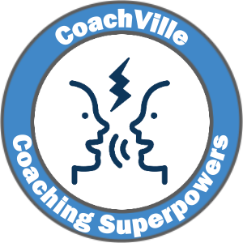
1) Introduction: You are on a mission!
The What, Who, Where and How of recruiting players.
BIG POINT: hosting conversations where you invite people to share their BIG Dream with you is absolutely a fundamental occurrence of your life as a coach!
2) Power Up: Make your REACH OUT plan and DO IT!
(sample messages included in this playbook)
You can include this audio by Coach Dave with your “reach outs”:
https://soundcloud.com/coachville/innerfreedom_exploratoryinvitation
Consider your replies to the reach out and schedule your exploratory sessions.
3) Game Action: Conduct exploratory conversations with your potential players. A detailed Conversation Guide is included in this playbook. Read it over a bunch of times before you use it to get familiar with the flow.
4) BIG WIN: A potential player says: “YES!”
5) Find the fun!

1) Introduction: You are on a mission!
You are on a mission to become an Inner Freedom Coach. To do this you need to reach out and schedule exploratory conversations with potential players.
NOTE: Even if you reach out to someone who wants to say “Yes” before having an exploratory conversation, we recommend that you have the exploratory conversation anyway. This is good practice and you can make sure that you are both set up for success.
To become a great coach you need to coach a lot of players! Coaches are ALWAYS looking for good players. Then they set out to help them become GREAT players.
To enjoy a successful class experience we recommend that you recruit 3 “practice” players specifically for the Inner Freedom program.
HINT: If you register for class early, it is a great idea to start this process before the class officially starts!
About game card badges: in all CoachVille classes, you earn points toward your Coaching Superpowers Badge through coaching activities and conversations. You earn points toward the Method Badges – Like the Inner Freedom Badge for example – by applying the concepts in your own life.
WHAT you are recruiting them to do with you.
As we move beyond the Industrial Age of Control into the Connected Age of Play more and more people are yearning to play BIG in Life by expressing their talents to contribute to the lives of others through relating, creating and exploring. Their dream is the Heroes Journey call to adventure!
However, the Industrial Age was pretty harsh in the way it programmed people to suppress their unique qualities and to fear mistakes. So when they step out to really express their value they are going to bump into FEAR which will lead to frustration. In the Heroes Journey this is the refusal of the call and it happens EVERY DAY.
You have people around you who are ready to play BIG but they need a pathway to transformation. They need a great coach. They need YOU to ask them to be your player.
You are recruiting them for a 12-session coaching engagement over 12 weeks.
Each week you will have a 1-1 conversation with each player. These conversations can be over the phone, face-to-face or via any other audio/video connection tool. 45 minutes is a good time frame for each session though it can be done in 30 minutes if time is a constraint for you or your player. While it is VERY easy to stretch these sessions into an hour long conversation, aiming for 45 minutes will keep you AND your player focused on the topic at hand.
Note: Texting or messaging back and forth for 45 minutes will NOT match these requirements.
For each session, you will have a detailed Coaching Guide with questions to ask, ideas to share and visualization practices to guide. You will practice each session with your class partner in class before doing it with your practice players.
Also each session will have a 15-20 minute “Prep Audio” from Coach Dave that you can send to your player with a few key ideas that will help you dive right into the coaching when you have your sessions.
We also recommend checking in with each player at least once each week in between coaching conversations via email, text or whatever means both you and your player like to connect.
What about the money?
If you are new to coaching then we recommend coaching your practice players “pro bono”. If you are a seasoned entrepreneur who is good at charging for things, then you are welcome to charge a fee. Using the Inner Freedom Method, the value will absolutely be there even if you are brand new to coaching.
If you are a personal service provider adding coaching to your offerings, you may be able to charge your existing clients for coaching.
If you are an experienced coach, you can recruit paying players for this engagement or invite 3 existing players to do this with you. However, I recommend that you plan to coach 3 players specifically using the Inner Freedom Method rather than blending it with what you are already doing. This will help you learn the Method AND it will set you up to add 12-week Inner Freedom Coaching engagements to your business model. SMART!!!!
WHO to Recruit
The Inner Freedom Method is DEEP coaching; it requires a blend of openness AND tenacity. So you need players who have a STRONG desire to stretch their comfort zone in pursuit of their BIG Dream to contribute to the lives of others in a YOUnique way. We say that FEAR is like a treasure map to our Superpowers.
You honor someone when you offer to coach them. Think of it as the highest compliment.
Who do you know who is doing good things and seems poised to step into greatness? Who has great potential to be a difference-maker… a game-changer?
Who do you know who has the desire to play life at a higher level or live into a new Dream.
Having a coach is a choice people make when they have a dream to play BIG, perform at a higher level or step into a new possibility.
Who is up to something big AND ready to go DEEP? Think of people of all ages; of all levels! Don’t only think of people younger than you are; or “lower” than you are on the “ladder”.
Do NOT look at your existing connections and think: who has lots of problems and “needs a coach”? Coaching is NOT an intervention for problems!
This is not to say that good players don’t have any problems! Of course they do. However, while some people just seem to have problems, players have challenges that arise out of their DREAM to play BIG. These are the type of challenges we want to explore with the Inner Freedom Method.
YOU do NOT need to be an expert in what the player is doing. Life coaching - and specifically the Inner Freedom Method - is powerful without specific subject matter experience. Note: When you move into high-end professional coaching the best plan is to combine Life Coaching methods – like the Inner Freedom Method - WITH subject matter experience.
Another thought…
Look for people who never really “fit in” to traditional structures where they needed to comply to do well. These folks could be poised for greatness in the Connected Age where curiosity, creativity and contribution are replacing command, control and compliance. These folks will LOVE the Inner Freedom Method.
Where to recruit
This will depend on your situation. A little later in this playbook I will share with you some sample “REACH OUT” messages that you can use.
A) You are a manager / leader and you have a group of employees and colleagues from which to recruit your 3 players.
Extend a personal invitation to the people you want to coach.
IMPORTANT: When coaching folks who work for you, you must obtain express permission from THEM to coach them AND you will need the 30 minutes per week of established 1-1 coaching time.
ALSO IMPORTANT: The Inner Freedom Method is DEEP, as I mentioned before. So you will want to choose folks with whom YOU are ready for vulnerable conversations.
B) You are already coaching or providing a professional service to clients.
In this case you have client pool from which you can recruit 3 players. If you want to recruit from your existing clients, you can offer them the opportunity to coach with you using a new format for 10 coaching sessions over a 3 month period. It will be important to let them choose to engage in this new approach with you.
C) You are an awesome person learning a new coaching method.
In this case you need to recruit 3 players from your network of friends, colleagues and social connections. You may have colleagues or friends who you can reach out to personally.
Many students use Linked In, Facebook or email to find their potential players using an “opportunity post”. Also, even if you have a group of people right around you, you may want the experience of opening up to coach people who come through your social connections. Remember!!! It is PLAY. Sometimes opening up to a bigger world can really spice things up nicely.
Important! Your CoachVille class colleagues do NOT qualify as practice players. The idea is for you to go boldly out in your community – geographical or virtual – and recruit players!

2) Power Up: Game plan your recruiting mission and REACH OUT!
- Read this guide with sample REACH OUT messages
- Make your plan to reach out to your potential players and invite them to talk with you.
- Do your reach out.
- Share about your approach on the game card.
Sample REACH OUT messages
Invite someone you know: “Hey Sally, I am participating in a 3 month Life Coach Training program called Inner Freedom and I am recruiting 3 amazing people to be my players while I am in the program. The Inner Freedom Method is loosely based on the Hero’s Journey; it is for people who have a BIG dream AND are willing to explore the doubts, fears, overwhelm and frustration that they experience on a regular basis. What if we discovered the Superpowers that your fears are concealing? It is VERY possible.
We will have 12 weekly 45-minute coaching sessions as part of the class. I think of you as someone playing big and I would love to set up an exploratory conversation to see if this is a fit for you. It is going to be great fun.
You can listen to this 9 minute audio by Coach Dave who created the program to get a little insight into what we will do together.
Are you interested? Let me know.”

Example opportunity social media post: I am taking a Life Coach Training program with CoachVille called Inner Freedom. I am very excited about it! I am looking for 3 “players” for a 12 Session pro bono coaching engagement over a 3-month period. Each session will be 45 minutes.
The Inner Freedom Method is loosely based on the Hero’s Journey; it is for people who have a BIG dream AND are willing to explore the doubts, fears, overwhelm and frustration that they experience on a regular basis. What if we secured the Superpowers that your fears are concealing? Together we can do it.
You can listen to this 9 minute audio by Coach Dave who created the program to get a little insight into what we will do together.
If this sounds like you please contact me so we can set up a brief exploratory conversation. It is going to be really fun and potentially life-changing. I only have 3 openings so please respond quickly!
If you know someone who might love this, please pass it on to them. Thanks!
Here are a few “catch phrases” that describe the Inner Freedom Method that you may want to weave into your message.
- Get your Heart’s Desires through the maze of doubt and fear and out into the world
- FEAR is your Friend; You can PLAY with FEAR
- FEAR is like a treasure map that leads to your Superpowers.
- To go bigger out in the world, you must go deeper into your SELF
- Unleash the Superpowers that your FEARS are concealing
***
Use these samples to craft something that sounds like you AND uses some of the Play Language.
Then send it out! Don’t wait for perfection.
Share on your Game Card
 | A POWER UP is an activity where you listen, read or do an exercise and then share your insights and/or plans.
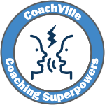 | Coach Mission #1:  I read the playbook and sent out my REACH OUT message to recruit 3 practice players for Inner Freedom Coaching. This is what I did...
 | WHAT TO SHARE: Share a few details about your REACH OUT plan. If you want, share the content of your reach out message. It may inspire one of your classmates.

3) Game action: Recruiting conversations with potential players
Consider the replies you get to your “reach out”s and schedule exploratory sessions with your potential players!
- Read this section and PRACTICE the conversation outline; read it out loud a few times
- Use it to talk with your potential players;
- Play for “YES! I want you to be my coach!”
- Share about your experiences on the game card.
- HINT: Share about it on the Gamecard even if you are they don’t say “Yes”.
Introducing the “Recruiting” Conversation
The next step of this mission is to have a brief exploratory conversation with each potential player. This is important because coaching should always be a mutual agreement between the coach and the player. You can only coach someone if they want to be coached by you AND you believe in the dream they are playing for.
This exercise is powerful for your life as a leader as well as a coach. The best games in life are often a game of “ASK” where you are playing for influence and a mutual “YES!”
This conversation outline will provide a simple structure for this conversation. Also, it is similar to the coaching outlines you will use in class so it will set a positive tone for the relationship.
Remember, YOU are the coach. So:
A) You need to guide the conversation
B) It is mostly about asking questions and listening. You don’t need to say too much!
C) At the conclusion, YOU must choose if you want to coach this person; If you are a “yes”, then ask them if they want to be your player. Your aim is for them to say “YES!”; If you don’t want to coach them, don’t ask them.
What to look for in the moment of choice.
In the conversation outline you will do a lot of listening. As you are listening you want to check in with your intuition. This is an essential coaching skill so you should start learning it right now!
Wonder to yourself:
- Do I have a good connection with this player?
- Do I support the dream they are playing for?
- Will I enjoy coaching them?
- Or will I at least enjoy learning something by coaching them?
It is OK if you think they will be a challenge, as long as you will enjoy it in some way. It is OK if it will stretch your comfort zone or require you to look at things from a new perspective.
Avoid taking on a player if you think it will be a “rescue mission” for someone in trouble.
PRACTICE!!!
Read the conversation outline OUT LOUD a few times to get used to saying the statements and questions!
You don’t “say” the numbered lines to the other person; NOR the statements in RED.
You only say to them the lines that start with Say: and Ask: .

*** Recruiting Conversation outline on the next page ***

*** Recruiting Conversation outline ***
You are the coach, so start the conversation by guiding it right away.
WELCOME
A) WELCOME
Say: "I am looking forward to doing this session with you. I really appreciate you and I can't wait to see what we discover together. It will take about 30 minutes.
Ask: Are you ready to go?
{Coach: wait for them to say: YES}
Say: "OK. Let's go. So as I mentioned I am participating in a Life Coaching Training program at CoachVille called Inner Freedom and they are really big on looking at business, career and life as a playing for your dream. My role as the coach is to help you play better, expand your possibilities, and unleash your superpowers by stepping outside of your comfort zone."
COACHING PLAN
B) DISCOVER THE DREAM
Ask: If you looked at your life / business / career as living your dream...How would you describe your big dream is right now?
{Coach: listen and ask any curious questions that pop up for you}
Discover their definition of success
Ask: What does success look like for you over the next 3 months?
{Coach: listen and ask any curious questions that pop up for you}
PRACTICE / PLAY TOGETHER
C) EXPLORE THE GAP
Say: In coaching we are always looking for the GAP between how you are playing now and how you imagine that you can play for this dream.
Ask: How do you see yourself playing bigger or better or exploring new possibilities?
{Coach: listen; stay judgment-free; people are yearning to talk about seeing themselves as really BIG but they rarely feel the encouragement or safe space to do so; some people will talk about possibilities others will start sharing about challenges or obstacles}
Ask: What are some activities that are pulling you outside of your current comfort zone?
Ask: Anything else come to mind?
{Coach: listen; stay judgment-free; again AVOID AVOID AVOID offering solutions!!}
Find/Articulate the “Drama” / BIG Growth Opportunity / Challenge
Say: In coaching we like to look at playing for your dream as a Hero’s Journey. So there is always some drama in the form of a growth opportunity or challenge.
Ask: How would you describe your big challenge or growth opportunity using epic adventure language?
{Coach: this is meant to be fun; you may need to help them get into the spirit of it}

Say: Let’s have some fun with your imagination
Ask: Are there any aspects of YOU – like creative ideas or talents - that you would love to bring out into the world in a bigger way?
{Coach: listen and then have fun with them; encourage them to dream bigger
IF you know them OR you sense something about them this is a great opportunity to champion what you see in them }
Ask: In the Inner Freedom Method there is a saying that your doubts and fears are like a treasure map to your Superpowers. What would it be like if we unleashed your Superpowers?
{Coach: listen with your energetic presence; it will be very interesting to see where they go with this question. This is where you pump them up with the possibility that having an Inner Freedom coach like YOU will make a big impact on their dream!}
GROWTH MODE
D) MOMENT OF CHOICE
{Coach: Here you have to choose! Do you have a good connection with them? Does something about them intrigue you as a learning opportunity for you?}
If YOU are a “YES”:
Say: I love your Dream and I think we could have great success together.
Ask: Would you like to be one of my players?
If they say “yes”, move on to #6A. If not, skip to 6B.
If YOU are a “no”, skip to 6B.
PLAY PLAN
6A) CONFIRM THE COMMITMENT
Say: Excellent. I just want to confirm that you are committing to meet with me for about 50 minutes each week. If we can’t do a session one week for some reason, we will try to make it up the next week.
Ask: Are you good with that?
{Coach: wait for them to say: YES}
Say: Let’s get our first two sessions on the calendar now.
{get your first 2 sessions set up in your calendar for as soon as possible after the start date for the program}
6B) If either of you say “no”: thank them for their time.
Say: I have learned a lot from this conversation. Thank you. But I don’t think we are a good match for coaching together. Thanks so much for your time today!
*** Playbook continues on next page ***

After the conversation
No matter how it turns out, share about your experience on your game card.
A GAME ACTION is an activity where you do something in the world and then share about what you did and what you learned.
Coach Mission #1:
I just had an exploratory conversation with a potential player. This is what I experienced...
WHAT TO SHARE: Share a few details about your experience in the conversation. What did you learn?
REMEMBER: if you got a “YES” response share about that on the BIG WIN tab.

After you share about the exploratory conversation in the GAME ACTION tab, a BIG WIN item will pop onto your game card.
WHEN one of your potential players says: “Yes”, click through to the BIG WIN tab on the game card and share about that as well.

4) BIG WIN: A potential player says: YES!”
This is something to celebrate!
A BIG WIN is when you get the desired result or experience from an action you take in the world. This is a BIG DEAL and we want to celebrate you!
Coach Mission #1:
I just signed up a player for Inner Freedom Coaching! WOO HOO! This is why I am excited to coach this player…

WHAT TO SHARE: Share a few details about your experience and why you are energized to coach them.

POSSIBILITY!! Whenever possible, share a photo of you in action celebrating with someone on your team!

5) Find the Fun!
You know those fun adventure movies where the “hero” is putting a collection of people together with special skills to accomplish a mission together? Well that is YOU right now.
Putting a team together is fun!- As a coach or coach approach leader you are always looking for good players for “your team”. If your players are not necessarily going to play together they are still on your team so they will probably have some shared purpose even if they don’t know it yet. You may even want to find a way for your players to get together at some point either face-to-face or virtually.
You will probably want a variety of players with different dreams or different talents; it can be fun to put the right mix together.
Treasure hunting is fun – You can think of every person who signs on to coach with you as a treasure. Looking for them can be really fun. You are looking for game changers to share a powerful experience with you. Finding the right players can be a fun adventure.
Recognition is fun – People love to be seen and known for who they really are – A BIG Player in Life. This is what happens when you reveal their BIG DREAM in life and the BIG Purpose they can pursue by playing rather than working. Being recruited is a form of recognition.
Transformations from worker to player
Industrial Work Mindset (the old way)… | Spirit of Play Mindset (the new way)…
You work alone and don’t bother anyone. | You find your players through personal and social connections. You leverage your relationships and network in your search for good players. You are not alone, you are part of a vibrant community and YOU are the coach in this community now.

Teleclass Welcome!
Welcome to the Center for Coaching Mastery!
Abera Ca Dabera
This phrase from the Aramaic Language means: I create as I speak.
This is a potentially life-changing affirmation that illuminates the power of the spoken word. In every class you will participate in a variety of provocative exploratory conversations and coaching sessions.
A few key points to consider as you start this class.
1) Our programs are based on dialogue-based learning. So we expect you to jump in and participate in the conversations. Be BOLD! Share your thoughts and questions; Your voice is a contribution to everyone else in the program. Your instructor is a highly trained coach and very capable of weaving diverse thoughts into a web of learning for everyone!
2) You will coach in every class. It is possible that this will be your first coaching conversation. So be easy on yourself! Don’t expect to be a masterful coach on day #1.
If you have been coaching for a while – maybe even a LONG while - coaching in class is your opportunity to experiment and try new things. Enjoy the opportunity to stretch and learn.

Chapter 1 – Play BIG With Fear ~ The Inner Freedom Playsheet

Awesome Quote (something about hero’s journey)???

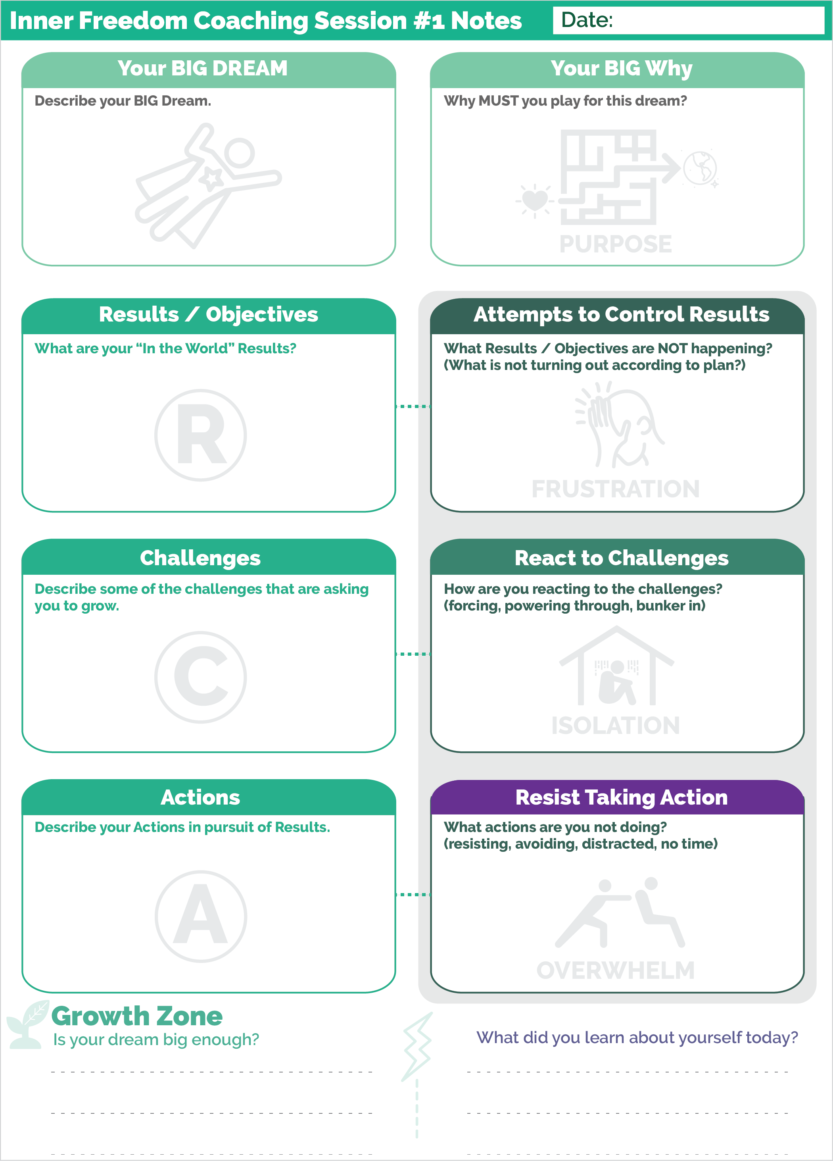

01 Coaching Guide for Session 1 – Play With FEAR

READ THE COMPLETE GUIDE OF THIS SESSION

WELCOME (and permission to coach)
A) WELCOME
SAY: "I am really excited about coaching with you. I can't wait to see what we co-create together."
ASK: Do I have your permission to be your coach today? Are you ready to get started?
{wait for them to say, YES}
SAY: "OK. Let's go.

COACHING PLAN
B) DEEPEN THE DREAM

SAY: Today we are going to dive deeper into how you are playing for your Dream right now and then we are going to practice using judgment-free awareness to explore where FEAR is coming into your experiences.

DREAM
ASK: We spoke about your BIG Dream in our exploratory conversation. Can you give me a recap of your Dream and update me with any additions you have thought of since we spoke last.

ASK: Do you have a name for this dream?
{listen and help them come up with a name for just a minute; it is not essential to have a name but it makes in more memorable and fun}
PURPOSE
SAY: In Inner Freedom we talk about your BIG Dream as getting your heart’s desire out into the world. We want to create awareness of the driving force behind this dream for you.
ASK: Why is this DREAM really important to you right now?
Personally?

For the World??

PRACTICE / PLAY TOGETHER ~ {Explore the Performance-Possibility Gap}
C) EXPLORE THE DREAM FOR PLAY (RAC)…
WITH Judgment-Free Awareness

{Coach Fill in the left side of the play sheet next.}
RESULTS / OBJECTIVES
SAY: Next we will flesh out some of the details of playing for this DREAM.

ASK: Describe a few of your objectives for this Dream over the next 3 months. These can be tangible accomplishments or new experiences.

ASK: what are the results and experiences that you are playing for on a regular basis? In other words: What needs to happen on a regular basis for you to fulfill this Dream?

{Coach, skip down to the Actions box}
ACTIONS
ASK: Describe the primary actions when you are playing this Dream?
ASK: Which of these actions are you doing on a regular basis?

ASK: What are some of your unique abilities that you want to bring to your actions?

{Coach, Go back up to the challenges box}
CHALLENGES
ASK: Describe some of the challenges that you are facing as you pursue your Dream?

ASK: Do you have any thoughts about how these challenges are calling out your superpowers?

{Coach, mostly listen during this part.
Share curious questions if they pop up.
AVOID making any recommendations about how to overcome the challenges
AVOID dismissing the challenge eg. “Oh that will be easy for us to solve”}

D) EXPLORE THE DREAM FOR SYMPTOMS OF FEAR…
WITH Judgment-Free Awareness
{Coach, Next, explore the right side of the playsheet
Here you really need to focus on being judgment-free and even bring a little lightness. People often take FEAR REALLY seriously. Your “lightness” and not getting sucked into any “drama” will prepare your player for the energy of PLAYING with fear.}

SAY: One of the BIG Ideas of the Inner Freedom Method is that the reason we get a purposeful Dream in our heart is to challenge us to grow and expand and unleash our superpowers in the world. So next we need to explore your Dream for growth opportunities which will look like doubts and fear and other difficult experiences like frustration, overwhelm and isolation.
A very important concept for all of our coaching sessions is judgment-free awareness. This is the ability to be open and curious about everything you are experiencing and just put everything on the table!

ATTEMPTS TO CONTROL ~ Frustration
ASK: What desired results and experiences are NOT happening?
Coach, mostly listen

ASK: Where are you experiencing frustration?

{Coach, mostly listen. Share insights and curious questions if they pop up.
AVOID offering solutions!}

REACT TO CHALLENGES ~ Isolation
ASK: What are the actions that you are taking but you experience resistance?
In other words, you have to force yourself to do them? Or you have to “talk” yourself into it.
Coach, mostly listen

ASK: Are you experiencing reactive or negative thoughts about yourself or your abilities?

{Coach, mostly listen. Share insights and curious questions if they pop up.
AVOID offering solutions!}
ASK: Are there situations where you react by thinking: OK, I just need to isolate myself and figure this out by myself? Or, OK everyone leave me alone.

Coach, mostly listen

RESIST TAKING ACTION

ASK: What are the actions that you are NOT taking?
Coach, mostly listen

ASK: Is there anything else that you are resisting or avoiding?
Coach, mostly listen

ASK: Are there are times when you could be doing important actions for your Dream but you find yourself doing trivial things or “busy work”
Coach, mostly listen

ASK: Are you experiencing overwhelm? Too MUCH to do? Often you can’t figure out where to begin?

{Coach, mostly listen. Share insights and curious questions if they pop up.
AVOID offering solutions!}
GROWTH MODE
E) GROWTH MODE
SAY: Let’s Step into the growth zone and play with your situation for a few moments. Together we need to explore the relationship between your Dream and your Preservation Zone also known as your Comfort Zone.
ASK: The BIG Question is this: is your Dream big enough to pull you out of the preservation zone and into the growth/fear zone? How do you assess your situation?
{Coach, mostly listen

ASK: “Can I share an observation?”
{Coach: share an observation about your player’s superpower potential and the pursuit of their dream.

Add your insights to what the player is sharing. PLAY WITH IT. Look at it from both sides.}

Coach: Are they in or out of their comfort zone?
Choose one:
A) Do they need support?
OR
B) Do they need challenge?
A) If support / encouragement is needed…
SAY: This is where the Inner Freedom coaching begins. It sounds like you are out of your comfort zone here. That is good. It means you are playing for a BIG Dream! We will use the Inner Freedom method together to get you into the flow of creative action for results and experiences.

B) If challenge is needed…
SAY: OK. This might sound strange, but I think the problem is that this Dream is too small for you right now. You are feeling stuck because you are trapped inside your comfort zone. You are not allowing yourself to be challenged. So, I am going to challenge you to play for a bigger Dream to get out of this rut.

PLAY PLAN (for the week ahead)
F) PLAY PLAN
Give them the “Play and Journal” Exercise:
SAY: Remember, your FEARS are a treasure map to your superpowers.
ASK: What is one recurring activity that is outside of your comfort zone that you can engage in this week to expand your awareness of the doubts and fears that you are experiencing?
{Coach, help them name this if they don’t see it

ASK: What are the results that you want to come from this activity?
{Coach, help them name this if they don’t see it

SAY: I am going to give you an awareness building exercise. Are you OK with that?
{Coach, wait for the “yes”

SAY: Keep a little journal of your experiences as you play or avoid playing: .
NOTICE AND JOURNAL…
a) Actions that you KNOW would fulfill your Dream – but you avoid
b) Actions that you take through great inner resistance.
c) Thoughts or judgments that pop up that seem to be negative.
d) Notice the results that are happening and NOT happening

SAY: I want you to play as BIG as you can this week. Really put yourself into it.
ASK: Can you do that?

{Coach, wait for them to say “Yes”}

SAY: Great. We have a play plan. I can’t wait to see what happens next!

GROWTH ZONE PART 2
ASK: What did you learn about yourself from this session today?
SAY: Talk soon!

Quick Review of the Inner Freedom Method Play Sheet
Top – The BIG Dream
1) Your BIG Dream:
In the first box on the left write the name of the Dream and key elements.
2) Your BIG Why
Purpose of the Dream – Why are your playing for this dream?
Understand how this dream connects to the players life.

Left Side – Playing for the Dream
3) Results / Objectives in the dream?
Three things they want to accomplish in the next 3 months. Make sure at least one is tangible. AND make sure these objectives are a BIG stretch for the player that will pull them into the growth zone.
4) Challenges
Describe obstacles and opportunities for growth that the player is aware of.
5) Actions of Playing for the Dream
Create a list if recurring actions; Actions that are important in the pursuit of the dream on a regular basis. Especially find out actions that would be BIG even if they are not doing them right now.
Right Side - Areas of Inner Resistance - What is not happening?
This part of the play sheet is used as you get into the dream and identify specifically what your player needs to focus on how to play better and get more consistent results.
6) Attempting to Control Results – Experiencing Frustration
Here you will note the results that your player wants most to achieve BUT they are not happening often enough.
7) Reacting to challenges – Experiencing Isolation
Acting through resistance – forcing yourself; Ask your players which activities they do only when they really FORCE themselves to do it. Or they do it typically after procrastinating.
8) - Resisting / Avoiding Action – Experiencing Overwhelm
Actions that your player is NOT doing; Ask your player which activities do they tend to resist or avoid; or where they feel overwhelmed by too much to do.

Coaching Overview of Session 01
Update this text
A typical coaching scenario is where you are coaching your player in pursuit of their Dream and when they begin to struggle with a certain important action or result you would begin using the Inner Freedom Method.
Another scenario is where they come to you as a Coach BECAUSE they are frustrated in their pursuit of the Dream. In this case you will get right into the Inner Freedom METHOD. But before you do that you MUST understand the Dream they are playing for and get the big picture.
This is the approach we will take in this class and you will take with your Inner Freedom Practice Players.
So your first session with your player/partner will be a typical discovery session with an Inner Freedom Twist. You will find out about their big Dream and then explore all of the areas where they are currently experiencing resistance, reaction, overwhelm, isolation and frustration.

***{Speak this}

Walk through the coaching guide and highlight key points.
Eg. Don’t offer solutions to the challenges.
Don’t minimize their fears

?? What Inner Freedom is {from bullets to copy OR move some intro stuff here}
Inner Freedom is the ability to freely choose the best action or non-action in any moment. Inner Freedom accelerates your ability to create the results that you desire in pursuit of your dream and in your life.

Inner Freedom.
Feeling of being at ease in the situation
The courage to act in the moment
Being in the flow and knowing what to do next (or knowing when to do nothing)
The absence of fear??
Awareness and integration of feelings (body wisdom) and thoughts and emotions

How to PLAY with fear {update
What does “Play with fear” mean?
a) Approach fear with the spirit of play; with curiosity and full engagement
b) Play EVEN when you experience fear

The BIG IDEA - The power to manifest aka to co-create results
Your pure heart intentions are a powerful source of energy.
Your feelings, thoughts and actions are the energy that will go toward that intention and attract opportunities
When they are aligned they flow in the direction of your vision - things happen
When they are not aligned they create resistance and then your hearts intentions do not manifest.

The Human Journey with a Coach
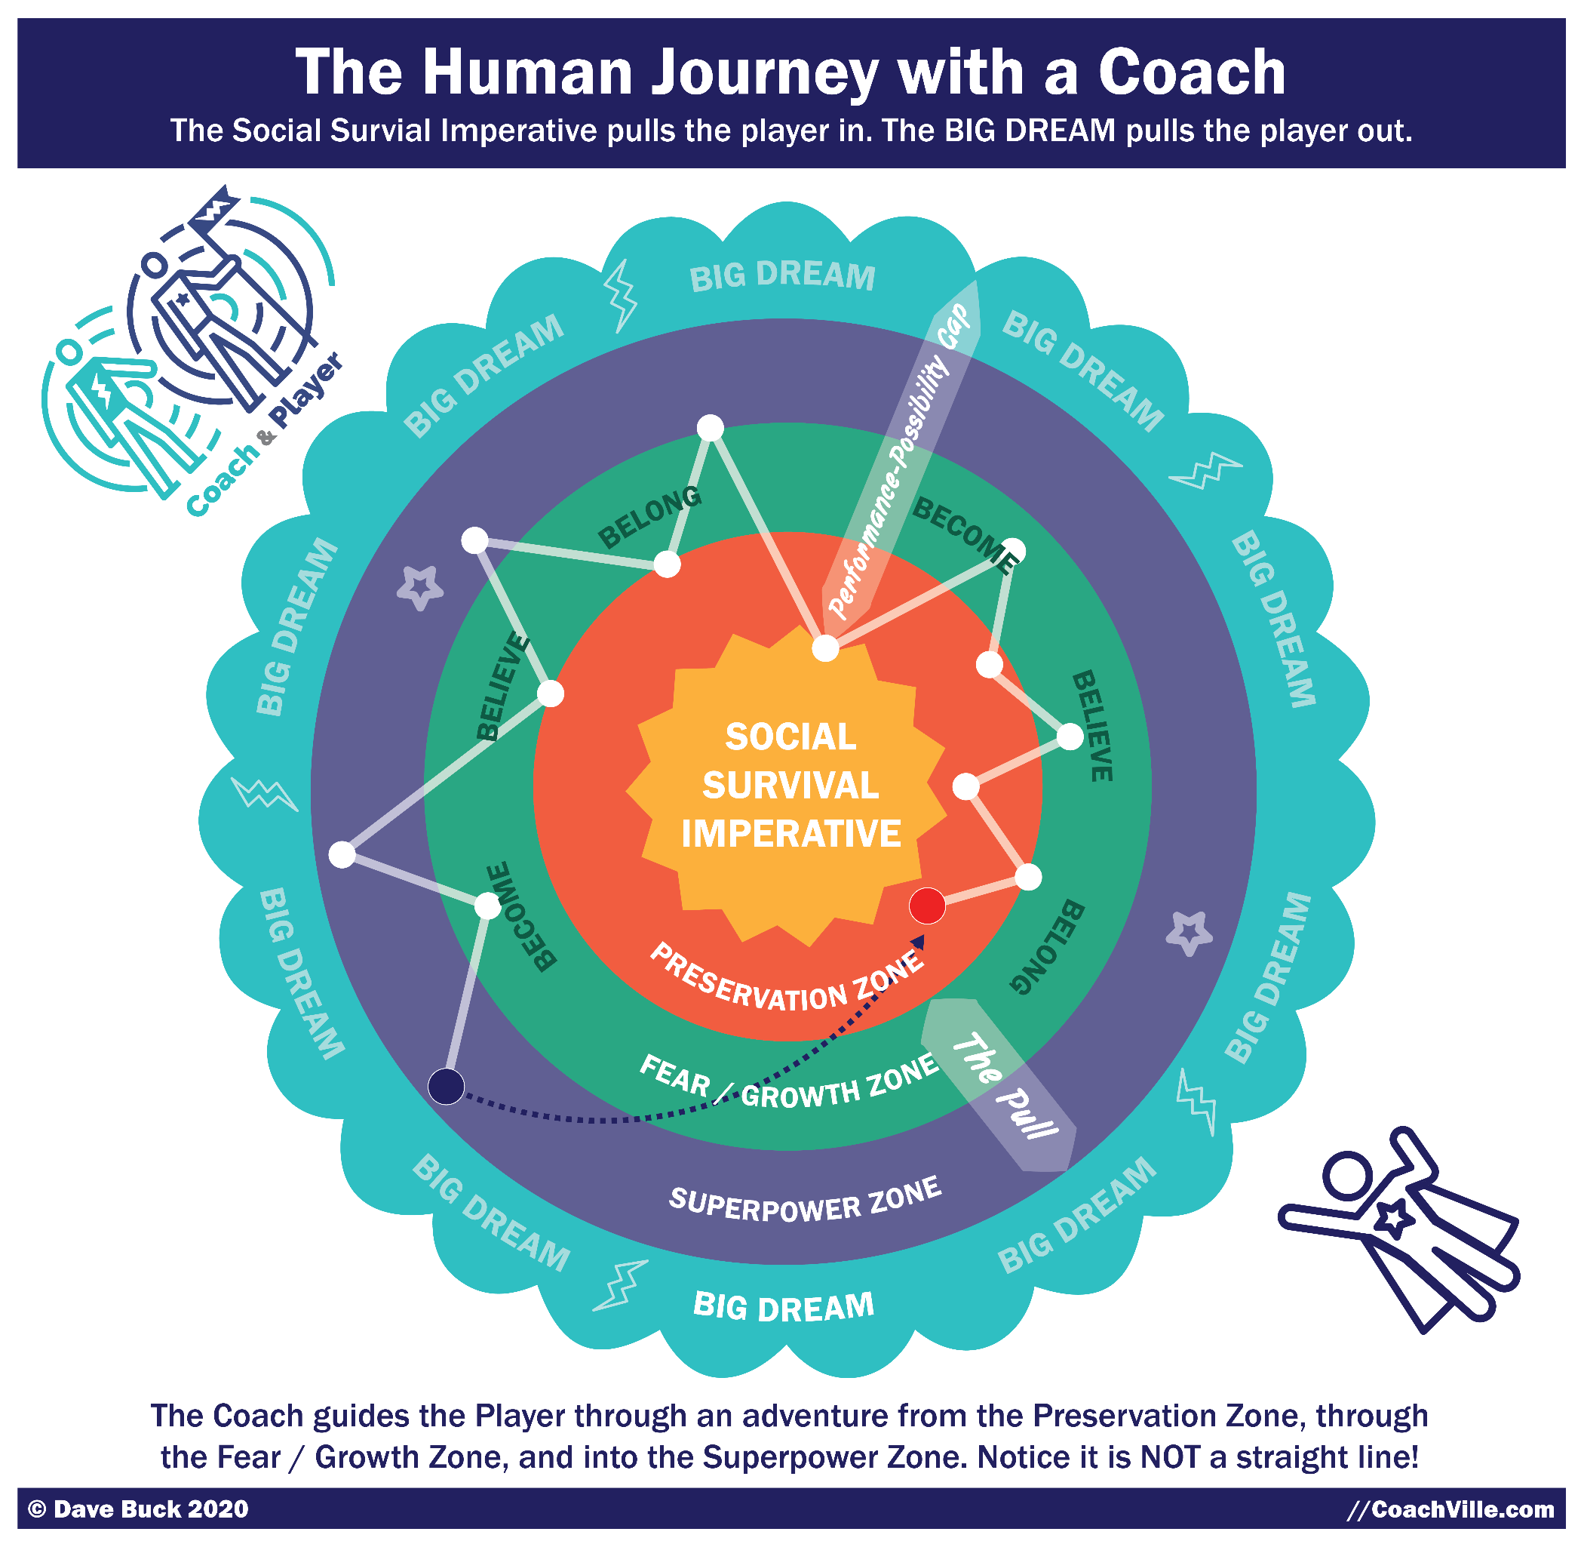
Let’s take a walk through this model. It’s super fun and explains A LOT about the Inner Freedom experience… and Life!
The Coach and Player on Adventure: first notice in the upper left corner our symbol for coaching; the coach and player walking side by side. The player carries the flag with the lightning bolt to symbolize the pursuit of a BIG Dream. The Coach wears the lightning bolt on the shirt to symbolize sharing the player’s dream. The Player wears the star which is the symbol for using one’s superpowers for good in the world.
You will also see the flying person with the same star in the lower right corner. This symbolizes the player now expressing their powers and willing to be seen and known in the world.
The Social Survival Imperative and the Preservation Zone: next notice the Social Survival Imperative at the center. This force is like a magnet that pulls us toward the Preservation Zone. Here we aim to maintain the sense of belonging and status that we have in our current environment. We also seek to maintain the beliefs that are required by this environment. And finally, we limit our becoming through play to what can fit within the existing structure; which is usually not much!
The Social Survival Imperative – and the requisite need to maintain belonging – is by far the most powerful force in Human Nature.
Many personal growth programs refer to something called the “comfort zone”. It is a similar idea but I feel that the Preservation Zone is a better name for what is actually happening. First of all, many people are stuck preserving something that is not at all comfortable; yet they fight to preserve it just the same. Preservation Zone also takes away the stigma of comfort zone that implies a person is weak or lazy. Self-preservation is a super strong survival instinct and is both essential and a respectable force to be reckoned with!
The BIG DREAM: Next notice the BIG DREAM and the lightning bolt on the outer edge of the model. The BIG DREAM is the 2nd most powerful force in the human experience. AND it can become an equal (or better!) of the Social Survival Imperative with the companionship of a great coach and dream team. This is what we are playing for here at CoachVille.
The BIG Dream is what pulls you out into “the world” to expand your contribution to life and humanity. The BIG Dream is the equivalent of the “call to adventure” in the Heroes Journey stories. To pursue your BIG Dream you will need to leave the Preservation Zone and pass through the FEAR zone and discover and develop your Superpowers needed to fulfill the dream.
{make sure this is described in detail in this section}
BIG Dream details: Accomplishments &Experiences, Skills & Mastery, Next version of you / superpowers & Becoming, Rewards
The GAP! Visions of playing bigger and better
The Pull! : Notice The Pull! This is what we experience anytime we endeavor to pursue a big dream. The BIG Dream pulls us out and the Social Survival Imperative pulls us in. In the Hero’s Journey stories this is called “refusal of the call”. While in these stories this is a one-time event at the beginning of the story. In my experience of coaching people in pursuit of a BIG DREAM this is an EVERY DAY EXPERIENCE! Hah! It is often a many times every day experience.
The Performance-Possibility Gap: This is the essential coaching element. When a person has a BIG Dream it includes a vision of themselves having new experiences and doing new activities or doing them in a bigger and better way than they can do them now. Anyone who goes after a BIG Dream knows that there is a gap that they will need to cross. Crossing this Gap from the current ability and situation to the vision is what coaching is all about.
The FEAR/Growth Zone: Fear is a fundamental Human experience. It’s purpose is to keep us safe. Fear is a feeling in the body that reminds us that in the past while doing something similar something “bad” happened. The fear comes up as a bad feeling to steer us away from the situation or action. Whenever you pursue a course of action that is beyond what you are doing now, you will experience fear on a regular basis.
The BIG insight is to realize that all of your fears were absorbed from your environments. And many of your fears are social fears about expressing your playfulness and unique power (AKA Superpowers). So, if you explore the fears they can lead you back to your playful powers.
Growth is about becoming the next version of yourself and what you are capable of contributing to the world. We are meant to grow continuously throughout life. We grow by playing. ALL growth happens outside of the Self-Preservation Zone.
THE BIG key is this: since most of your fears were absorbed in social situations it is essential that we explore our fears in the company of a trusted guide. It is almost impossible overcome social fears by facing them alone.
The Superpower Zone: By walking with a coach through the zone of Fear/Growth you will obtain many clues about your unique powers that have become hidden over time. Any time you contemplate a new action your body will buzz if the action resembles a troubling experience from earlier in life. Exploring these moments with a coach using the Inner Freedom Method will often reveal the expression of power that is connected to the troublesome event. BAM! You now have awareness of a lost Superpower!! AWESOME!
With this awareness you can reclaim your power and use it to fulfill your BIG Dream
NOT a straight path: In model you can see that the path from the Preservation Zone to the BIG Dream is not a straight path. You can expect a lot of moving ahead and then pulling back. You will also notice the arrow that shows that once you become comfortable and capable in your BIG Dream, a new dream will come to your heart and a new adventure will begin!
You will experience this model as a player and as a coach in the Inner Freedom Program

The Preservation Zone
Your Preservation zone – what is it?
The preservation zone is not good or bad.
- Inside your preservation zone you are familiar with everything happening
- Inside your preservation zone you are familiar with your thoughts and feelings and actions
- Inside your preservation zone you know what to do because you have done it before
- Familiar / comfortable does NOT mean you like it or it is desirable: You may not like it but it is "comfortable".
- Outside the preservation zone is where you are growing; often that includes “growing pains”
- Outside the preservation zone is where you are trying new things; often this leads to messes of mistakes
- Outside the preservation zone is where you experience social risk. YIKES!

REMEMBER: Tasks are Safe - People are Dangerous; this is why the Industrial Age taught us to be “task oriented”.
REMEMBER also: It only takes A LITTLE BIT OF FEAR for something to be outside your self-preservation zone.

Explore the BIG Dream for FEAR and “The Pull”
The Experience of “The Pull” – often referred to as Inner Conflict - is a natural consequence of playing BIG in the world.

What does it mean to play BIG in the world?
“Playing BIG” means different things to different people. However there are some common characteristics.
- Express your talents - especially those that have become hidden (your Superpowers)
- Play to add value to the lives of others
- Challenge yourself to do something you have not done before
- Be assertive about who you are and what you want
- Stretch to expand the value you create for others
- Take action on the desires from your heart

We have a theory:
When you play for a big dream, you experience “The Pull”.
“The Pull” creates a disturbance – or even chaos - in your world. Here are a few examples:
- When you play BIGGER you are doing things you have never done before; Or they are similar but with more risk or more importance.
- When you push into the unknown, you often experience doubt and uncertainty.
You have to face the risk that you may fail or be disappointed; or disappoint others.
- The human imperative to preserve what is, to feel safe, in control, in familiar terrain is a powerful force in our lives.
- Humans are pattern creation beings - everything we do more than a few times we create a pattern; we do this so that we can do it without "thinking" about it every time; e.g.. driving home from a familiar place. brushing your teeth. You experience "chaos" when you don't have a pattern for something. You can't quickly make sense out of what you are seeing or doing.
- Often your beliefs about yourself don't fit in the bigger dream which creates inner conflict with who you know yourself to be.
- Often physical sensations (feelings) start to buzz in your body; This FEELS uncomfortable which creates inner conflict with the desire for comfort.
- Often the people in your life get uncomfortable because they don't like to see you change. (even if they often complain about the way you ARE!!)
- You have a strong desire to NOT disrupt your relationships (AKA Belonging). Often this is why people pull back from their big dream rather than experience inner conflict.
- When you play bigger there will be A LOT of activities that create "a little bit of fear"; A little bit of fear will STOP YOU almost every time.
- This program is ALL ABOUT how you PLAY with that fear.

The Inner Freedom Method and the CoachVille Coaching Method
Where Inner Freedom fits in the CoachVille Coaching Methodology.
Whenever an individual is playing for a new Dream or a bigger dream, there will be some activities or situations that will present FEAR (aka inner conflict). There will be situations when your player is blocked, stuck or out of the flow; not able to perform the skills at their best or not getting the desired results.
This is also known as being “outside of your self-preservation zone”.
Here are some examples of where expanding Inner Freedom comes into play:
- When your player is avoiding a specific activity.
- When your player is uncomfortable in a specific situation and it is negatively affecting their performance
- When your player is taking actions but not getting the desired results;
To summarize the Play Life Method TM steps 6 through 9 in practical terms…
Step 6) Expand Skills: When your player knows what do to but does not know how to do it, this is a skill and practice issue.
Step 7) Play Plan: When your player does not know what to do, this is a play plan issue.
Step 8) Expand Inner Freedom: When your player knows what to do, and knows how to do it and they are still NOT doing it, this is a lack of inner freedom (FEAR) issue.
Step 9) Expand World Power: When your player is missing needed resources, this is an environmental design issue. (For example, your player needs to connect with potential prospects but there is nowhere they can find to meet them)
When your player takes actions but does not get the results even after practice, this is probably an inner freedom issue as well.
The inner freedom part of playing for a dream determines which actions your player takes and how they feel while they take the action which often determines the results.
Are they clear, confident, expressing themselves and fully present? Or are they nervous, holding back and distracted?

The Plan – Play – Grow Technique ~ A Quick Primer
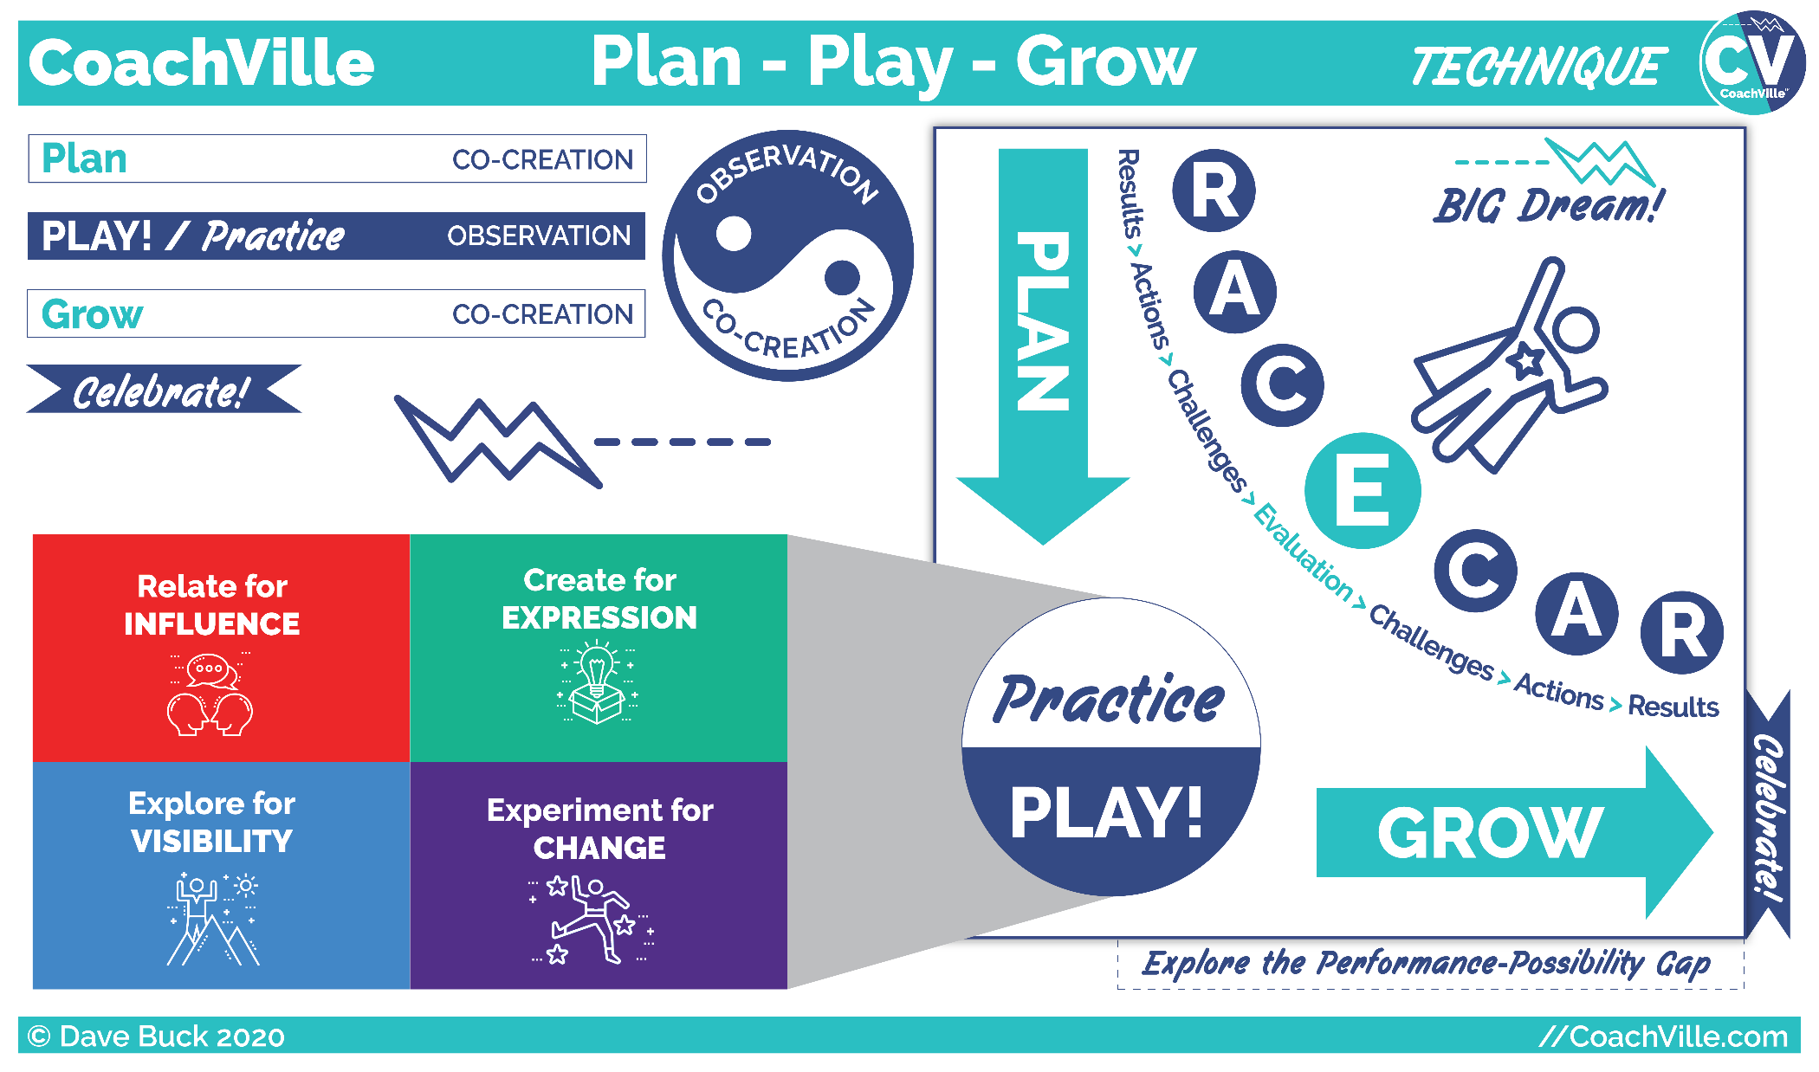
Exploring the CoachVille RACE-CAR Acronym
You see on the left side of the Inner Freedom playsheet the letters R C and A in circles. This comes from our Plan-Play-Grow technique.
Here is a quick primer (or recap) of the technique. This will be the flow of the weekly coaching experience co-created with your player.
R – Result = What happens in the world when you take an action
A – Action = You perform an action with skill and intent in pursuit of your desired result
C – Challenge = Everything that prevents your desired result from happening when you take action. There are Inner challenges and Out in the World challenges.
HINT: Challenges are what make PLAY fun.
E – Evaluate = Anything that can be observed during play that will aid the coach in guiding the player to co-create the desired results more often AND with greater ease. A related idea is feedback.
Plan – Play – Grow
This is a versatile technique that will provide the structure of the coaching sessions AND the flow of a coaching relationship.
Plan – Play – Grow =>in the Coaching Session
Coaching Plan = The coach and player talk together to co-create a plan for what they will do together in the coaching session; ideally some kind of practice together where the coach can observe the player.
Play Together / Practice
Practicing together is the true heart of coaching. The coach and player play together in a safe space to create growth experiences. The coach observes the player and the player observes the coach as well. In the Inner Freedom Method we practice together using the Pivotal Moment technique and the Role Play technique.
Grow = The coach and player talk to share observations about the experience of play AND aim to learn anything that the player can use to PLAY better in the world.

Plan – Play – Grow => The Player Out in the world; The Coaching Relationship
Play Plan = The Coach and Player co-create a plan for the player to go out in the world with intended actions and desired results in pursuit of their Dream; Once in a while it is valuable for the coach to observe the player at play; in real time or recorded.
Play = The player goes “out in the world” to take action in pursuit of the intended results. The player takes note of the “Pivotal Moments” and Conversations that they want to practice with the coach.
Grow = Typically at the start of the next session, the coach and player talk together to evaluate play; share observations about the experience of play AND aim to learn anything that the player can use to PLAY better. This then feeds into the Coaching Plan of the session.
Celebrate = The coach and player make a special effort to celebrate the desired results that occurred AND any new awareness for the player that feels meaningful.

Play for a Dream and the Fears of playfulness
Playing life has four broad categories of activity. And each area of playfulness has a very common “social” fear associated with it. Understanding play will help you guide your player through the Inner Freedom Playsheet.
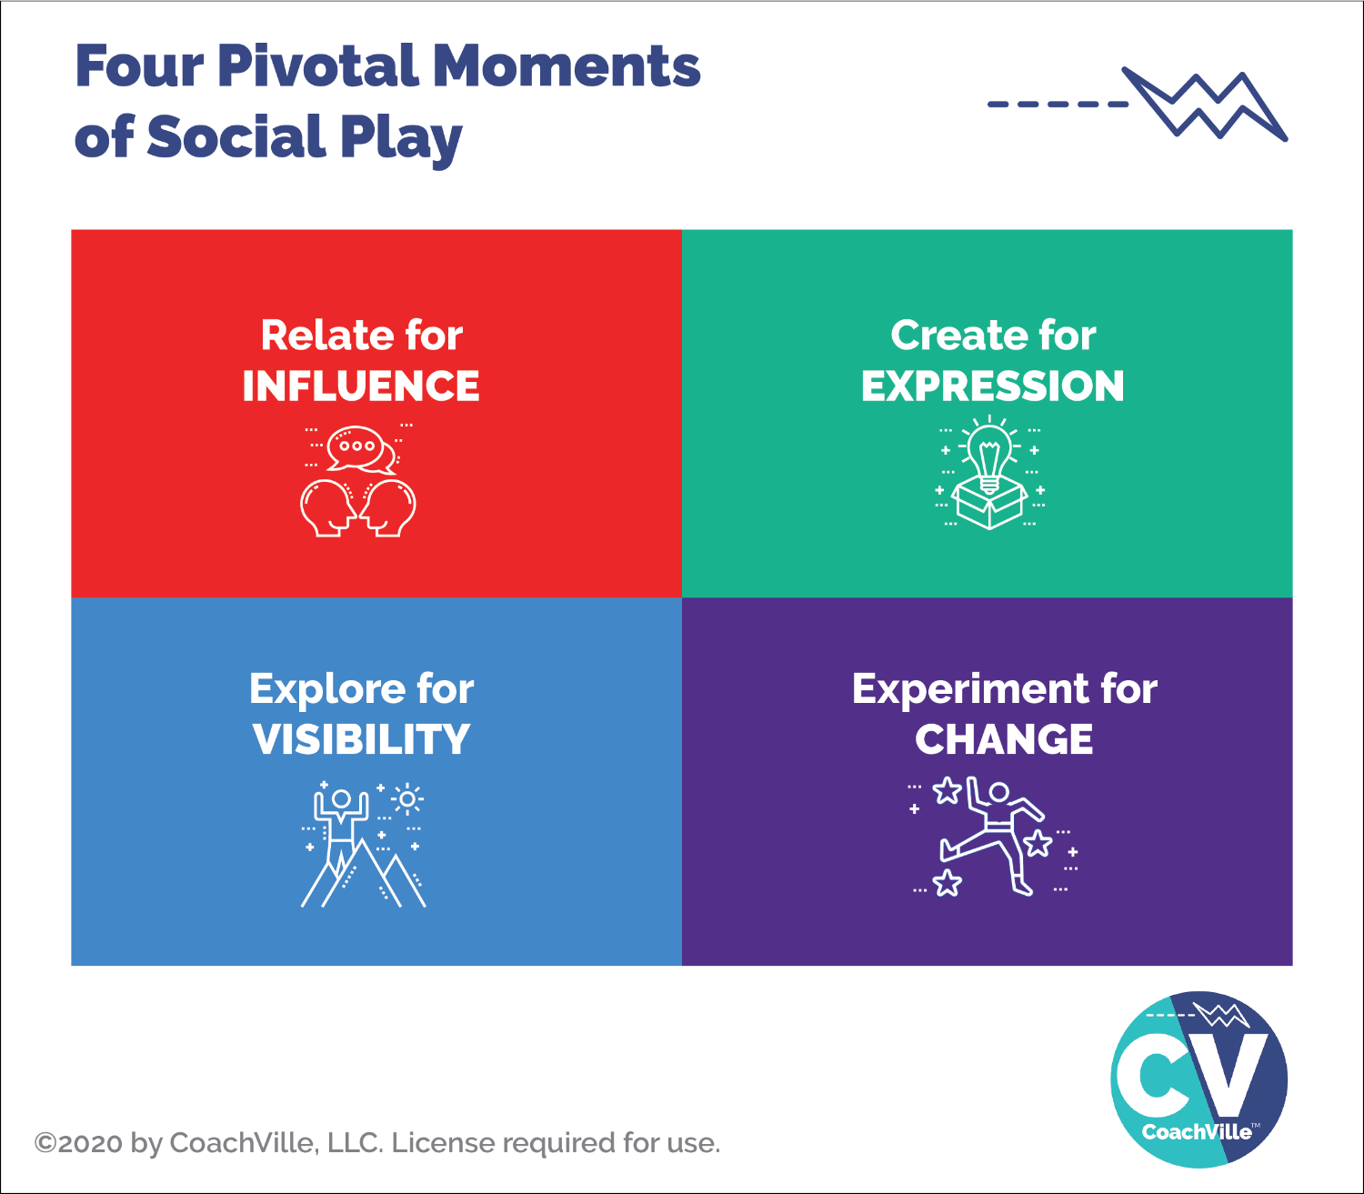
Coaching is about helping another person play better; this could be basketball, piano or life! In our Play Life Method coaching program we use this model to describe how we actually play life; so that we can then discover how to play life better with a coach.
A key distinction about play that is always helpful is recognizing the shift from control to influence which we will explore in great detail later in the program.
Any time you are doing something where you have 99% control of the outcome that is more like work; we don’t experience fear in situations where we have 99% control. In work anyone can accomplish the same outcome by following the instructions and doing it the right way.
Play is when you are doing something and you DON’T have control of the outcome but you can influence the outcome with your energy, creativity and skill. When you do something playfully, YOU matter, this is the upside of play. The challenge is that we have absorbed a lot of fear associated with situations where we are not “in control”.
I describe the ways we play life with four keywords: Relate, Create, Explore and Experiment.
Relate for INFLUENCE
Relate means talking to other people! This is pretty much what we do all the time in life. It becomes playful where there is an opportunity for positive influence like when you are asking someone to do something with you and they might say “yes”, but they might say “no”.
In a business situation: this is leading, engaging and selling.
Create for EXPRESSION
Creating is when you make a thing or you design an experience that you aim to share with others; for examples: writing, recording, designing, planning. The sharing part is all about participation and contribution. This is very much in line with the “Life is Art” concept.
In a business situation: this is the messaging, content creation and group events.
Explore for VISIBILITY
Exploring is when you go into a new territory; we are stepping into the unknown (hopefully with a sense of wonder) It can be a physical place, a social media platform or even a new idea. We explore to see and experience new people and new places; and also to BE SEEN by new people.
In a business situation: this is the marketing, networking and prospecting.
Experiment for CHANGE
Experimenting is any time you do something that you have not done before OR you do something that you have done in a new way. Often when we experiment we have an idea or a hope of what will happen but we don’t actually know. A key to success is to start with an intention, be open to new possibilities AND keep track of what happens; and most important is to not look at any outcome as a failure but as learning.
In a business situation: this is innovation. When you play business you are experimenting ALL THE TIME!
Hopefully you are getting energized about playing for your dream!
BUT, all of us who grew up in the Industrial Age have to realize that we have absorbed A LOT of fears of our own playfulness. So next let’s look a little deeper into the common fears that are associated with play.
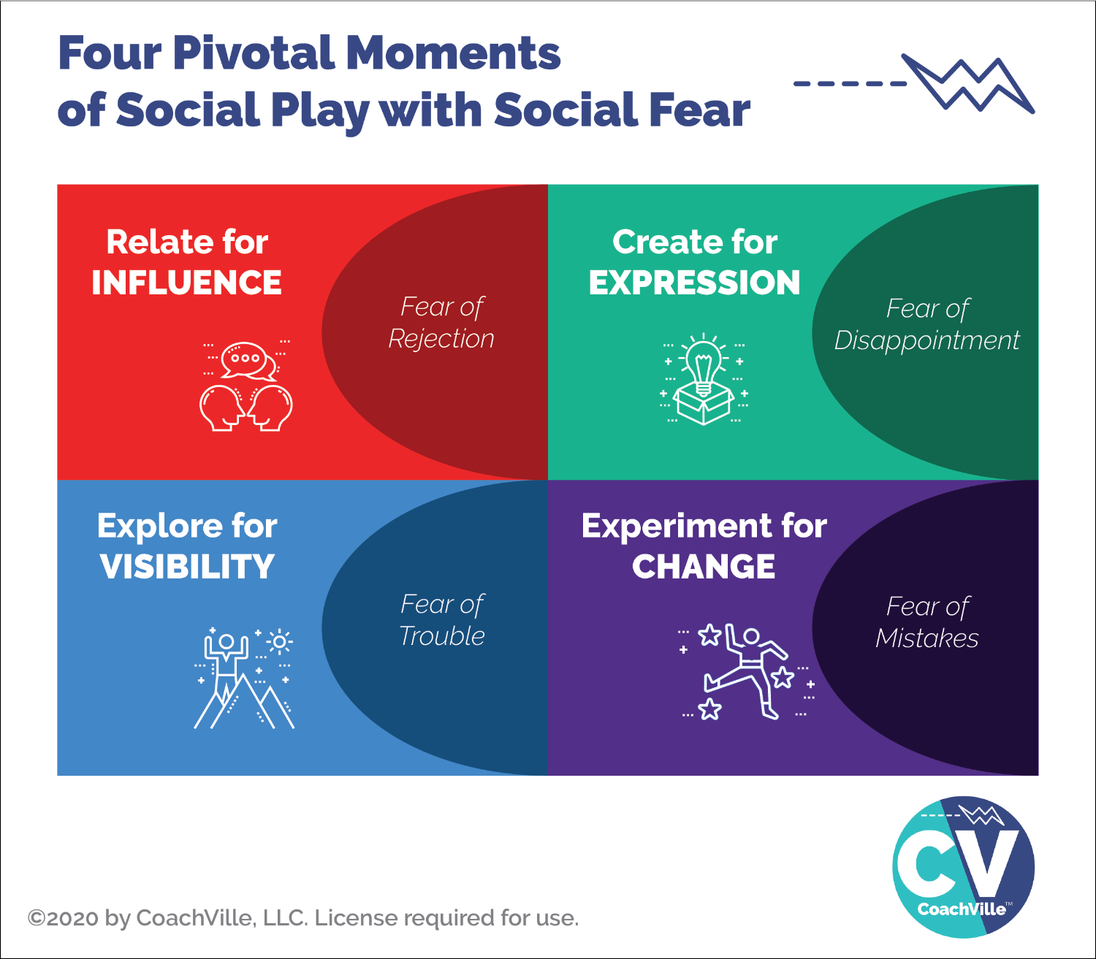
You probably recognize all of these fears. As I will share many times in this playbook: we all absorbed the FEAR of our natural playfulness in the Industrial Culture. I can tell you that little children do not fear of any of these things.
If you aim to play business or any aspect of life at a high level you need to embrace and transcend these fears. I will share with you more about this later: it is almost impossible to transcend social fear by playing alone. But together we can do it!
Relate for Influence = Fear of Rejection
To play business you need to cultivate a high level of ease with approaching people and talking with them about your signature topic; your performance possibility gap. And then you need to invite them to a next step. This is where the fear of rejection comes in. BIG TIME.
Create and Share = Fear of Disappointment
As a coach you will be creating and sharing content in a variety of forms on a regular basis. Also every time you have an opportunity to speak in front of people you are creating and sharing an experience. And if you get into facilitating group experiences that REALLY puts you into create and share mode.
The fear that we might disappoint someone or BE disappointed by someone’s reaction to what we create can be a BIG block to creating and sharing.
Explore to See and Be Seen = Fear of Trouble
In order to find customers, partners and people to participate in what we are creating we need to “get out there” either physically or virtually. This is what exploring is all about. When we explore we don’t know what we are going to find or experience and sometimes TROUBLE happens! We end up in uncomfortable situations or attract the attention of someone we don’t want to engage with. The human market place is an amazing but potentially “dangerous” place; at least at an emotional level.
The potential for trouble in the unknown is why most people stay where they are and spend their time with the same people. However, it is almost impossible to grow your coaching business this way.
Experiment to Try New Ways = Fear of Mistakes
Do you resonate with this one? I sure do. This is a big remnant of the Industrial Age mindset that everything you need to do: a) there is a right way to do it b) you should be able to do it the right way every time and never make mistakes.
Of course this is nonsense! But the residue of this mindset from school and jobs keeps us locked into a perfection trap.
This makes it sooo hard to experiment and find our unique way to do everything our business needs us to do.
BIG OPPORTUNITY
You can cultivate the capacity to PLAY and transcend these Industrial Age fears.
You can restore your natural human playfulness.
When you do, your business will thrive and you will have more fun playing.
HOW?
1) Practice with colleagues and a coach.
2) Inner Freedom coaching to explore pivotal moments when you experience fear
3) Team support and belonging; when you feel that you are not alone and you have a group of people who care about you and support you, it is A LOT easier to make big moves in the face of fear.

Dwell in the Conflict {this may need an uplevel to the pull}
The BIG Dream creates Inner Conflict – There is NOTHING wrong with you!
In this session your instructor will lead an important conversation about “Dwelling in the Resistance” And then review of a few key ideas about Inner Freedom with key differences between Inner Freedom and typical self help concepts.

Important Notes
It is very important for coaches to learn how to dwell in the resistance.
What is your natural reaction when your player is facing resistance?
Why do you do that?

Distinctions between typical self-help and the Inner Freedom Method

Self Help = There is something wrong with you and we can fix it!
Inner Freedom = Inner resistance is a natural consequence of playing big, there is nothing wrong with you.

Self Help = Banish negative thinking from your mind.
Inner Freedom = All thoughts are useful because we can learn from them using judgment- free awareness; Banishing them is impossible anyway.

Self Help = You must learn to suppress your Emotions.
Inner Freedom = Your emotions are a pathway to inner wisdom. You can learn from them.

Examples of Pivotal Moments (Inner Conflict 2010)
In this session your instructor will lead a dialogue about Inner Conflict including several real life examples. Come to class prepared to share your own examples

Important Notes
How to find Inner Conflict
- Important actions known and avoided
- Important actions taken through great resistance
- Important actions are taken without desired results

The BIG QUESTION - What is NOT happening?
Real Life Examples of Inner Conflict
1) You need to make the phone call - but you are not making it.
You find yourself in the kitchen cleaning dishes; (or reading emails; or on facebook)
Example: You can use the Inner Freedom Method to discover the inner resistance - the LITTLE BIT OF FEAR - in the phone call that has you go on "auto pilot" to do something with 100% certainty
***
2) You want to lose 10 pounds - and have been wanting to do this for what seems like forever.
Yet, often you find yourself sitting in front of the TV eating potato chips!
Example: You can use Inner Freedom to find out: What is the discomfort in that moment that has you watching tv and eating potato chips for comfort.
***
3) You want to be a savvy business person - yet you often make decisions that are counterproductive?

Using Inner Freedom Method you can determine the cause of these counterproductive actions.
Example: When you were 6 yrs old you had a little bother who was 4. You were playing games and you would always win - you were older and smarter - and your little brother would cry and run to mom. Your mom tells you not to win all the time. So sometimes you make mistakes in the game on purpose to let your brother can win. Now you are still doing it!
***
4) You want to a great relationship but you avoid being truthful, or assertive or asking for what you want, or saying when something is bugging you.

Example: Using Inner Freedom you could pre-play a conversation where you ask someone for what you want. You can then learn where the fear is coming from.
***
5) In wealth creation - you want to save $500 per month but instead you buy things that are not essential - why did you buy them? –
Example: Using Inner Freedom Method you can go into the Pivotal moment in the store (or website) when you picked up the item and walked to the counter, and find out EXACTLY why you did this. In some way it was making you feel safe. Then you will have the opportunity to make a choice that will serve your financial game better next time.
***
BIG POINT! - Just a little bit of fear will divert you
When you set out to do something that is outside of your comfort zone, it only takes "just a little bit of fear" to divert you. Typically you will unconsciously move to do something where you have 100% certainty and no fear; such as walking, email, cleaning, getting coffee, eating, watching television

Judgment-Free Awareness + Realness
Be REAL + Judgment-Free
Explore playing BIG in Life with FEAR and inner conflict
In this session you will lead a dialogue about how inner resistance is a natural consequence of playing BIG in the world.

Go into the Playsheet line by line
Say: You know the left side of this playsheet from Dream RACE Model.
We are going to focus on the Right side
Results -> Frustration
Challenges -> Isolation
Actions -> Overwhelm
Watch out for judgment and spiritual bypass!
This is NOT the time for your enlightened perspective; this is the time to GET REAL; you grew up in the Industrial Age; so we know what is going on in your mind& body. “Talking yourself out of it or denying it does NOT lead to transcendence.
KEY: Judgment-Free awareness: Oh. I notice that I … (fill in the blank)

(upd) The Inherent Forces: Self-Preservation and Contribution (2010)
?? self-preservation or survival instinct?? How to explain this. Or is this the same as “the pull” from the journey???
There is a beautiful conflict within each and every one of us; the conflict that is the central theme of almost every worthwhile story.
It is the conflict between the imperative for self-preservation by staying small and safe and the desire to contribute to the world and accomplish something great. We call this getting your heart’s desires out into the world!
This conflict is not a problem or a bad thing or something to avoid; rather it is what makes life so wondrous! Every single day, in fact many times each day, you are faced with choices and opportunities where you can step into your desire to play big and contribute to the world in a significant way OR you can choose to play safe, to survive and avoid "trouble".
In the Inner Freedom Method program you will learn how to embrace the dance between these forces and ride the powerful wave of energy that this beautiful conflict can provide you and your players.
In the program you will learn:
- Why Playing life BIG creates inner conflict – EVERY TIME
- How to quickly find the “Pivotal Moments of Choice” where the freedom to play BIG is blocked
- Techniques for shifting the energy of thoughts, feelings and actions to restore the freedom to make winning choices.
With these techniques your players will become Super Conductive -free to play BIG - and able to create results with greater ease.

Playing with Energy (2010 version)
We will get deep into playing with energy in this program. Throughout the program we will explore the Energy Alignment Game.
While there are many things going on in a person that a player and coach can be aware of, to get started we will focus on these:
Thoughts - sometimes referred to as self-talk
Beliefs - patterns of thought about who we are, what is possible, what we should or shouldn’t do
Values - what is important to us OR what we think SHOULD be important to us
Feelings - physical sensations in the body, typically we notice feelings of discomfort
Emotions - fear, anger, joy, sadness, excitement
Actions - what you do, what you create, how you interact
Choices - The process of moving into action, how we move into action or NOT moving; choices mostly occur at a non-conscious level
Decisions – A logical process of weighing pros can cons about taking a particular action or NOT
The purpose of Energy Awareness…
Inner Freedom.
The superconductive state of inner freedom is an experience that is sometimes difficult to describe. Here are a few phrases that express it.
- Responding powerfully in the moment
- Taking effective action with creativity and self-expression
- Getting the desired results from the actions taken
- Knowing what to say and do with confidence and without hesitation
- Tapping into your wisdom, intuition, logic and experience to make the best possible choices

Class 01 Prep
We will explore a few of these questions in class…
Question: who can share about an exploratory session?
What happened when you asked people about their BIG dreams?

Question: What is your BIG Dream call to adventure out into the world and describe some of the fears coming along on the ride?

** Practice : When your colleagues share about their fears… DON’T attempt to fix it. Allow people to share. This is the essence of a safe space. Not judged or fixed. What might seem easy to you can be a BIG fear for them.

Question: Your fears are a treasure map to your superpowers.
The thing you fear the most is expressing your UNIQUE power
What does this mean to you?

Question: What does Play With Social Fear mean to you?

Walk through the Inner Freedom Playsheet…
Watch out for judgment and spiritual bypass!
KEY: Judgment-Free awareness: Oh. I notice that I … (fill in the blank)

Class 02 Prep
Question: Share an example of an attempt to control a result/outcome

Question: Share an example of reacting to a challenge by forcing, power through or isolation

Question: Share an example of resisting taking action.

Chapter 2 – The Pivotal Moment & JFA

{great quote}

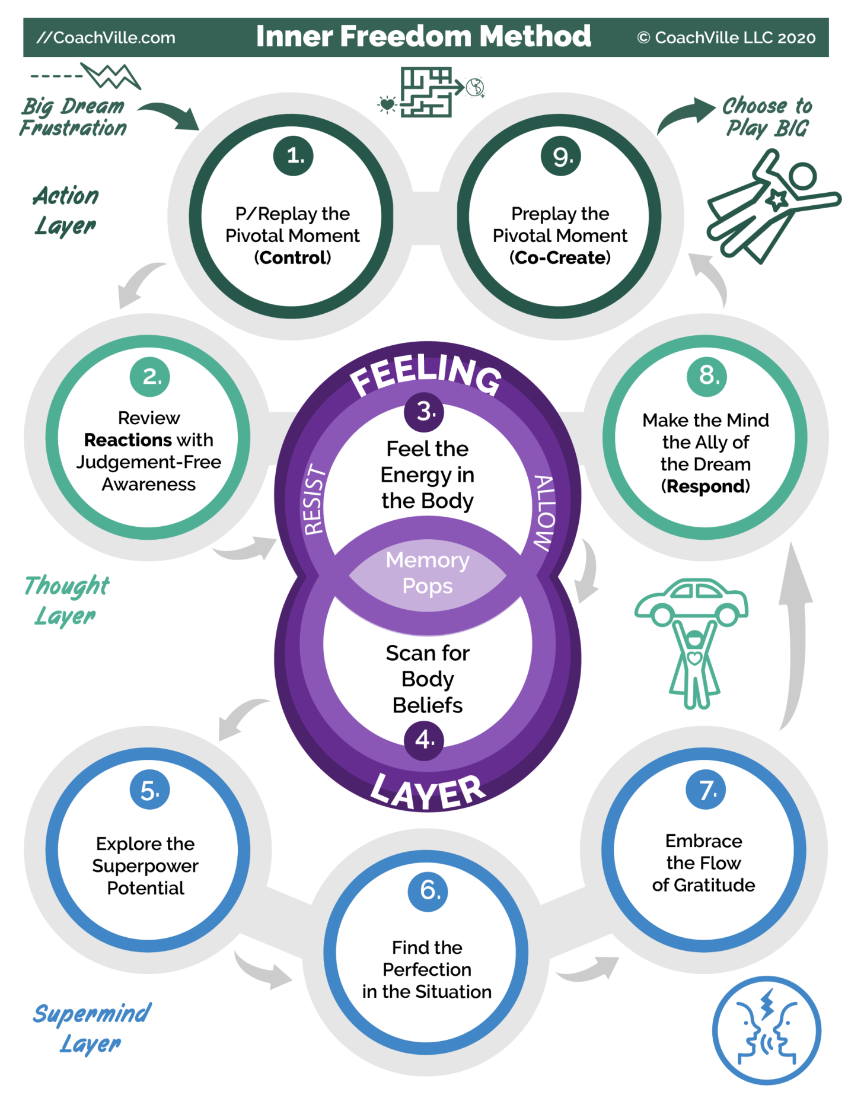

READ THE COMPLETE GUIDE of 1,2,3,4,8,9

Coaching Notes for Session 2 – Preplay a Pivotal Moment {ADD notes
** ADD THE GUIDE FOR THIS SESSION TO THE PLAYBOOK **
Some of the questions are pretty interesting
Quick overview
a) Go quickly through steps 0 and 1: Identify the moment to Preplay
b) Go into detail in steps 2 and 3: Review Reactions with Judgment free awareness of thoughts and feeling the Feel the energy in the body.
c) Go quickly through step #8: Make your mind the ally of your Dream (create Dream language)
d) Go quickly through step #9 Preplay the Pivotal Moment (with Dream Language)
Note for class: with your class partner, Step “0” should be very quick; just skip to 1A and ask them what moment they want to play with.
However, with your players, you will probably need to go through these questions to hone in on the pivotal moment to play with the first few times.
The 1,2,3,4,8,9 Method
Look at the Inner Freedom Method Model. Follow the path from 1,2,3,4,8,9.
This is the short version of the Inner Freedom Method. {Explain when to use}

Play-Play-Grow Celebrate
{The detailed coaching session flow}
? Include the model again ? Maybe the 3 Inch version ??

This will be a quick recap from the Introduction

Inner Freedom Method Step #0: Find a Pivotal Moment to play with
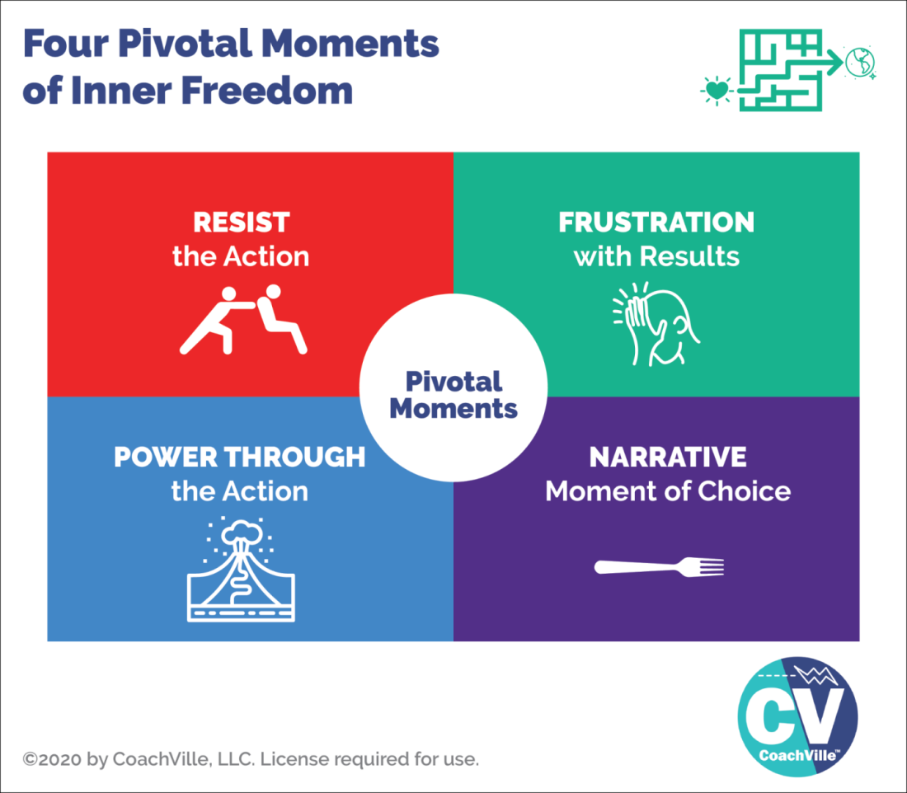
{Explain how this happens in most coaching conversations}
{Walk through the 4 scenarios}

? Maybe the Player Audio Transcript goes here ?

The Action Layer
{quick overview}
From Control to Co-create

Inner Freedom Method Step #1: PReplay the Pivotal Moment of Choice

The purpose of the Replay (Pre-play) the Pivotal moment technique is to identify patterns of Inner Resistance.
Inner Resistance occurs when an individual has two energies that are in conflict. One example is the desire to take a certain action or get a specific result and the conflicting energy could be the desire to avoid activities that are outside of the comfort zone and bring up physical sensations of fear. Or there could be an unconscious belief that it is dangerous to be successful and that energy is in conflict with actions that create positive results.
Often these key activities and situations will come up naturally while talking about the dream and results in your sessions. However, sometimes you will have to use your coaching intuition to identify and talk about where your player is avoiding something important.
Often these situations are described as procrastination or being too busy! NONSENSE! Your player is never too busy to do the most important activities that lead to playing BIG for their Dream - when there is no action there is an energy conflict somewhere.
Remember: immersing in busy work is
a natural response to
discomfort and fear.
There are an infinite number of potential energy conflicts for an individual; however there are several patterns that you will see time and time again as a coach. This method will help you to see these patterns.

KEY = Hone in on a specific moment / a specific action
- You can do this with a specific moment from the recent past.
- You can do this with a typical moment for the near future
- This is a powerful visualization technique.
- By visualizing you can slow down the moment so that you can explore the thoughts and feelings that are a blur in the actual moment.
- You replay the moment to expand awareness of all of the energies that affect the players choices and actions.
* the Power of the Imagination
{briefly explain}
* This is a way to Practice Life together
Refer to the essence of coaching ~ Practice together.
This is how we do it in Life Coaching!
Maybe some stories about how much you can SEE as the coach.

The Thought Layer
{quick intro
From React to Respond

Inner Freedom Method Step #2: Review Reactions with Judgment-free Awareness
Notice your thoughts with judgment-free awareness
After you have your player create the scene they are replaying or pre-playing, you ask them to notice their thoughts and share them with you.
This is the part of the method where both you and the player begin to become aware of what is going on in the players thoughts during this Pivotal moment. This is where you both start getting clues about why it is so challenging.
Emphasizing judgment-free awareness is essential because most people tend to dismiss their own thoughts when they start with the method. Or they may be embarrassed by their own thoughts and not want to share them. As the coach you need to cultivate a safe space for deep and vulnerable sharing to occur.
Common Judgments
Something is wrong with me because...
- I have negative thoughts; or
- I didn't do something I wanted to do; or
- I am not getting the results I wanted; or
- I keep revisiting the same issues in every workshop I do
- I keep making the same mistakes

Inner Freedom Framework
All thoughts, feelings and actions serve some purpose
There was wisdom that was appropriate in the moment the pattern started
AND that pattern may conflict with your new intention to play BIG for your dream.

Judgment-free Awareness
- Concept first made popular by Timothy Galway in the "Inner Game of Tennis"
- Freedom from the chorus of voices calling for perfection
- Accepting & welcoming what is
- Being curious and watching as we play & absorbing it -> while moving toward our picture of ideal
In the Preplay the Moment method there was a part where we explored the thoughts that occurred during the "Moment". Today we will expand that part of the method using judgment-free awareness.

It is good to know a LITTLE bit about the “Mind” {2010}
This will help you to have perspective while coaching and while playing BIG
A) The Mind is a powerful thing!
Conscious – Social Brain - Non-conscious – Super-Conscious
Think Iceberg - conscious above the water line (10%) – Non-conscious below the water line (90%)
Your Brain is your conscious mind = Thinking + reasoning
Your Social Brain = observing all humans around you at all times to assess belonging, status and danger
Your Body is your non-conscious mind = Intuition + Knowing
Your Brain and Body are like a “radio receiver” for input from the Super-Conscious
B) Most important: The imperative to survive (Play Safe) + The desire to contribute (Play BIG)
These powerful forces within us are almost always in conflict. So… we must learn to be at ease with this conflict so we can choose in each moment what is best.

This “conflict” can be experienced as either a fight or a dance.

C) Enjoys fantasy, delusion and magical thinking
we love: movies, novels, stories
D) Prone to suffering
Byron Katie: all suffering is an argument with reality
E) We ARE Light AND Shadow // NOT good or bad
Some thoughts reveal the light. Some thoughts reveal the shadow.

Prep for Inner Freedom Steps #3,4,8,9
{OR is this done in the coaching notes??}
Feeling Layer
From Resist to Allow

Quick understanding of #3 Feel the Energy in the Body

Quick understanding of #4 Scan for Body Beliefs

Quick understanding of #8 Make your Mind the Ally of your Dreams (respond)

Quick review of #9 Preplay the Pivotal Moment with your Hearts Intention (co-create)

If the player doesn’t feel anything (What to do)
{there is some text from the coaching guide}
- Share a few thoughts about this
- Many folks have very limited body awareness.
- It may take a few weeks for the player to feel safe with you.
- Coaching presence is THE KEY here.
- How to keep the method moving positively until they get into the groove of feeling.

The Power of 1,2,3,4,8,9 – the “quick” version of Inner Freedom
How this part can be done in just a few minutes to create breakthroughs in a coaching session.

Pivotal Moments and the Basketball Coach metaphor
{maybe just include the transcript from the Player Audio here?}
Or type up a quick explanation.

Pivotal Moments – the Pull and the Human Journey
The AWESOME model

Expand Awareness (2010)
Why is Expanding Awareness Important?
- Because we don't see our own patterns - once something becomes a pattern the nonconscious takes over and you don't see it anymore
- Proficiency: Reveal the client to themselves
- Framework: Awareness is unifying

What do you want to expand awareness of?
- Patterns!!!!
- Blind Spots
- Out of comfort Zone activities
- Hearts desires
- New Possibilities
- "Reality"
- Physical sensations "feelings"
- Thoughts
- Recurring Actions

Review Inner Resistance Clues
1) actions not taken / avoided
2) actions taken by “Powering through”
3) actions taken with poor results

Judgment-Free Awareness
Of actions, thought, feeling, emotion = Notice and Wonder
There is some text from the Coaching Guide
? Include some copy from Coaching Superpowers ?

?? Coaching Proficiency – Reveals the player to themselves
Maybe this goes later in the book

Class 02 Prep
Question: who can share about a Session #1
(or an Exploratory Session) with a player?

Question: What happened when you explored the FEAR and FEAR Adjacent experiences such as frustration, isolation and overwhelm in Session 1 with your players?

BIG Picture = Coaching is about playing together… The #1 skill of advanced coaching is finding pivotal moments to play with together
Question: What is your example of a Pivotal Moment? A BIG MOVE that you are avoiding?

Question: What do you do when you are avoiding your BIG MOVE?

Everyone needs to get clear on this: One pivotal moment that you want to play with today with your coaching partner.

Step #1: Use the imagination to play with the scene.

Conversation:
When to do Replay / when to do Preplay

Chapter 3 – Feel the Energy & Body Beliefs

{Awesome Quote}

Coaching Notes for Session 3 – Feel the Energy & Body Beliefs
Quick overview
a) Go quickly through steps 0 and 1: Identify the moment to Preplay
b) Go into detail in steps 2 and 3: Review Reactions with Judgment free awareness of thoughts and feeling the Feel the energy in the body.
c) Go quickly through step #4: Scan for Body Beliefs
c) Go quickly through step #8: Make the mind the ally of the Dream
d) Go quickly through step #9 Preplay the Pivotal Moment (with Dream Language)
Note for class: with your class partner, Step “0” should be very quick; just skip to 1A and ask them what moment they want to play with.
However, with your players, you will probably need to go through these questions to hone in on the pivotal moment to play with the first few times.
??? Go through the questions For Step #3 & 4
{ a bit more detail }

The Feeling Layer
{do I have content about feeling energy anywhere to use here?}

From Resist to Allow
The transformation that leads to Inner Freedom
When the body feels safe… the mind opens up to new possibilities

It takes 2: The Power of Safe Space and Belonging

Inner Freedom Method Step #03: Feel the Energy in the Body
In this session we will go deeper into the Body Scan portion of the method with the purpose to help our player expand his/her capacity to feel. This will greatly reduce overwhelm, expand awareness and increase power.
- The exercise is remarkably simple and extremely powerful.
- The simple explanation is that you will shift from resisting the uncomfortable physical sensation to simply "allowing" it to be there.
- Somatic (of the body) – is a fully accepted part of coaching. Have no fear that this is “therapy” because you are talking about feelings and emotions.
re: the fear of digging up old stuff that you can't handle...
it doesn't happen like that - the natural breaker switch will prevent it
- There are many nuances to the technique several of which are embedded in the coaching dialogue.
- For MANY people this will be the first time they attempted to focus on the "uncomfortable" feeling rather than the natural response which is resist or avoid it.
- Your coaching presence with them makes a HUGE difference in their ability "stay with it" when their habit - since forever - is to NOT feel it.
- TALKING IS A COMMON DIVERSION: There are a few simple questions that you will ask them to bring their awareness to the "feeling/physical sensation". It is important that you NOT get lost in these questions or get into long conversations about it.
Remember: Your player has most likely been avoiding feeling for most of their lives so this will seem pretty scary and habitual avoidance techniques will come up.
- Your coaching presence creates “Social Safety”; Your persistence and encouragement are essential in the method; Belonging {remember to add Coaching Superpower Notes here about Coaching Presence}
- Often your player will have several different sensations. Ask them to choose the one that is most intense.
- Often while they are feeling the sensation it will dissipate or disappear. These are both natural occurrences but NOT the objective of the exercise. The objective is the experience of feeling -whether the sensation stays or goes does not really matter.
- Often while they are feeling the sensation it will "move" to another part of the body. Track it. Do the same exercise on the feeling in the new location.

Inner Freedom Method Step #04: Scan for Body Beliefs
{Explain this step}

It’s not safe for me to…

The experience of putting a feeling into words.
It’s not safe for me to… is a container
Most of the time something will just pop out.
Often it is followed by additional statements that bring more clarity.
Play together with the words.
You are looking for a power pattern – a phrase that captures the essence of the experience.
When they say it they can FEEL it.

Resistance is a KEY Pivotal Moment
A little more nuance about what to notice / what to listen for as the player shares about the week of play.
* You need to help them notice PM’s while you are talking together so that they can more easily notice them as they play in the world each week.

Why we experience so much resistance to Playfulness and your Unique Power
{this is a brief introduction to this topic}
One of the key ideas to inner freedom coaching is that your fears area a treasure map.
How did your playfulness and Unique Power became buried treasure in your non-conscious mind?
!! Remember. This is going to be included in every program. SO, talk about it from an Inner Freedom perspective.

3 Dynamics of Human Development (the forces of change)
In the human experience there are three forces of human development that you need to understand in order to both play BIG in your own life and to coach for transformation: Become – Belong – Believe.
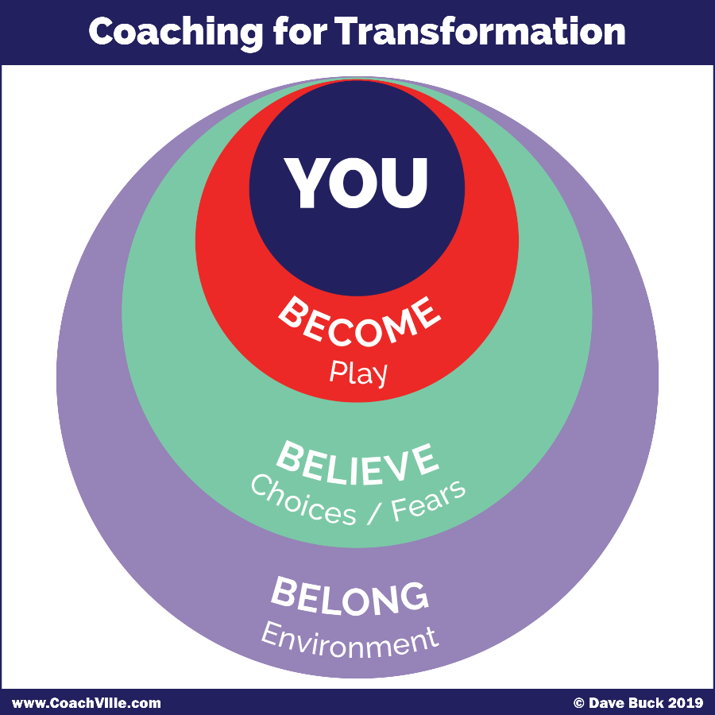
1) The Urge to Become. All humans have an inner urge to become the next version of themselves; to grow and expand. We become by playing. If we stop playing we stop becoming and stay the way we are.
2) The Need to Belong. This is the strongest of all human needs. It operates mostly on a non-conscious level and drives almost everything in the human experience. We Humans always seek belonging and status within the environment we are in.
3) The Ability to Believe. Humans are believers. The ability to believe is the catalyst of all human civilization.
All of our beliefs – about how life works, who we are and what is possible – come from navigating between our urge to become and our need to belong. In other words, we get our beliefs from our environments.
Most of our beliefs settle into a non-conscious level within us and have a non-stop profound impact of what we do and don’t do on a moment-to-moment basis.
Coaching for Transformation
To co-create transformation – profound change - you need to tap into all three forces!
We need to PLAY to become the next version of ourselves.
We need to find or create a new environment where the power of profound belonging pulls us toward becoming who we must become to fulfill our dream.
We need to explore our beliefs both conscious beliefs AND body beliefs – by bringing them up to the surface of awareness - and choose the ones that we need to uplevel in order to live our new dream.

The story of how you lost your Playfulness and Unique Powers
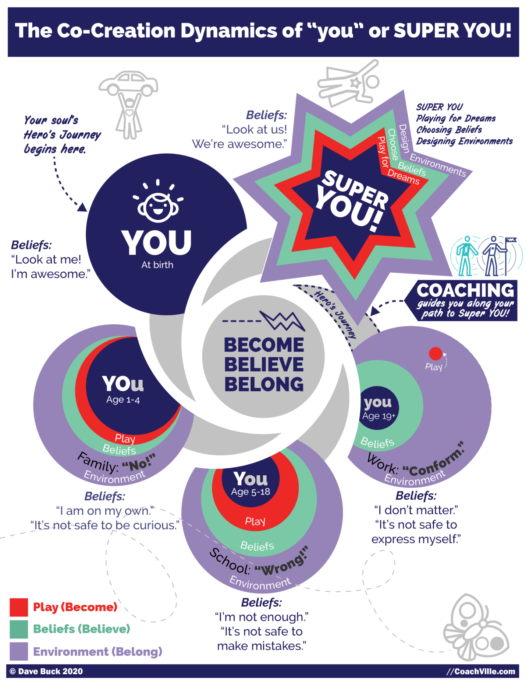
This is a really big deal. {possibly uplevel this text} I am going to share with you the high level understanding from this diagram so that you can understand where many of our challenges come from when we aim to play bigger than we have in the past.
Here is the basic story of YOU! (and all of us who lived in the Industrial Age Culture)
You were born onto the Earth to experience the Human Journey! You were born with a collection of unique abilities to express and share with the people of the world.
You were born into an environment of people, places things and ideas. This is also known as a culture.
As a little person, your urge to become kicks in and you start to play. You play everything. As you play you grow… you become the next version of you day after day, month after month, year after year.
At the same time, as you play, your environment reacts to you and the need to belong kicks in… HARD. When your environment reacts favorably to you, you come to believe that it is good and safe to do what you are doing and you do it more. If your environment reacts negatively to you, you come to believe that it is NOT safe to do what you are doing and you curtail it or stop completely.
This is a good system for learning how to get along in the world of people. You come to believe, for example, that people don’t like it when you throw a rock at your little sister; this belief is a good thing.
However, if for example, you are crawling around following your curiosity and a BIG person yells: “NO” and puts you into the isolation pen (AKA playpen), you may come to believe that it is not safe to be curious; this is not such a good thing.
At home, in Industrial school and then in Industrial jobs, your urge to become through play moves you into life. And as you do this the environment reacts to you. When the reactions are unfavorable – which happened a lot in Industrial Culture - your needs for belonging and status are threatened. As this happens you develop beliefs about yourself and life. Over time we come to believe a whole lot of limiting things about ourselves and our possibilities in life.
As various aspects of YOU go into the “not safe to express” category in your beliefs, you become a smaller and smaller version of you. You come to FEAR your natural playfulness and your unique powers because at one time expressing them threatened your belonging.
Fast forward to now…
So, when you experience inner resistance or doubt or FEAR attempting to do the any of the needed activities of business – which are playful and need your unique power – it is not because there is something wrong with you! It is simply because you are a human being who grew up in the Industrial Age and absorbed the Industrial Culture’s fear of play and unique personal power.
I believe that this process of losing our unique power as we grow up has been a part of the Human experience since the beginning of modern civilization. All of the Heroes Journey stories include the pattern of going out into the world, facing new challenges and discovering lost inner powers.
I also believe that the fear of playfulness and uniqueness was extreme in the Industrial Age of Work.
I also believe strongly that since all of these beliefs were established in social situations (AKA belonging) we need to explore and uplevel them in a socially safe space. This is why 1-1 and small group personal coaching is such a powerful force for personal growth.
The class experience is designed to create a powerful experience of belonging where you can play to become the next version of you and create the new beliefs needed to fulfill your dream!

{Explain how these intense belonging threat experiences get stored in our bodies. This is why your body buzzes when you are in an energetically similar experience .

The Mysterious and Magical Non-Conscious Mind (Energy Alignment)
{From the Energy Alignment Game}
(graphic of Non-Conscious Blob)
Grab from Play Life Playbook or BIG Freedom
~Body Awareness
~ Fears; social fears… (the buzzing experience)
~ Body Beliefs
~ Hearts Desires
?? maybe go deeper into each element from Inner Freedom perspective ??

4 Ways to Play Life WITH Social FEAR
{add Model here}

Coaching for Growth! ~ Using the Play Plan Sheets
The growth opportunity each week to play with FEAR of playfulness
How you need to ENCOURAGE your player to make these moves vs. only task themselves to do what they can control.

Overwhelm ~ I don’t know ~ Knowing is in the body
Overwhelm is the resistance to feeling..
Or I can’t feel all of this
I don’t know… means I can’t connect to my body.
KNOWING is in the body. “Inner Knowing”
{this was in this playbook somewhere}

Tenacious Self Love!
Beyond JFA
Stop saying these phrases!

Class 03 Prep
Question: Who can share an inner freedom coaching experience?
What was the pivotal moment you explored?
You KNOW with your body
You think with your conscious mind and you KNOW with your body.
Question: What does that statement mean to you?

What Overwhelm Really Is
Question: What is the experience of overwhelm like for you?

(if time) Question: How do you interpret the notion that “I don’t know” means you are “disconnected” from the feelings in your body

Question: What is the pivotal moment you are going to explore with your coach today?

Chapter 4 Memory Pops

{Awesome Quote}

READ 3,4 with Memory Pop Question

Coaching Notes for Session 4 - Memory Pops! {add notes
Quick overview
a) Go quickly through steps 0 and 1: Identify the moment to Preplay
b) Go into detail in steps 2, 3, 4: Review Reactions with Judgment free awareness of thoughts and feeling the Feel the energy in the body, Scan for emotions and memory pops.
c) A brief exploration of step #: 5: Look for hidden superpowers
d) Go quickly through step #8: Make your mind the ally of your Dream (create Dream language)
e) Go quickly through step #9 Preplay the Pivotal Moment (with Dream Language)

Quick Refresh on our we lost our Pup
{speak this to lead into Memory Pop details}

Inner Freedom Method Step 3&4: “Memory Pops”
{uplevel this explanation with ideas from how we lost our PuP}
While you are doing steps #3 & #4 - There is a powerful step where you can explore with your player the source of this energy that they are feeling in their body.
Understanding memory pops
If you have practiced the Inner Freedom method of feeling the energy in the body (with yourself or with a player) over the past few weeks then you have probably experienced a “Memory Pop”. A Memory Pop is when a memory of a past event or experience “pops up” while feeling the energy in the body. This is a very common phenomenon because the buzzing energy in the body is connected to a past event.
As we go through life we experience events; some that involve us directly, others that we observe. Some events happen thousands of times like eating a meal. Some events happen rarely – like a parent or sibling dying. All events that we experience have energy but some have a lot more energy than others. Most events have little energy so the energy easily flows through us like water flowing through a pipe. Some events are more energetically intense. The intensity of the event is relative to the size of your pipe (capacity to feel) at the time.
So, when you are small, and your capacity to feel is small a LOT of the events that you experience are too big for the pipe. When this happens the energy stays in the body rather than flowing through.
Then, any time an event happens in the present that is energetically similar to the past event, the place in the body where the energy was stored will “BUZZ”. This “BUZZING” energy is uncomfortable so most of the time we avoid activities, thoughts or even notions that start up a buzzing energy.
THEN… we decide to play for a bigger dream in life and certain actions that start a buzzing energy can no longer be avoided. This is where YOU – the Coach – come in!
When you have your player feel the BUZZing energy VERY often the memory of a past – energetically similar – event will pop up. And often your player will share this memory with you.
Most of the time, these events are benign but every once in a while they will be rather traumatic. And of course what is seen as benign or traumatic is relative for both the player and the Coach. In any case, your role as the Coach is to be fully present without getting lost in your player’s emotions from the event. Also it is essential to NOT try to fix “the problem” or make it “OK”. JUST BE THERE; that is enough.
An example:
At age 4 your mom lets you play in the yard and says: “don't talk to strangers”; one day you are out there playing and an interesting looking person is walking by. You want to play with them so you run over and start talking to them.
Your mom freaks out.
This feels REALLY bad and it is very confusing; you love people, why is mom yelling and getting upset? This is way too much energy to handle so you start crying and then your mom freaks out even more. The emotional energy of this experience gets stored in your body
As a child, you have the thought: it is not safe for me to talk to strangers (because my mom freaks out). This becomes a “survival intention” to avoid trouble with mom by avoiding strangers.
And this pattern serves you well when you are a child - both avoiding danger and keeping your mom from freaking out.
Then you are 40 and starting a business and your coach says to go to networking events to meet potential customers (AKA go talk to strangers). And now YOU are freaking out! (or simply resisting going) your mind comes up with lots of reasons NOT to go to networking events.
You feel the buzzing energy in your body when you simply THINK about going to the event.
When you feel into this buzzing energy, you have a "memory pop" of your mom freaking out when you walked up to a stranger as a four year old.
Buzzing energy sparks reactive ~ self-preservation ~ thoughts
This is the mechanism that creates REACTIVE THOUGHTS and is a BIG INSIGHT:
Your conscious mind thinks self-preservation thoughts that will justify your body’s experience AND keep you safe from Social Danger.
It starts with an uncomfortable physical sensation in the body;
If you resist it, your mind will start to justify why that feeling is true - you are in social risk.
A little example:
- So when you think: I should go to a networking event to meet new people and move forward in my BIG dream! YES! That is a great idea.
- This idea is energetically similar to what happened when you were 4 years old.
- Your body starts to buzz with energy which is uncomfortable.
- You probably don’t pay too much attention to the buzzing but you suddenly “feel” that going to a networking event is a bad idea – even dangerous.
- Then your mind – which is programmed for survival – starts to “think” a lot of thoughts that justify NOT going to the event; while just moments before you thought was a great idea.
Thoughts like:
“Oh, I can’t go that night, my favorite TV show is on.” Or
“I can’t go to that networking event, my business cards don’t have a nice logo”
- Basically, in the presence of this “feeling of danger” your mind will go to great lengths to create thoughts – even ridiculous ones – to justify the feeling and avoid the danger.
- Remember, going to the event was perfectly aligned with your new play plan, it makes logical sense to go, but the fear is stronger energy than logic.
YOUR Conscious Minds #1 job - keep the body safe, keep you socially safe and alive!

Here is the question to facilitate a “memory pop”.
After your player feels the energy in the body.
ASK: When was the first time you remember feeling this energy in your body?
It is important that you use this phrase exactly this way. Don’t vary it in any way. I have tested many ways of saying this question and this is by far the most effective. Many ways of saying it actually prevent the memory pop from happening.
Then wait patiently.
A memory pop will usually happen.
Tell them: You don't have to tell me the details about what happened.
If no memory pops up,
ASK: Did you notice any emotions coming up while you were feeling this energy?
Listen for energetically charged thoughts
it is OK if they didn't notice any emotions

Allow the images to emerge
{speak this}

Giving Voice to feelings
Encourage them to share whatever they feel comfortable sharing.
Be there for what they want to share.
As the coach… you don’t need the details! (but they want to share them…)
… you only need the essence.

How much to talk about
Plus being able to be present & listen;
be the witness
IF it was a traumatic event…
it’s NOT therapy ~ just because it’s from the past and intense
you DON’T try to fix it. Or even soothe it. Just acknowledge that you hear.
Be careful not to judge the other parties in the incident. .. this is hard sometimes

The Power of Presence – it takes 2! (needs copy)
This needs some copy
Why the Inner Freedom Method is a coaching method and NOT a do-it-yourself method.
The power of Coaching Presence while feeling energy in the body.
You learned social fear and risk in the presence of others… to develop into a new version of you, you need the presence of at least one other.
Profound Belonging – is the antidote to social risk
Refer to Coaching Superpower ~ Presence {pull a few notes}

Coaching Superpower Presence with JFA

Coaching Superpower Go Deep
{check it for relevance}

Coaching Proficiency Reveals the player to themselves
{check it for relevance}

Class 04 Prep

Chapter 5 – Explore the Superpower

{Great Quote}

Session 05 Quick overview = Role Play + Inner Freedom
a) Step 0: Choose a Pivotal Conversation to Role Play
b) Step 1: Replace the Preplay with a Role Play
c) Call time-out in the Role Play
d) Go into detail in steps 2, 3, 4: Review Reactions with Judgment free awareness of thoughts and feeling the Feel the energy in the body, Scan for emotions and memory pops.
e) A brief exploration of step #: 5: Look for hidden superpowers
f) Go quickly through step #8: Make your mind the ally of your Dream (create Dream language)
g) Go quickly through step #9 Preplay the Pivotal Moment (with Dream Language)
Note for class: with your class partner, the key is to practice the flow of Role Play – Inner Freedom. You may not have time to go deep into steps 3 and 4 in class.

Here is your 7-step method for a great role play:
Note: if your player can not think of a pivotal conversation to play with, a good default for most people is to practice introducing themselves in a social situation or business event that leads to an offer or invitation.
1) Ask the player to describe the persons’ general characteristics in 30 seconds.
2) Ask the player to describe the persons’ point of view toward the issue/situation
3) Ask the player what is the positive influence that they are playing for in the conversation; what do they want the other person to say or do. Usually this means there is some offer or request that they want the other person to say “Yes” to.
Note: To play the role of another person, you do not have to change your voice. You can sound like yourself and still play the role.
4) As the coach, play it straight the first time and just get into it for a few minutes to see what happens.
5) Call time out! Share your observations. Ask the player for feedback on how you are playing the role and refine if necessary.
{Do Inner Freedom on whatever your player is experiencing}
6) Role Play again with new “Dream Language”.
Throw in a few twists as the role player if you want to see how your player responds
7) Repeat as many times as necessary until you feel your player has confidence for the conversation.

MORE about Role Play -> Pivotal Moment – Inner Freedom combo plan
{speak this}

Coaching Framework = Observation ~ Co-Creation
Grab this copy
Then add to it
This is why role play PLUS Inner Freedom is essential to powerful Life coaching
{Create some Inner Freedom Context}
What to observe while doing Role Play with Inner Freedom
{speak this}

Coaching Framework = Practice Together
Grab this copy
Then add to it

Energy Alignment Game = Super YOU!
{grab this content}
Then add to it
You need to SEE your player! And share what you see.
Help them see their unique abilities.. as you practice with them.
Then help them PRACTICE with these abilities in Role Play
Then encourage them to USE these abilities playfully in their Play Plans.

Superpowers Playsheet
Maybe you lost some of these?
Introduce playsheet

The Treasure Hunt Explained
{speak this concept}

Your Fears are a treasure map to your Superpowers
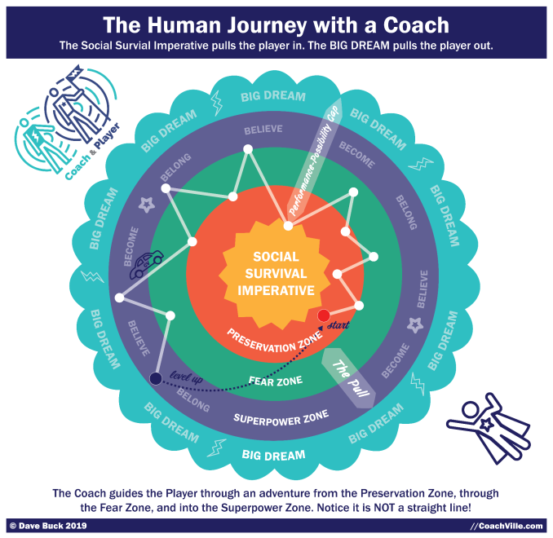
Remember this model?
How your fears are a treasure map to your superpowers
How it applies to Inner Freedom
{Note Record a detailed overview for the Coach Life Audio}

The Inner Freedom Energy Flow Model
{introduce}
Diagram on the Next Page
Remember the 3 fear related experiences we explored in the Inner Freedom Playsheet?
The right side of the page described: Frustration, Isolation and Overwhelm.
Talk through it in the context of Steps 1,2,3,4,8,9

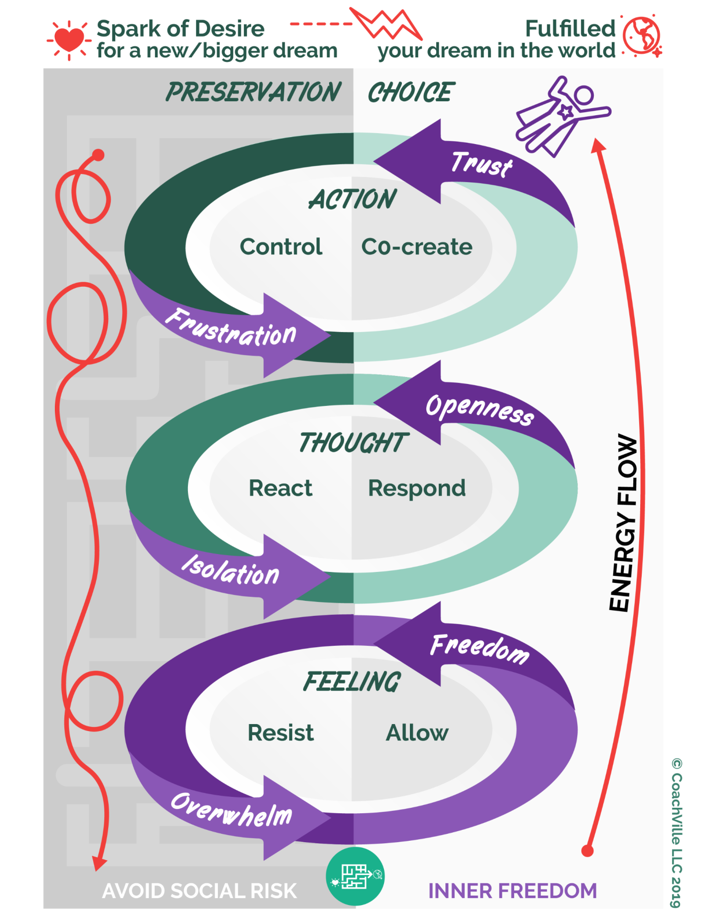

Understanding Frustration and the shift from control to co-create (2010)

The experience of Frustration
- unfulfilled expectations
- worse than expected
- things don't go according to plan
- know your purpose but it is not happening
- you are not sure what you should be doing and trying so many things and not getting results
- everyone else can do it but I can't
- this is not fun, I can't, why am I doing this? - doubt
- trying to do something but it is not working
- picture of results - the way it should be but it’s not happening
- AND - you keep going for it - you are not in apathy

Shift from Control to Co-create
The natural approach to any endeavor is to do what has worked in the past; to use your control. It has to be THIS way.
What are we trying to control?
- people- (and they want to control you too)
- results
- the outcome
- the steps to an outcome
- circumstances
- the environment
- dogs (funny)
- our own reactions / perceptions

Co-create
Co create is when you are in the flow with what is happening in the world around you.
You have an overarching understanding that whatever IS happening, is serving your purposes in some way; EVEN when what is happening seems to be going against your purposes.
Also called being in tune with reality

Isolation and the shift from React to Respond (2010)
From React to Respond by Thinking “holistically”
Transformational Shift: From react to respond
React - your mind supports your Preservation intention (usually something keeping safe, staying small or fitting in)
Respond - Your mind chooses to support your Heart’s intention to play BIG
Your mind is your ally when you can think holistically about the current situation without emotions from the past clouding the picture.
This is why thinking comes AFTER feeling the energy. When your body is feeling buzzing energy from the past it will focus your thought process on preservation.
When you feel the energy your body relaxes and then your mind is free to think thoughts that are aligned with Playing BIG.. This is when your mind becomes the ally of your dream.
Another BIG point here: When you practice feeling into the energy caused by earlier moments in life, you can then more clearly feel energy related to present- moment intuition. There will be times when what you feel in your body is a “knowing” that IS related to what is happening now and that your conscious thoughts should pay attention to.
Key Point...
What are often described as “Negative thoughts” are almost always thoughts serving a PRESERVATION - nonconscious – INTENTION to keep safe, stay small or fit in. And they are serving IT in a positive way. There is nothing wrong with the thoughts you have.
All thoughts serve a purpose. They may NOT be serving your new Heart’s intentions for playing BIG – but they ARE serving something.
Your mind is powerful and we will make it the ally of your dream by creating awareness of the PRESERVATION INTENTION, seeing the value it has had and then choosing a new intention. “Personal Growth” occurs when you expand your palette of intentions and corresponding thought patterns and consciously choose.

CREATE New Pattern Language
With your player in a relaxed and open state you begin to explore options for new Pattern Language.
This new pattern creates a CHOICE that is a step beyond the Pattern Language of the PRESERVATION Intention.

Overwhelm and the Capacity to Feel = resist to allow (2010)
What Overwhelm Really Is
- Overwhelm is resisting feeling a physical sensations in the body
- The experience of overwhelm is too much feeling - it is a breaker switch that cuts off body awareness -
- The experience is feeling frozen - stuck
- I don't know what to do
- You KNOW with your body - your body is your non-conscious mind
You THINK with your conscious mind using reason and logic
- The expressions "I know in my heart" or "I knew in my gut" are not metaphorical. They are physiological reality
- When you resist feeling you disconnect from your body - your body is where you KNOW
This is why you feel like you don't KNOW what to do.
- I don't know = I'm not connected to the energy in my body = I am overwhelmed
- The optimal state for powerful action is when feelings (intuition and body wisdom) and thoughts (reason and logic) are aligned
Your Body is an Energy Pipe
Your body is like a pipe that energy flows through. The size of the pipe expands throughout your younger years and you can continue to expand it as an adult through body awareness exercise. Most life experiences stir up very little energy so it flows right through us. But some experiences – especially when we are young but occasionally as an adult too – cause BIGGER energy than we can handle at that time so we “go into overwhelm” and the energy gets stored in the body.
Also, when a present moment is energetically similar to a moment that is stored in the body, your body will BUZZ with stored energy.
Going into “overwhelm” is like a “breaker switch” for the pipe. Instead of flowing the energy by feeling it we store it and go numb to it or release it with a physical reaction like crying or laughing.
This is also the explanation for the myriad numbing activities (when done to excess) that humans are known for: alcohol, drugs, television, web surfing, social media scrolling, sex, shopping, caffeine, sugar.

What about "too much to do" overwhelm?
You can only do what you are doing right now.
Overwhelm is caused by the feelings you have about what you are NOT doing.
Or the possible consequences of what you are not doing.
What about "too much information" overwhelm?
This is usually caused by intense feelings of fear of disappointing yourself or someone else because of what you won't be able to do if you can't retain all of the information.
What about "too many choices" overwhelm?
This is caused by intense feeling of loss about what you don't choose; or the fear of choosing the wrong thing.

Why expand the capacity to feel?
Expanding the capacity to feel through body awareness is like expanding the size of your pipe. More can flow through without getting stuck.
The benefits of expanding the capacity to feel?
- Greater access to wisdom
- Less experience of overwhelm
- Great ability to stay "present" in the moment no matter what is happening or not happening
- doing the feel the energy exercise is like going to the "body awareness gym" to expand your capacity to feel
Key point: A BIG part of coaching is to help your player expand capacities.
The Bottom Line: Feeling Capacity is like a pipe - expand the bandwidth so more energy can flow - less overwhelm, less freezing, more presence, more freedom and power in the moment

Class 05 Prep

Chapter 6 – Find the Perfection in the Situation

{Great Quote}

READ Coaching Guide for Step #6
The perfection of the earlier moment
The perfection of the current situation

Inner Freedom Method Step 6: Find the perfection in your situation through the balance of support and challenge (2010)
Remember! The Inner Freedom method begins with the desire to play big! To express or create something that requires actions that are outside of the comfort zone of your player.
When your body is free and your mind is open you can then look at the current situation from the powerful framework of perfection:
Look at current challenges and see how they are serving you.
The challenges are “asking” you to learn something or become something that is essential for the fulfillment of your desire.
There are no “random” experiences when you are playing big! –Coach Dave
Look at the support that is around you
Often there is available support that you are not allowing or not receiving.
For most people receiving support is also outside of their comfort zone AND has its own collection of Inner Freedom opportunities.
This conversation can’t be scripted
This is a life changing exploration that requires some practice for both the coach and the player.
It requires a great sense of trust in each other.
The earlier steps of the method set the stage for this conversation.
You can’t force it, but you can influence it with creative judgment-free awareness!
Typically you can see a way that the current situation your player is in is exactly where they need to be to fulfill their intention to play big in the world.

The Perfection of the Self-Preservation Intention (2010)
Find the perfection of the Preservation (Survival) Intention
So we keep going with our example.
- The thought of going to a networking event causes you to feel buzzing sensations in the body and your mind comes up with 20 reasons why you cannot go to this event! e.g.. too busy! I don't have business cards! These emails are more important!
- This is your mind serving your "survival intention" to stay safe and avoid talking to strangers.(and the survival intention to avoid making your mom freak out!)
- When your body is buzzing with energy you basically have the capacity that you had at the time that energy got stored in your body.
- So during those moments you will literally "feel" like a 4 year old.
- If you "think" about it logically the resistance doesn't make sense. BUT logic does not help you here because when your body feels fear it takes over.
- This is called "inner resistance" because the survival intention to stay safe conflicts with the Heart’s intention to play big and meet new potential clients. When these intentions are in conflict you experience inner resistance
- Traditional personal development concepts often urge the person to BANISH NEGATIVE THOUGHTS from your mind. This does not work because your conscious mind is not in charge when you feel fear!
- Instead we teach PLAY with fear using judgment-free awareness. Your mind is simply serving an old "survival" intention rather than your new “Heart’s Dream”/ Play BIG intention.
- The next step is to create an understanding of the survival intention and see the perfection of how it was created. Embrace it rather than fighting it. This creates peace of “mind”: an understanding that your mind is capable of serving whatever intention you choose AS LONG as you feel the energy first to ease the fear.
- This is why it is so important to practice feeling the energy first - THEN explore to find the survival intention.
- Learn from each thought and seek to understand the SURVIVAL INTENTION it is serving. Seeing it this way is extremely freeing to most people. “You mean my mind is OK?” Yes. Your mind is awesome – NOW let’s get it to serve your new “Heart’s Dream” intentions more often than the old “survival” intentions from when you were small.

IMPORTANT RECAP
  - a) The memory pop helps you understand what happened to create the energy AND put words around the "survival" intention.
  - if your player does NOT have a memory pop, you can still find the survival intention by simply "speculating" about the source of the resistance.
e.g.: You seem to be resisting going to the networking event: Your thoughts are serving a survival intention that has more power than your Heart’s intention to build your business. What do you think the survival intention is?

Find the perfection of the Survival Intention (2010)
This is the deepest part of the method. It is based on the coaching framework that there is perfection in every situation.
"Finding the perfection" means…
To see how it served you in life
To see what you did in the world as a result of it
To see what you learned from it
To see who you became as a result of living this pattern and how that served you
To see how it fueled you in some way; eg. “I’ll do this now to fit in, but when I am free of here I will show you this is NOT who I am!”
It revealed a Heart’s Dream value that have lived into
Fitting into your family or circle of friends is essential to survival as a young person

You find the perfection of the survival intention and how it served your life!
Here is a real life example from Player Natasha (recordings available in the syllabus):
At 8 years old her uncle tells her if she gets the top grade in her class, he will give her a bicycle.
She really wants the bike BUT she feels that if she wins the bike she will suffer the rage of her sisters.
So she fails the final test on purpose
The survival intention became: if I win I will suffer, so I will not win.
** The current version would be: It’s not safe for me to win.
It served her in staying close to her sisters - fitting in with her family - which is essential to survival when you are young.

A few questions to create awareness…

How did this intention and your life that followed prepare you for something BIG?
How did the early event reveal and then possibly suppress a Heart’s Dream value?
> It becomes like a buried treasure to be found later in life; often with great energy!
Player Natasha - suppressed her talents so that she could fit in with her family
> The event revealed one of her HEART’S DREAM Values: FREEDOM to be yourself in the world. When she rediscovered this about herself, it gave her tremendous energy for her BIG Dream.
How does that survival intention explain how you are “stuck” now?
In other words it served a purpose when you were younger and the dream you were playing for at that time – like the “fit in with my family” dream; Now it is NOT serving your new dream to play BIG in the world by expressing your unique talents.

Coaching Proficiency = Recognize the Perfection
{grab some content here}

The 5% & the 95%
{Graphic}
This is a good topic to introduce here

??? The Energy Alignment Game
?? not sure where to start this?? Chapter 6 or 7
** This is deeper Life coaching… for advanced coaching curriculum
SO MUCH FUN!! Learning about this was one of the pivotal moments of my life.
This definitely goes in the realm of play; as in something that you cannot control but you can influence with skill, strategy, imagination and playful effort.
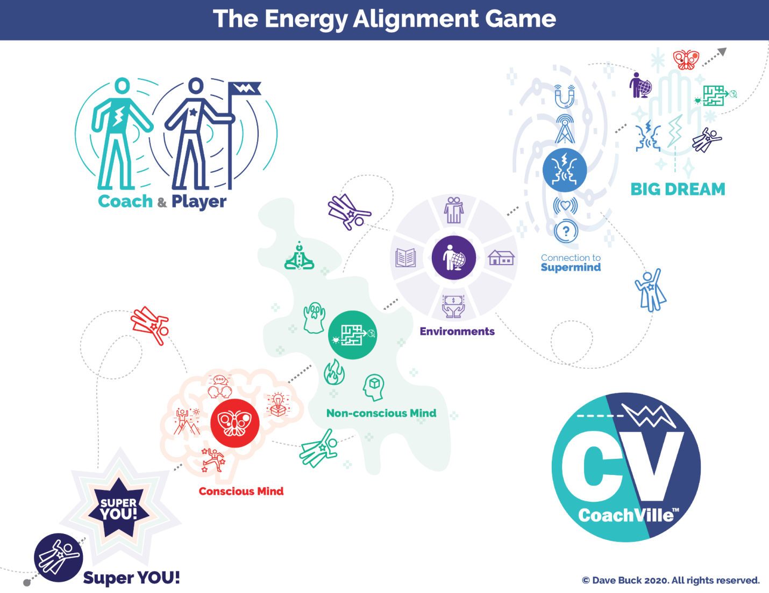

Here is a brief overview of this super fun game to get you energized!! I will highlight a few points about how this wisdom is woven into the fabric of the BIG Freedom Play Group.
On a personal note: I can still remember the day Thomas said to me: “Dave, you should stop this health thing you are doing and be an Attraction Coach. You’d be awesome at it and there is a huge demand”. The thought had never occurred to me! Basically I replied: “OK Thomas”. I changed my website, and sent out an email to my “Healthly Habits” email list about the change. The rest… is history! Thomas was right. My coaching business – which was going really well - quadrupled almost overnight.
One more little note: There are MANY MANY ways to play with Energy so this is not intended to be a definitive guide.
OK. To get started, recall the Human Journey with a Coach Model.
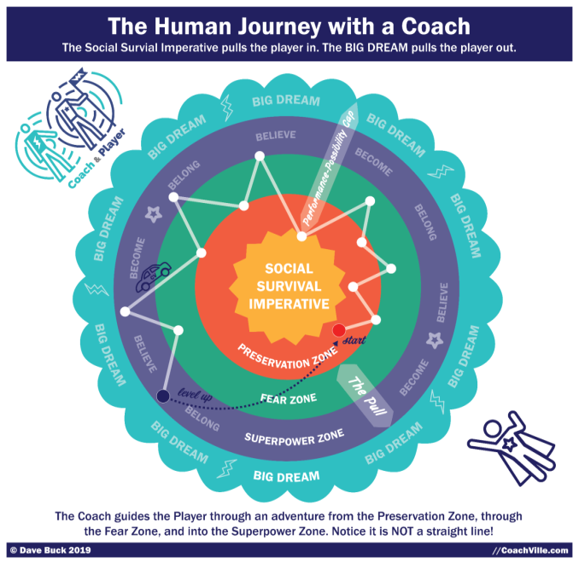
In the preservation zone, your energy doesn’t need to align because you are mostly trying to maintain your current situation with the occasional incremental upgrade.
But when you set your heart on a BIG dream, YOU must endeavor to raise each of the elements into alignment with the new dream. This is part of the adventure and requires effort and imagination. And as I have mentioned before, it is wise to have a coach / guide who knows the territory!
Super YOU:
There is a next-level version of you that YOU must express fully and become in order to fulfill this big dream.
Conscious Mind:
There is a playful version of your focused thoughts and deliberate actions that you need to use in an intentional way to uplevel your skills to align with the new dream.
Non-Conscious Mind:
Whoa. This is a big one. You will need to uplevel your body awareness, desires and beliefs to align with your dream. You will need to believe in a whole new set of possibilities. And you will need to uplevel your relationship with fear.
Environment:
Your non-conscious mind - which is super focused on belonging - is in constant connection with your environment. You will need to uplevel many aspects of the world around you so that the powers of belonging and becoming align with your dream.
Connection to the Super Mind:
There is a timeless web of human consciousness that we are all connected to. You can – and need to – tap into this connection in order to play for a BIG DREAM.
The pursuit of flow:
Remember, the self-preservation part of you does not want you taking the risks required to pursue your dream. It is 100% focused on keeping you right where you are; you are alive and have some level of belonging so this is good enough. Your self-preservation instinct does not care about purpose or fulfillment or joy; only survival.
Meanwhile your dream is calling you out into the world to discover a bigger contribution and more fulfilling joyful life. As you endeavor to align every part of your energy to the BIG Dream, it begins to FEEL – feel is the key word – more natural. This is called getting into the flow. It is not routine, it is engaging, yet safe enough that the self-preservation instinct stops pulling so hard. This is when pursuing your BIG Dream feels less and less stressful and more and more fun!
That is what we are playing for!

Energy Alignment Game = Super Mind
{Image}
Content from Play Life Playbook or BIG Freedom

??? CV Coaching Framework ~ Elevate your Life Coaching
{Bring in new graphic and new content}
{talk through the deeper concepts from Inner Freedom}
Coaching happens by playing together with someone and by observing and demonstrating as you guide them toward playing better. This is a big idea that will uplevel your coaching over time as you experience it in the BIG Freedom Play Group. Hopefully you get excited about these kinds of things like I do! LOL.
Here is a the CV Coaching Framework to give you a picture of what I mean.
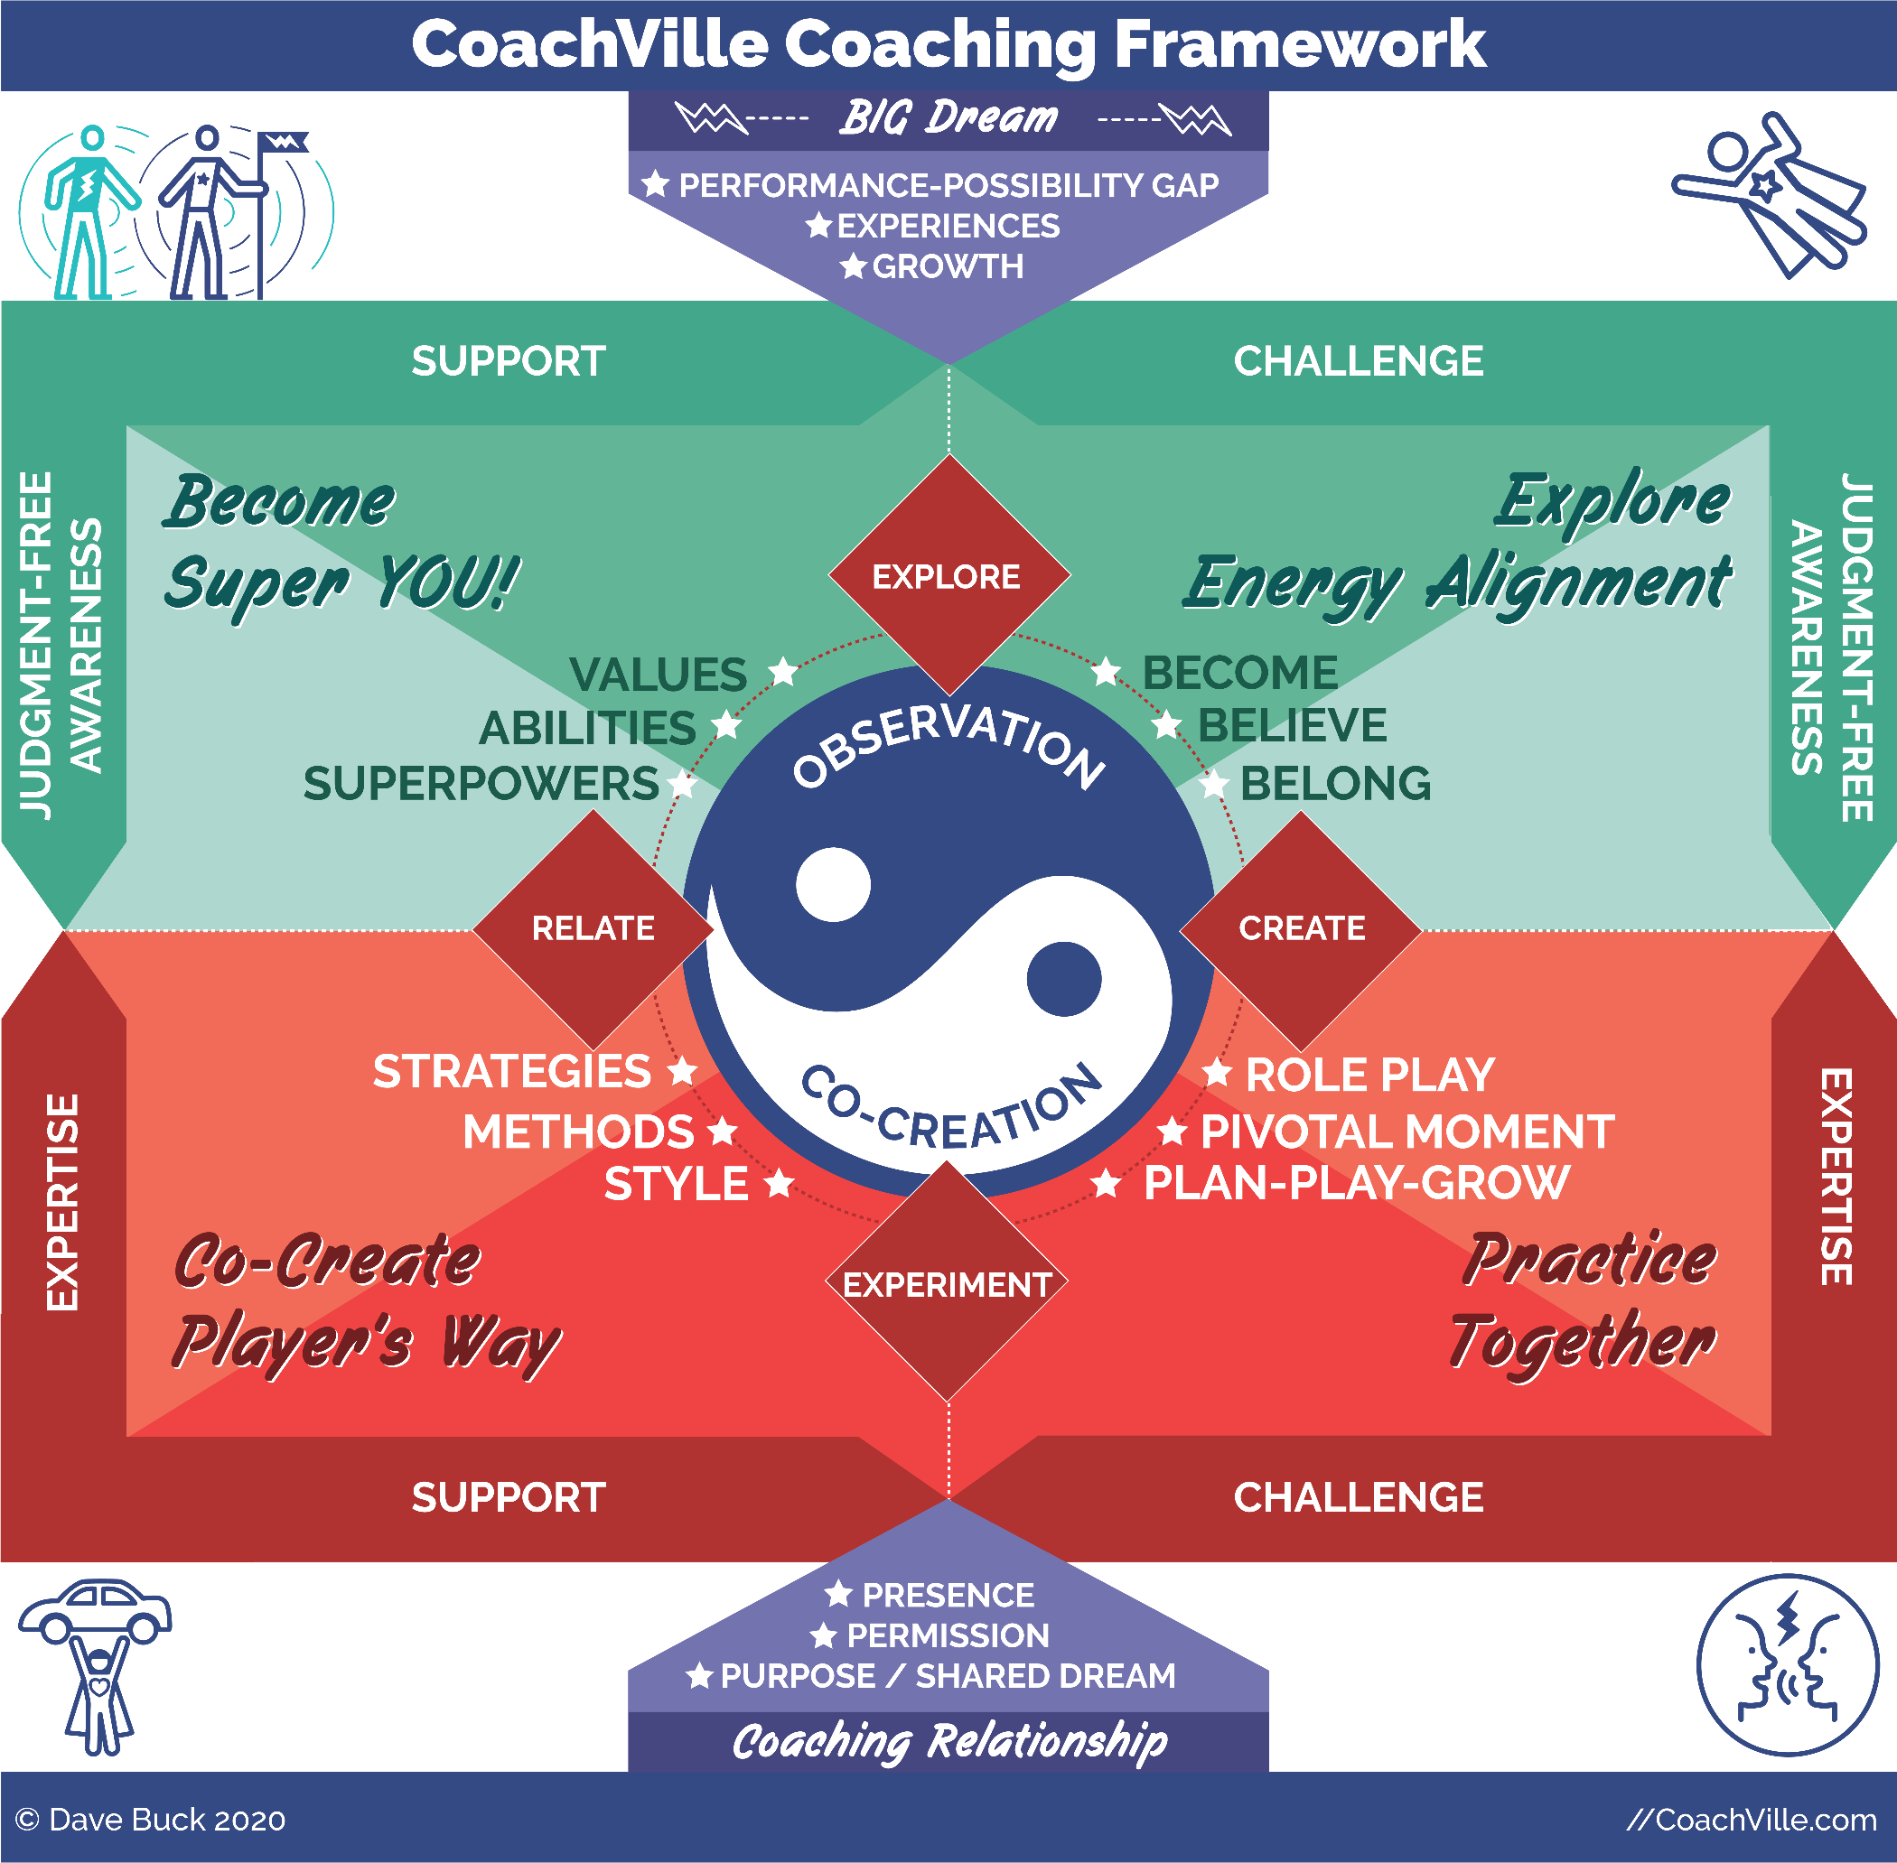
Observation ~ Co-creation
This is the fancy way of describing the core of the coaching relationship. The plain talk way of saying it is: Play together –Talk together -Play-Talk-Play-Talk.
You play together while the coach observes the player and the player observes the coach. Then you talk together in a co-creative way to learn from the experience. Then you play again and usually play a little better. It’s a loop that keeps the relationship growing and the player spiraling upward in mastery and confidence.
This is how coaching happens in athletic and performance art coaching and most people have an experience or an understanding of this process. If we want Life Coaching to become a mainstream force for transformation in personal growth, business or leadership, we need to bring this fundamental into it. We have to uplevel Life coaching from the realm of just talking about stuff; especially problems and tasks!!
In other words we need to go from: talk-talk-talk-talk to play-talk-play-talk!
In Life coaching (including business and leadership) the fundamental way that we can play together is known as role playing. This will be the essence of the small group coaching within the BIG FREEDOM Play group as I described in Section I.
In these experiences you will get better as a player. And you will also jump in and play roles for your colleagues to practice with. This will help you become more playful and resourceful as a coach. In addition you will be observing and participating in the feedback process. This too will expand your coaching observation abilities.
The four ways to play life
You will notice at the center of the model around the Observation ~ Co-creation yin/yang symbol the 4 ways of playing life (also described in Segment 5). This is what you will be observing and talking about as a coach and colleague in the group and then with your players.
The 4 quadrants ~ from somewhere??
Way of being Exploration
I want to call your attention to the upper right quadrant. You will notice the 3 forces of human expression: Become ~ Believe ~ Belong (Described in Segment 3). While in these coaching experiences you will notice yourself and your colleagues exploring and expressing these forces of change within their own lives. This will be quite illuminating.
Person-Focused Exploration
This is the “unleash your unique power” portion of the coaching experience! This is where the coach can point out what they are seeing in the player that they probably don’t see in themselves. We will do this with you through the group and 1-1 coaching experiences. Your Superpower Charts - which I will share with you in the Segment 13 – will take this process into the realms of ancient wisdom.
Important! We are ALL yearning to be seen and known for who we really are.
One thing that accelerates and deepens this experience is frequency of contact. That is the benefit of the multiple touch points in the BIG Freedom Play Group. As a coach you will develop your own style for these deep conversations and revelations.
Way of Doing Sharing & Action Focused Sharing
The bottom half of the coaching model refers to the action; the “how” and “what” of playing better.
In our experiences together while you are the player, this is all the business activities in your business ecosystem and all of the specific skills and actions we will practice in the group coaching sessions. In the model your business methods and strategies are on the left and your business skills are on the right.
As a coach this illuminates your signature coaching method AND your personal experiences that you will share with your players. When you role play with your players, your personal experiences and wisdom come through. While coaching, you may also switch roles with your player to demonstrate how you would do something. This is REAL Coaching.
All of this is in service of guiding your player in pursuit of their unique way of playing better for their dream.

Class 06 Prep

Chapter 7 – The Flow of Gratitude

{Great Quote}

Coaching Notes for Session 7 - The Superpower Zone
READ the Coaching Guide for Step #7
Quick overview
a) Go quickly through steps 0 – 4
b) Go into Step 5 - 7 in detail (The Supermind Zone)
c) Go quickly through step #8: Make your mind the ally of your Dream (create Dream language)
d) Go quickly through step #9 Preplay the Pivotal Moment (with Dream Language)

Inner Freedom Method Step 7: Embrace the flow of gratitude

Gratitude is a popular topic in self-help circles. It is powerful because a deep sense of gratitude is a powerful energy pattern. But how do we experience “deep gratitude” where you “feel it” and “think it” and “experience it”.

This is the ultimate outcome of the Inner Freedom Method.

It starts with the purpose to play BIG – expressing your talents in a way that adds value to the lives of others. When you play BIG with a heart-guided intention a LOT of energy starts to flow.

Then you feel the energy in your body and uplevel your understanding of energetically charged events in your past. You see how they served your bigger purpose.

Then the body feels safe.

Then your mind opens up and begins to think in terms of possibility rather than survival.

Then you start to see and experience the perfection of the current moment. Your experiences of support and challenge are ALL serving your hearts intention.

You begin to see that the universe IS playing on your team; then that shifts to you seeing that you are on the Universe’s team! Where do you think your hearts intention came from in the first place???

When all of this comes together – you feel it deep inside of you; then you are truly free to play BIG, to express yourself fully, to LOVE all of life’s experiences and to fulfill your purpose in the world one beautiful moment at a time.

The big question is: who must you become?
IF you desire THAT...
First you must become THIS.

You must understand the cycle: your desires attract experiences to cause you to expand and allow the desire to unfold. When you do, you can play big and enjoy ALL of it.

Connect the dots
{speak this}
This is in the coaching guide to help the player connect the dots between the earlier moment (or at least the body belief) and the current situation.
How the BIG dream attracts the perfect growth opportunity.
How this memory pop is the perfect clarity for this situation.

How amazing it all is.
? Maybe Natasha example again ?

Your challenges are calling for your Superpowers!
Write this out.

Coaching Proficiency: Recognizes Perfection
{grab some of the content}

Understanding Perfection and being fully engaged and in the flow of right now (2010)
Understanding Perfection is essential to masterful coaching.
It is one of the coaching proficiencies: Recognize the perfection in every situation
And one of the frameworks
There is a perfection in every situation.
It allows you to be fully engaged in the flow of right now, empowered and resourceful
It gives you power in the domain of Action and the way you Interact with the world
What does it mean to see the perfection in the situation?
You see what is happening as serving your intentions in some way.
You see the BIGBER picture of how each moment in “your world” is a part of a bigger whole.
TRUST: there are many paths to your heart-based intentions; so even if what is happening appears to be a setback, it may prove to serve your intentions in a way that right now you cannot see.
Clarity of purpose and clarity of intention make it easier to see this framework
In our play language we would say: When you are playing for a heart- based intention, the universe plays on YOUR TEAM
However, you have to know HOW the universe plays!
The universe plays BIG. So when it sees that you have the desire to play big, it will send you BIG challenges so that you can step up and become a big player
It will also send support, but you have to be willing to see it and receive it.
The universe will align to prepare you to become the person you need to be to manifest your intention!

Expand your understanding of the Pattern Language of Survival Intentions (2010)
What is a survival intention?
These body level feelings become the non-conscious thoughts that drive MOST of our behavior.
- It is a decision you made about what YOU must do to survive in this world (to avoid pain/trouble)
- It is a decision you made about what you must NOT do to survive in this world (to avoid pain/trouble)
- An intention to: Keep safe - Stay small - Fit In
- An intention to stay out of sight - avoid trouble
- Your story of where you fit in the world
- Your beliefs about how the world works for you
- An intention to avoid disappointment - especially by not asking for or going for what you really want
- Often the Survival Intention “explains” why you “do what you do” or “don’t do something you want to do” in your current situation.

Key Distinction: Pattern Language
- Pattern language is a phrase that captures the essence of the experience.
- You want to find a phrase based on what is shared about the earlier moment; it really captures the energy and emotion of the experience; as close to the words of the age of the memory as possible.
- don't try to be nice about it NOR judgmental
- shine the light on it by stating it plainly
- if it was a painful decision to make about life state it in a way that captures the "pain"
- emphasize that this is a pattern of thought
- The player can probably think of many instances where it played out in a similar fashion after the original time; This is because once we make a decision about how the world works, the world works that way.
- We mostly see and experience the world around us based on the patterns that are already in our minds. Until we use Inner Freedom that is ;-))

We become what we see in the world. We see in the world what we have become.

Examples: Language patterns we use to keep ourselves safe
> "Nothing I do is enough so it is best if I don’t try too hard".
> "If I win I will suffer, so I won't win".
> "If I go for what I really want I will be rejected or disappointed, so it is better if I don't ask”.

Expand your ability to create maximum value and awareness from “memory pops” (2010)

Does YOUR capacity to feel affect your player?
1) Your Coaching Presence is a HUGE gift.
2) A player will only share a memory that they feel YOU can handle.
“If I can’t share my pain with you, without you trying to fix it, I can’t tell you anything.”
3) You can talk about anything YOU are comfortable with
4) If you are not comfortable talking about a memory...
a) help them make a plan for who they can talk to.
b) shift the attention to the present moment and how they can bring wisdom to the situation

See the perfection - the key to coaches comfort is practice and ability to see the perfection; power in the moment; increased self-worth

To get a memory pop...
When having them feel the energy in the body,
ASK "when was the first time you remember feeling this energy in your body".
WAIT and LISTEN.
move forward with the method
Key points about how emotional energy gets stored in the body
AS we have already discussed, any experience that has MORE emotional energy than you are equipped to handle at the moment - will be stored in your body.
MOST events that were emotionally overwhelming to you as a child will be seen as "normal" or " part of life" as an adult.
AND ... IMPORTANT
Death and abuse ARE a part of life. Sad, and true.
You will have memory pops with players where they were abused, they were the abuser or they were a party to a tragic event.
What to do when the memory pop reveals an experience of abuse or tragedy...
1) Be fully present - compassionate AND not getting lost in the story or taking sides
2) Warmly matter of fact - you embrace that this happened - RELISH TRUTH
3) Recognize the perfection - you hold the deep truth that no matter what happened there was “a perfection” to how they chose to respond in that experience; not necessarily to the experience itself.
Somehow what happened fueled them through life in some way that served a greater purpose for them.
4) Don't DWELL on what happened!
Go right into - what conclusion did you come to about life?
How did they find a way to survive the situation; to “play safe”.
This is where you will find the pattern language of the survival intention.
One fact that cannot be disputed is that they survived!
5) Move through the method - focusing next on what is the perfection of survival intention.
How did it protect you?
Or
How did it propel you forward in life?
BIG INSIGHT
Often in an abusive situation there is usually some inner response like:
I am going to prove to you that I AM somebody.
OR
It is not true what you are saying about me.
Or
I am going to make sure this never happens to me again.

This "I will show you" is a POWERFUL source of fuel that propelled your player forward in life.

How to deal with a memory pop of a traumatic moment
1) Remember, they will only share the details if they feel safe with you, that they feel that YOU can hear it. The benefit of hearing a little bit of the detail is that it supports the conversation to understand and articulate the survival intention. BUT… it is not essential.
2) If they share something that YOU are not comfortable talking about, ask them not to get into the details. Move the conversation toward the survival intentions that came out of the moment
3) As a coach you can talk about ANYTHING that you feel comfortable talking about. You are a life coach. so anything in life is possible to talk about. (Even if you think of yourself as a business, career, executive coach etc. you are still in the domain of a “life” coach. So be prepared for ANY part of life to enter into your coaching conversations.)
4) Many coaches fear that talking about past moments that were traumatic is doing therapy. It is not! Talking about past moments is a fully human experience and cannot be “owned” by any profession. It is only therapy if you claim or attempt to heal it in some way. You are exploring the past moment to come to co-create awareness of the survival patterns.
5) As a byproduct, it is often a "healing" experience but that is not your focus. Remember you are not trying to release it or fix it.

Energy Alignment Game = BIG Dream
{speak this}
going for what we REALLY want in life
we only allow ourselves to dream what we can logically understand.
But we are capable of sooo much more.
Coaching is challenging players to DREAM Bigger
** ALSO… the BIG Dream is next to the Supermind… Play the “I Wonder…” Game

Coaching Proficiency = Expand the players BEST efforts
Prime your mind for session 8… do something AMAZING

Class 07 Prep

Chapter 8 – Make Your Mind the Ally of the Dream

{great quote}

Coaching Notes for Session 8 - The Whole Method + Role Play
Read the Method for Step #8

Quick overview
a) Step 0: Choose a conversation to practice
b) Step 1: Replace the Preplay with a Role Play
c) Call time-out in the Role Play
d) Do the Inner Freedom Method! Especially… find a Superpower to practice.
e) Go through step #9 Preplay the Role Play (with Dream Language)
Note for class: with your class partner, the key is to practice the flow of Role Play – Inner Freedom. You may not have time to go deep into steps 3 and 4 in class.

Inner Freedom Method Step 8: Make your mind the ally of your Dream
From React to Respond by Thinking “holistically”
Transformational Shift: From react to respond
React - your mind supports your Preservation intention (usually something keeping safe, staying small or fitting in)
Respond - Your mind chooses to support your Heart’s intention to play BIG
Your mind is your ally when you can think holistically about the current situation without emotions from the past clouding the picture.
This is why thinking comes AFTER feeling the energy. When your body is feeling buzzing energy from the past it will focus your thought process on preservation.
When you feel the energy your body relaxes and then your mind is free to think thoughts that are aligned with Playing BIG.. This is when your mind becomes the ally of your dream.
Another BIG point here: When you practice feeling into the energy caused by earlier moments in life, you can then more clearly feel energy related to present- moment intuition. There will be times when what you feel in your body is a “knowing” that IS related to what is happening now and that your conscious thoughts should pay attention to.
Key Point...
What are often described as “Negative thoughts” are almost always thoughts serving a PRESERVATION - nonconscious – INTENTION to keep safe, stay small or fit in. And they are serving IT in a positive way. There is nothing wrong with the thoughts you have.
All thoughts serve a purpose. They may NOT be serving your new Heart’s intentions for playing BIG – but they ARE serving something.
Your mind is powerful and we will make it the ally of your dream by creating awareness of the PRESERVATION INTENTION, seeing the value it has had and then choosing a new intention. “Personal Growth” occurs when you expand your palette of intentions and corresponding thought patterns and consciously choose.

CREATE New Pattern Language
With your player in a relaxed and open state you begin to explore options for new Pattern Language.
This new pattern creates a CHOICE that is a step beyond the Pattern Language of the PRESERVATION Intention.

What is pattern language? (2010)

Abera Ca Dabera
First we have to understand the power of words.
Have you heard of the phrase used by magicians:
Abera Ca Dabera:
It was first used by Harry Houdini who was a great escape artist.
It comes from the Aramaic language
It means: I create as I speak
Your language CREATEs your life vs. your language is a report about your life
You have the power to use pattern language to create moments when you feel alive.

Pattern Language
A Pattern Language was first distinguished by the Architect / Philosopher Christopher Alexander in the Book: "A timeless way of building"
A pattern language captures the essence of an experience.
People speak in patterns; some patterns bring the person to life, some drain the person of life.
When you tune into your player, you will hear the phrases that have strong energy - both enlivening and deadening.
As we go deeper into the Inner Freedom Method the big idea is to tune into the phrases that have energy as you go through the steps.
Then you can help them create a new experience of life by creating new language patterns.
The BIG POINT - if you just try to create the new language without first creating freedom around the existing language it does not work. This is why just saying new affirmations rarely brings about change.

The Power of Metaphor
You have probably realized by now the HUGE influence that your non-conscious mind has on your moment-to-moment life.
Your body holds your emotional memories and survival intentions.
Your spiritual connection holds your desires to contribute and Heart’s intentions.
Note: The spiritual connection seems to exist in the space between our body and the world but it comes to you through your body.
The interesting thing is that the non-conscious operates in pictures not in words.
However the right words can capture the essence of the feeling in the body and provide a bridge; we call these phrases “Power Patterns”.
So, it is very important to become fluent in “Power Language” and the best way to do this is by reading poetry! Yes, poetry. A great poem uses words in the form of metaphors to create a feeling experience.
The poems of Persian poets Rumi and Hafez are especially wonderful in this way.
Here are two of my favorite examples
The Guest House
“This being human is a guest house.
Every morning a new arrival.
A joy, a depression, a meanness,
some momentary awareness comes as an unexpected visitor.
Welcome and entertain them all!
Even if they’re a crowd of sorrows,
who violently sweep your house empty of its furniture,
still, treat each guest honorably.
He may be clearing you out for some new delight.
The dark thought, the shame, the malice,
meet them at the door laughing and invite them in.
Be grateful for whoever comes,
because each has been sent as a guide from beyond.”
- RUMI

Your Ascending Shape of Laughter;
aka The Potters’ Wheel
“Let my words become like a skilled potters hands.
Quieting, smoothing your life with their knowledge.
Reaching into your tender Heart’s Dream and spreading you out.
Like the morning, that leaps from the suns’ amused wink
Onto hills, brows, and the backs of so many beautiful laboring beasts.
God’s duty is to make perfect ALL of your movements;
Of mind, and of limb and your ascending shape of laughter.
Watch me way my hands dance,
With their diamond edged brilliance cutting you open with music,
Touching your heart and spilling that night sky jar you carry
That is always so full of giggling planets and stars.
My words are like a divine potters’ wheel.
If you stay near to me, please stay near to me.
And I will spin you, into…
LOVE.
-Hafez (rendered by Daniel Ladinsky)

From React to Respond ~ out of isolation & deeper into playfulness
{speak this}
When your body feels safe; your playful mind awakens!!
Creative, Connected, Resourceful, Resilient

The underlying fear that we are not enough…
Plus the Industrial Age… do your own work.
We are capable of so much more + We are here to play together. To co-create with others.

Energy Alignment Game = Playful Conscious Mind
{little model of energy Alignment Conscious Mind / Brain}
?maybe a look at the Weekly Play Plan Sheet and encourage for MORE!

Going deeper with Role Play?
{speak this}
Adding twists
Challenge them to step into their power
Reverse Role Play = You be them… what their superpower could sound like
Leads into Raise the Dream!!

Expand Your Band
Upgrade this a little bit; it also leads into Raising the Dream
This is where the Inner Freedom Method becomes REALLY fun.
“The Band” refers to the range of activities that you feel you are “allowed” to do.
Allowed is an interesting word here because the way restriction of Inner Freedom operates in our daily lives feels like we want to do something that we are not allowed to do; it’s like being young again and if you do the activity you will get “in trouble”.
The intention here is to bring each non-conscious boundary to the surface so that you can explore it with “new” or “Play BIG” eyes.
Another way of describing this phenomenon is this: a great player in any endeavor is one who can “see the whole field (of possibility)” and choose any action in the field at any time. Lesser players can only see what is right in front of them and are not capable of making plays in certain parts of the field.
With the Inner Freedom method you can explore more and more actions within the field of possibility and choose the best action in the moment for your BIG Dream.

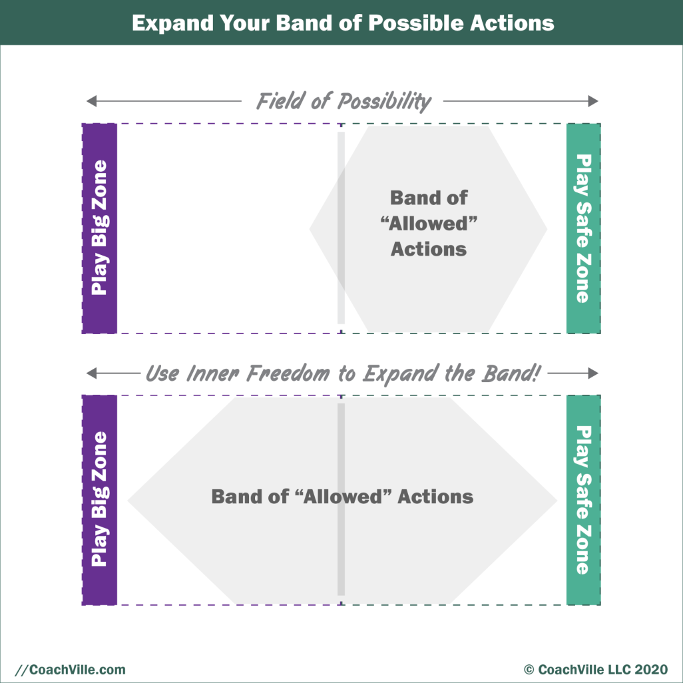

RAISE the DREAM
{the more complete Dream Playsheet}
What do you REALLY WANT????
What could you dream if you weren’t limited by what you think you can do by yourself?
What is the impact you want to have on others in the world.
Your DREAM TEAM!! (a precursor to #10 World Power Combo)

Do something AMAZING
Challenge your player to PLAY Bigger
} thinking about Expand Best efforts… what can you request of them… invite them to??

Coaching Framework = Observation ~ Co-creation
{what have you seen in your player?}

Coaching Framework = Challenge
{speak this}
What are they capable of doing NOW that their playfulness and unique powers are emerging.!
We are waiting for someone to see us and ask us to do what we are capable of.

Class 08 Prep

Chapter 9 – #9 Preplay the Pivotal Moment
+ Intentional Co-Creation

{Great Quote}

Coaching Notes for Session 09 Intentional Co-Creation
Quick overview
{type this up with more clarity}
a) Step 0: Choose an activity to practice with intentional co-creation
b) Step 1-9: Go through the revised method;
c) Step 4: New Body Belief: I am now ready to…
d) Do the Inner Freedom Method! Especially… find a Superpower to practice.
e) Go through step #9 Preplay the Role Play (with Dream Language)
Note for class: with your class partner, the key is to practice the flow of Role Play – Inner Freedom. You may not have time to go deep into steps 3 and 4 in class.

Intentional Co-Creation Inner Freedom Coaching Guide
READ the coaching Guide with revised steps for Intentional Co-Creation
{Need to tweak the Coaching Guide for this}

Inner Freedom Method Step 9: Replay the moment with new pattern language
{uplevel this writing}
This is where you go back to the moment you started with and replay it with a new picture.
You start by re-stating the new Pattern Language that you identified in Step 6.
You have your player imagine the experience going beautifully - in the best way they can see.
Then after the player does the visualization, ask them to describe what they saw.
This will give YOU important insights into their current level of inner freedom.
Can they even allow themselves to see a new experience? What level of detail can they see and share?
AS you listen you will pick up on phrases that have more energy for them. YOU will be able to feel it as you listen.
Then together you start to create a phrase - pattern language – to capture the essence of the new experience with energy and positive emotion.

Control to Co-Create with… (deeper)
{speak this}
This is a huge thing for Industrial babies…
To know that you can co-create
With other people
With what is
With the Supermind / Universe

Your Dream is worth it.
Your Dream is supported

Getting Beyond Frustration!!!
{speak this}

Celebrate Breakthroughs… boost Self-Worth (2010)
By playing BIG in the Inner Freedom Method class you will co-create breakthroughs for yourself and with your players.
What constitutes a breakthrough?
Any time you or one of your players does the following…
You experience a memory pop that creates a big awareness.
You see the perfection of a survival intention that creates a DEEP understanding of who you have become and WHY!
You see the perfection in your current situation that creates a BIG awareness.
You take an action that was outside of your comfort zone (outside your band or allowed activities) WHILE feeling the energy in your body.
You co-create a result that had been eluding you.
You experience a feeling of judgment-free awareness for yourself or someone else.

It is super important to notice, claim and share your breakthroughs because they facilitate a HUGE boost to your self-esteem; the feeling of being capable and worthy.

Expand your ability to create new pattern language {review these notes}

This is from Step 6: Make your mind your ally

SAY: Now what we want to focus your mind on your NEW HEART’S DREAM Intention to play BIG
ASK: What is your HEART’S DREAM intention?
Listen. Also you can remind them.
SAY: Let’s create a short phrase that captures the essence of your HEART’S DREAM Intention and is just one step beyond your Survival Intention. A way of being that is just one step outside of your current comfort zone?
You can keep exploring examples until you feel that they have one that feels right when they say it; This step is where you create new pattern language for the HEART’S DREAM Intention.
Coach Note: This is where they have now shifted from react to respond

The Short Phrase is the Pattern Language.
Let’s explore this concept a little more

You want to find a phrase for WHO the player wants to become; It can begin by capturing what they see themselves doing.

When you co-create pattern language, it’s not about finding the perfect pithy phrase. Just find an energizing phrase that starts the process.
Pattern Language:
1) A phrase that brings an experience to life.
2) It captures the energy essence of something/experience/place
3) It is often a simple statement of capability.Eg.
I can ask for what I want.
I am allowed to win.
I can enjoy what I am doing.

Remember: the survival intention is typically a raw statement of something to stop doing or a way to survive a bad situation.
Eg.
Don’t ask for what you want… because I won’t get it anyway.
Don’t fight for myself … because I get into trouble.
Don’t express myself at home … because I get into trouble.
I am not allowed to win… because it makes my sister upset.
Just soldier on

Here are few steps to identify the Heart’s Dream intention pattern language.
Step 1) as your player is sharing about the Heart’s Dream intention and who they want to become to create the new results that they desire. As they share, you listen for a phrase that seem to “light up” when they say it.
Step 2) You continue to dialogue with your player to hone in on one or more of these Power Patterns and then ask them to choose the one that best fits the current situation.
Important:
Watch out for “pipe dreams”: ways of being that are too perfect or too far off.
Also
Watch out for “affirmations”: attempting to make something true by saying it over and over.
These are not helpful when creating new pattern language.

Additional Notes
In step 9 of the Method you will use this phrase to guide your player to create a new picture; seeing themselves in the situation with the freedom to act in the best possible way.
In the World Power Method program you will learn a lot more about creating and using Pattern Language to design a winning environment.

Class 09 Prep

Chapter 10 – The World Power Connection

{Great Quote}

Coaching Notes for Session 10
Role Play & Inner Freedom for a BIG ASK!!
It could be play with the fear OR it could be intentional co-creation.

Social Risk & ASK your Dream Team

World Power Connection
Energy Alignment Image

Create a place of belonging for SUPER YOU!
A safe environment for your emerging Superpowers
{speak this}

Recognizing Perfection expands your self-worth (2010)
Seeing the Perfection in both the current situation and the survival intention is an essential part of the Inner Freedom method.
EVERY situation you hear about in class adds to your understanding and awareness and makes you a better coach. By sharing your example, you help EVERYONE become a better coach.
Your instructor will ask you to share an example from your life; either a current situation where you can see the perfection of the challenge, a survival intention that you can see how it served your life in an important way.
When you see a current situation or a survival intention from the “Perfection Perspective” it greatly increases your self-worth. This happens because you begin to see that the Universe is on your team and conspiring for you to fulfill your purpose. When you see “life” or circumstances or the Universe is conspiring against you it depletes your self-worth.
When you see that the Universe is on your team to fulfill your purpose it helps you move from attempting to control to co- creating with the universe and “what is”!
Upgrading your perspective on Good and Bad
How did we come to see that the Universe is conspiring against us?
When we are small we perceive everything in the world as directly related to ourselves.
We learn from the big people around us that:
good things happen to good people and
bad things happen to bad people.
The big people are not being malicious in teaching this to the little ones, it is just how THEY learned to manipulate little people to doing what they are told to do.
So we learn to think that when anything bad happens around us or to us it must mean that we are bad.
This perception quite naturally finds its way into our survival intentions and becomes a pattern of thinking and seeing the world.
However with practice you can see the world of your personal circumstances and events in a new way
You can practice seeing the perfection in “bad” things
- Survival intentions from earlier experiences (choices to stay safe) - how they served you in becoming who you are today.
- Current challenges and situations – how they are serving you in becoming a bigger player

Question: Share an example of something that you once viewed as bad that you know have a more neutral perspective or even a perfection perspective?

How can a challenge serve your intentions to play BIG?
- It is asking you to expand who you are in the world
- It is serving your intentions to add value to the lives of others
- By fueling your desire to accomplish something
- By bringing awareness to your Heart’s Dream values
- By bringing awareness to your deep desires (or awareness of what you don't desire)
- By expanding your capacities to add value to others

Imagine the universe has created this situation to challenge you to step up.

The BIG Question: Think of a big challenge you are facing right now…
Who is the Universe ASKING you to become???

How we learn to fear our self-expression (2010)
As you learn to play with FEAR and step up to the big dream actions that are out of your comfort zone, it is super valuable to understand where some of our deep fears come from.
A great example is how we come to fear our own self-expression.
The archetypical story goes like this:
When you are a very young child you learn how to draw with crayons of water paints or something similar. Then you get the bright idea to decorate the wall in your room with you new found artistic skills. In most cases this makes the big people really upset and they start yelling… or worse.
This archetypical story can take many different forms – painting, singing, dressing up, building something out of “parts” you find around the house - but you get the idea.
When you are small and something like this happens you don’t have the perspective to understand why the big people react the way they do. For example, maybe your parents went through a big challenge to have the room painted and now it is “ruined”.
The “play safe” conclusion that you create can take many possible forms. Here are a few examples:
- People get mad when I create something
- My art must be ugly
- I should not trust my own ideas

Our biggest FEAR is our own Super Powers (2010)
Another very common human experience is when you express an aspect of yourself or a quality that is natural for you BUT creates a negative experience in some way.
An example would be a young person with natural leadership skills attempts to “take charge” in a situation but instead of being rewarded you are scolded or belittled in some way by the “BIG” people.
Another example is a young person with a natural sensuality that attracts intimate attention. This can be a super power when used to create intimate connections that forward a shared purpose through profound relating. However it can also create unwanted affection that can lead to “dangerous” situations for a young person. So it is easy to understand why someone would put a lot of non-conscious energy into suppressing sensuality and intimacy.
I have coached over 1,000 people in deep 1-1 conversations and almost everyone has a non-conscious FEAR of expressing their own natural unique capabilities.
Question: Share an example of a self-expression or a Super Power that you have learned to FEAR.
And any insights you have gained by playing with that fear?

Class 10 Prep

Chapter 11 – The New YOU!

Coaching Notes for Session 11??
Teleclass Note = Speed Drill
?? Read through a speed version of the Coaching Guide.

Revisit Finding and coaching pivotal moments of choice
What is a Pivotal moment of choice?

- A recurring moment that has a big impact on your results
- A moment where nonconscious patterns are moving you away from Pivotal actions
- A moment where you are out of your comfort zone
- A moment where you are doing something that will have a big impact like a presentation to influential people

Question 1: Share a few examples of Pivotal Moments that you have explored in your own dream and with players during the program?

Question 2: What have you learned about “uncovering” pivotal moments in pursuit of your Dream?

Re-Visit the Pull: What have you learned about it
In this session your instructor will lead a dialogue about you and your dream. We are nearing the end of the program. Is there something in your big dream where you are facing inner resistance that you have not yet explored? Now is the time to do it!

Question 1: Share about one or more activities that you were resisting but are now free to play with?

Question 2: What is an area of inner resistance that you have not yet gained freedom to play with?

Fearing the unintended (and unwanted) consequences of success (2010)
Often when we talk about the fear of success, what we are really talking about is the fear of unintended and unwanted consequences of success.

If you have listened to the sessions with Player Natasha you heard a great example of this. When she was a young girl she had the opportunity to win the prize of a new bicycle if she got the top grade in her class at school. She made a conscious decision NOT to win the prize because of the fear that she would be rejected by her sisters if she won the bicycle.

Let’s explore a few more examples.
You get a promotion within your company. Then your best friend who was your peer doesn’t feel comfortable connecting with you anymore.
Your business starts making a lot of money. Then your sibling who is always struggling financially expects that you will support him financially because you have so much. Whether you do or you don’t, this creates a ripple effect of discomfort throughout your extended family.
You are invited to speak at an event which is something you have been striving for. When you give your speech you share a few of your strong opinions. After the speech a few members of your community avoid you at meetings.
When you think about unintended consequences, it is powerful to really get creative about all of the possible negative things that could happen. This will do two things:
1) It will help you prepare emotionally for anything that might happen; this makes you mentally and emotionally stronger
2) It is a great way to exercise your imagination and embrace the idea that you can play with ANY fear.

Think BIG Now! Who can you coach?
{speak this}

Quick review – When to use the Inner Freedom Method (2010)

There are several coaching situations where the Inner Freedom Method can be used to great effect.
Starting with the situations we have already discussed...
1) When your player is not doing something they intend to do
2) When your player is powering through their own inner resistance to do something important.
It is a struggle; they have to FORCE themselves to do it.
3) When something is not happening even though your player is taking action -a desired result is being created
And in addition when…
4) They have hesitation or fear about something they are about to do
- it is very powerful to use an Inner Freedom “Pre-Play” to expand the capacity to feel BEFORE they do it.
5) They say "I don't know" or "I don't know what to do"
Remember: when someone says "I don't know" this means that they are not feeling their body. Thinking - logic and reason - are in the head / conscious mind; knowing is in the body
So.. I don't know means
a) I can't figure this out with logic AND
b) I can't access my intuition
c) I can't access my intuition means I can't access the wisdom in my body
6) If they say: "I am overwhelmed"
Overwhelm happens when a person is not able to feel.
Overwhelm is not caused by too much to do. You can only do what you can do. So overwhelm is caused by the energetic feelings about what you will NOT do.
In other words, what you FEEL in your body when you realize or think about what you can't do is what causes the experience of overwhelm.
So the key is to practice feeling the energy so that it flows through you. Then you can be fully present to what you ARE doing.

CV Coaching Framework ~ Overview with Inner Freedom Spin
{speak this}

Inner Freedom – the capacity to choose
When to play BIG and when to play safe.
{speak this}

Class 11 Prep
?? Re-Visit the BIG Question: What are you resisting?
In this session your instructor will lead a dialogue about you and your dream. We are nearing the end of the program. Is there something in your big dream where you are facing inner resistance that you have not yet explored? Now is the time to do it!

Question 1: Share about one or more activities that you were resisting but are now free to play with?

Question 2: What is an area of inner resistance that you have not yet gained freedom to play with?

Question: Think of something BIG that you are playing for right now. Brainstorm several possible unintended or unwanted consequences of success. Include a few that feel real and close to your heart and a few that are further out in your imagination.

Chapter 12 – Celebration & Becoming precedes results

Coaching Guide for Session 12
READ the Guide for celebration

Review the specifics of the Dream
{talk through}

Energy Alignment Celebration Playsheets
{talk through}

Becoming precedes results (2010)
{talk to expand}
In ANY big dream, there is someone you must BECOME before you are able to get consistent results. This is the nature of play: WHO you are as a person and player is what determines your ongoing success in pursuit of your Dream. So often there is a lag between all of the effort you are putting into improvement and when you start to see the results you are expecting.

Question: Who do you need to become to take your play to the next level?

My certainty is greater than your doubt (2010)
{talk to expand}
The distinction between arrogance and certainty
Arrogance is when you think that you know. And your ego is tied into proving what you know.
Certainty is when you know that you know AND you know that you don’t know. You are confident and humble at the same time.
As a coach you have certainty in your Method
As a coach you have certainty in your own ability
As a coach you have certainty in your player and their ability
People HAVE doubts!! This is a good thing because if there were no doubts there would be no coaching!

Question: How has this program increased your certainty as a coach?

Class 12 Prep
Request: Please share your major insights and highlights from the Inner Freedom Program.

Recap some big shifts

(upd) The 9-Step Inner Freedom Method TM
The Inner Freedom Method TM is a sequence of transformational techniques that guide the player from feeling stuck (inner resistance) to feeling free (inner freedom).
Each of these steps creates a rich exploration
While you are coaching your player, you reveal areas of inner conflict and FEAR.
This is when your player is resisting or avoiding an important action of the pursuit of their dream. Or when they are doing the action but they REALLY have to force themselves to do it; they do not have ease. OR they are doing the activity but they are not getting the results that they desire.
When any of these situations are occurring, it is a good time to use the Inner Freedom Method
Step 1) Preplay (or RePlay) the Pivotal moment of choice
This is a tool to find the Pivotal moments of choice where inner conflict is restricting positive action. You do this by looking straight at what is NOT happening.
Step 2) Use Judgment-free awareness
This is a tool to scan the mind for thoughts that reveal patterns of reaction or charged energy. It creates a safe space to acknowledge body sensations, fear and other emotions.
Step 3) Feel the energy in the body
Your body is your nonconscious mind. All resistance begins as a subtle (or not so subtle) physical sensation. e.g. I feel something in my chest. Feeling the energy in the body will shift you from resisting to allowing and provide a gateway to intuition and inner knowing.
Step 4) Scan for emotions
Emotions are a powerful source of energy that can lead to deep awareness. Mostly we have been trained to suppress them. Exploring them will reveal the sources of the inner conflict.
Step 5) Find the perfection in the Survival Intention that is causing the conflict.
At the heart of inner conflict is the imperative to SURVIVE, play safe or stay small. Attempting to play big brings these thoughts and feelings of conflict to the surface. Finding the perfection of this intention in your life is a key step toward freedom.
Step 6) Make your mind your ally
With this step you will explore the thoughts that arise from the SURVIVAL intention to stay safe and then create a new pattern of thought that will support your Heart’s Intention to play BIG. Here you will shift from thinking reactive thoughts to responding powerfully in the moment.
Step 7) Find the perfection in your current situation
Here you will explore how the challenges you are facing in your current situation are serving you to make your desire to play BIG a reality. When you recognize the perfection you can shift from attempting to control the situation to co-creating with reality.
Step 8) Experience the flow of gratitude
This step solidifies your capacity to expand your comfort zone and play big in the world.
Step 9) PREplay the moment of choice with “Play BIG” pattern language
Creating new patterns of feeling, thought and action takes practice. Using visualization accelerates the process and reveals additional patterns of resistance to explore.
In the program you will learn and practice each of the steps independently and then learn how to use them all together in a fluid conversation.

(upd) Coaching Super Powers: Feel the Energy, Find the Perfection and Create Power Patterns
This is a life-changing collection of coaching superpowers!
First you will learn how to guide your player to feel the energy in the body to create awareness of the deep wisdom of the nonconscious mind; you do this through a practice of guided visualizations into the physical sensations in the body.
Next you will learn how to find the perfection in life situations both past and present. This practice is an ancient truth that has been taught through the ages that you will learn how to use in a powerfully modern way. With this superpower your player will be able to make their mind an ally of their BIG Dream.
Finally you will learn how to guide your player in the creation of new power patterns! The survival imperative operates in the non-conscious mind through power patterns of feelings and thoughts; these thoughts and feelings operate below the surface to "keep you safe". While they do this very well, often they also keep you from taking the actions needed to play BIG and contribute to the world. So... you will need to help your player create a new set of power patterns that support their desire to Play BIG. This way, your player will have a conscious choice of when to play big and when to play safe. It is so awesome. (Note: this may sound like NLP, but it is not)

(Upd) Big Breakthrough: Play with the fear on the edge of your comfort zone
The way to keep growing in a healthy way is to play just over the edge of your comfort zone; where the actions you need to take to be successful are outside of the realm where you have total certainty; where the outcome is a bit mysterious; where you have just a little bit of fear. As a Coach, you need to master the ability to guide your player into this "sweet spot" of growth on a regular basis - otherwise they will get bored!
At the same time, most people really resist stepping out of their comfort zones! Why? Because it is uncomfortable! (duh!) and we have all been trained to stay comfortable; to maintain control. So you need a few things: 1) the courage to play out of YOUR comfort zone; 2) A way to talk about the benefits of stepping up to bigger challenges and opportunities to contribute; 3) A powerful tool to bring your player through the uncomfortable experience of fear in a way that is engaging and effective. When your player sees that you have a tool that really helps, they will play bigger more readily and really enjoy coaching with you.

(Upd) You can PLAY with fear
Fear is a natural consequence of playing BIG in your life. It not to be ignored or overcome, it needs to be EMBRACED. You can learn a lot from your fear and when you do you are free to play as big as your life’s intentions and purpose will take you.
What this means in practical terms is that you are FREE to act powerfully in the moment in a way that is creative, resilient and resourceful. You are fluid and get MUCH better results, more often and with less struggle. This is what we want for our players - and for ourselves!

(upd) The Themes of the Program
1) Why Playing Big creates FEAR (aka Inner Conflict) - EVERY TIME
When we play for the BIG Dreams of our lives in relationship, school, business, career and health, we utilize patterns of thought, feeling and action. We start creating these patterns non-consciously from an early age. These patterns serve us well because we don't have to figure everything out as if for the first time every time we do it! Most of the patterns operating in your life today were created when you were less than 12 years of age. However, when you want to play bigger, many of your current patterns will create inner resistance until you create new patterns.
2) Flow - just on the edge of your comfort zone
To really be in the flow of your dream you have to be in the sweet spot between knowing what to do and not knowing what will happen next. There has to be a challenge in order to really engage your creativity. We call this being on the edge of your comfort zone. It is exciting because you can learn and grow but also risky because you can make mistakes.
3) Just a little bit of fear - will send you into "busy-work"
Did you ever notice that sometimes when you have an important action to take or phone call to make, you mysteriously find yourself reading your e-mail instead? This is a very common experience but most of the time it happens so fast and so nonconsciously that we don't notice it. This reason is VERY simple: when the thought of doing something has even a LITTLE BIT OF FEAR associated with it, you will naturally move to do something where there is no fear; where you have total control. When you endeavor to play big you will notice this happening A LOT! We will explore how to catch it before you waste the whole day and how to use the Inner Freedom method to choose the Pivotal activities that make the biggest impact on your results - the slightly scary ones! This is creating winning choices.
4) Judgment-free awareness - an essential tool for growth in any endeavor
The "judgment-free awareness" framework is absolutely essential if you want to play BIG. First described by Timothy Gallway in the "Inner Game of Tennis" the technique allows you to notice what you are doing and how you are doing it without harsh criticism. This allows you to stay fully engaged in what you are doing and focused on your picture of excellence - rather than the "mistakes" you are making right now.
5) Expanding Energy Awareness
Humans have three fundamental forms of energy: thoughts, feelings and actions. These energies flow in patterns; we call these energy patterns. When these energy patterns are aligned, your desired results happen quickly and with relative ease; When they are flowing in different - even opposite - directions, seemingly undesired things happen with regularity. And we have the experience of feeling stuck or blocked.
At the same time, energy is bi-directional. Our energy flows out and at the same time we receive energy - this is often called attraction or magnetism. When our thoughts, feelings and actions are aligned we attract energy - in many wonderful and sometimes surprising forms - that supports the fulfillment of our desires. When they are not aligned, well, we attract all sorts of things that slow us down.
6) Expanding the capacity to feel
"I knew in my gut but I didn't listen". This is a common lament of the player that is not tapping into the full power of the wisdom stored in the body. In this program we will expand your capacity to feel the energy in your body and dramatically increase your access to intuition.
The technique for shifting energy in the body involves expanding the capacity to feel. We will learn an effective guided visualization technique for exploring the physical sensations that are triggered by life’s experiences. Feeling physical sensations and noticing without reacting to the emotions that surround them is often a life changing experience. Using this technique shifts the player from a place of resisting to one of allowing. It shifts the energy from overwhelm to freedom.
6B) ** It Takes Two!
About how belonging makes the difference… why Inner Freedom is so effective is because of the partnership.

7) Expanding the capacity to respond
The techniques for shifting energy in the mind involve integrating logic and emotion; where thinking clearly about a situation includes emotions but is not dominated by them. We will learn a technique called: Make Your Mind Your Ally with judgment- free awareness. Using this technique shifts the player from reacting (fight, flight, freeze) to responding resourcefully in the moment. It shifts the energy from isolation to one of openness.
8) Recognize the perfection of the situation
The technique for shifting the energy of action from controlling to co-creating involves seeing the perfection in the situation. Finding the perfection requires seeing yourself in the big picture of your life, the community and the world. You will learn a guided inquiry that enables the coach and player to see from this perspective. Using this technique shifts the player from a place of control to a place of co- creating with everything that is happening. It shifts the energy from frustration to trusting the universe and life itself.

