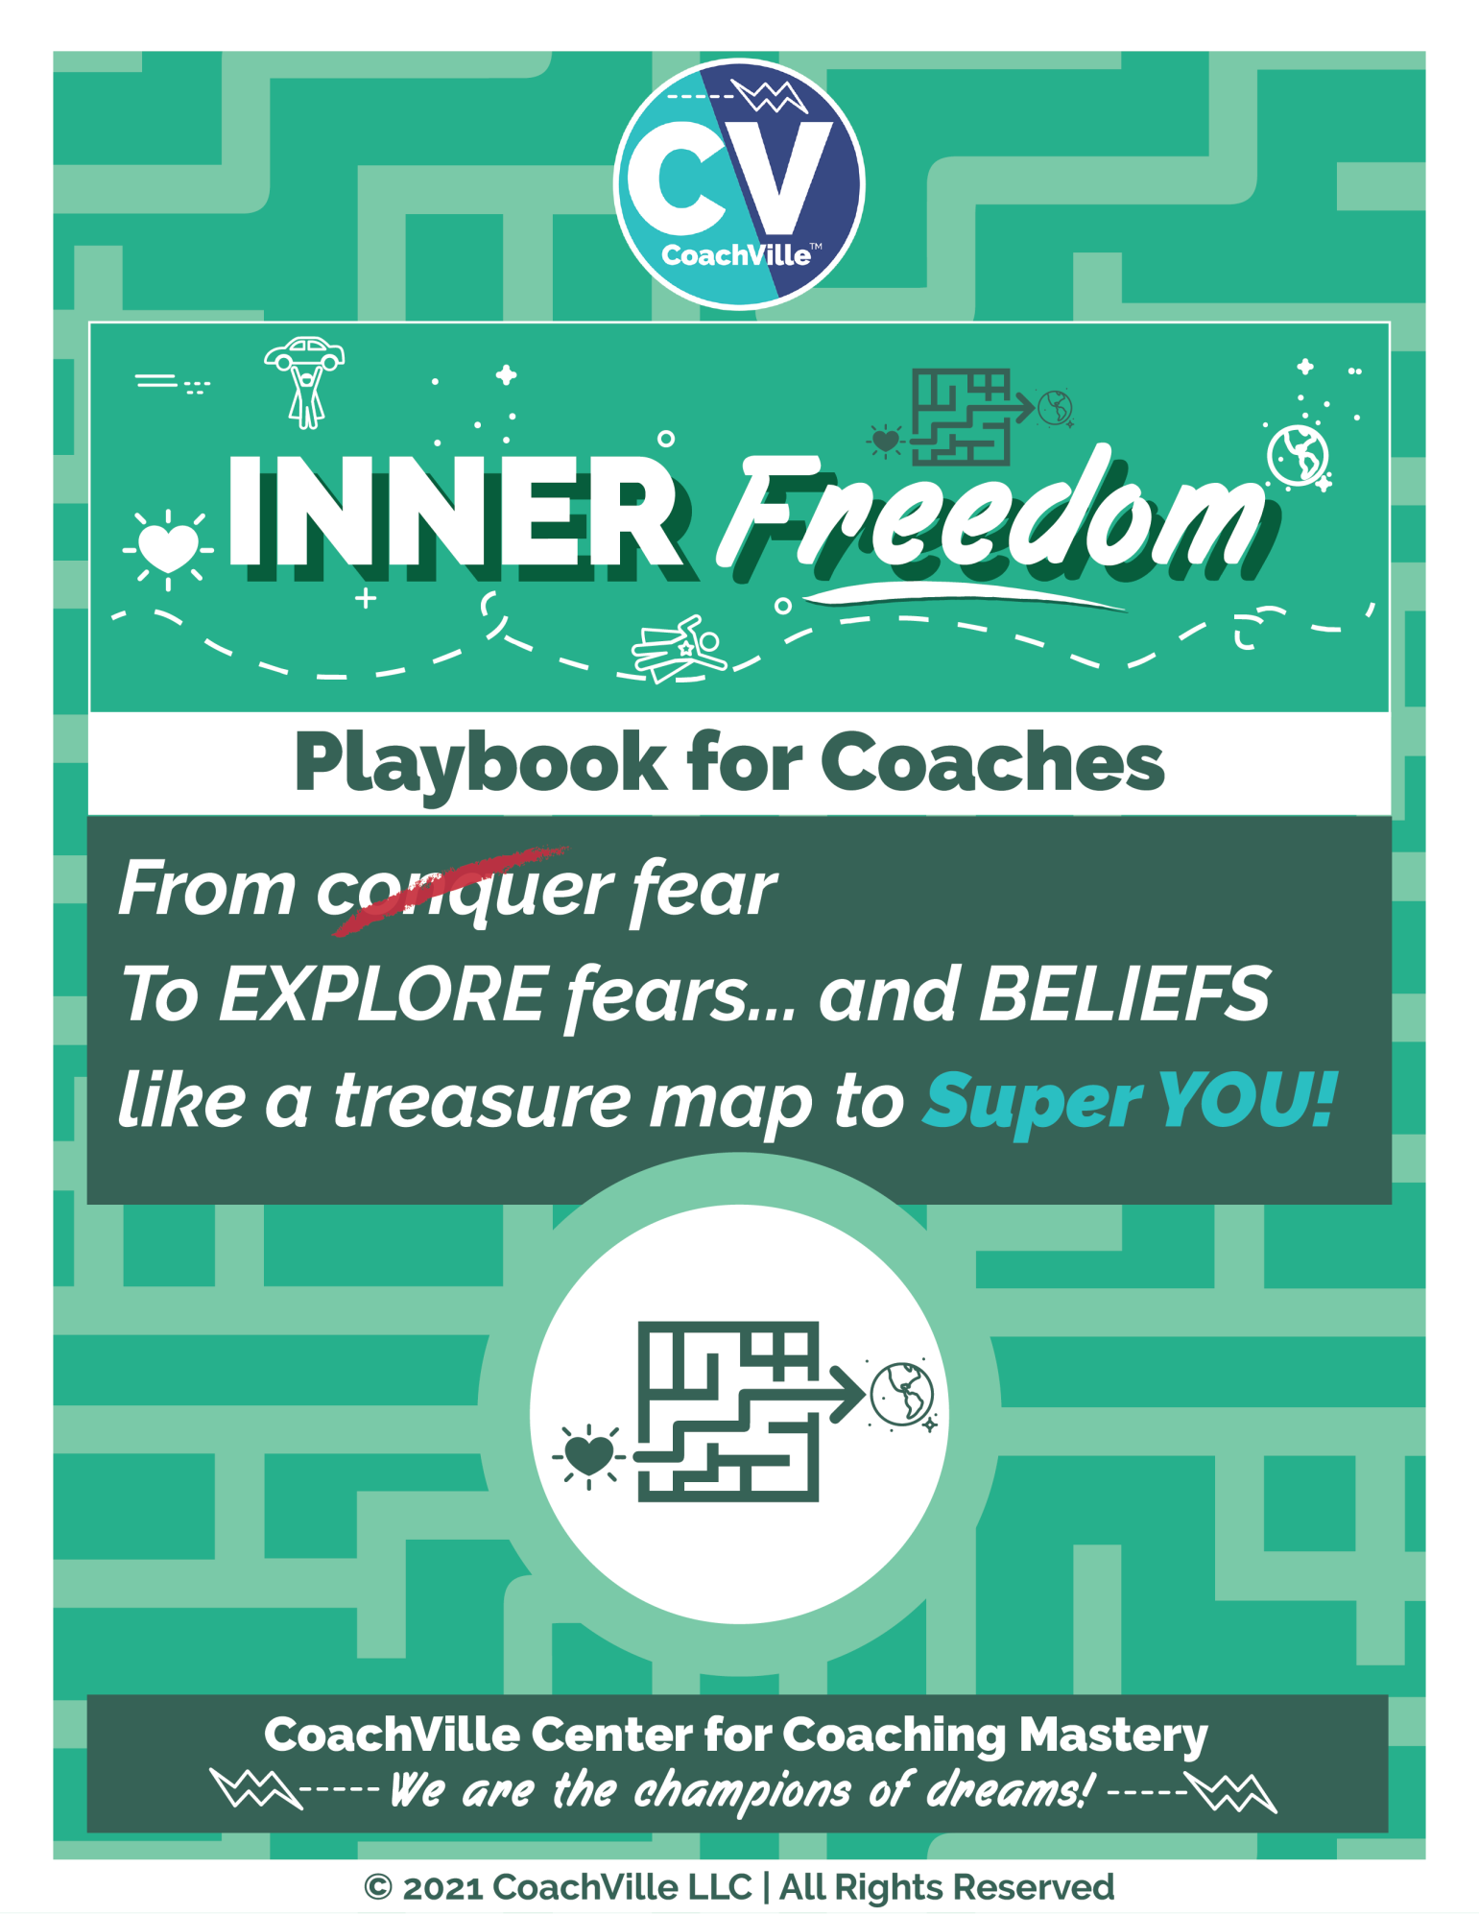
WE FREE EACH OTHER!

Welcome. On behalf of the entire CV Team, I want to welcome you to the Inner Freedom Method TM Coaching Program.
The themes of the program:
The Pursuit of Inner Freedom to get your Hearts Desires out into the world.
AND
Learn how to befriend fear and it will guide you like a treasure map to your playfulness and Superpowers!

The BIG IDEA that is the focus of this program is this: People playing a BIG Dream in life are often highly aware of exactly what to do, but they are unable to do it on a consistent basis because of the strong inner resistance of Social FEAR.
The powerful truth is: You can PLAY with FEAR! This is the coaching opportunity that we will explore in this program.
And we will play with our fundamental coaching theory: The World is a playground and we are here to play together!

The emphasis will be on PLAYING BIG in life and adopting a “PLAY Life framework” in your personal, business and career life. Specifically, you will design and play for your dream with actions that require you to play outside of your current preservation zone. This is a potentially transformational shift and we invite you to PLAY along with us.
Of course, there will be LOTS of coaching as well! As a part of our “Active learning” method you will collaborate with a coaching partner throughout the program. You will coach and be coached by the same person in all of the in-class coaching exercises. We believe this will allow you to go deeply into the coaching and experience a real coaching relationship.
The BIG BIG DREAM…
Life Coaching is a global freedom movement! When people are free to play big for their dreams they can think for themselves and care for the collective at the same time. This way of living is essential for us to uplift the Human Family.
Enjoy the program and remember…
FREE PEOPLE, FREE PEOPLE!

Coach Dave Buck and the CV Team!

Table of Contents
Table of Contents 3
Introduction 9
Pre-Class Play Plan 10
Understanding Coaching and it’s greater purpose in the world 14
Understanding Playing 19
Inner Freedom Mission 1 = Make a play plan for your Dream 24
Understanding Human Nature 34
Understanding Energy Alignment 43
Understanding How to Learn How to Coach… The CoachVille Way 46
Coach Mission 1: Recruit 3 Players 53
1) Introduction: You are on a mission! 54
Coaches Notes for the Exploratory Session 65
Understanding the Inner Freedom Method 66
Chapter 1 – Play With Social Fear 74
Chapter 1 Prep 75
Session #01) Play With Social Fear 75
Coaching Notes for Session #01 84
Chapter 1 Key Points 87
The Human Journey with a Coach – From the Coach Perspective 88
The Preservation Zone 90
Explore the BIG Dream for Social FEAR and “The Pull” 91
The Practical Inner Freedom Method and the CoachVille Coaching Method 92
Inner Freedom vs. Self Help 93
A Few Inner Freedom Examples (From 2010) 94
Playing with Energy (2010 version) 96
Scenarios for weaving the Inner Freedom Method into your Coaching / Business 97
Class 01 Prep 98
Chapter 2 – Pivotal Moments and Judgment-Free Awareness 99
Chapter 2 Prep 100
Session #02) Pivotal Moments and Judgment-Free Awareness 100
Coaching Notes for Session #02 110
Inner Freedom Method Step #1: P/Replay the Pivotal Moment 112
Inner Freedom Method Step #2: Review Reactions with Judgment-free Awareness 114
It is good to know a LITTLE bit about the “Mind” {2010} 116
If the player doesn’t feel anything (What to do) 117
The Power of 1,2,3,4,8,9 – the “quick” version of Inner Freedom 119
Expand Awareness (2010) 119
Pivotal Moments and the Basketball Coach metaphor 120
Using the Play Plan Sheets ~ to spark awareness of Pivotal Moments 121
Class 02 Prep 122
Chapter 3 – Feel the Energy and Body Beliefs 123
Chapter 3 Prep 124
Session #03) Feel the Energy and Body Beliefs 124
Coaching Notes for Session #03– Feel the Energy & Body Beliefs 129
Inner Freedom Method Step #03: Feel the Energy in the Body 131
Inner Freedom Method Step #04: Scan for Body Beliefs 133
Overwhelm ~ I don’t know ~ Knowing is in the body 133
Class 03 Prep 135
Chapter 4 Memory Pops 136
Chapter 4 Prep 137
Session #04) Memory Pops 137
Coaching Notes for Session #04- Memory Pops! 145
Inner Freedom Method Step 3&4: “Memory Pops” 146
The “memory pop”.question 149
Allow the images to emerge 150
Giving Voice to feelings, body beliefs and social fears 150
How much to talk about 151
The Power of Presence – it takes 2! 151
Class 04 Prep 151
Chapter 5 – Explore the Superpower 153
Chapter 5 Prep 154
Session #05) Explore the Superpower Potential 154
Coaching Notes for Session #05= Role Play + Inner Freedom 164
The Transformation Potential in Role Playing 165
Step #5 Explore the Superpower Potential 169
Class 05 Prep 170
Chapter 6 – Find the Perfection in the Situation 171
Chapter 6 Prep 172
Session #06) Find the Perfection 172
Coaching Notes for Session #06 181
Inner Freedom Method Step 6: Find the Perfection 182
The Perfection of the Preservation Intention 187
Class 06 Prep 189
Chapter 7 – The Flow of Gratitude 190
Chapter 7 Prep 191
Session #07) Flow of Gratitude 191
Coaching Notes for Session #07- The Superpower Zone 201
Inner Freedom Method Step 7: Embrace the flow of gratitude 202
Connect the dots 204
All challenges are an invitation for growth 204
Understanding Perfection and being fully engaged and in the flow of right now (From 2010) 205
Expand your understanding of the Pattern Language of Self-Preservation Intentions (2010) 206
Expand your ability to create maximum value and awareness from “memory pops” (2010) 207
The Three Shifts (From 2010 Version) 209
Class 07 Prep 213
Chapter 8 – Make Your Mind the Ally of the Dream 214
Chapter 8 Prep 215
Session #08) Make the Mind the Ally of the Dream 215
Coaching Notes for Session #08 - The Whole Method + Role Play 222
Inner Freedom Method Step 8: Make your mind the ally of your Dream 224
What is Pattern Language? 225
From React to Respond and Thinking “holistically” 227
The Coaching Perspective on Go Time! 229
Class 08 Prep 229
Chapter 9 – #9 Preplay the Pivotal Moment 231
Chapter 9 Prep 232
Session #09) Preplay the Pivotal Moment 232
Coaching Notes for Session #09 - Intentional Co-Creation 239
Inner Freedom Method Step 9: Preplay the Pivotal Moment 241
Celebrate Breakthroughs… boost Self-Worth (2010) 242
Class 09 Prep 243
Chapter 10 – The World Power Connection 244
Chapter 10 Prep 245
Session #10) Upgrade your People Environments 245
Coaching Notes for Session #10 252
Create a place of belonging for SUPER YOU! 253
Recognizing Perfection expands your self-worth (2010) 254
How we learned to fear our self-expression (2010) 255
Class 10 Prep 256
Chapter 11 – The New Super YOU! 257
Chapter 11 Prep 258
Session #11) The New Super YOU! 258
Coaching Notes for Session #11 266
Fear of unintended (and unwanted) consequences of success (2010) 266
Quick review – When to use the Inner Freedom Method (2010) 267
Inner Freedom – the capacity to choose 268
Think BIG Now! Who can you coach? 268
Class 11 Prep 268
Chapter 12 – Celebration 270
Chapter 12 Prep 271
Session #12) Celebration 271
Coaching Notes for Session #12 275
Energy Alignment Celebration Playsheets 275
My certainty is greater than your doubt (2010) 276
CoachVille Coaching Framework ~ With Inner Freedom Focus 277
Class 12 Prep 281
THANK YOU! 282
Hey Coach! 283

Introduction
Most of these Introduction pages are excerpted from my upcoming book about coaching called: ”Champion of Dreams”.
The purpose is for you to gain the advanced understanding needed to make the most of this coach training program; and to be a great coach in the world.
I have a few provocative ideas to share with you… that will shift how you see yourself, the world around you and your opportunity to thrive as a coach in a joyful way. AWWW Yeah.

Pre-Class Play Plan
It looks like a lot… but it will be fun to prepare for our adventure.
1) Read the Introduction of this playbook (Wooo Hooo! You are doing that now!)
2) Get the Inner Freedom Coaching Guide PDF;
I recommend printing this and putting it in a binder.
3) Get the Player Playbook Introduction PDF
You can send this to your potential players to entice them to sign on for the life-changing experience you are offering them! Team Play for Transformation.
4) Listen to the Player Prep Audio for the Exploratory Session
You can send your potential players this audio as an enticement to have an exploratory conversation with you; OR send it to them to help them prepare for the exploratory conversation with you.
5) Listen to the Sample Exploratory Session with Player Leanne
6) Recruit 3 players to coach by reaching out and having exploratory conversations.
This Introduction contains a detailed plan for doing this. Aim to have your 3 players signed before class starts; or during the first week at the latest.
7) Get on the Game Card for this program:
On the Milestone Card Read the “how to play” Playbook (for first time students only)
Share about your exploratory sessions on the Milestone Gamecard
8) Get the Inner Freedom Playsheet PDF;
Follow the printing instructions.
Send this to your players after they sign on with you.
9) Get the Player Playbook PDF
Send this to your players after they sign on with you
10) Listen to the Player Prep Audio for Session 1
Send this to your players after they sign on with you for the Inner Freedom Coaching experience. (Team Play for Transformation!)
11) Give some thought to what your BIG Dream is and what your Inner Freedom “Mission” will be for the 12-week program
12) On the program home page, read the “Dyad Guide” (for first time students only)
13) Listen to the Coaching Demonstration Session 1 Audio with Player Leanne
14) Read Chapter 1 of this Playbook
15) Read the Coaching Guide for Session 1 a few times (at least once out loud)
16) Update your Gamecard to share about what you learned during all of these activities!
You are READY for the first class!

I promise that the play plan for weeks 2 – 12 will be much lighter!
1) Share on the Gamecard your insights from class!
2) Coach your players using what we practiced in class (then share on the Gamecard about each one)
3) Listen to the player prep audio for the upcoming session.
4) Read the Chapter in this playbook for the upcoming session (then share on the Gamecard).
5) Listen to the coaching demonstration audio for the upcoming session (then share on the Gamecard).
6) Read the Coaching Guide a few times for the upcoming session; at least once out loud.
7) If you missed class… Listen to the class audio from the class you missed.
See! Easy.

The Game Card
Your REAL LIFE is PLAY!
Each week you will play a fun and challenging game
where you earn points for doing and then SHARING:
1) Read your class Playbook; SHARE your insights.
2) Participate in class; SHARE about what you have learned in class conversations
4) Listen to the recorded coaching demonstrations; SHARE your insights
5) Complete Missions to coach your players; SHARE what happened in the sessions.
6) Complete Missions to play BIG for your dream; SHARE what you have discovered.
7) Stay in contact with your class partner (player/coach) SHARE what you have discovered together.
8) Inspire your team mates And being inspired by them. SHARE your You Inspire Me points (YIM).
Your personal “game card” will provide you with a visual display of what you need to do and what you have already accomplished. And… when you share you will attempt to inspire your classmates. (so that they give you “You Inspire Me” Points)
The public leaderboard will allow you to see how everyone else is doing. Then you can explore the game cards of your class mates for ideas and inspiration. (And to give away your “You Inspire Me” Points)
Note: Center for Coaching Mastery Students need a minimum of 150 points total on game cards to pass the class. At CoachVille we don’t give right/wrong answer tests… not our thing!

Team Play for Transformation!
Life is a co-creation.
Freedom is a co-creation.
The coaching relationship is a co-creation.
At CoachVille we play with co-creation all the time. CoachVille founder Thomas Leonard was a wildly successful co-creator with a group of coaches he called his “R&D Team”. So it is part of our DNA.
We have taken this idea to a new level by co-creating a set of informative and compelling resources for you to share with your players. These resources will make your coaching more impactful… but they will also make you look really good in the eyes of your players! (Status Matters)
There is a collection of concepts that when your player absorbs them your Coaching will be more impactful; for example the concept of “Pivotal Moment”. When your player understands how to recognize a Pivotal Moment in their life they will make much better use of their coaching time with you.
At the same time, it would take a bunch of time for you to explain it to them… and this would take away from the time that you can be practicing with them, observing them and listening to them; which is where the magic happens.
So we have created a playbook and a set of audios that you can share with your players that explain all of the concepts needed for Inner Freedom Coaching.
In the playbook and audios I explain to the player that I will be their bonus companion while they are on the coaching adventure with you.
There is a playbook chapter and an audio that will help the player prepare for each session and make the most of their time with you.
There is also a playsheet PDF with a sheet that matches the unique flow of each session. (If you follow the coaching guide ;-)
Your players will love these resources and you will love that they come to each coaching session ready to play. SO GOOD.
Meanwhile, this will make coaching with you a step above anything else they have experienced in the coaching or personal growth space. Like I said… status matters. It leads to impact, advocacy and referrals.
Here is the Playsheet Pack PDF
Here is the Introduction to the Player Playbook
Here is the Audio to prepare for the Exploratory Session.

You may notice…
You may notice that these resources are also on the preclass play plan that started this Introduction. YES!!! That is because in the Inner Freedom Program you are BOTH a coach and a player.
As you use these resources to be a better Inner Freedom Player, you will gain confidence in sharing them as a coach.
The Benefit for us at CV… and the World!!
There is a BIG benefit for us at CV with regard to your players; in addition to you being the most awesome coach they have ever had!
It happens often that people who experience transformation with a Life Coach want to learn how to be a Life Coach – or coach approach leader – themselves.
Free People, FREE PEOPLE!
It is our hope that with their experience of your coaching and these impactful resources that they will join us in our school. And our world changing team of “rebels with a cause” to uplift the Human Family will continue to grow!

Teleclass Welcome!
A quick note to the reader: this playbook is used for both the teleclass and the “self-study with a buddy” version of the program.
This little section is just for the teleclass participants.
In every class you will participate in a variety of provocative exploratory conversations and coaching sessions.
A few key points to consider as you start this class.
1) Our programs are based on dialogue-based learning. So we expect you to jump in and participate in the conversations. Be BOLD! Share your thoughts and questions; Your voice is a contribution to everyone else in the program. Your instructor is a highly trained coach and very capable of weaving diverse thoughts into a web of learning for everyone!
2) You will coach in every class. It is possible that this will be your first coaching conversation. So be easy on yourself! Don’t expect to be a masterful coach on day #1.
If you have been coaching for a while – maybe even a LONG while - coaching in class is your opportunity to experiment and try new things. Enjoy the opportunity to stretch and learn.
Self-study with a Buddy students: plan to listen to the class audio and then engage your buddy with the class prep questions at the end of each chapter.
3) You will coach in every class. If you are a new student at CV it is likely that you have little coaching experience and possible that you have never conducted a coaching session before. So be easy on yourself! Don’t expect to be a masterful coach on day #1. Coaching in class is your opportunity to experiment and try things that you have not done before. Enjoy the opportunity to stretch and grow.

Understanding Coaching and it’s greater purpose in the world

The Practical… The Problems … The Purposeful
As your Guide on your Inner Freedom adventure, my role is to prepare you for each leg of the journey so that you can really LOVE it and thrive as both a player and a coach.
So the first thing I want to do is share with you a few of the “real world” benefits of Life Coaching in general - and Inner Freedom Coaching in particular - in the form of practical benefits, problems solved and bigger purpose and aspirations.
I have phrased these from the perspective of the player. From the coach’s perspective, they explain what you will guide people to accomplish and experience.
The Practical
- If your dream or purpose feels fuzzy or lost, it will come into focus and gain energy.
- Positive actions that used to seem hard, will start to feel easy.
- Your life will start to feel like a fun, growth-oriented adventure… MOST DAYS
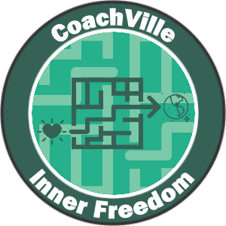
- You will have more fulfilling experiences with people you enjoy; in ALL aspects of your life!
- You will gain awareness of where your doubts and fears are coming from… and you will feel more and more FREE!
- You will greatly expand your “body awareness” and “emotional awareness” which will increase your intuition, inner knowing and self-trust. << THIS IS A BIG ONE!
- You will feel more ALIVE… and feel like your life is more vibrant than it used to be!
The Problems
Coaching is NOT an intervention for problems! It is about playing better for your dream.
However… as you play better with your Inner Freedom coach, many of life’s common problems will lessen or disappear completely.
- You will experience LESS anxiety.
- You will experience LESS self-doubt.
- You will experience LESS procrastination on important actions.
- You will experience LESS negative self-talk;
- You will experience LESS limiting beliefs; and the idea of self-sabotage will disappear.
- You will experience LESS frustration, isolation and overwhelm! (A LOT LESS)
- OFTEN… You will experience LESS of unwanted addictions.

You have to admit… this will be awesome!
The Purposeful… and Aspirational
- You will gain influence. You will begin to see yourself as powerful and capable of having a profound positive impact in the lives of others and in the world!
- You will gain creativity. You will gain clarity on the YOUnique qualities that you have within you that you can use to co-create the results and experiences you desire.
- You will make changes. You will feel more confident in taking risks that can bring about positive rewards for your dream.
- You will gain visibility. You will feel more courage in being seen and owning your value.
- You will develop the ability to tap into your body wisdom to make bold choices.
- You will develop the ability to tap into the Supermind for needed insights and possibilities… and then ACT on them.
- You will feel like your energy is flowing and aligned with your dream and greater purpose.
- Last but not least… you will stop the futile exercise of trying to conquer fear and you will learn how to EXPLORE fear – specifically social fear – which will lead to an extraordinary boost in your FREEDOM. INNER FREEDOM!
- As you practice exploring the FEAR you experience in social situations, you will rediscover your lost playfulness and YOUnique capabilities. AKA Your Superpowers!
AWWWW Yeah!

What coaching is
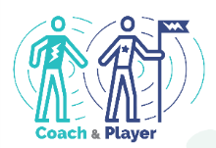
Next I want to share with you a few thoughts about life coaching because there is a lot of confusion about this.
Here is our definition of coaching:
Coaching Is…
1. A profound personal relationship
2. Wherein the coach guides the player
3. In pursuit of playing better for their dreams
4. Through perceptive observations
5. And co-creative conversations

Some folks have gotten the idea that coaches talk with you to help you solve your own problems. Others think that coaches tell you what tasks to do and hold you accountable.
Life Coaching is not about problems or tasks because life is not about problems and tasks. Life is for playing for our dreams and Coaching is about playing together to play better; also known as practice.
Let’s go a little deeper into each of the elements.
1. A profound personal relationship
Coaching is a personal relationship. Your coach will care about you as a person and you will care about your coach. It is very different than the ideas we got about Industrial Age Professional that was robotic and impersonal.
Coaching is profound because it goes beneath the surface of life into feelings, emotions, beliefs, desires, possibilities, fears, visions, ideas… the important stuff.
2. Wherein the coach guides the player
Coaching is NOT hierarchical… which is an important detail we will explore in a moment.
Guiding another person on an adventure is a real artform. It is not the same as directing or controlling; but it is more than a passive companion.
Think about the guide on a hero’s journey like Star Wars Obi Wan Kenobi to Luke Skywalker. They are on the adventure together, they are both actively involved. Obi Wan is sharing observations with Luke BUT… Luke makes his own choices about what to do.
Another way to think of this is the Olympic Coach. They are in the Training Center with the athlete every day sharing the dream together. Olympic athletes deeply thank their coach when they win a medal; they could not have done it alone.
3. In pursuit of playing better for their dreams
Playing better is the essence and the purpose of what ALL coaching is about.
Playfulness is an awesome Human Superpower. Helping you restore and maximize your playfulness is a big part of Life Coaching. I will get into that much deeper in a few moments because the idea of play may be scrambling your mind right now.
To ease into the exploration here are a few ideas to help you understand what I mean by PLAY and playfulness:
- Curious and Creative
- Resourceful and Resilient
- Explore and Experiment
- Fun! (usually, but not always)
The 3 Frameworks of Play
There are 3 areas of life where we see play all the time. One way to get into playing for your dream is to identify with one or more of these and re-imagine your dream with this framework.
1) Performance Art: You have talents, a “voice” or perspective and something to say or share. You practice A LOT to refine both your skills and your message. You use your talents to co-create experiences with your audience.
2) Game / Athletics: The urge to compete drives you to hone your skills to perform at a high level. You enjoy the thrill of victory and embrace the difficulty of defeat. You enjoy the camaraderie of your team mates and the competitors. The definition of compete from the ancient Greek language is actually quite inspiring.
To Compete: to seek the best in oneself in the company of others likewise engaged.
3) Epic Quest: You have been “called” to adventure. There is something you MUST do even though it means leaving behind the comfortable of your well known surroundings and place in the world. You face great challenges in pursuit of your mission. If you are successful, you reap some great reward which you can bring back to your tribe for all to enjoy.
Your Dreams
This is another topic we will talk about A LOT in this playbook and with your partner coach. Your Dream is your vision for who you want to become and what you want to experience in the world.
In the next section we will get into the details of The Dream.
4. Through perceptive observations
We are ALL yearning to be seen by someone who knows what they are looking at!
Your coach is going to observe you as you adventure together and share with you what they see in a judgment-free way!
We all have blind spots in our thoughts and actions because we can’t see ourselves very clearly…a trusted outside observer can really accelerate our growth.
This is the way life is meant to be played; we are meant to co-create life with others.
5. And co-creative conversations
Talking together is a big part of how coaching happens.
The key in Life Coaching and Life Playing is to co-create a safe space for deep and provocative conversations.
This brings me to one of my favorite things to share with new Life Players!
The ancient power of co-creation!
In the ancient Aramaic Language there was a power phrase: Abera Ca Dabera – It means: “I create as I speak”. You have probably heard of it being used in the context of a magic trick but it is much more practical than that! When two people are talking together in deep conversation with purpose, permission and presence – as happens in a Life Coaching relationship – it can take on a life all its own.
With your words you can speak your dream into existence and create the new version of YOU needed to fulfill your dream. This is the “magic” of co-creating that makes coaching such a powerful force in the world!
With focus and determination you can experience this transformational power as an Inner Freedom Life Coach and Player!
The Global Life Coaching Movement… to FREE THE PEOPLE!
I want to take this co-creation idea one step further here and share with you that as a Life Coach you are part of a global movement of vital importance to the Human family.

We Free Each Other… The Global Life Coaching Movement
By signing on to become an Inner Freedom Life Coach you are participating in one of the most important movements happening in the world today!
The movement is to free the people from the dehumanizing, traumatizing and demoralizing hierarchical control structures that are dominating life today like a bad virus.
The movement is to “RE-Humanize” the human family to be the connected, playful, feircly egalitarian, FREE co-creators we were born to be.
While hierarchical controls aim to suppress Human Nature, Life Coaches play to unleash Human Nature. We are awesome!
I like to refer to us as “Rebels with a Cause”; even though I know that is a quirky cliché.
All around the world Professional Life Coaches as well as Coach-Approach leaders, managers and entrepreneurs are uplifting the Human Family – one person at a time - out of the dehumanizing Industrial Age of Control and into the Connected Age of Play by unleashing the Superpowers of Human Nature: Become – Believe – Belong! (whew… that is a doozy of a sentence!)
Dehumanizing Hierarchical Control
The idea that the best way – or the only way - to organize human endeavor is through top-down control hierarchies is like a bad virus that has infected the Human Family; it started a few thousand years ago but it has really spread over the past 150 years.
The way I see it:
- Schools are all about controlling the human nature of children.
- Most religions are about controlling human nature
- Corporations are based on command – control - compliance
- And because of all this control everywhere… even families are often focused on controlling each other.
It’s REALLY BAD… IT’s traumatizing and dehumanizing.
Why do I say dehumanizing?
Because … we HUMANS HATE being controlled. We do. We hate it. But yet somehow human systems based on control are everywhere.
What happens is, when a human is subjected to control everywhere they go, eventually they succumb to it… most do anyway – except for us rebels… they absorb it and pass it on.
In hierarchical control structures:
- Our dreams are squashed
- Our playfulness is shamed
- Our voices are silenced
Just look around at the anxiety, depression, addictions, all the supremacies (white, male, wealth, religious), the discord, the growing power of authoritarian political leaders and the pervasive mean spiritedness we see; It’s EVERYWHERE. It’s all caused by dehumanizing control hierarchies suppressing the goodness – the awesomeness – of Human Nature.
Controlled people, control people.
Hurt people, hurt people.
Life coaching is our way out of this mess.
Rather than trying to intervene or fix people, we can transcend the situation by uplifting people through Life Coaching!
Life Coaching is about freedom!
- Freedom to be your playful self and continue to grow and become a new version of you easily and naturally.
- Freedom to express ALL of who you are and contribute your YOUnique value to others and enjoy the rewards.
- Freedom to pursue your own dream with a team of people who share your dream.
- Freedom to co-create belonging with people who enjoy ALL of YOU and who you are becoming and what you are contributing.
Every person who “gets free” in this way then passes freedom on to everyone around them; co-creating a ripple effect of good.
A key point here is that we don’t get free by struggling alone! Freedom is social. We only get free together… we must free each other by stopping the status quo habits of Industrial Control and sharing the rebellious joy of Connected Play and Co-Creation.
Free people, free people!

I am super excited to have you on our team as an Inner Freedom Life Coach!!!

Understanding Playing
Since coaching life is all about guiding another person who desires to play life better in some way, the next thing we need to explore is how we PLAY life.
This is a big topic for sure. For now we will talk about two main ideas:
- Playing for a BIG Dream
- Playful actions in pursuit of a Dream

Possibilities for your BIG Dream (and the Dreams you can Coach)

The first thing your partner coach is going to talk with you about (and you with your players as well) is your Dream; because going for your Dream is what playing life is all about. An important point here is that playing life with a Life Coach is MUCH different than going it alone. So I am encouraging you to think bigger than you might normally allow yourself to think.
Why Dream… rather than objectives or goals?
- Your Dream includes your imagination.
- Your Dream includes your vision.
- Your Dream includes your heart’s desires.
- Your Dream includes how you want to contribute to life.
- Your Dream includes who you want to become.
- Your Dream includes the experiences you want to co-create.
- Your Dream includes the spirit of play.
- Your Dream includes a sense of wonder and mystery.
Often we don’t think too much about our dreams, we just focus on what we can control by working alone. This is how we were trained to think in the Industrial Culture. (We will get to this in a moment) This approach tends to keep us pretty small; which is OK sometimes. But truly life can be MORE.
You may be very clear on your Dream and already in pursuit. Or you may be a little fuzzy about the details but just know you are ready for more. Wherever you find yourself now is the perfect place to start your adventure. The purpose of this little section is to spark your imagination for what your BIG Dream can be.
Our mantra is: The world is a playground. Let’s Play Together.
Here is a “starter” list of the endeavors that people dream of playing better. This will spark your imagination for the many possibilities you have with your Inner Freedom Life Coach AND as an Inner Freedom Life Coach for your players!
Aspects of Life you can play better with a Life Coach
- small business ownership,
- career development & transition into something joyful & meaningful
- business growth through team play,
- leading a worthy cause
- growing a vibrant community or tribe
- spiritual quest through community participation,
- financial freedom through value creation,
- corporate management and/or leadership of a great team
- artistic expression and performance
- health and wellness through engagement
- personal growth through self-expression and participation (this includes co-creating relationships and partnerships)
How you will grow as you play for your dreams…
- You will express your superpowers, energy and creativity
- You will enjoy the company of people on your growing Dream Team
- You will grow your skills and capabilities
- You will experience personal transformation; to become, believe and belong
- You will grow in status within a community
- You will change your world or THE world in a positive way
You will LOVE playing for a Dream that is engaging, supportive, challenging, purposeful and fulfilling.

The 4 ways to Play Life. The 4 things we desire!
A BIG difference between playing with a coach and working in isolation is well… a focus on play… specifically Social Play.
These are the four things EVERYONE playing big in the world wants more of; wants to do better or bigger in their own unique way to make a positive impact; to matter.
By adding activities in these four areas into your plan each week, your coach will be able to guide you toward the experiences you desire, the impact you desire and personal transformation AT THE SAME TIME!.
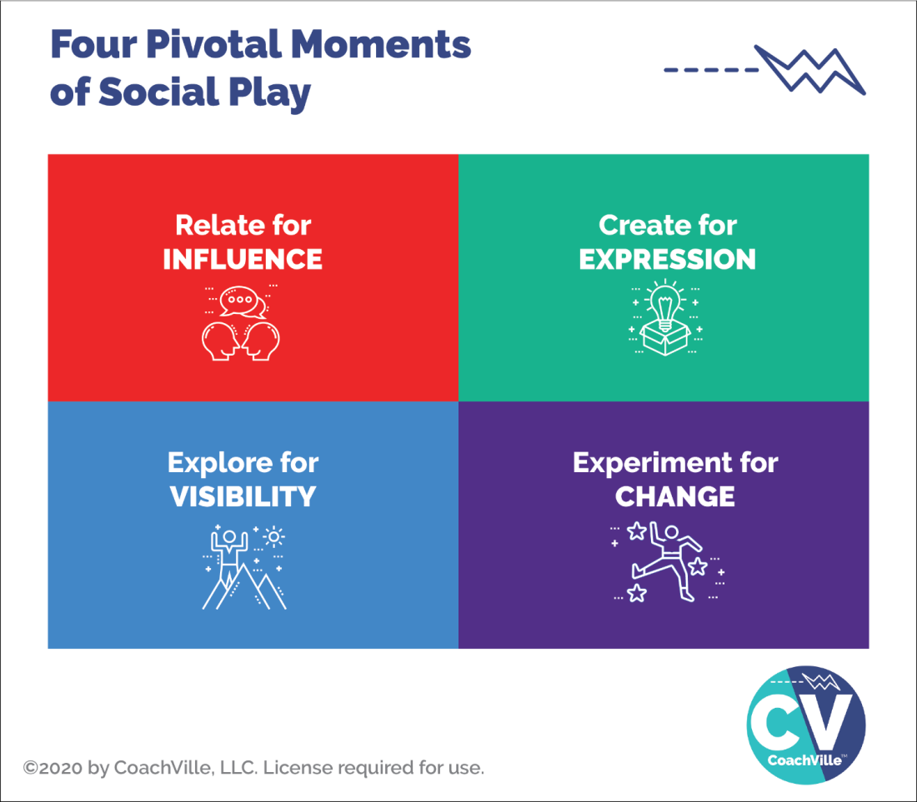
Here is an important insight to consider: Anything that you cannot control but you can influence is an opportunity to play and play better with a coach!
So I want you to wonder… to dream… of what you would do if you were able to increase your influence in the world around you.
These are the four essential activities of the Connected Age of Purpose.
We call them pivotal moments of social play.
- Relate, Create, Explore and Experiment
- A pivotal moment is a coach-able moment that you can improve through practice and energy alignment.
- Social play means that it involves co-creating the experience with one or more other people rather than completing a task in isolation; as was the norm in the Industrial Age of Control.
And here is another BIG point: Everyone has unique superpowers within them that can be unleashed to become AWESOME in each of these 4 types of social play.
The Four “Things” people playing life want more of…
Entrepreneurs, leaders of teams and organizations, people with a cause, people with an idea… anyone who aims to move beyond the status quo of life wants these four things:
- Influence
- Visibility
- Expression
- Change.
That means YOU!

Relate for Influence
Relate means talking to other people! This is pretty much what we do all the time in life. It becomes playful where there is an opportunity for positive influence like when you are asking someone to do something with you and they might say “yes”, but they might say “no”.

Create for Expression (AKA to Share)
Creating is when you make a thing or you design an experience that you aim to share with others; for examples: writing, recording, designing, planning. The sharing part is all about participation and contribution. This is very much in line with the “Life is Performance Art” concept.

Explore for Visibility (AKA to See and Be Seen)
Exploring is when you go into a new territory; you are stepping into the unknown (hopefully with a sense of wonder) It can be a physical place, a social media platform or even a new idea. You explore to see and experience new people and new places; and also to BE SEEN by new people.

Experiment for Change (AKA to Try New Ways)
Experimenting is any time you do something that you have not done before OR you do something that you have done in a new way. Often when we experiment we have an idea or a hope of what will happen but we don’t actually know. A key to success is to start with an intention, be open to new possibilities AND keep track of what happens; and most important is to not look at any outcome as a failure but as learning.
Hopefully you are getting energized about playing for your Dream!

The BIG Picture…
Inner Freedom is a transformational method of Life Coaching where you practice pivotal moments of social play that lead to influence, visibility, expression and change.
You will experience this fully over the next few months and you just might be inspired to take a “coach and play” approach to many of your future pursuits in life.
The next step toward understanding playing for a dream is consider how YOU will play for your Dream.
Next I will share with you the PLAY mission for this program. Remember, you are both a player and a coach in every CoachVille program. Giving some thought and conversation to playing for your dream will prepare you to explore dreams and play plans with your potential players.
Also in this “Mission” are references to the CoachVille Gamecard… Power Up, Game Action and BIG Win. We do this to introduce you these language patterns.

Inner Freedom Mission 1 = Make a play plan for your Dream
““All growth happens over the edge of your self-preservation zone.”
- Coach Dave

Outline
- Introduction: You are on a mission to get your Hearts Desires out into the world. AKA Your BIG Dream
- Let’s go deeper into PLAY in the Connected Age:
Influence, Visibility, Creative Expression and Change
- Power Up: Design Your Inner Freedom Play Plan Version 1.
- Game Action: Elicit support from your team
- BIG WIN: You get verbal support for your DREAM and your PLAY BIG Moves!
- Find the Fun!

1) Introduction: You are on a mission to get your Heart’s Desires out into the World!
(if you haven’t already) Listen to this audio about how to prepare to be a player:
https://soundcloud.com/coachville/innerfreedom_exploratoryinvitation

BIG Idea:
Get your Heart’s Desires through a FUN and challenging “Maze of FEARS and Body Beliefs” out into the World by PLAYING in pursuit of your BIG DREAM. Explore those FEARS and Body Beliefs like a treasure map to your lost superpowers! Fully immerse yourself in the Inner Freedom Method by experiencing it as a player.
A few points to remember:
- You are both a player and a coach of life.
Growing as a player will accelerate your growth as a coach.
- As a Coach you are always leading by example!
Remember that coaching happens through Observation and Co-Creation. While you are observing your players, THEY are also observing YOU!
It’s YOUR Dream:
What is your current Purpose / BIG DREAM?
How/What would you LOVE to contribute to the world? (AKA your fellow humans)
What are your Hearts Desires?
What is the dream that you are playing for that is BIG enough to need a coach to play better?
These questions reveal your “mission” to PLAY BIG for your DREAM with a coach.
The IMPORTANT point here is that you DO NOT need perfect clarity. You just need a place to start. The details will reveal themselves while you are on the adventure.
Go for something that connects to your purpose so that it is meaningful and edgy; something that will inspire a combination of tenacity and vulnerability.
Places in your life you can look for a BIG Dream worth playing for:
- Boost your career,  - Build your business,  - Energize your relationships,  - Expand your network,  - Rejuvenate your health,  - Uplevel your environments | - Financial freedom (or stability, sustainability or independence)  - Spiritual quest  - Personal leadership  - Community leadership  - Artistic expression and performance
Be a GOOD Player
1) Choose something that you are DEFENITELY doing in your life right now. Do not choose something that you may not have time for on a given week.
2) Choose something that you have a desire to do better; to get better results.
3) Do NOT choose something that you are doing but wish you were not doing.
4) It can be something you are already doing; it does not have to be a new thing.
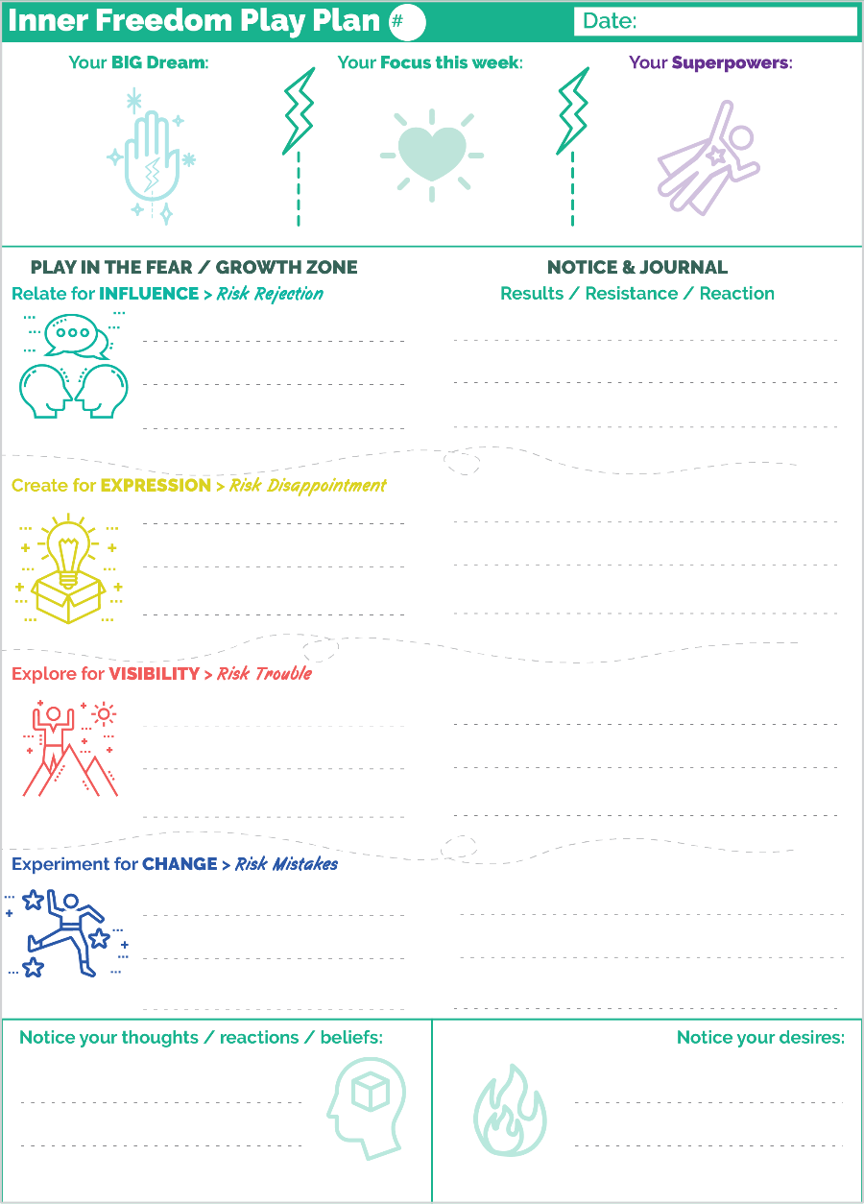
We PLAY LIFE:
We will use the Pivotal Moments of Social Play framework to create a fun weekly play plan to get your Hearts Desires out into the world!
RELATE to be a positive INFLUENCE (also called Play for “YES”).
CREATE for self-EXPRESSION of things and experiences that you aim to SHARE with people.
EXPLORE for VISIBILITY with new people, groups and places to see and be seen.
EXPERIMENT for CHANGE by trying new ways of doing things.
Influence, Expression, Visibility and Change… these are the four experiences that we are all playing for in the Connected Age of Play.
As you think about your PLAY MOVES, consider that playing BIG means to express yourself and create results that contribute to the lives of others. It’s not just about you doing something; it includes influencing or sharing with other people in some way.
Even if you are not 100% sure what your PLAY MOVES are, dive into play. You only need an inkling about where to start.
Plan-Play-Grow
In the Inner Freedom program you will use the Plan-Play-Grow technique to create opportunities to play with the FEAR on the edge of your self-preservation zone; to play in the fear/growth zone and… the Superpower Zone!
You will learn later in the program why we use the term self-preservation zone rather than what is typically called the comfort zone.
Your Performance-Possibility Gap
Another way that we describe this is your Performance-Possibility Gap. As a player, you always look for the next level; for how you can play bigger and better.
Think about what a HUGE opportunity this is. YOU PROBABLY ALREADY KNOW WHAT YOUR PLAY MOVES ARE! The activities and results that if you played them with freedom, grace and energy every day – it could send your business / career / relationship into a state of awesomeness!
We are going to do this together! With the powerful assistance of your new Inner Freedom class partner and your Inner Freedom colleagues you will be able to take actions and get results that have eluded you in the past. Let’s DO IT!
Together we will co-create transformation:
From: fear and emotions are something you ignore or power through; the subconscious mind is dark and mysterious and must be avoided.
To: you can embrace and play with fear and emotions; the non-conscious mind and the Social Survival Imperative is “a bit of a maze” but it can become a vast resource of wisdom and your superpowers.
Make sure your play moves involve other people!
I will say this to you a bunch of times because I need to counteract the number of times you were told to do your own work or don’t bother anyone.
Finally stay connected to these FUN ideas about the Inner Freedom Method:
- Get your Heart’s Desires out into the world
- FEAR is your Friend; You can PLAY with FEAR
- FEAR is like a treasure map that leads to your Superpowers
- Actions and results that seemed really hard, suddenly become easy and fun
- To go bigger out in the world, you must go deeper into your SELF”.

2) Let’s go deeper into PLAY: Relate, Create, Explore and Experiment
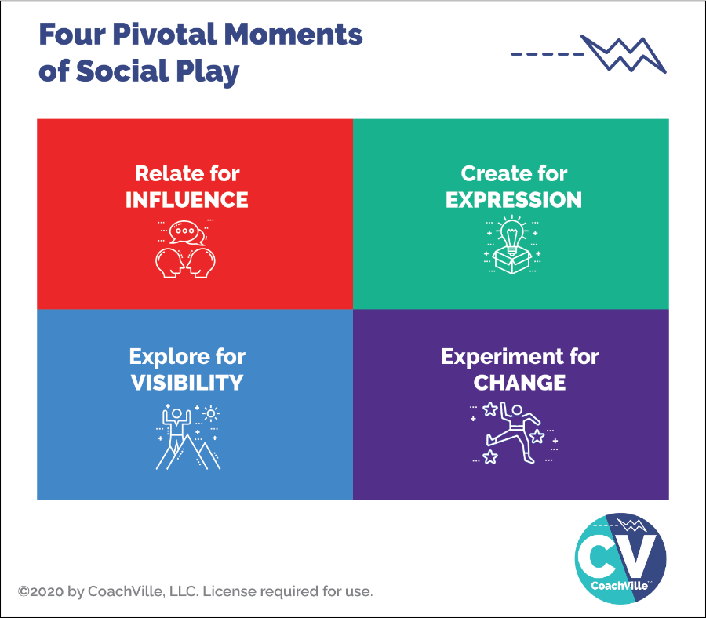
Now we take the idea of playing life and we make it REAL by doing it in your life every day. You start the adventure when you CHOOSE to play BIG. You choose activities where you will embrace some risk in pursuit of rewards. These are the activities where you can grow. You choose to do activities where you will experience some fear, doubt or uncertainty.
Choose Play Moves you can do at least a little bit most days. These activities will keep you on the edge of your preservation zone and give you lots of experiences to explore with your partner / coach.
The Inner Freedom Method is about what happens in your body and mind during pivotal moments when you choose to do something where you will experience some fear, doubt or uncertainty.
Playing Life is about what you can accomplish in the world and discover within your Self by taking social actions with some social risk in pursuit of desired resulting impact or influence; AKA risk and reward.
Take fun actions for desired results.
Embrace social risks for social rewards.
The examples provided are meant to spark your imagination for how YOU want to play for your dream right now.
There are 4 types of Play MOVES that we will focus on.
1) RELATE for INFLUENCE: (play for “YES”)
Here you take the relating action with the intention of producing a resulting positive influence on another.
You embrace the risk of rejection (and judgment).
Relate for influence | Risk Rejection
Enrollment and recruiting for your business: Connect with potential clients. | Play for “YES, I would LOVE to be your client!”
Enrollment and recruiting for your ideas: share with colleagues about something important to you in order to enlist their support. | Play for “YES, I will support you”.
Reach out to an influential person that you know to share about your dream and ask them to introduce you to a person or group. | Play for “YES, I will introduce you”.
ASK people involved with your company in any way - as employees, customers or advocates - to talk with you about THEIR vision for your company / cause. | Play for “YES”, I will talk with you contribute my ideas.

2) A “CREATE for EXPRESSION (Create to Share)
Here you take action to CREATE a “thing” or “experience” and then share what you have created to get the resulting engagement, participation or feedback.
It can also be expressing an ability that you have that you rarely if ever use.
Usually it is the “sharing part” that involves the risk disappointment (or failure).
The rewards are many including the joy of seeing that your “thing” had a positive impact and the feedback that you receive that helps you improve it for the next time.
Create for expression  (sharing a thing or an experience) | Risk Disappointment (and judgment)
The self-expression/business skill of blogging/posting: write provocative posts that spark engagement. | Play for comments about the value of your article”.
Write a chunk of your book and ask for feedback from different readers. | Play for “YES, I would love to read it and give you feedback.”
Create a “beta” version of a program / product / experience / method and invite people to be a part of the “beta” group. | Play for “Yes” I will participate in it and share my feedback.
Organize a talk, “meetup”, zoom event or even a party. | Play for “YES, I will attend.”
A Personal challenge to do an action every day (for example: exercise in a unique way) and share the experience WITH a different person each time; or a rotation of a few people.  (expand out from the typical “accountability partner”) | Play for “YES, I will participate with you.” AND they show up.

3) EXPLORE for VISIBILITY (to see and be seen)
Here the action is to venture out to meet new people, participate in new groups or visit new places where you might meet someone or be inspired. The desired result is that you connect with someone and co-create a positive experience.
The risk is that you can find trouble in an unknown place or group.
The reward is when a new relationship leads to a new possibility for your dream.
Explore for visibility | Risk Trouble
The business skill of networking and follow up: attend networking events and make a follow up call to every person that you met. The magic is in the follow up. | Play for “YES, I want to know more about what you do.” OR “YES, I will recommend you to someone”.
Reach out to someone that was referred to you. | Play for “YES, I want to know more about what you do.”
Give a presentation to a group of people; either that you don’t know OR you know them but they don’t know about your dream. | Play for “YES, I want to know more about what you do.”
Engage with the posts of folks in a social media group… invite them to talk with you. | Play for “YES, I would love to talk with you.”
Visit a new place with the intention to meet someone by chance; or to get inspired by something you experience. | Play for “YES”, I will engage with you in this moment; then anything is possible.

4) EXPERIMENT for CHANGE. New activities and ideas
Experimenting is about using your imagination to try new actions. This can be doing an action that you have never done before; OR doing an action in a new way.
The desired result is that what you expect happens or something even better than you expect happens.
The risk is that you make a mistake or make a mess. Often you will experience a feeling of fear, doubt or uncertainty because of this risk.
The reward is that you discover a new way to do something that is really effective or that you learn something or get an even better idea. And you gain practice in judgment-free awareness.
Experiment for Change | Risk Mistakes
Pick an area of your life / business and look at all of the actions and results. Proactively think of a different way to do each thing. | Do it and observe what happens with judgment-free awareness.
Pick an area of your life / business and look at all of the actions and results. Proactively find a person / partner to co-create new ways with; (perhaps someone who does a similar things) | Do it and observe what happens with judgment-free awareness / learn from each other.


3) Power Up: Name your Hearts Desire and Potential PLAY Moves
Inner Freedom Power Up: OK. You got the basic idea. Here are a few points to emphasize.
Choose something you REALLY WANT to do.
Yes it is scary in some way and
yes, you have been avoiding it in some way but
you KNOW it would be awesome if you could really do it with ease and create the results that you desire.
1) Come up with a fun name for your Dream.
Use just a few words to capture the idea with some ENERGY!
2) Identify a few Superpowers
Name a few abilities that you want to express and develop into Superpowers – aka ability to IMPACT others – while you play.
REMEMBER! It is OK if you feel that you don’t know too much about your own Superpowers. That is normal. Just go with your intuition at this time. As you play for your Dream, WITH your coach, your unique abilities will emerge.
3) Start with your Action -> Result sequence..
Whatever it is, you are going to do it in a way that expresses your unique abilities AND requires participation with other people! Remember: a result is when something happens “in the world”; the world is other people!
Is it VITAL that you get really good and seeing action -> result sequences and experience many variations on these themes. IT will serve you SO WELL as a player, Coach and Coach Approach Leader!
4) Next, identify the Challenges.
The next aspect of your Play Plan is to anticipate the challenges that you will face in your pursuit of results. This is another vital playfulness skill: the ability to anticipate challenges and be inspired by them rather than stopped.
This is a shift from the Industrial Age where everything was organized so that there were no challenges AND so that you keep your unique abilities suppressed. Everything just moves along on the same routine day after day… UGH!
The truth is, you may only anticipate a fraction of the challenges that you will eventually face, but it is good practice to think about it before you play; then learn more AS you play.
For each challenge that you can imagine, imagine a superpower that you can develop to overcome the challenge.
5) Finally, prepare to Grow
This step will evolve and emerge a lot as you play the game.
Seeing your unique abilities, expressing them and developing them into Superpowers takes a LOT of practice, determination AND FEEDBACK!
At this point you think about your desired results, your actions and anticipated challenges and ask yourself: “How will I know how well I played at the end of the day of PLAY? What will I look at for feedback?
Got it? OK, you are ready to play.
6) Update your game card.
Once you have your initial idea for your Dream Play Plan, update your game card!

 | A POWER UP is an activity where you listen, read or do an exercise and then share your insights and/or plans.
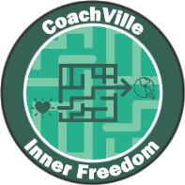 | Inner Freedom Mission #1:  Here is my BIG Dream to get my Hearts Desires out into the world! Here are a few activities I aim to do to expand my Influence, Creative Expression, Visibility and Change.
 | WHAT TO SHARE:  1) Share the name of your Dream  2) Relate: Share a few Influence Plays you are playing for. Are you playing for “Yes”?  3) Create and share: Share about anything that you are going to create and share with others (either a few specific people, a group or the World!)  4) Explore: Describe any new territories, frameworks, groups you are going to explore to see and be seen.  5) Experiment: Describe a few changes you want to make by doing new activities or doing current activities in a new way.

4) Game action: Enlist support for your Play BIG Moves
This is the Connected Age of Play. Your Hearts Desire is NOT a game of solitaire. AND even if your Hearts Desire and Play Moves might seem easy for someone else, they are a BIG DEAL for you, and that is all that matters.

Also, you may need to make a few changes in your daily routine to make space for your play moves and that will require some support from the people in your life.
AND here is the other thing… sharing about your Hearts Desire and PLAY MOVES with your “team” is often on the edge of your preservation zone so it is good practice!
Your Team = family, friends, colleagues, advocates, customers.
You can find your own words but it can be helpful to share it in the context of the course.
Example: Say something like: “I am participating in a program called Inner Freedom where we create a mission to get our Heart’s Desire out into the world. “Can I share mine with you?”
Go for it! And share about each conversation you have whether they like your PLAY BIG MOVES or not!
 | A GAME ACTION is an activity where you do something in the world and then share about what you did and what you learned.
Inner Freedom Mission #1
I just shared about my Hearts’ Desire and PLAY BIG MOVES with someone on my “team”. Here is what happened and what I learned...

WHAT TO SHARE: Share about the experience of sharing with someone on your TEAM. Share about anything you noticed about your thoughts or physical sensations before, during and after.
REMEMBER: if you got an acknowledgment of support share about that on the BIG WIN tab so that we can celebrate YOU.
 | POSSIBILITY!! Whenever possible, share a photo of you in action!
After you share about the game action, a BIG WIN item will pop up on your game card (look on the Big Win tab). If you got an acknowledgment of support then you can ALSO share about that next.


5) BIG WIN: “Yes. I will support you!”
When someone on your team listens to you share about your Hearts Desire and PLAY MOVES and expresses their intention to support you… THAT IS A BIG WIN. Relish it.
So when this happens you will share in both the Game Action area AND the Big Win area for the same conversation.
 | A BIG WIN is when you get the desired result or experience from an action you take in the world. This is a BIG DEAL and we want to celebrate you!
Inner Freedom Mission #1
I just got an acknowledgement of support for my PLAY BIG MOVE from someone on my team! I am so grateful because…
 | WHAT TO SHARE: Share a few details about how you feel and what is possible now that you have this acknowledgement of support.
 | POSSIBILITY!! Whenever possible, share a photo of you in action celebrating with someone on your team!

6) Find the Fun!
Make the play plan your own!- When you play for your dream it is fun to customize the play plan for your personal desires; then bring the spirit of play to the PLAY MOVES of your dream.
Creativity is fun – Find a collection of fun ways to approach your PLAY MOVES. Challenge your mind to come up with a variety of fun alternatives – keep it fresh.
Collaboration is fun – Find ways to get other people involved with your PLAY MOVES. Playing with others is always more fun than playing solitaire and you tend to get better results as well (although it is more risky).
Fear is fun – It is exhilarating when you step out of your preservation zone and embrace the experience.
Transformations from worker to player
Industrial Control Mindset (the old way)… | Connected Play Mindset (the new way)…
Do what you are told to do. | It’s YOUR Dream. Define your own key initiative and have fun going after it.
Do your own work! Bunker in to work in solitude. If you ask for help from others that is cheating. (we all learned this lesson in Industrial Age School) | Humans are collaborative creatures. We are at our best when we engage others in our initiatives. People love to contribute, play along and give feedback.
Do it the same way every time to make it routine and eliminate mistakes | Routine is the enemy of your brain! Challenge your mind to find creative ways to approach your initiative in a new way every day.

Understanding Human Nature

The Social FEAR of Social Play
Now you might be thinking: “Yes, these social play actions and results are exactly what I want!
“But when I think about it:
- Asking for what I want or need is pretty hard for me.
- Sharing what I create can be a real struggle.
- I know I need to “get out there” and be more visible, but it’s not easy.
- Trying new things often feels too risky so I stick with what I always do.”
EXACTLY.
These feelings are the opposite of Inner Freedom.
These four social play activities will bring up seven really intense FEARS!
As you explore these fears in your own life, you will become more capable as a Guide for your players on their journey.
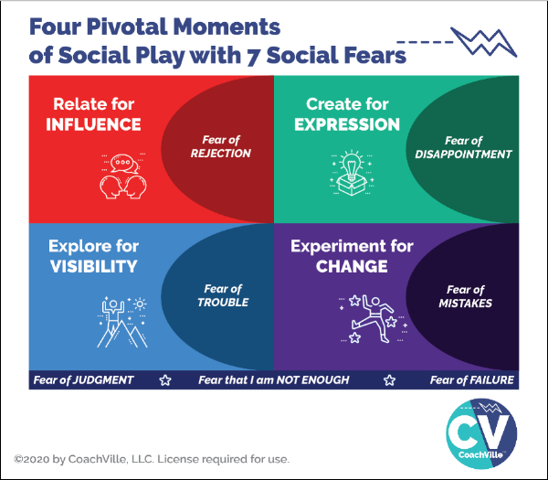
While all of us with a BIG Dream to contribute our unique value and voice to others want these four experiences… we are all also navigating through these seven intense fears; mostly on a non-conscious level and mostly with a variety of not-so-effective methods! (Hah! That is an understatement).
- Fear of Rejection
- Fear of Trouble
- Fear of Disappointment
- Fear of Mistakes
- Fear of Judgment
- Fear of Failure
- Fear that I am NOT ENOUGH (The “BIG Kahuna” Fear)

IMPORTANT POINT!
In Inner Freedom we explore Social Fears like the ones stated above. We do not explore physical fears like fear of heights or fear of spiders. We also do NOT explore the fear of another person physically harming you.

Relate for Influence = Fear of Rejection
To play for impact in the world – even with just a few people - you need to cultivate a high level of ease with approaching people and talking with them. And then you need to invite them to a next step. This is where the fear of rejection comes in. BIG TIME.

Create for Expression = Fear of Disappointment
Playing BIG for your dream will include creating and sharing experiences (or content) in a variety of forms. Also every time you have an opportunity to speak in front of people you are creating and sharing an experience. The fear that we might disappoint someone or BE disappointed by someone’s reaction to what we create can be a BIG block to creating and sharing.

Create and share is the essence of the idea that life can be played like performance art!

Explore for Visibility = Fear of Trouble
Exploring for visibility is often described as: “I need to get out there”. And for many people this is a BIG struggle; this is because the Fear of Trouble is VERY REAL.
In order to contribute your gifts to others you need to find people (customers, colleagues or partners) to participate in what you are creating. You need to “get out in the world” either physically or virtually.
The world of people is an amazing but potentially “dangerous” place; at least at an emotional level. The potential for trouble in the unknown is why most people stay where they are and spend their time with the same people. However, it is almost impossible to pursue your dream this way.

Experiment for Change = Fear of Mistakes
As coaches and entrepreneurs we are change-makers! But at the same time we are often crippled by the fear of mistakes.
This is a big remnant of the Industrial Age mindset that everything you need to do: a) there is a right way to do it b) you should be able to do it the right way every time and never make mistakes.
Of course this is nonsense! But the residue of this mindset from school and jobs keeps us locked into a perfection trap. This makes it sooo hard to experiment and find our unique way to do everything our Dream needs us to do.

Fear of Judgment ~ Fear of Failure ~ Fear that I am not enough
These fears are basically accumulations of the four fears of playfulness. They are deep artifacts of the Industrial Age of Control and they impact our thoughts and feelings in a debilitating way.
Here is a BIG idea: these social FEARS – and the beliefs that form around them - are not inherent to us, we absorb them from the culture through our life experiences.
If you aim to play for your Dream at a high level you need to embrace and explore these fears with profound curiosity. This is what I mean by explore your fears like a treasure map. The treasure is your playfulness and unique superpowers - for Influence, Visibility, Expression and Change - that are deep within you waiting to be activated.
BIG POINT regarding the power of coaching: it is almost impossible to explore social fear by playing alone. But together we can do it!
More about that in a few chapters.
So by playing with your Inner Freedom Life Coach, who is a very capable guide of the Human Journey… out in the social world… through these intense fears… you can become very capable in Pivotal Moments of Social Play in pursuit of your BIG Dreams.
YES!
That’s why you are here with us.
The BIG question you might be wondering…
How / where did I get all of these fears?
How did I become so fearful of activities that seem so natural and essential?
This is the question of the century! (quite literally)
Let’s talk about how this happened to all of us.

We were born to play but then we were trained to work.
I believe that the idea of playing life is the most natural, effective and joyful way to live. I also believe that the Human Spirit of Play is the most untapped resource in the world today. It has the power to transform lives, relationships, families, communities, businesses and the sustainability of life on the planet. Yeah… it’s that BIG.
But all of us were trained in the Industrial Age to look at everything as work; as something that needs to be controlled. School was work, jobs and business are work, and we also work on our relatonships and even our golf game! UGH!! In the Industrial Age you were trained to work in isolation rather than play in the world.
The essence of Industrial Age work is control.
The essence of Connected Age play is co-creation.
In his TED Talk Steve Kiel says that: “the opposite of play is not work. The opposite of play is depression”. Remember all those problems I mentioned at the beginning? They start when we stop playing. And we stop playing because we were made to feel shame for being playful at school, often at home and then at work.
What we are talking about here is our approach to life: we can work on it in an attempt to control it or we can play and co-create with it.
Hint: playing is more fun, less stressful and WAY more effective!!
Play is a better way!
The “Industrial Age” – which became mainstream around 1880 – made routine work the central theme and approach to life for most humans.
Many historians say that the Human focus on work and control began when humans started farming food and domesticating animals. At that point they became tied to the daily grind of working on the same plot of land every day. Whereas our hunter-gatherer ancestors lived every day as a free spirited adventure; albeit with additional risks.
But in 2010 something BIG happened… suddenly almost every human had a super computer in their hands and with it the ability to connect with anyone in the world in an instant. I call this the dawning of the Connected Age.
I believe that as the Connected Age unfolds there is an opportunity for playfulness to become the central theme and approach to life. We can restore the free-spirited playfulness that is our Human heritage and combine it with the security of well-organized shelter and food production that our ancestors lacked.
WOW! SO GOOD.
I made a little chart to help us go a little deeper and recognize the differences between The Industrial Age of Control and The Connected Age of Play.
The important thing to notice is how the Industrial Age of Control culture created a HUGE need for Life Coaching! And especially Inner Freedom Coaching.

The Transformation from Control to Play
 | 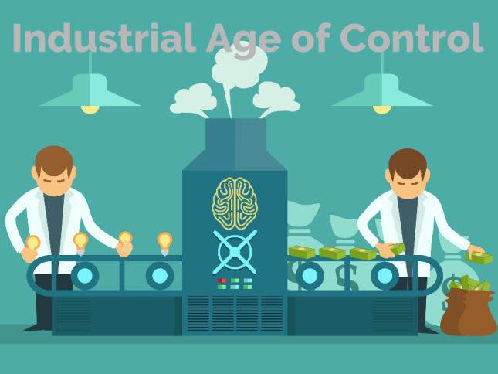 | 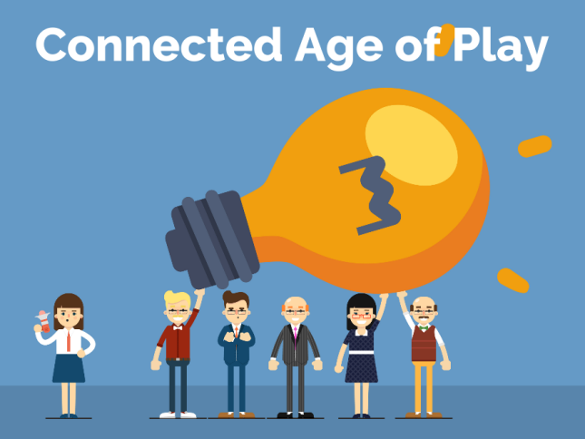
Time frame | 1880 – ~2030 | ~2010 - ????
The Framework | Everything – schools, businesses, communities - is run by authoritarian control like a military operation. | Most things are run like a talented performance art or athletic team co-creating inspiring experiences.
The Approach | Innocent teachers, managers and business owners become unwitting henchmen for the dehumanizing top-down hierarchy.  The 3 C’s  Command  Tell them what to do  Control  Show them how to do it  Compliance  Make sure they do it right | Inspired Life Coaches and coach-approach teachers, entrepreneurs and leaders play to unleash the best of Human Nature.  The 3 B’s  Become  The urge to Become through play  Believe  The ability to Believe in a dream  Belong  The need to Belong with a dream team
The Power | In the “system” | In the YOUnique Superpowers  of Individual Players in  an uplifting environment
Where we  learn | In School.  Sitting silently at a desk  memorizing the right answers  working alone completing tasks  preparing for the test | Life (and Online)…  Learning from the world  co-creating, sharing, connecting  playing games with global friends  pursuing the next level
Memes | Do it right the first time  or don’t do it at all;  (at school)Do your own work  if you help your neighbor  you are a cheater | After you fail, play again  Together we play better  Get to the next level
You are a | Worker / servant  Consumer | Player  Co-Creator / Investor
You have a | Job  with a Manager / Boss  (enjoyment unlikely) | Dream / Purpose  with a Coach  (enjoyment assumed)
What you do | Complete tasks  Fix problems | Co-Create Results and Experiences  Express Superpowers to add value
Why? | To earn a living | To live your dream and GROW
The Feeling? | Suppressed & Traumatized  Dreams squashed  Playfulness shamed  Unique voice and power silenced | Rewarding and challenging experiences and opportunities to contribute make every day a fulfilling adventure
The Path to Success... | Do it right  Don’t make mistakes  Fit in by being like the others  Don’t try to be special  Mind your own business | Play big to make a difference  Risk failure, learn fast and grow  Find a place / group that embraces ALL of who YOU are  Own your value.
You buy… | Things - More is better  Things will make you happy (NOT)  Entertainment to  “get away” from meaningless  or repetitive work | Things that inspire you  and tools for creation;  Experiences that expand your skills and awareness;  Coaching to play better  and pursue your Dream
You aim to | Save some money for retirement;  then you can enjoy life. | Co-Create a freedom-filled lifestyle  economic freedom  creative freedom  emotional freedom  spiritual freedom  location freedom

I know this chart paints a pretty bleak picture of our current culture in the left column. You may be an optimistic person and think: “it’s not that bad”. I understand. I am an optimistic – make the best of any situation – kind of person myself. However… for most people in the world it IS bad. AND we have normalized it so that we have become numb to it. AND most importantly we have been taught that we are powerless to change it.
I have been a professional Life Coach for almost 25 years for over 1,000 amazing individuals. I can tell you: even folks who are optimistic, investing in themselves and aiming big are boxed in by fears of their own Human Nature. They have no idea what their REAL powers are and their capacity to engage in social play activities is severely stunted.
Meanwhile, the situations we face as a human family demand that we stop “making the best of it” and start reclaiming our Human Superpowers to make change! Especially when we consider that most of the trauma, pain and suffering that is happening… we are doing it to each other without even being aware of it!
Together we can change the experience of life for the better… for everyone.

Get Your Human Nature Back!
There are three Superpowers of Human Nature that you need to unleash in order to play BIG for your Dream: Become – Belong – Believe.
You saw the “3 B’s” in the chart about the Connected Age of Play.
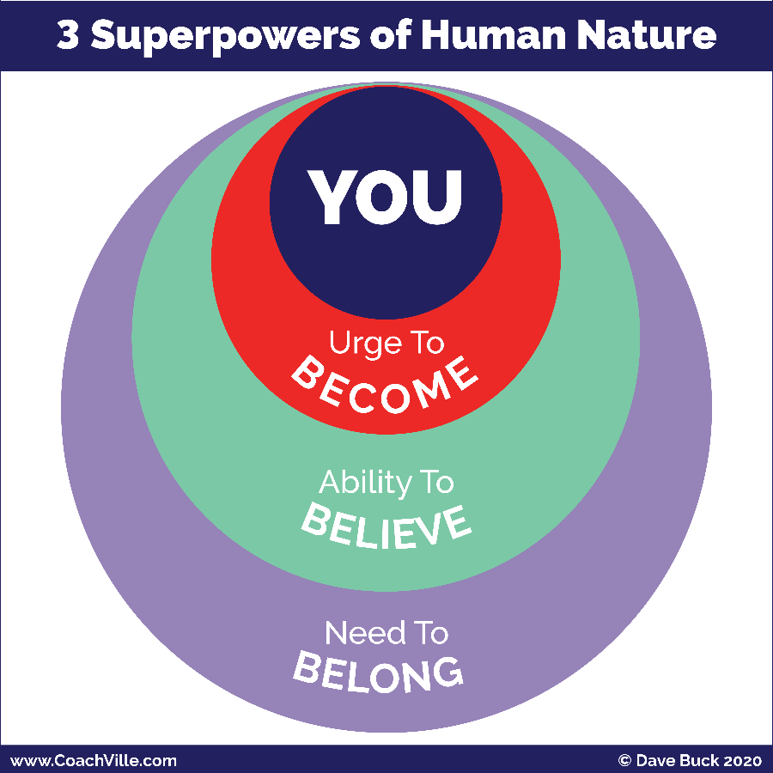
1) The Urge to Become. All humans have an inner urge to become the next version of themselves; to grow and expand. We become by playing. If we stop playing we stop becoming and stay the way we are.
2) The Need to Belong. This is the strongest of all human needs. It operates mostly on a non-conscious level and drives almost everything in the human experience. We Humans always seek belonging and status within the environment we are in.
3) The Ability to Believe. Humans are believers. The ability to believe is the catalyst of all human civilization.
All of our beliefs – about how life works, who we are and what is possible for us – come from navigating between our urge to become and our need to belong. In other words, we get our beliefs from our interactions with the world around us.
Some of our beliefs are conscious and we think and talk of them often. Most of our beliefs settle into a non-conscious level within us and have a non-stop profound impact of what we do and don’t do on a moment-to-moment basis.
To create change we need to unleash all three superpowers!
- We need to PLAY to become the next version of ourselves.
- We need to find or create a new environment of profound belonging where we are supported and challenged to become the next version of ourselves; where we feel safe to be our Superpower selves!
- We need to believe in our own dream. Then we need to explore our beliefs and choose the ones that we need to uplevel in order to live our new dream.
This is the essence of the Inner Freedom Method!
This is where you REALLY need a great Life Coach! We are not meant to unleash our Superpowers alone.

Life Coaching Starts Here
When a player signs on with a Life Coach there is a purpose behind it.
They want to:
- Accomplish something
- Experience something
- Get better at something
- Change something
They probably don’t think: “Oh, I need help unleashing my Human Nature Superpowers!”
LOL
True. However, to get that “something” they want, that is exactly what we need to do.
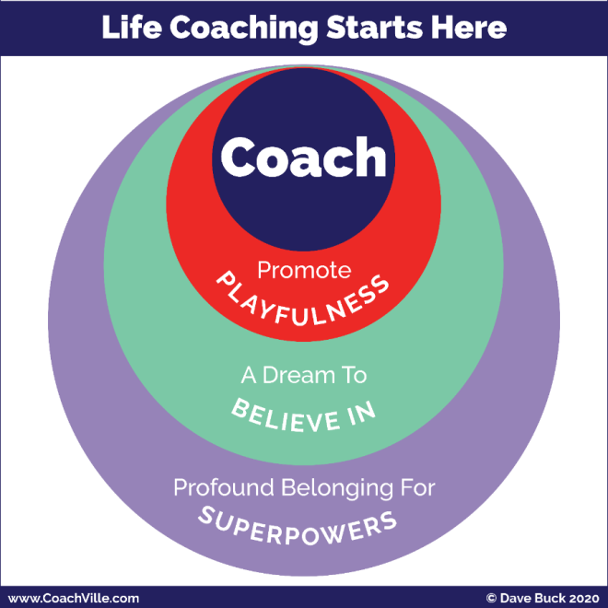
And not only will it energize the path to the “something”, it will also open doors to amazing new possibilities!
In this little diagram called: “Life Coaching Starts Here” you will recognize the structure but the words have changed.
Promote Playfulness
The Urge to Become… Promote Playfulness
This is essential because coaching and playing go hand in glove since the purpose of coaching is playing better. So you will co-create ways for your player to PLAY life in pursuit of their dream.
A Dream to Believe In
The Ability to Believe… Believe in your Dream
Life coaching is about living our dreams! So you will focus in on what your player’s dream is. Don’t worry if it is not clear. You can start with even the smallest inkling and grow it into a BIG Dream.
Profound Belonging for Super YOU
The Need to Belong… co-create a place of profound belonging for YOU and your Superpowers.
You will start be creating a “safe space” – a judgment free space – for your player to express their dreams and practice being Super YOU!
As their confidence grows from your time you will begin to encourage your player to be Super YOU out into the world so they can find where they BELONG!

Our Fears Are a Treasure Map to Our Superpowers
I am addressing this section to you as a player… you will also guide this process as a coach.
This is a major theme of the Inner Freedom coaching program that you saw on the cover page so I just want to illuminate it a little bit here. We will be swimming in it full on once the coaching starts.
Here is the BIG AWARENESS: Growing up in the Industrial Age of Control you absorbed A LOT OF SOCIAL FEAR!!!
And the ways we were taught to “deal with” our fears were misguided.
AKA They don’t work at all.

From: Conquer Fear; Fear is a weakness that I must squash or overcome.
To: Explore Fear; Fear is my friend that is trying to keep me safe.
This is a very different way to look at fear than what you are used to. In the Industrial Age the idea was to make everything a simple task where nothing would ever go wrong and everything was under control. In this life you only experience the fear of shame for doing something wrong; any other fear must be squashed immediately so you can carry on doing your work in isolation.
The thing is, life is not that simple. I refer to this Industrial Mindset as the “Delusion of Control”. When you start playing for your dream out in the world of people, you realize that you can’t control it (or them) and you WILL experience fear… A LOT!
Then in the 80’s and 90’s the “Self-Help” movement really took off and continues today. While there are some good ideas in there, there was a LOT of nonsense about how you need to conquer your fear. And you can do it yourself with a self-help program.
The problem with the self-help movement is that it is based in the Industrial Culture of Isolation and working alone; somehow with the right information you can do everything yourself.
My experience has been that we can’t get free of social fears by working alone… it is impossible. So these programs lead most people to deeper feelings of shame and despair.
Here is the clue: Humans are not meant to do great things alone!!! We are social animals. We are here to co-create life together.
So the key is to change your relationship to fear.
If you attempt to conquer fear, it will defeat your dream.
If you honor and befriend fear, it will guide you to it.
Here is the next BIG idea to consider that will be a recurring theme in the Inner Freedom experience: In the Industrial Culture, the experiences you learned to fear the most were when you expressed your YOUnique power and playfulness.
What happened to most of us:
We got in trouble for being ourselves!
Your fears aim to keep you out of “trouble” so the thing you fear the most is your own power!
These dehumanizing experiences put our power and playfulness into the shadows of our inner being. This is what we refer to as the treasure map.
I know this may sound strange, so I am asking you to trust me on this one and then be curious and open. We will explore this possibility all throughout the program. The good news is that your Inner Freedom Coach knows how to guide you on the treasure hunt!
So when you feel fear, DON’T FREAK OUT, and don’t ignore it! Make a note about the situation and share it with your coach. Then the adventure continues.
The Treasure Map
I call it a treasure map because it is not a like a road map with easy-to-read signs. It is an adventure with lots of challenges and quirky clues.
TO Your Superpowers
A Superpower = A unique ability that you can practice
until it is capable of making a BIG IMPACT on people or situations.
Again, the key is to stay open and curious and your coach will guide you on the Inner Adventure to discover the power that is hiding behind that shadow of fear.
This includes the Human Nature Superpowers we have talked about a few times AND your YOUnique abilities that have gone missing because of dehumanizing Industrial Age trauma.
There is a lot more to YOU than you are aware of right now.

Understanding Energy Alignment

There is more to life than meets the eye!
Another way of saying this is: there is more to life than what we can control.
A LOT MORE!
This is a BIG idea that I want to share with you to give you the bigger picture of Life Coaching and playing for your dreams.
We call it “Energy”; or Energy Alignment.
Here is a little diagram to show the elevation of Life Coaching from the Industrial Mindset focus on Control to the Connected Play mindset focus on playing with energy.
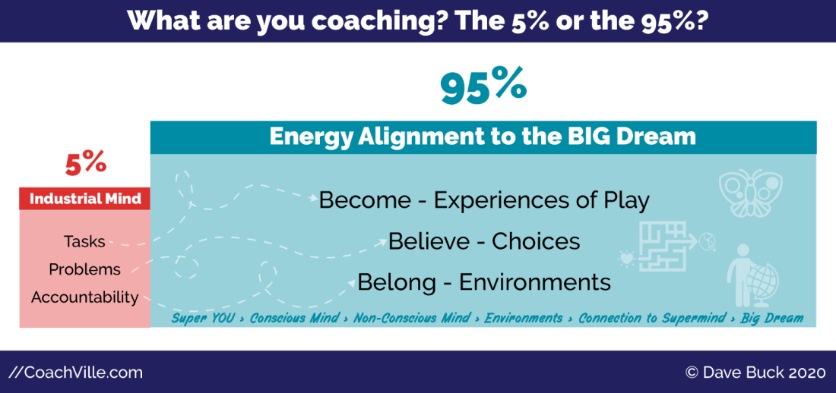
Life Coaching has come a LONG way in the past 25 years… and at CoachVille we have been a really big part of that evolution.
In the early days of Life Coaching – in the 1990’s – we were greatly influenced by the culture of the Industrial Age. So as a result, Life Coaching got tangled up in concepts like tasks, problems and accountability.
But in the grand scheme of life, completing tasks, fixing problems and holding accountability is only a small fraction of what it takes to live a joyful life of freedom and co-creation!
You may have wondered:
Why is the life I imagine so difficult to realize?
The answer is: The energy is not aligned!
And most Industrial Age “success” training ignores Energy Alignment.
One way of thinking about this is in concepts you already recognize: attitude, intuition, attraction and synchronicity.
Energy Alignment makes these ideas very practical while adding the sense of mystery and wonder.
As an Inner Freedom Coach will be focused on guiding your players to their BIG Dream through:
- becoming the next version of you through playful practice and the freedom to BE your powerful self,
- upleveling their non-conscious beliefs and choices and exploring your fears of your own power
- leveraging the need to belong by upgrading thier environments to embrace their power.
When you develop in these areas you seem to make the right moves at the right time without a lot of wasted effort. And good things and opportunities just seem to come to you.
Yes, here we see yet another variation on the Become – Believe – Belong theme. It’s everywhere because your awesome Human Nature is everywhere!
The idea is to play for your dream and live in the flow of energy RATHER than holding you accountable for an endless list of tasks and problems.
WOOO HOOOOO!

The Energy Alignment Game Overview
Let’s explore Energy Alignment a little deeper because it is woven throughout the Inner Freedom Coaching Experience.
I am going to share with you the picture and a brief overview to energize you and spark your curiosity. We will go into each of the elements as we move along on our Inner Freedom adventure together. (Something to look forward to ;-)
You don’t need to “worry” about understanding this; it will happen naturally as your coach guides you using the Inner Freedom Method.
The “Game” is to align all aspects of YOU with your BIG Dream to create a state of flow.
Energy Alignment Game
SO MUCH FUN!! Learning about this concept was one of the big moments of my life.
This definitely goes in the realm of play; as in something that you cannot control but you can influence with skill, strategy, imagination and playful effort.
One little note: There are MANY MANY ways to play with Energy so this is not intended to be a definitive guide.
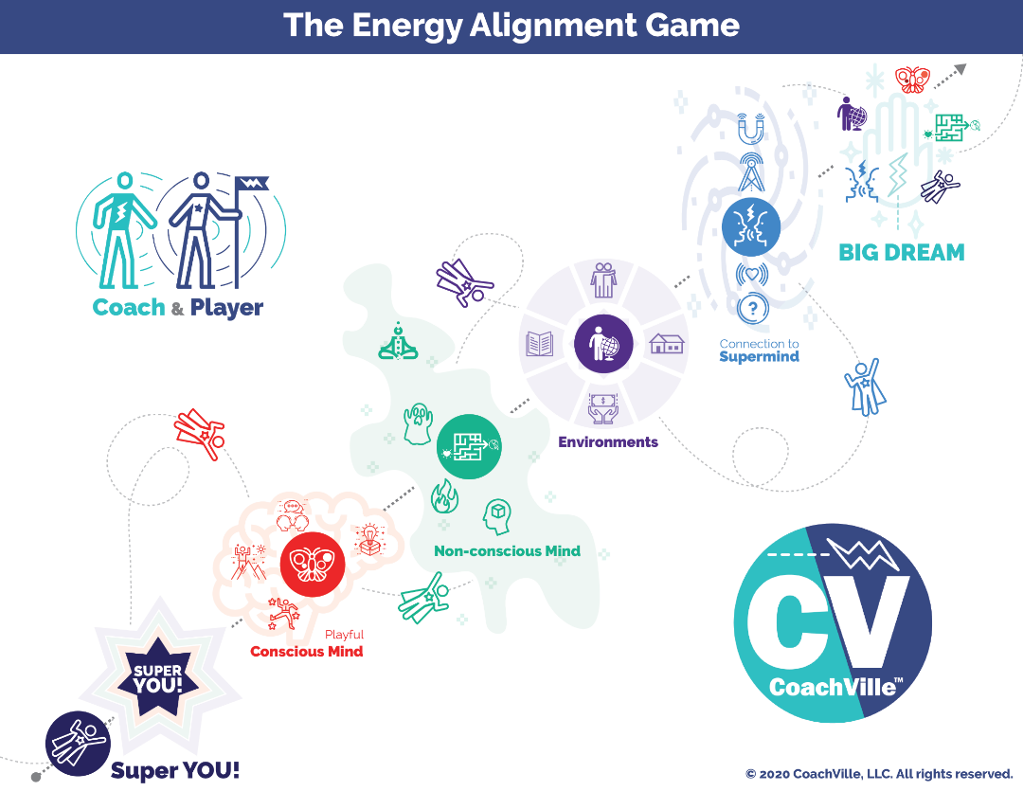
Your BIG Dream
This is your vision of what you aim to accomplish, experience, express or co-create in the world. Your Dream comes from your hearts desires but is often sparked by what you see – or don’t see – in the world around you.
Often our hearts dreams are a little mysterious; even to the one who has the dream.
Most BIG Dreams include an essence of contribution.
Next we will go to the lower left to explore all of the energies that we can align with your dream.
Super YOU
There is a next-level version of YOU that you must express fully and become in order to fulfill this big dream.
One of the reasons your Heart has dreams is so that you can discover and express more of your abilities.
Playful Conscious Mind
There is a playful version of your focused thoughts and deliberate actions that you need to use in an intentional way to uplevel your skills to align with the new dream. Your playful conscious mind responds to the urge to become the next version YOU. Play is all about becoming. In the model hopefully you recognize the 4 symbols for the Pivotal Moments of Social Play that we explored earlier.
Non-Conscious Mind
Whoa, this is a big one. Your non-conscious mind is the power source of belief and desire within you. It is like an energetic bridge between the urge to become in your playful conscious mind and the need to belong in the environment around you. You will need to expand your body awareness; where your intuition and inner knowing live.
You will need to uplevel your relationship with fear from enemy to friend and a treasure map to your Superpowers. Your dream will need you to tap into your hearts desires for focus and fuel. You will need to cultivate belief in a whole new set of possibilities to align with your dream.
The non-conscious Mind is the main focus of the Inner Freedom Method coaching… whew! We need it.
Environment
Your non-conscious mind - which is super focused on belonging - is in constant connection with your environment. You will need to uplevel many aspects of the world around you so that the powers of belonging, believing and becoming align with your dream. And as you unleash your Superpowers, you will need to find or cultivate an environment where it is safe for you to express them. Inner Freedom will give you the courage to make those changes.
Connection to the Super Mind
There is a timeless web of human consciousness that we are all connected to. Through big questions, gratitude and intentional thoughts your dream can become a magnet for the insights, inklings, spontaneous awareness, opportunities and synchronicities that you need to live your dream. But be prepared, the Super Mind plays rough so you need to expect a tumble or two.
The pursuit of Flow
Your dream is calling you out into the world to discover a bigger contribution and more fulfilling joyful life. As you endeavor to align every part of your energy to the BIG Dream, it begins to FEEL – feel is the key word – more natural. This is called getting into the flow. It is not the ultra-safe under control routine. It is engaging, yet safe enough that the potential rewards seem worthy of the potential risks. This is when pursuing your BIG Dream feels less and less stressful and more and more fun!
That is what we are playing for!

Understanding How to Learn How to Coach… The CoachVille Way
To say that we think and feel deeply about the craft of coaching would be an understatement. HAH!! It’s in our DNA as a company with the original mission to improve the quality of coaching worldwide. That was in the year 2000 and we are still focused on this profound and nuanced question: how do we guide another person in pursuit of becoming a truly great Life Coach?
It’s not a question that you can definitively answer… like many awesome questions it is one that we live into rather than answer.
There are some fundamentals to the pursuit of getting good at anything – also known as the pursuit of mastery - that we utilize here at CV.

How to Learn How to Coach
Whoa! There is a lot to say about this topic. I will share just a few points for the purposes of helping you jump into the coaching class experience.
First, it takes over 100 hours of coaching for most people to go from novice to good; many more to go from good to great. This is a real conundrum because no one wants to be a “novice” coach for the person they are coaching; especially because often when we start out we are coaching someone we know!
This is where the Coaching Guides come in! By following the Guides you will co-create a good – sometimes even great – coaching session way before you are good at it!
Coaching is a performance art. It is a LOT like learning to play music. When you first start learning there is a LOT going on. You are learning how to make sounds with the instrument, you are learning the techniques of the instrument and you are learning how to read and understand music; then after a lot of practice you figure out how to put these three things together with your personal artistry to create music that expresses you in a meaningful way.
When you learn an instrument, your desire is to make music; you have heard other people play and it sounded so beautiful. But when you play, it doesn’t sound like that! This is why there is music for a new player that facilitates them learning all of these things a few steps at time. And with a little practice they experience music that is fun to create and pleasing to listen to.
Following this metaphor, the Coaching Guides are like the “music for new coaches”. At the same time they are fun for experienced coaches who want to learn a new style of coaching.
Let’s explore this metaphor a little closer. We will use learning to play the piano as a quick and relatable example.
On a personal note: my mom was a piano and voice coach and her music studio was right below my bedroom in our home. So I heard this process happening every weekday for over 10 years!! It works… and it is truly amazing how people can transform through coaching.
To learn how to perform music on the piano there are a few distinct steps. But we generally learn simultaneously.
- Learn how to read the notes & chords on the paper
- Learn how to make sounds on the instrument
- Learn to practice and play a song
- Learn how to perform a song for an audience
Learn to perform piano | Learn to coach
1a) Learn how to read the notes on the paper | 1a) Learn the coaching skills / superpowers
1b) Learn how to read chords etc. | 1b) Learn the coaching proficiencies
2) Learn how to make sounds on the instrument | 2) Learn coaching techniques
3) Learn to practice and play a song | 3) Learn the steps of the Method and how to follow a Coaching Guide to create a complete coaching session; practice with a partner.
4) Learn how to perform a song | 4) Learn to co-create coaching sessions with a player

What most coach training programs do is steps 1a and 2; they skip steps 1b, 3 and 4.
This would be like teaching you how to read a sheet of sequential notes and play them on the piano (like the scales if you are familiar with music)
… then they say: “OK, go and make music for people!”
You would say: “WAIT! I don’t know any songs, how can I make music?”
The Coaching Guides are the songs!

Here is a little sample of a Coaching Guide
WELCOME (and permission to coach)
A) WELCOME
SAY: "I am really excited about coaching with you. I can't wait to see what we co-create together."
ASK: Do I have your permission to be your coach today? Are you ready to get started?
{wait for them to say, YES}
SAY: "OK. Let's go.

COACHING PLAN
B) DEEPEN THE DREAM
SAY: Today we are going to dive deeper into how you are playing for your Dream right now and then we are going to practice using judgment-free awareness to explore where FEAR is coming into your experiences.

ASK: We spoke about your BIG Dream in our exploratory conversation. Can you give me a recap of your Dream and update me with any additions you have thought of since we spoke last.
{listen and affirm their effort}

ASK: Do you have a name for this dream?
{listen and help them come up with a name for just a minute; it is not essential to have a name but it makes in more memorable and fun}

SAY: In Inner Freedom we talk about your BIG Dream as getting your heart’s desire out into the world. We want to create awareness of the driving force behind this dream for you.
ASK: Why is this DREAM really important to you right now?

{most people will orient either on themselves or the world around them; based on which one they focus on, ASK about the other}
ASK: What about for you personally?
OR
ASK: What about for the world?

**!!** (End of Coaching Guide Sample) **!!**

A few notes about the Guides
There are headings for each section that follow a basic flow: Welcome & Celebration, Coaching Plan, Play Together, Growth Mode (Celebrate, Plan, Play, Grow)
You say the parts that start with ASK: or SAY:
The parts in {RED} offer instructions that are for you to read but not say.
NOTE: if you are color blind, the RED parts are always in {braces}
They will help you know what to listen for or offer a choice about where to go with the conversation.

HOW TO PRACTICE AND LEARN THEM DEEPLY
1) The BEST way to practice is to read each coaching guide OUT LOUD several times. You need to get the feel of the words in your mouth, in your ears and in your brain. After you read through it a few times, you will be able to follow the guide and put your attention on your player at the same time with ease!
2) Then in class you will practice with your coaching partner. This is your time to practice with another person. This time is for YOU to get the feel for the guide and how to observe another person as they respond to what you are exploring. This is your time to follow the Guide and NOT to worry too much about the special needs of your partner. They need to step up and be a player so that you can practice coaching.
3) Then the next step is to follow the Guides as you coach your practice players. Here you practice observing your player within the structure and content provided by the Coaching Guides.
Then… and this is the important part…
4) They will become a part of you and you will be able to perform them naturally.
5) Then… you will start to perform them with your own interpretations and styling (sort of like jazz piano)
6) You will create your own music; AKA coaching guides that you write for yourself that become your coaching methods!
Perceptive Observations
Another point about life coaching (actually ALL coaching) is that the MOST important thing that makes you good is the ability to observe your player at play and then share perceptive observations that help them gain awareness and play better. What the coaching guides allow you to do is take your mind off of figuring out what to talk about or what questions to ask and put it on listening deeply and observing your player.
Another aspect of the Coaching Guides is that they provide a pathway to “play jazz”; meaning they provide a basic structure that sounds good and then as your abilities improve you can improvise – add your personal flair and imagination – within the structure.
Practice bypassing your Industrial Mind!
A BIG thing most people need to UNLEARN when they start coaching is the Industrial Mindset pattern of looking for a problem to solve. Most people in a conversation have a desire to be helpful by looking for a problem that they can help solve with some advice. This is a habit you need to pay attention to and practice bypassing because coaching is NOT about solving problems; coaching is about playing better. Following the guides will really help with this! The Guides will coax you toward playing together to play better and away from Industrial Age problems and tasks.

What to do in a “Coaching” Conversation
Coaching is a co-created experience between a coach and a player. It is a very distinct experience. However, it looks a lot like a “normal” conversation and when we converse we tend to fall into comfortable conversational patterns like: friend to friend; colleague to colleague; boss to employee; parent to child; counselor to “counselee” etc. It will take a little practice to avoid falling into other patterns while you are coaching. You will need to be both patient AND vigilant to BE the coach.
Two specific things new coaches need to avoid:
1) Being the fixer
A lot of folks get into coaching because they are good at solving problems or providing good advice. While there is a time for offering solutions to problems in a coaching relationship, for the most part you will need to hold back on that habit when you start coaching. Often the “quick fix” stops the flow playing together in search of the deeper growth opportunity.
2) Being the dutiful listener
A lot of folks get into coaching because they are good at empathetic listening as the other person tells a long story or “tale of woe”. While empathetic listening is an important coaching skill, you will need to learn to use “artful interrupting” to keep your player and your sessions focused on playing for their dream.
How to structure your coaching sessions
It is a very good idea to set a specific time frame for the coaching conversation. This can be anywhere from 30 minutes to one hour; 50 minutes is very common for professional coaching sessions, 30 minutes is common for coach approach leader sessions with a team member. Some coaches like to do an extended session for the first session of a new “season” where you are defining the dream and the objectives.
In my coaching sessions I am usually hustling to try to complete the session within an hour because I get so into the experience I lose track of time. But I often have my next session with another player at the top of the next hour!
As explained above, we have solved this by providing clear coaching outlines (AKA Coaching Guides) for your coaching conversations. These outlines will guide you and your player through a sequence of inquiries, this way you can focus your attention on two things:
1) Using the techniques you have studied and skills that you have developed. It is very effective.
2) OBSERVATION – you must cultivate your ability to put your attention on the other person and observe them on multiple levels. Not worrying about how to orchestrate the whole conversation will allow you to practice this.
In this program you will begin or continue your journey toward talking like a coach. To make the journey easier we have developed the Plan-Play-Grow Technique for structuring coaching conversations. We use this technique in every CoachVille Class.

How to do a great coaching practice session in class
1) You will both get to be Coach and Player. So choose who will be the coach and who will be the player in the first session
2) Get RIGHT INTO the coaching – skip the traditional small talk
3) When you are the Coach - Follow the Coaching Guide
Ask the questions and then BE CURIOUS to clarify what your player is sharing. Focus your attention on deeply observing your player.
4) When you are the Player DO NOT READ GUIDE – just be real, be yourself; tap into your desire to play for your dream.
A few more points for when you are the coach:
1) The questions are a guide so you can focus on being the coach within each question; rather than trying to think of what to ask next.
2) Follow the Guide! BUT don’t treat it as a task to cover all the questions before you run out of time.
You can think of it like an actor performing in a play. When you observe it, it looks natural. You don’t think: “Oh, they are only reciting lines.”
Or you can think of it as a singer performing a song. They are creating an experience for you. You don’t think: “Oh, they are only singing the notes on a page that someone else wrote”.
3) As you talk with your player about each question, allow your intuition to pop with insights and follow up questions. BUT don’t go too far down a “bunny trail”. Follow your intuition for a few minutes and then move to the next question.
4) Stay on track and stay loose at the same time.
5) HOLD YOUR TONGUE if you feel the urge to tip or fix the situation!
Tipping is for waiters and waitresses - NOT coaches
Tipping - is when your player shares something about their situation and you think you have a good, quick solution and share it.
"Did you ever try...”
There IS a time and place to share solutions and ideas. This will come when you are role playing together.
This is GREAT practice.
An important point for teleclass participation:
You WILL NOT have enough time to do the whole coaching guide during the practice time in class. Your instructor will advise you about which sections to focus on during in class practice.
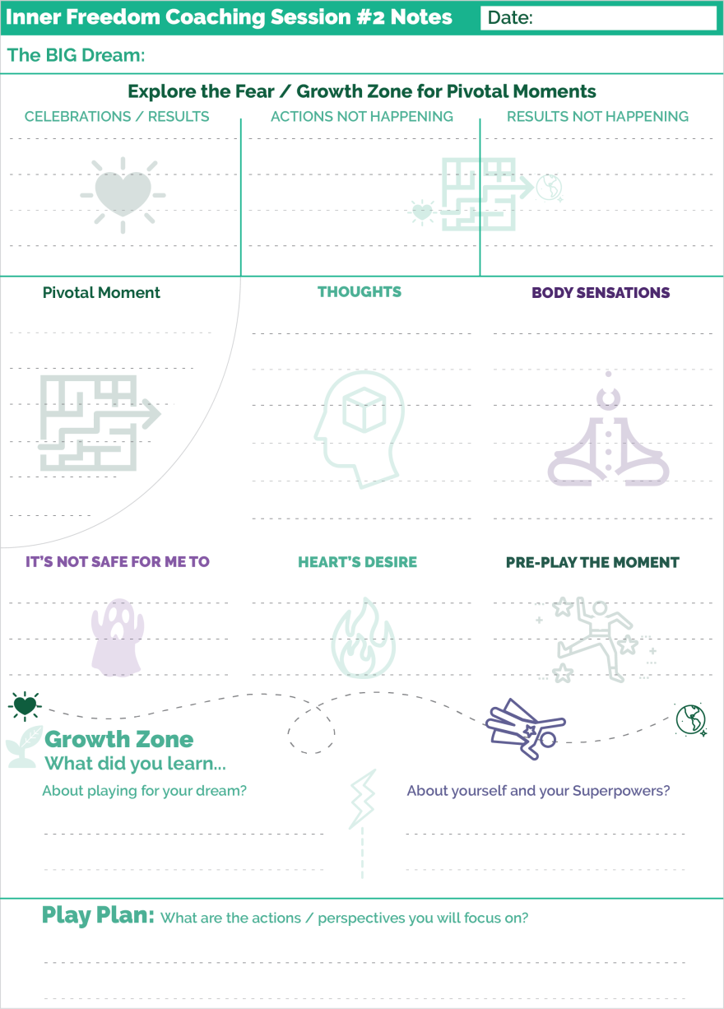
Also, you will want to stick closely to the guide and avoid going too deep into any one inquiry. When you get into it you will see that it is possible to do a quick version or a deeper version of each Coaching Guide.
Do the quick version with your class partner; do the deep version with your players.
Also, if both you and your class partner can do it, meet up outside of class to finish the parts of the guide that you didn’t get to while in class.

How to use the Play Sheets for taking notes
There is a PDF with the playsheets for the 12-week program. There is a unique sheet for each session.
Here is a quick overview of how to use these sheets for yourself and with your players.
In General
You do want to take a few notes during a coaching session… but not A LOT of notes.
You do NOT need to write down everything your player says like dictation; doing this detracts from your coaching presence.
It is a good idea to write a few keywords as the session goes along.
Weekly Playsheets
To facilitate this process we have created playsheets that follow the flow of each session with a place to write keywords. For each coaching session there is a 1-page playsheet that has a section for each part of the conversation.
Note: There is a sample on the previous page that has been miniaturized.
I recommend that YOU recommend to your players to use these sheets for notes during the session. They too should focus on the conversation and take just a few keyword notes to facilitate the growth process.
The Inner Freedom Adventure Log
This is a 1-page overview to track the 12-session adventure. There is a place to write the date and a few keywords from each session.
Use these to track the whole experience and to always know which session you are on with each player.
The Weekly Play Plan
These are for the player. You saw this sheet in the Inner Freedom (Player) Mission. There is just one sheet that should be printed 11 copies.
They are designed for the player to make a play plan for each week, use as a visual reminder of the plan and then make notes as these actions become “pivotal moments”; aka coach-able moments.

Coach Mission 1: Recruit 3 Players

Outline:
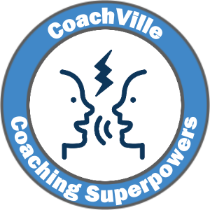
1) Introduction: You are on a mission!
The What, Who, Where and How of recruiting players.
BIG POINT: hosting conversations where you invite people to share their BIG Dream with you is absolutely a fundamental occurrence of your life as a coach!
2) Power Up: Make your REACH OUT plan and DO IT!
(sample messages included in this playbook)
You can include this audio by Coach Dave with your “reach outs”:
https://soundcloud.com/coachville/innerfreedom_exploratoryinvitation
Consider your replies to the reach out and schedule your exploratory sessions.
3) Game Action: Conduct exploratory conversations with your potential players. A detailed Conversation Guide is included in this playbook. Read it over a bunch of times before you use it to get familiar with the flow.
4) BIG WIN: A potential player says: “YES!”
5) Find the fun!

1) Introduction: You are on a mission!
You are on a mission to become an Inner Freedom Coach. To do this you need to reach out and schedule exploratory conversations with potential players.
NOTE: Even if you reach out to someone who wants to say “Yes” before having an exploratory conversation, we recommend that you have the exploratory conversation anyway. This is good practice and you can make sure that you are both set up for success.
To become a great coach you need to coach a lot of players! Coaches are ALWAYS looking for good players. Then they set out to help them become GREAT players.
To enjoy a successful class experience we recommend that you recruit 3 “practice” players specifically for the Inner Freedom program.
HINT: If you register for class early, it is a great idea to start this process before the class officially starts!
About game card badges: in all CoachVille classes, you earn points toward your Coaching Superpowers Badge through coaching activities and conversations. You earn points toward the Method Badges – Like the Inner Freedom Badge for example – by applying the concepts in your own life.
WHAT you are recruiting them to do with you.
As we move beyond the Industrial Age of Control into the Connected Age of Play more and more people are yearning to play BIG in Life by expressing their talents to contribute to the lives of others through relating, creating and exploring. Their dream is the Heroes Journey call to adventure!
However, the Industrial Age was pretty harsh in the way it programmed people to suppress their unique qualities and to fear mistakes. So when they step out to really express their value they are going to bump into FEAR which will lead to frustration. In the Heroes Journey this is the refusal of the call and it happens EVERY DAY.
You have people around you who are ready to play BIG but they need a pathway to transformation. They need a great coach. They need YOU to ask them to be your player.
You are recruiting them for a 12-session coaching engagement over 12 weeks.
Each week you will have a 1-1 conversation with each player. These conversations can be over the phone, face-to-face or via any other audio/video connection tool. 45 minutes is a good time frame for each session though it can be done in 30 minutes if time is a constraint for you or your player. While it is VERY easy to stretch these sessions into an hour long conversation, aiming for 45 minutes will keep you AND your player focused on the topic at hand.
Note: Texting or messaging back and forth for 45 minutes will NOT match these requirements.
For each session, you will have a detailed Coaching Guide with questions to ask, ideas to share and visualization practices to guide. You will practice each session with your class partner in class before doing it with your practice players.
Also each session will have a 15-20 minute “Prep Audio” from Coach Dave that you can send to your player with a few key ideas that will help you dive right into the coaching when you have your sessions. Team Play for Transformation!
We also recommend checking in with each player at least once each week in between coaching conversations via email, text or whatever means both you and your player like to connect.
What about the money?
If you are new to coaching then we recommend coaching your practice players “pro bono”. If you are a seasoned entrepreneur who is good at charging for things, then you are welcome to charge a fee. Using the Inner Freedom Method, the value will absolutely be there even if you are brand new to coaching.
If you are a personal service provider adding coaching to your offerings, you may be able to charge your existing clients for coaching.
If you are an experienced coach, you can recruit paying players for this engagement or invite 3 existing players to do this with you. However, I recommend that you plan to coach 3 players specifically using the Inner Freedom Method rather than blending it with what you are already doing. This will help you learn the Method AND it will set you up to add 12-week Inner Freedom Coaching engagements to your business model. SMART!!!!
WHO to Recruit
The Inner Freedom Method is DEEP coaching; it requires a blend of openness AND tenacity. So you need players who have a STRONG desire to stretch their comfort zone in pursuit of their BIG Dream to contribute to the lives of others in a YOUnique way. We say that FEAR is like a treasure map to our Superpowers.
You honor someone when you offer to coach them. Think of it as the highest compliment.
Who do you know who is doing good things and seems poised to step into greatness? Who has great potential to be a difference-maker… a game-changer?
Who do you know who has the desire to play life at a higher level or live into a new Dream.
Having a coach is a choice people make when they have a dream to play BIG, perform at a higher level or step into a new possibility.
Who is up to something big AND ready to go DEEP? Think of people of all ages; of all levels! Don’t only think of people younger than you are; or “lower” than you are on the “ladder”.
Do NOT look at your existing connections and think: who has lots of problems and “needs a coach”? Coaching is NOT an intervention for problems!
This is not to say that good players don’t have any problems! Of course they do. However, while some people just seem to have problems, players have challenges that arise out of their DREAM to play BIG. These are the type of challenges we want to explore with the Inner Freedom Method.
YOU do NOT need to be an expert in what the player is doing. Life coaching - and specifically the Inner Freedom Method - is powerful without specific subject matter experience. Note: When you move into high-end professional coaching the best plan is to combine Life Coaching methods – like the Inner Freedom Method - WITH subject matter experience.
Another thought…
Look for people who never really “fit in” to traditional structures where they needed to comply to do well. These folks could be poised for greatness in the Connected Age where curiosity, creativity and contribution are replacing command, control and compliance. These folks will LOVE the Inner Freedom Method.
Where to recruit
This will depend on your situation. A little later in this playbook I will share with you some sample “REACH OUT” messages that you can use.
A) You are a manager / leader and you have a group of employees and colleagues from which to recruit your 3 players.
Extend a personal invitation to the people you want to coach.
IMPORTANT: When coaching folks who work for you, you must obtain express permission from THEM to coach them AND you will need the 30 minutes per week of established 1-1 coaching time.
ALSO IMPORTANT: The Inner Freedom Method is DEEP, as I mentioned before. So you will want to choose folks with whom YOU are ready for vulnerable conversations.
B) You are already coaching or providing a professional service to clients.
In this case you have client pool from which you can recruit 3 players. If you want to recruit from your existing clients, you can offer them the opportunity to coach with you using a new format for 10 coaching sessions over a 3 month period. It will be important to let them choose to engage in this new approach with you.
C) You are an awesome person learning a new coaching method.
In this case you need to recruit 3 players from your network of friends, colleagues and social connections. You may have colleagues or friends who you can reach out to personally.
Many students use Linked In, Facebook or email to find their potential players using an “opportunity post”. Also, even if you have a group of people right around you, you may want the experience of opening up to coach people who come through your social connections. Remember!!! It is PLAY. Sometimes opening up to a bigger world can really spice things up nicely.
Important! Your CoachVille class colleagues do NOT qualify as practice players. The idea is for you to go boldly out in your community – geographical or virtual – and recruit players!

2) Power Up: Game plan your recruiting mission and REACH OUT!
- Read this guide with sample REACH OUT messages
- Make your plan to reach out to your potential players and invite them to talk with you.
- Do your reach out.
- Share about your approach on the game card.
Sample REACH OUT messages
Invite someone you know: “Hey Sally, I am participating in a 3 month Life Coach Training program called Inner Freedom and I am recruiting 3 amazing people to be my players while I am in the program. The Inner Freedom Method is loosely based on the Hero’s Journey; it is for people who have a BIG dream AND are willing to explore the doubts, fears, overwhelm and frustration that they experience on a regular basis. What if we discovered the Superpowers that your fears are concealing? It is VERY possible.
We will have 12 weekly 45-minute coaching sessions as part of the class. I think of you as someone playing big and I would love to set up an exploratory conversation to see if this is a fit for you. It is going to be great fun.
You can listen to this 9 minute audio by Coach Dave who created the program to get a little insight into what we will do together.
Are you interested? Let me know.”

Example opportunity social media post: I am taking a Life Coach Training program with CoachVille called Inner Freedom. I am very excited about it! I am looking for 3 “players” for a 12 Session pro bono coaching engagement over a 3-month period. Each session will be 45 minutes.
The Inner Freedom Method is loosely based on the Hero’s Journey; it is for people who have a BIG dream AND are willing to explore the doubts, fears, overwhelm and frustration that they experience on a regular basis. What if we secured the Superpowers that your fears are concealing? Together we can do it.
You can listen to this 9 minute audio by Coach Dave who created the program to get a little insight into what we will do together.
If this sounds like you please contact me so we can set up a brief exploratory conversation. It is going to be really fun and potentially life-changing. I only have 3 openings so please respond quickly!
If you know someone who might love this, please pass it on to them. Thanks!
Here are a few “catch phrases” that describe the Inner Freedom Method that you may want to weave into your message.
- Get your Heart’s Desires through the maze of doubt and fear and out into the world
- FEAR is your Friend; You can PLAY with FEAR
- FEAR is like a treasure map that leads to your Superpowers.
- To go bigger out in the world, you must go deeper into your SELF
- Unleash the Superpowers that your FEARS are concealing
***
Use these samples to craft something that sounds like you AND uses some of the Play Language.
Then send it out! Don’t wait for perfection.
Share on your Game Card
 | A POWER UP is an activity where you listen, read or do an exercise and then share your insights and/or plans.
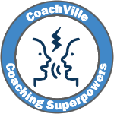 | Coach Mission #1:  I read the playbook and sent out my REACH OUT message to recruit 3 practice players for Inner Freedom Coaching. This is what I did...
 | WHAT TO SHARE: Share a few details about your REACH OUT plan. If you want, share the content of your reach out message. It may inspire one of your classmates.

3) Game action: Recruiting conversations with potential players
Receive the replies you get to your “reach out”s and schedule exploratory sessions with your potential players!
- Read this section and PRACTICE the Conversation Guide; read it out loud a few times. It is structured like the Coaching Guides that you will use in class and with your players. We call it a “Conversation Guide” because at this stage you are not officially coaching them yet.
- Use it to talk with your potential players;
- Play for “YES! I want you to be my coach!”
- Share about your experiences on the game card.
- HINT: Share about it on the Gamecard even if you are they don’t say “Yes”.
Introducing the “Recruiting” Conversation
The next step of this mission is to have a brief exploratory conversation with each potential player. This is important because coaching should always be a mutual agreement between the coach and the player. You can only coach someone if they want to be coached by you AND you believe in the dream they are playing for.
This exercise is powerful for your life as a leader as well as a coach because you are practicing relating for influence. Some of the most important moments in life are when we are making an “ASK” where you are playing for influence and a mutual “YES!”
This Conversation Guide will provide a simple structure for this conversation. Also, it is similar to the coaching outlines you will use in class so it will set a positive tone for the relationship. We call it a “Conversation Guide” because at this stage you are not officially coaching them yet.
Remember, YOU are the coach. So:
A) You need to guide the conversation
B) It is mostly about asking questions and listening. You don’t need to say too much!
C) At the conclusion, YOU must choose if you want to coach this person; If you are a “yes”, then ask them if they want to be your player. Your aim is for them to say “YES!”; If you don’t want to coach them, don’t ask them.
What to look for in the moment of choice.
In the conversation outline you will do a lot of listening. As you are listening you want to check in with your intuition. This is an essential coaching skill so you should start learning it right now!
Wonder to yourself:
- Do I have a good connection with this player?
- Do I support the dream they are playing for?
- Will I enjoy coaching them?
- Or will I at least enjoy learning something by coaching them?
It is OK if you think they will be a challenge, as long as you will enjoy it in some way. It is OK if it will stretch your comfort zone or require you to look at things from a new perspective.
Avoid taking on a player if you think it will be a “rescue mission” for someone in trouble.
PRACTICE!!!
Read the conversation outline OUT LOUD a few times to get used to saying the statements and questions!
You don’t “say” the numbered lines to the other person; NOR the statements in RED.
You only say to them the lines that start with Say: and Ask: .

*** Recruiting Conversation outline on the next page ***

*** Recruiting Conversation Guide ***
You are the coach, so start the conversation by guiding it right away.
WELCOME
A) WELCOME
Say: "I am looking forward to doing this session with you. I really appreciate you and I can't wait to see what we discover together. It will take about 30 minutes.
Ask: Are you ready to go?
{Coach: wait for them to say: YES}
Say: "OK. Let's go. So as I mentioned I am participating in a Life Coaching Training program at CoachVille called Inner Freedom and they are really big on looking at business, career and life as a playing for your dream. My role as the coach is to help you play better, expand your possibilities, and unleash your superpowers by stepping outside of your comfort zone."
COACHING PLAN
B) DISCOVER THE DREAM
Ask: If you looked at your life / business / career as living your dream...How would you describe your big dream is right now?
{Coach: listen and ask any curious questions that pop up for you}
Discover their definition of success
Ask: What does success look like for you over the next 3 months?
{Coach: listen and ask any curious questions that pop up for you}
PRACTICE / PLAY TOGETHER
C) EXPLORE THE GAP
Say: In coaching we are always looking for the GAP between how you are playing now and how you imagine that you can play for this dream.
Ask: How do you see yourself playing bigger or better or exploring new possibilities?
{Coach: listen; stay judgment-free; people are yearning to talk about seeing themselves as really BIG but they rarely feel the encouragement or safe space to do so; some people will talk about possibilities others will start sharing about challenges or obstacles}
Ask: What are some activities that are pulling you outside of your current comfort zone?
Ask: Anything else come to mind?
{Coach: listen; stay judgment-free; again AVOID AVOID AVOID offering solutions!!}
Find/Articulate the “Drama” / BIG Growth Opportunity / Challenge
Say: In coaching we like to look at playing for your dream as a Hero’s Journey. So there is always some drama in the form of a growth opportunity or challenge.
Ask: How would you describe your big challenge or growth opportunity using epic adventure language?
{Coach: this is meant to be fun; you may need to help them get into the spirit of it}

Say: Let’s have some fun with your imagination
Ask: Are there any aspects of YOU – like creative ideas or talents - that you would love to bring out into the world in a bigger way?
{Coach: listen and then have fun with them; encourage them to dream bigger
IF you know them OR you sense something about them this is a great opportunity to champion what you see in them }
Ask: In the Inner Freedom Method there is a saying that your doubts and fears are like a treasure map to your Superpowers. What would it be like if we unleashed your Superpowers?
{Coach: listen with your energetic presence; it will be very interesting to see where they go with this question. This is where you pump them up with the possibility that having an Inner Freedom coach like YOU will make a big impact on their dream!}
GROWTH MODE
D) MOMENT OF CHOICE
{Coach: Here you have to choose! Do you have a good connection with them? Does something about them intrigue you as a learning opportunity for you?}
If YOU are a “YES”:
Say: I love your Dream and I think we could have great success together.
Ask: Would you like to be one of my players?
If they say “yes”, move on to #6A. If not, skip to 6B.
If YOU are a “no”, skip to 6B.
PLAY PLAN
6A) CONFIRM THE COMMITMENT
Say: Excellent. I just want to confirm that you are committing to meet with me for about 50 minutes each week. If we can’t do a session one week for some reason, we will try to make it up the next week.
Ask: Are you good with that?
{Coach: wait for them to say: YES}
Say: Let’s get our first two sessions on the calendar now.
{get your first 2 sessions set up in your calendar for as soon as possible after the start date for the program}
6B) If either of you say “no”: thank them for their time.
Say: I have learned a lot from this conversation. Thank you. But I don’t think we are a good match for coaching together. Thanks so much for your time today!

*** Playbook continues on next page ***

After the conversation
No matter how it turns out, share about your experience on your game card.
A GAME ACTION is an activity where you do something in the world and then share about what you did and what you learned.
Coach Mission #1:
I just had an exploratory conversation with a potential player. This is what I experienced...
WHAT TO SHARE: Share a few details about your experience in the conversation. What did you learn?
REMEMBER: if you got a “YES” response share about that on the BIG WIN tab.

After you share about the exploratory conversation in the GAME ACTION tab, a BIG WIN item will pop onto your game card.
WHEN one of your potential players says: “Yes”, click through to the BIG WIN tab on the game card and share about that as well.
Relating the Exploratory Questions to the Human Situation
In this conversation you are talking with your potential player about their dreams, about being playful, about their unique abilities… exactly the things that have been squashed, shamed and silenced by the Industrial Culture.
Don’t expect your potential players to be fluid in these explorations! It might be difficult for them. They may have no idea what to say.
This is OK!
It is not a test! There are no right answers. It is meant to be provocative and aspirational.
It is meant to spark possibilities within them.
When you ask these questions in an affirming way – as if to say: yes, of course you can do these things – it will start to wake up these elements within them.
A BIG key to coaching is to always remember that EVERY human has dreams, playfulness and unique power.
It is your role create a safe space for the player to explore and practice and BECOME the version of themselves that expresses them in the world.
In the conversation be gentle, empathetic and affirming that they CAN speak it and they CAN do it.

4) BIG WIN: A potential player says: YES!”
This is something to celebrate!
A BIG WIN is when you get the desired result or experience from an action you take in the world. This is a BIG DEAL and we want to celebrate you!
Coach Mission #1:
I just signed up a player for Inner Freedom Coaching! WOO HOO! This is why I am excited to coach this player…

WHAT TO SHARE: Share a few details about your experience and why you are energized to coach them.
POSSIBILITY!! Whenever possible, share a photo of you in action celebrating with someone on your team!

5) Find the Fun!
You know those fun adventure movies where the “hero” is putting a collection of people together with special skills to accomplish a mission together? Well that is YOU right now.
Putting a team together is fun!- As a coach or coach approach leader you are always looking for good players for “your team”. If your players are not necessarily going to play together they are still on your team so they will probably have some shared purpose even if they don’t know it yet. You may even want to find a way for your players to get together at some point either face-to-face or virtually.
You will probably want a variety of players with different dreams or different talents; it can be fun to put the right mix together.
Treasure hunting is fun – You can think of every person who signs on to coach with you as a treasure. Looking for them can be really fun. You are looking for game changers to share a powerful experience with you. Finding the right players can be a fun adventure.
Recognition is fun – People love to be seen and known for who they really are – A BIG Player in Life. This is what happens when you reveal their BIG DREAM in life and the BIG Purpose they can pursue by playing rather than working. Being recruited is a form of recognition.
Transformations from worker to player
Industrial Work Mindset (the old way)… | Spirit of Play Mindset (the new way)…
You work alone and don’t bother anyone. | You find your players through personal and social connections. You leverage your relationships and network in your search for good players. You are not alone. You are part of a vibrant community and YOU are the coach in this community now.

Coaches Notes for the Exploratory Session
The main purpose of the exploratory conversation is to figure out if you would like to coach this player.
- You know you will enjoy coaching them
- You know you will learn a lot from their situation
- You know they will love the Inner Freedom Method and will make great progress
Any one of these 3 is good enough!
The secondary purpose is to set the stage for Life Coaching
- Focus on their dream
- The use of play pattern language
- Exploring growth opportunities
And along the way they start to get a feel for the structure of a coaching conversation and the types of questions you will be exploring together.
LOTS of good things.
The main thing is to co-create the feeling that you will be guiding them but not telling them what to do. This is confusing for some people at first because somehow they got the perception that a Life Coach tells you what to do.
Another key, that we will talk about more in the Session 1 notes is to be really pro-active in the conversation sharing observations WITHOUT giving the idea that you are going to try to fix them or solve their problems.
The Drama
This part is meant to be really fun. You may need to coax them along a little bit. You want them to get the idea that this is going to be an epic adventure with you as their guide. EVEN if they just do the things they were doing before – like going to work each day – with you as their coach it is going to take on a lively new feeling.
The Superpowers
Most people have no clue what their unique abilities or superpowers are beyond the infinitely bland “good communication skills”. The point of talk about this is to spark their conversation and whet their appetite!
CHOOSE
Most people are fun to coach even if they are a challenge; there is almost always a valuable growth opportunity. However, if you get a bad vibration from someone or feel that they are really not open to personal growth, then I recommend not taking them on as a player; not even as a pro bono player.
Coaching is meant to be FUN!

Understanding the Inner Freedom Method

The Inner Freedom Method Model
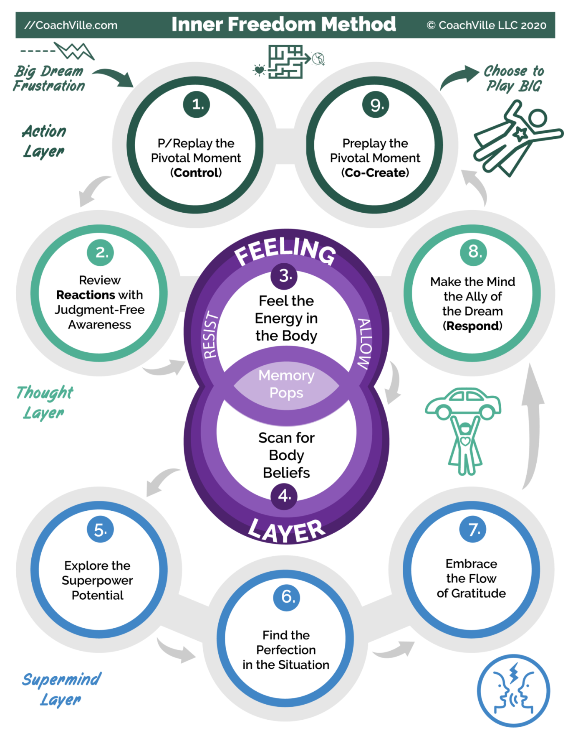

Program Description
A 9-step Coaching Method to transform FEAR
into a treasure map leading to your hidden playfulness and superpowers
The Inner Freedom ™ Method is a powerful 9-step method where you identify non-conscious patterns of fear and transform them into a powerful path of discovery to fulfill your purpose to Play BIG for your Dream.
The Inner Freedom Method is a precise sequence of guided exploration conversations, practice experiences, visualizations and body awareness experiences.
You cannot do the Inner Freedom by yourself; it is NOT a self-help method. The Inner Freedom Method is a co-created experience that requires two people. (There is a way to do a modified version in a small group as well)
In Session 1 you and your player will explore their BIG Dream for it’s possibilities as well as any “fear adjacent” experiences that they are aware of. From that point forward, each session you will guide the exploration of a “pivotal moment” of social play that they want to explore to unleash their power.
I will get into the details of the life-changing concept of a “Pivotal Moment” in Chapter 1 of this playbook and in the audio series. (Something else to look forward to!)
Here are the 12 Sessions of the Inner Freedom Method Coaching Adventure:
#1) Play With Fear
#2) Pivotal Moments and Judgment-Free Awareness
#3) Feel the Energy and Body Beliefs
#4) Memory Pops
#5) Explore the Superpower Potential
#6) Find the Perfection
#7) Flow of Gratitude
#8) Make Your Mind the Ally of Your Dream
#9) Intentional Co-Creation
#10 Upgrade Your Environments
#11 The New Super YOU!
#12 Celebrations

The Inner Freedom Method Adventure Log
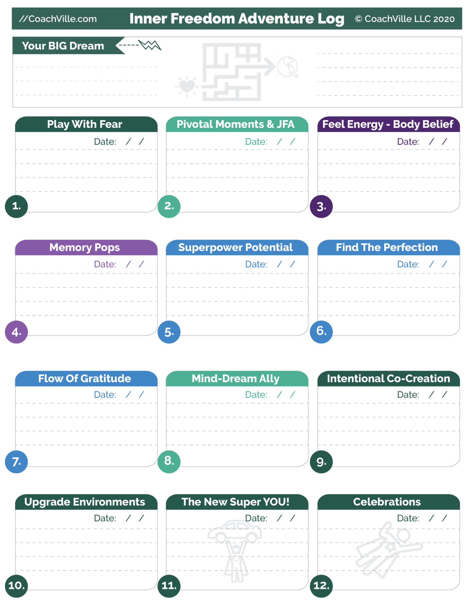

Inner Freedom and the CoachVille Curriculum
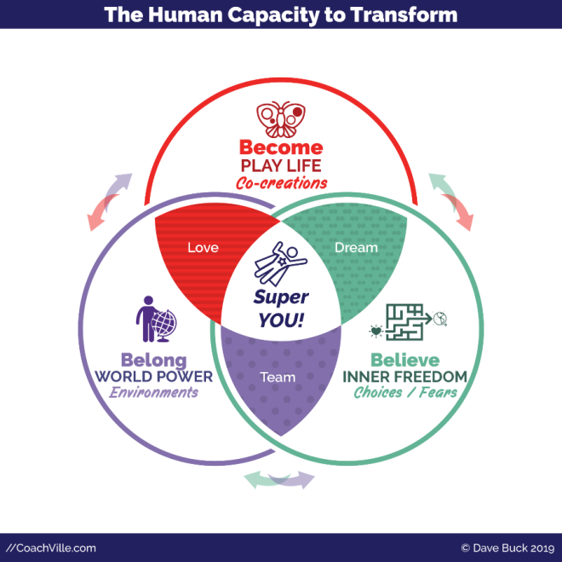
The Inner Freedom Method is one of a trilogy of methods designed to co-create transformation by unleashing the superpowers of Human Nature within the player.
(While the Industrial Culture works feverishly to control them!)
This little diagram maps the three methods to the three superpowers of Human Nature that we have explored a few times: Become – Believe – Belong.
The Inner Freedom Method is especially focused on exploring and unleashing the Ability to Believe. Specifically, the ability a person has to believe in their own dream and to choose the beliefs that align with that dream.
Or beliefs determine the choices we make in our days and our lives.
Many of the beliefs we absorbed in the Industrial Culture were intended to keep us in fear. Specifically to fear our playfulness and expressing our YOUnique powers. This is what is meant by the maze in the symbol for the program. Our beliefs, choices and fears become a tangled maze that we must explore in order to get our hearts desires out into the world. On the journey we rediscover our playfulness and unique Superpowers. FUN!

Your story as a player...
As you step into your vision to Play for your dream in a BIG WAY, you will often find yourself severely slowed or even “paralyzed” by the invisible force of FEAR! With the Inner Freedom Method you will create a personal transformation...
From: fear and emotions are something you conquer; the non-conscious mind is dark and mysterious and must be avoided.
To: you can befriend your fear and emotions and play with them; the non-conscious mind is a vast resource of wisdom and power.
With the Inner Freedom Method you learn how to approach fear with the spirit of play; to explore it with curiosity. This brings deep understanding to the self-preservation patterns that are creating conflict with your desire to play BIG in the world. With expanded awareness we can transform inner conflict into positive energy, joyful self-expression and deep confidence. This leads to choices aligned with your dream and heart-fulfilling results!
The BIG Question: How BIG do you CHOOSE to play in this amazing journey of your life?
With Inner Freedom it is truly your choice!

Your story as a Coach...
When you coach your player to play big in the outside world their “Inner World” will put up a LOT of resistance. Nearly every decision we make in social situations is instantaneously determined by patterns of feeling in the non-conscious mind; what to say, NOT say, what to do, must NEVER do. When we start playing big, we often notice how restricted we feel; and it's frustrating.
This is your opportunity for coach-able moments – we also call them pivotal moments - of transformation that lead to breakthrough results...
From: Motivate your players to overcome (power through) fear and control their emotions.
To: Guide your players to PLAY with fear and respond to their emotions.
When you bring the Inner Freedom Method to your coaching conversations your players will be amazed at the awareness that comes into focus. And they will be thrilled when freedom and RESULTS replace frustration! You will be a coaching hero! (always fun)
With the Inner Freedom Method you will be able to coach the biggest players in the most challenging and high impact dreams.
When the word gets out about what you can do, you will be in high demand.
The BIG questions: How BIG do you want to be as a coach?
Do you see yourself as a professional coach or coach approach leader of influence with people who truly want to make a difference in your community? in the world?

The BIG Picture
Humans are emerging from the Industrial Age of Control into the Connected Age of Play. More and more of us are yearning to live more purposefully; to experience and express our uniqueness AND our connectedness. To do this, we MUST be highly aware of and leverage ALL aspects of the Human Experience: including purpose, desires, emotions and fear.
Together we must embrace the truth that PLAYING Life INCLUDES challenges and hardships that give us opportunities to grow more fully into ourselves and connect more deeply with others. We have a choice in how we play the moments of our lives. To be a coach in the world means living, loving and guiding the adventure.

How the Inner Freedom Method will make you a better coach
1) Your confidence as a coach will increase dramatically because you KNOW you have the tools to handle ANY challenging situation your player is in.
2) Your ability to find the "Pivotal moment" and shift the experience for your player from inner resistance to inner freedom will create extraordinary richness in every session. You will learn exactly what questions to ask and what to look for.
3) Understanding and using body awareness will allow you to help your players expand and tap into intuition and inner knowing.
4) The ability to find the perfection in situations past and present is a most extraordinary booster to self-worth; which is something EVERYONE values greatly.
5) Your players will FEEL more capable to play BIG in the world after every session with you.
6) You will become masterful in reading the dynamic of in/out of the self-preservation zone and know just how to keep your players on the growing edge.
7) You will have a deep understanding AND a solution for the common challenges people face today: overwhelm, frustration, isolation and even apathy! This will give you great confidence in coaching a player through challenging situations.
8) You will learn how to talk about FEAR and inner resistance as a catalyst for growth with your players.
9) You will expand your understanding of the dynamic balance between support and challenge which has the effect of boosting your player’s self-worth. This in turn will greatly enhance their ability to play for their Dream and get results.

The Backstory of the Inner Freedom Method
After about a year of pulling together ideas and putting together a website, Thomas Leonard launched CoachVille in July of 2001. We had been friends since 1997 and I was his right hand man.
After a wildly successful CoachVille Conference in Las Vegas in late 2001, Thomas and I went on a jet-setting speaking tour all over the US and the English Speaking world. Thomas did not like being on stage alone so I was his sidekick; filling in ideas or giving examples.
One idea that Thomas talked about all the time was something he called: Superconductivity. This is a concept from the field of electro-magnetism but he was using it as a personal growth concept. He talked about how it was possible to align your energy so that you could achieve your goals with very little friction.
The thing was, he talked about that you could do it, but he never explained HOW to do it.
Just before he died he was creating a personal growth program to explain HOW. It was going to be called: “Absence of You”. I hated the name, but it was meant to explain how parts of us were creating the friction that prevented Superconductivity to our goals and aspirations.
Thomas - like most personal growth gurus of the 20th Century – was stuck between empowering people to be awesome and telling them how to fix what was wrong with them.
Anyway, when Thomas died this was just one of the many puzzles he left for me to solve.
Thomas had been collaborating with a fellow named Tom Stone on the Absence of You program. He and I finished the program in 2003 and offered it a few times. This collaboration didn’t go so well; mostly because I was growing increasingly uncomfortable with the “there is something wrong with you and I can fix it” style of coaching. We parted company and he parted with the Absence of You program which he later renamed.
I set off to find a better pathway to Coaching for Energy Alignment; AKA Superconductivity.
Another major event in this story is when I hired Marshall Thurber as my Coach. Marshall was a protégé of W Edwards Deming and Bucky Fuller and he insisted that everything we taught had a strong theory and method behind it. This was SUPER helpful in crafting all of the Methods; but especially the Inner Freedom Method.
For a little while I was calling it the Superconductivity Method. But no one could figure out what in the world that meant! LOL.
Along the way I was dating and collaborating with an amazing Transformational Coach named Lise Janelle. We had SOOO many conversations about our coaching experiences that helped hone in on the ideas and the steps of the method.
So after several different attempts, the Inner Freedom Method came to life.
When Lise and I parted as a couple she created her own version of the Method called the Heart Freedom Method.
In 2015 while staying at a B&B on Block Island I quite accidentally picked up a book on a bookshelf titled: “The Continuum Concept”. This book changed my life forever. It was a fascinating story of a European woman who got separated from a few fellow adventurers in the Amazon and was taken in by a Stone Age tribe of Humans living a “pure” Hunter Gatherer life.
The way she described their lives was a lightbulb moment for me. It confirmed my hunch that almost all of the Human qualities or situations that we describe as problems or defects are not inherent to Human Nature; rather they are a product of living in the Industrial Age Control Hierarchy. I was also shocked to learn that the narrative I had learned in school – that Hunter Gatherer Humans were wild savages – was a bunch of bunk! What else had we been told in school that was purposefully misleading? It turns out… A LOT!
I researched and read a few more accounts of Hunter Gatherer Humans and I was thoroughly convinced that Human Nature itself is beautiful, loving, playful, egalitarian and co-creative. Everything else comes from the culture.
With that, I rewrote all of our coaching materials to remove ALL notions that “there is something wrong that we can fix”. Instead of fixing, we need to FREE our Human Nature from the chains of Hierarchical Control. We need to co-create environments where we are FREE to be fully ourselves. Together we can co-create an amazing world or peace, prosperity and possibility with EVERYONE included.
You will definitely continue to pick up on this underlying theory throughout this book.
This is the essence –and the PURPOSE – of the CoachVille Coaching Curriculum; and as I see it: the purpose of Life Coaching in the world today.
As a side note: you can get an extremely applicable version of the Human Story in the book: “Free to Learn” by Peter Gray. He also refers to “The Continuum Concept” as a classic. Fun.

Let’s Play!
Whoa! We have come a long way already and our adventure together is just beginning.
Look out world… here we come!
Note to the coach about the playbook
There are A LOT of concepts, ideas and perspectives in this playbook. There are a lot in the first few chapters and much less in the latter chapters. The Inner Freedom Method is a very different way of approaching coaching and life and there is a lot to learn in the beginning. You may want to read the first few chapters a few times over the course of the program.
As we move along on our adventure the focus will shift from concepts to your own coaching experiences… and your deeper explorations as a player.

Chapter 1 – Play With Social Fear

“In a sky full of people,
only some want to fly.
Isn’t that crazy?
… Cause we’re never gonna survive
unless…we get a little crazy.”

-Recording Artist Seal

Chapter 1 Prep
Before Class
Read through the complete coaching guide for Session 1 (Page 6)
(this is a link to the PDF with the complete set of coaching guides)
Listen to the Player Prep Audio for Session 1
(this is a link to the Player Prep SoundCloud audio)
Playsheet Pack: Print 2 copies of page 6
Listen to Coaching Demo of Session 1
(Coach Dave and Player Leanne)

{From the Player Playbook}

Session #01) Play With Social Fear
In this first session with your Inner Freedom Coach you are going to explore first your BIG Dream. Then you will get into the details of some of the Actions, Challenges and Results that are part of playing for the dream. Finally you will explore a few experiences that are caused by social fear and doubt. We will get into all of that in a moment.
As a player, develop the ability to:
Talk about dreams, action plans and social fears in a playful way.
Talk about your dreams with playful imagination.
Talk about the actions related to the dream as a play plan with a focus on what you want to co-create in the world; rather than a task list of what you can control by yourself.
Talk about fear, doubt, frustration, isolation and overwhelm in a light-hearted and curious way. Describe being stopped by social fear without feeling shame; or that there is something wrong, or something that needs to be fixed in you.
But first, there are a few ideas that I want to share with you.
Play with Fear has two meanings:
1) to approach social fear in a playful way.
2) to play EVEN THOUGH you are experiencing social fear.
To put this notion of fear into perspective, let’s explore the Human Journey…

The Human Journey with a Coach
It used to be called the Hero’s Journey. We believe that EVERY human can choose to live a hero’s life by playing for a BIG Dream to contribute to others by expressing their superpowers! So we call it the Human Journey.
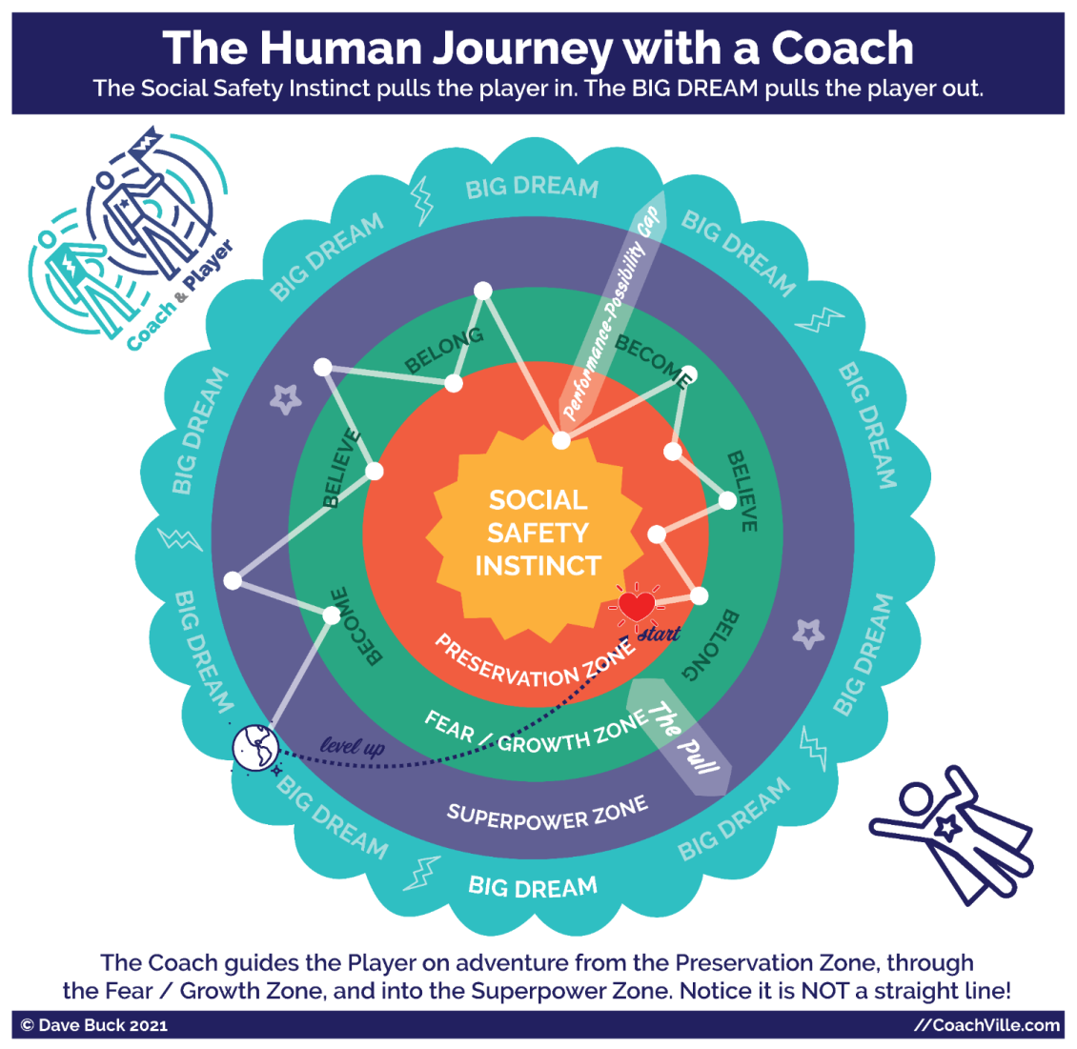
One of the key ideas about Inner Freedom Coaching is called: your social fears are a treasure map to your Superpowers. This diagram shows this idea of travelling with your coach starting in the Preservation Zone, through the Fear / Growth Zone into the Superpower Zone to reach your BIG Dream. Let’s walk through it.

There is a “play safe” version of your life that is available to you now in the Preservation Zone. In this life you preserve who you are and where you are. You are strongly influenced by the Social Safety Instinct to maintain the belonging that you have by avoiding any social risks. This is how most people live. But this is NOT how you live when you have an Inner Freedom Life Coach!
The outer ring is your BIG Dream! The adventure is to get your heart’s desire out into the world. It is your heart that is calling you to adventure! This is where the experiences and results that you imagine happen with regularity. You are in the flow of life contributing your unique value to the world in a way that is fulfilling for you. AND after some time you will be in the Preservation Zone at your new level and it will be time to pursue your next BIG Dream!
The Growth/Fear Zone is the unknown. This is where you will face challenges that you cannot overcome as the current version of you. You will need to become the next version of you, uplevel your beliefs and establish a new environment of belonging. This is where you face social risks in pursuit of social rewards. In the Fear/Growth Zone you see the 3 B’s of Human Nature: Become, Believe, Belong that we explored in the Introduction.
The Superpower Zone is where you discover the powers and playfulness within you that have been hidden in the shadows that you will NEED to live your dream. You have Superpowers for influence, expression, visibility and change that you have not yet tapped into. OR you may be using them, but now you are being called to raise your level of mastery.
Your coach will be your guide every step of the way on the adventure.
Notice the “Performance Possibility Gap” (in the upper right). . This is the gap between the sum total of who you are now and what you can do now AND who you must become to fulfill your dream. You have a vision of yourself playing life at a higher level of impact. This is a good thing!
Also notice “The Pull” (in the lower right). . We will speak about this often. This is the natural tug within all of us between the need to preserve “what is” by playing safe and the desire to pursue our heart’s Dream by playing BIG. The experience of “The Pull” will ALWAYS be there!
The Inner Freedom Method is ALL about exploring The Pull!

Your Superpowers

Your coach is on a mission to unleash your Superpowers by exploring your social fears! It helps to know what a Superpower is AND to have some examples of phrases that can be used to describe them. When you are discovering something within yourself that has been hidden in a shadow it can be really difficult to put it into words.
A superpower is a unique ability that you practice and refine through coaching until it is capable of BIG Impact on other people and situations.
We all have the Superpowers of Human Nature:
- Urge to Become
- Ability to Believe
- Need to Belong
In addition, we all have a combination of innate energies and abilities that are unique to us as individuals.
There are so many amazing abilities that only some humans are awesome at! It’s so fun. This is why we are born for Team Play!
Your Inner Freedom Coach is interested in ALL of your abilities – both common and unique – and will guide you toward expressing ALL of “who you are” to live your dream.
There is an aspect of our human abilities that has been mostly overlooked for a long, long time: the abilities to co-create change. This is because the forces of the hierarchical control status quo don’t want us to even know that we have these abilities.
These are the abilities that can be discovered, honed and refined with a Life Coach. These are the Superpowers that you can cultivate to uplift the Human Family into Freedom.
The Superpowers for Play!
We have a list of 64 “Superpowers for Play” to spark your imagination. As you explore the list you may see one that resonates as how you want to relate for influence, explore for visibility or create to express ideas or experiences and experiment for change.
Look it over and go with your gut to choose a few that seem to overlap these two criteria:
- Who is my Dream asking me to become?
- Do I feel this Superpower inside me?
The Super YOU page is something I created that is loosely based on the ancient I-Ching (Book of Changes). I have learned a lot from several rebellious translators of the I-Ching in co-creating this list. It uses language that is “playful” and meant to spark your imagination.
Feel free to change words or combine a few of them to create the “superpower phrases” that really FEEL like YOU!
The more you discover and unleash your superpowers the more alive you will feel.
AND it might feel pretty scary sometimes… we will get to that later.
MOST IMPORTANT: Have fun, use your imagination while you look over the list of energies and abilities and imagine yourself possessing them and using them.
For our purposes right now, just select a few and write them in the box. This is just a place to begin.
Reality check
Most people that I have coached had some awareness of a few things that they were good at doing. And some had an idea about their “strengths” or something similar from doing a self-assessment test. These inklings and readouts are valuable. But most had no idea about their Superpowers for Play! As we will explore together in Chapter 4, over the course of our lives often our Superpowers go into the shadows to hide until we are ready to embrace the risks involved with using them. NOW is the time.
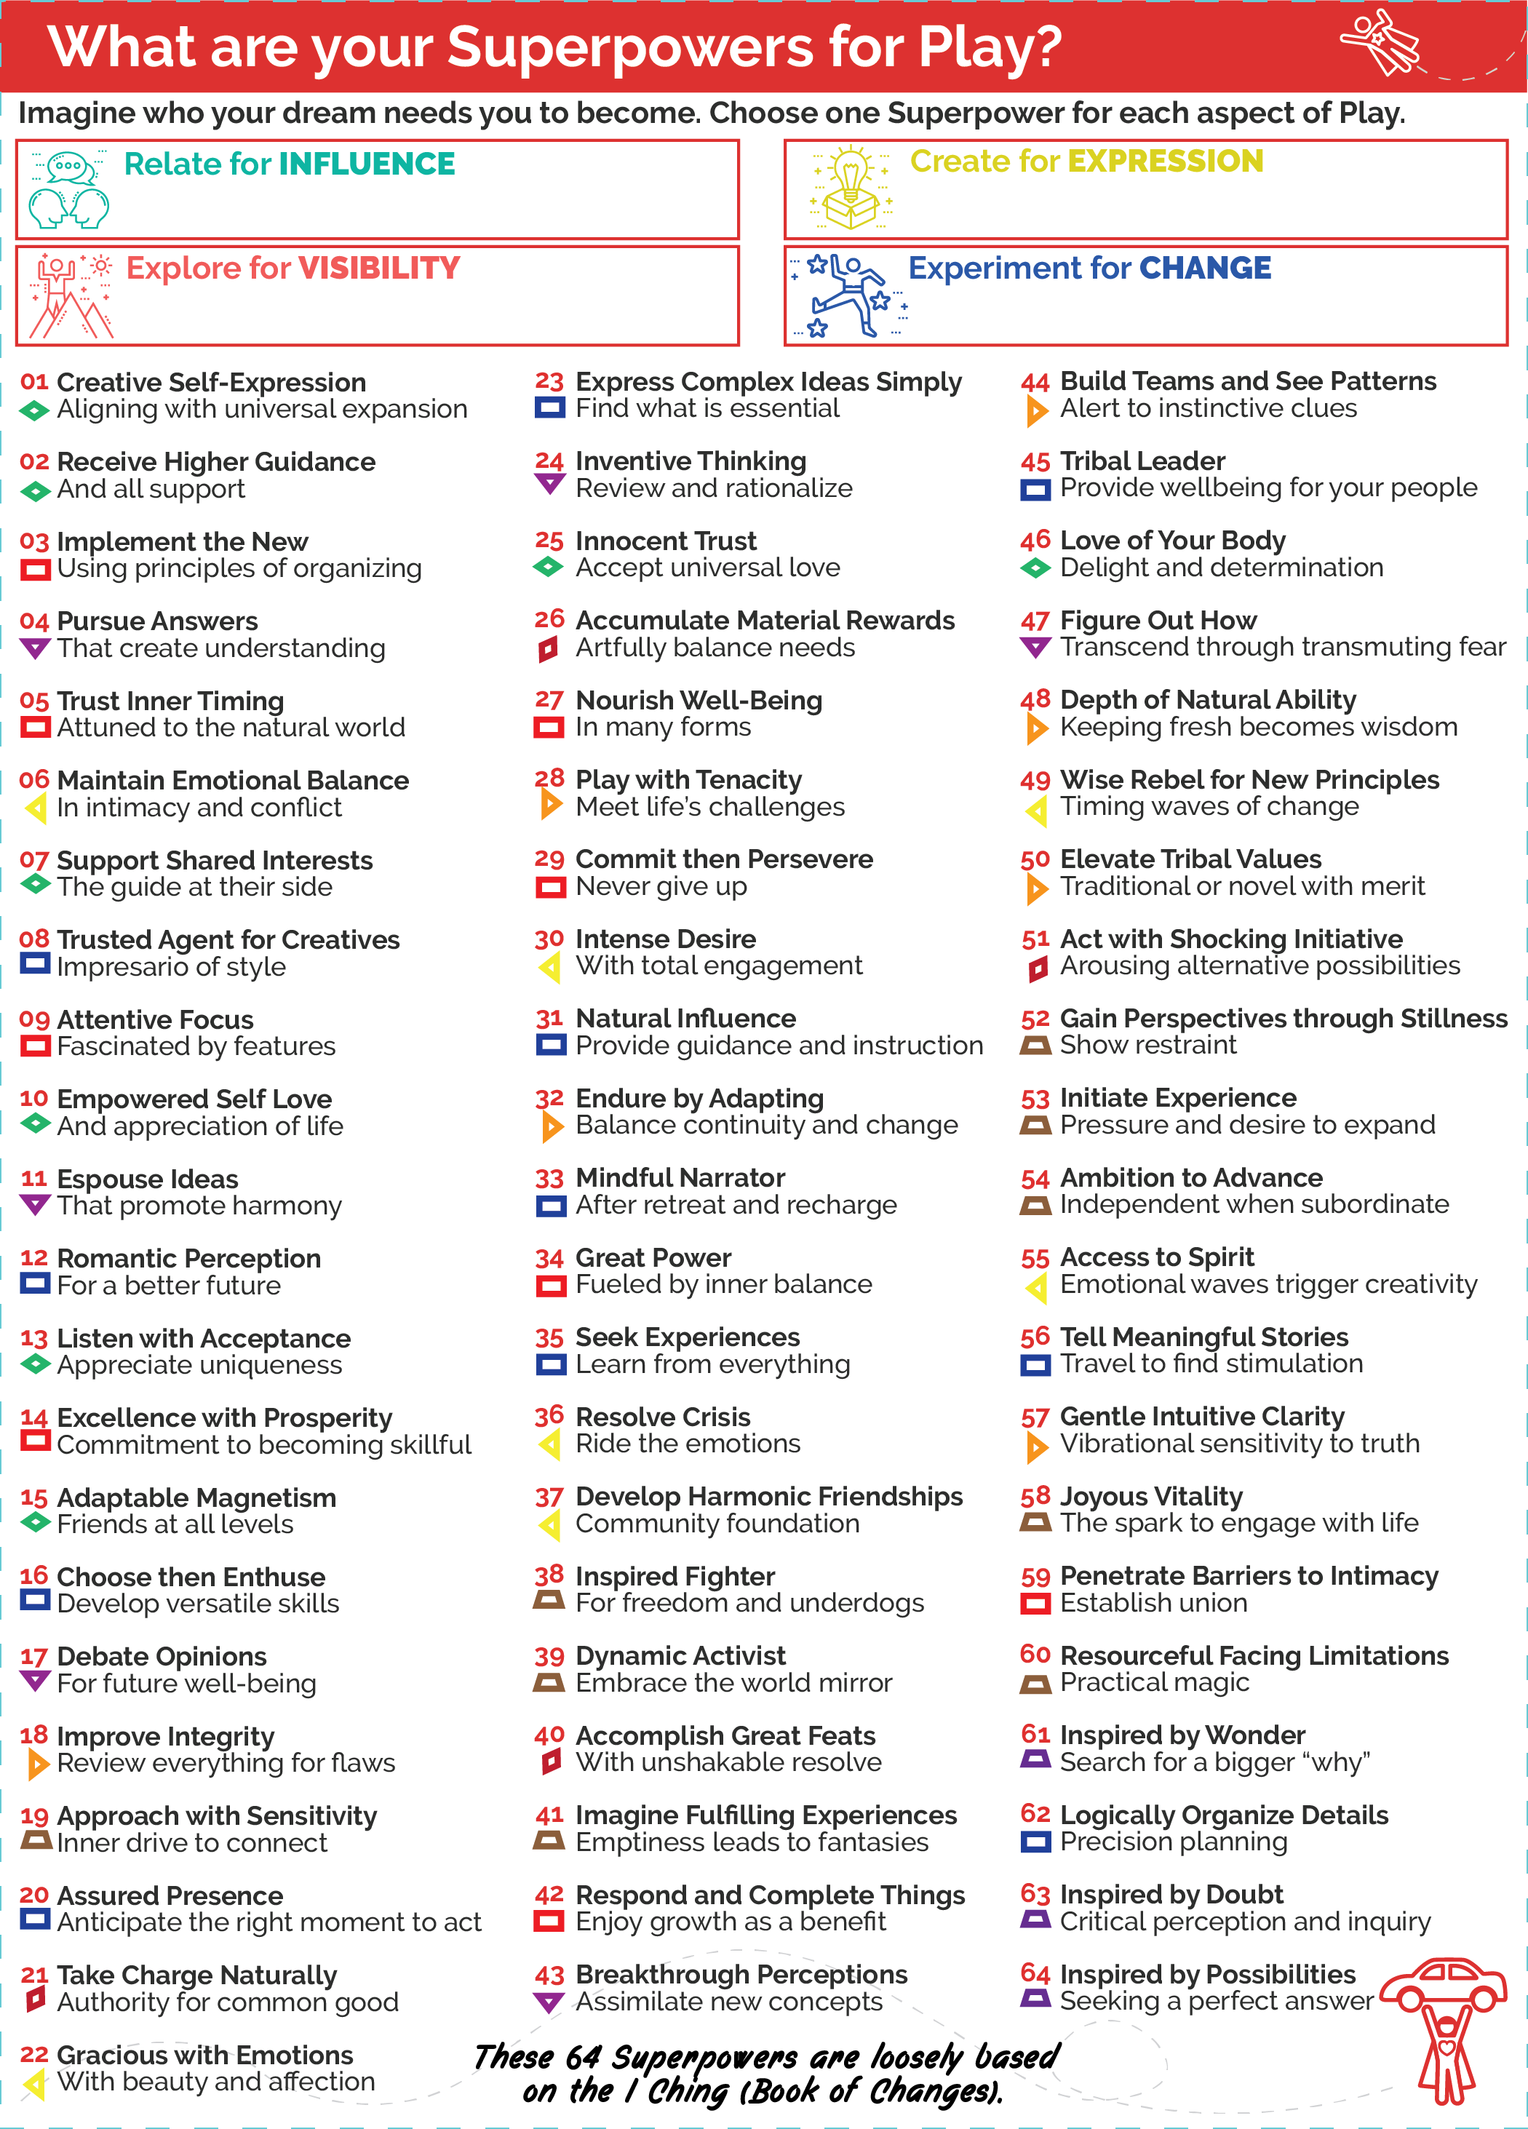
4 Pivotal Moments of Social Play and Social Fear
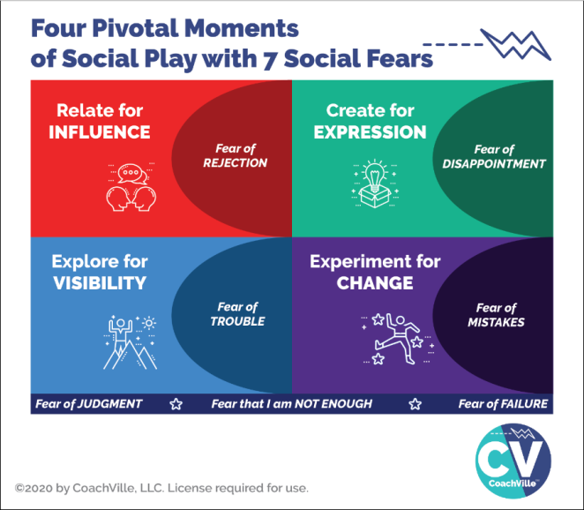
I want to quickly call back something we covered in the Introduction: the 4 Pivotal Moments of Social Play AND 7 Social Fears.
In this session, your coach is going to explore with you your BIG Dream and some of the actions you are taking or want to take. Consider actions where you can expand your influence or visibility. Consider ideas and experiences that you would love to create and share with others. What would you LOVE to change in your world or THE world?
Allow yourself to dream of being an influential person in your world.
And when your coach asks you about what you are avoiding or resisting… allow yourself to acknowledge activities that you currently wouldn’t even try because you have some of the social fears described on this diagram.

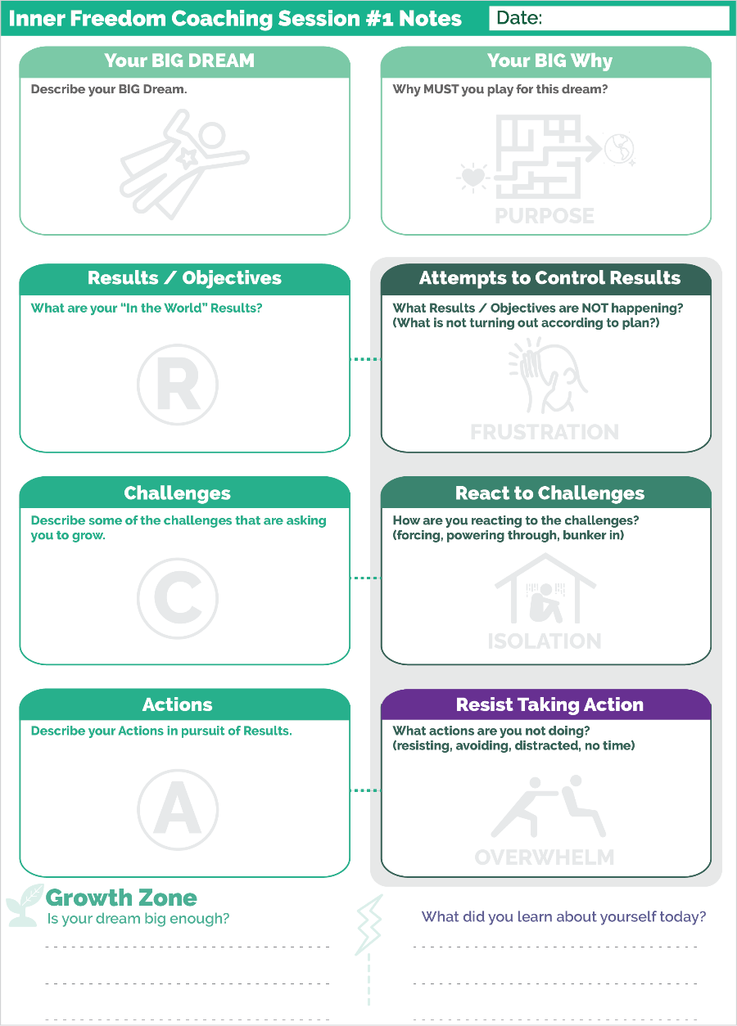
Prepare for Session 01 - Play With Fear
The purpose of this first session with your coach is to sketch out the starting point for your adventure together. As you saw in the Human Journey Diagram there is a Performance Possibility Gap that you desire to cross.
Here is a big point: in the Industrial Age the goal was to be a perfect task completion machine; you were never supposed to have a Gap or at least never admit it.
This is different! Here, the Gap is the start of the fun. Make it big and energizing and remember that you won’t be going alone.
Your BIG Dream
All coaching begins when you have a BIG dream and choose a coach to guide you on the adventure. As the “player” you must have a vision of experiencing something beyond what you are doing today; you must have a desire to become the next version of YOU!
We use the word Dream rather than objective or goal for a few reasons. First these are Industrial Words. Second we want you to tap into your imagination, your heart, your playfulness and your desire; among other things.
You may be very clear about your BIG Dream. However, if you are like most people, your dream starts out a bit “fuzzy”. If that is you, please don’t let that stop you. Start with whatever clarity you have and know that your dream can come into clarity over the next several weeks with your coach. AND it is absolutely OK to change your dream half way through the adventure.

Remember the power phrase that I introduced you to in the Introduction: Abera Ca Dabera; I create as I speak. Your Dream will get clearer and more energized every time you speak about it with your coach AND the other folks on your Dream Team.
Here are a few thoughts to help you hone in on your dream right now.
- Focus on something that you CAN do right now. It is great if you also have a “someday” dream, but your coach can only guide you toward a dream you can pursue now.
- If you have a “someday” dream that is not possible now, choose a dream that will develop you in a way that moves you toward your “someday”.
- Choose something that will pull you out into the world of other people; even if that is virtually rather than face-to-face. Something that you can do by working in isolation is not a BIG enough dream for playing with a coach.
- Choose something that will ask you to GROW; something that will take on a life of its own and “ask” you to become the next version of YOU.
Your BIG Why
The BIG why is about tapping into your deep desires for your life. What are the driving forces behind this dream for you? What is the impact you REALLY want to have on your world and the people in your life?
Results / Objectives
Co-creating results with the world is what makes playing for your dream the so exhilarating. The results are what happen when you perform the action with skill and focused intent. In a playable Dream, when the desired results are achieved on a regular basis they accumulate into the desired Tangible Outcomes of the dream. Your impact on the world will ripple out into the world for good.
Actions
Every playable Dream has actions that happen over and over again as you play; like shooting the ball toward the basket in basketball. When actions are taken to co-create desired results WHILE holding a vision of excellence, they grow into a new level of Mastery. Again remember that you want to focus on relating, creating, exploring and experimenting rather than completing routine tasks.
Challenges
Any dream worth playing for is full of interesting challenges; some anticipated, some unexpected! The challenges are what get in the way between actions and results. The key for you and your coach is to find the sweet spot between easy and hard. If the dream is too easy it is not inspiring. If it is too hard (not attainable) then apathy sets in. It is through facing challenges that you become the person you desire to be.
Attempts to Control Results ~ Frustration
(What is not turning out according to plan?)
Frustration is a very common experience for folks who go for their BIG Dreams in life. LOT’s of the time, things don’t go as planned. The key is to share what is not turning out without judging it. Often when we experience frustration we are attempting to control something that we can’t control; but we can influence by playing better.
React to Challenges ~ Isolation
(Forcing, powering through, bunkering in)
In the Industrial Age a challenge meant that you were doing something wrong. That is not how we view it in Connected Play. However, since we grew up in the Industrial Age where we were trained to work in isolation, when things don’t go our way often our first instinct is to “bunker in” and work harder to figure it out before anyone finds out.
Reacting in this case is referring to your thoughts and how you perceive your self and your situation when things go wrong.
Resist Taking Action ~ Overwhelm
(Resisting, avoiding, distracted, no time)
This is the one that is often easiest to notice. However, again since in the Industrial Age we were trained to be perfect, when we don’t do something we needed to have a good excuse. Or we needed to say that we were just too busy to do it. Being busy or overwhelmed is the go-to reason for almost everything we resist or avoid.
If there is an action that would really move your dream forward and you are not doing it, then that is something to recognize and call it what it is. This will open up a wide pathway for personal growth with the Inner Freedom Method!

Growth Zone
When we play together we grow; all the time. But since most of us have been in the Industrial Status Quo for a while we lose our awareness of growth. Your Coach is going to ask you about growth in every session. Get used to it! With your attention on you and your coach’s attention on YOU, you can recognize your own growth and start to feel really alive again. FUN!!!
No Shame in the Game
When your coach asks you about the activities you are resisting etc., the most important thing you can do is to talk about these experiences in a straight forward, open, curious, judgment-free way. Every BIG Dream will give you a fair share of troubles and sleepless nights. This does not mean that you are doing it wrong! In fact, it probably means you are ready for the kind of breakthroughs that Inner Freedom Coaching can create with you.
Watch out for “Spiritual Bypass”
Spiritual Bypass is a term that refers to a situation where you try too hard to maintain a positive attitude or stay in a place of gratitude – which in general are valuable practices. But when you try too hard you can go blind to the real challenges around you and within you and lose your determination to co-create change.
Connecting a Few Dots…
One last thing about the Coaching Notes sheet and Coaching Session #1
When you have a desired result, and you attempt to control the result (rather than co-create), it can lead to frustration.
When you face a challenge, and you react to the challenge (rather than respond), it can lead to isolation.
When you intend to take an action, and you resist the action (rather than allow it), it can lead to overwhelm.
Whew! There are so many growth opportunities. We will explore them along the way.

How to use the weekly Play Plan Playsheet every week.
I shared this with you in the Introduction. But since it is such an important part of the growth process I want to share a few extra thoughts about how to use these sheets each week.
AFTER each coaching session…
The top of the page sets your intention for the week. This is super important and empowering!
In the left section write a phrase or two to describe your BIG Dream. This may change and evolve as you play; or you may write the same thing every week. Either way… writing it out each week and looking at this page often will keep it close to you. The palm with the lightning bolt is the symbol for the mystical power of your dream.
In the middle section write your focus for the week. This can be a theme or a specific action. The symbol is the illuminated heart! This is from the Inner Freedom symbol for getting your hearts desires through the maze and out into the world. Giving a theme to your week will keep your energy vibrating at a high level.
In the right box write a few of your Superpowers that you aim to play with this week. This may be a little sparse in the early weeks. But you will add more as you become aware of them. Remember this is your intention. By writing a few power phrases in there and then reviewing the sheet every day, you will be amazed at how often you will feel the urge to use your Superpowers!!
Then there is a section for each of the 4 ways to play in the FEAR / Growth Zone. Write a few action items in each section. (at least one) Remember this is not a task list; this is a play plan. You have intentions for actions and results but you don’t know what will happen.
Write what does – or doesn’t happen – in the right column as you play the week. It is labeled “Results / Resistance / Reactions”.
Results – it is important to separate the action from the result. What happened “in the world”? Remember it was not automatic so notice the details.
Resist - Write in if you had a time or thought to do the action but didn’t do it. This is definitely not something you do with a task list!
Reactions – Notice your thoughts and body as you are doing the action and make a few notes if they are noteworthy.
This will give you a great summary that you can share with your coach.
The bottom section is for you to write a few notes about beliefs and desires that pop up for you as you play through the week. These are mostly non-conscious so you need to catch them when they pop up and write them down.
Remember, this is just the first week! So just play with it the best you can and know that you will gain confidence in this process over time.

Ready to go!
Allright!! That is all you need to know to jump in to Inner Freedom Coaching Session #1.
One last thing…
Coaching is a co-created experience. There is no right or wrong answer to questions or explorations.
The point of this playbook is for you to understand the concepts that will help you dive into the co-creation; this is where the real fun and big breakthroughs come from.
Be your full-on Self; trust your Self and trust the experience.
It is going to be awesome, illuminating… and FUN!!
Enjoy it!
**!!** {End of Player Playbook} **!!**

Coaching Notes for Session #01
Session 1 assumes that you have had a brief exploratory conversation with the player. But even though you know a little bit about their Dream and some of the details for their vision of playing better, you will cover those same areas again and go a little deeper.
In this session you will explore the players BIG Dream. Then you will go into some of the details of PLAYING for the dream by talking about results, actions and challenges.
This is all fun stuff.
Then you are going to dive in on the much deeper side of life to set the stage for a truly amazing growth oriented experience. You are going to explore experiences of frustration, resistance, and reactions.
YOUR big focus for this session:
Maintain the same sense of fun and light-hearted exploration while you are talking about dreams, actions AND frustration, resistance etc.
This is SUPER important.
Your energy will make a big difference for how the player feels in the session.
You want to bring a vibration of…
- Whoa that challenge sounds like fun!
- Oh that frustration is going to be so juicy to explore together.
- Wow! What a great growth opportunity.
- Whoa! resisting an action like that means there is a big superpower in there somewhere. I can’t wait to find it with you!
Meanwhile…
NOT EVEN A HINT… that YOU are going to fix or solve anything they bring up.
Not a hint of: “Oh that sounds so hard for you; oh poor you”. NOPE!
You need to be able to dwell in the struggle with your player while maintaining the “vibe” that everything is going to be a growth-oriented, co-created, FUN adventure together.
If you bring that vibration to each session… over a few sessions they will match you.
Judgment-free awareness is absolutely essential to the Inner Freedom Method. So it is up to you to consistently model it from the first minute. This approach will enable your player to talk about the struggle without feeling bad; or feeling like something is wrong with them. This is BIG because in the Industrial Age we didn’t really talk about such things; except when we were complaining to colleagues.
Also… as a coach you need an inner knowing that there IS renewed power and playfulness under every frustration, resistance, overwhelm, reaction etc.
The Structure
Every session will be unique. BUT the structure will be the same. This really accelerates the player feeling comfortable and safe with you. This will be vital as the conversations dig deeper with each session.
Welcome – Coaching Plan – Play/Practice Together – Growth Zone
Every session you will ask the player to speak their dream. This is very empowering for the player. The consistency will help create trust.
The Distinctions are NOT important in this case
In the session you will ask about frustration, reacting to challenges, resisting action, avoiding etc. The Guide offers up a sequence of questions with a variety of words.
The point of this is to get the player talking about things they usually would NOT talk about. In the Industrial Culture you never admit that you are stuck or not completing your tasks.
The point is NOT to get into the details of whether something is reacting or resisting. Whichever question gets them talking is good! Different questions will spark different shares by the player.
Don’t salve their fears
While you are keeping it light and curious and judgment free… At the same time, don’t minimize their fears or challenges.
Avoid saying things like:
- Oh, that’s not so bad.
- Oh, that happens all the time, we can fix it
- Oh, I know how you feel, here is a quick tip to feel better
It is a bit of an emotional balancing act on your part.
People respond to the dehumanizing Industrial Culture in a wide variety of ways and have adopted a wide range of approaches to how strange it all is Human Superpowers.
Staying judgment-free means that you don’t judge their fear or frustration or try to take it away from them.
If they are feeling really frustrated about something, let them be there.
Some folks have never been listened to and may go overboard detailing their problems when they discover a listening ear. Here you need to encourage them to get to the bottom line and make room for the growth opportunities.
Some folks have read so many self-help books that they won’t allow themselves to share about problems or frustration. They will recite affirmations like: “it’s all good” or “it wasn’t meant to be”. For them you need to encourage them to allow themselves to say how it really feels. You can ask them if that “enlightened perspective” is how they really feel. You can tell them that it is safe to feel how they really feel. It is OK to be frustrated or disappointed!
You want them to feel that they can share anything with you and you will be right there with them… and always ready for the next growth opportunity to explore.
Does it sound like a contradiction to on the one hand keep it light and talk about the fun adventure, on the other hand allow them to feel their fear or frustration?
Welcome to Inner Freedom Coaching.
You can do it.
Is the Dream Big enough?
This is the BIG question toward the end of the session.
Here is what I have learned from doing this many times.
Some people are frustrated because their dream is BIG and they have not grown into it yet.
Some people are frustrated because their dream is too small and they are getting lost in details that don’t excite them.
It is up to you to help the player navigate this question so that you can provide them either support or challenge.
Either way will be awesome.
Coaching Notes Playsheet
It is important to write a few notes on the Coaching Notes Playsheet. It is organized to match the flow of the session. At it at the end of the 12 Session engagement, you will be able to clearly see how far the player has gone both in terms of tangible actions AND personal growth!

Chapter 1 Key Points
As a Coach
The BIGGEST thing is the ability to talk with a person about their fears and doubts in a light-hearted and curious way… with NOT EVEN A HINT that you are going to fix it.
Avoid making any judgments or assessments or suggestions about how they can get out of the discomfort they may be feeling.
We call this “dwelling in the resistance” (the inner resistance) rather than trying to fix it or soothe it. You know that the Inner Resistance between the Dream and the Social Safety Instinct / preservation zone is where the Human Journey begins.
A few additional practical points about Inner Freedom
- Inner Freedom is the ability to freely choose the best action or non-action in any moment.
- Inner Freedom accelerates your ability to create the results that you desire in pursuit of your dream and in your life.
- Inner Freedom is the feeling of being at ease in the situation
- Inner Freedom is being in the flow and knowing what to do next (or knowing when to do nothing)
- Inner Freedom is the awareness and integration of feelings (body wisdom) and thoughts and emotions

The meaning of “PLAY with fear”
Play with fear has a double meaning:
a) Approach fear with the spirit of play; with curiosity and full engagement
b) Play EVEN when you experience fear

The BIG IDEA - The power to manifest aka to co-create results
Your pure heart intentions are a powerful source of energy.
Your feelings, thoughts and actions are the energy that will go toward that intention and attract opportunities
When they are aligned they flow in the direction of your vision - things happen
When they are not aligned they create resistance and then your hearts intentions do not manifest.

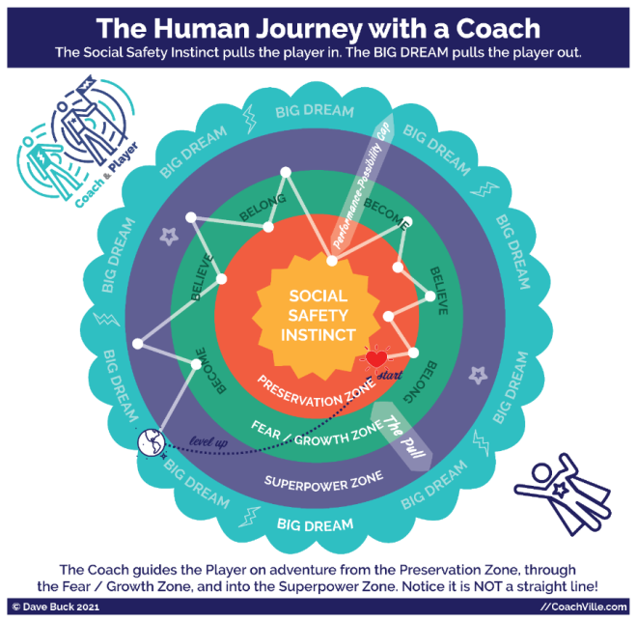
The Human Journey with a Coach – From the Coach Perspective
Let’s take another walk through this model. This time from the coach’s perspective because it truly explains A LOT about the Inner Freedom Coaching experience… and Life!
The Coach and Player on Adventure:
First notice in the upper left corner our symbol for coaching; the coach and player walking side by side. The player carries the flag with the lightning bolt to symbolize the pursuit of a BIG Dream. The Coach wears the lightning bolt on the shirt to symbolize sharing the player’s dream. The Player wears the star which is the symbol for using one’s superpowers for good in the world.
You will also see the flying person with the same star in the lower right corner. This symbolizes the player now expressing their powers and willing to be seen and known in the world.
The Social Safety Instinct and the Preservation Zone:
Next notice the Social Safety Instinct at the center. This force is like a magnet that pulls your player toward the Preservation Zone. Here your player aims to maintain the sense of belonging and status that they have in their current environment. They also seek to maintain the beliefs that are required by this environment. And finally, they limit their becoming (and play) to what can fit within the existing structure; which is usually not much!
The Social Safety Instinct – and the requisite need to maintain belonging – is by far the most powerful force in Human Nature.
Many personal growth programs refer to something called the “comfort zone”. It is a similar idea but I feel that the Preservation Zone is a better name for what is actually happening. First of all, many people are stuck preserving something that is not at all comfortable; yet they fight to preserve it just the same. Preservation Zone also takes away the stigma of comfort zone that implies a person is weak or lazy. Self-preservation is a super strong survival instinct that is both essential and a respectable force to be reckoned with!
The BIG DREAM:
Next notice the BIG DREAM and the lightning bolt on the outer edge of the model. The BIG DREAM is the 2nd most powerful force in the human experience. AND it can become an equal (or better!) of the Social Safety Instinct with your companionship as a great coach and by helping them co-create with a dream team. This is what we are playing for here at CoachVille.
The BIG Dream is what pulls your player out into “the world” to expand their contribution to life and humanity. The BIG Dream is the equivalent of the “call to adventure” in the Heroes Journey stories. To pursue their BIG Dream they will need to leave the Preservation Zone and pass through the FEAR zone and discover and develop their Superpowers needed to fulfill the dream.
The Pull! :
Notice The Pull! This is what your player experiences anytime they endeavor to pursue a big dream.
The BIG Dream pulls them out and the Social Safety Instinct pulls them in.
This is the epic drama!
This is the compelling narrative.
This is what transforms life from boring daily routine to EVERY day a new adventure.
In the Hero’s Journey stories this is called “refusal of the call”. While in these stories this is a one-time event at the beginning of the story. In my experience of coaching people in pursuit of a BIG DREAM this is an EVERY DAY EXPERIENCE! Hah! It is often a many times every day experience.
The Performance-Possibility Gap:
This is the essential coaching element. When a person has a BIG Dream it includes a vision of themselves having new experiences and doing new activities or doing them in a bigger and better way than they can do them now. Anyone who goes after a BIG Dream knows that there is a gap that they will need to cross. Crossing this Gap from the current ability and situation to the vision is what coaching is all about.
The FEAR/Growth Zone:
Social Fear is a fundamental Human experience. Its purpose is to keep us safe. Social fear is a feeling in the body that reminds us that in the past while doing something similar something “bad” happened. The fear comes up as a bad feeling to steer us away from the situation or action. Whenever your player pursues a course of action that is beyond what they are doing now, they will experience social fear on a regular basis.
The BIG insight is to realize that all of our social fears were absorbed from our environments. And many of our fears are social fears about expressing our playfulness and unique power (AKA Superpowers). So, if your player explores the fears with you they can lead them back to their playful powers.
Growth is about becoming the next version of ourselves and what we are capable of contributing to the world. We are meant to grow continuously throughout life. We grow by playing. ALL growth happens outside of the Preservation Zone.
THE BIG key is this: since most of our fears were absorbed in social situations it is essential that we explore our fears in the company of a trusted guide; AKA YOU, the Life Coach. It is almost impossible to overcome social fears by facing them alone.
The Superpower Zone:
By walking with your player through the zone of Fear/Growth they will obtain many clues about their unique powers that have become hidden over time. Any time they contemplate a new action their body will buzz if the action resembles a troubling experience from earlier in life. Exploring these moments with your player using the Inner Freedom Method will often reveal the expression of power that is connected to the troublesome event. BAM! They now have awareness of a lost Superpower!! AWESOME!
With this awareness they can reclaim their power and use it to fulfill their BIG Dream
NOT a straight path: In model you can see that the path from the Preservation Zone to the BIG Dream is not a straight path. You can expect a lot of moving ahead and then pulling back. You will also notice the arrow that shows that once your player becomes comfortable and capable in their BIG Dream, a new dream will come to their heart and a new adventure will begin! YES… this is why Life Coaching is such an amazing business model!
You will experience this model as a player and as a coach in the Inner Freedom Program.
We are referring to Social Fear as distinct from Physical Fear.
An example of Social Fear would be the resistance to asking for what you want because of the fear of being rejected by the other person.
An example of Physical Fear would be the fear of heights or the fear you feel when you walk near a high cliff edge.
There is a hybrid of these when you feel a fear that another person intends to harm you physically. This is NOT the type of fear you explore with Inner Freedom. This is the type of fear where you “get the heck out of there”.

The Preservation Zone
Your Preservation zone – what is it?
The preservation zone is not good or bad.
- Inside your preservation zone you are familiar with everything happening
- Inside your preservation zone you are familiar with your thoughts and feelings and actions
- Inside your preservation zone you know what to do because you have done it before
- Familiar / comfortable does NOT mean you like it or it is desirable: You may not like it but it is "comfortable".
- Outside the preservation zone is where you are growing; often that includes “growing pains”
- Outside the preservation zone is where you are trying new things; often this leads to messes and mistakes
- Outside the preservation zone is where you experience social risk. YIKES!
REMEMBER: Tasks are Safe – In the Industrial Control view of the world People are “Risky” because they are hard (or impossible) to control; this is why the Industrial Age taught us to be “task oriented”.
REMEMBER also: It only takes A LITTLE BIT OF FEAR for something to be outside your preservation zone.

Explore the BIG Dream for Social FEAR and “The Pull”
The Experience of “The Pull” – often referred to as Inner Resistance - is a natural consequence of playing BIG in the world.
What does it mean to play BIG in the world?
“Playing BIG” means different things to different people. However there are some common characteristics.
- Express your talents - especially those that have become hidden (your Superpowers)
- Play to add value to the lives of others
- Challenge yourself to do something you have not done before
- Be assertive about who you are and what you want
- Stretch to expand the value you create for others
- Take action on the desires from your heart
We have a theory:
When you play for a big dream, you experience “The Pull”.
“The Pull” creates a disturbance – or even chaos - in your world. Here are a few examples:
- When you play BIGGER you are doing things you have never done before;
Or they are similar but with more risk or more importance.
- When you push into the unknown, you often experience doubt and uncertainty.
You have to face the risk that you may fail or be disappointed; or disappoint others.
- The human imperative to preserve what is, to feel safe, in control, in familiar terrain is a powerful force in our lives.
- Humans are pattern creation beings - everything we do more than a few times we create a pattern; we do this so that we can do it without "thinking" about it every time; examples include: driving home from a familiar place and brushing your teeth. You experience "chaos" when you don't have a pattern for something. You can't quickly make sense out of what you are seeing or doing.
- Often your beliefs about yourself don't fit in the bigger dream which creates inner chaos with who you know yourself to be.
- Often physical sensations (feelings) start to buzz in your body; This FEELS uncomfortable which creates inner conflict with the desire for comfort.
- Often the people in your life get uncomfortable because they don't like to see you change. (even if they often complain about the way you ARE!!)
- You have a strong desire to NOT disrupt your relationships (AKA Belonging). Often this is why people pull back from their big dream rather than experience a threat to belonging.
- When you play bigger there will be A LOT of activities that create "a little bit of fear"; A little bit of fear will STOP YOU almost every time.
- This program is ALL ABOUT how you PLAY with that fear.
The idea of Inner Freedom Method coaching is to:
- Embrace the Pull
- Honor the Pull
- ENJOY the Pull
Even though “The Pull” is challenging and even disorienting, it is what makes life so engaging and growth oriented.
The Pull is what Life Coaching is truly all about. You don’t get hired as a Life Coach by a person who wants to stay where they are doing what they are already doing.
TRUTH!

The Practical Inner Freedom Method and the CoachVille Coaching Method
Here is a quick summary to describe where Inner Freedom fits in the CoachVille Coaching Methodology in practical terms.
Whenever an individual is playing for a new Dream or a bigger dream, there will be some activities or situations that will present FEAR (aka inner conflict). There will be situations when your player is blocked, stuck or out of the flow; not able to perform the skills at their best or not getting the desired results.
This is also known as being “outside of your preservation zone”.
Here are some examples of where expanding Inner Freedom comes into play:
- When your player is avoiding a specific activity.
- When your player is uncomfortable in a specific situation and it is negatively affecting their performance
- When your player is taking actions but not getting the desired results;
To summarize the Play Life Method TM steps 6 through 9 in practical terms…
Step 6) Expand Skills: When your player knows what do to but does not know how to do it, this is a skill and practice issue.
Step 7) Play Plan: When your player does not know what to do, this is a play plan issue.
Step 8) Expand Inner Freedom: When your player knows what to do, and knows how to do it and they are still NOT doing it, this is a lack of inner freedom (FEAR) issue.
Step 9) Expand World Power: When your player is missing needed resources, or does not feel safe being fully themselves these are environmental design issues. (For example, your player needs to connect with potential prospects but there is nowhere they can find to meet them)
When your player takes actions but does not get the results even after practice, this is probably an Inner Freedom issue as well.
The Inner Freedom part of playing for a dream determines which actions your player takes and how they feel while they take the action which often determines the results.
Are they clear, confident, expressing themselves and fully present? Or are they nervous, holding back and distracted?
BIG OPPORTUNITY.

Inner Freedom vs. Self Help
As a Life Coach, it is very likely that you have read a lot of self-help / personal development books; perhaps has many as 100 or more! You have likely attended a lot of workshops and seminars as well. Possibly it was these experiences that inspired you to become a Life Coach.
It is also quite possible that your players will have read many of these books as well; folks who read these type of books are typically the most open to hiring a Life Coach.
With this in mind I want to share with you a mindset to be on the “look out” for within your Self AND with your player that comes from reading a lot of these books.
I have mentioned it a few times now.
The premise is: “There is something wrong with you. But don’t worry I can fix it.”
I will share more about this in a few places in this book but here is the basic idea:
The Industrial School system is obsessed with testing, grading and ranking children. This dehumanizing process leaves almost every participant with an underlying sense that:
- They are not smart enough
- They are not good enough
- They are not worthy of good things
- They don’t belong here
- There is something wrong with them
And that is just the tip of the iceberg.
Whether this is an unfortunate side effect or the actual purpose of Industrial School… that is a question for another book; although I will touch on it briefly in an upcoming chapter.
On a related note, many religious teachings are based on the premise that there is something wrong with us - or our human nature – which fills us with self-doubt.
Similarly the constant assessing, ranking, firing, lay-offs or downsizine of employees by organizations also contributes to this nagging self-doubt.
The outcome of all of this is this:
A clever way to sell a lot of books is to start with the premise that there is something wrong with you; because this is what the reader already believes. AND sell them that the solution to the problem is in getting the right information; because this is also what the reader believes from Industrial School.
This is self-help marketing in a nutshell.
I know personally many of the authors of the bestselling books of this kind and most of them generally mean well. However, MOST of the time, reading the information in the book will not actually enable the reader to fix “the problem”; because, of course, no information can fix the damage done by Industrial Age trauma.
And then of course, failing to properly implement the information that was guaranteed to solve the problem, and seemed to work for so many other people, just adds to the growing self-doubt; and funnels them to the next book that will save them.
Why am I sharing this with you?
It is highly likely that you have a lot of these self-help ideas in your own mindset and beliefs. It is highly likely that your players do as well.
There are thousands of different versions of this type of belief or dictum
- You must banish negative thinking from your mind
- You must get your emotions under control
- Your brain has a negativity bias
- You have a procrastination problem
- You can use these 7 tips to stop worrying
- You have a gremlin in your mind giving you negative self-talk
- Your EGO is not allowing you to listen
- If you don’t apply the good advice you receive it is your own fault if you fail
- You must crush your fear so you can crush your goals!
- You are a self-saboteur (I hate this one the most)
I can tell you from experience that it is SUPER easy to blurt out ideas like this while you are in a coaching session.
And it is super common to hear your players lamenting about failing to apply these things as well.
Together, we can uplift the narrative!
First, start to notice when you think or say this type of thing. Remember to be judgment-free with yourself! And you can affirm that you are ready for a better approach.
You can do the same with your players.
The awesome thing about being in the Inner Freedom Class is that you are a coach AND a player. So you will have plenty of support in your quest to believe in the AWESOMENESS of your Human Nature!
With Inner Freedom (just a few examples):
- All thoughts are useful because we can learn from them using judgment- free awareness; banishing them is impossible anyway.
- Your emotions are a pathway to inner wisdom. You can learn from them.
- Your EGO is how you remember who you are; this is a very useful human ability.
- Not taking an action is almost always a form of self-preservation which is honorable; Except for EXTREME cases there is no self-sabotage
- It is wise to honor your fear! Attempting to crush an essential human quality, like fear, is not a good plan.

A Few Inner Freedom Examples (From 2010)
How to find a Pivotal Moment
- Desired actions are known but avoided;
OR Taking an action that seems counterproductive to your dream
- Desired actions taken through great resistance
- Desired actions are taken without desired results
The BIG QUESTION to find resistance: What is happening or NOT happening?
1) You have a goal to reach out to 3 people per week to grow your connections.
You set the time in your calendar to make calls, but when the time comes you don’t do it. You find yourself in the kitchen cleaning dishes (common for those working from home); or reading emails; or on Facebook)
You can use the Inner Freedom Method to explore the Pivotal Moment of picking up the phone to dial it.
You notice thoughts about how the person won’t have time to talk with you. Hint: this reveals the risk of reducing your social status. When you picture the scene you can see yourself “checking out” and making a move to avoid the call; to do something that feels safe.
When you feel into the energy you have a memory of a time as a child when you went over to visit a friend. The mom came to the door and told you that the friend didn’t want to play with you today. The backstory was that the friend had a recurring illness at that time.
***
2) You want to lose 10 pounds
You want to lose 10 pounds so you have more confidence in making presentations; you have had this goal for a long time. Yet, often you find yourself sitting in front of the TV eating potato chips.
You can use the Inner Freedom Method to explore the Pivotal Moment when you pick up the bag of chips and head for the couch.
You notice thoughts that reveal that you feel kind of lonely.
Feeling into it brings up a memory pop of when you used to sit on the couch with your sister eating chips while watching TV; it brings up a feeling of belonging.
***
3) You want to be a successful business person
You want to be a successful business person, yet you often make decisions that seem counterproductive?
You can use the Inner Freedom Method to explore the Pivotal Moment of a recent situation where you gave up very easily while facing a challenge.
Exploring the moment reveals that you have some apathetic thoughts about success.
Feeling into it brings up a memory pop of when you were young playing games with your little sister. One time when you won the game she cried and ran to mom. Your mom yells at you and tells you not to win all the time. So sometimes you would make mistakes in the game on purpose to let your sister win.
There seems to be a connection between staying in the good graces of you mom and NOT being too ambitious.
***
4) You want to be a great relationship
You want to be a great relationship with a loving partner. But every time you are in a relationship you end up feeling ignored.
You can use the Inner Freedom Method to explore the Pivotal Moment of being assertive and asking someone for what you need; or speaking your truth.
Exploring the moment you notice a lot of thoughts about the possible negative consequences of asking; being worried about how the other person will feel.
Feeling into the energy reveals a memory of your parent getting really upset when you asked for something. The backstory is that there was a period of financial hardship within the family for a number of years when you were young.
***
5) You are playing for Financial Freedom
You aim to save $500 per month but instead you often buy things that are not essential - why did you buy it?
You can use the Inner Freedom Method to explore the Pivotal Moment of walking up to the checkout counter with the item in your hand; OR seeing the item in your online shopping cart and clicking the “buy now” button.
Exploring the moment reveals mixed thoughts about wanting to buy it but knowing you don’t need it.
Feeling into the energy a memory pops up of being in a store with your mom. You remember feeling seen and loved when she bought something for you.
***
BIG POINT: Just a little bit of social fear of not belonging will divert you!
When we set out to play for our BIG Dreams, there will be new actions that you need to start doing. Often there will also be common actions for you that you need to STOP doing.
Both stopping and starting can be outside of your current preservation zone. So many of our actions can be stopped by the risk of not belonging to someone or something; so many of our actions are difficult to stop because they create a feeling of belonging to someone or something.
In these situations we often move toward actions where we have 100% certainty and no fear; such as walking, email, cleaning, getting coffee, eating, watching television, scrolling through social media, etc.

Playing with Energy (2010 version)
We will get deep into playing with energy in this program. Throughout the program we will explore the Energy Alignment Game.
While there are many things going on in a person that a player and coach can be aware of, to get started we will focus on these:
Thoughts - sometimes referred to as self-talk
Beliefs - patterns of thought about who we are, what is possible, what we should or shouldn’t do
Values - what is important to us OR what we think SHOULD be important to us
Feelings - physical sensations in the body, typically we notice feelings of discomfort; and often we don’t notice physical feelings of joy.
Emotions - fear, anger, joy, sadness, excitement
Actions - what you do, what you create, how you interact
Choices - The process of moving into action, how we move into action or DON’T move; choices mostly occur at a non-conscious level
Decisions – A logical process of weighing pros can cons about taking a particular action or NOT
The purpose of Energy Awareness…
Inner Freedom.
The superconductive state of inner freedom is an experience that is sometimes difficult to describe. Here are a few phrases that express it.
- Responding powerfully in the moment
- Taking effective action with creativity and self-expression
- Getting the desired results from the actions taken
- Knowing what to say and do with confidence and without hesitation
- Tapping into your wisdom, intuition, logic and experience to make the best possible choices

Scenarios for weaving the Inner Freedom Method into your Coaching / Business
Use it when FEAR comes up
A typical coaching scenario is where you are coaching your player in pursuit of their Dream and when they begin to struggle with a certain important action or result you would begin using the Inner Freedom Method with them.
Offer it as a Series
Another scenario is where they come to you as a Life Coach BECAUSE they are frustrated in their pursuit of the Dream. In this case you will get right into the Inner Freedom METHOD. But before you do that you MUST understand the Dream they are playing for and get the big picture.
I know several coaches who offer the Inner Freedom Series as a distinct offering in their business model.
Some coach 12 straight weeks in a 3-month package.
Some coach 3 sessions per month in a 4-month package.
How to learn it
The best way to learn it is by coaching the 12-Session series with a number of players; 10 is a great goal to play for.
Make it “your own”
Coaching is a craft. As a craftsperson you are always accumulating new techniques to enhance and expand how you practice your craft.
Once you master all the steps of this method you can weave it into what you are doing in parts or using the whole method when needed.

Class 01 Prep
We will explore a few of these questions in class…
Question: who can share about an exploratory session?
What happened when you asked people about their BIG dreams?

Question: What is your BIG Dream call to adventure out into the world and describe some of the fears coming along on the ride?

** Practice: When your colleagues share about their fears… DON’T attempt to fix it. Allow people to share. This is the essence of a safe space. Not judged or fixed. What might seem easy to you can be a BIG fear for them.

Question: Your fears are a treasure map to your superpowers.
The thing you fear the most is expressing your UNIQUE power
What does this mean to you?

Question: What does Play With Social Fear mean to you?

Chapter 2 – Pivotal Moments and Judgment-Free Awareness

“It is nothing short of a miracle that the modern methods of instruction have not yet entirely strangled the holy curiosity of inquiry; for this delicate plant, aside from stimulation, stands mainly in need of freedom; without this it goes to wreck and ruin without fail. It is a very grave mistake to think that the enjoyment of seeing and searching can be promoted
by means of coercion and sense of duty.”
-Albert Einstein

Chapter 2 Prep
Before Class
Read through the complete coaching guide for Session 2 (Page 14)
(this is a link to the PDF with the complete set of coaching guides)
Listen to this audio to prepare for Session 2
(this is a link to the Player Prep SoundCloud audio)
Listen to Coaching Demo of Session 2
(Coach Dave and Player Leanne)
Playsheet Pack: Print 2 copies of page 7

{From the Player Playbook}

Session #02) Pivotal Moments and Judgment-Free Awareness
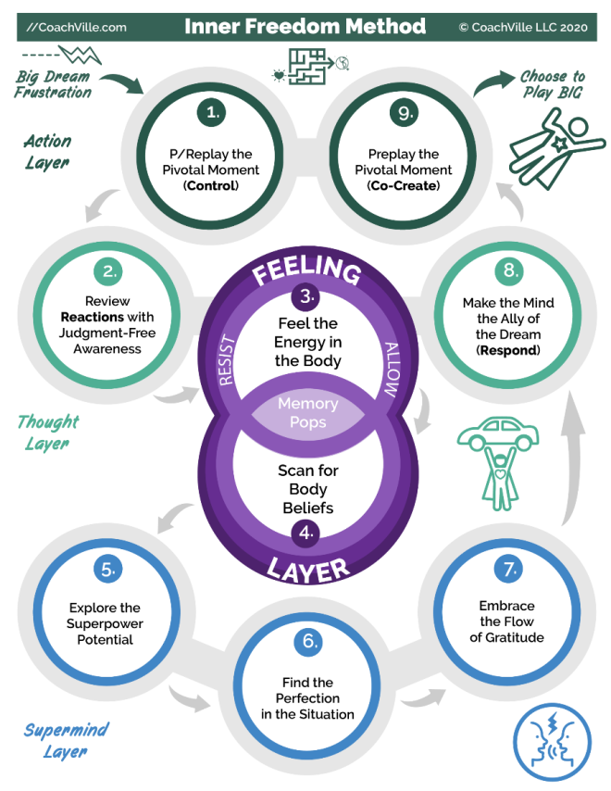
Your coach is going to use a short version of the Inner Freedom Method for the first few sessions. On the diagram this will be steps: 1,2,3,4,8 and 9
Also I will share with you our Plan-Play-Grow technique so that you can get into the rhythm of playing with a coach.
Understanding the concept of the pivotal moment is essential to thriving with your Inner Freedom Coach so we will get into this in detail. A pivotal moment is anytime you intend to make a play for your BIG Dream but it doesn’t turn out as you intended.
We will go over Steps #1 and 2 in detail in this chapter, Steps #3 and 4 in the next chapter.

Choosing a Pivotal Moment to play with
The first part of your coaching session each week will involve reviewing some of the events from your week of play. This weekly exploration serves several good purposes:
1) Your coach can celebrate with you the moments that went well and
2) Your coach can explore with you the moments that didn’t go so well.
From this exploration you and your coach will choose a moment to practice using the Inner Freedom Method.
A metaphor that really helps in understanding this aspect of Life Coaching is to imagine an athletic coach watching their team in a game. In a game there are MANY moments that happen. When the coach and the team gather for their next practice, the coach will have selected a few pivotal moments from the game to focus on with the players. Then they will practice ways to play better in moments like that in the next games.
This is the same idea, except you need to play the key role in noticing the pivotal moments because your coach isn’t watching you play. So what I aim to do in this chapter is share with you how to notice a pivotal moment when you are playing for your dream. In any week of play there will likely be several juicy pivotal moments to explore. Your coach will help you choose the ONE to focus on for the session.
Before we move onto the Steps of the Method, I want to share with you some BIG ideas about how to notice pivotal moments while you play for your dream.

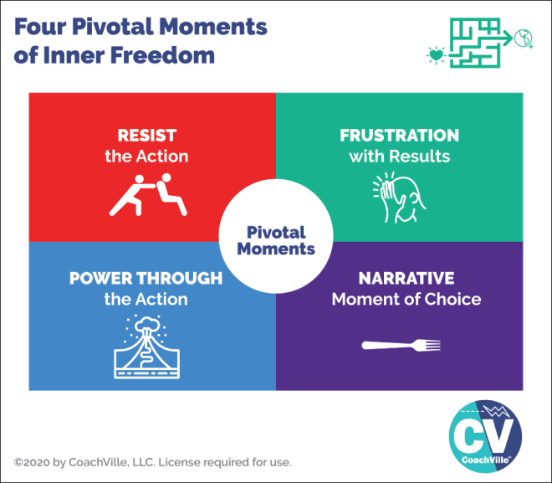
4 Pivotal Moments Of Inner Freedom
As you look at the model you might notice that it is similar to some of the ideas and images from the Playsheet for Session #1 when your coach was asking you about the actions that were not going so well in playing for your Dream. A VERY IMPORTANT point for this exercise is to maintain judgment-free awareness; be open and curious; no blame, no shame. (I am going to remind you about this every week; the Industrial Mindset is super “Judgey”)
The reason we are going into this in such detail is because MOST of the time these pivotal moments go by so fast that we don’t even notice them. There is a LOT going on, but it is happening at a non-conscious level so most of the time it passes by. BUT… now that you have an Inner Freedom Coach you need to learn how to pay attention to these moments.
Resist the Action
This is typically the easiest to recognize. This is when there is an action for your dream that you intend to do and even want to do but you just don’t seem to do it. You find yourself putting it off; sometime deliberately and oftentimes non-consciously by “getting busy”. If it is an action that is important for your dream and you are not doing it then you are resisting it; there is some kind of fear involved…plain and simple.
Power Through the Action
Powering through is very similar to resisting except that after resisting the action for some time you eventually do it. BUT typically you have to really gear yourself up to do it. Or you just get so annoyed with yourself for not doing it that you just do it to get it over with; not the best energy for an action that is part of living your dream! ;-)
The purpose of Inner Freedom is for you to get into your actions with an easy flow!
Frustration with Results
This is when you take the action but you don’t get the results that you desired. Remember with your BIG Dream we are talking about playful actions where you can’t control the outcome but you can influence it. So when you don’t get your desired results that is an opportunity to expand your influence.
This is situation where your energy may be impacting the outcome in a way that is not beneficial. But it is VERY difficult to notice your own energy while you are in the moment. A goal of your coach with Inner Freedom Method is create awareness of how your energy is flowing in the moment you take the action. When you shift your energy you often get better results.
Narrative Moment of Choice
This is a situation where there is a “story” involved about how or why something didn’t happen. Typically in a story like this there was a moment of choice to go one way or another. (the metaphorical fork road) In that moment you made a choice that pulled you toward the safety zone and away from your Dream.

Plan-Play-Grow Technique
To help you make the most out of your coaching experience I am going to share with you how to get into the rhythm of playing with a Life Coach. There is a coaching technique we use to create this rhythm called: Plan-Play-Grow. If you have ever had an athletic coach or a performance art coach then you will recognize this technique.
On a personal note, I first learned about this technique by observing my mom who was a piano and voice coach. Her music studio was right beneath my bedroom in the house, so I heard coaching happening every day after school. Even though I wasn’t tuned into the details I did notice one very dramatic thing: over time all of her students played a lot better! This is exactly how it happens… and it yields great results almost every time.
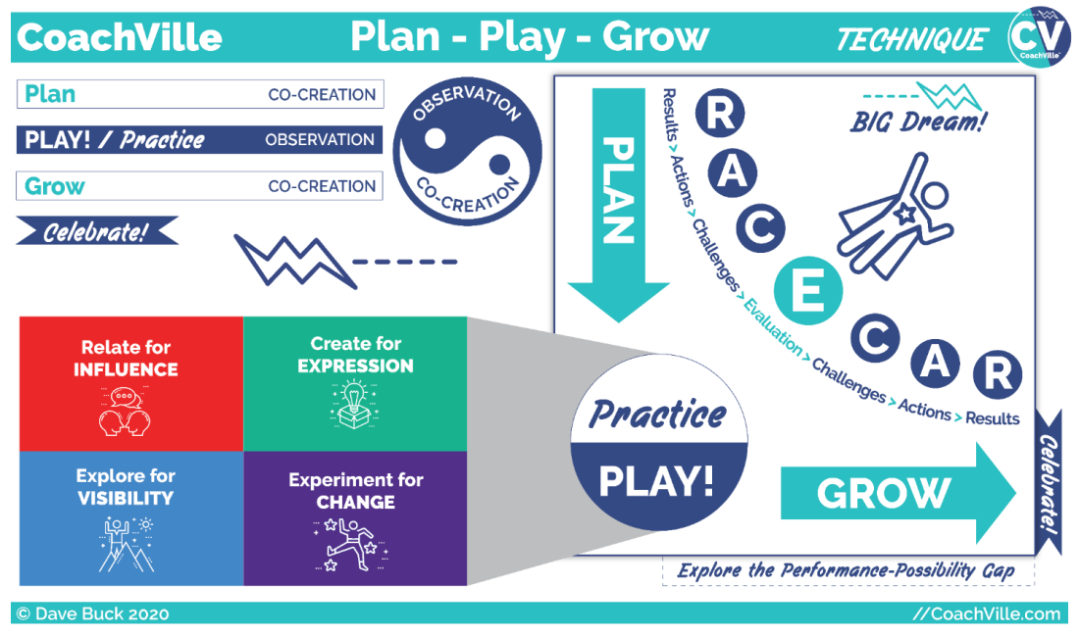
Let’s explore this model together.
We start in the upper left where you see Plan – Play / Practice – Grow – Celebrate. You also see the yin/yang symbol with the core of the coaching experience which is observation and co-creation. You may recognize those terms from the definition of coaching I shared with you.
Next, look at the right side of the diagram. You see the Plan – Play / Practice – Grow – Celebrate again but this time you also see what we call the RACECAR acronym: Results – Actions – Challenges – Evaluate. We will get into that in a few moments.
Also in the lower left you see a call out from the Practice / Play circle into the 4 primary activities of playing for our dreams; AKA Social Play. You saw this in the Playbook Introduction. (It’s all coming together!)
Whew! We have a lot to talk about here.
Let’s first get clear on the coaching rhythm because it will really help you get the most out of your sessions with your coach.
In the coaching session:
You and your coach will celebrate the notable experiences since your last session; especially moments of play where something good happened.
You and your coach will co-create a coaching PLAN for the session by first EVALUATING what happened when you played. You will also explore your insights. And you will share specifics about key playful actions and the results in the world.
You and your coach will PRACTICE together to co-create new awareness, new possibilities, new capabilities and new confidence. We will explore a variety of practice techniques in this Inner Freedom Coaching program.
You are your coach will capture your GROWth from the session. (The Growth Zone in the Coaching Notes Play Sheet) The intention of a good coaching session is that you grow during the session… and then continue to grow as you play in the world.
Make a few notes on you’re the coaching notes sheet as you talk together.
You and your coach will co-create your play PLAN for the upcoming time frame; focusing on the 4 types of actions to play BIG for your dream.
You will write out the most important items on your Play Plan Playsheet.
Then…YOU go out in the world to play:
You PLAY for your Dream aiming to co-create RESULTS and experiences by taking the 4 types of ACTIONS and facing CHALLENGES along the way.
You notice your GROWth opportunities as you play.
Make a few notes on your playsheet about what happens as you play (or avoid playing).
In the next coaching session:
You and your coach will CELEBRATE your RESULTS (and your challenges)
You and your coach will co-create a coaching PLAN for the session by first EVALUATING what happened when you played.
You and your coach will PRACTICE together.
You are your coach will capture your GROWth from the session.
You and your coach will co-create your play PLAN for the upcoming time frame.
YOU go out in the world to play:
The rhythm repeats from here.
When you get into this rhythm with your coach, you will be amazed at how quickly you feel your progress and good things start to happen. It really is fun.

Understand RACECAR
One of the most important shifts that your coach and I want to help you make is from Industrial Control to Connected Play.
Understanding the acronym RACECAR from the Plan-Play-Grow technique can help you make this shift.


R is for Results in the world
Probably the most challenging part of the shift is the focus from completing tasks to co-creating results in the world.
In the Industrial Age we were told to only focus on what we can control.
So we should only focus on completing our tasks and doing them right; mostly in isolation so that we don’t bother anyone. Since we can’t control what happens with other people we should not put our attention there.
In the Connected Age of Play it’s ALL about co-creating with others; we use our powers and energy to be a positive influence in the world; to make a positive impact.
We put our attention on the results that happen because that is the purpose of playing for our dream. In play you have to look beyond yourself… out into the world or people around you that you aim to influence or contribute to or be seen by or make changes with.
In play… there is NOTHING you can control. When we play for results sometimes they happen and sometimes they don’t. That is what makes it play. Practicing with a Coach to play better means getting the results we desire more often than we do right now.
Remember the results from our 4 pivotal moments of social play: influence, expression that contributes to others, visibility and change.
STOP getting people under control
Another quirky angle on Results from the Industrial Age of Control is that we SHOULD be able to control everyone and everything by following the manipulation instructions properly.
There are a lot of manipulation techniques in the Industrial Age because the whole focus is on getting everyone and every situation under control. This is very difficult of course because as I emphasized in the Introduction, we humans HATE being controlled!
So what happens most of the time is that our attempts to control are futile and frustrating. This is one of the reasons why there is so much chronic anxiety and depression in the Industrial Culture: people are in positions or roles where they are supposed to control other people and they are judged based on their ability to control others. This is SUPER stressful.
Letting go of the delusion of control is one of the most freeing benefits of shifting into the Connected Age of Playing for Influence as a co-creator.
This is a LOT of what Inner Freedom is about.
A is for Actions with your Superpowers

We all do a lot in a given day. The key here is to find moments when you can take the social play actions: relate, create, explore and experiment.
Since we are all used to going through our days completing tasks, it requires some intentional effort to get into play.
A) There are some actions that you are doing already that you can now approach playfully.
B) You can intentionally add playful actions into your day.
Playful actions are when you aim to be a positive influence on someone or co-create with them AND you pay attention to the result that happens (or doesn’t happen).
The performance-possibility Gap
The idea of the Performance-Possibility Gap is integral to coaching. You have a current level of facility with playful actions and your superpowers. And you and your coach share a vision that you can expand that facility.
You can co-create the results you desire more often.
You can PLAY better.
The key to getting into play mode is to drop the Industrial Age Control mindset that you have to do things perfectly every time. This “perfection trap” is antithetical to play. It literally makes it impossible to play and that was the intention; to get you to stop playing and become a compliant worker doing what you are told to do by the boss. Sad but true… we have been doing this to each other for a long time now.
But not anymore!!!
You can break free of the perfection trap and enjoy playing again.
The next step is to embrace challenges.

C is for Challenges with the Spirit of Play.
When I was describing results I wrote that sometimes they happen and sometimes they don’t. This is the nature of play.
Well, everything that contributes to the desired result NOT happening is a challenge.
There are several different types of challenges.
1) A challenge where you need to develop more skill and experience in what you are doing.
2) A challenge where you experience some doubt or fear related to what you are doing.
3) A challenge where there is something in the world – probably some force of the status quo – that doesn’t want you to achieve your desired result.
The key to being playful is to embrace challenges with the spirit of play.
There are some challenges that you are already aware of. And there will be plenty of challenges that you don’t even know about yet but will arrive as you play more and more.
Every challenge presents you with a growth opportunity. Growing and playing better is fun! Players embrace challenges. Great players LOOK for challenges.
When you are really passionate about the result you are playing for, the experience of a challenge can elicit your Superpowers. Somehow the challenge causes you to reach deeper into yourself and your real power comes through. This is why playing for dreams can lead to surprising discoveries within yourself.
A benefit of playing with a coach is that you can talk through what is happening when you play and identify the challenges you are facing. And then co-create a plan to play with them by expressing your superpowers.
There is nothing wrong.
Embracing challenges is another element of play that requires a shift from the Industrial Control mindset. When the focus is on following the instructions and keeping everything under control, a challenge usually meant that you were doing something wrong. IT meant that you were not perfect… oh the horrors!
Embracing challenges as fun growth opportunities – rather than something is wrong – will significantly reduce your stress and expand your joy.

E is for Evaluation with judgment-free awareness
I know that the experience of being evaluated can bring up a lot of bad memories. Starting with the dehumanizing and traumatizing testing we all suffered as children in school. Followed by the dreaded performance reviews many of us suffered in jobs. The purpose of the whole thing was to show you what you were doing wrong. UGH!
I am inviting you here to look at evaluation with a fresh perspective. YOU are not being evaluated. YOU – with your coach - are evaluating the results WITH judgment-free awareness. You are doing this to assess the impact you are having and look for ways to play better.
In this setting, evaluation is a co-created experienced aimed at helping you become MORE.
This is another situation where it will take a little practice to shift out of feeling that there is something wrong into seeing ways to grow.
You and your coach will do it together.
C-A-R is looking at it from the other direction
- You experience and embrace a challenge
- You take your playful actions
- In pursuit of your desired Results.
The idea of the RACECAR acronym is to look for results, actions, challenges and evaluation for growth opportunities in a fun and playful way.
Next let’s get into the Inner Freedom Method!

Step #1 P/Replay the Pivotal Moment

Once you choose a pivotal moment to play with the next few steps of the Inner Freedom Method are sort of like watching game film of the moment together. Looking at the moment together from an Energy Alignment perspective… you will explore the action, thoughts in your mind and physical sensations in your body. This is the first step in getting your hearts intentions through the maze and out into the world.
To start you will bring the moment into your imagination and play the scene out and describe what is happening to your coach so that you can “look” at it together.

Replay OR Pre-Play
Often you will replay the moment that happened in the recent past.
However, you can also preplay a moment in the future.
This is an advantage that your imagination has over actual game film in an athletic coaching situation. Your imagination is so powerful that you can preplay a moment in your future with just as much detail as you can replay a moment in your past.


Step #2) Review Reactions with Judgment-Free Awareness
Our minds are truly amazing! And we are going to tap into this amazingness in Step #2 of the Inner Freedom Method.
While you imagine yourself in the scene of the Pivotal Moment (either replay or preplay) you can also notice the thoughts that are going through your mind in that scene. We refer to these thoughts as reactions because they frequently reveal how you are reacting to the situation; usually your non-conscious beliefs will aim to keep you safe by popping thoughts into your mind that will keep you “in the safe box”. In Step #8 we will make a transformational leap from react to respond.
So, you are both in the scene and also the observer of your thoughts about the scene AT THE SAME TIME!
BIG WOW!
And your coach is there with you also observing as you describe the scene and then your thoughts.
The big breakthrough here is to notice your thoughts with judgment-free awareness.
This means that you are gentle, open and curious about every thought that you notice. No filter, no blame, no negative assessments, no ignoring some because they don’t seem relevant… just notice and share each thought; they are all relevant and valuable.
Your coach will help you make sense of it all as you move along.

Brief review of Steps 3,4,8,9
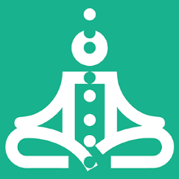
Your coach will do steps 3,4,8 and 9 with you for the first time in this session.
Steps 3 and 4 are where we explore what is happening in your body (The Feeling Layer) while you are in the scene. This may be a new experience for you so just go into it with curiosity. Feeling energy is something that gets better with practice… so this is just the beginning. Your coach will guide you so you can just relax and enjoy the adventure.
We will explore these two steps in detail in Chapter 3. It will be easier to explain after you have experienced it.
Step 8 is where you explore how your dream wants you to respond to the situation. This will reveal the opportunity to choose between your Dream and your Social Safety Instinct (Remember “the Pull”).
Then in Step 9 you use your imagination again to preplay the scene the way your dream wants it to go. It’s fun. This is the type of guided visualization that all of the top performers in Athletics, Performance Art and Life do with their coaches on a regular basis. It is powerful and it will lead to better and better play over time. YES!!

Prepare for Session 02 – Pivotal Moments
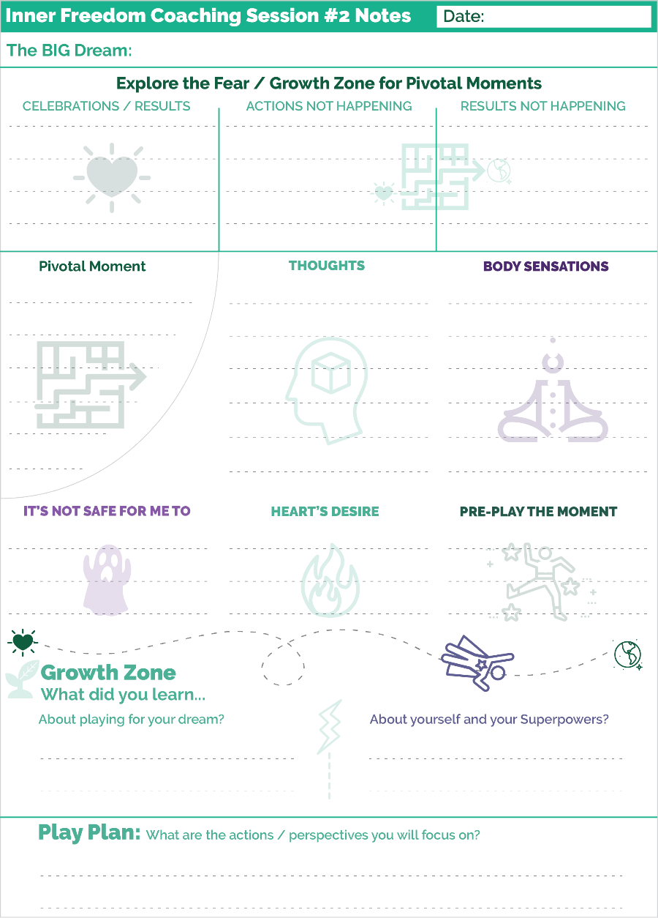
A mini version of the Coaching Notes Play Sheet for Session #2 is on the right.
The purpose of these sheets is to provide you with a basic structure where you can write in just a few key words along the way; like a mind map.
A coaching session is not school! You don’t need to write a lot down. It is a co-created experience so you need to be fully present and fully participating. Having the structure of the conversation on the page allows you to just write a few words in each section that you can review after the session.
The trick is for some parts of the coaching session you will be visualizing with your imagination and you will have your eyes closed; not an easy way to take notes! After each visualization write a few key words in to the relevant box.
Before the Session
For the start of your coaching session have your Play Plan Playsheet from the previous week in front of you. It should have your notes from your experiences of playing for your dream. Highlight a few moments you want to share with your coach.
The BIG Dream
Your Coach will ask you about this every week. Allow yourself to speak it from the heart each time. You may notice yourself describing it in a new way. Write down the key phrases at the top of your sheet.
Explore the Fear/Growth Zone for Pivotal Moments
Share with your coach the key moments from your week of play. Sharing is powerful. As you talk about it you may come to a new realization or understanding. Avoid the “task list read out” vibe. Share each one as a short story.
- Celebrations and Results
- Actions Not Happening
- Results Not Happening
Celebrate any experience that was noteworthy for you! Remember: A Result is when something happens in the world as a result of your actions.
Then with judgement-free awareness note anything you planned to do but did not; and when you took action but did not get your desired results. BE JUDGMENT FREE!!!!
Choose a Pivotal Moment to Practice
The next step will be to choose a pivotal moment from all the possible moments. You may know exactly which one to choose. If not your coach will help you choose one.
Write the essence of it on your play sheet.
Then your coach will guide you through the Method.
Thoughts – Share what comes up for you.
Body Sensations – This is an eyes closed exercise; after you do it write a few notes. As far as noticing body sensations, this may be new for you. Stay as open and receptive as you can.
It’s not safe for me to: - This will reveal a body belief / non-conscious belief.
Heart’s Desire – This will connect your dream to the moment you are exploring.
Pre-Play the moment – This is a powerful exercise to put your energy into a vision of the future.
Growth Zone
It is valuable to capture your growth oriented insights right as they happen. It is easy for them to disappear when you get back into your day.
Play Plan
You and your coach will co-create a few actions to focus on in the days ahead. This is just a start. You will develop a complete play plan each week and write it on a new Play Plan Play Sheet as soon as possible after the session.
The Value of the Play Sheets
You will remember all of the key points and create a compelling diary of the experience.
It is also very helpful to review the sheets from time to time to look for patterns. And it will be fun to review after the adventure is over to remember the key moments along the way.
Ready to go!
Again remember that your coaching session is a co-creation with your coach. It is not a test; it is not a counseling session to talk about your problems. It is an opportunity to explore new ways that you can play BIG for your dream. To prepare for the session all you need to do is refresh your memory of your pivotal moments from your week of play.

**!!** {End of Player Playbook} **!!**

Coaching Notes for Session #02
In session #2 we get into the Inner Freedom Method. In the exploratory and Session 1 we were setting vision for the adventure. Now the adventure begins.
In the first few sessions we will use Inner Freedom Steps 1,2,3,4,8,9.
This “short version” of the Inner Freedom Method is called the Pivotal Moment Technique.
We use this in all of our coach training programs now!
It wasn’t always this way. Over time I figured out that the short version of the method could be done fairly quickly with practice. AND it was such a great technique for so many situations that I wove it into all of the other programs.
So… if you have done any of our other programs in 2020 or beyond, some of this will be familiar to you.
STRUCTURE
Just another quick reminder: that the structure of the sessions will utilize the Plan-Play-Grow technique. If you are familiar with this it will help you ease into the flow of it with your players. Again, a little structure – like knowing that every session you will ask about their dream; and every session you will ask them to celebrate – will accelerate your player feeling that this is a safe space to explore and share and be vulnerable.
Pivotal Moments and The Coaching Plan Section
Within a few sessions your player will usually come to the coaching session with a pivotal moment that they want to explore. But in the first 3,4,5 sessions you will need to help them see the pivotal moments. This is the purpose of the inquiries in the COACHING PLAN section.
It can be alluring to go deep into some of these questions but this is not yet the time for deep dives. It is up to you to keep the conversation moving while making notes about the pivotal moments that you are observing.
THEN you give the player a little menu of options and let them choose which one to explore.
Quick understanding of #1 Preplay the Pivotal Moment
Preplay or Replay?
It really doesn’t matter. When I first created this method it was always a replay from the recent past. But now my experience is some players have an easier time in the beginning with a preplay of a future moment.
If the player has a CLEAR moment from the past week where they experienced resistance, that can be a good place to start. But even then if they want to preplay taking that action in the near future it will work just fine.
Quick understanding of #2 Review Reactions with JFA
The key here is to listen and be judgment free as the player shares the thoughts.
AND don’t deep dive or ask any follow up questions about them. Just listen.
You don’t want this part to go on too long. You just want to create a safe space for the player to share what is on their mind… AND for the player to notice that they have a lot going through their mind that they didn’t notice before.

Quick understanding of #3 Feel the Energy in the Body
Follow the GUIDE!!!
I don’t recommend improvising on this the first bunch of times you do it; but especially this step. The sequence really matters here.
Also, read the guide outloud a bunch of times so that you are comfortable with the flow of all the A/B sections where you choose a direction based on what is happening with the player.
It is all spelled out in the Guide… BUT don’t try to read it for the first time while doing it!
For example, read it through with the situation that the player does NOT notice a physical sensation.
Read it through with the situation that they DO notice one.
Make sure you understand how to jump around as the session unfolds.
About Feeling
A LOT of people have no experience at all with body awareness. So they may not be able to notice a physical sensation the first few times.
The MOST important thing for you is to not put out the energy that something is wrong. Stay calm and affirming all the time, every time.
If you get a little unsure because they are not feeling anything, they will feel that and it will hold them back.
The key to feeling energy in the body is to feel safe with the coach first.
It is up to you to create the vibration of safety for them.

Quick understanding of #4 Scan for Body Beliefs
This is all about giving your player an opportunity to give voice to the resistance that they are experiencing. It is super powerful.
Here you are the witness first. And sometimes also the wordsmith if they need help putting it all into words.
Quick understanding of #8 Make your Mind the Ally of your Dreams (respond)
The point of this step is for your player to experience that their mind can think thoughts of preservation (typically reacting to a situation) AND / OR they can think thoughts for their dream.
When the body feels safe, the mind is capable of extraordinary thoughts.
For many people this is a huge awakening; because it’s been a really long time since they “felt safe” in their body. It’s fun.
Here you may need to help your player choose words for their dream.

Quick review of #9 Preplay the Pivotal Moment with your Hearts Intention (co-create)
Now using their imagination they preplay the scene in the vibration of their hearts intention.
This is usually really fun and illuminating for the player.
VERY often – but not always – they will just do the activity with ease in the days after the session.
Coaching Notes Playsheet
It is important to write a few notes on the Coaching Notes Playsheet. Trust me! Do this during or after every session. You will so happy to flip through these pages during and at the end of the engagement.

Inner Freedom Method Step #1: P/Replay the Pivotal Moment
Inner Resistance occurs when an individual has two energies that are pulling in different directions. One example is the desire to take a certain action or get a specific result and the pulling energy could be the desire to avoid activities that are outside of the preservation zone and bring up physical sensations of fear. Or there could be a non-conscious belief (AKA body belief) that it is dangerous to be too successful and that energy is pulling against actions that will create positive results.
Often these key activities and situations will come up naturally in the first part of the session while talking about the dream, actions, challenges and results with your player. However, sometimes you will have to use your coaching intuition to identify and talk about where your player is avoiding something important.
Often these situations are described as procrastination or being too busy. But this is Industrial Age NONSENSE! Your player is never too busy to do the most important activities that lead to playing BIG for their Dream - when there is no action there is a pulling energy somewhere.
Remember: immersing in busy work is
a natural response to discomfort
and social fear.
There are an infinite number of potential pulling energies for an individual; however there are several patterns that you will see often as a coach. This method will help you to see these patterns.
The KEY to doing this well is to hone in on a specific moment / a specific action
- You can do this with a specific moment from the recent past.
- You can do this with a typical moment for the near future
- This is a powerful visualization technique when the moment is very specific; when the moment is fuzzy, the visualization won’t illuminate much.
- By visualizing you can slow down the moment so that you can explore the thoughts and feelings that are a blur in the actual moment.
- You replay the moment to expand awareness of all of the energies that affect the player’s choices and actions.
The Power of the Imagination
In Step #1 you ask the player to use their imagination to put themselves in the scene and see themselves taking action; or avoiding taking action.
When your player is “in the scene” in their imagination they will experience the same inner experiences as if it was actually happening.
The Inner Freedom Method makes ample use of the amazing power of Human Imagination! In my view the ability to imagine yourself in a scene or situation taking action and simultaneously notice the thoughts going through your mind and the physical sensations pulsing through your body is a BIG WOW!
When you imagine yourself in a scene your thoughts and body respond as if it was really happening! Except that in your imagination you can fast forward or rewind or slow down just as if you were watching it on a video. It’s quite amazing.
This should be considered another Human Superpower and by doing Inner Freedom you develop the ability to use this power for good!
This leads me to an important point about coaching.
This is a way to Practice Life together
The essence of coaching is practicing together to play better. In activities like singing or basketball it is easy to understand how to play together. In life it isn’t so straight forward, but it is VERY possible.
In the Inner Freedom Method you will make use of three powerful ways to play together:
- Co-creative conversations
- Active imagination
- Role playing conversations
We practice with our players using these “ways” in every CoachVille coaching program. In the Inner Freedom Method you will experience the profound power of Active Imagination; hopefully it will become an active part of your life while playing and coaching.
The Action Layer
On the Model for the Inner Freedom Method you can see that Step #1 connects with Step #9 in what is called the “Action Layer”.
Each layer has an important transformational shift that is available to your player as you move through the steps of the Method.
In the Action Layer the shift is:
From Control
To Co-create
This is a really BIG shift for all of us indoctrinated into the Industrial Culture of Hierarchical Control.
It’s called the Action Layer because these are the steps where the player is focused on the action in the world; even though it is all happening in the player’s imagination, it is all about the action.
When you enter into Step #1 there is typically some kind of resistance or upset about the action or the results.
By the time you and your player get to Step #9 their body will feel safe and their mind will be open and it will be easy for them to imagine a scene where they are in action in a whole new way; trusting life, trusting themselves, trusting their playfulness and trusting their power.
I call this Co-Creating with life.
AND often in the scene the 2nd time around the player can see themselves co-creating WITH the other people in the scene rather than attempting to control them.
This is how Inner Freedom very often quickly translates to Freedom in the World.

Inner Freedom Method Step #2: Review Reactions with Judgment-free Awareness
Notice your thoughts with judgment-free awareness
After you have your player create the scene and imagine themselves in the action they are replaying or pre-playing, you ask them to notice their thoughts with judgment-free awareness and share them with you.
This is the part of the method where both you and the player begin to become aware of what is going on in the players thoughts during this Pivotal moment. This is where you both get clues about why it is so challenging to take the action or co-create the desired result.
Emphasizing judgment-free awareness is essential because most people tend to dismiss their own thoughts when they start with the method. Or they may be embarrassed by their own thoughts and not want to share them. As the coach you need to cultivate a safe space for deep and vulnerable sharing to occur.
Common Judgments
Something is wrong with me because...
- I have negative thoughts
- I didn't do something I wanted to do
- I am not getting the results I wanted
- I keep revisiting the same issues in every workshop I do
- I keep making the same mistakes
- I can’t get out of my own way
- I am a known procrastinator
Inner Freedom Framework
All thoughts, feelings and actions serve a purpose
Every pattern within our inner being has a purpose; there was wisdom that was appropriate in the moment the pattern started
AND that pattern may now pull against the new intention to play BIG for our dream.
Judgment-free Awareness & PLAY!
- Concept first made popular by Timothy Galway in the "Inner Game of Tennis"; his concept is that there is an inner doer and an inner executive. The inner doer is doing their best all the time; the inner executive thinks you SHOULD be able to do everything perfectly every time and is constantly judging every action. My view on this is that this Inner Executive was absorbed from the Industrial Culture (starting with being tested as a child in school); it is NOT a part of the Pre-Industrial human experience.
- We learn to judge ourselves by being judged by others! Since we were judged A LOT in the Industrial Culture it is as if there is a chorus of judges within us that are demanding perfection.
- Being judgment-free is accepting and welcoming what is; even when you have a different picture in your imagination of how you want it to be.
- When we do something new we usually have a vision of how we want to be able to do it; but we can’t do it that way without a lot of practice. By being curious as we play we can take actions AND move toward our vision at the same time; AND we can enjoy the experience of getting better at something RATHER than the Industrial Age frustration of not being perfect from the first attempt.
The Thought Layer
On the Model for the Inner Freedom Method you can see that Step #2 connects with Step #8 in what is called the “Thought Layer”.
Each layer has an important transformational shift that is available to your player as you move through the steps of the Method.
In the Thought Layer the shift is:
From React
To Respond
This is a powerfully important shift because you develop the ability to influence your own mind (notice I didn’t say control!)! I know this sounds strange.
In Step #2 you notice the thoughts in your mind; typically these thoughts are what we call Reactive. They are thoughts about why you shouldn’t do the action you want to do; or thoughts about why the results probably won’t turn out as planned.
In this state we experience very little influence over our own thoughts. It is like they are on auto-pilot which is pretty accurate.
When our body does NOT feel socially safe; our mind gets full of thoughts generated by the Social Safety Instinct. (Remember this from the Human Journey?) It is an epically powerful force and it will dominate your mind with thoughts that “talk you out of” taking the action; OR actively disrupt the action in progress.
Social FEAR is so powerful. The important thing for personal growth is to HONOR this fear; and honor the Social Safety Instinct; and honor the feeling within the Preservation Zone.
BUT… the story does not need to end there! (Although for most people it does)
By diving into Steps #3 where we feel the energy in the body and Step #4 where we give voice to the Body Belief / Social Safety Instinct, in the presence of another person who is creating belonging and a safe social space, something MAGICAL happens…
Your mind opens up to new possibilities!
When your mind is open you are able to intentionally THINK of new ways to respond to the situation; or new ways to approach the action.
In this state you can influence your thoughts to focus on how your DREAM would like you to approach this action. You realize that when you feel safe, your imaginative mind is capable of SOO creativity and resourcefulness. You may also notice that you feel socially safe a shockingly small amount of the time; this is a conversation for another time.
It is this transformational shift in the Thought Layer that activates the transformational shift in the Action Layer.
SOOO GOOD!

It is good to know a LITTLE bit about the “Mind” {2010}
This will help you to have perspective while coaching and while playing BIG
A) The Mind is a powerful thing!
Conscious Mind – Social Brain - Non-conscious – Super-Mind Connection
Think Iceberg - conscious above the water line (10%) – Non-conscious below the water line (90%)
Your Brain is your conscious mind = Thinking + reasoning
Your Social Brain = Operates non-consciously observing all humans around you at all times to assess belonging, status and danger; it will push thoughts into your conscious mind when alarmed.
Your Body is your non-conscious mind = Intuition + Inner Knowing
Your Brain and Body are like a “radio receiver” for input from the Super-Mind

B) Most important: The imperative to survive (Play Safe) + The desire to contribute (Play BIG)
These powerful forces within us are almost always in conflict. So… we must learn to be at ease with this conflict so we can choose in each moment what is best.

This “conflict” can be experienced as either a fight or a dance.

C) Enjoys fantasy, delusion and magical thinking
we love: movies, novels, stories
D) Prone to suffering
Byron Katie: all suffering is an argument with reality
E) We ARE Light AND Shadow // NOT good or bad
Some thoughts reveal the light. Some thoughts reveal the shadow.

If the player doesn’t feel anything (What to do)
{there is some text from the coaching guide} WRITEHERE
Even though we will get to Step #3 Feel the energy in detail in the next chapter, I need to share a few ideas about this with you here because you will do Step #3 with the player in this session.
A quick point here is that up until a few years ago the entire Inner Freedom Method was predicated on the player feeling energy in their body. If they didn’t feel anything the coach was stumped.
This was not good!
So that is why you see in the Coaching Guide all of the places where it says in RED: {if the player feels energy do this; if they don’t feel the energy do that}.
I had to do this to account for the very real possibility that the first few times you do the method with a new player that they won’t be able to detect any sensations in their body when you ask them to do the body scan.
This makes the coaching guides way more clunky to read and follow! But it also makes the experience available to many more people and many more situations. So it’s better. But it requires more preparation for your part as the Coach.
This will happen fairly often because a LOT of people have become numb to the emotional signals in their physical body. This is another side-effect of the dehumanizing and traumatizing Industrial Control Culture. It really is sooo bad how we treat each other; often as if someone was not important; or as if their feelings don’t matter. Even though many of these things have become “normal” in Industrial Culture they are NOT NORMAL to our Human Nature. And if you are a sensitive person – which many of us are – it is absolutely intolerable and you shut down your capacity to feel out of self-defense.
Another common scenario is with folks who are logically oriented and tend to be more “heady” than body aware. Getting these folks to trust that they CAN feel, it is SAFE to feel and it is VALUABLE to feel, will take a few sessions.
Of course, EVERYONE, can feel energy in their body!
But it may require a lot of judgment-free trust and safe space before they feel comfortable enough to allow themselves to feel in your presence AND to share what they are feeling.
When we talk about feeling, we are talking about physical sensations in the physical body. Sometimes we use the word feeling to describe emotions of descriptions of emotions: like I feel angry. But when we talk about feel, we mean FEEL. As in: I feel a buzzing sensation in my solar plexus.
A few of these points I wrote in the Coaching Notes for the session but I want to explain them a bit here.
Be Prepared for the “Don’t feel anything” path
Read through the coaching guide a bunch of times. And practice the path through the session where you do the body scan with the player and they don’t notice any sensations. You want to be very comfortable with this version of the method so that you can present the vibration to the player that this is totally normal.
When they understand that you can do the method with them not matter what happens, this will help them feel safe.
The method definitely produces bigger breakthroughs when the player can feel the energy; and even bigger breakthroughs when they have Memory Pops during or after feeling. However, even if they don’t feel a sensation, the method will still lead to greater freedom.
After a few sessions, that greater freedom will eventually accumulate into the capacity to feel again. This in and of itself will be a huge transformation for the player!
Judgment-free Safe Space really is the thing
I just want to stress this one more time. The more YOU feel comfortable with feeling energy and with exploring and talking about all kinds of life situations – even trouble and trauma – the easier it will be for your player to feel physical sensations.
Inner Freedom is a co-created experience. The social safety that you provide is so valuable and amazing that it is really hard to put into big enough words.
I share this with you to encourage you to keep expanding your capacity to feel and deeply listen and stay judgment-free in your presence. All of this will speed up the process for your player to feel energy and talk about it.
At the same time, I encourage you to step into the enormous value that you are creating by expanding these capacities and using them in Inner Freedom Method Life Coaching.
Speaking for the Humans of the world yearning to be truly FREE:
THANK YOU!!

The Power of 1,2,3,4,8,9 – the “quick” version of Inner Freedom
WRITEHERE
I mentioned this in the Coaching Notes section but I want to say one more quick think about it. The “short version” of the Inner Freedom Method where you skip steps 6 and 7 is also known as the Pivotal Moment Technique. It is woven throughout our coach training programs.
In the first few sessions with your player we also skip Step #5.
The purpose of this is to allow you and your player to build both trust in each other and also trust in the flow of the Method. Then we can go deeper by delving into the Supermind Layer (also the Superpower Layer) in steps 5,6 and 7.
In the earlier versions of the Inner Freedom Method we were diving straight into the deep inquiries of these steps and often the player just wasn’t ready to go there.
There is a capability set to the 3 transformations:
Control -> Co-Create (the Action Layer) – The capacity to activate the imagination
React -> Respond (the Thought Layer) – The capacity to think for your dream
Resist -> Allow (the Feeling Layer) – The capacity to FEEL energy in the body
This version focuses on building confidence in these three capacities. These are the capacities that are needed to explore “the Treasure Map” to recover their Superpowers AND align their energy with their dream.
Even these few weeks are like a big adventure for most players, you can think of this part of the series as basic training at base camp before setting out into the REAL unknown world.
The other important part about this is that with practice you can do these steps – even with a new player – in just a few minutes. This can become a standard part of just about any coaching session you do in the future.

Expand Awareness (2010)
Why is Expanding Awareness Important?
- Because we don't see our own patterns - once something becomes a pattern the nonconscious takes over and you don't see it anymore
- Proficiency: Reveal the player to themselves
- Framework: Awareness is unifying

What do you want to expand awareness of?
- Patterns!!!!
- Blind Spots
- Out of comfort Zone activities
- Hearts desires
- New Possibilities
- "Reality"
- Physical sensations "feelings"
- Thoughts
- Recurring Actions

Review Inner Resistance Clues
1) actions not taken / avoided
2) actions taken by “Powering through”
3) actions taken with poor results

Pivotal Moments and the Basketball Coach metaphor
I shared about this idea in the Player Prep audio using the example of a basketball coach observing their team play in a game.
I used basketball only because I think more people are familiar with it than my main sport, which is soccer. I have played soccer since I was 12 and was assistant coach for a top University Team for 14 years.
The reason I am sharing this example from athletics is because I really want Life Coaching to stay true to the roots of coaching which are from athletics and performance arts: coaches help players play better.
Here is something we can learn from this perspective.
Athletic Coaching
As an athletic coach, you observe your players in the game.
After the game, we have a debrief with the coaching staff and choose the pivotal moments from the game that we want to use as “teaching moments” in the next practice session.
Then we craft exercises and situations to play with in practice so that our players are more prepared to thrive in similar situations in the next game.
Voila! Athletic Coaching.
Life Coaching
So how do we replicate that fun and effective flow in what we do as Life Coaches?
The end part we have! The Inner Freedom Method is a great way to play with situations and develop new ways to play better; especially when we add in the Role Play technique!
The only question is how do we find the Pivotal Moments, because we don’t get to watch the players in the game; unless they are doing something via video that we can watch.
In Life Coaching there are two ways we approach this.
1) Teach the players how to observe their own Pivotal Moments. This is the purpose of the Player Prep Audio.
2) Develop a way of debriefing with the player what happened since the last coaching session to co-create awareness of Pivotal Moments. This is the purpose of the Coaching Plan section at the start of each session.
Voila! Life Coaching.

Using the Play Plan Sheets ~ to spark awareness of Pivotal Moments
Speaking of your player developing awareness of Pivotal Moments, let’s talk about the Play Plan Playsheets for a moment.
Are you using them to play plan YOUR week of play?
Are you encouraging your players to use them to play their week?
The purpose of these sheets is to create a visual cue to remind them (AND YOU) to put some PLAY in their DAY; to put at least some energy every day into Relate, Create, Explore and Experiment.
We don’t have pivotal moments when we are completing tasks where we know exactly what will happen.
We only have Pivotal Moments – AKA Coach-Able Moments – when we play for something that we cannot control but we can influence.
It’s up to you as the coach to let your player know that you care about them playing.
Find a way to stay connected to your players in between coaching sessions. It’s not practical for you to actually observe them playing. BUT… they can feel your presence in their lives.
Ask your players to message you when they notice a pivotal moment; and when they have a playful moment to celebrate.
You can ask your player to fill out their playsheet and then send you a photo of it. I actually just thought of that one right now and I am going to start doing that with my players. ;-)
Remember that the lifelong habit, since Industrial School, is to sit in isolation completing tasks. So that way of living has a tremendous pull; plus it is VERY SAFE.
For those in corporate life there are lists of tasks and boring meetings where people report in on their tasks; or make more lists of tasks; again staying locked in the Preservation Zone.
You are their Champion of Dreams.
You are their living example of co-creation.
So it is up to you to be their “Beacon of Play”!
YOU GOT THIS!!!

Class 02 Prep
We will explore a few of these questions in class.
Question: who can share about a Session #1
(or an Exploratory Session) with a player?

Question: What happened when you explored the FEAR and FEAR Adjacent experiences such as frustration, isolation and overwhelm in Session 1 with your players?

BIG Picture = Coaching is about playing together… The #1 skill of advanced coaching is finding pivotal moments to play with together
Question: What is your example of a Pivotal Moment? A BIG MOVE that you are avoiding?

Question: What do you do when you are avoiding your BIG MOVE?

Everyone needs to get clear on this: One pivotal moment that you want to play with today with your coaching partner.

Chapter 3 – Feel the Energy and Body Beliefs

“Your body is your subconscious mind.”
-Candace Pert

Chapter 3 Prep
Before Class
Read through the complete coaching guide for Session 3 (Page 21)
(this is a link to the PDF with the complete set of coaching guides)
Listen to this audio to prepare for Session 3.
(this is a link to the Player Prep SoundCloud audio)
Playsheet Pack: Print 2 copies of page 8
Listen to Coaching Demo of Session 3
(Coach Dave and Player Leanne)

{From the Player Playbook}

Session #03) Feel the Energy and Body Beliefs
In this chapter we are going to deep dive into this experience that we call: “The Pull” ; the pull between your BIG Dream and your Social Survival Imperative. I have a model for this that will help you understand your pivotal moments.
Finally we will explore Inner Freedom Method Step #3 Feel the Energy and Step #4 Body Beliefs which are the heart of the Inner Freedom Method.

Speak Your Dream! (why we do this every session)
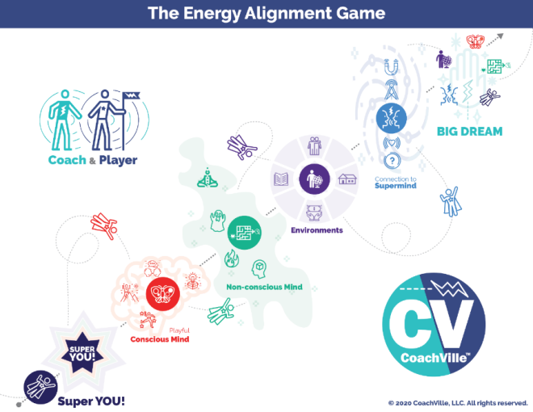
This is super important!
Remember the Energy Alignment Game I shared with you in the Introduction? On the right is a mini version of the model.
You see your BIG DREAM in the upper right. The whole game is to align every aspect of YOU and your environment with your dream.
At the start of every session your coach is going to ask you to speak your dream. We do this for several reasons ranging from pragmatic to energetic.
On the practical side, your dream is the reason for having a Life Coach; it is what the coaching is all about… YOUR Dream! Speaking it out loud sets the tone for the session: it’s about playing for your dream. That’s it.
As you speak it each week you might say a different version or you might realize that it is evolving in some way. As you gain clarity it gets easier to align. Also, this way your coach can stay aligned with it as well.
From an energetic perspective speaking your dream with someone who shares the dream with you activates the connection to the Supermind. That is the cosmic looking blue area to the left of the BIG DREAM.
Often in a great coaching session amazing insights and ideas will just pop in to either the coach or the player; puzzles are solved, new possibilities are sparked. Speaking your dream opens up the channel for these powerful experiences.

Why we celebrate & what to celebrate
Celebrating is a powerful human experience. We love to celebrate and I feel we don’t do it enough in our daily lives. I notice in athletics and performance art there is lots of celebrating from the high five on the field or court to the ovation in the hall.
In the Industrial Age where everything was “allegedly” under control there was no reason to celebrate anything because everything that happened was supposed to happen; just do your job.
But playing for a dream is different! There is no control. And anytime you take the risk to play for influence, visibility, expression or change… this is something to celebrate; especially when what you are playing for happens!! But beyond the obvious celebration of positive results, you can celebrate the bold action no matter how it turns out. You can celebrate a big challenge for how it is asking you to grow.
Celebrate. It’s good for your soul. AND it deepens your connection to the Super Mind.

Keep looking for Pivotal Moments as you play
In the next segment we are going to go deeper into understanding the experience of a pivotal moment; it is called “The Pull”. This is when you notice that your dream is pulling you one way and your social survival imperative is pulling you another way.
You will notice it most easily through the four pivotal moment experiences: resist, power through, no results and moments of choice. The more you notice these moments, the faster you will grow!

The Pull!
Remember “the Pull” from the Human Journey with a Coach model we explored in Chapter 1? Well, now we are going to deep dive into this experience.
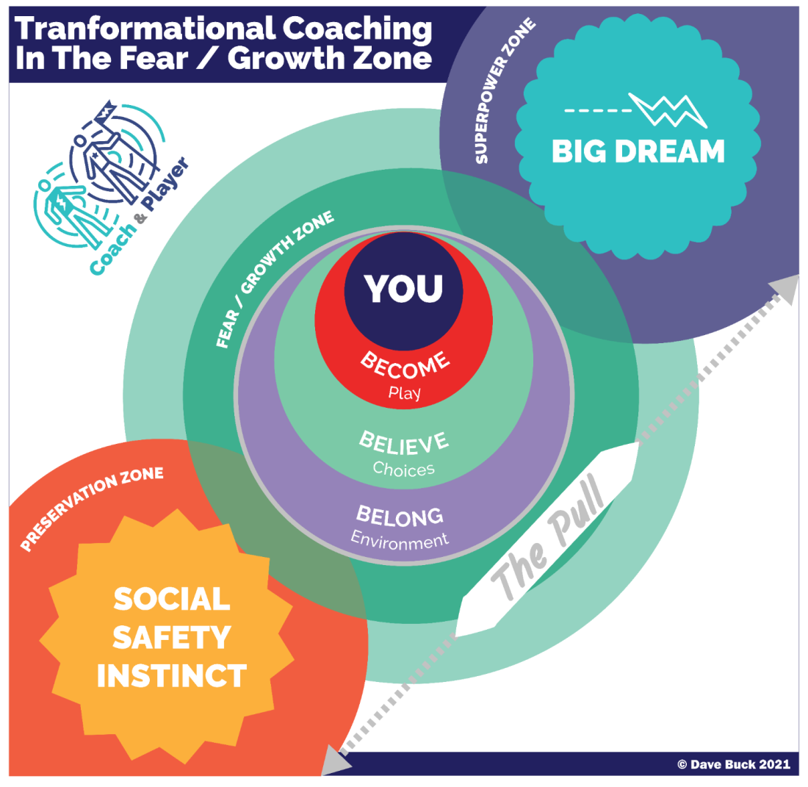
In the Human Journey with A Coach model we depicted your Big Dream as an outer circle pulling you out and the Social Safety Instinct as an Inner Circle pulling you in. Here we will dive deeper into this life experience that is at the heart of all Life Coaching.
There is wisdom in the creation of YOU. The dreams in your heart – including the one you are playing for now – are meant to require the playfulness and unique power that you were born to express. Yeah, the wisdom of creation!
These moments of choice between playing safe and playing BIG happen many times in an adventurous day of playing for our dreams. And as we have discussed, they often happen at a mostly non-conscious level. You don’t really notice them.
What you may notice is that you had a brief thought to take an action for your dream… then you felt a little buzzing energy somewhere in your body… and you “decided” to check your email/Facebook/”distraction of choice” instead.
Hopefully you are thinking right now: “Oh crap! That happens all the time!” Yes, it does. AND this is why I say that the success of your dreams requires that you pay as much attention to your energy as you do to your activity.
Social FEAR is learned
Remember when you did the Inner Freedom Method with your coach, you were exploring energy in your body and your coach asked you to fill in the blank: It’s not safe for me to: (fill in the blank)? I want to share something with you.
I created this technique many years ago and have used it over a thousand times. One of the most common things people share is: It’s not safe to be me.
WOW. That is a really profound thing to say and hear. And truly this is how most of us feel deep within. This is an example of a self-preservation belief. In other words I will stop expressing my power so that I can maintain a sense of belonging with the people around me. We will get into this in great detail in Chapter 4.
Often the moments earlier in life when we tried to use our power to help or contribute or create and we “got in trouble” (or worse) are the moments that impacted us emotionally the most deeply. The Social Survival Imperative is based on the need to belong. It is one of our Human Nature Superpowers. The Preservation Zone is where we don’t take an action that will risk our current status of belonging.
FEAR is the way your SELF tries to protect you from events and situations that seem similar to an experience in your past when you experienced trouble or even trauma.
As a result, in the FEAR / Growth Zone we feel a strong PULL between our BIG Dream and the Social Safety Instinct. “The Pull” is a natural byproduct of playing BIG for our dreams because your Dream is “designed” to require your unique powers – the ones you got in trouble for earlier in life!
This is why it is so important that you don’t think of fear as an enemy or that if you are stopped by fear that means that you have “issues”. You don’t have “issues”! You have a BIG Dream and a strong Self Preservation instinct both pulling you in opposite directions.
I encourage you to stop saying things like “Self-limiting beliefs”.
“Self-limiting beliefs” make us sound foolish! Why would anyone limit themselves?
But this is not what is happening. These are self-preservation beliefs that are pulling against the actions of your BIG Dream. Self-preservation is essential for social survival and it is honorable. Your coach is aiming to empower you to cultivate the capacity to CHOOSE when to play safe and honor your self-preservation instinct and when to play BIG and honor your BIG Dream. No judgment; simply to power to choose.
Also in the Growth / Fear zone you have the three B’s of Human Nature: the urge to Become the next version of YOU, the need to uplevel a few Beliefs and the opportunity to co-create a new environment of profound Belonging for you and your dream. We will explore this in the upcoming Chapters.
The FEAR / GROWTH Zone impacts our choices in life at a mostly non-conscious level. That is why your coach uses the body awareness technique during the Inner Freedom Method. Through this guided visualization exercise you bring non-conscious fears and growth opportunities into conscious awareness so you can observe them. I encourage you to really dive in on these moments with your coach; this is how you unleash your greatest power.

Step #3) Feel the energy in the body
In the last session with your coach you experienced this part of the method. While you are playing the scene in your imagination, your coach asks you to scan your body for physical sensations. This may have been the first time anyone has guided you in a body awareness exercise.
When you look at the Inner Freedom Method model you see Step 3 is in the heart center of the model. This is because feeling the energy in your body is the heart of the Inner Freedom Method.
A powerful way to understand this is to say that your body IS your non-conscious mind.
(via Candace Pert in the movie “What the Bleep” and her book: “Molecules of Emotion”; Ms. Pert calls it the subconscious mind)
A few things to know about feeling energy:
1) It is an essential life skill but somehow it is not often taught. It is awesome that you have an Inner Freedom Coach! Feeling energy is the gateway to your inner awareness, intuition, wisdom and freedom.
2) The goal of the exercise is to allow yourself to experience the energy. Just let it be there. The goal is NOT to get the energy to “release” although often it does.
3) When your coach asks you to close your eyes and scan your body from the top of your head to your waist, just be patient and notice.
4) The energy may feel like a buzzing sensation or heat or pressure or a whole host of other things.
5) The typical places where we feel energy like this is in the gut, solar plexus, heart, throat, jaw, behind the eyes and forehead. But it could show up anywhere from the waist up or even your whole body.
6) It can take a little practice to distinguish between feeling energy and some other agitation. For example: an energy in your gut vs. something that you ate agitating your stomach. You will know.
7) You may notice more than one sensation. In this situation your coach will ask you to choose the one that is most intense.
8) It is great to practice feeling energy when you are by yourself. AND the transformational potential is amazing when you are guided by a coach who is co-creating the experience with you.
9) If you don’t really notice any physical sensations after relaxing and breathing into it… that is OK! You are not doing it wrong. Even if you don’t notice a specific sensation, you are still breathing and scanning which gets you into your body.
I have done this method with MANY people and for lots of folks it takes some consistent practice before they started to notice subtle physical sensations. Stay with it; they will come into awareness when they are ready.
10) The main thing is just to trust the process! With practice it will become something that expands your awareness in a way that will serve you well for the rest of your life.

Step #4) Scan for Body Beliefs
After feeling the energy, your coach is going to explore the “body belief” with you. This is a powerful way to give voice – and words - to the wide variety of social beliefs and fears that have settled into your non-conscious mind. You may recall the phrase your coach used in the last session:
It’s not safe for me to: {fill in the blank}
Just allow words to come through you rather than thinking of words. The point of doing this is to bring these Social FEARs into your awareness so that you can understand them. We also refer to these feelings as: Social Safety Instincts or Preservation Instincts. Their purpose is to keep you safe. Their purpose is to direct you away from any social risk activity that could jeopardize your current status of belonging. You could say it is a friendly ghost. (sort of like Casper, the cartoon character from the 40’s & 50’s ;-)
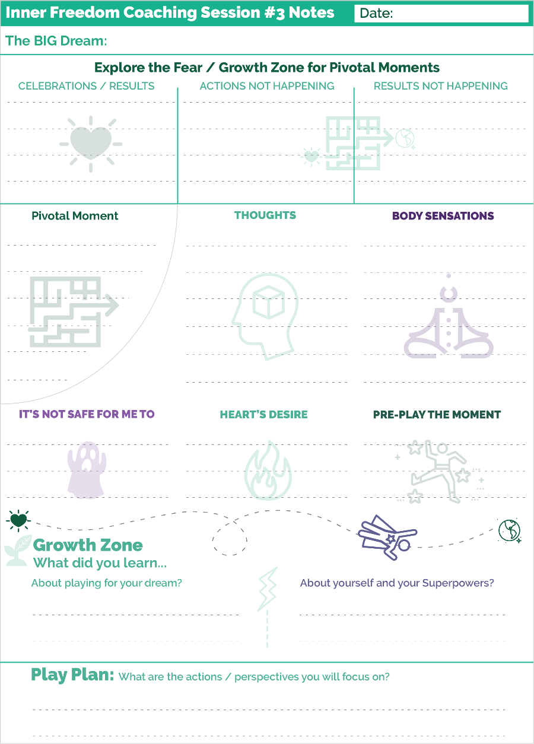
After you get a little practice with this process, these feelings and body belief phrases will provide clues on the treasure map that we will use to hunt for your superpowers! The thing we learned to fear the most is expressing our playfulness and unique power.

Prepare for Session 03 – Feel the Energy
A mini version of the Coaching Notes Play Sheet for Session #3 is on the right. You may notice that it is exactly the same as the sheet for Session #2.
The session will follow a similar structure as last week but will be a different experience because you will practice a different pivotal moment.
When I use these sheets as a player – yes, I am a player too – I find it interesting to look back at the pivotal moments, thoughts, body sensations and beliefs from each session. Over time it will give you clues on the treasure map. Fun!

**!!** {End of Player Playbook} **!!**

Coaching Notes for Session #03– Feel the Energy & Body Beliefs
The Coaching Guide for Session #3 is the same as for Session #2.
The only little difference is that you don’t explain to the player again about what the preplay / replay is all about. They get it now.
A note about coaching in class
In class we have less time to practice than you will usually have with your players. So to accelerate the process we have you skip the COACHING PLAN section except for asking your player to share their dream. It is good to do this every week!
It is great if you can catch up with your partner in between sessions so that you are up to date on what is happening with their dream. This can be done via email as well.
BE PREPARED!
The other super important thing is to come to class prepared with a Pivotal Moment that you want to practice with your coach. We skip the Coaching Plan section of the Coaching Guide so we can get straight into the Inner Freedom steps. But the Coaching Plan part is where we hone in on the Pivotal Moment to practice. Since we skip this part, you have to come to class prepared.
It can be the most important moment from your past week! Or it can be any pivotal moment that would be fun to practice.
YOU CHOOSE!
Just do not come to class, get into the dyad and say to your partner: “I don’t really have a Pivotal Moment this week”. AAARRRRRRGGGGGGGGHHHHHH! Please don’t do that.
Step #3
While you are doing this step it is important for you to slow down a bit; your aim is to be a calm and STRONG presence. You want them to feel you with them.
That is the absolute key to this exercise. Inner Freedom is NOT a solo exercise. It is a co-created experience.
The Shape, color and temperature…
the purpose of this is to get your player “into” their body; and it is really effective. The actual content of what they share does not have any special meaning.
It is very nurturing when you say it back to them… “OK just allow yourself to feel this cold grey swirly blob in your chest”
You don’t need to set a timer on your watch for 30 seconds! (even though you say that you will time them)
Approximately 30 seconds is good enough.
Truth is for me as a coach… it’s usually closer to a minute. Hah! Who’s counting?
Did anything come up for you?
Often your player will have memories pop up while doing this exercise. In the first few times we just listen and don’t go into the details. We WILL go into the details starting in the next session.
The point here is for your player to feel comfortable sharing with you; knowing that you are not judging what comes up when they speak freely.
Step 4
This step is very simple but VERY powerful.
Giving your player the safe space to “give voice” to something they are experiencing at a non-conscious level is truly special.
As your player does this every session they will start to notice the patterns AND be aware that they can CHOOSE how to honor these beliefs without being held back by them.
It’s awesome.
Coaching Notes Playsheet
YES! Write a few notes on the Coaching Notes Playsheet. Keep doing this during or after every session.
As a side note: You will notice that the Coaching Notes sheets follow the flow of the Coaching Guide. After you do each session a few times, you will be able to coach the entire session just by using the Coaching Notes Sheet.

Inner Freedom Method Step #03: Feel the Energy in the Body
In this session we will go deeper into the Body Scan portion of the method with the purpose to help our player expand their capacity to feel. This will greatly reduce overwhelm, expand awareness and increase power.
- The exercise is remarkably simple and extremely powerful.
- The simple explanation is that they will shift from resisting the uncomfortable physical sensation to simply "allowing" it to be there.
- Somatic (of the body) – is a fully accepted part of coaching. Have no fear that this is “therapy” because you are talking about physical sensations, feelings and emotions. These are all aspects of the Human Experience that we are all free to explore and capable of exploring.
- There are many nuances to the technique that make it effective. I am not going to try to explain all them in this playbook; that would be a much different book. Just know that this knowledge is embedded in the Coaching Guide; when you follow the Guide… it works. Sort of like using a calculator for math; you don’t need to know how the electronics inside the thing produces the arithmetic; it just works.
- For MANY people this will be the first time they attempted to focus on the "uncomfortable" physical feeling related to an emotional experience; rather than the natural response which is to ignore, resist or avoid it.
- Your coaching presence with them makes a HUGE difference in their ability "stay with it" when their habit - since forever - is to NOT feel it.
- When you ask your player to scan their body for sensations; or when you ask them to feel the energy for 30 seconds, TALKING IS A COMMON DIVERSION. While you are guiding them into the body experience it is important that you NOT get lost in the questions or get into long conversations about it. Stay focused on getting them to FEEL.
- Remember: Your player has most likely been avoiding feeling in this way for most of their lives so this will seem pretty scary; common avoidance techniques will come up.
- The pivotal moment we are playing with is a social situation; the physical sensations are connected to social fears; this is why it is so important that your coaching presence creates “Social Safety”; Your presence, persistence and encouragement co-create a safe space of Belonging which balances the social fear and makes it possible for the player to PLAY with what they are experiencing.
- Often your player will have several different sensations. Ask them to choose the one that is most intense.
- Often while they are feeling the sensation it will dissipate or disappear. These are both natural occurrences but NOT the objective of the exercise. The objective is the experience of feeling -whether the sensation stays or goes does not really matter.
- Often while they are feeling the sensation it will "move" to another part of the body. Track it. Do the same exercise on the feeling in the new location.
- When you ask your player if “anything came up for them”, the important thing is to provide a calm judgment-free listening presence. In the first few times you don’t really explore what they share; the point is build up trust for the player to feel safe feeling and sharing.
It takes 2: The Power of Safe Space and Belonging
I will share this point several times because it is so important. The Inner Freedom Method is a coaching method; it is not a self-help method. It is the co-creation, the going on the inner adventure together, that makes it so magical, transformational and effective.
As I mentioned above: your presence while guiding that creates the safe space of belonging is what makes it possible for the player to PLAY with their inner experiences. You can’t play if you don’t feel safe. And it is very difficult to feel safe while exploring a social fear while you are alone. Social safety – AKA Belonging – is what makes it work.
The Feeling Layer
The feeling layer is the Heart of the Inner Freedom Method! While all of the different steps are powerful in their own way, the turning point, or the pivot point is feeling the energy.
The the BIG key here, as I will say many times, is that your guiding presence and the safe space of belonging that you co-create is what makes this a powerful – even magical – experience.
As you will experience as a player and as a coach, when we feel safe with another person AND within our body, everything changes.
From Resist
To Allow
This is the centerpiece transformation that leads to Inner Freedom.
When we shift from resisting the feeling of the physical sensation to allowing it to be there, in the company of a trusted guide, this creates a feeling of safety within the body.
When the body feels safe… the mind opens up to new possibilities.
When we allow the feeling, we can also allow the action.
When the mind opens up, the imagination activates.
With our imagination we can create a “Feels Good” vision of the experiences that our Heart desires for our dream.
When our imagination sees it and feels it, then it is much easier to take action in the world. Essentially, this is practicing life to build the confidence and capability to play life.
The important thing here is that even if the experience in life turns out differently than in practice – which it usually does – our co-creative playfulness and resourcefulness will lead to a favorable experience.
Voila! Life Coaching.
Hah! I just like saying that now ;-)

Inner Freedom Method Step #04: Scan for Body Beliefs
This step was not part of the original Inner Freedom Method. I still remember the coaching session where I was doing step #3 with a player exploring what came up for them while feeling the energy, when I suddenly just said: “fill in the blank… it’s not safe for me to:” It just happened. My player had such a huge awareness and I knew I had stumbled upon a major upgrade to the method. At the same time I was thinking: “oh crap, now I need to rework this whole thing to fit this in”. Hah! Such is the life of a coaching method creator.
Anyway… I love this part of the method now. It is so simple but so important because it creates the clear contrast between the Social Safety Instinct and The Dream (in Step #8).
I will reiterate here from the Player description of this step that the key is to not force the words or “think” the words; but rather to allow the words to come up. Just like Step #3 is all about just allowing the energy to be there; and allowing yourself to feel it.
Your role in this part of the method is to be firs the listener and then the co-creator; and sometimes even wordsmith playing together with the words.
Your player may come up with a few different phrases! It is amazing that when you give the non-conscious mind a voice for a few moments… it has a lot it wants to say!
The important thing is for the player to have a phrase that really captures the feeling for them. It does not need to be pithy or perfect. Just good enough.
Sometimes you may need to be the one to notice which phrase captures the feeling the best.
You are looking for a power pattern; a phrase that captures the essence of the experience.
When they say it you both will FEEL it.

Overwhelm ~ I don’t know ~ Knowing is in the body
While we are on the subject of feeling in the body I want to share with you a little pattern that I picked up on during my years of coaching.
That is to notice when you ask your player a question and they answer: “I don’t know”.
This is a curious answer because most questions that we ask in a coaching session don’t have “correct” answers! They are an opening for sharing or exploring.
The concept of knowing is quite interesting.
I often say that we think with our conscious mind and we KNOW with our body.
As in:
- I know in my heart…
- I know in my gut…
- I just know it is the right thing to do…
All of these common phrases point to knowing as an inner experience rather than a logical thinking experience.
So when someone answers: “I don’t know”, what they are really saying is: “I am not connected to my inner experience / my inner knowing right now.
Or said another way: “I am not tuned into the knowing in my body; OR “I don’t trust the knowing in my body”.
All of this is NOT at all surprising because we are trained from a young age that we cannot trust ourselves; we cannot rely upon our own inner knowing when choosing what to do. We need someone with more authority to tell us what to do.
This is all an unfortunate consequence of a lifetime of Hierarchical Control in families, schools and jobs.
The Capacity to Feel and re-learning how to trust our Inner Knowing
By practicing scanning the body and feeling into emotionally-based physical sensations you are helping your player build up their capacity to feel.
And this capacity leads to the development of inner knowing and intuition and self-trust.
While we are focused on guiding our players toward their dreams, we are equally focused on guiding our players to become the next version of themselves. Developing the capacity to feel is an awesome part of that.
What OVERWHELM actually is
People also often answer: “I don’t know” when they are feeling overwhelmed.
Notice the keyword of the phrase: FEELING overwhelmed.
We often think that overwhelm comes from having too much to do or having to many different things happening in our lives. But, this is actually NOT the cause of overwhelm.
Overwhelm is caused by how you FEEL about what you are not going to do from your list. Or what you won’t be able to control in all the things that are happening.
It’s how you FEEL about them that causes the overwhelm. Specifically if you don’t have the capacity to feel all the feelings about what you won’t be able to do, it’s like a circuit breaker switches and you disconnect from the feelings in your body.
Then when you are disconnected, you can’t tap into your inner knowing… so then you don’t KNOW what to do.
KNOWING what to do
As a Life Coach, your approach to all of this is to:
1) Slow down and co-create a safe judgment-free space
2) Guide your player into the exercise of noticing the sensations in their body
3) Feel deeply into one of them
4) After the body feels connected and safe… they will KNOW exactly what to do.
In other words, don’t make a big list and then do a logical analysis of ranking the pros and cons of each action. LOL.

Class 03 Prep
We will explore a few of these questions in class.
Question: Who has listened to Player Leanne Audio’s? What is your insight so far?

Question: Who can share an inner freedom coaching experience?
What was the pivotal moment you explored?

Question: Who can share a Pivotal Moment from your life in the past week?

Question: You think with your conscious mind and you KNOW with your body. What does that statement mean to you?

Question: What is the experience of overwhelm like for you?

(if time)
Question: How do you interpret the notion that “I don’t know” means you are “disconnected” from the feelings in your body

Question: What is the pivotal moment you are going to explore with your coach today?

Chapter 4 Memory Pops

“The formation of the child’s character involves the will as well as the understanding…Above all, it is necessary to break the natural willfulness of the child.”
While the schoolmaster who seeks to make the child more learned is to be commended for cultivating the child’s understanding, he has not done enough. He has forgotten his most important task, namely that of making the will obedient.
The supervisor’s presence will stifle the pupil’s inclination toward sinful behavior, and slowly weaken his willfulness”
-August Hermann Francke
Leader of the Pietist Schooling Movement

Note: This is an early prototype of the Compulsory Industrial School System in place today in much of the world. And… this should explain a few things!

Chapter 4 Prep
Before Class
Read through the complete coaching guide for Session 4 (Page 28)
(this is a link to the PDF with the complete set of coaching guides)
Listen to this audio to prepare for Session 4.
(this is a link to the Player Prep SoundCloud audio)
Listen to Coaching Demo of Session 4
(Coach Dave and Player Leanne)
Playsheet Pack: Print 2 copies of page 9

{From the Player Playbook}

Session #04) Memory Pops
I have lot’s of provocative goodies for you in this chapter! We are going to explore Memory Pops. A memory pop is when you are feeling energy in your body and a memory of an earlier moment in life pops into your mind; often it was an emotionally charged moment; some troublesome, some joyful. Before we do that though I am going to provide an explanation of how these emotionally charged moments got into your Non-Conscious Mind in the first place!
Then we will explore a few ideas about your non-conscious mind from the perspective of The Energy Alignment Game I shared with you in the Introduction.

Become-Belong-Believe
Remember this model from the Introduction. Next we are going to explore how most of us lost access to these 3 Superpowers of Human Nature.
These are the 3 Superpowers we all need to activate in order to Play for our dreams and make positive change within ourselves and out in the world.
Let’s do a quick recap:
1) The Urge to Become. All humans have an inner urge to become the next version of themselves; to grow and expand. We become by playing. If we stop playing we stop becoming and stay the way we are.
2) The Need to Belong. This is the strongest of all human needs. It operates mostly on a non-conscious level and drives almost everything in the human experience. We Humans always seek belonging and status within the environment.
3) The Ability to Believe. Humans are believers. The ability to believe is the catalyst of all human civilization. All of our beliefs – about how life works, who we are and what is possible for us – come from navigating between our urge to become and our need to belong. In other words, we get our beliefs from our environments.
On the next page is a model that tells the story of how we lost our playfulness, human nature superpowers and unique powers in the Industrial Control Culture.
I have coached over 1,000 people and heard so many individual stories of how superpowers were lost during incidents at home, at school and at jobs.
While each of these stories are unique, in aggregate they reveal a few patterns.
I share this model with you for a few reasons:
1) To have compassion for your own process of re-discovering your powers and re-humanizing!
2) It will help you navigate the experience of memory pops that you are about to experience with your coach.

The story of you becoming Super YOU!
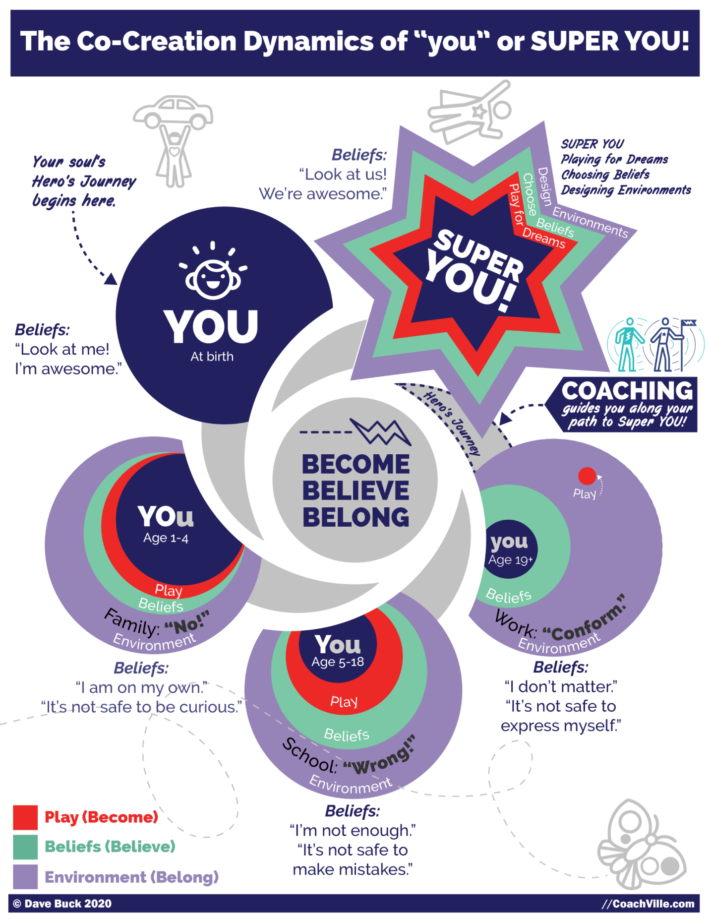
As a little person, your Urge to Become activates and you start to play. You play everything. As you play you grow… you become the next version of you day after day, month after month, year after year.
At the same time, as you play, your environment reacts to you and the Need to Belong kicks in… HARD. You naturally and automatically do whatever you feel you need to do to maintain belonging with the group (aka family) you are in.
When your environment reacts favorably to you, you come to believe that it is good and safe to do what you are doing and you do it more. If your environment reacts negatively to you, you come to believe that it is NOT safe to do what you are doing and you curtail it or stop completely.
The Capacity to Believe is extremely useful for learning how to get along in the world of people. You come to believe, for example, that people don’t like it when you throw a rock at your little sister; this belief is a good thing.
However, if for example, you are crawling around following your curiosity and a BIG person yells: “NO” and puts you into the isolation pen (for some reason it is called a “playpen”), you may come to believe that it is not safe to be curious; this is not such a good thing.
First at home, then in Industrial school and then in Industrial jobs, your Urge to Become through play moves you into life. And as you do this the environment reacts to you. When the reactions are unfavorable – which happened a lot in Industrial Hierarchical Control Culture - your need for belonging and status are threatened; this is called getting “in trouble”. As this happens you develop beliefs about yourself and life. Over time we come to believe a whole lot of things about ourselves that restrict access to our powers; the activities and expressions that we feel safe to do gets smaller and smaller.
As various aspects of YOU go into the “not safe to express” category in your beliefs, you become a smaller and smaller version of you. You come to FEAR your natural playfulness and your unique powers because at one time expressing them got you in trouble; AKA threatened your belonging.
Also notice in the diagram that as you move from home to school to jobs your playfulness gets smaller and smaller as does your access to your unique superpowers.
Fast forward to now and urge to play BIG for your Dream…
So, when you experience inner resistance or doubt or FEAR attempting to do the any of the needed activities of your dream – which are playful and need your unique superpowers – it is not because there is something wrong with you! It is simply because you are a human being who grew up in the Industrial Age and absorbed the Industrial Control Culture’s fear of play and unique personal power. These are the pivotal moments that you need to observe with judgment-free curiosity.
I believe that this process of losing our unique power as we grow up has been a part of the Human experience since the beginning of modern civilization. Most of the Hero’s Journey stories include the pattern of going out into the world, facing new challenges and discovering lost inner powers.
However, I also believe that the fear of playfulness and uniqueness was extreme in the Industrial Age of Control so most of us have become very small versions of our potential.
I also believe strongly that since all of these “don’t do it” beliefs were established in social situations (AKA belonging) we need to explore and uplevel them in a socially safe space. This is why 1-1 personal coaching is such a powerful force for personal growth.


Memory Pops
Social risk actions evoke social fears. Actually merely thinking about a social risk action will evoke social fear. And you will feel that fear somewhere in your body.
In Step #3 Feel the Energy in the Body, your coach asks you to feel into a physical sensation in your body. After you do this, your coach is going to ask you if anything came up for you.
Often while you are feeling body energy a memory will pop into your mind; probably a memory of a situation from home, friends, school or work.
About Memory Pops
VERY IMPORTANT: when we are small, LOTS of situations that seemed like trouble at the time are actually benign in the grand scheme of life. Also, common situations, like moving to a new home with your family, can create a lot of emotionally intense situations even if there was no real trouble.
Another important point about memory pops is that very often they reveal situations that were not really troubling, they were just strange or intense. These types of moments can also put our powers into shadows as well.
In Step #4 Scan for Body Beliefs, your coach is going to ask you a question: It is not safe for me to: {fill in the blank}.
This is another situation where you are not trying to think of an answer; you just allow the words to bubble up. When the words come it will be illuminate the self-preservation instinct and “the Pull” we spoke about in Chapter 2.
Often when body belief words are bubbling up, additional memories will pop up that will illuminate the situation.
The power of Safe Space with your Coach
The final point I want to make about memory pops is to encourage you to BE UNAFRAID of your memories; welcome them. Most memory pops are benign but revealing. The ones that are more intense you can feel safe exploring with your coach.
If the memory involves some “gory” details, you do not need to share them at all! Only share what you feel comfortable sharing. In fact the gory details are not needed for the method to work beautifully. Your coach only needs to know “the essence” of the situation to help guide you to freedom to reclaim your power.
You are not alone; that makes all the difference.
Talking About Memories Is Not “Therapy”
I need to bring this up because it often comes up around this topic: Talking about memories from your life is not “Psychotherapy”. Two humans talking together can talk about anything they choose to; you don’t need a “degree” to talk about memories.
Another important point here is that you and your coach are not “just talking” about memories. The memories that pop WHILE feeling energy in the body reveal clues that help you regain your power to play fully for your dreams. Everything we do in coaching is about playing for your dreams. That’s it.

The Treasure Map (in brief)
We will talk more about the concept that our fears are like a “treasure map” to our superpowers in the next chapter. The idea I want to share with you now is that every time in your life where you experienced some trouble (or trauma) when you were expressing your power or playfulness becomes an emotional memory that is stored in your body / Non-conscious Mind.
So there are hundreds or thousands of these emotionally intense memories in there that create the energy you feel when you contemplate a socially risky action to play for your dream. Each one has its own Body Belief / Fear; though they tend to have common themes.
Your non-conscious mind is the territory that the treasure map describes. In a safe space, these sensations reveal emotional memories that can provide clues on the treasure map that will lead to your lost Superpowers and Playfulness!

Your non-conscious mind is always ready.
(Energy Alignment Game)
Remember the Energy Alignment Game I shared with you in the Introduction.
In several chapters I will elaborate on one aspect of this “game” and connect it to what your Inner Freedom Coach is doing with you.
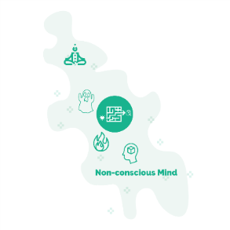
Your Non-conscious Mind is a big “blob” of everywhere power. Learning how to access, channel and align this power for your dream is an endless supply of fun!
In this model I am highlighting a few key elements:
Body Awareness: This is the ability to close your eyes, scan your body and notice the “energy”; often in the form of buzzing, pressure or tightness. This is also where insights and inner knowing come from. Another smart move is to care for your body so physical ailments are few and they are clearly distinguishable from Inner Knowing signals.
Fears: your fears aim to keep you safe. They are the “friendly ghost” that aims to scare you away from socially risky actions. With practice they can also guide you toward your lost unique superpowers and playfulness.
Desires: your hearts desires light your path when you learn to trust them and act on them. Your BIG Dream is one aspect of your hearts desires.
Beliefs: everything we believe we have absorbed from the world (and people) around us. While some of your beliefs are part of your conscious thinking process, most are embedded in your non-conscious where you are not aware of them. Your dream will require that you bring them into awareness and then uplevel a few and develop some new.
You will notice the symbol for the Inner Freedom Method (the heart energy finding a way through the maze out into the world) at the center of the Non-Conscious Mind Model. The Non-Conscious Mind IS the maze! It is also the territory of the Treasure Map where we will discover your playfulness and superpowers.
As you play for your BIG Dream your non-conscious energy, fears, desires and beliefs will come to light! You will have the opportunity to explore them in deep conversations with your Inner Freedom Coach; this is SOOO powerful. Then you and your Coach will co-create awareness of new choices and new possibilities. Power Up!

Tenacious Self Love!
I recommend you remove these phrases from your vocabulary
An important note: The experience of beliefs and fears limiting our ability to play big for our dream – which is a TOTALLY NATURAL HUMAN EXPERIENCE – has acquired a lot of blame and shame in the personal growth / self-help movement. This is not helpful! You have probably heard or said many of these things. I highly recommend you stop saying them about yourself or anyone else!
- You are sabotaging yourself,
- You can’t get out of your own way,
- You are a procrastinator,
- You have self-limiting beliefs,
- You have a gremlin inside of you
- Your EGO is causing your problems
- You need to crush your fear!
I flat out do NOT believe in self-sabotage nor any of these shaming concepts! You will not hear your coach use these judgmental phrases with you.
When you understand how these beliefs, doubts and fears got into you, it doesn’t seem right to shame them.
I believe in tenacious self-love! This is where we embrace our humanness with judgment-free awareness. We embrace all of our human experiences and see everything as included in our pursuit of our dreams.

The Freedom to Choose!
The big idea of Inner Freedom is the freedom to choose when you play BIG and when to play safe. It is not that one is good and one is bad as is always portrayed in the self-help world; BOTH are honorable! Your Big Dream is honorable. Your self-preservation beliefs, acquired through a lifetime of experiences, are honorable!
There is social risk and reward with almost every activity in your Dream. That is what play is all about! In any kind of play – but especially in sports - there are constant moments of choice where you evaluate risk and reward in the blink of an eye.
The big idea here is that if you are not aware that the choice is happening, the default choice is to play safe because your body and brain will prioritize safety over fulfillment.
As you continue to practice with your coach you will begin to sense your emerging freedom to choose how you want to play in any moment; and often playing BIG – and taking the risk – will be the clear and natural choice! That is when good things start happening for you... and the people you aim to contribute to.

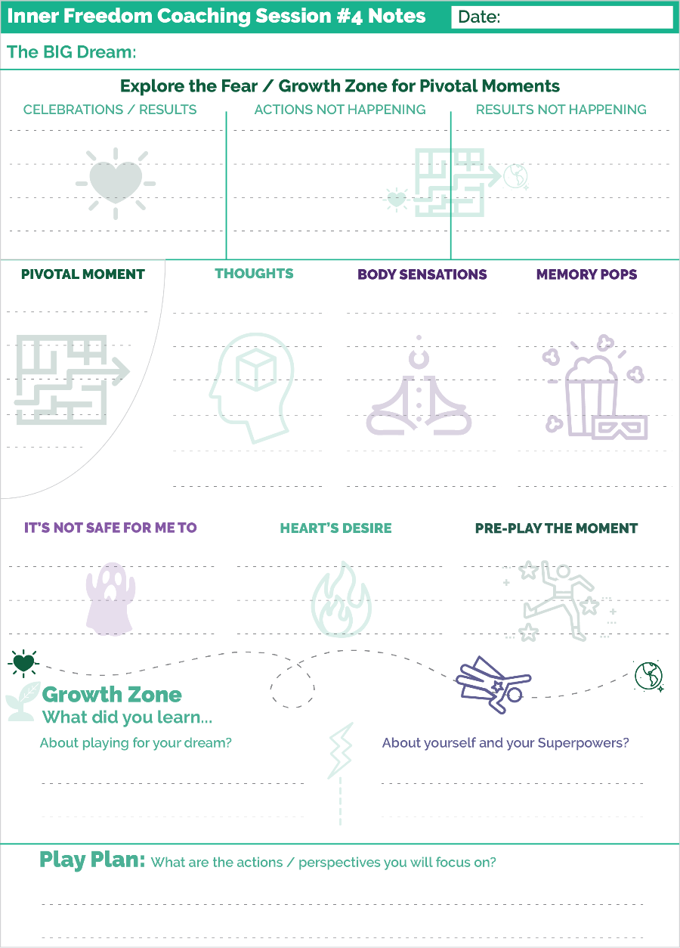
Prepare for Session #04 – Memory Pops
When you look at the playsheet you can see a new little section called Memory Pops with the popcorn icon.
Here are a few key points about the memory pop exercise.
ALLOW it, don’t force it.
One key that I can share with you about this exercise is to just allow a memory – usually as a picture or as a scene - to emerge into your mind. You don’t need to force it or try to think of it. In fact, trying to think of something will block the flow.
Often times it will start as a vague image.
Often it will seem like the image “has no relevance” to the current situation. HAH. Never underestimate the power of your Non-conscious mind. Trust that whatever is popping up has value; it is part of the treasure map.
This is about gently allowing the non-conscious awareness of the earlier moment to move into your conscious mind and imagination. We all have had many emotional experiences where we experienced trouble while expressing our power; or where we were attempting to use our power to help a situation and it didn’t work. These are the types of memories that will pop up when we feel the energy related to the social risks of playing for our dream.
Another key to this part of the method is to avoid predicting what the memory will be. Many people I have coached have a few stories of really troubling life experiences that they remember from time to time. The memories that “Pop Up” during inner freedom are rarely those moments.
You have a lifetime of memories in your non-conscious mind; They are ALL potentially part of the treasure map. Just allow the image of the memory to emerge into your conscious mind… don’t force it.
With judgment-free awareness, you and your coach can explore these moment in a way that is illuminating and fun.
We will get deeper into these fun explorations in the next few sessions.

**!!** {End of Player Playbook} **!!**

Coaching Notes for Session #04- Memory Pops!
In Session #4 we will go a little deeper into the “feeling the energy” experience.
Here is a chunk of the Coaching Guide that I want to explain because it’s a bit tricky.
The point of this is that by this session the player is probably having memory pops. If they are not… DON’T PANIC! But… you can dwell in the feeling part a little longer so that the player gets more comfortable with this exercise.
Here is the Coaching Guide:
**!!**
ASK: What was that experience like? Did anything come up for you?
{Listen for a moment}
{If your player has a "Memory Pop…}
SAY: If you want to, you can tell me about the essence of what happened without getting into the details. But you don’t need to.
{Dialogue as much as feels right.
You only need to get the essence of what happened from their perspective and not the details. Be sure not to get lost in the story AND IT IS ESSENTIAL to maintain judgment-free awareness toward the event and anyone else involved in the event.
Skip ahead to 4)
Otherwise… keep going
3c) Go Deeper
ASK: Do you feel that you are able to go a little deeper?
If yes, refocus them on the physical sensation;
Coach Note: Sometimes the physical sensation will move to another place in the body.
SAY: I will time you for another 30 seconds.
Encourage them gently – this is often a BIG moment for them.
**) Scan for Memory Pops
Feeling Layer
IMEDIATELY after feeling the energy the 2nd time.
ASK: When is the first time you can remember feeling this sensation in your body?
Wait patiently. This may take a few moments. Listen carefully.

**!!**
After you ask: “did anything come up for you”, give them plenty of time to respond. Memory pops seem strange at first.
If they do have a memory or an emotion, this is when you give them the time to share a little bit about it.
If they DON’T have anything come up, then you go to “3c” and invite them to re-locate the physical sensation and feel into it for another 30 seconds.
THEN…
You ask what we call: The Memory Pop Question.
ASK: When is the first time you can remember feeling this sensation in your body?
Then you WAIT.
This question has a high reliability of opening the pathway for a memory pop.
It is very important that you ask this question just this way. Again, this is not the time to improvise.
As we move forward, the Coaching Guides will evolve a little bit and we will go straight into the memory pop question right after they feel the energy.
Coaching Notes Playsheet
YES! Write a few notes on the Coaching Notes Playsheet. Keep doing this during or after every session.
This really helps as you move along through the program. You will be able to look back to get a quick recap of the Memory Pops your player has had; this will help you see patterns.

Inner Freedom Method Step 3&4: “Memory Pops”
First of all, I LOVE this icon for the memory pop experience!
This is an icon for the movie theatre with popcorn and 3D glasses.
The popcorn is a good symbol for memory pops, popping up during or after feeling the energy. The 3D glasses are the perfect symbol for the kind of moving images that flow into the imagination. Often they start out kind of fuzzy and slowly come into focus.
While you are doing steps #3 & #4 - There is a powerful step where you can explore with your player the source of this energy that they are feeling in their body.
Understanding memory pops
As you have practiced the Inner Freedom method of feeling a physical sensation in your body (as a player or a coach) over the past few weeks then you have probably experienced a “Memory Pop”. A Memory Pop is when a memory of a past event or experience “pops up” while feeling the energy in the body. This is a very common phenomenon because the buzzing energy in the body is connected to a past event.
As we go through life we experience events; some that involve us directly, others that we witness. Some events happen thousands of times like eating a meal. Some events happen rarely – like a parent or sibling dying. All events that we experience have energy but some have a lot more energy than others. Most events have little energy, so the energy easily flows through us like water flowing through a pipe. Some events are more energetically intense. The intensity of the event is relative to the size of your pipe (capacity to feel) at the time.
So, when you are small, and your capacity to feel is small a LOT of the events that you experience are too big for the pipe. When this happens the energy stays in the body rather than flowing through.
When we consider ALL of the confusing, dehumanizing, troubling and traumatizing situations we experience in compulsory education etc. – as detailed in the “Story of becoming you” model – you can see just how many of these energetic / body beliefs are in you. A LOT!
As a fellow coach I will tell you this profound thing: I have coached over 1,000 people, and almost every single one was suffering from self-doubt and had a belief that I would call: “It is not safe to be me”. Almost EVERY ONE. That points to a systemic failure of the Industrial Culture. OR if you are cynical: the profound success of the Industrial Culture to transform humans from Wild and FREE Co-Creators to subservient and obedient workers. This is something that you must understand as you coach your fellow Humans in pursuit of their dreams.
Any time an action or event happens in the present that is energetically similar to the past event, the place in the body where the energy was stored will “BUZZ”. This “BUZZING” energy is uncomfortable so most of the time we avoid activities, thoughts or even intentions that start up a buzzing energy.
THEN… we decide to play for a bigger dream in life and certain actions that start a buzzing energy can no longer be avoided. This is where YOU – the Coach – come in!
When you have your player feel the BUZZing energy VERY often the memory of a past – energetically similar – event will pop up into their conscious mind like a scene from a movie. And often your player will share this memory with you.
Most of the time, these events are benign – standard Industrial Culture - but every once in a while they will be rather traumatic. And of course what is seen as benign or traumatic is relative for both the player and the Coach. In any case, your role as the Coach is to be fully present without getting lost in your player’s emotions from the event. Also it is essential to NOT try to fix “the problem” or make it “OK”. JUST BE THERE; that is enough.

An example from my life:
In this example I use the phrasing that we now use in the Inner Freedom Method. This was not how I understood it at that time.
I was in my mid 30’s and growing my coaching business and my business coach recommended that I go to networking events to meet potential clients. I would look in the newspaper for upcoming events. I got the Chamber of Commerce event schedule. But I resisted going. My mind came up with lots of reasons NOT to go to networking events.
I had a successful coaching business, but definitely not because of networking! I got all of my clients by calling people I knew; and then from referrals from those people.
A few years later – still avoiding networking - I had a coaching colleague who did a form of energy work with me. I could feel the buzzing energy in my body when I simply THOUGHT about going to a networking event.
When I felt into this buzzing energy, I had a "memory pop" of my mom freaking out when I walked up to the stranger as a child.
The memory pop clarified in my mind over the next few days…
At age 4 my mom lets me play in the yard and says: “don't talk to strangers”; one day I was out there playing and an interesting looking person was walking by. I wanted to play with them so I ran over and started talking to them.
My Mom FREAKED OUT!!
She came running off the porch and grabbed me. This felt REALLY bad and it was very confusing; I love people, why is my mom yelling and getting upset? This is way too much energy to handle so I started crying and then my mom freaks out even more. The emotional energy of this experience got stored in my body.
My mom was just being a good Industrial Age mom! But to my 4 year old self it was troubling.
As a child, at a non-conscious level I formed the belief: it is not safe for me to talk to strangers (because my mom freaks out). This became a “social safety instinct / body belief” to avoid trouble with mom by avoiding strangers.
And this belief served me well when I was a child by keeping my mom from freaking out.
Later, I figured out that it was the buzzing energy in my body that had my mind come up with hundreds of unique and creative reasons why I could not go to networking events. It seemed like every event I planned to attend, there was a new reason why I couldn’t go.
Buzzing energy sparked reactive ~ avoid social risk ~ thoughts.
These thoughts were coming from a belief that was preserving belonging with my mom.
This was a big insight for me:
My conscious mind thinks self-preservation thoughts that will justify my body’s experience AND keep me safe from social risk.
It starts with an uncomfortable physical sensation in the body;
If I resist it, my mind will start to justify why that feeling is true – Networking is a social risk.
But when I felt into the energy and allowed it to be there, my body calmed down and going to networking events at least became do-able. NOT easy by any stretch.
Inside the event, I still didn’t go up to anyone (AKA Strangers) to talk. But eventually people came up to me and I got to meet people that way. Whew!
A quick recap:
- So I make a play plan to go to a networking event to meet new people and move forward in my BIG dream! YES! That is a great idea.
- THINKING about networking with strangers is energetically similar to what happened when I was 4 years old and my freaked ou.
- My body started to buzz with energy which was uncomfortable.
- I didn’t pay too much attention to the buzzing but I suddenly “feel” that going to a networking event is a bad idea – even dangerous.
- Then my mind – which prioritizes social safety and preserving the belonging I have (with my mom) – starts to “think” a lot of thoughts that justify NOT going to the event; while just moments before I thought was a great idea.
Thoughts like:
“Oh, I can’t go that night, my favorite TV show is on.” Or
“I can’t go to that networking event, my business cards don’t have a nice logo”
- Basically, in the presence of this “feeling of social risk” my mind will go to great lengths to create thoughts – even ones that don’t really make sense– to justify the feeling and avoid the danger.
- Remember, going to the event was perfectly aligned with my play plan, it made logical sense to go. But the fear was stronger energy than logic.
OUR Conscious Minds #1 job when the body does not feel safe: avoid social risk and preserve what is.

The “memory pop”.question
{There are 2 versions in the Coaching Guide #4}
A quick point of emphasis here about something I covered in the Coaching Notes.
We ease into memory pops with the player over the first few sessions.
The Player Prep Audios will really help your player acclimate.
In the first few sessions we have them scan for energy and feel into it.
Then we just ask: “Did anything come up for you?”
Then in session 4 we have the option to go a little deeper if they don’t have a memory pop.
We have them feel into the energy for another 30 seconds.
Then we use what I call the “Memory Pop” question because it facilitates the player having a memory pop almost every time.
ASK: When was the first time you remember feeling this energy in your body?
It is important that you use this phrase exactly this way. Don’t vary it in any way. I have tested many ways of saying this question and this is by far the most effective. Many ways of saying it actually prevent the memory pop from happening.
After you ask this, the key is to wait with presence!
A memory pop will usually happen.
VERY often they will say something like: I don’t remember anything.
Just stay quiet!
VERY often after a few more moments they will start to describe a scene. But the first few times they will say something about: “this doesn’t make sense, but this is what is coming up”.
Just stay with them as they talk it out.
You can tell them: “Only share with me the details that you feel comfortable sharing”.
If no memory pops up,
ASK: Did you notice any emotions coming up while you were feeling this energy?
Often sharing emotions will also lead to a memory pop.
But if it doesn’t it is OK!
Next we talk about the body belief.
From feeling the energy and speaking the body belief they will have enough clarity and safety to move on to the next step.

Allow the images to emerge
This point is more for you as a player.
When your partner coach asks you the memory pop question, just allow images to emerge into your mind.
The key is to not attempt to explain or justify what is coming up. Just allow it in.
Once you do this a few times, it will be easier for you to guide your players through the experience.

Giving Voice to feelings, body beliefs and social fears
Encourage them to share whatever they feel comfortable sharing.
Be there for what they want to share.
As the coach… you don’t need the details! (but they want to share them…)
… you only need the essence.

How much to talk about
Exploring memory pops and connecting the dots to the present situation is deeply fascinating and satisfying!
However, it is best to ease into these conversations.
That is why the coaching guides don’t get into this at all until session 5 or 6.
But guiding your player to feel energy and have a memory pop and then just allow them to share a few details without getting into the depths of it, you create a bond of trust.
Remember…
IF it was a traumatic event…
It’s NOT therapy ~ just because it’s from the past and intense; two people can talk about anything they both choose to talk about.
When you DON’T try to fix it, or even soothe it, but just acknowledge that you hear them, it creates the safety to explore what their Dream wants them to do next.
Be careful not to judge the other parties in any story your player shares, even though this is hard sometimes.
Be careful not to judge your player if they share a story about hurting someone or making a mistake that caused another person to hurt.
To be a great Life Coach, you need to be able to embrace ALL of the human experience; which can be tragic sometimes.

The Power of Presence – it takes 2!
I think it is important to remember that when you feel belonging with another person, your non-conscious mind is just as energized by your dream as it is in preserving social safety.
This is why the Inner Freedom Method is a coaching method and NOT a do-it-yourself method. AND why it is SOOOO valuable in the world.
The power of Coaching Presence to create a safe space while feeling energy in the body is transformational.
You learned social fear and risk in the presence of others… to develop into a new version of you, you need the presence of at least one other person.
Profound Belonging is the antidote to the social safety instinct!

Class 04 Prep
We will explore a few of these questions in class.
BIG Group: Sharing experiences of Inner Freedom

Question: Share your Pivotal Moments as an epic human adventure: the PULL between your Dream and your Social Safety Instinct. (give it some drama!)

Question: Share an experience of a Memory Pop

Question: What is the benefit of expanding your Capacity to FEEL?

Chapter 5 – Explore the Superpower

“I never let school interfere with my education.”
- Mark Twain

Chapter 5 Prep
Before Class
Read through the complete coaching guide for Session 5 (Page 36)
(this is a link to the PDF with the complete set of coaching guides)
Listen to this audio to prepare for Session 5.
(this is a link to the Player Prep SoundCloud audio)
Listen to Coaching Demo of Session 5
(Coach Dave and Player Leanne)
Playsheet Pack: Print 2 copies of page 10

{From the Player Playbook}

Session #05) Explore the Superpower Potential
In this chapter we are going to dive into 3 important topics.
1) Role Play a pivotal conversation. Ideas for conversations to role play.
2) How to explore your fears as a treasure map to your superpowers. (I know you have been wondering about this!)
3) Inner Freedom Step #5: Explore the Superpower Potential
Let’s go!!

Role Play the Pivotal Conversation
Coaching is about practicing moments to help you play better!
In Inner Freedom we practice together in 2 ways.
1) Playing with a moment using your imagination. This is called the Pivotal Moment Technique (we have been doing this in the last few sessions).
2) Playing with a conversation by role playing.
A Pivotal Conversation is one where you are relating for influence:
- You might face the fear of rejection
- You might face some inner resistance or hold something back;
- You fear you may lose your clarity of words.
- You doubt that you will be able to create the influence that you desire.
On the next page is the model for the Role Play Technique.

The Role Play Technique
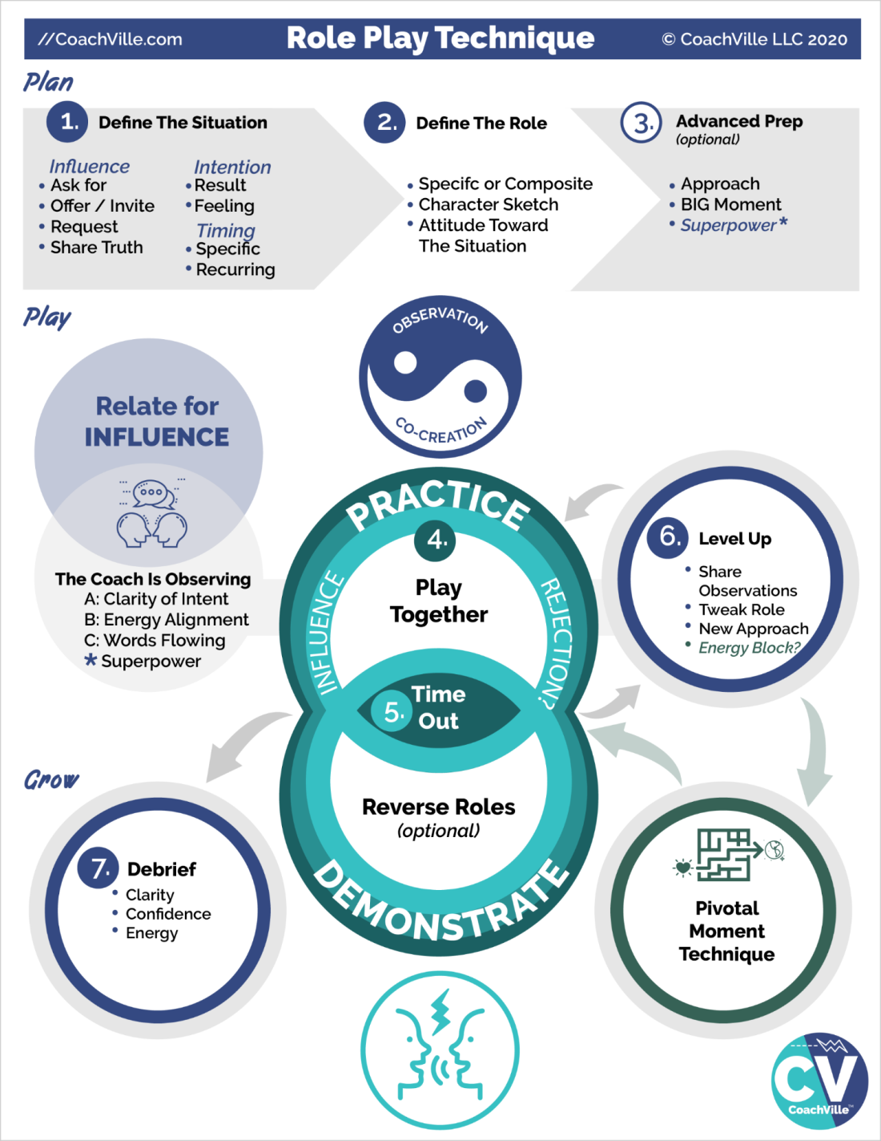
To do a great role play only takes a few minutes.
The role play is where the coach plays the role of the person the player needs to talk with. It could be a specific person. Or it could be a “typical” person for a recurring activity.
Observation ~ Co-Creation
This is on the model to remind you that this is the centerpiece of the coaching relationship and that Role Play is a great way to bring this framework to a coaching session.
Relate for Influence
Coach: while you are co-creating the scenario with your player and then practicing with your player you are also OBSERVING your player.
Your Coach is observing:
A) Clarity of Intent – your coach will listen for how clearly you are moving toward your intention.
B) Energy Alignment – while you are playing in the conversation your coach will pay attention to the feelings that they notice.
C) Words Flowing – The words that you speak are mostly effected by your clarity of intent and flow of energy. Yet, sometimes there are better ways to say things that your coach can suggest after a time out.
*) Superpower – This is a subtlety of advanced coaching. If you want to practice a particular Superpower for Influence – which is awesome – then your coach can notice when you use it or AVOID using it.
PLAN
In steps 1,2 and 3 you are sharing just a few details so that your coach can play the scene with a fair degree of authenticity. It is play so it does not need to be perfect or exactly accurate; just close enough for you to “get into the moment” with your coach.
1) Define the situation
What is the influence you are playing for?
- Ask for something
- Offer something they want them to accept
- Invite them to do something they want them to say yes
- Request for support; for an action; for a change
- Share a truth; something they want to say and want to be heard
What is the intention?
- What is the result you are playing for? What do you want the other person to do? How do you want the other person to feel?
- What is the situation? : Is this a one-time situation with a specific person or is this a recurring situation with a type of person.
- Usually there is something you want the other person to say “Yes” to and commit to an action.
2) Define the “Role”
Is this a specific person or composite of a typical person?
Character sketch: what are their essential qualities?
Attitude: what is their likely point of view about the situation?
Note: To play the role of another person, your coach will not change their voice. They can sound like themselves and still play the role.
3) Advanced Prep
If you have plenty of time you can explore these before jumping into practice.
What is your approach to the conversation? How are you going to authentically move them toward the “Yes” you are playing for?
In the conversation, what is the big moment? Your coach can steer the scene toward this moment.
What is the Superpower you want to practice while you are in the role play?
Through practice you can become the next version of Super YOU!
PLAY
4) Play together
Just jump into the role and play. Don’t think about it too much or worry about if you are doing it right! Truly… the more you allow yourself to co-create in the flow, the better the practice will be.
5) Call time out!
Either the coach or the player can call time out to end the scene.
6) Level Up
Talk it over for a few moments.
A) Share observations. What did you FEEL is the most important thing to share because that is the part that will most impact your results; AND that you can explore using the Pivotal Moment technique.
B) Tell your coach if they need to tweak how they are playing the Role in any way?
C) New approach of experiment? Sometimes you will immediately know that you want to try it again a different way. Sometimes your coach will share a few ideas and co-create a new approach with you.
Pivotal Moment
This is what we are doing in this session. See… you are already receiving advanced coaching!!
Play Again
4) After exploring the energy with the Pivotal Moment technique you will jump back into the role play and play again… or a few more times.
Advanced Technique… Reverse Role Play
Reverse Role Play is where the coach plays the role of the player and the player plays the role of the person they are going to talk to.
This can be really powerful for 2 reasons.
1) It gives you – the coach - the opportunity to demonstrate a new way for the player to approach the situation; demonstrating new ways is a classic coaching move.
2) It gives your player the opportunity to put themselves into the perspective and mindset of the person they want to talk to. By “stepping into their shoes” and playing as them, they start to imagine new ways to approach them.
Grow
7) Debrief
Talking together about the role play and pivotal moment experience is an excellent opportunity to capture growth.
Look back on the practice and highlight the three ways to play better while relating for influence:
- Clarity of intent
- Confidence in how the words are flowing
- Energy alignment
It is powerful to experience growth in real time!

BIG LIST of Relate for Influence conversations to practice

The more you study the Dreams of life, like personal growth, business, leadership or romance, the more you realize that communication / relating is the primary activity. Playing for a dream is mostly about talking to other people and relating for influence!
Relating well has MANY underlying factors like clarity of intention, being present, really listening and sharing authentically.
So a BIG part of your coach using Role Play with you is helping you become a skilled relator for influence through practice. In most dreams there are MANY distinct conversations – where social reward and risk are involved - that you can identify, observe and then practice.
Each unique type of conversation is a different skill
The key to a good role play is to hone in on:
A) A very specific conversational skill
OR
B) A very specific conversation situation
Examples of distinct conversation (Skills):
- Make a request for support
- Ask for something
- Make an offer to do or share something
- Ask another person to change their behavior in a positive way
- Introduce yourself in a way that sparks deeper conversation
- Invite someone to an experience with you
- Invite someone to hire you for something AKA discuss the money!
Examples of specific conversation situations:
- I want to ask my boss for the opportunity to lead the next project.
  - I want to call Bill from the Chamber of Commerce and suggest that I give a talk at a meeting
  - I want to reach out to Sally and let her know that I want to be a part of the community leadership team.
There are so many possibilities!!!

Relate for Influence: Practice together to play better
Let’s make the connection between role playing a pivotal conversation and Social Play activity number 1: Relate for Influence.
When you raise your game in “pivotal conversations” a LOT of big things can happen for you. When someone agrees to hire you, buy from you, participate with you, join your team, advocate for you or support you in a big way, your dream can really take off.
Practicing pivotal conversations with your coach can really pay off for you because it can help you uplevel ALL of the elements that lead to a “yes”.
Here are the elements that lead to YES, in order of importance:
1) Clarity of intent
2) Alignment and flow of energy
3) Flow of your words + listening from the heart
4) Use your Superpowers for Influence (once you have them unleashed)
You might be surprised to see that “flow of words” is 3rd. YES they are ALL important. But in terms of influence the flow of words is less than clarity and alignment. You know this because you have had many big conversations in your life where you rehearsed the words in your head a hundred times but then in the moment those words didn’t come out the way you envisioned.
1) The first benefit of practicing with your coach is to clearly state your intent. Knowing exactly what you want in the conversation and why you want it is the most important thing. Your coach can help you gain this level of clarity.
2) The next one is alignment and flow of energy. This speaks to the 95% vs. 5% idea I shared with you in the Introduction. When you are talking with someone they feel your energy WAY more than they hear your words. Your energy is what moves them – or not - most of the time.
When you role play with your coach, the MAIN thing they are observing is your energy. And this is the big benefit of practicing with your Inner Freedom Coach. By using the method together you can uplevel your energy into alignment with your dream.
3) The words will flow. Sure there may be a few key phrases that you want to plan and practice. However, the path to success is to get the first three items elevated so that you can trust yourself to speak from the heart.
After a few experiences of practicing pivotal conversations with your coach and then playing for your dream out in the world… you will realize that having an Inner Freedom Coach is an amazing investment that pays dividends!
While you are speaking from the heart, you also need to listen from the heart. Being present and really hearing the other person will improve your heartfelt flow of words. This takes practice!! In deeper and more extensive role plays your coach can help you improve in this skill.
4) We all have a unique way of relating for influence. And as we have discussed often, many of our powers were squashed earlier in life… but especially when it comes to playing for yes. I have coached many people that have been shut down to the point where they are terrified to ask for anything. So this kind of situation is definitely an opportunity to explore for your lost power.
The great thing about role playing is that you can practice using your power in a safe space and build confidence to the point where you feel really good about being yourself and expressing what you really want or need to say.

Super YOU (Energy Alignment Game)
“A Superpower = A unique ability that you can practice
until it is capable of making a BIG IMPACT”

Inherent to the desire to pursue a BIG dream is the requirement to become the next version of you; which means developing your Superpowers. So Fun!!
The flying person wearing the star is the symbol of expressing unique power in the world to have a positive impact on situations and for the good of others.
This includes expanding your mastery of abilities that you have already expressed. AND it also includes discovering and unleashing aspects of you that have become hidden in shadows of social fear while you adapted to the environments of your life so far.
This discovery process is baked into the wisdom of your BIG Dream!
You will identify your Superpower potential by exploring actions in the world required to play for your dream and noticing the social fears that you experience. Using the Inner Freedom Method your coach can help you find the unique energies hidden behind your social fears.
Then, you will practice bringing Super YOU into the actions and situations of your dream. AND, during a role play you can practice the situation while specifically expressing one of your newly discovered superpowers.
SOOOOO GOOOOOOD!!!!


Step #5: Explore the Superpower Potential
Understanding the nature of the treasure map gives us a foundation to explore Inner Freedom Step #5. You are playing with a Pivotal Moment where you experience the Pull. You have the moment alive in your imagination; you notice your thoughts, you feel the energy in your body.
Often while feeling the energy or shortly after you will have a memory pop of an earlier event in your life. You now know how that emotionally intense memory got in you!!
Your coach will ask you to explore the body belief: It’s not safe for me to: {fill in the blank}.
This gives language to the feeling. Just let the words pop up; don’t try to “think” of the words.
Step #5 is to explore both the memory pop and the social safety instinct / preservation body belief to look for clues about the power or playfulness that you were expressing or trying to express in that moment.
Clues from the memory pop
- What was going on?
- What were you doing?
- Someone didn’t like your behavior or attitude; what didn’t they like?
- If you were trying really hard to help someone or improve a bad situation, what were you trying to do?
Don’t expect crystal clear answers from this exploration; though sometimes that will happen. Most of the time you will have a feeling about it and the clarity will come later.
In the next section I will introduce you to a more detailed version of the Superpower playsheet we used in Chapter 1. There are a lot of provocative words and phrases for Superpowers for change. Often by scanning this page after a session a phrase will jump out at you to articulate the power you were using or trying to use in that moment.
It’s fun!

Detailed Superpower Playsheet
In Chapter 1, I shared a playsheet with 64 Superpowers for change listed on it. I encouraged you to read it over and pick out a few Superpowers that you want to “become” in the next version of you.
Now that you know more about your dream, more about YOU and more about how you came to fear your most unique powers…. Let’s take a deeper look at this list. On the next page is the 64 Superpowers for Change again; as I shared before, it is loosely based on the “I-Ching” (Book of Changes).
There are a few ways to use this chart.
1) Read it over a few times to look for the unique powers you are noticing within you AND your Dream needs you to develop them and express them NOW.
2) Look at it after each session to see if there is a Superpower that relates to the pivotal moment or memory pop you just explored; feel into the earlier experience. You were expressing SOMETHING. What was it? Look at this page of superpowers to find a phrase that resonates with you.
3) Read it over and while thinking of each of the 4 areas of Social Play:
- You have Relate for Influence Superpowers
- You have Create for Expression (to share) Superpowers
- You have Explore for Visibility Superpowers
- You have Experiment for Change Superpowers
Look for them on this page!
Feel free to mix and match words and phrases to create the phrase that really feels true for you.

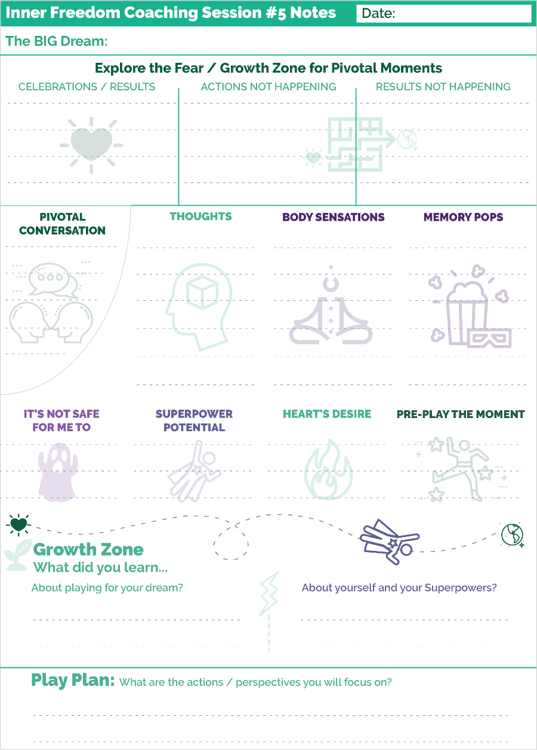
Prepare for Session #5 – Superpower Potential
Whew! This chapter had a lot to offer.
Let’s do a quick walk through of the Coaching Notes sheet and notice a few new elements from what we have seen so far.
1) Where the Pivotal Moment section usually is, we now see a Pivotal Conversation. This is a special subtopic of a Pivotal Moment where we start with a Role Play.
AWWW Yeah.
Here is how it works. Usually in Step #1 you play a moment in your imagination. Here you will play the moment with your coach in a role play. Then Steps #2, #3, #4 and #8 are the same as you have done before. For Step #9 rather than preplaying the scene in your imagination, you jump back into the role play conversation with your coach.
You will be amazed at how different it feels and sounds the second time!
And you will likely feel empowered to take the risk – whatever the conversation was – soon after the session.
2) You see a new section for Step #5: Explore Superpower Potential.
This will be a regular part of each coaching session moving forward. Now that you have some comfort level with the basic steps of the Inner Freedom Method it is time to start exploring the treasure map for your lost powers.
There are a few points I want to share here:
1) The main benefit of the Inner Freedom Method is that actions that seemed hard or scary for some reason just become easy. Often results that were not happening just start happening. This experience often comes down to you expressing your playfulness and power in a new way. You may not necessarily be able to NAME the power; it just happens.
2) I have shared with you a few tools to help you give names to these powers. It’s a fun exercise AND when you can name it, you can own it. You can practice it and use it intentionally.
3) When you are exploring a Pivotal Moment with your coach you may not be able to name the power while you are in the session. But if you scan the Superpower Playsheet after the session, something will jump out at you. Or you might find yourself expressing that power again naturally – now that it is unleashed – and after a few times you will be able to name what it is.
The most important thing is to keep playing. Enjoy your adventure. Enjoy your emerging freedom to express your power.

**!!** {End of Player Playbook} **!!**

Coaching Notes for Session #05= Role Play + Inner Freedom
In this session we will do a Role Play for the first time in the series.
And we will start the exploration for Superpowers for the first time as well.
There is no connection between these 2 events! It just worked out this way in the flow of learning the method step by step..
Using Role Play plus Inner Freedom is such a great way to coach and I want to get you into it. BUT we needed enough comfort with the player and the method to do this kind of growth oriented practice.

Here is a quick outline of how you combine them.
a) Step 0: Choose a Pivotal Conversation to Role Play
b) Step 1: Replace the Preplay with a Role Play
c) Call time-out in the Role Play
d) Go into detail in steps 2, 3, 4: Review reactions with judgment free awareness; Feel the energy in the body; Explore memory pops; Name the body belief
e) A brief exploration of step #: 5: Look for hidden superpowers
f) Go quickly through step #8: Make your mind the ally of your Dream (create Dream language)
g) Replace step #9 Preplay with another Role Play
Here you want to help the player really step into their new confidence and clarity.
If you have time, you can challenge them to practice playfully expressing / BEING a superpower. Encourage them to use their imagination to express what their dream wants in new ways.
A little tweak in the Memory Pop Section
You will notice this section in the Coaching Guide when the player does not have a memory pop after feeling the energy
**!!**
** If it feels right to you… Invite them to feel into the energy for 30 more seconds
ASK: Did anything come up for you?
**!!**
Often dwelling in the energy for another 30 seconds will create enough “safe space” for the non-conscious mind to reveal an image.
If it does, explore it briefly.
If it doesn’t, act like everything is going perfectly (because it is) and move on to Step #4.

Step #5 Explore for Superpower Potential
This is the treasure map!!
There are two versions of this step: one if they have a memory pop, the other if they don’t have one.
If they do have a memory pop it is much more of an exploration.
- You get the essence of what happened in the earlier moment.
- You see if there is something obvious that they were expressing at the time… that somehow contributed to the trouble.
- You don’t want to go digging too deep if it was a really troubling event. BUT most of the time it will be “routine Industrial Age Trouble”; basically getting in trouble for being your SELF; Or trying to use your power to help and it didn’t work.
- You use your imagination to and curiosity to put the pieces together and share with the player what they are seeing. Usually people have a hard time seeing that they were expressing some unique power when the trouble happened.
If they don’t have a memory pop it is more of a “best guess” exercise.
- You start with the voice of the body belief: It’s not safe for me to… (fill in the blank);
- Often from that social fear you can make an educated guess about the Superpower or playfulness they were expressing.
- Sometimes when you ask the question… the voice of the body belief and the wondering about the superpower will actually cause a memory pop!
Either way… it is important to NOT get stuck on this part. If it doesn’t come into clarity within a few minutes, just leave it as an open question and move on to the next step.
Very often, this is more of a seed planting exercise and an insight will pop into your players mind in the next few days.
Also, by exploring this question regularly over the next 6 sessions, your players will start to see their memory pops through this lens.
Coaching Notes Playsheet
YES! Write a few notes on the Coaching Notes Playsheet. Keep doing this during or after every session.
This really helps as you move along through the program. You will be able to look back to get a quick recap of the Memory Pops your player has had; this will help you see patterns.

The Transformation Potential in Role Playing
Practice Together
As Life Coaches we must find creative ways to bring the “Practice experience” to our coaching sessions. For one reason: this is what coaching is. For a second reason, we don’t want Life coaching to resemble talk therapy or counseling! So we need to bring the “play together / practice together” energy to what we are doing!
Role Play is the most clear and obvious way to get into a playful practice of an experience that goes way beyond “talking”. AND it gives you an opportunity to do a second coaching essential: observe your player at play and share what you observe; this is one important way to see your players hidden superpowers.
Relating back to the four pivotal moments of social play, Relate for Influence while facing the risk of Rejection is the one we can practice with a role play to spark development.
Pivotal Moments of choice – the core of the Inner Freedom Method – is a way to play together with a situation in the players’ imagination as if you were a coach and player watching a performance “video” to find ways to perform better.
Part of your opportunity as a coach is to create your own signature “Practice” experiences that take you and your player way beyond “just talking”. When the spirit of play and co-creation are close at hand, you are on the path!
Thoughts about Role Play
Doing a role play can feel uncomfortable for both coach AND player but when you understand the power of it, it is well worth both of you expanding into the growth zones.
The bottom line is that playing for a big dream requires practice. Doing a role play allows you, the coach, to “observe” your player in action and get a much better idea of their capabilities as a player. And it allows the player to build confidence in their abilities as a relator; especially in a conversation for influence where they feel the risk of rejection.
Going Deeper Into the Role Play Technique
Let’s go a little deeper into the Role Play Technique and Model. Here are a few thoughts beyond what I included in the Player Playbook.
The role play is where the coach plays the role of the person the player needs to talk with. It could be a specific person. Or it could be a “typical” person for a recurring activity.
Observation ~ Co-Creation
This is on the model to remind you that this is the centerpiece of the coaching relationship and that Role Play is the premium way to bring this framework to a coaching session.
Relate for Influence
Coach: while you are co-creating the scenario with your player and then practicing with your player you are also OBSERVING your player.
You are observing:
A) Clarity of Intent – listen carefully as they define the scenario and then in the role play assess how clearly they are moving toward their intention.
B) Energy Alignment – while you are playing in the conversation is it vital that you pay attention to the feelings that you notice within your Self and feel coming from them.
C) Words Flowing – The words that someone speaks are mostly effected by their clarity of intent and flow of energy. Yet, sometimes there are better ways to say things that you can suggest after a time out.
*) Superpower – This is the advanced coaching of Inner Freedom. If the player wants to practice a particular Superpower for Influence – which is awesome – then be prepared to notice when they use it or AVOID using it.
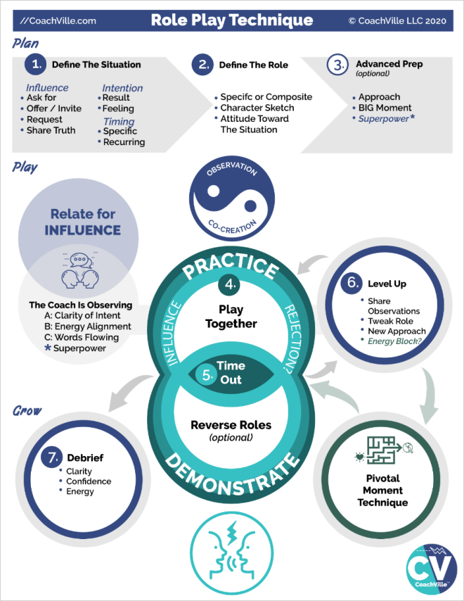
PLAN
Notice the Plan – Play – Grow sequence within the Role Play Technique. It’s a pattern!
In steps 1,2 and 3 you are getting just a few details so that you can play the scene with a fair degree of authenticity. It is play so it does not need to be perfect or exactly accurate; just close enough for your player to “get into the moment” with you.
1) Define the situation
What is the influence they are playing for?
- Ask for something
- Offer something they want them to accept
- Invite them to do something they want them to say yes
- Request for support; for an action; for a change
- Share a truth; something they want to say and want to be heard
What is the intention?
- What is the result they are playing for? What do they want the other person to do? How do they want the other person to feel?
- What is the situation? : Is this a one-time situation with a specific person or is this a recurring situation with a type of person.
- Usually there is something they want the other person to say “Yes” to and commit to an action.
2) Define the “Role”
Is this a specific person or composite of a typical person?
Character sketch: what are their essential qualities?
Attitude: what is their likely point of view about the situation?
Note: To play the role of another person, you do not have to change your voice. You can sound like yourself and still play the role.
3) Advanced Prep
If you have plenty of time you can explore these before jumping into practice.
What is your approach to the conversation? How are you going to authentically move them toward the “Yes” you are playing for?
In the conversation, what is the big moment for the player? As the coach you can steer the scene toward this moment.
PLAY
4) Play together
Just jump into the role and play. Allow the character you are playing to come through you. Don’t think about it too much or worry about if you are doing it right! Truly… the more you allow yourself to co-create in the flow, the better the practice will be for your player.
The first time you play the scene, “play it straight”. In other words, use a light touch and allow your player to do their thing so you can observe them.
When you get to a second time in the scene or more you can add different twists to challenge your player.
5) Call time out!
Either the coach or the player can call time out to end the scene.
*) Pivotal Moment Technique / Inner Freedom
If you, or the player, notice that the player is experiencing resistance, confusion, doubt etc. in the conversation, this is the ideal moment to explore with the Inner Freedom Method.
6) Level Up
Talk it over for a few moments.
A) Share observations. What did you FEEL is the most important thing to share because that is the part they don’t know about.
B) Ask your player if you need to tweak how you are playing the Role in any way?
C) New approach of experiment? Sometimes the player will immediately know that they want to try it again a different way. Sometimes you will need to share a few ideas and co-create a new approach with them.
Play Again
4) Repeat as many times as necessary until you feel your player has confidence for the conversation.
As you and your player get more confident in this type of practice, YOU can really push the growth opportunities by bringing more challenge to the role play scenarios.
Advanced Technique… Reverse Role Play
Reverse Role Play is where the coach plays the role of the player and the player plays the role of the person they are going to talk to.
This can be really powerful for 2 reasons.
1) It gives you – the coach - the opportunity to demonstrate a new way for the player to approach the situation; demonstrating new ways is a classic coaching move.
2) It gives your player the opportunity to put themselves into the perspective and mindset of the person they want to talk to. By “stepping into their shoes” and playing as them, they start to imagine new ways to approach them.
GROW
7) Debrief
Practicing a conversation like this is very empowering for the player. And it an experience of real coaching because the player will grow in clarity, confidence and energy alignment WHILE you are practicing with them. It is important to capture this growth after the practice time. It will propel them out into the world to play what you practiced.
TRANSFORMATION: Here we are doing just one role play. My hope is that your player hires you for a very long time and you do MANY role plays together. This will create a powerful coaching path to deep playful growth. YES!

Step #5 Explore the Superpower Potential
I will probably share this point with you in a few different places: ALWAYS remember: people don’t know what their superpowers are!
As you observe your player, be generous and share what you see. Being able to see qualities in the people you coach, and then articulate them, is an advanced coaching skill that takes practice.
I recommend you read over the 64 Superpowers of change sheet on a regular basis and get comfortable with these phrases… and any other collection of unique qualities. (Gallop Strength Finder and UPenn Via Character are also good examples).
With regard to using these assessments with your players, I am very cautious about these tests because most people don’t see themselves clearly enough to answer the questions. This is a big human question called: how do we come to know ourselves? What we think about ourselves is a mashup of who we are and what we see reflected to us from our environments over time. This can be like a funhouse mirror sometimes!!
So what this means is, when you get into these conversations, often YOU will have to share an observation to spark awareness of the players unique power or playfulness.
THE Best way for someone to become aware of their superpowers is to play alongside someone who can share what they OBSERVE. AKA COACHING!
My awareness of my unique qualities comes more from things Thomas (my coach and friend Thomas Leonard) told me than from any assessment where I answered questions; and I have done dozens of these things.
So for your players… it’s up to YOU to really SEE them. Trust that you will bring better clarity than the “funhouse” mirror!
You can do it… and it can be life changing for your players.
When do you SEE them:
- While co-creating clarity by talking with your player about their actions, results and challenges
- While exploring pivotal moments together
- While role playing together!
- While connecting in between sessions
All the awesome stuff we are doing in Inner Freedom Coaching.
A quick few notes about self-assessment tests
As a related side note: In addition to my caution with self-assessments, I do not use assessments where you take a test with lots of questions and the result is that you are a certain type in a box. This type of statistical sampling is highly unreliable in predicting human qualities! (hah! That is an understatement)
Assessment tests that reveal your preferences or qualities, based on your answers, can be helpful as a starting point… NOT as the ultimate answer to who you are. Like I said earlier, the caveat is that the person needs enough self-awareness to answer the questions. Most people answer based on who they think they are supposed to be.
Energy Alignment Game = Super YOU!
Here is a quick recap of how you coach the player to become Super YOU!
- Help them see their unique abilities.. as you practice with them.
- You need to SEE your player! And share what you see.
- PRACTICE with them and encourage them to use these abilities in Role Play.
- Encourage them to incorporate these abilities playfully in their Play Plans.
- Then debrief with them about what happened when they used their Superpowers.
Voila! Life Coaching. ;-)

Class 05 Prep
We will explore a few of these questions in class.
BIG Group: Sharing experiences of Inner Freedom

Question: What Superpowers have you discovered within yourself?
Within your players? Share an example.

Question: During a role play, what are you observing?

Question: What conversation are YOU going to practice?

Chapter 6 – Find the Perfection in the Situation

‘One way of looking at life is to believe that everything happens for a perfectly good reason, even if we cannot always see or know that reason within our own lifetime. The point here is to look for and find how a player's event, problem, situation or trait is perfect, even if it's clearly not. Seeking to understand and recognizing perfection first, instead of offering tips, techniques and solutions as a knee-jerk reaction, is what the Great Coach does naturally.”
- Thomas Leonard

Chapter 6 Prep
Before Class
Read through the complete coaching guide for Session 6 (Page 44)
(this is a link to the PDF with the complete set of coaching guides)
Listen to this audio to prepare for Session 6.
(this is a link to the Player Prep SoundCloud audio)
Listen to Coaching Demo of Session 6
(Coach Dave and Player Leanne)
Playsheet Pack: Print 2 copies of page 11

{From the Player Playbook}

Session #06) Find the Perfection
And the Supermind Layer
In this chapter we start our transition into the deeper parts of the Inner Freedom method.
1) We will explore the Supermind Connection which is part of the Energy Alignment Game.
2) Your Fears are a Treasure Map to your Superpowers… the details.
3) Step #6 Find the Perfection in the Situation
4) A Coaching Proficiency called: Recognize the Perfection in Every Situation

Remember the Energy Alignment Game
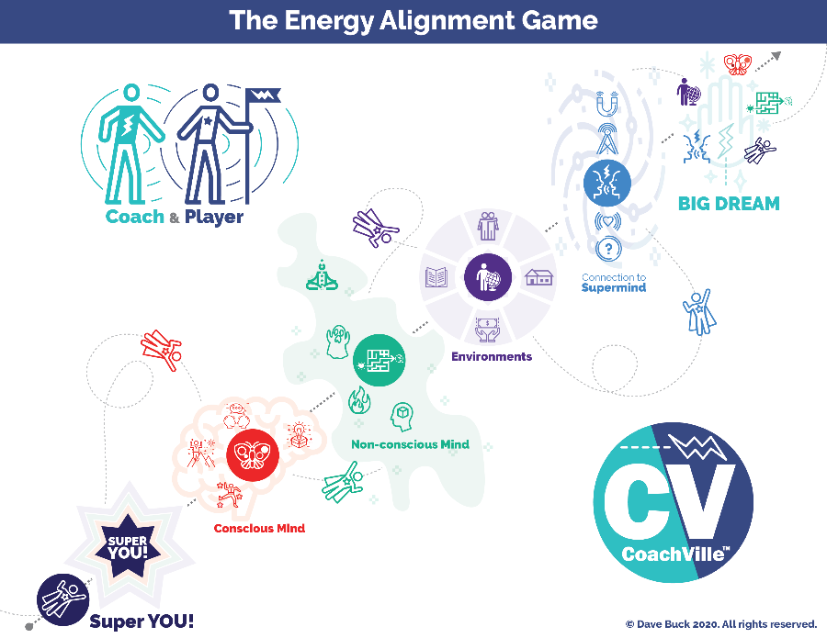
Over the 2nd half of the program we are going to continue to explore the Energy Alignment Game.
The BIG idea is this: the results we co-create in life are only partially caused by our actions; the energy behind our actions is mostly responsible for how results are co-created. Steps 1,2,3,4,8,9 that we have played with so far are focused on the Non-conscious Mind and Playful Conscious Mind.
In the Inner Freedom Method Steps 5, 6 and 7 are part of what we call the Supermind Layer where you strengthen your connection with Life Force Energy. (“Use the Force Luke”)
In these steps we also intensify our treasure hunt for Super YOU!
So let’s explore a few details about the Supermind Connection before we dive into Inner Freedom Step #6.

The Supermind Connection (Energy Alignment Game)
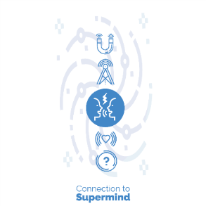
The Supermind is the web of Consciousness that we all have access to. It is sometimes referred to as “The Universe”, “The Field” or Life Force Energy.
This is another aspect of life that will provide an endless supply of insight and fun when you approach it with a sense of wonder.
The Supermind is responsible for spontaneous insights, synchronistic events and profound inspirations. The Supermind is essential to the coaching relationship!
When you think of someone who you haven’t spoken to in a while, and then shortly after they call you seemingly “out of the blue”, this is the Supermind in action.
When you are talking with your coach and a new idea “comes to you” while you are talking or your coach has an “inkling ” or “a flash” about your superpowers, this is the Supermind in action.
There are many ways to play in this realm to get into alignment with your BIG Dream.
The “?” symbol indicates living by BIG questions and staying open to “answers” as they come to you.
The emanating heart is the symbol for the well-known process of gratitude which is an essential practice for Supermind Connection.
The radio tower is the symbol of the power of thinking about and speaking your Dream and intentions; putting them “out there”.
The magnet is the symbol of attracting experiences that move you toward your dream as long as you stay open to the perfection of each situation. People and experiences are drawn to you by the magnetic power of your BIG Dream.
As your Supermind Connection gains strength it feels like you are co-creating with Life Force Energy. It feels like events are happening in favor of your dream; it feels like the Supermind WANTS your dream to happen as much as you do.
The AWESOME thing is that expanding your connection with The Supermind is baked in to the Inner Freedom Method that your coach is using! The talking faces with the lightning bolt is the symbol for our Coaching Relationship model at CoachVille.
When you share your dream with a coach it amplifies your connection to the Super Mind! This is why your coach asks you to speak your dream at the start of every session; sharing your dream with your Coach and your Dream Team amplifies your connection to the Supermind because we are all connected to it.
When your coach asks you a provocative question that sticks with you for a few days… and then insights start coming to you, this is the Supermind Connection in action.

Your Fears are a Treasure map
Let’s go deeper into this idea that your fears are a treasure map to your playfulness and Superpowers.
I have been a Professional Life Coach for 24 years – that means people pay me to help them Play Life better. I have coached over 1,000 individuals. SOOO fun.
This Inner Freedom Method is based on what I have figured out while coaching amazing people who really want to be free and contribute value in the world; that’s who I coach.
Here is a brief recap of a few ideas:
I have learned that EVERYONE has a dream in their heart that will call them to adventure to contribute to the world. That is why you have a Life Coach right now!!!
AND everyone has absorbed a lot of Social FEARS from their environment throughout the course of their life time.
I have coached many people to reclaim and unleash their superpowers on our Human Journey together. A big insight I have developed is the idea that our fears are a treasure map to our superpowers.
It is a quirky concept. Here are a “baker’s dozen” ideas to help you understand it and embrace the adventure.
1) Your Superpowers = your voice, your value, your impact
A superpower is an energy or ability that you can practice to become capable of a big impact on people and situations. You are here to contribute your value and use your voice to uplift the Human Family in some unique way. There is a reason you are here. And that reason may evolve many times in your life time.
2) It’s a treasure map not a road map
The Industrial Age hyper focus on control and logic - there is a right way to do everything; there is a correct answer to every puzzle – has gotten us out of balance with life. Logic has its place; but most of life does not run on logic nor should it. There is not a step-by-step task list for most things you want to accomplish in life and there is definitely not one for recovering your Superpowers.
A treasure map is about looking for clues, reading mysterious signs, solving puzzles without enough information and trusting your inklings and intuition. When a challenge comes your way, there is probably a purpose for it. Look deeper. Pay attention to any sleeping dreams that you remember. Allow yourself space and time to just “Be” so that flashes of insight can come to you.
3) You have a LOT of energy and abilities and possibilities that you are not currently aware of
You were born with a host of energies and abilities. All of them have value for you to share with others and a few of these have Superpower potential; Aka the potential for BIG impact. The need to belong with family, friends, teachers, communities and then co-workers often causes us to hide our uniqueness. This is part of every human story! The purpose of your BIG Dream is to call you out into the bigger world to discover your power and find the people who want and need the WHOLE you… SUPER YOU!
4) You are allowed to change
You don’t need to be consistent. You don’t need to stay the way you have always been. These notions are artifacts of the Industrial Age mindset where everyone was supposed to be “like a machine”. You are not a machine. You are a Human and beyond being allowed to change… you are SUPPOSED to change as you gain wisdom from life’s challenges. You can evolve the way you see the world. You can change your perspective. Most likely, some people won’t like this. See Point #6
5) You CAN change / uplevel
You CAN change. You can become the next version of you. You can add capabilities and make more powerful use of the capabilities you are using already. However in order to add new capabilities you are going to have to PLAY… try new things… experiment… take risks. The reason most people stop changing is because they stop playing. People mostly stop playing because of the risks of social play: rejection, mistakes, trouble, disappointment… and failure. The key is to tap into your inner urge to become and allow yourself to play: relate, create, explore, experiment. Remember anything that you cannot control but you can influence is an opportunity for play.
6) Some people won’t like you becoming Super YOU…
You have to embrace the notion that some people that you care about don’t want you to change. Or if they do want you to change it is according to their standards; not the changes your dream needs.
Always remember there are two transformational power sources inside of you: the urge to become and the need to belong. If someone in your life doesn’t want you to change – take more social risks; become more powerful – the need to belong is going to pull you back. It’s going to hurt.
I have coached so many people who started into an adventure with the belief that their spouse/child/parent/friend supported them 100%, only to find out that this was contingent upon them not changing in any way. This created a lot of pull back.
So part of your adventure is going to include influencing the people in your life to get on board with your Dream and who YOU will become in the process. Be prepared to have lots of real conversations. Hint: you can role play these with your coach.
Also be prepared to find new people to play bigger roles in your life; people who ENCOURAGE you to become Super YOU and embrace who you are becoming. We call this your Dream Team.
A quirky related note…
I have coached players who were holding on to a version of themselves that a parent / friend/ teacher wanted them to be… even when that person was no longer in their life (or even on the Earth). That person from their life history wanted or needed my player to be a certain way… so they adapted to please them and maintain belonging with them. They found themselves staying that way to honor their memory. They had to find a new way to honor the memory and trust the calling of their dream.
7) You are wasting a LOT of energy holding your own power back
Have you ever been in a situation where you were looking after some young humans (say 2 -5 years old) and you were trying to contain them; to keep them “safe”… from everything? It takes a tremendous amount of energy to contain the playful energy of a 5 year old wielding their creative power! This is a great analogy for what is happening inside of you.
Your playful self is eager to take action to co-create your dream in the world. Meanwhile your preservation instincts are trying to keep you “safe”… from everything… by curtailing your playfulness and your unique creative power. Your inner self feels fear because you got “in trouble” for using that power when you were small. (Remember from Chapter 4)
Now you find yourself in an inner “tug of war” that is quite exhausting!; needing sugar and/or caffeine to power you through the day. Because safety and self-preservation are the default priority, your non-conscious energy is pumping up your mind with ways to distract your focus so that you don’t take any social risks; and to keep your power under control.
What your coach is doing with the Inner Freedom Method is to focus as much of YOU as possible onto your Dream so that it can attain equal footing with self-preservation.
As you become more at ease within your Self, you will recoup soooooo much energy; energy that you can use for your Dream!!
8) Moments when your unique power got you in trouble
Because the Industrial Age mindset got everyone so hyper focused on control our playfulness and self-expression got us into trouble a lot… at home, at school (for sure) and in jobs (double sure). (again from Chapter 4)
All of these moments hurt, but …
Your moments of unique creative self-expression
where you got in trouble for “being yourself”
are traumatic moments that hurt the most
and become your deepest fears.
These were intense experiences. But the good news is that these experiences leave clues in your non-conscious mind; clues that you can explore with your coach to find and restore the power that you lost!
9) Moments when your power failed you
Another pattern that I have seen in many players is this: an earlier moment when someone (or something) they cared about was suffering or in some kind of trouble. And they attempted to use their power to help them, but it didn’t work. They tried so hard, but they failed to have the impact they wanted to have.
These are also intense moments when our power can go into the shadows. But again, these experiences leave clues… they are on the treasure map… and you will find them when you adventure out to live your dream.
10) Where there is fear… there is desire.
If you make fear your enemy it will defeat your dream
If you make fear your friend it will guide you to it
You’ve heard the expression: “where there is smoke there is fire”.
This is exactly like that: where there is fear there is desire.
When you move into action for your dream and experience the pull back to safety… the pull of fear… this is a Pivotal Moment. This is a moment where you have the desire to use your power… so you feel the fear of using your power.
When you explore one of these “pull” / pivotal moments with your coach, you are following the treasure map together. Each time you will learn more and more about the fears you have absorbed, the desires urging you forward and the Superpower potential that is within you.
11) Follow your hunches and inklings about actions for your dream…
The more you focus on living your dream, the more you will experience inklings and intuitions about what you need to do. This is the Supermind in Action: when you THINK and IMAGINE your dream it activates the Supermind Connection and these inklings pop into your mind.
Follow these hunches and inklings… try new things and take social risks. Your dream is calling you into the world of people to contribute your voice and value. Expand your self!
Quite often these hunches will pull you into a Pivotal Moment where you experience fear. It can feel like logic trying to “talk you out of it”. Your Dream is not dependent upon logic nor control. It is dependent upon play and growth. Notice the fears that come up… be super curious… explore with your coach.
12) Trust Your SELF and Honor all parts of YOU
One of the big side effects of these earlier moments where we experience trouble while being ourselves… in addition to our power going into the shadows… we often lose trust in ourselves at the same time. This lack of self-trust leads to all sorts of dilemma, an underlying sense of anxiety and low self-worth being the most troubling.
A big step back to Super YOU is when you honor all parts of YOU… including your doubts and fears! Understand that you got them from your environment and they are based in the need to belong which is essential and honorable. Be curious and cultivate judgment free awareness toward everything you are feeling and experiencing.
Trust yourself first to notice and consider the actions you desire to take in pursuit of your dream. By practicing with your coach you will gain respect for your ability to play with your power AND to respond powerfully to the challenges that will inevitably arrive.
13) Expect a lot of back and forth; go and stop
Some days you will move powerfully into the Growth Zone toward your dream. Other days the FEAR feels big and the Social Survival Imperative pulls you back into the Preservation Zone.
The path through the Superpower Zone to your BIG Dream is not a straight path; not by a long shot. Expect to zig zag all over the treasure map!
AND… with your coach by your side you will make more and more moves into the Superpower Zone! AWWW Yeah! That’s how you live the dream. Thanks Coach!

Step #6 Find the Perfection in the Situation

Finding the perfection in a situation is a transformational process that can take many forms. The essence of it is this: Each experience serves a meaningful purpose in your life; and in addition is possibly providing some value in your ability to live your dream.
AND with really troublesome or traumatic experiences you may never be able to “find” the perfection and that is OK.
Finding the perfection in situations dramatically expands your connection to life which is a huge confidence booster… but it takes some practice. This is where your Life Coach comes in!
By the time we arrive at Step #6 in the Inner Freedom Method you and your coach are playing with 2 distinct and related moments. The first is the Pivotal Moment of Choice in the present that you are playing with. The second is an earlier moment in life that may have “popped” up while feeling the energy in your body.
As we move deeper into the method over the next few sessions your coach will explore both moments with you for “perfection”. The idea is that your BIG Dream is a magnet that draws experiences to you. Many of these experiences are awesome and fun while some seem really difficult or even troubling BUT they are exactly what you need to experience to step into your power and live your dream.
This perspective is often difficult to see on your own, and as I said before, with your Life Coach with you it becomes much easier and clearer.

Coaching Proficiency: Recognizes the Perfection in Every Situation
I love sharing ideas from our Coaching Programs with you as part of your experience of having an Inner Freedom Life Coach.
CoachVille founder Thomas Leonard (and the founder of professional Life Coaching) was really big on the idea of a Life Coach and Life Player (YOU!) looking together for perfection in situations. He wove it into almost every program he created and we have continued along that path.
From Thomas…
“One way of looking at life is to believe that everything happens for a perfectly good reason, even if we cannot always see or know that reason within our own lifetime. The point here is to look for and find how a player's event, problem, situation or trait is perfect, even if it's clearly not. Seeking to understand and recognizing perfection first, instead of offering tips, techniques and solutions as a knee-jerk reaction, is what the Great Coach does naturally.”
“Recognizing perfection doesn't mean that things are "ideal" or the way the player would have consciously chosen it. It does mean being able to identify different possible meanings, seeing multiple realities. You may need to transcend your own bias against the word ‘perfect’”.
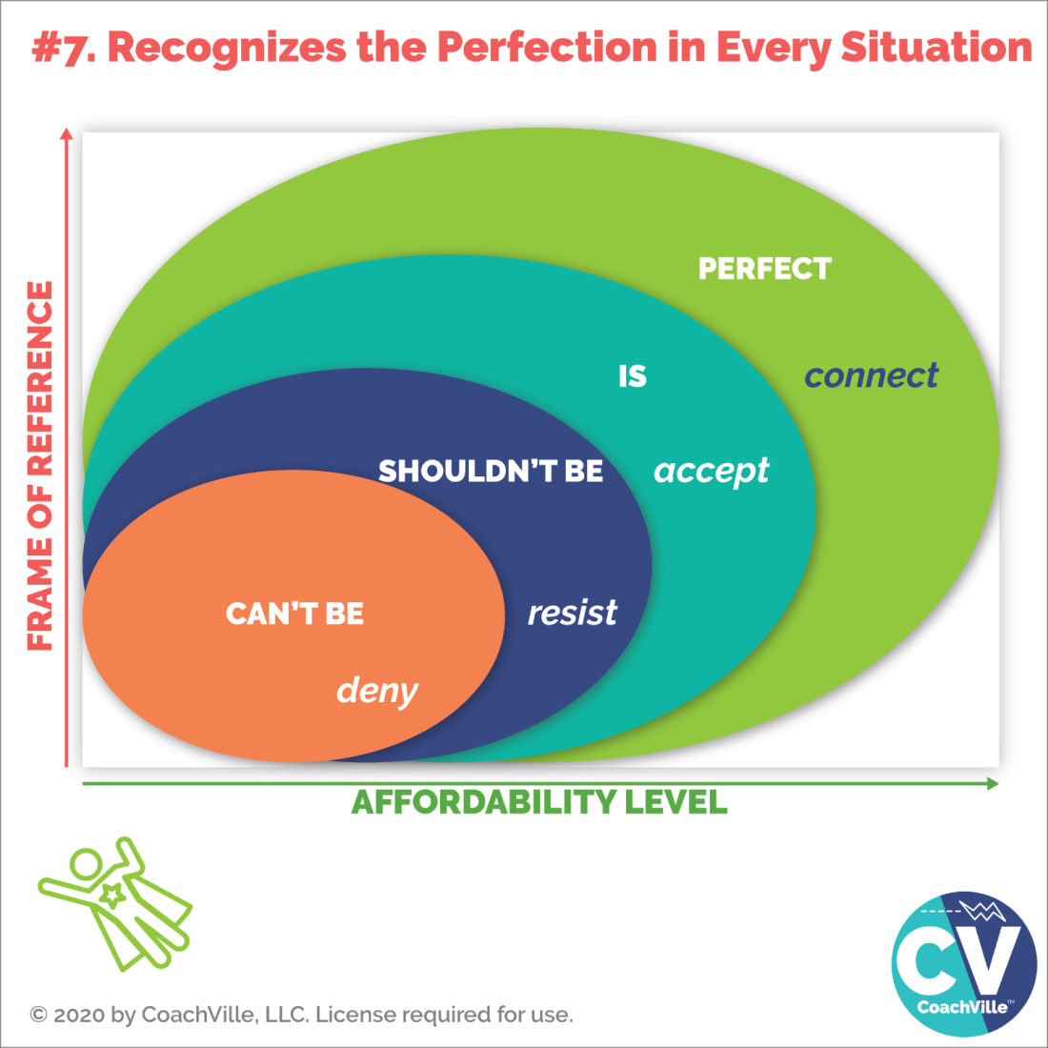
When you can recognize the perfection of the situation you feel a deep connection to life, the Supermind and to the meaning of your dream.
Here is a list that Thomas created to compliment the model above:

Things that don’t seem perfect, yet can be seen as perfect

- Failure
- Resistance
- Missed opportunity
- Frustration
- Confusion
- Dislocation
- Sliding backward
- Mistakes
- Financial loss
- Stress
- Difficult relationships
- Competitive threats

What Inner Freedom is
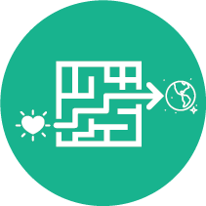
Now that we are half way through the experience, let’s do a quick recap on the Inner Freedom Method
Inner Freedom is the ability to choose when and how to get your hearts dream out into the world – through the maze of non-conscious beliefs and fears that are trying to keep you safe by avoiding social risk.
The symbol of the Inner Freedom Method is the heart moving through the maze toward the world.
This is a transformational experience:
From: fear, emotions and “limiting” beliefs are something you "power through"; the non-conscious mind is dark and mysterious and must be avoided.
To: you can play with fear and emotions; you can uplevel your beliefs; and the non-conscious mind is a vast resource of wisdom and power.
The BIG idea is that you can approach fear with the spirit of play and explore it with curiosity like a treasure map. This brings deep understanding to the self-preservation patterns that are creating conflict with your desire to play BIG for your dream.
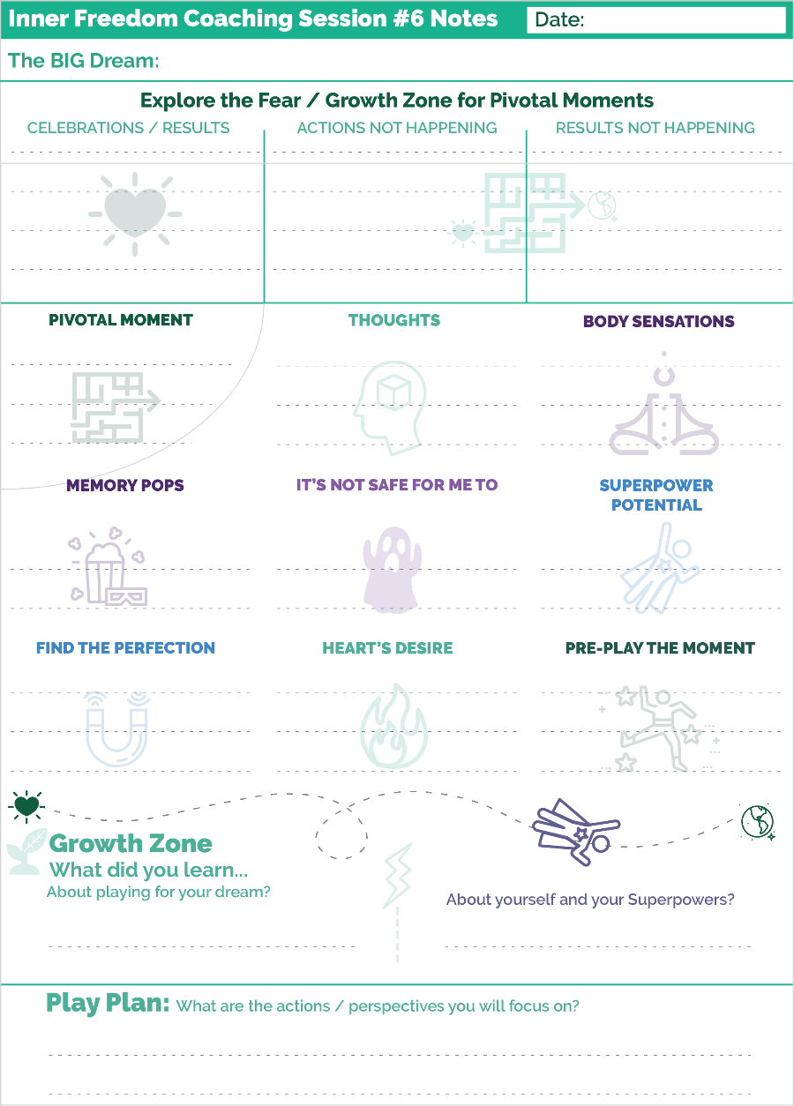
With expanded awareness we can transform inner conflict into positive energy, joyful self-expression and deep confidence. This leads to the freedom to choose playful actions that require social risk and the ability to co-create your desired results and experiences with the world!

Prepare for Session #6 – Find the Perfection
How are you doing with noticing your pivotal moments?
Is it getting easier to hone in on the moment with the greatest upside potential for your dream?
These are usually the ones with the biggest growth opportunity.
Let’s have a look at the coaching notes playsheet for Session #6.
We start off the same way we do each session:
Sharing your current version of your BIG Dream.
Sharing celebrations and results
Exploring Actions and Results that are no happening.
Next we get into the Steps of the Method.
Notice the writing spots are getting smaller! This is because now there are 9 sections whereas before there were 8. In session #7 there will be 10.
There is a section for each step of the method. PLUS there is a section for Memory Pops. This is not a “Step” but when it happens you want to write it down.
Notice the Find the Perfection section – for Step #6 - is on the sheet now.
Then at the bottom are the sections for the Growth Zone and your Play Plan.
Remember that with your coach you will probably only talk about new items that came up in the session. Then you write up your complete Play Plan with all of the playful actions you are focused on for the week.
Ready to play…
For this session with your coach, choose a pivotal moment that you know has great potential to unleash your Superpowers! In other words, choose a moment where you are experiencing a lot of fear. ;-)

**!!** {End of Player Playbook} **!!**

Coaching Notes for Session #06
Notice: in Step 3 – Straight to the memory pop question;
if a memory doesn’t pop up, then invite / encourage them to feel into it for another 30 seconds.
By now, your player is most likely comfortable with memory pops and understands how somewhat random scenes will come into their mind after feeling the energy.
Step #6 has two parts
a) The perfection of the self-preservation belief
b) The perfection of the current situation
In this version of the Coaching Guide we only explore 6a.
The text in Part 6a has two versions: One for a memory pop, the other for no memory pop; just like in Step #5.
It is a similar situation. With the memory pop you can explore the earlier moment, and the self-preservation / body belief, to get to a deep clarity of the specific honor and purpose for the belief.
If there is no memory pop then you need to talk about the self-preservation / body belief in more general terms. This is valuable; though not quite as valuable as when there is a memory pop to provide the deeper understanding.
Again, by going through the same steps in either scenario, your player will get comfortable, feel safe and in the flow of the method and this will make memory pops easier.
Coaching Notes Playsheet
YES! Write a few notes on the Coaching Notes Playsheet. Keep doing this during or after every session.
As we move through the program and add steps to the method the “chunks” for writing notes get smaller and smaller; hopefully you are also getting better at capturing the flow of the session with just a few key words!

Inner Freedom Method Step 6: Find the Perfection
As I just shared in the coaching notes for this session, this step has two related parts.
a) The perfection of the self-preservation belief
b) The perfection of the current situation
I put some important concepts about this in the player playbook because this is a somewhat challenging but also liberating perspective.
In this section I am to go a little deeper to give you the coach’s perspective. As I wrote in the player playbook, it is VERY difficult to see a situation from this perspective when you are alone; and especially when you are alone and afraid.
Your presence as a coach can make all the difference in this path to liberation and connection to life.
The reason we do this step with our players after doing the basic version of the method for a few sessions is to build up the safe space of belonging which makes this step easier for both the player and the coach.
Here are a few extra notes about each of the two parts.
Find the perfection of the Self-Preservation Belief (2010)
In the original version of the Inner Freedom Method we called this the survival intention. Now we call it the self-preservation belief.
We made the switch to self-preservation because it is a little lighter than survival but also because we want to Amp up our ability to honor all of the self-preservation aspects of our inner being… I call this Tenacious Self Love! Honoring them rather than demonizing them – as in self-sabotage – makes a HUGE difference in our ability to embrace our humanity and grow into the next version of ourselves.
This is the deepest part of the method. It is based on the coaching framework that there is perfection in every situation.
"Finding the perfection" means…
- To see how it served you in life
- To see how it kept you safe while you were in the environment
- To see what you learned from it
- To see the positive aspects of who you became as a result of living this belief
- To see how it fueled you in some way; eg. “I’ll do this now to fit in, but when I am free of here I will show you this is NOT who I am!”
- It revealed a Heart’s Dream value that now you are living into
Belonging - fitting in – with your family or circle of friends is essential to survival as a young person! This is the driving force behind almost EVERYTHING we believe about ourselves, good and bad, right and wrong, life… everything.
Inner Freedom is the ability to look at any belief and choose if you want to continue to live by it OR if you want to use the Believe Human Superpower to choose a new belief.
My sense of this is that the belief from earlier in life doesn’t go away when you actively choose a new one. It will still activate in certain situations. What happens is that you develop the capacity to feel it and choose something better for your dream sooner, faster with more ease. This requires practice.
You find the perfection of the self-preservation instinct and how it served your life!
Here is a real life example from Player Natasha (recordings available in the syllabus):
At 8 years old her uncle tells her if she gets the top grade in her class, he will give her a bicycle.
She really wants the bike BUT she feels that if she wins the bike she will suffer the rage of her sisters.
So she fails the final test on purpose.
The survival intention became: if I win I will suffer, so I will not win.
In our new version would say the self-preservation belief: It’s not safe for me to win.
Also remember we refer to the self-preservation belief as the “body belief”; to distinguish it from a consciously considered thinking belief.
In this case it is easy to see the connection between the need to belong and the self-preservation belief that it is not safe for me to win.
These correlations are often plain to see. But sometimes they will require you and your player to use a little creativity to “connect the dots”.
It served her in maintaining belonging with her sisters - fitting in with her family - which is essential to survival when you are young.

A few deeper questions to create awareness…
Here are a few ideas that you can use to go deeper in these conversations>
- How did this belief, and your life that followed, prepare you for something BIG?
- How did the early event reveal, and then possibly suppress, a Heart’s desire?
> It becomes like a buried treasure to be found later in life; often with great energy!
- Player Natasha - suppressed her talents so that she could fit in with her family
> The event revealed one of her HEART’S DESIRES: FREEDOM to be yourself in the world. When she rediscovered this about herself, it gave her tremendous energy for her BIG Dream.
- How does this self-preservation belief explain how you feel something holding you back when you take action for your dream?
In other words it served a purpose when you were younger and the dream you were playing for at that time – the “fit in with my family” dream; Now it is NOT serving your new dream to play BIG in the world by expressing your unique talents.
If it creates a “pull back” when you have an opportunity to “win” the respect of your students in a class; or “win” the respect of the dean of the school; then this “not safe to win” belief is going to create strong resistance.
Often this type of deep exploration creates a BIG “AH HA” for your player.
Sometimes the big “AH HA” comes in the days after the coaching session. Don’t feel the need to force it in the conversation. Share what you see, ask the player to consider this perspective and then let it work it’s magic.
Always remember!!! The drive to be FREE is in all of us. Sometimes it takes a while to bubble up to the surface.
In earlier versions of the method we tried to talk with the player about the perfection of the situation itself; the experience of the earlier moment. I have found this very often to be too difficult to get one’s head and heart around; especially for the troubling and traumatic experiences in life.
However, exploring the perfection – value or purpose – of the belief itself is MUCH easier; and it provides a greater sense of freedom. This is because it’s the non-conscious belief (body belief) that developed in the player during the earlier moment that is causing “the pull”; not the experience itself.
This is a big – and very helpful - distinction.
A few other points exploring early moments in life
Judgment-free awareness is really important here! It is up to you to create the safe space.
This means not judging any of the people involved in a situation your player shares.
- Sometimes your player will be witness of a troubling experience and feel powerless to help.
- Sometimes your player will the “cause” of a troubling experience through an accident or unintended consequence.
- Sometimes your player will be the perpetrator of a troubling experience.
The key to all of this is to focus the exploration on the beliefs rather than the details of what happened. While exploring the beliefs sometimes the details of events will come into the conversation. Your role is to be a calm, steady presence; co-creating belonging with your player so that they feel safe to explore and share.
Often we need to say something in order to see it. Be the listener.
NOT Therapy
I mentioned this in the player playbook in Chapter 4. But I want to amplify this point again from the coach’s perspective because this step is where we can get into deep reflection about moments from our past.
Since this question comes up all the time I will just say a few words here to help ease any worries that you may have.
Talking to a fellow human about earlier moments in their life and how they sparked the development of non-conscious beliefs is not “doing therapy”.
It is true that Psychotherapists do talk with people about their past events in life.
But that does not mean that talking about the past with someone is doing the work of psychotherapy no more than looking at someone’s teeth means you are doing dentistry.
Talking about moments from our past to find meaning and purpose is a thing we human’s to together.
I will leave it there.
The Superpower Connection
Often “seeing” a non-conscious belief is very freeing.
Seeing and honoring the source event of a belief is even more freeing than talking about the event itself.
And sometimes… all of this reveals your players playfulness or power; AKA the treasure map!
The perfection framework for almost all of these situations has the same pattern. Add this pattern to your “treasure map reading skills”.
It goes like this…
- At an earlier moment in life you were playfully expressing your power in pursuit of your dream at that time in your life.
- Something bad happened; someone didn’t like what you were doing; your belonging was threatened; OR your power didn’t work and you were devastated.
- Your non-conscious mind kicks in and creates a belief that it’s not safe to do what you were doing.
Note: often the player was playfully expressing their power when a troubling thing happened that had NOTHING at all to do with the player; however as a small person we often make these non-conscious cause and effect connections.
- At this moment your superpower went into a dormant state.
- The perfection is that you didn’t have the ability or wisdom to safely use or express that power at that time. So keeping it dormant kept you safe.
- Now you are facing a challenge or an opportunity within your dream that is calling your power out of its dormant state.
- The timing is perfect because now you have the wisdom to use your power in the world. AND you have a coach who can help you practice your power before you use it! (I love sharing that part with my players)
- Life is amazing!
Find the perfection in the current situation through the balance of support and challenge
This part of the method does not appear in the Coaching Guide until session #7. But I want to give you the background information now.
Remember! The Inner Freedom method begins with the desire to play big! To express or create something that requires action that is outside of the self-preservation zone of your player.
When your body is free and your mind is open you can then look at the current situation from the powerful framework of perfection:
Look at current challenges and see how they are serving you.
The challenges are “asking” you to learn something or become something that is essential for the fulfillment of your Dream.
There are no “random” experiences when you are playing big! Every experience that comes your way has the potential to move you closer to your dream.
Look at the support that is around you
Often there is support available that you are not allowing or not receiving. (There is that word Allowing again)
For most people receiving support is also outside of their self-preservation zone AND has its own collection of Inner Freedom opportunities. That may sound weird that receiving support would go against self-preservation. The key is to understand that many people group up in an environment where not needing anything from anyone was the way to be admired in the family. When being self-sufficient gets tied into belonging and status – which happens A LOT in Industrial families and Industrial schools – accepting support can feel like a threat to one’s status.
This conversation is a co-created experience
Seeing that a challenge or difficult situation as an essential experience to living a dream is a life changing exploration that requires some practice for both the coach and the player.
It requires a great sense of trust in each other.
The earlier steps of the method set the stage for this conversation.
You can’t force it, but you can influence it with creative judgment-free awareness and by creating a permission space to share what you see.
Often you can see a way that the current situation your player is in is exactly where they need to be to fulfill their intention to play big in the world. The question is how do you communicate this to your player? This can be delicate, especially when they are feeling stuck or upset.
I have found that if a take an approach like this it really works: Hey, something is coming to me here. I am not sure if it will resonate with you. Can I share it with you? {wait for them to say “yes”.} I am wondering if it might be X. What do you see in that?
Then let them reject the idea of consider the idea. It is up to them. Your role is to ask permission and share what you see.
I have been able to say some really provocative – often counter intuitive – things using this approach. And very often it creates a major shift for the player.
An example is a time a player was feeling terrible because they were just laid off from a job that they LOVED and had been in for many years. After setting it up as I just described I said: “What if this was the only way you would be set free to pursue your REAL dream?” This shocked them! But within a few minutes it took on a life of its own in the players’ imagination. Then over the next few days they were posting on social media about being set free to pursue their dream. It was awesome!

The Perfection of the Preservation Intention
{review ~ figure out how to connect to the first part of example in Chapter 4
Remember this story I shared from my own life in Chapter 4? The one where I was trying to understand why I was so terrified of going to Networking Events.
While it all makes sense now, I can tell you that during the 3 or 4 years when I was figuring it out and starting to develop the Inner Freedom Method, it was VERY confusing!
I was a very successful Life Coach. I had lots of clients. I had money. I love meeting new people. I was really good at talking with people.
WHY?
Why did walking up to a stranger, at an event specifically designed for this to happen, stop me in my tracks?

Find the perfection of the Preservation (Survival) Intention
Let’s do a quick recap and then talk about the steps 5 and 6 in this example.
Recap
- I have a big dream to build my coaching business further and expand beyond the referral business
- My coach recommends going to networking events and I agree this is an awesome idea for me
- Just the thought of going to a networking event causes me to feel buzzing sensations in my body and the my mind comes up with 20 reasons why you cannot go to this event! e.g.. too busy! I don't have business cards! These emails are more important!
- This is my mind serving your "social safety intentions" because my body does not feel safe
- On the surface this situation was very confusing because clearly I have all the social skills required to be a capable networker. Why wouldn’t I go?
- If you "think" about it logically the resistance doesn't make sense. BUT logic does not help here because when the body feels fear it overrules the conscious mind.
- After practicing some guided body work I figured out that the body sensations were connected to a moment earlier in life where I got in trouble with my mom for walking up to a stranger. I had a body belief that was preserving belonging with my mom.
- This is called "inner resistance" because the social safety instinct to stay safe pulled against my Heart’s intention to play big and meet new potential clients. When these intentions pulled in opposite directions I experienced overwhelm then isolation then frustration.
- Traditional personal development programs – and I was doing A LOT of these -would urge me to BANISH NEGATIVE THOUGHTS from my mind. I repeated affirmations like: I love networking; I am good at networking; people like me. This did not work at all because the conscious mind is not in charge when we feel social fear! And actually, these programs and affirmations made me feel worse about myself.
  - Steps #3 & 4: The memory pop helped me understand what happened to create the energy in my body AND helped me put words around the body belief: It’s not safe for me to walk up to strangers.
Got it so far?
- A big clue came when I started getting invited to speak at networking events!
Through my growing coaching business and sharing ideas about my topic at the time – personal branding – I got invited to speak at Networking events.
I would go to the event and not talk to anyone except the person who booked me to speak. Then I would do my talk; and I was VERY entertaining ;-)
Then after my talk lots of people would walk up to me and want to talk with me.
Turns out… I was amazing in this situation. Many times after 3 or 4 minutes talking with someone they wanted to hire me for coaching.
- Step #5:Turns out… talking to strangers, and getting into deep conversations quickly, is one of my superpowers!! This revealed to me the whole Superpower thing. Taking a step back, surely my mom freaked out trying to keep me safe in many different situations. So why did this one time stick with me so deeply. It was BECAUSE I was using my superpower when I got “in trouble”. Getting in trouble for being yourself hurts a LOT! It creates body beliefs that it is not safe to express that part of you.
- WHOA!!!
- Using the Superpowers of Play sheet I found the Superpower called: #19 Approach with Sensitivity. This described pretty well what my power was AND what my Heart’s Dream needed me to do.
- Step #6a: Instead of being frustrated with my fear of networking I could PLAY with social fear using judgment-free awareness. I could see the perfection of social safety instinct: it was maintaining a sense of belonging with my mom. I can honor that. With my body feeling safe I could choose a new way to stay connected to my mom and experiment with new ways to express my Approach with Sensitivity Superpower.
- This is why it is so important to practice feeling the energy first - THEN explore to find the Social Safety Instinct.
- Step #6b: This revealed the “perfection” of my BIG Dream to grow my coaching business AND the perfection of my coach encouraging me to go to networking events. Without these events I would never have had to explore this fear; and I would never had rediscovered this Superpower.
- Figuring out that there was nothing wrong with my mind or my attitude or my energy I was really FREE to pursue my dream. With my coach I could get my mind focused on my new “Heart’s Dream” in a way that had equal power to my Social Safety Instinct to avoid talking to strangers.
- The social fear of walking up to strangers at a networking event did NOT go away! I still feel it every time. I still work around it most of the time by hosting the events or getting invited to speak first. BUT, when needed for my dream, I can feel into the energy and walk up to someone that I want to talk to. And after I am talking to someone, it is almost always REALLY FUN!

Class 06 Prep
We will explore a few of these questions in class.
The Inner Freedom Method Review
- Tell me what is a Pivotal Moment?
- Describe step 1 = Pre-play or Replay in your imagination
- Describe step 2 = Notice thoughts with JFA
- Describe step 3 = Feel the energy
- Describe step 4 = Give voice to body beliefs

Question: In the preservation zone, what are we trying to preserve?

Chapter 7 – The Flow of Gratitude

“A few years ago a family of high wire artists had a terrible fall from the high wire in the middle of their performance. All of them were killed, except the father, who escaped with broken legs. But even after losing his children in the fall, a few months later he was back to work, in the circus, on the wire again.
Someone asked him in an interview, how he could bring himself to do it, after such a terrible accident. He answered: ‘On the wire, that’s living… all the rest is waiting’”.
From Christopher Alexander

Chapter 7 Prep
Before Class
Read through the complete coaching guide for Session 7 (Page X)
(this is a link to the PDF with the complete set of coaching guides)
Listen to this audio to prepare for Session 7.
(this is a link to the Player Prep SoundCloud audio)
Listen to Coaching Demo of Session 7
(Coach Dave and Player Leanne)
Playsheet Pack: Print 2 copies of page 12

{From the Player Playbook}

Session #07) Flow of Gratitude
In this Chapter we will explore:
1) The Power of Your BIG Dream (The Energy Alignment Game)
2) The 3 Energetic Transformations of Inner Freedom
3) The fun and freedom of the 95%! Why actions and results happen easier
4) Another look at pivotal moments and social fear
5) Review the complete method
6) Step #7 Embrace the Flow of Gratitude
7) Prepare for Session #7
Whew! Here we go.

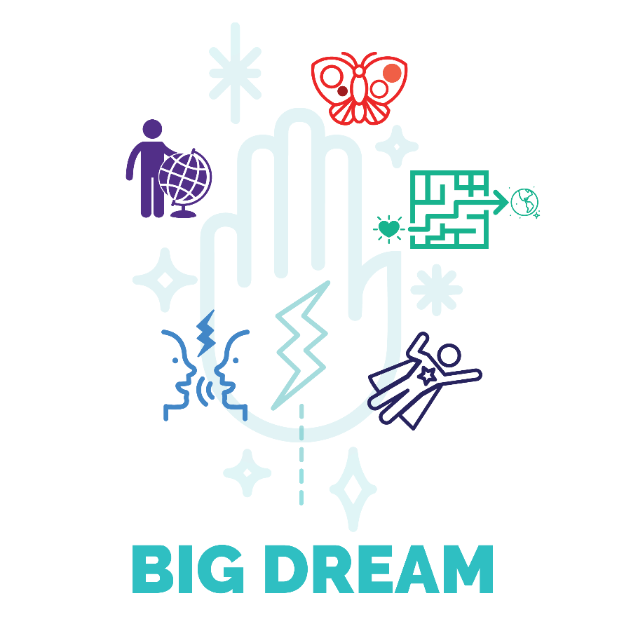
BIG Dream (Energy Alignment Game)
How are you feeling about your BIG Dream?
Are you playing for the life you truly desire, WAY beyond what you can control on your own?
Are you noticing that your dream “attracts” to you a wide variety of new experiences and challenges?
I hope so!
I shared with you a few ideas about your BIG Dream in the Introduction. Keep Dreaming!
Now you have experienced orienting toward your dream with the Inner Freedom Method
Speak your dream every week. Allow it to guide you and your actions and NOTICE the situations that your dream attracts to you.
Also… the BIG question near the end of every Inner Freedom Coaching session: What does your dream want you to do?
This gives your dream a life of it’s own; a voice of it’s own. It’s powerful.
Now that we are a little ways down the path I want to share with you a few more ideas about playing for a BIG Dream.
BIG Dream Insights
It takes courage to play for something beyond what you can control but you can influence. Embrace the idea that YOU are a person of courage. Note: the word courage comes from the French word “Coeur”, which means heart. You are a person of heart!
Also, your dream takes you out of the self-preservation zone where everything is predictable and safe and out into the wild world of the unknown. Try to remember that this is the fun! LOL. Even when it doesn’t seem like so much fun.
When you are new to playing BIG for a Dream your dream can evolve or even change completely quite often. This is OK! Go with the flow. AND at some point it will serve you to speak a dream and play for it full-on for a period of time… say 3 months. Then every 3 months step back and choose to keep going or change the dream.
The reason for this approach is that it is more powerful when you play full on with every situation and challenge without needing to step and wonder: “mmm is this the right dream for me?”
The “Video Game” Metaphor
A fun way to think about your BIG Dream is to imagine that the world is a video game console and your BIG Dream is a game that you pop into the console to play.
As you pop the game into the console new situations and challenges are presented to you on the screen. These situations require you to expand your capabilities as you move toward the intended outcomes of the game.
Your BIG Dream is a lot like that. As you speak a dream with strong intent to play, suddenly your life has new situations and challenges that are asking you to grow.
Just like a good video game has a sequence of levels that get more and more interesting and challenging; a good dream also has many levels. The difference is that a video game is created from the imagination of the game designers, your BIG dream is created from YOUR imagination.
SOOOO MUCH FUN!

The 3 Energy Transformations of Inner Freedom
Next I have a model for you that displays the energy transformations that you have experienced in the first six sessions with your Inner Freedom Coach.
First lets recall the Inner Freedom Method model:
The Action Layer: Transform from Control into Co-create
The Thought Layer: Transform from React to Respond
The Feeling Layer: Transform from Resist to Allow
As you experience these energy transformations you get into the flow of the connections between you, your dream, your life and the world you aim to impact.
From Preservation and Avoid Social Risk to Inner Freedom and Choice
Remember the “Human Journey with a Coach Model” and “The Pull”.
The transformation we are playing for together is to go from being stuck in the Self-Preservation zone where we avoid social risk to the experience of Inner Freedom and the ability to choose when to play BIG for our dreams by using our playfulness and Superpowers.
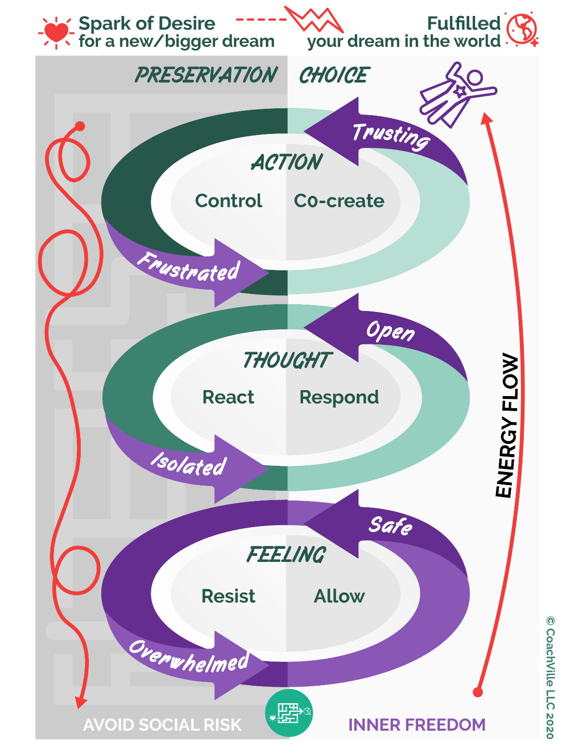
This is a deep challenge because the need for belonging is such a powerful force in our Inner World. If you are in an environment where it is not safe to be ALL OF YOU – as most people are – your Human Nature superpower of belonging will naturally avoid social risk.
Add to it the hyper-control and perfection trap of the Industrial Age and it is easy to see why we avoid social risk.
This model will show how the Inner Freedom Method with a coach is guiding you toward transformational shifts in 3 layers of your experience. We will go down the left side and then up the right side.
We come into the Inner Freedom experience with a sense of frustration about our actions or our results. We are attempting to control something and it is not working. This is revealed in Step #1.
Often in this state of frustration we have reactive thoughts that something must be wrong with our situation or with ourselves. We resort to the Industrial Age formula: work harder in isolation. This is revealed in Step #2
From Resist to Allow in the Feeling Layer
There are actions that we want to take in the world but they involve social risk. These social risk activities almost always bring about a sensation in the body somewhere. If we resist or ignore these sensations we feel overwhelmed; often we do a task or “safe” activity to distract ourselves; like scrolling through social media.
This brings us to Step #3 where we scan the body for physical sensations.
By feeling into the energy and allowing it to be there in the safe space of belonging provided by your coach you begin to feel safe within your body.
From React to Respond in the Thought Layer
When you feel safe within your body everything changes! Your mind opens up to new possibilities and can think from the desires of your BIG Dream. This brings us to Step #8 where you can now respond to your situation with creativity and enthusiasm. Your mind can now align with your dream and come up with actions that are clear and brave.
From Control to Co-Create
After your mind opens up you move into a space of trust. You can trust yourself. You can trust life. You can trust your dream. You can trust that the situation you are facing is here to propel you into your dream. You can trust in the value of what you are aiming to do in the world. From this state your imagination can move into a powerful co-creative place and you can pre-play the pivotal moment with ease and power; you can imagine yourself as Super YOU.
YOU out in the world
After the Inner Freedom experience the pivotal moment that felt so difficult suddenly seems easier; your actions flow with clarity of purpose; often requiring very little time. With the energy aligned the results start to happen, often in magical ways. Now this doesn’t mean that everything happens as planned every time. But over time it does get easier and better and most importantly YOU feel more connected to life… this is Inner Freedom.

The Fun and Freedom of the 95%!!
Remember this model that I shared with you in the Introduction to set the purpose for playing the Energy Alignment Game?
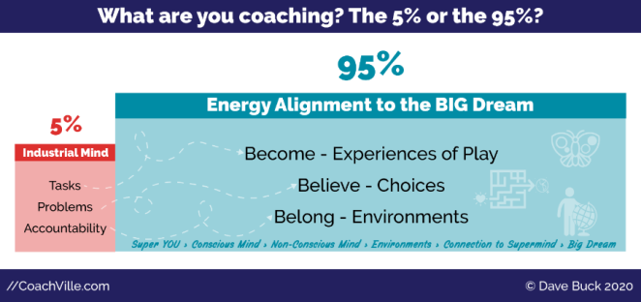
You can make more progress toward your dream by playing with a few high impact social risk activities than a month of safe, under control tasks in isolation.
The point here is to release the industrial mindset that you must sit and complete tasks all day.
Remember!!! You – all of us – were subjected to the somewhat sinister intentions of the Industrial Culture to diminish you from a wild, free, co-creative human into an obedient servant; who will show up for the job and do what the boss tells you to do for pay that is far less than you are worth. Then to use that pay to buy the Industrial CRAP put out by the machine. This keeps you a cog in the Industrial machine producing wealth for the Billionaire “Captains of Industry”. BLAGH!
Your coach is guiding you to be FREE; to feel confident and capable and practiced in pursuit of your dream. A dream where you contribute your value to others in a business or a role where you are compensated fairly! Then you can use what you earn to invest in quality products and services offered by people who are also being paid what they are worth! This is the intention of the Connected Age of Play!
The path to freedom includes:
- Playful Actions where you express your power and value; become Super YOU
- Uplevel Beliefs where you choose your power and value and honor your fears
- Design Environments of belonging where your power and value are embraced

With a Coach you are NOT alone…
First with a coach, then with a team of capable co-creators, you expand your influence in the world around you.
Sharing BIG moments together creates profound belonging.
Profound belonging is the catalyst to a lot of growth!!
This is you, your coach and your dream team together!!
Don’t have your Dream Team yet? Not to worry!! It will happen if you keep playing with a Coach.

Look for Pivotal Moments of Social Play and Social Fear
You might be thinking: “gee to call the Industrial Culture sinister seems harsh.” I get it. My aim here is not to get us caught up in some conspiracy theory. However, my purpose in life as a Life Coach and with this Inner Freedom program is to guide my fellow humans toward freedom. And part of playing for freedom is to understand what we are getting Free FROM; while putting our attention on the freedom TO play for our dreams.
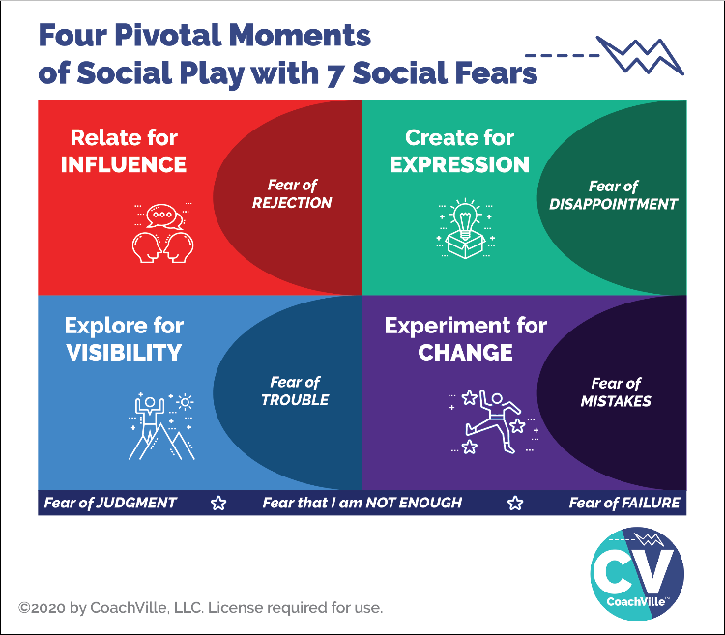
Remember this diagram with the 4 Pivotal Moments of Social Play and 7 Social Fears. By now you are starting to notice these fears when you give voice to the body beliefs and self-preservation instincts: It’s not safe for me to:…
As you notice these fears and have memory pops emerge many of them will come from moments in school, in jobs and with your family. Remember too that all social fear is learned. You are not born with social fear.
I am only suggesting that you connect the dots and wonder: why school, jobs, and families of people who were diminished in schools and jobs, create so much social fear? Why are so many of us left believing: That we are not enough; that we don’t truly belong, that it is not safe to make a mistake… etc. How did we become such small versions of our possible selves?
THE BIG CHANGE
When you focus your energy on YOUR Big Dream; when you start to restore your playfulness and unique power, when you have an Inner Freedom Life Coach, everything changes!! AWWW Yeah!
While the social fears that you absorbed will always be a part of you, you develop the ability to choose new beliefs; beliefs that serve your dream.
You begin to LOOK for and enjoy challenging growth situations. You know they will create opportunities to expand into your power.

Step #7 Embrace the Flow of Gratitude
Seeing your life, and the situations you are in, with gratitude is an essential skill for The Supermind Connection; feeling in the flow with life.
In Step #6 Find the Perfection we used judgment-free awareness to intentionally notice how the current situation is serving your dream. And if you had a memory pop of an earlier moment in your life, you intentionally reframe it to see how it served you in some way or prepared you for the growth you can experience now.
Now in Step #7 we take a moment to FEEL the gratitude for the growth oriented awareness that is occurring and the value of playing for a dream.
It is powerful when you can feel gratitude for the path to growth – for how your dream has pulled the perfect growth opportunity to you to open a path for you to become the person who can live your dream.
Connect the dots
Your Superpowers and Playfulness left clues for you!!!
In Step #7 we also connect the dots – between the earlier moment (revealed in the memory pop) and the current situation.
In can be extremely freeing when you can see how the fear or resistance that you are experiencing now came from an earlier moment in life; a moment when you had much less influence and capability than you have today.
It is also illuminating when the memory pop reveals how you either:
a) got in trouble for using your power OR
b) your power failed you in some way
Now you are more capable of learning to use your power with wisdom for positive IMPACT!
When you are able to honor the fear and its origins it loses its unseen power over your choices. You can choose to play safe if it serves you; but you are doing it with clear intention.
Then in Step #8 you explore what your DREAM is asking of you; presumably to play big in some way.
THEN… YOU have the choice. You can choose to play safe OR you can choose to play BIG.
Embrace both. Both have honor. This gives you tremendous Inner Power.
What I have found is that when you embrace both, it becomes quite easy to take the play BIG action.

The Coaching Notes sheet for Session #7 has the complete method!
Let’s take a moment to review it so you can get a deeper understanding of what is happening.

Prepare for Session #7 – Flow of Gratitude
Review the method…
Set Up)
Identify a VERY SPECIFIC moment to play with together. It will most likely be a moment where the player is experiencing at least a little bit of frustration, doubt, fear, stress, overwhelm or hesitation.
0) Choose a pivotal moment
You will likely have several Pivotal Moments to choose from each week. Choose the one that seems to have the biggest impact for you now.
1) P/Replay the Pivotal Moment (Control)
Activate your imagination and visualize yourself IN the moment and share the scene with your coach.
We use the funny looking word – P/Replay – because you can play with a moment from the recent past (replay) or an imagined moment in the near future (preplay).
Playing with a Pivotal Moment sets up the shift from Control to Co-Create in Step #9

2. Review Reactions with Judgment-Free Awareness
Use the incredible power of your imagination to be in the moment and witness yourself in the moment at the same time. Describe the thoughts in your mind WITH judgment-free awareness and curiosity.
This creates an experience of profound belonging with your Coach; they are WITH you in the experience. This is super powerful!!
Witnessing your thoughts sets up the shift from React to Respond in Step #8

3) Feel the Energy in the Body
Your coach will invite you to explore your body for the physical sensations while you are in the moment. Again, in the moment and witness to the moment at the same time.
They will ask you to describe the shape, color and temperature.
This step is also known as Somatic Experiencing (meaning: of the body).
It creates a Feeling Layer shift from Resisting to Allowing which creates an experience of safety.
Memory Pop)
Because the physical experience you are feeling is related to an emotionally intense moment (or many moments) from your past, often a memory will pop into the mind.
At the your discretion, this moment can be explored briefly while maintaining judgment-free awareness for the people and the situation.
The key to the memory pop is to just allow it to come into your mind; don’t try to think of a memory. And then don’t dismiss a memory because it doesn’t seem to make sense. Whatever pops up will provide valuable clues.
Once you do the Inner Freedom Method a few times, it is likely you will have some kind of memory pop up every time. But if you don’t… it’s OK. The Method will still work.
Always remember… the non-conscious mind is not logical or controllable. Like life! ;-)
4) Scan for Body Beliefs
There is great wisdom in the voice of the body; especially fear. Your Coach will guide you to use the power phrase: It’s not safe for me to {fill in the blank} to give voice to the belief or fear. What is the fear trying to preserve or protect? Honor this wisdom completely.
When you feel safe within your body, your mind opens up to new possibilities.
Short version – go to step 8. You did this with your coach in the first few sessions.
Long version – go to step 5, 6, 7
5) Explore the Superpower Potential
ALL of us lose access to our unique power – our superpowers – through our troubling experiences in life where our belonging is threatened. The pursuit of our Dreams in the world is an opportunity to discover and reclaim these powers. This truth is the essence of every Hero’s Journey story.
Very often in the moment that originated the belief or fear, you were doing something or expressing something that was essential to who they are; a unique ability. And either you “got in trouble” for expressing it OR you tried to use the power to assist someone or something you cared about and it didn’t work.
Often you will have an inkling about what that unique ability was. This can provide a valuable clue that you and your Coach can use to explore in pursuit of your hidden superpowers.
6) Find the Perfection in the Situation
By the time we arrive at Step #6 in the Inner Freedom Method you and your coach are playing with 2 distinct and related moments. The first is the Pivotal Moment of Choice in the present that you are playing with. The second is an earlier moment in life that may have “popped” up while feeling the energy in your body.
Next you will explore both moments to find the “perfection”. The idea is that your BIG Dream is a magnet that draws experiences to you. Many of these experiences are awesome and fun while some seem really difficult or even troubling BUT they are exactly what you need to experience to step into your power and live your dream.
This perspective is often difficult to see on your own, and as I said before, with your Life Coach with you it becomes much easier and clearer.
“Post Traumatic Growth” / or Post Trouble Growth
Your Coach will ask you to consider how the earlier moment of the Memory Pop served your life in some way. This can be difficult if the moment was traumatic or troubling.
This is not to say that what happened was “good”. It means that you developed a belief in that moment and probably that belief helped to keep you safe; which was good. Also in challenging moments sometimes they fuel us to rise up in some way. Or they move us to choose a path in life where some good things happened.
And at the very least, it planted a seed within you for “post-traumatic growth” which is now coming to the surface. Post Traumatic Growth means that your response to the event – even many years later – leaves you stronger than you were before it happened.

7) Embrace the flow of Gratitude
Your coach will ask you to connect the dots between the earlier moment and the current situation. Remember the power of Abera Ca Dabera – I create as I speak! Be open to the magic. Start talking and often amazing connections will come to you; no need to force anything. Allow the seeds of awareness to be planted.
Also, sometimes you won’t see it but your coach will see something and share it with you. This is the mysterious power of the Supermind; you never know where the insights will go.
Often big insights about how your life is unfolding perfectly will come to you after the session. Embrace these moments of clarity. Write notes on your playsheet for the week.

8) Make the Mind the Ally of the Dream (Respond)
After feeling the energy in the body in the presence of profound belonging with your coach your mind will “feel safe”; then it will open up to new possibilities. This is BIG.
Your Coach will ask you what your Dream wants you to do. This is the “Dream Request.” This is another “Abera Ca Dabera” moment. Together you and your Coach will co-create a power phrase to describe it.
This creates a Thought-Layer shift from reacting to the situation (in Step #2) to responding to life (in Step #8).
The BIG Ah-Ha moment comes when BOTH playing safe AND playing big are honored as valid choices. The key is that it is now a conscious choice.
9) Preplay the Pivotal Moment (Co-Create)
Your Coach will guide you back to the original scene using your imagination to visualize yourself in the situation taking the action with ease while holding the Dream Request in your heart and mind.
Here you are putting your BIG Dream energy out in front of you into the future. WHOA! Powerful.
This creates the Action-Layer shift from attempting to Control which leads to frustration, to Co-creating with life which leads to freedom.
Now you can freely choose how to play the next time you are in this situation. FREEDOM!!!
Next… here is the Coaching Notes sheet with the complete method.
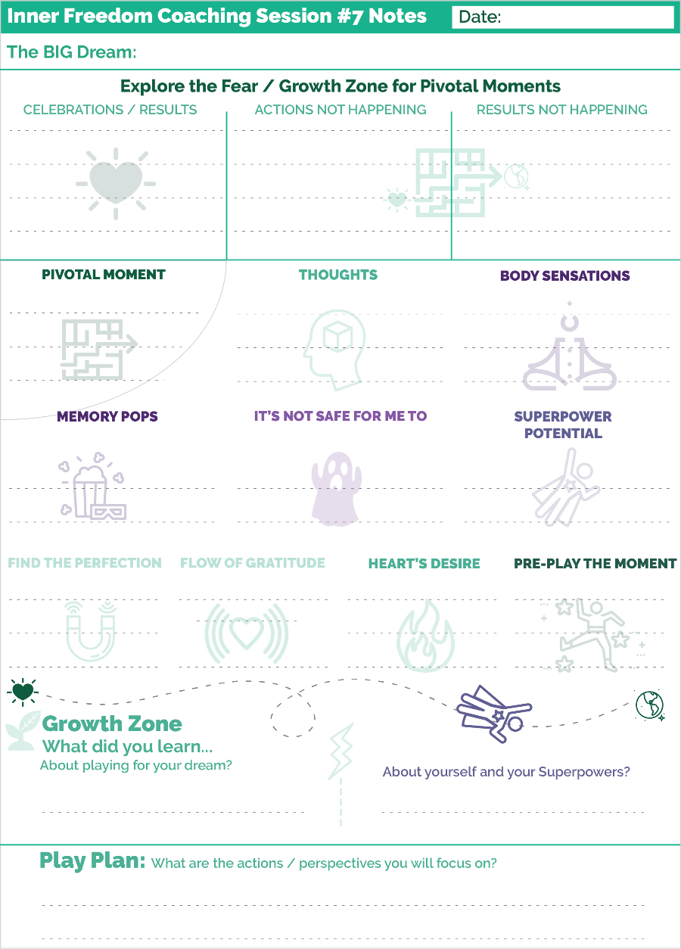
We start the session with the usual…
1) Share your dream – this amplifies your connection to the Supermind
2) Celebrate results, challenges and growth… also… The Supermind!
3) Explore what is NOT happening with judgment free awareness.
Jump into Inner Freedom… (As we just walked through)

1) Choose a Pivotal Moment and play the scene in your imagination.
2) Review thoughts with judgment-free awareness
3) Feel into body sensations (Allow)
3B) Explore memory pops
4) Voice Body Beliefs: It’s not safe for me to:
5) Explore Superpower Potential
6) Find the Perfection of the current situation and memory pop situation
7) Embrace the Flow of Gratitude
8) Voice your Heart’s Desire (Respond)
9) Preplay the moment (Co-Create)

Then…
Get into the Growth Zone.
It is super important to speak and capture the growth you experienced in the session. Your conscious mind needs this constant reinforcement.
Superpower Awareness
Every Inner Freedom session is another exploration of the treasure map in your non-conscious mind. Make notes about any inklings you had about your lost playfulness and unique power.

**!!** {End of Player Playbook} **!!**

Coaching Notes for Session #07- The Superpower Zone
New (full) version of Step #6
We add step 6B: Find the Perfection in the Current Situation
6B is about exploring the Pivotal Moment as a challenge with a growth opportunity.
This inquiry is based in the interpretation that when you are playing for a DREAM, EVERYTHING that happens is happening for the purpose of you living your dream.
This is different than the typical Industrial Control Mindset which says that anything happening that is not according to the plan is a problem that should NOT be happening.
This Industrial Control Mindset is why we experience so much frustration in the first place. HAH! But our plan is to guide our players to shift from stressful control to joyful co-creation.
The perspective is: every challenge - every result that is not happening, every intention that is not unfolding - is presenting a growth opportunity for the player.
Using the “BIG Dream is a video game in the video console of life” metaphor, every situation that comes up, is part of the game!
As a coach, your role with the player is to continue to encourage them to see every situation from this perspective.
Along the lines of the video game metaphor, every challenge also presents an opportunity to discover or practice use of a Superpower. It is the challenges that call us to use our Superpowers for good.
A quick point about the Coaching Guide:
Step 5 Explore the Superpower Potential follows Step #4 where we give voice to the body belief; we try to figure out if the non-conscious body belief is hiding a Superpower. Then in 6B we are exploring the current challenge and how it is asking the player to grow; which also connects to the Superpower.
These seem similar. But one is coming from the past – the Inner Experience - and the other comes from looking objectively at what the current situation is calling for.
Often these will be the same thing. But sometimes they will be slightly different. It’s up to you to navigate this gracefully with the player.
This is all part of the “reading the treasure map” skill set. It is all about looking for clues. Sometimes the clues are redundant. Sometimes the clues take you in different directions.
Your role is to make it all seem connected and fun.

Shift gears to look for support
**!!**
SAY: Often in the face of a challenge there is support around you that you are not seeing. The universe always provides support when it throws a challenge your way.
ASK: What support can you see if you really open up look for it?
**!!**
In the flow of the coaching session this question can seem to come “out of the blue” because up until this moment the whole experience is very inward focused. Then this question asks them to look at the world around them. It can seem a bit jarring.
But at the same time, when the player is feeling safe and open, it is the perfect time to ask them to use their imagination to SEE what support is around them. They will often have ideas pop into their mind of people that they can ask for support that never occurred to them before.
And then the next question is about the growth needed to allow support in?
This is a big growth because in order to allow support in you have to feel that YOU are worthy of support; and that your dream is worthy of support.
As a coach you need to hold the perspective that whenever there is a challenge, there is always support available that is EQUAL to the challenge.
Step #7 Experience the flow of gratitude
This step is all about connecting the dots between the dream, the current situation, the earlier moment revealed in the memory pop and “who” the player needs to become to rise up to the situation.
You ask the player to connect the dots. Definitely leave a LOT of silence after this question! This is typically an “abera ca dabera” moment that the player will create as they start speaking. This is for sure NOT a “right answer” type of question. So encourage them to just start explaining it and talk their way into it.
Also, you may need to share an observation about the connections you see.
Often they will say something like: “Oh, at first I thought this memory pop was strange and made no connection to this situation. Now I see it was exactly what I needed to see to understand this pivotal moment”.
Coaching Notes Playsheet
YES! Write a few notes on the Coaching Notes Playsheet. Keep doing this during or after every session.
This is the first coaching notes sheet that has the whole method on it.

Inner Freedom Method Step 7: Embrace the flow of gratitude
The BIG idea of gratitude is this that when you feel gratitude:
- you feel connected to life;
- you feel that your Dream is unfolding in just the perfect way
- you feel that your non-conscious mind is mysterious and powerful
- you feel that the situations you are in are exactly what you need right now
- you feel that your human superpowers are amazing and coming on line
- you feel that your unique superpowers are expanding every day
- you feel encouraged to make the changes you want to make
- you feel empowered to grow and play
When you feel this way, your energy is aligning with your dream and the actions you want to take get easier and easier. The results you want to co-create feel more in the flow.
Gratitude is a popular topic in self-help circles. It is powerful because a deep sense of gratitude is a powerful energy pattern. But how do we experience “deep gratitude” where you “feel it” and “think it” and “experience it”.
This is the ultimate outcome of the Inner Freedom Method.
An important point before we dig into it a little deeper
Embracing the flow of gratitude is a Life Coach perspective on life. You can choose how you want to blend it into your beliefs about the “Energy Side” of Life. Also, it is not necessary for your player to see this the same way that you do. You can hold this perspective and “come from” it without “teaching” it. It is baked into the method and spritzed lightly in the Player Playbook; like a lemon zest ;-)
In this part I use the pronoun “you” to represent the player.
It starts with the purpose to play BIG – expressing your talents in a way that adds value to the lives of others. When you play BIG with a heart-guided intention a LOT of energy starts to flow.
Then you feel the energy in your body and uplevel your understanding of energetically charged events in your past. You see how they served your bigger purpose.
Then after steps 3 and 4 – with the presence of the Coach - the body feels safe.
Then the mind opens up – the imagination activates - and begins to think in terms of possibility rather than self-preservation.
Then you start to see and experience the perfection of the current moment. Your experiences of support and challenge are ALL serving your hearts intention; they are all building toward the Dream.
You begin to feel that “the Energy” – or the field or “life force” - IS playing on your team; then that shifts to you seeing that you are on the World’s team!
Then the dream flips:
From: this is MY Dream to get out into “The World”
To: this is “The World’s” Dream that I am playing for; that I am a vital part of.
When you can live as if both are true at the same time then you are really feeling connected.
It becomes: “Oh I see. ‘The World’ gave me this Dream to call me toward becoming my FULL Self; to encourage me to live a FULL life.”
When all of this comes together – you feel it deep inside of you; then you are truly free to play BIG, to express yourself fully, to LOVE all of life’s experiences and to fulfill your purpose in the world one beautiful moment at a time.
The big question is: who must you become?
IF you desire THAT experience...First you must become THIS bigger version of you.
It helps to see it as a virtuous cycle: your desires attract experiences to cause you to expand and allow the desire to unfold. Then the next desire / Dream comes into view.
(You plug the next dream in to the video game console of life)
When you do, you can play big and enjoy ALL of it.
AWWWW YEAH!!!!!!!

Connect the dots
Connect the dots is a metaphor - that most people understand – that comes from a type of puzzle where you draw a line from one numbered dot to the next. As you connect the dots a picture emerges. It’s a fun type of puzzle. And it beautifully illustrates what we are doing in this part of the method.
When you explore the Dream, the Pivotal Moments, the Memory Pops of past moments, the Body Beliefs, the discovered Superpowers, the Perfection of the Situations… week after week… a picture emerges.
How the BIG dream attracts the perfect growth opportunities.
How a memory pops out of the Non-conscious Mind to provide perfect clarity for this situation; to understand who you are; to understand your current beliefs; to see the superpowers to reclaim for who you can become.
How amazing it all is.
Important: it is SUPER hard to connect the dots on your own. You will probably need to share a few possibilities and observations to spark the exploration.
When you ask the player to connect the dots - whether they see something or you see something – it creates an undercurrent of awareness that all of this is playing together for something beautiful to emerge.
Connecting the dots is another way of describing looking for clues on the Treasure Map. The Treasure Map is another metaphor that describes the adventure of searching through mysterious territory looking for something of great value.
You can think of connecting the dots puzzle in each coaching session as one of the many clues on the treasure map.

All challenges are an invitation for growth
This is another concept from the category called “How Life Coaches View the World”. LOL.
The idea is that when you play for a dream (plug a game into the video console of life) there are no challenges that are impossible. Every challenge is an invitation to grow AND the growth is possible.
It could be a Superpower within you that is being called out.
Most likely this superpower will require quite a bit of newfound wisdom.
Most likely this superpower will have a healthy dose of fear clouding it.
Most likely this Superpower will require quite a bit of practice!
It’s there… but growth is required.
It could be a resource around you that you can find and utilize.
Most likely this resource will require you to embrace the social risk of ASKING.
Most likely this social risk will have quite a healthy dose of fear clouding it.
Most likely making this ASK will require quite a bit of practice.
It’s there… but growth is required.
As Life Coaches, we are the Champions of Dreams. We guide people on the growth oriented adventure to become the person who can live their dream.
No matter what the challenge is for the player, we hold the framework that the challenge is an invitation for growth. We encourage the player to accept the invitation and then we are on for the next adventure… together!
Voila! Life Coaching. ;-)

Understanding Perfection and being fully engaged and in the flow of right now (From 2010)
Understanding Perfection is essential to masterful coaching.
It is one of the coaching proficiencies: Recognize the perfection in every situation
And one of the Frameworks
There is a perfection in every situation.
It allows you to be fully engaged in the flow of right now, empowered and resourceful.
It gives you power in the domain of Action and the way you interact with the world
What does it mean to see the perfection in the situation?
You see what is happening as serving your intentions and Dream in some way.
You see the BIGGER picture of how each moment in “your world” is a part of a bigger whole.
TRUST: there are many paths to your heart-based Dreams; so even if what is happening appears to be a setback, it may prove to serve your Dream in a way that right now you cannot see.
Clarity of purpose and clarity of intention make it easier to see this framework
In our play language we would say: When you are playing for a heart- based Dream, the World plays on YOUR TEAM
However, you have to know HOW the World plays!
The World plays BIG. So when it sees that you have the desire to play big, it will send you BIG challenges so that you can step up and become a big player
It will also send support, but you have to be willing to see it and receive it.
The World will align to prepare you to become the person you need to be to manifest your Dream!

Expand your understanding of the Pattern Language of Self-Preservation Intentions (2010)
In Chapter 4 I shared with you about my ah-ha moment of discovering the phrase: : It’s not safe for me to {fill in the blank}. Well before we had the technique for voicing the body belief we used a different approach. After the player shared about the memory pop experience we asked them to describe the intention that was trying to keep them safe. We called this the survival intention.
It was a pretty clunky process!
I think learning about the old way will give you some deeper insights into the Inner Freedom experience.
What is a Survival (Self-Preservation) intention?
These body level feelings become the non-conscious beliefs (now we call them body beliefs) that drive MOST of our behavior.
- It is a decision you made about what YOU must do to survive in this world (to avoid pain/trouble)
- It is a decision you made about what you must NOT do to belong in this world (to avoid pain/trouble)
- An intention to: Keep safe - Stay small - Fit In
- An intention to stay out of sight - avoid trouble
- Your story of where you fit in the world
- Your beliefs about how the world works for you
- An intention to avoid disappointment; don’t ask for what you need; do not go for what you really want
- Often the Self-Preservation Intention “explains” why you “do what you do” or “don’t do something you want to do” in your current situation.

Key Distinction: Pattern Language
- Pattern language is a phrase that captures the essence of the experience.
- You want to find a phrase based on what is shared about the earlier moment; it really captures the energy and emotion of the experience; as close to the words of the age of the memory as possible.
- don't try to be nice about it NOR judgmental
- shine the light on it by stating it plainly
- if it was a painful decision to make about life state it in a way that captures the "pain"
- emphasize that this is a pattern of thought
- The player can probably think of many instances where it played out in a similar fashion after the original time; This is because once we make a decision about how the world works, the world works that way.
- We mostly see and experience the world around us based on the patterns that are already in our minds. Until we use Inner Freedom that is ;-))

We become what we see in the world. We see in the world what we have become.

Examples: Language patterns we use to keep ourselves safe
> "Nothing I do is enough so it is best if I don’t try too hard".
> "If I win I will suffer, so I won't win".
> "If I go for what I really want I will be rejected or disappointed, so it is better if I don't ask”.

Expand your ability to create maximum value and awareness from “memory pops” (2010)
There may be times with your player that you both want to deep dive into the experience coming up in a memory pop. These notes from the early version of the Method will illuminate your path.
Note we used to call the body belief a survival intention. In this text I have changed it to a phrase more in line with our current version: self-preservation intention.
YOUR capacity to feel affects your player
1) Your Coaching Presence is a HUGE gift.
2) A player will only share a memory that they feel YOU can handle.
“If I can’t share my pain with you, without you trying to fix it, I can’t tell you anything.”
3) You can talk about anything YOU are comfortable with
4) If you are not comfortable talking about a memory...
a) help them make a plan for who they can talk to.
b) shift the attention to the present moment and how they can bring wisdom to the situation
There is power in your ability to see the perfection; the key to coach’s comfort is practicing seeing the perfection in life situations.
Seeing the perfection in a situation is a HUGE Self-Worth building for the player.
To get a memory pop...
After having the player feel the energy in the body,
ASK "when was the first time you remember feeling this sensation in your body".
WAIT and LISTEN.
Then move forward with the method.
Key points about how emotional energy gets stored in the body
Any experience that has MORE emotional energy than you are equipped to handle at the moment - will be stored in your body.
MANY events that were emotionally overwhelming to you as a child will be seen as "normal" or " part of life" as an adult.
AND ... THIS IS IMPORTANT: Death and violence ARE a part of life. Sad, and true.
You will have players with memory pops where they were the victim of violence; physical, emotional, mental; you need to be prepared to be charge neutral (judgment-free) for these explorations.
Sometimes they will be the perpetrator of violence or the cause of a tragic event; you need to be prepared to be charge neutral (judgment-free) for these explorations.
What to do when the memory pop reveals an experience of violence or tragedy...
1) Be fully present - compassionate AND not getting lost in the story or taking sides
2) Warmly matter of fact - you embrace that this happened - RELISH TRUTH
3) Recognize the perfection - you hold the deep truth that no matter what happened there was “a perfection” to how they chose to respond in that experience; not necessarily to the experience itself.
Somehow what happened fueled them through life in some way that served a greater purpose for them.
4) Don't DWELL on what happened!
Go right into - what conclusion did you come to about life?
How did they find a way to survive the situation; to “play safe”.
This is where you will find the pattern language of the self-preservation intention.
One fact that cannot be disputed: they survived!
5) Move through the method - focusing next on what is the perfection of self-preservation intention.
How did it protect you?
Or
How did it propel you forward in life?
BIG INSIGHT: In an violent situation there is often an inner response that fuels growth: I am going to prove to you that I AM somebody.
OR, it is not true what you are saying about me.
Or, I am going to make sure this never happens to me again.

This "I will show you" is a POWERFUL source of fuel that may have propelled your player forward in life.

How to deal with a memory pop of a traumatic moment
1) Remember, they will only share the details if they feel safe with you, that they feel that YOU can hear it. The benefit of hearing a little bit of the detail is that it supports the conversation to understand and articulate the self-preservation intention. BUT… it is not essential.
2) If they share something that YOU are not comfortable talking about, ask them not to get into the details. Move the conversation toward the survival intentions that came out of the moment
3) As a coach you can talk about ANYTHING that you feel comfortable talking about. You are a life coach. so anything in life is possible to talk about. (Even if you think of yourself as a business, career, executive coach etc. you are still in the domain of a “life” coach. So be prepared for ANY part of life to enter into your coaching conversations.)
4) Many coaches fear that talking about past moments that were traumatic is doing therapy. It is not! Talking about past moments is a fully human experience and cannot be “owned” by any profession. It is only therapy if you claim or attempt to heal it in some way. You are exploring the past moment to come to co-create awareness of the self-preservation patterns to contrast them with the intentions of your Dream.
5) As a byproduct, it is often a "healing" experience. But this is not your focus. Remember you are not trying to release it or fix it.

The Three Shifts (From 2010 Version)
In the Player Playbook I shared a model of the 3 Energy Shifts that are facilitated by the Inner Freedom Method. I love this model
In this section is a collection of notes from the 2010 version of the Inner Freedom Class. I think you will find them complimentary to the new descriptions.
A lot of this content was gathered from in-class conversations with Life Coaches.

Understanding Frustration and the shift from control to co-create (2010)
The experience of Frustration
This is a collection of comments from students in class
- Unfulfilled expectations
- Worse than expected
- Things don't go according to plan
- I know my purpose but it is not happening
- I am not sure what I should be doing and trying so many things and not getting results
- Everyone else can do it but I can't
- This is not fun, I can't, why am I doing this? I am full of doubt.
- Trying to do something but it is not working
- I have a picture of results - the way it should be but it’s not happening
AND - I keep going for it – I am not in apathy

Shift from Control to Co-create
The natural approach to any endeavor is to do what has worked in the past; to use your control. It has to be THIS way.
What are we trying to control?
- People
- Results
- The outcome
- The steps to an outcome
- Circumstances
- The environment
- Our own reactions / perceptions

Co-create
Co-create is when you are in the flow with what is happening in the world around you.
You have an overarching understanding that whatever IS happening, is serving your purposes in some way; EVEN when what is happening seems to be going against your purposes.
This state is also called being in tune with “what is”.

Isolation and the shift from React to Respond (2010)
From React to Respond by “Thinking holistically”
Transformational Shift: From react to respond
React - your mind supports your Preservation intention (usually keeping safe, staying small or fitting in)
Respond - Your mind chooses to support your Heart’s intention to play BIG
Your mind is your ally when you can think holistically – by seeing the whole picture - about the current situation without emotions from the past clouding the picture.
This is why thinking comes AFTER feeling the energy. When your body is feeling buzzing energy from the past it will focus your thought process on preservation.
When you feel the energy your body feels safe and then your mind is free to think thoughts that are aligned with Playing BIG.. This is when your mind becomes the ally of your dream.
Another BIG point here: When you practice feeling into the energy caused by earlier moments in life, you can then more clearly feel energy related to present- moment intuition. There will be times when what you feel in your body is a “knowing” that IS related to what is happening now and that your conscious mind should pay attention to.
Key Point...
What are often described as “Negative thoughts” are almost always thoughts serving a PRESERVATION – non-conscious – INTENTION to keep safe, stay small or fit in. And they are serving IT in a positive way. There is nothing wrong with the thoughts you have.
All thoughts serve a purpose. They may NOT be serving your new Heart’s intentions for playing BIG – but they ARE serving something.
Your mind is powerful and we will make it the ally of your dream by creating awareness of the PRESERVATION INTENTION, seeing the value it has had and then choosing a new intention. “Personal Growth” occurs when you expand your palette of intentions and corresponding beliefs and consciously choose the ones you want to focus on right now.

CREATE New Pattern Language
With your player in a relaxed and open state you begin to explore with them options for new Pattern Language.
This new Dream pattern language creates a CHOICE that is a step beyond the PRESERVATION Intention Pattern Language.

Overwhelm and the Capacity to Feel = resist to allow (2010)
What Overwhelm Really Is
- Overwhelm is resisting feeling; a physical sensations in the body
- The experience of overwhelm is too much feeling - it is a breaker switch that cuts off body awareness -
- The experience is feeling frozen - stuck
- I don't know what to do
- You KNOW with your body - your body is your non-conscious mind
You THINK with your conscious mind using reason and logic
- The expressions "I know in my heart" or "I knew in my gut" are not metaphorical. They are physiological reality
- When you resist feeling you disconnect from your body - your body is where you KNOW
This is why you feel like you don't KNOW what to do.
- I don't know = I'm not connected to the energy in my body = I am overwhelmed
- The optimal state for powerful action is when feelings (intuition and body wisdom) and thoughts (reason and logic) are aligned
Your Body is an Energy Pipe
Your body is like a pipe that energy flows through. The size of the pipe expands throughout your younger years and you can continue to expand it as an adult through body awareness exercises. Most life experiences stir up very little energy so it flows right through us. But some experiences – especially when we are young but occasionally as an adult too – cause BIGGER energy than we can handle at that time so we “go into overwhelm” and the energy gets stored in the body.
Also, when a present moment is energetically similar to a moment that is stored in the body, your body will BUZZ with stored energy.
Going into “overwhelm” is like a “breaker switch” for the pipe. Instead of flowing the energy by feeling it we store it and go numb to it or release it with a physical reaction like crying or laughing.
This is also the explanation for the myriad numbing activities (when done to excess) that humans are known for: alcohol, drugs, television, web surfing, social media scrolling, porn, shopping, caffeine, sugar.

What about "too much to do" overwhelm?
You can only do what you are doing right now.
Overwhelm is caused by the feelings you have about what you are NOT doing.
Or the possible consequences of what you are not doing.
What about "too much information" overwhelm?
This is usually caused by intense feelings of fear of disappointing yourself or someone else because of what you won't be able to do if you can't retain all of the information.
What about "too many choices" overwhelm?
This is caused by intense feeling of loss about what you don't choose; or the fear of choosing the wrong thing.

Why expand the capacity to feel?
Expanding the capacity to feel through body awareness is like expanding the size of your pipe. More can flow through without getting stuck.
The benefits of expanding the capacity to feel?
- Greater access to wisdom
- Less experience of overwhelm
- Great ability to stay "present" in the moment no matter what is happening or not happening
- doing the feel the energy exercise is like going to the "body awareness gym" to expand your capacity to feel
Key point: A BIG part of coaching is to help your player expand capacities.
The Bottom Line: Feeling Capacity is like a pipe - expand the bandwidth so more energy can flow - less overwhelm, less freezing, more presence, more freedom and power in the moment

Class 07 Prep
We will explore a few of these questions in class.
The Inner Freedom Method Review
- Describe step 5 = Explore Superpowers
- Describe step 6 = Find the Perfection
- Describe Step 7 = Embrace the Flow of gratitude
- Describe step 8 = Make your mind the ally of your Dream
- Describe step 9 = Preplay the moment with new awareness

In a hero’s journey every challenge reveals either a hidden superpower within the player OR an unseen support around the player.
Question: Describe the Pull… between the social safety instinct and your dream. Either the concept OR an example from your life OR an example from a player

Chapter 8 – Make Your Mind the Ally of the Dream

“You can make more progress toward your dream by playing with a few high-impact social risk activities than a month of safe, under control tasks in isolation.”
-Coach Dave Buck ;-)

Chapter 8 Prep
Before Class
Read through the complete coaching guide for Session 8 (Page 61)
(this is a link to the PDF with the complete set of coaching guides)
Listen to this audio to prepare for Session 8.
(this is a link to the Player Prep SoundCloud audio)
Listen to Coaching Demo of Session 8
(Coach Dave and Player Leanne)
Playsheet Pack: Print 2 copies of page 13

{From the Player Playbook}

Session #08) Make the Mind the Ally of the Dream
In this chapter we are going to explore…
1) Your Playful Conscious Mind (The Energy Alignment Game)
2) Step #8 Make your Mind the Ally of the Dream
3) How to explore Social Reward and Social Risk
4) A concept called: Expand Your Band
5) It’s Go Time!!
6) Why your coach wants to Expand Your Best Efforts
7) Prepare for Session #8: Role Play a BIG ASK, then play with the fear.

Playful Conscious Mind (Energy Alignment)
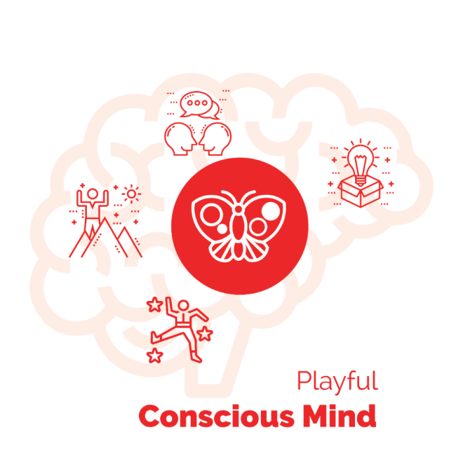
Think playfully.
Act playfully.
Your playful mind was squashed pretty hard in the Industrial Age. BUT it is in there. Hopefully you are starting to recognize it, embrace it and listen to it.
And also recognize it is NOT easy to shake free of the Industrial Mindset of working on tasks in isolation and doing everything perfectly, never make mistakes; only do what you can control.
“If you ask for help you are a cheater”. We heard these messages and saw them play out over and over. You saw kids in school being shamed for getting wrong answers or low grades and it probably happened to you as well.
BUT… You are a human and all humans are born to play.
The spirit of play.
Curious and Creative
Resilient and Resourceful
Explore and Experiment
Wonder and Fun. And Joy
Enjoy the activity… enjoy the challenges.Enjoy the unknown.
Enjoy the growth… enjoy the pursuit of getting good at actions and results.

Choose to Play for influence in the your community… for your company… in the world.
This is the calling of your dream.
Let’s explore the relationship between the playful conscious and the other elements in the Energy Alignment Game.
Super You – playful YOU wants to be awesome!!
Non-conscious Mind… It’s complicated. When you feel socially safe, your non-conscious mind will supply you with amazing insights and spontaneous playful ideas. When you don’t feel safe your non-conscious mind will stop you from playing and work to keep you small.
Environment – That depends!! When you are in an environment of profound belonging it will call for your playfulness and Super YOU. There will also be people who you observe and get inspired by. In an environment where you and your playful power don’t belong, you will feel the 7 social fears of playfulness quite intensely.
Supermind – The sense of wonder; the trust in life… embracing what is happening and responding to it resourcefully…these are playful.

The BIG idea is this
When you work… you are a replacable cog in the wheel.
When you play..YOU matter! Your unique abilities and contribution make the diffference.

Step #8 Make the Mind the Ally of the Dream
You have experienced Step #8 several times by now. Hopefully you have noticed how different your mind is before and after feeling the energy in your body and giving voice to your self-preservation beliefs.
When your body feels safe,
AND you feel profound belonging with your coach,
your imagination activates and your mind opens up to new possibilities…
it can “see” and “feel” what your dream wants you to do; and who it wants you to become.
And then you can give voice to your heart’s desire.
Your Coach will ask you: What is your Heart’s intention in this situation?
OR What does your dream want you to do?
Both of these questions give you the opportunity to “Abera Ca Dabera” – I create as I speak - for your dream.
A really important point here that I have shared a few times: this is not something you can easily do by yourself. This is a co-creative experience. The presence of your coach – who shares your dream – creates the belonging and social safety that allows your mind to open up.
Thought Layer – from React to Respond
Steps 2 and 8 are connected in the Thought Layer of the Inner Freedom Method Model.
When your body is feeling fear… then your mind’s #1 job is to preserve the status quo and stay safe; which resorts to the logic of the Industrial Mindset.
Often in the “reactive” state the Industrial Mindset will serve up thoughts like: “leave me alone so I can do my work”. This leads to isolation.
When your body is feeling belonging… then your mind’s #1 job is to contribute out in the world… to play BIG for your Dream; it taps into your imagination and connection to life.
Often in the “responsive” state the Connected Mindset will serve up possible ways to reach out, team up and co-create with others.
Use Colorful Language
The Coaching Question is: What is your Heart’s Intention in this situation?
Sometimes there is a clear directive for action. This is what my heart wants me to do…
Sometimes it is more of a becoming; something more about expressing your superpowers.
A good way to explain colorful language:
- The words paint a picture you can see.
- The words describe an experience you can feel.
In other words, after a deep exploration of Memory Pops, Superpower Potential, Finding Perfection and Embracing the flow of Gratitude, your Heart’s Intention will speak to you!! Abera Ca Dabera. LISTEN!!
Use the Superpower Playsheet
You will have some words come up during the session with your coach. Remember the key is not to force the words; but rather, allow them to come through you. (This takes a little practice)
A fun idea is to review the Superpower playsheet (the 64 Superpowers of Play) right after the session to see if any of the phrases jump out at you to explain who you dream wants you to become.
Examples:
#19 Approach with Sensitivity – Inner Drive to Connect … one of mine.
#38 Inspired Fighter for Freedom and Underdogs … one of my favorites
#49 Wise Rebel for New Principles … another favorite!

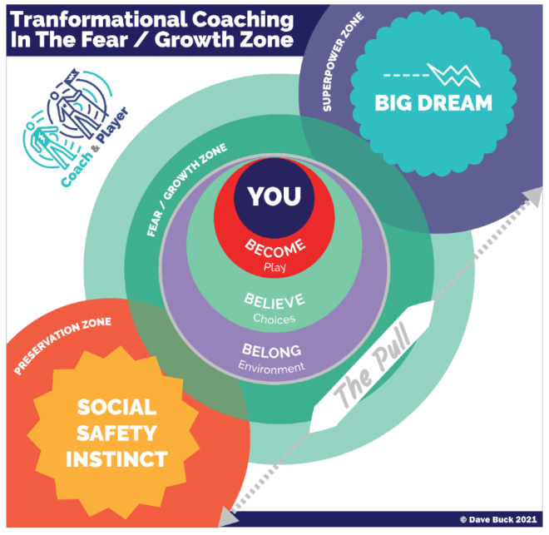
Explore Reward and Risk – Feel the Pull and Then Choose!
Inner Freedom is the ability to choose when you play BIG for your Dream and when to play SAFE for (self) Preservation:
- When to risk your social status for the potential reward that could move you closer to your Dream.
- When NOT to risk your social status and focus on tasks that preserve your place in the social status quo.
The most important THING is to honor both options.
AND recognize that engaging with reward and risk is the essence of playfulness!!
Use judgment-free awareness about the need to play safe sometimes.
This will free you up to play BIG more often than you do right now.
The FEELINGS in your body are not going to go away.
The physical sensations that accompany social risk will always be a part of your life.
The key is to notice them, listen to them, embrace them and give them honor in your life. Then you are free to choose when to play safe and when to play BIG

Expand Your Band
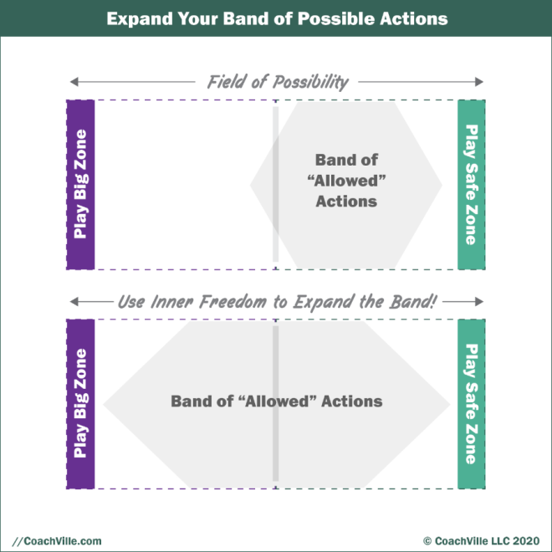
This is a fun model to open up some new possibilities for you; opportunities to expand into more activities of social risk for social reward.
After being diminished by the Industrial Culture we have a relatively small “band” of activities that we feel we are allowed to do. AND a LOT of activities that are possible but we feel that we are NOT allowed to do them; so we don’t even think of doing them. This is the wide range of actions that we either got in trouble for or witnessed someone else getting in trouble for.
An example would be: Asking for what you want; or speaking your truth to someone who has more power than you do.
So now we find ourselves with a band of allowed activities that is mostly in the Play Safe Zone.
Your coach is aiming to help you see more of the field of possibility!
Coach Manny (my “boss” for 14 years: “great players can see the whole field and choose what the game is asking them to do.”
Now Coach Manny was talking about the Soccer Field; but the same truth holds for Life and the Field of Possibility!
When your body feels safe and your mind is open your imagination can see more of the field!

It’s GO TIME!!
There are 4 sessions left in this adventure with your coach. Possibly there are many more to follow, but either way, now is a great time to pump up the volume.
Now is the time to embrace your emerging freedom and play BIGGER.
Imagine the BIG actions – with plenty of social reward and risk – that you can practice with your coach and then play with in the world.
When you play with a Social Risk you may gain a social reward… AWESOME.
OR you may experience some new doubt or fear which gives you a new pivotal moment to explore… also AWESOME.
- Try something new / Experiment
- Explore a new community or network
- Reach out to people… ASK for things / Offer things.
- Create something and then share it… something meaningful

Expand your best efforts…
It’s your coach’s job to push you!!!
Thomas Leonard – the founder of Professional Life Coaching – called Coaching Proficiency #5: Expand the Players Best Efforts.
Here are a few thoughts from this classic body of knowledge from 20 years ago so you understand where your coach is coming from:
Expand Your Players Best Efforts
One of the reasons players hire a coach is to support them to do more in a shorter period of time than they would do on their own. Hence, the Certified Coach acts as both a catalyst and accelerant. By supporting the player to do more than they have done or think that they are capable of doing, significant value is added.

Your player has done well, but is it the best that they can do?
1. Players hire coaches to help them do more than they would do otherwise.
2. Whether they actually do more is up to them, it's up to the coach to introduce the possibility and make the request or invitation.
3. Even though the player may feel that they have made their best efforts, the coach shows them an even bigger picture.
4. Expanding may mean adding new players, earning more income, being more productive.
5. Or, it may mean accomplishing the same results in a shorter time, with less effort.
6. It may mean taking the goal and moving it into a much, much larger frame of reference.
8. Your player's expanded success in a particular area can redefine their values. It can shift their priorities; make them think differently about their goals and purpose.
9. You will have given your player a new environment where they can evolve for the next 20 years - it's very empowering!
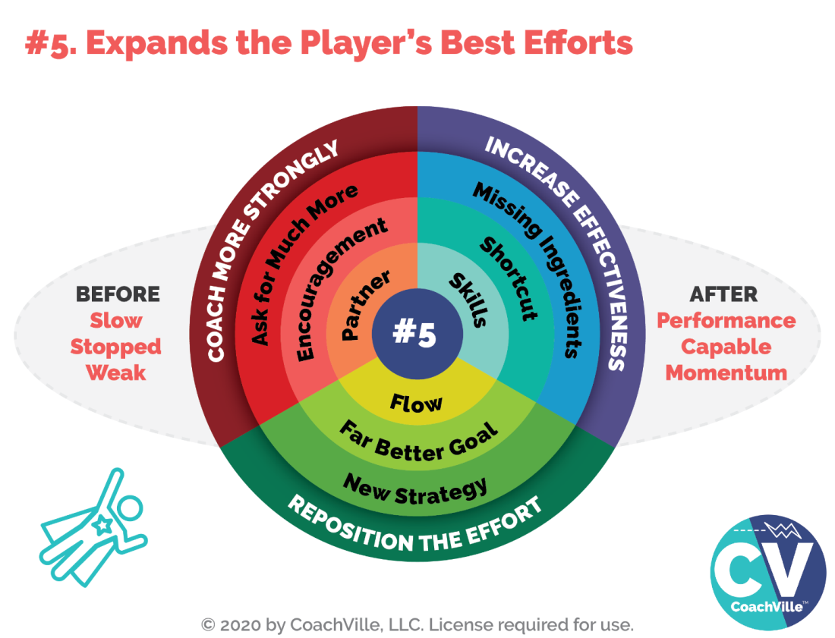
- Coach more strongly.
Ask for much more than the player expects. Encourage the player. Act like a partner, and ask them to do the same.
- Reposition the effort.
Develop new strategies. Establish a better goal. Look for the flow.
- Increase the player's effectiveness.
Identify the missing ingredients. Help them identify and utilize shortcuts. Identify what skills are missing and help the player develop them.
What are the areas to expand?
1. Action levels.
2. Performance.
3. Capabilities.
Recognize the player for what they have already done, then expand their awareness as to what they are truly capable of doing.
1. Recognize and acknowledge what the player has already accomplished.
2. Then suggest a bigger result, and ask the player to react.
3. Expand until your player resists, don't back off too soon.
4. Bring emotional motivation into the conversation, asking how they would feel after
5. Ask for an even greater best effort. Build on their answer, asking how they could carry that feeling further into their future.
6. Expand your players thinking beyond just numerical results.
7. Ask them to think in visionary terms, Move from personal to community.

FUN!!

Prepare for Session #8 – Make Your Mind the Ally of Your Dream
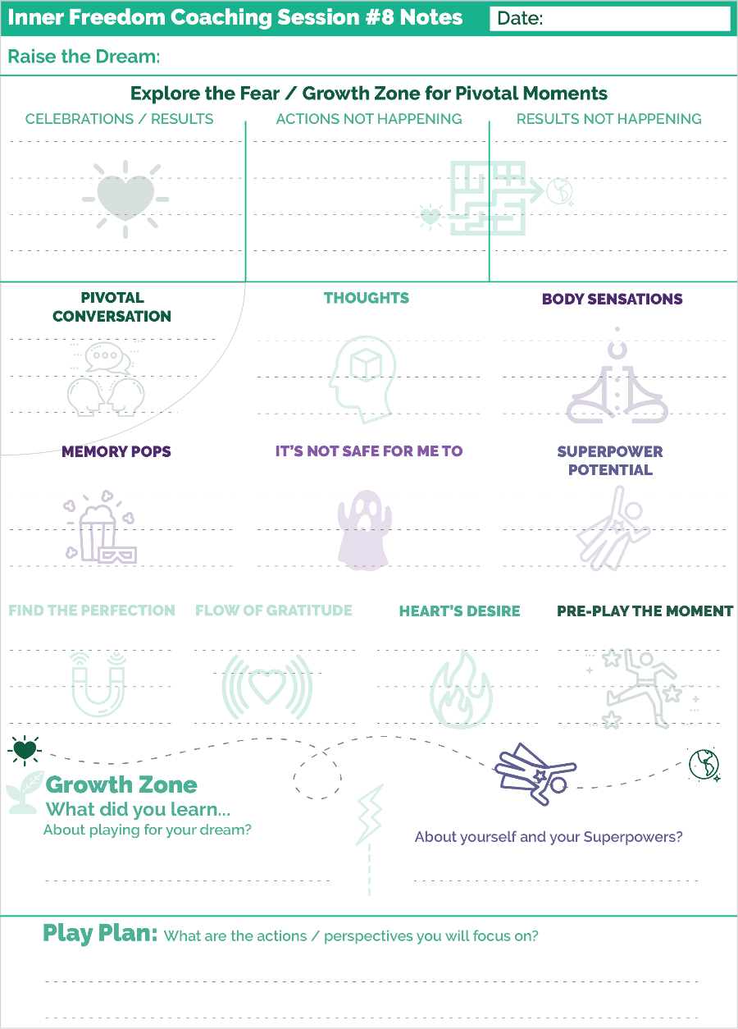
Role Play PLUS Inner Freedom… Again
In this session we are going to do a Role Play with a BIG ASK.
Think of the invitation, request, offer, pitch to an influencer for something you wouldn’t normally ask for (remember to expand your band).
Think of an ASK that you know will bring up some fear when you think about it. Then use the Inner Freedom Method to clear the path energetically!
Look for an opportunity to use your power in a unique way.
Remember when we do the Role Play + Inner Freedom:
Step 1) Role play the BIG ASK and call time out when you feel the fear.
Steps 2 – 8) Use the Inner Freedom Method to explore the FEAR and energize your dream.
Step 9) Rather than preplaying in your imagination, you go back into the Role Play and notice your clarity and confidence.
THEN… go out in the world and PLAY… make the ASK; make a BUNCH of asks. Remember… this is your BIG Dream… AND the world needs your dream to happen. Allow influential people to support your dream.
Ready to go!
Remember that your coaching session is a co-creation with your coach. It is not a test; it is not a counseling session to talk about your problems. It is an opportunity to explore new ways that you can play BIG for your dream. To prepare for the session all you need to do is look over your notes of your pivotal moments for a Relating for Influence opportunity.

**!!** {End of Player Playbook} **!!**

Coaching Notes for Session #08 - The Whole Method + Role Play
We did the Role Play + Inner Freedom Method combination a few sessions ago. So your player will be familiar with this experience.
Now is your opportunity to raise your game a little bit!
You do this by challenging your player to practice a conversation for influence that has high social reward potential.
You can raise the level by encouraging your player to practice using one of their superpowers in the role play; maybe a power that they might feel some fear about expressing.
You can also raise the level by spicing up the challenge that you provide as the other person. You can add twists into the situation that will spark their fears.
These are just ideas! It is the role of the coach to provide the level of challenge that will best help your player grow; remember to observe your player closely as you play together.

Quick overview of the flow
a) Step 0: Choose a conversation to practice
b) Step 1: Replace the Preplay with a Role Play
c) Call time-out in the Role Play
d) Do the Inner Freedom Method! Especially… find a Superpower to practice.
e) Go through step #9 Preplay the Role Play (with Dream Language)
Note for class: with your class partner, the key is to practice the flow of Role Play – Inner Freedom. You may not have time to go deep into steps 3 and 4 in class.
For Step #8 you need to expand your ability to create new pattern language
This is from Step 8 Coaching Guide: Make your mind your ally
**!!**
ASK: What is your HEART’S intention in this situation?
Listen. Also you can remind them.
SAY: Let’s create a short phrase that captures the essence of your HEART’S Intention to step into the Growth Zone.
PLAY WITH THEM! You can keep exploring examples until you feel that they have one that feels right when they say it;
This step is where you create new pattern language for the HEART’S Intention.
**!!**
The Short Phrase is called Pattern Language. There is not a precise way to do this because it is a co-created exercise. In this and the next few sections I will share with you a bunch of ideas to help you understand how to approach this step.
Pattern Language – a quick definition:
1) A phrase that brings an experience to life.
2) It captures the energy essence of something/experience/place
3) It is often a simple statement of capability.
When you co-create pattern language, it’s not about finding the perfect pithy phrase. Just find an energizing phrase that moves the process along.
You want to find a phrase for WHO the player wants to become, what they see themselves doing or a new belief they want to energize to counterbalance a Social Safety Body Belief.
A few examples are:
- I am really creative when talking to potential customers.
- It’s good for me to ask for what I want.
- I am allowed to win.
- I can enjoy what I am doing.
- It’s safe for me to express my XYZ Superpower
Here are few steps to identify the Heart’s Dream intention pattern language.
Step 1) as your player is sharing about the Heart’s Dream intention and who they want to become to create the new results that they desire. As they share, you listen for a phrase that seems to “light up” when they say it.
Step 2) You continue to dialogue with your player to hone in on one or more of these Power Patterns and then ask them to choose the one that best fits the current situation.
Important:
- Watch out for “pipe dreams”; ways of being that are too perfect or too far off.
- Watch out for standard “affirmations”: that attempt to make something true by saying it over and over. These are not helpful when creating new pattern language.
In step 9 of the Method you will use this phrase to guide your player to Preplay the Pivotal Moment while feeling the new pattern language.
Additional Note about Pattern Language
In the World Power Method Coaching Program you will learn a lot more about creating and using Pattern Language to design a winning environment.

GO TIME!
In the Play Plan Section you will challenge your player to level up their play in some way.
Here is the section from the Coaching Guide:
!!**!!
F) PLAY PLAN ~ FOR THE DAYS AHEAD
SAY: “OK, let’s add a little juice to our Play Plan for this week. We have four sessions to go in this series so we like to call it “Go Time!”
ASK: “How can you level up your ACTIONS?
{Coach: listen and DEFENITELY SHARE an idea or two; recommend actions with more social risk; actions that will call upon the superpowers they are rediscovering}
!!**!!
Two points here:
1) You can use a word other than “juice” if that is something you would never say. ;-)
2) As you plan for this session with your player, think of Go Time ideas for them. Even if your player is on board with “Go Time”, they may not be able to think of ideas for actions that increase their social risk. Be prepared to offer a few suggestions.
Coaching Notes Playsheet
YES! Write a few notes on the Coaching Notes Playsheet. Keep doing this during or after every session.

Inner Freedom Method Step 8: Make your mind the ally of your Dream
In Step 2 we guide our player to notice the thoughts from the Pivotal Moment experience with judgment-free awareness. Usually these thoughts are aligned with the Social Safety Instinct and the Preservation Zone. They mostly advocate the reasons why they shouldn’t or didn’t do the action their dream was asking for.
The culmination of this state of mind comes in Step #4 when we help our player articulate the Body Belief: It’s not safe for me to… {fill in the blank}
We make sure this phrase is a powerful pattern language that the player can see and feel.
Now in Step #8
Now in Step #8 we create a new phrase that speaks the intention of the player’s Hearts Dream! We also want this phrase to be an equally colorful phrase that the player can see and feel.
We do this for 2 BIG reasons.
1) To create a clear contrast between the 2 honorable forces: Social Safety and the BIG Dream; a contrast that presents a clear choice for the player. Also the player can see clearly the social risk and the social reward. This makes it easier to get energized by the potential reward!
2) To create a compelling Dream Energy that the player can FEEL when we go into Step #9 to Re-imagine the Pivotal Moment with social safety and new found freedom.
This is a lot of fun. The key here is to spend the right amount of time on the language. It’s good to tease it out a little bit, BUT don’t get bogged down on trying to wordsmith the perfect phrase.
Let’s explore for a moment this “thing” that is super important in coaching and one of the most important concepts created in the 20th Century!
CREATE New Pattern Language
With your player in a relaxed and open state you begin to explore options for new Pattern Language.
This new pattern creates a CHOICE that is a step beyond the Pattern Language of the Social Safety Instinct.
I have experienced that sometimes when the player speaks for their dream it comes out too big; the vision is too ideal and too far from where they are now. This is understandable because our Dreams are BIG.
I often encourage the player to embrace that BIG language but also to hold it as a future possibility; meanwhile, let’s find a phrase for what our dream wants that is equally energizing AND accessible now. Let’s find a phrase that describes the next step for who they can become and what they can do.
This is a bit of a balancing act for the Coach! Use your intuition and your sense of the player to guide them toward the sweet spot of empowered and possible.

What is Pattern Language?
From the Player playbook we call it colorful language rather than Pattern Language.
A good way to explain pattern language:
- The words paint a picture you can see.
- The words describe an experience you can feel.

Pattern Language
A Pattern Language was first distinguished by the Architect / Philosopher Christopher Alexander in the Book: "A timeless way of building".
A pattern language captures the essence of an experience.
As a quick aside to the importance of this concept to the 20th Century and how it has impacted the 21st Century: All of the new computer programming languages – especially the ones used to create the apps on your phone – are based on the concept of Pattern Language! As are almost all architecture and community design projects – especially “Green Architecture”. Yeah… pattern language is a powerful concept.
People speak in patterns and create in patterns; some patterns bring the person to life, some drain the person of life.
When you tune into your player, you will hear the phrases that have strong energy - both enlivening and draining.
As we go deeper into the Inner Freedom Method the big idea is to tune into the phrases that have energy as you go through the steps.
Then you can help them create a new experience of life by creating new language patterns.
The BIG POINT - if you just try to create new language without first creating freedom around the existing social safety beliefs it usually falls flat. This is why just saying new affirmations rarely brings about change.
Abera Ca Dabera
We have spoken about this a few times now. It is essential to understand the power of words in the Human Experience.
I shared with you the Aramaic Power Phrase used by magicians:
Abera Ca Dabera:
It translates to: I create as I speak
It was first used by Harry Houdini who was a great escape artist.
While we all use language to report or describe our lives, we can also use generative language to CREATEs our lives.
We have the power to use pattern language to create moments and experiences when we feel alive. The Life Coaching experience is built upon the generative power of language.
Let’s make a quick side excursion into one of my favorite subjects!
The Power of Metaphor
You have probably realized by now the HUGE influence that your non-conscious mind has on your moment-to-moment life.
Your body holds your emotional memories and social safety instincts and preservation intentions.
Your spiritual connection holds your Heart’s intentions / desires to contribute
Note: The spiritual connection seems to exist in the space between our body and the world but it comes to you through your body.
The interesting thing is that the Non-conscious Mind operates in physical sensations and it activates pictures in your mind; not words.
However the right words can capture the essence of the feeling in the body and provide a bridge; we call these phrases “Power Patterns”.
So, it is very important to become fluent in “Power Language” and the best way to do this is by reading poetry! Yes, poetry. A great poem uses words in the form of metaphors to create a feeling experience.
The poems of Persian poets Rumi and Hafez are especially wonderful in this way.
Here are two of my favorite examples:
The Guest House
“This being human is a guest house.
Every morning a new arrival.
A joy, a depression, a meanness,
some momentary awareness comes as an unexpected visitor.
Welcome and entertain them all!
Even if they’re a crowd of sorrows,
who violently sweep your house empty of its furniture,
still, treat each guest honorably.
He may be clearing you out for some new delight.
The dark thought, the shame, the malice,
meet them at the door laughing and invite them in.
Be grateful for whoever comes,
because each has been sent as a guide from beyond.”
- RUMI

Your Ascending Shape of Laughter;
aka The Potters’ Wheel
“Let my words become like a skilled potters hands.
Quieting, smoothing your life with their knowledge.
Reaching into your tender Heart and spreading you out.
Like the morning, that leaps from the suns’ amused wink
Onto hills, brows, and the backs of so many beautiful laboring beasts.
God’s duty is to make perfect ALL of your movements;
Of mind, and of limb and your ascending shape of laughter.
Watch the way my hands dance,
With their diamond edged brilliance cutting you open with music,
Touching your heart and spilling that night sky jar you carry
That is always so full of giggling planets and stars.
My words are like a divine potters’ wheel.
If you stay near to me, please stay near to me.
And I will spin you, into…
LOVE.
-Hafez (rendered by Daniel Ladinsky)

From React to Respond and Thinking “holistically”
Transformational Shift: From react to respond
React - your mind supports your Social Safety Instinct (usually keeping you safe, staying small or fitting in; staying in the Preservation Zone)
Respond - Your mind chooses to support your Heart’s BIG Dream; expanding into the Superpower Zone.
Your mind is the ally of your Dream when you can think holistically about the current situation without beliefs from the past dominating the picture.
This is why thinking comes AFTER feeling the energy. When your body is feeling buzzing energy from the past it will focus your thoughts on self-preservation.
When you feel the energy – in the safe judgment-free presence of another person - your body relaxes and then your mind is free to think thoughts that are aligned with Playing BIG.. This is when your mind becomes the ally of your dream.
Another BIG point here: When you practice feeling into the energy caused by earlier moments in life, you can then more clearly feel energy related to present- moment intuition. There will be times when what you feel in your body is a “knowing” that IS related to what is happening now; and that your conscious thoughts should pay attention to.
Key Point...
What are often described as “Negative thoughts” are almost always thoughts serving a Social Safety – non-conscious – instinct to keep you safe, stay small or fit in. And they are serving IT in a positive way. There is nothing wrong with the thoughts you have.
All thoughts serve a purpose. They may NOT be serving your new Heart’s intentions for playing BIG for your Dream – but they ARE serving something honorable.
Very often my players have a residue of feeling bad about their social safety body beliefs. I often make a little joke by telling them that their social safety instincts are “world class”! And that this is something to be proud of. Meanwhile they now need to Amp up the power of their Dream so that the two forces are on equal terms. This often shifts them to feeling good about their Inner Being and feeling capable of the growth opportunity in front of them.
Your whole mind is powerful and we can make it the ally of your dream by creating awareness of the Social Safety Instinct / Body Belief, seeing the value it has had and then choosing a Big Dream intention or belief.
“Personal Growth” occurs when you expand your palette of beliefs and intentions and corresponding thought patterns and consciously choose one.

From React to Respond ~ out of isolation & deeper into playfulness
When your body feels safe; your playful mind awakens!!
Creative, Connected, Exploring, Experimenting, Resourceful and Resilient!
And FUN!!
A quirky point here:
Remember back to session 1 where we were asking the player about reacting to challenges and mistakes and the feeling of isolation.
Meanwhile we talk about the Body Beliefs and Social Safety Instincts.
How are social safety and isolation both part of the same experience?
It’s an artifact of the Industrial Age and the way we came to believe that we are not enough. Or we absorbed the body belief that “it is not safe to be me”. (I have heard this one so many times) When we feel that we are not enough, social safety comes in the form of being isolated.
Plus the Industrial Age mantra to “do your own work” also gives us the idea that if things are not going well, the correct approach is to hunker down by yourself and figure it out; or do more tasks; to work your way out of the trouble.
One of our big jobs as coaches is to re-introduce our players to the joy, effectiveness and fun of co-creation. AND we need to upgrade our player’s beliefs to include that they are worthy and capable of both partnership and support.
This is the reason behind my constant refrain:
The World is a playground and we are here to play together!

The Coaching Perspective on Go Time!
In the Player Playbook I shared with your player about the Coaching Proficiency: Expands the Players Best Efforts!
So they know what is coming! ;-)
They may be really excited about who they are becoming and what is now possible. They may be able to see some fun and challenging ways to rise up over the next few weeks.
Or… maybe not! It may be up to you.
As you have been observing your player for quite a while now, what do you see in them?
What are they capable of doing that would further stretch and strengthen their playfulness and Superpower expression?
Remember, we are all waiting for someone to see us and ask us to contribute what we are truly capable of.

Class 08 Prep
We will explore a few of these questions in class.
Part 1
Set up:
Come into Inner Freedom Session in frustration.
You notice reactive thoughts with JFA
Your mind is focused on Self-Preservation.
You FEEL energy WITH the coach
You explore the Perfection of the situation you are in…
THEN… your mind opens up to new possibilities!
Your mind can imagine for your dream!
The Coaching Question is: What does your DREAM want you to do??

Small Group Question: what does this question mean to you? what are your experiences of this question as player AND Coach?
Part 2
#6 Find the perfection in the situation
In the method
A) Find the perfection of the Early Moment
B) Find the perfection of the current challenge
The concept.
This was a BIG point from the teachings of Thomas Leonard.
Recognize the perfection.
This can be seeing how the situation you find yourself in is serving YOU and your dream.

Question: What is the purpose of recognizing the perfection in a situation?

Part 3
Expand Your Band
Getting In Trouble… Your belonging is threatened.
Painful Consequences for an action.
As a little child… you got IN TROUBLE for a lot of different things… including being yourself; expressing yourself.
As a child in school… you got IN TROUBLE for making mistakes; for expressing creativity; for not understanding;
As an adult at work… you got IN TROUBLE for disagreeing with the boss or for having an idea.
The Inner Freedom Phrase: It’s not safe for me to… ________
You have hundreds of these in your non-conscious mind.
Anything after It’s not safe for me to… Is in the “not allowed band”

Often I hear : Oh! I would never do X!

Question: Name a few activities that are possible to do, even reasonable to do, other people seem to be able to do them, but for you it seems like you are not allowed to do them. They are in the PLAY BIG Zone so you need to expand your band!

Chapter 9 – #9 Preplay the Pivotal Moment
Plus: Intentional Co-Creation

“When you preplay a moment in your imagination AFTER feeling the energy in your body and speaking the desires of your dream, you are able to move your energy out in front of you; into the future.”
-Coach Dave Buck ;-)

Chapter 9 Prep
Before Class
Read through the complete coaching guide for Session 9 (Page 70)
(this is a link to the PDF with the complete set of coaching guides)
Listen to this audio to prepare for Session 9.
(this is a link to the Player Prep SoundCloud audio)
Listen to Coaching Demo of Session 9
(Coach Dave and Player Leanne)
Playsheet Pack: Print 2 copies of page 14

{From the Player Playbook}

Session #09) Preplay the Pivotal Moment
and Intentional Co-Creation
I hope your first week of Go-Time was invigorating. Keep going!!
Here is our plan for this chapter:
1) We will explore Step #9 - Preplay the Moment.
2) We will go deeper into understanding the Non-Conscious Mind (Energy Alignment Game) We started this in Chapter 4 now we have enough experiences to explore further.
3) We will talk about the realization that Your Hearts Desire has body beliefs too!
4) Then we will talk about a powerful and fun way to use the Inner Freedom method called: Intentional Co-Creation. You will use this with your Coach in Session #9.
5) How to prepare for Session #9

Step #9 Preplay the Pivotal Moment
You have done this a bunch of times now. It is super powerful! In this step you use your imagination to preplay the pivotal moment; this time with your body feeling safe and your mind open to your dreams intentions that you articulated in a power phrase.
You allow yourself to feel the power phrase of your Heart while you imagine the pivotal moment – in a fast forward mode – turning out just the way your heart desires it. See yourself expressing yourself fully, using your superpowers and creating the impact you want in the lives of other people.
In the Infographic for the Inner Freedom Method you see that Step #9 is connected to Step #1 in what we call the Action Layer. This is where you see yourself in action “in the world”.
The transformational shift we are going for is:
From: Attempts to Control
To: Co-Create with Life. (Dancing with Life!)
In step #1 usually you are in a place of frustration; either you are struggling to take the action OR you are not getting the results that you desire. This type of moment typically happens when we are trying to control something; or feeling that we SHOULD be able to control what is going to happen. But it is not happening, so we feel frustration (or fear, doubt etc.)
I know this sounds strange, but this is AWESOME! It means you are on the cusp of a personal growth opportunity. So together, with your coach, you embrace it.
By the time we get to Step #9 you are in a very different place! (Hah! That is an understatement)
When you preplay a moment in your imagination AFTER feeling the energy in your body and speaking the desires of your dream, you are able to move your energy out in front of you; into the future. When you can see it and feel it, the power grows and you become more confident. And you become more resilient when the moment happens. Even if it doesn’t go exactly the way you imagined it, the ACT of pre-playing it with your energy aligned gives you the ability to go with the flow of the moment.
Pre-playing it doesn’t mean it will, or has to, go exactly that way. It means that you are prepared and ready to play. I know that may sound strange, but it really works!
While it is very useful to practice visualizing these pivotal moments by yourself, the power is greatly amplified when you co-create with your coach first. Belonging and safe space sets the stage for your playfulness and power.
Bottom line: Do BOTH!!!

The Non-Conscious Mind (Energy Alignment Game)
Let’s go deeper to understand what your Non-Conscious Mind is all about.
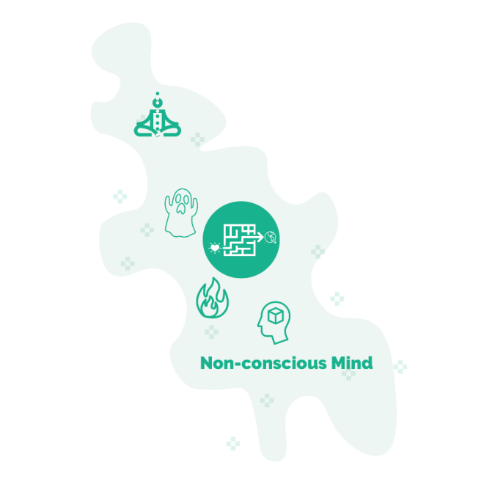
It is the accumulation of all of your life experiences; especially the emotional content!
That is VAST. It has amazing wisdom. It includes inner wisdom through body awareness, fears, desires and beliefs.
One way I like to explain it is this:
The TOP priority of your Non-Conscious mind is to keep you safe. That is a strong and sometimes confusing imperative because “safety” – in particular social safety – is not a black and white matter; there are a lot of grey areas.
The second priority is to pursue your dreams.
So unless you consciously, actively and intentionally focus on your dreams the default priority of safety will rule your life.
The Non-Conscious Mind is amazingly resourceful and creative! It has the memory of everything you have experienced which includes what you have done but also what you have observed! You have seen a lot.
Think of all the creative ways it has to get you to NOT do something.
But imagine if you were able to align that power and resourcefulness in the direction of your Dreams… WOW!
This is what the Inner Freedom Method is ALL about!!
The Non-Conscious is connected to everything!!!
Let’s do a quick walk through the Non-Conscious connection to all of the forms of energy in Energy Alignment.
Is it safe to express Super YOU?
Is it safe to play? Or do you need to be quiet and work?
Do you feel that playful SUPER YOU belongs in the environment? Or do you need to scale yourself back to feel safe.
Are you feeling the connection to life as it unfolds? Or does it seem like life is against you?
Your Dream is a version of your Heart’s desires. Is it safe to believe in your dream?
Self-Preservation Confusion
As I mentioned earlier, the TOP priority of your non-conscious mind is self-preservation. BUT self-preservation is often a confusing imperative. We have all experienced someone who stays in a situation that does not look super-safe emotionally, but they act to preserve it anyway. The “bad” situation seems safer than the unknown.
This is why the deep dive of Steps 5, 6 and 7 is so valuable. It gives you an opportunity to look at what your self-preservation instinct is trying to preserve. Then you can consciously choose if preserving whatever it is, is actually beneficial for your Dream; or even for your life overall. Often it is not.
But we don’t judge it! We just notice it. It is important not to judge your inner self… it is confusing in there sometimes. Just notice it. And when you feel safe with your coach, you can speak your truth about what you and your dream want to do now.
Good vibrations!
Body Beliefs can be Positive!!
When your body feels safe and you move toward your dream that ALSO creates buzzing energy in your body. It’s not easy to explain but it feels like joy.
It takes just as much practice to allow your body to feel joy as it does to allow your body to feel fear.
YES! Feeling joy takes practice!!!
We will explore this a bit more in a moment.
Depending on how things go, you might experience this with your coach in your session this week; but if not this week, then in a future session.

Your Hearts Desire has Body Beliefs Too!!!
We have been exploring the physical sensations and body beliefs of your fears. It is powerful to allow yourself to feel them and then give voice to your fears with the phrase: It is not safe for me to: {fill in the blank}
You have done this a bunch of times by now.
NOW it is time to play with feeling and giving voice to your hearts desires!
Your hearts desires are in your body so they also have physical sensations that we don’t often pay attention to and they have a voice but we don’t often give them a forum to “speak”. But you will do this with your coach in Session #9.
You will see this on the coaching notes playsheet: I am now ready to: {fill in the blank}
Just like giving voice to your fears, remember this is a co-created “Abera Ca Dabera” moment, you don’t “THINK” of the answer, you allow your body to speak the words that just come out.
You might be amazed at what your Heart’s Desires will say to you!!

Intentional Co-Creation
Now I want to explain this version of the Inner Freedom Method called: Intentional Co-Creation.
I try to avoid hyperbole because it is too easy to say that this or that will change your life. But in this case I want you to know that doing this on a regular basis with your Coach can change your life. This is because it allows you to align your energy and your actions and then PUSH your energy into the future… into the world.
It’s juicy.
The idea is to preplay a sequence of moments that you aim to co-create; rather than just a single moment.
Another difference is that you play with the actions you aim to take AND also the impact you aim to have on another person with the action.
So first you write it out so that you are clear about the sequence. Then you and your Coach will pre-play the sequence in your imagination.
While your coach walks you through the preplay, you stay aware of how you are feeling.
You may notice that you feel really excited about the whole sequence.
OR
You may notice that one or more of the actions or impacts gives you a feeling of fear or doubt.
Let your coach know which it is.
Then you and your coach will play through the rest of the method together; there will be a slight tweak in the process depending on if the overall energy was joy or fear.
If it is fear, then it will be the same as what you have done before. And your coach will help you explore the fear and body beliefs… eventually you will preplay that one element at the end.
If it is joy, then you will explore that feeling just like you would a feeling of fear. It’s powerful to allow the feeling of joy to move through you.
I know that was a little twisty. Let’s play with a sample sequence.
I think the best way to prepare for this is to use pen and paper and write it out.
On a sheet of paper draw a line down the middle.
At the top of the left column write actions.
At the top of the right column write impacts.
For the actions think about the four Pivotal Moments of Social Play.
For the impacts think about what you want the other person to feel and/or do.

Here is an example: writing the article with the intention to impact people and then connect with people after they read it.

ACTIONS | IMPACTS
1) Imagine writing an article and enjoying the process of creating something that you want to share.  You see yourself posting the article on LinkedIn | 2) Imagine someone reading the article on LinkedIn. You see them really intrigued by it. Then they send you a Linked In Message.
3) Imagine you see the message from the reader. See yourself feeling good that someone read your article and enjoyed it.  You see yourself responding with an offer to meet on zoom. | 4) You see them getting your offer. Responding yes. And setting up an appointment to talk with you.
You can leave it there. OR you can add the next step to envision the conversation; where both of you are enjoying a strong connection.
You could imagine whatever outcome you want!! It’s YOUR imagination.
You could imagine they want to share your article with their group; they want to hire you; promote what you are doing… etc.
For the first time doing this with your coach, 4 or 5 steps is probably a good place to start.
A more elaborate example:
To plant a seed for a future possibility, here is an example from one that I did with a player recently. She teaches Reiki - which is a form of energy healing. She is planning her first class via zoom.

ACTIONS | IMPACTS
1) She imagines the ideal participant for her event - she SEES them in her imagination.

2) She creates the landing page for the potential student to read about the program. She sees herself enjoying the “create and share” experience. She imagines the words will really appeal to them.

3) She sees herself creating the Facebook ad and having fun creating it.

 | 4) She imagines her ideal participant seeing the ad and feeling really excited and clicking to view the page.
 | 5) She imagines the potential participant reading the page and knowing that they want to do it.
 | 6) She imagines them getting out their credit card to sign up. She sees them feeling confident about their commitment to learn about the energy side of life.
7) She sees herself receiving the money and feeling rewarded for her marketing efforts.

 | 8) She imagines the person on the zoom screen loving the experience.
 | 9) She imagines them telling their friends that they HAVE to learn Reiki!!

The power of the intentional co-creation technique is that you can focus on the final outcome with your intentions. You can move your energy for influence out into the world of other people.
Believe it or not, this does pave the way – energetically-for these experiences to happen.
ALSO, it gives you an opportunity to notice your own internal experience all the way through the sequence. Remember, if at any point during the visualization, if you notice an energy of doubt or fear in your mind, share this with your coach.
One of the main reasons that our intentions don’t become reality is because we have resistance to some aspect of the experience.
You might think… but this is what I want to happen, why would I resist it?
Never underestimate the quirky complexity of your Social Safety instincts and self-preservation beliefs!! Hopefully you have some understanding of this by now.
Similarly, if you feel good all the way through the visualization, you can really amplify it by feeling the joy in your body as you will do in the Inner Freedom Method.
When your vision is really clear in your imagination AND FEELS really strong within you that means the energy is aligned and something good is about to happen.

Prepare for Session #9 PrePlay the Pivotal Moment
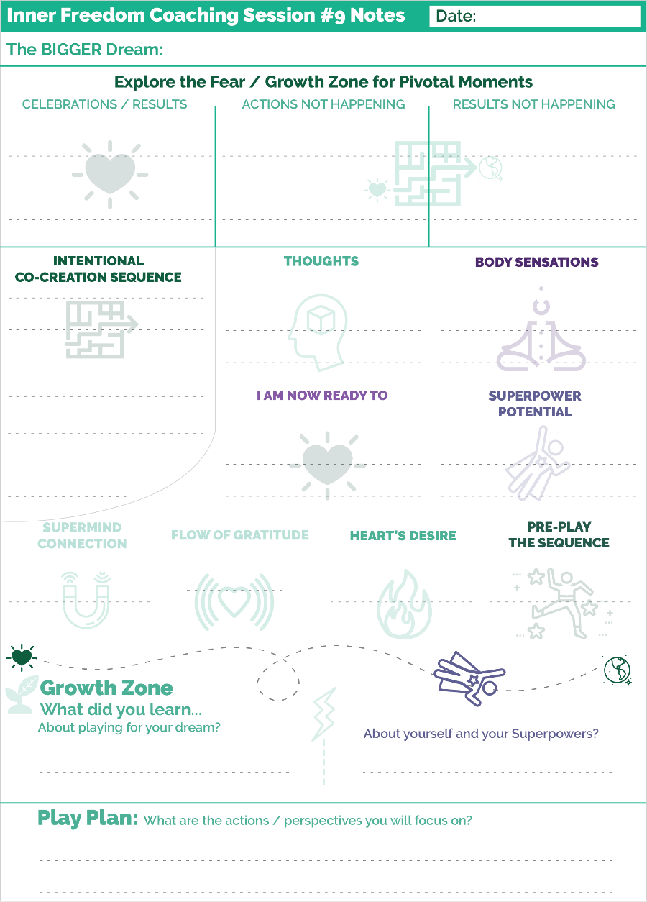
The most important thing is to think of a future outcome that you are playing for.
Then imagine a sequence of actions that you will take and impacts that will happen with others on the path to this outcome.
That’s all you need!
You and your coach do the usual stuff to celebrate and talk about what is not happening.
Then your coach will ask you to share the co-creation sequence with them. Keep the steps succinct so that they can follow along.
THEN… while you close your eyes and get into the visualization, your coach will read back the steps to guide you through the experience.
After that, it is the Inner Freedom Method of sharing thoughts and feeling energy etc.
IF your thoughts are positive your coach will go down the path of exploring the joy.
If your thoughts are doubtful your coach will go down the normal path of exploring the fear.
Either way will be AWESOME and create great value.
Sometimes it is just a little doubt that can derail your dream. Exploring it with your coach can clear the energetic path!!
Have fun with this.
Remember…
It’s GO TIME!!

**!!** {End of Player Playbook} **!!**

Coaching Notes for Session #09 - Intentional Co-Creation
This is a truly powerful and fun add-on to the Inner Freedom Method.
The change is to pre-play a sequence of actions and results rather than just one action.
The player notes for this technique shows a few examples.

The first key difference the session from the coach’s perspective is co-creating the sequence of 4 - 6 events. The important thing here is to focus the player not just on what they are going to do but also to visualize the impact on another person. By doing this the player can push their energy out into the world; out into the future.
A key to the impact vision is to envision just ONE other person. Even if their desire is to impact many people with the action, you have them focus on one.
While you are co-creating this with your player take notes using key phrases; there is a place to do this on the Coaching Notes sheet for the session.
The reason for this is because step 1B is different in this session. When they close their eyes to pre-play the sequence in their imagination, YOU are going to slowly read the steps back to them.
Share it like you are narrating the events of a story or a movie. Bring energy to your voice as you read it. You want to really invite them into the story as you read it back to them.
Let’s walk through the steps and review the differences to the standard Inner Freedom Method.
Step 2 Reviewing thoughts
Hopefully the player’s thoughts are providing ideas about the positive experience. But if they are having doubtful thoughts, then you know to proceed with the standard Inner Freedom Method.
Step 3 Feel the Energy
The next BIG difference to this version of the method is that you are aiming for the player to feel positive as they preplay the sequence. You hope that it gives them a feeling of joy and anticipation rather than fear.
You will have them feel the energy; but now you are guiding them to find the physical sensation of joy or excitement.
I am now ready to…
In step 4 you will guide them to give voice to the body belief of their Hearts desire using the phrase: I am now ready to… {fill in the blank}
Take your time on this part! This is when the players dream is finding it’s voice!
Hopefully step 5 provides a vision of a superpower coming out for expression in the scene.
Step 6 is a different Supermind access question.
In step 6 you aim to tap into the Supermind by wondering what insights of wisdom are available to flow in from the vision of the intention. When you speak and feel a Dream it is a magnet for energy, ideas and experiences. The practice is to be open to what comes to you.
Step 7 is a different gratitude access question.
You ask them to see the growth opportunity in the vision and to feel the gratitude for their dream unfolding into the future.
It’s powerful!
In Steps 8 and 9, you double clarify the Dreams intention for the sequence of events and then walk through the steps one more time to really get the energy out there!

What if the vision brings up fear?
In this session we hope the player feels the positive energy of the future vision. BUT, as I mentioned in Step #2 above, it can bring up fear as well. You will know this by how they respond in Step #2 when they describe the thoughts going through their mind.
If the thoughts sound fearful or resistance etc, abandon this version of the coaching guide and revert back to the standard Inner Freedom Method. Quickly flip to the Coaching Guide for Session #7 and pick up at Step #3 – Feel the Energy in the Body.

GO Time
WRITETHIS
The purpose of Go Time is to challenge your player to PLAY Bigger; to tap into their emerging freedom. We really don’t know that we have more freedom until we try to do something we wouldn’t try before.
I shared the Coaching Proficiency Expand the Player’s Best Efforts with them so that they would know that this is your job!
The Intentional Co-Creation technique with the Inner Freedom Method is designed for your player to feel that they can play to impact other people even though they cannot control the outcome.
They may have lots of ideas.
But they may need you to give them a boost!
What can you request of them?
What can you invite them to do?
Thomas Leonard often said that our players are waiting for us to ask them to do something amazing!

Ideas to RAISE the DREAM (just a little bit)
What do they REALLY WANT????
What could they dream if they weren’t limited by what they think they can do by themselves?
What is the impact they want to have on others in the world.
You can encourage them to start to grow a DREAM TEAM!! (This is a a precursor to session #10 World Power)

Coaching Notes Playsheet
YES! Write a few notes on the Coaching Notes Playsheet. Keep doing this during or after every session.
The chunk for the Intentional Co-Creation steps may not be big enough to use during the session. I recommend writing the key words on a full sheet of paper. Then after the session add the essential words for the steps onto the Coaching Notes Sheet.

Inner Freedom Method Step 9: Preplay the Pivotal Moment
With Aligned Energy!
This is where you go back to the Pivotal Moment from Step #1 and replay it in their activated imagination with aligned energy to create a new picture.
SOOO POWERFUL!
As the coach, you encourage them to feel the Heart’s intention for their Dream by re-stating the new Pattern Language that you identified in Step #8.
You give them some space to imagine the experience going beautifully - in the best way they can see it. In the coaching guide there are some encouraging words to share at a slow, even pace while they are in the visualization.
Then after the player does the visualization, ask them to describe what they saw. It is empowering for your player to be able to speak their imagined experience. And this will give YOU important insights into their current level of inner freedom.
Can they allow themselves to see a new experience? What level of detail can they see and share?
AS you listen you will pick up on phrases that have more energy for them. YOU will be able to feel it as you listen.
The point here is just to get a sense of how fully your player can see themselves in the action that you were playing with together.
Control to Co-Create with… (deeper)
Moving from working alone and attempting to control to co-creating with others and with life is a HUGE shift for all of us who grew up in the Industrial Culture. Co-creating is the natural human way… however it is NOT the way of the Industrial Age.
So as you guide your player in this direction, know that you are guiding them into one of our Human Superpowers! We are playful co-creators.
As a Life Coach you are their role model for co-creation! You are co-creating the coaching experience with them. They will feel that you are co-creating their dream with them as well.
You are modeling by guiding but not controlling; by playing situations with them; by sharing without attachment.
Their co-creative relationship with you will encourage them to co-create with others; to form a Dream Team! We will get into that a lot more in the next Chapter.
Another important aspect of the Inner Freedom Method and Energy Alignment is for your player to cultivate the perspective that they are co-creating WITH life. Your player can develop an open connection to “The Supermind” and feel in the flow of wisdom, energy and synergistic events. Life Coaching is a catalyst to this perspective.
This is very different than a more common perspective that we need to overcome all obstacles; that life is a “Me against the world” experience.
We need Inner Freedom in order to co-create!
We have to KNOW that we are worthy of co-creating.
We have to KNOW that we have value to contribute to life
We have to KNOW that our dream is worthy of being supported.
For most folks this level of inner knowing requires quite a bit of personal growth!
That is what you are providing as an Inner Freedom Coach.
Voila! Life Coaching. ;-)

Celebrate Breakthroughs… boost Self-Worth (2010)
Speaking of knowing that we are worthy of co-creating, this section of celebrating breakthroughs from the 2010 version will provide some good clues on this experience.
By playing BIG in the Inner Freedom Method class you will co-create breakthroughs for yourself and with your players.
What constitutes a breakthrough?
Any time you or one of your players does the following…
- You identify a Pivotal Moment of Social Play that you aim to play better
- You experience a feeling of judgment-free awareness for yourself or someone else.
- You are able to notice and feel into a physical sensation in your body.
- You experience a memory pop that creates a big awareness of a body belief.
- You reveal a superpower that had been hidden behind a social safety instinct.
- You see the perfection of a body belief that creates a DEEP understanding of who you have become and WHY!
- You see the perfection in your current situation that creates a BIG awareness about the value of your dream in your life.
- You are able to open your mind to the possibilities of your dream.
- You can envision yourself taking a dream action in your imagination and seeing the desired impact on another person.
- You take an action that was outside of your preservation zone (outside your band or allowed activities) WHILE feeling the energy in your body.
- You co-create a result with another person that had been eluding you.
Basically, in my mind, every step of the Inner Freedom is a breakthrough worthy of celebration! Every step is a step away from the constraints of the Industrial Age Mindset aiming to keep you obedient and under control. Every step is a step toward FREEDOM!
It is super important to notice, claim and share your breakthroughs because they facilitate a HUGE boost to your self-esteem; the feeling of being capable and worthy of FREEDOM.

Class 09 Prep

We will explore a few of these questions in class.

Question: What are you doing for “Go Time”?

Step #9 – The shift from Control (Frustration) to Co-Create (Trusting)
Question: share your experiences as a player of the action layer. What was the pivotal moment – what was the shift from #1 control to #9 co-create

Intentional Co-Creation
In small group: practice sharing your sequence of actions and results
Practice listening to sequences to make sure the impact on the other person is clear; make sure it is not a list of tasks they can do alone!

Chapter 10 – The World Power Connection

“There is a central quality which is the root criterion of life and spirit in a person, a town, a building, or a wilderness. The quality is objective and precise, but it cannot be named.
The search which we make for this quality, in our own lives, is the central search of any person, and the crux of any individual persons story. It is the search for those moments, and situations when we are most alive.”
-Christopher Alexander

Chapter 10 Prep
Before Class
Read through the complete coaching guide for Session 10 (Page 76)
(this is a link to the PDF with the complete set of coaching guides)
Listen to this audio to prepare for Session 10.
(this is a link to the Player Prep SoundCloud audio)
Listen to Coaching Demo of Session 10
(Coach Dave and Player Leanne)
Playsheet Pack: Print 2 copies of page 15

{From the Player Playbook}

Session #10) Upgrade your People Environments
1) Inner Freedom is a Growth Accelerator
2) Become – Belong – Believe (reprise)
3) Environments (Energy Alignment Game)
4) Co-Create with Your Dream Team
5) Prepare for Session #10
Remember it’s Go Time!

Inner Freedom is a Growth Accelerator! (and a magnet)
Let’s take a moment for the BIG picture.
First, we have now explored all 9 steps of the Inner Freedom Method. AND you have experienced a bunch of Inner Freedom coaching sessions. FUN!!
Over the final three chapters I will share with you some bonus ideas about the Inner Freedom experience.
So one thing you may have noticed is that when you start playing bigger in the world, you attract more growth opportunities in the form of challenges! (Hah. That is an understatement.)
The idea is to embrace this acceleration, knowing that this is how dreams happen. This is also how Hero / Human Journey stories happen; they speed up as you move forward. An aspect of this is to let go of the Industrial Culture idea that you should be able to get good at your job and then it is just easy every day because everything is under control. This is NOT the way you want to live; but you do need to pro-actively let go of the expectation that it will get easier.
It won’t get easier! What happens is that as you really step into your dream and start to experience your dream fulfilling… you will start to imagine a new BIGGER Dream.

The PULL between Social Reward and Social Risk
Social risk is really intense. I can tell you that for me, even though I have been playing for my dream with Inner Freedom for 15+ years, I still feel queasy in my stomach when I am about to take an action with social risk. STILL!!!
There is still this self-preservation feeling that I am about to get in trouble and I should stop this right now. STILL!
The key is to recognize this feeling and honor where it’s noble purpose: trying to keep you safe; by whatever complex notion of “safety” your non-conscious mind has developed.
Then remember to WONDER! Wonder what the growth opportunity is. Wonder what aspect of your YOUnique power or playfulness is waiting to be discovered.
The sense of wonder is a powerful balancing partner with your social safety instinct. Thomas Leonard, who I have mentioned a few times, referred to this as “Navigate Via Curiosity”. It was one of his touchstones to an impactful life.
FREEDOM = to Dream, to Play, to become your BIG Self.
Another thing to accentuate here is that we are playing for FREEDOM; some really impactful freedoms that we don’t think about often but are really core to living an impactful life. Often we think about creative freedom, emotional freedom, lifestyle freedom and financial freedom. I LOVE all of these. These are the freedoms that many people hire a coach to play for.
Meanwhile, there are a few deeper freedoms that open the way for these:
- Freedom to Dream
- Freedom to Play and express your playfulness
- Freedom to believe what you choose to believe.
- Freedom to BE your BIG Self; to express your YOUnique Superpowers.
You have probably experienced feeling at least a little more free in these three areas; you probably also notice that these three freedoms resemble the model for where Life Coaching begins from the Introduction.
Remember…
- A dream to Believe in
- Promote Playfulness
- A place of Belonging for your Superpowers
All three of these were suppressed in the Industrial Culture. So it takes some pro-active focus to bring them back to life.
YOU are doing it!! With your coach by your side.
Please remember to pass freedom along to the folks you know… and the folks you will meet as you pursue your dream… and your next dream… and your next dream.
Free people, free people.
Now let’s go a little deeper into the 3 Superpowers of Human Nature.

Become-Belong-Believe + Be Free and Befriend!
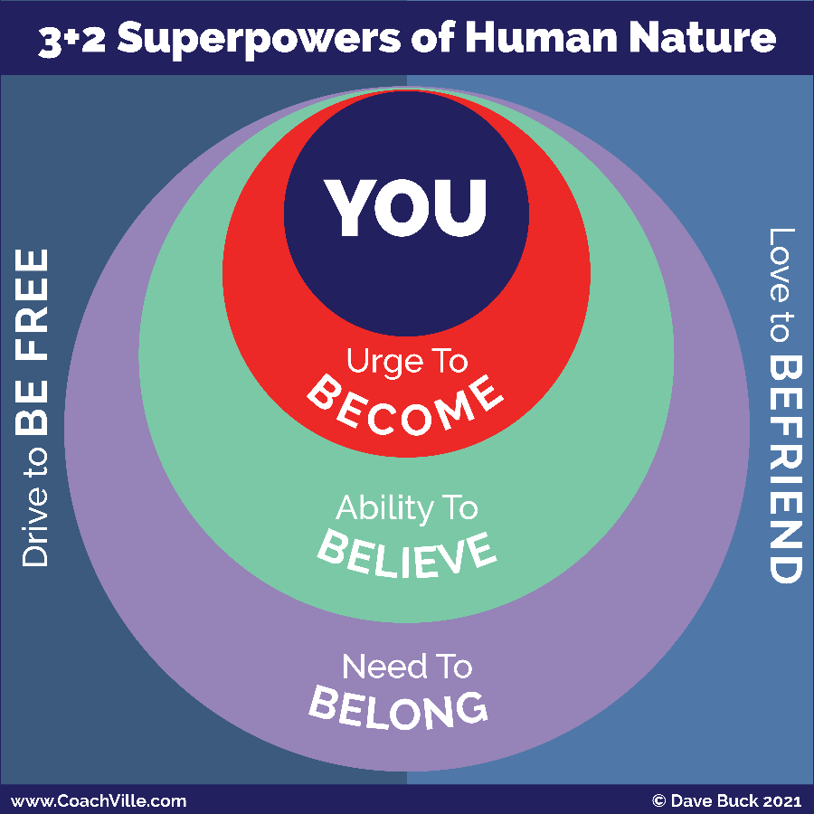
We have been playing a LOT with the three Superpowers of Human Nature that you need to understand in order to play BIG for your Dream: Become – Belong – Believe.
- Urge to Become
- Need to Belong
- Ability to Believe
WHOA! Now I want to add 2 Human Superpowers into the mix:
- Drive to Be Free
- Love to Befriend
I believe there are many Human Superpowers that we all have access to; as well as the BIG LIST of more YOUnique qualities that each of us have to contribute to the Human Family.
I like this 3 + 2 idea because these are the ones we aim to amplify through Life Coaching; and, in English at least, they all start the “Be” which makes them easy to remember!
There is not much to say about Be Free and Befriend because we all know these are Superpowers that we are born to express! There is a dynamic tension between Be Free and Befriend that is essential to our Human experience. I believe that our ability to co-create lives in this tension.
The other thing about them is that both are severely squashed by the Industrial Control Culture! Industrial School in particular is specifically designed to crush our Drive to be Free; or as they described it in the early days: “Break the will of the child”. (Ugh! That makes my skin crawl). Then, the constant testing, grading and ranking, along with the “If you help your neighbor you are a cheater” mantra, painfully suppress our Love to Befriend.
As I have said before, our collective mission as Life Coaches is to unleash our Human Superpowers so that we can co-create the beautiful world that is possible for all of us.
For now, let’s get a deeper understanding of Become – Believe – Belong.
The primary dynamic that we experience BEFORE we have a Life Coach is what we have called “The Pull”. This is when your Urge to Become pulls you toward your Dream and the Superpower Zone while your Need to Belong pulls you toward (Self) Preservation, social safety and the status quo.
Remember that our beliefs are ALWAYS evolving to navigate between the Urge to Become and the Need to Belong. AND since social safety is the top priority of our Non-Conscious mind, most of our Beliefs are aligned with Belonging and so they pull us toward the Preservation Zone as well.
So the Urge to Become is in there, it tries to get a thought into your mind from time to time, BUT it is pretty much outnumbered by your Status Quo Body Beliefs and the Need to Belong
BUT… there is another AMAZING … way to Play Life!
We call it World Power!
This is the name for another awesome 12-week coaching engagement that we have at CoachVille; it is something that you might want to ask your coach about.
Here is the basic idea...
Create a safe environment for you to practice and develop into Super YOU; we call this your own personal Olympic Training Center! One aspect of this is your Dream Team which we will talk about in a moment.
Create a place of belonging for Super YOU; an environment that WANTS you to be ALL of you; an environment that needs your Superpowers.
You do this by pro-actively upgrading your environments to align with your Dream. I will get to this in a moment as well.
When you put yourself in this new environment, the Need to Belong AND the Urge to Become both pull you toward the Superpower Zone and Your BIG Dream.
And then… you start to develop new beliefs; Beliefs that aim for you to BELONG with the powerful people in your new environment.
This is when life really gets awesome!
The key is that it takes a healthy dose of Inner Freedom to have the courage to co-create an Environment like this.
Let’s explore this idea for a moment… then we will prepare for an Inner Freedom Coaching session where you will take “one small step” in this direction.

Environments (Energy Alignment Game)
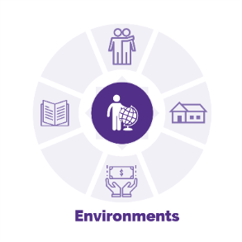
While your environments are a tangible thing, they have a major impact on your energy. This is because your non-conscious mind is in constant communication with your environment taking cues and clues about your safety, belonging and status. This is how the energy of your environment gets into you so deeply without any active participation on your part.
When we are young we don’t have much choice about our environments and a lot of energy gets into us. This isn’t good or bad… it just is. But mostly the energy aims to have you become a person who can “fit in” with what is already all around you. Because of the Industrial Culture, most likely, this will not be a good fit for the dream you have today.
If you are fortunate, there have been times in your life when belonging and becoming have joined forces in your life. So you may have an experience of how awesome this feels. An example would be in High School when you joined a sports team or a singing group and you had friends that inspired you. On this team and with your friends there was constant support and challenge to become the best version of you.
Another example would be if you were lucky enough to be on a business team with a group of people who had a shared dream. And who inspired each other to grow to become an important contributor to the dream; a team where everyone respected each other’s’ value and pulled for each other to become great; a team where everyone pulled together for the shared dream. Every once in a while, a business team will jell together like this; especially when they have a Coach Approach Leader.
Going back to this idea of your environments…
The BIG point here is that we have a 2-way relationship with our environments. While we are always adapting to the environments we are in, we are also co-creating our environments by choosing where we go and who we spend time with.
Again, these adaptations are mostly non-conscious and so are most of our choices.
Now that you are playing for this BIG Dream, you will need to proactively design and uplevel the people, places, things and ideas around you to align with your dream. This way you use the force of belonging to pull you toward your dream. This is an accelerated way to become the next version of you that your dream needs you to be.
- People: Everyone you know and your networks
- Places: Physical and virtual spaces
- Things: Tools, technology and finances
- Ideas: Knowledge and information
First of all, your Inner Freedom Coach and emerging Dream Team are your new environment. AWESOME!!! With your team you can share about your ideas for experiments and explorations and learn from the experiences of your team members!
Next as you endeavor to align your environments with your dream you will need to have a lot of BIG conversations with people in your environment; both people close to you AND people in your network who you don’t know yet but want to collaborate with. You can role play these conversations with your coach and then explore the fears with the Inner Freedom Method. This will make a huge difference.
Upleveling our close relationships can be one of the hardest things in the world to do; even with folks who are supportive of your dream. While the people who care for you want you to pursue your dream, they are human and will also have strong preservation energy that wants to keep you safe; and most of the time they just want you to stay the way you are now. Practicing with your Coach and then your dream team will help you approach these conversations with clarity and confidence.
Another big part of playing BIG for your dream is this: you are surrounded by resources that can make your dream come true! But you will have to ASK! And if you are like most people who grew up in the Industrial Age you absorbed the belief that it is not safe to ask for what you want. This is one of the hardest beliefs to uplevel. But with practice and your Inner Freedom Coach you will soon be able to do it. Then… look out world!
Remember this key point: To get to the next level of any endeavor will require a new environment. In the pursuit of your BIG Dream there will likely be several next level / “need a new environment” experiences.
In the World Power Coaching Program we do a deep dive into every aspect of your environments and endeavor to uplevel them into alignment with your dream. Then it feels like the world around you is REALLY on your Dream Team.

Co-Create With Your Dream Team!
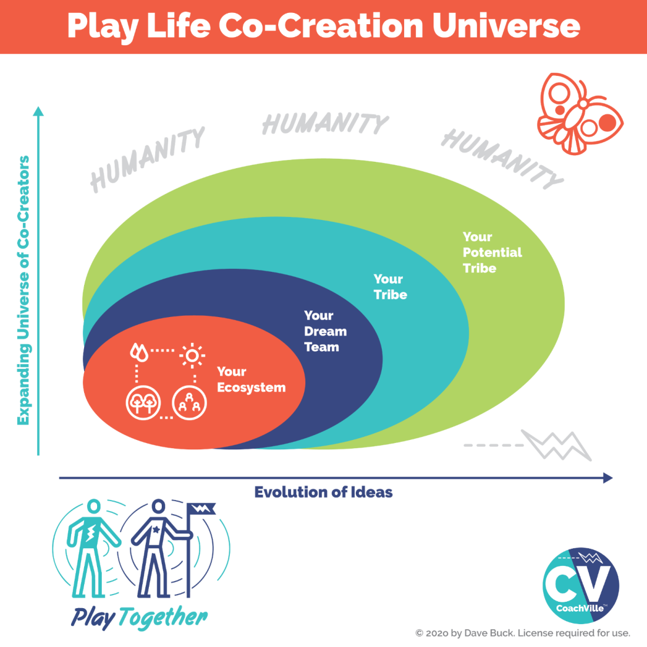
The essence of your BIG Dream adventure is to contribute your YOUnique Superpowers to create value in the world for others. FUN!
Your Ecosystem:
You start by seeing yourself and your dream as part of an ecosystem rather than an isolated entity. Look for the holistic picture. You are a part of something bigger and your contribution is essential to your thriving ecosystem of colleagues, partners, advocates and customers. You want everyone and everything in your ecosystem to thrive.
Your Dream Team:
This is your trusted inner circle and includes your Coach!
Your Tribe:
These are the folks that you aim to serve / contribute to / participate with as part of your BIG Dream. Anything that happens or doesn’t happen when you engage with your tribe is essential feedback to evaluate.
Your Potential Tribe:
As you grow in capability and confidence in whatever you are doing there is an expanded circle of people and possibilities that you can explore.
Humanity:
While you aim to create value with and for your tribe, it is good to hold the intention that your contribution is for the betterment of Humanity and The Earth!
The BIG Idea
The point of this view of the world is to realize that you and your dream are an essential part of a bigger picture; you are a part of something!

A few points to pull all of this together…
The key to living your Dream is to co-create with your Dream Team!
You are here to create VALUE for the folks in your world.
ASK for what you need. You deserve it… your Dream deserves it.
WHOA! But that is the challenge.
Most of us have a significant set of beliefs that it is not safe to ask for what we need!
This is where the Inner Freedom Method comes in.
As I mentioned earlier, it takes a fair amount of Inner Freedom to BELIEVE that:
- You are worthy of your Dream
- Your Dream is worthy of a TEAM
- Your TEAM will support you if you ASK
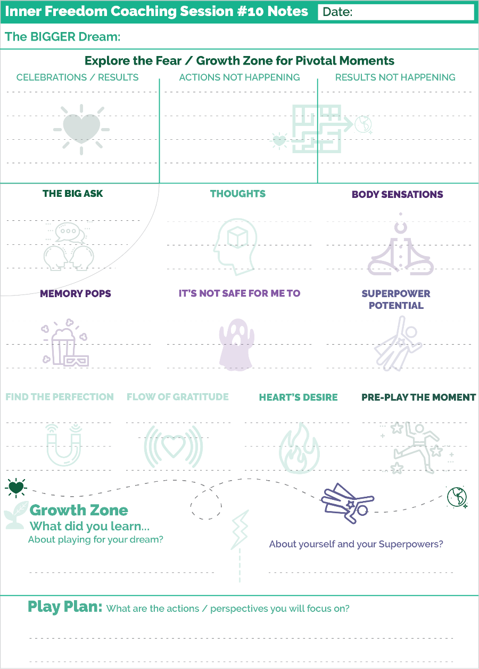
(I have mentioned this before, but it is worth repeating) Here is a BIG truth for most of us with BIG Dreams: It only takes one or two highly influential people to embrace your dream and promote you for your life to change forever.
BUT… You have to ASK!!

Prepare for Session #10 Upgrade Your People Environment
Role Play + Inner Freedom … ONE More time
A BIG ASK.
Remember… It’s Go Time!
This is a really big shift for most people: to develop a dream team, to co-create with your team, to engage with your team with clarity and confidence.
It all starts with one conversation; it keeps growing with the next conversation and the next one. There are SOOO many conversations that you can practice with your coach as you play for your Dream.
For this next session… you just need to pick one!
But pick a good one; one that you know will bring up some social fears.
Then you and your coach will follow the same structure as you did in Session #8 where the Role Play takes the place of Steps #1 and #9.

You know the rest!
And here is another point… you are beginning to experience what this is all about. Believe me, you and your coach could do this together every week for years and it wouldn’t get old. You could keep playing BIGGER and BIGGER for a long, long while; and the world would be better for it!

**!!** {End of Player Playbook} **!!**

Coaching Notes for Session #10
Session 10 is another Role Play + Inner Freedom Combo; with a little extra twist.
You are introducing your player to the life changing possibility of upgrading their people environment to create a Dream Team for the Superpower Version of themselves.
This takes WAY more than one session! But the it is an idea that will really stick with them and guide them over time.
AND – side note – You can share with them the possibility of doing at 12 Session World Power Series with them to really bring this idea into their life!
At this point though the big idea is to invite them to Role Play what we call a BIG ASK of someone in their People Environment.
Social Risk & ASK your Dream Team
The key is to challenge your player to practice a conversation with some social risk.
This could be asking someone they know to support them is a new or more proactive way; to become an active part of their Dream Team.
You may need to offer a few suggestions, so be prepared for the session.
Going deeper with Role Play?
Another big point about this session is to show your player the powerful growth potential in doing role plays with you on a regular basis. This can set the stage for a long term engagement because they see the power of growth oriented practice.
This can be an excellent opportunity to do a Reverse Role Play!
Reverse Role Play is a wonderful way to use your creativity and share your knowledge of a situation your player is facing. You play the part of your player and your player plays the role of the person they want to talk to.
This will enable you to:
- Give them a demonstration of a different way to approach the conversation
- Express their superpower so that they can experience what it could sound like. Often it is powerful to exaggerate a quality for your player to observe.
- See what they actually have in mind as the perspective of the other person.
It is powerful and fun!
This is what powerfully playful coaching can be.
Coaching Notes Playsheet
Write a few notes on the Coaching Notes Playsheet. Keep doing this during or after every session. Hopefully you experience this as a valuable part of your coaching process now!

Create a place of belonging for SUPER YOU!
In the Industrial Culture we learned – by observing – to treat each other very badly.
- Actions judged
- Ideas shamed
- Needs disrespected
- Unique qualities or characteristics blamed
- Accomplishments ignored
- Manipulated with lies or false promises
Together, we could make a very long list of these ways.
I bring this up for a couple of reasons.
It is very easy to descend into apathy and conclude that Humans are trouble. I want to encourage you to advocate for Humans are amazing, BUT in a dehumanizing environment, bad things happen.
In other words: Hurt people, hurt people.
We can uplift the Human family one person at a time.
Along these lines, since we all grew up in this dehumanizing culture, it is easy to go numb to it, stop noticing it AND – as we have seen – even act to preserve it. Yikes!
So it may take a lot of observing and sharing on your part to encourage your players not to tolerate an environment that treats them badly; even Industrial Culture normal bad.
You can encourage them to make moves to ask for better. You can point out to them that they are worthy of more.
With your coaching, they can find or co-create an environment of belonging that treats them very well; An environment that embraces the SUPER YOU that they are becoming.

Recognizing Perfection expands your self-worth (2010)
This section from the 2010 version provides some additional insight to our focus in Chapter 7. A note about a word: in the 2010 version I was using a commonly used word “The Universe” to describe the “all that is seen and unseen” that is all around us. For this new version I have backed away from that word to get disentangled with various spiritual constructs. For the new version I am using the word “The World” to describe the “all that is seen and unseen” around us.
Seeing the Perfection in both the current situation and the Body Belief / Preservation intention is an essential part of the Inner Freedom method.
When you see a current situation or a Body Belief / Preservation intention from the “Perfection Perspective” it greatly increases your self-worth. This happens because you begin to see that the World is on your team and conspiring for you to fulfill your dreams. When you see “life” or circumstances or “the World” is conspiring against you it depletes your self-worth.
When you see that the World is on your team to fulfill your purpose it helps you move from attempting to control to co- creating with the universe and “what is”!
Upgrading your perspective on Good and Bad
How did we come to see that the World is conspiring against us?
When we are small we perceive everything in the world as directly related to ourselves.
We learn from the big people around us that:
Good things happen to good people and
Bad things happen to bad people.
The big people are not being malicious in teaching this to the little people, it is just how THEY learned to manipulate little people into doing what they are told to do; to devolve them from wild and free to obedient and subservient; AKA the Industrial Way of Hierarchical Control.
So we learn to think that when anything bad happens around us or to us it must mean that we are bad.
This perception quite naturally finds its way into our social safety instincts and becomes a pattern of feeling and a way of seeing the world.
However with practice you can see the world of your personal circumstances and events in a new way
You can practice seeing the perfection in “bad” things
- Preservation intentions from earlier experiences (choices to stay safe) - how they served you in becoming who you are today.
- Current challenges and situations – how they are serving you in becoming a bigger player
How can a challenge serve your intentions to play BIG?
- It is asking you to expand who you are in the world
- It is serving your intentions to add value to the lives of others
- By fueling your desire to accomplish something
- By bringing awareness to what really matters to you
- By bringing awareness to your deep desires (or awareness of what you don't desire)
- By expanding your capacities to add value to others

Imagine your Dream has created this situation to challenge you to step up.

How we learned to fear our self-expression (2010)
As you learn to play with FEAR and step up to the big dream actions that are out of your comfort zone, it is super valuable to understand where some of our deep fears come from.
A great example is how we come to fear our own self-expression.
The archetypical story goes like this:
When you are a very young child you learn how to draw with crayons or water paints or something similar. Then you get the bright idea to decorate the wall in your bedroom with your newfound artistic skills. In most cases this makes the big people really upset and they start yelling… or worse.
This archetypical story can take many different forms – painting, singing, dressing up, building something out of “parts” you find around the house - but you get the idea.
When you are small and something like this happens you don’t have the perspective to understand why the big people react the way they do. For example, maybe your parents went through a big challenge to have the room painted and now it is “ruined”.
The “play safe” conclusion that you develop can take many possible forms.
Here are a few examples:
- People get mad when I create something
- My art must be ugly
- I should not trust my own ideas
Our biggest FEAR is our own Super Powers
Another very common human experience is when you express an aspect of yourself or a quality that is natural for you BUT creates a negative experience in some way.
An example would be a young person with natural leadership skills attempts to “take charge” in a situation but instead of being rewarded you are scolded or belittled in some way by the “BIG” people.
Another example is a young person with a natural sensuality that attracts intimate attention. This can be a super power when used to create intimate connections that forward a shared purpose through profound relating. However it can also create unwanted affection that can lead to “dangerous” situations for a young person. So it is easy to understand why someone would put a lot of non-conscious energy into suppressing sensuality and intimacy.
Every individual has their own unique version of this common story. This is why most of us have non-conscious Social FEARS of expressing our natural unique capabilities.

Class 10 Prep
We will explore a few of these questions in class.

Question: Share an example of something that you once viewed as bad that you know have a more neutral perspective or even a perfection perspective?

Question) Describe an environment safe for your superpowers
Who / what do you need to ask for?

Question) Practice talking about what your dream wants you to do.
What are some specific ASKS you could make?

Chapter 11 – The New Super YOU!

“The fear which prevents us from being ourselves, from being that one person unique in all the world, from coming to life – that may mean nothing greater than the fear of giving up the image of a certain job, an image of a certain kind of family life”
- Christopher Alexander

Chapter 11 Prep
Before Class
Read through the complete coaching guide for Session 11 (Page 83)
(this is a link to the PDF with the complete set of coaching guides)
Listen to this audio to prepare for Session 11.
(this is a link to the Player Prep SoundCloud audio)
Note: this audio is long… about 40 minutes. I re-recorded it several times to make it shorter and every time it got longer! So… take me along on a walk. ;-)
Listen to Coaching Demo of Session 11
(Coach Dave and Player Leanne)
Playsheet Pack: Print 2 copies of page 16,17,18

{From the Player Playbook}

Session #11) The New Super YOU!
1) Becoming Precedes Results
2) Industrialization… why it’s so hard to become Super YOU
3) The Energy Alignment Path to Super YOU!
3) The Fear of Unintended Consequences (not success)
4) How to prepare for Session #11 – Play for something BIG!

Becoming Precedes Results
I have been a Life Coach for a LONG time. ;-) Most everyone who hired me had some specific things they wanted to accomplish. With a little honing these became the essence of a BIG Dream. While we often think about it in terms of accomplishments, I like to focus on the experiences we want to have. New life experiences are what it’s all about.
At the same time though, there is another focus that rides along on the adventure. This is a focus on WHO we want to become; a vision we have of ourselves as more capable or even more formidable. This is what we refer to as Super YOU!
Often we need to become the next version of ourselves through inner development before we start having the experiences and results that we desire.
Inner development – leads to – Bolder Expression – leads to – Dream Experiences.

Industrialization… why it’s so hard to become Super YOU
The questions you may continue to wonder…
Why is it so hard to become the next version of me?
Why is it so hard to express my value to impact others?
Why is it so hard to own my value in the world?
All of this can be called: “Coach Dave’s view of the world and recent history”.
The answer to all of these questions:
Industrialization.

Only the past 140 years out of 100,000 years of Human experience. So it’s a very new thing and there are some BIG problems with the current version.
A) The nature of Industrialization is the get humans to work at a job that is defined by the organization. And you pay the worker a LOT less than the value they create. The gap is called PROFIT.
B) The second thing is you need to get people to consume what you are making AND to pay more than the cost. The gap is called PROFIT.
Meanwhile we are humans who are creative, playful, powerful and free and who naturally love and respect the uniqueness of others AND who need belonging AND HATE being controlled.
So how do you create a human culture where most of the Humans submit to being controlled, who will work at something that is not fulfilling, getting paid FAR less than the value they create; AND are willing to exchange their energy for money that they then use to buy things that cost more than they are actually worth.
THAT is a heck of a system right there.
We were ALL sucked into it. And it is not joyful. It is not freeing.
You have to make the Humans feel that they are not good enough. Make them doubt their value, their playfulness, their inner knowing, make them afraid. Make them feel they have no choice but to work under these unfair conditions. Convince them that they can feel better about themselves by buying stuff that is worth less than it costs.
How do we make our fellow Humans feel this way about themselves?
School – Jobs – stressed out families
1) School – unnatural for children.
EVERYONE KNOWS children do not learn by sitting still and listening to adults talk.
But we organize everything that way anyway.
EVERYONE KNOWS that testing children is dehumanizing. That it serves no value to learning.
But we organize everything that way anyway.
Why do we do these things?
Because the original stated intention of public schooling was two things:
A) To break the “will of the child” and
B) To teach them necessary skills for public life like reading, writing and arithmetic.
Later a 3rd intention was added:
C) To make them good patriots who will serve their country.
The “will of the child” is our Human Nature: self-determination, playfulness, creativity, curiosity, egalitarian spirit and much more. Egalitarian spirit means that we don’t think anyone should control us AND we don’t think we should control anyone else. This is an essential quality of Human Nature.
Earlier in the book I said it another way: “We all HATE to be controlled”. Meanwhile the purpose of the school system is to get us – AKA our Human Nature - under control.
When you understand this, it should come as no surprise that we feel the way we do.
2) By the time Humans graduate high school, MOST of us are convinced that they are not too smart. “You better just get a job and do what you are told; follow orders and stay out of trouble”.
The few that do think they are smart enough… “you better go to college”.
After college most then feel they better get a job to pay off all the student debt.
If that doesn’t work, then the system convinces us that we need a big house and a mortgage and a car and lots of stuff.. and… “don’t worry we have an easy credit application process.”
As a result, the system gets almost everyone into financial debt. “You better pay it or you are in trouble. You better get a job and do as you are told so you can pay your bills”
3) Coming back around to families, most have 1 or 2 parents that are stifled, stressed about money, undervalued and overworked. As a kid you can feel this stress and the social fear gets into you.

Why am I sharing my perspective on all of this with you?
A) I just want you to understand why you feel the way you feel about yourself and your power. My aim is for you to reclaim your natural Human Superpowers. YOU are not strange. You are an awesome Human in a really strange culture. There are over 7 billion YOUnique ways to be smart. YOU are very smart.
B) So that you feel empowered to use your influence to gain freedom for yourself… and for others. In a business, career or job, play for getting paid what you are worth. It is probably more than you are getting paid now.
C) If / when you are in a position to hire people, make sure THEY have an opportunity to express their power and feel valued and are paid what they are worth.
D) When you do have money, use a local bank. Support local artisans and businesses. Avoid buying industrial crap whenever possible. And whatever you do… avoid buying anything from Jeff Bezos. (OK. I just had to put that in there.) Whenever possible, use your influence to support small business not Billionaires.
E) These are ways that YOU can play with us to co-create a MUCH BETTER world.
FREE PEOPLE, FREE PEOPLE

The Energy Alignment Path to Super YOU!
When we look at the Energy Alignment Game model, we have been describing it as aligning everything with the BIG Dream; sort of striving our way up to the upper right corner.
But another way to look at it is to see everything as flowing down to the bottom left corner where Super YOU resides.
As we near the end of this 12-Session adventure, I want to share with you a few more thoughts about the Energy Alignment Game – this time from the perspective of becoming Super YOU.
Your Dream
The purpose of your Dream is to call you out into the world of the unknown… because THIS is the only way to become the next version of YOU.
And the Urge to BECOME is a major force within each of us.
Your Dream will keep evolving. Love and learn from the situations it attracts to your life experience!
Every time you uplevel your dream or change your dream completely, you start a new Energy Alignment Game; and the need to become yet another version of YOU.
Trust your heart! It knows what you should do to maximize your joyful life experiences and contribution to life.
The Supermind Connection
Stay open and connected to the bigger “Field” of energy!
The “Field” is what makes Intentional Co-Creation” possible.
Ask curious questions and wait for the insights to come to you.
Since profound belonging activates and amplifies the Supermind Connection often insights will flow in to you and your coach while you are speaking. These insights often arrive as “quirky” inklings that you can’t logically explain. It is OK! When it comes to living our dreams, logic is overrated!!
Speaking your dream out loud with your coach – AND with your Dream Team – amplifies your connection to the Supermind. Do this often!
Feel and express gratitude for the experiences that come to you through your dream… especially the challenges.
When your coach asks you: “Who is this challenge asking you to become?” allow the answer to come through you; rather than trying to “think” of the answer.
The purpose of all of this is to get the FEELING that you – AND your Dream – AND who you are becoming - are in the flow of life.
There is a feeling that “life” seems to want your dream to happen as much as you do and it “sends” just the right experiences, challenges and opportunities to you; so you can BECOME the person who can steward this dream into reality.
It’s not actually relevant if this perspective on life is “true” or not. My sense of this after 20+ years of living and coaching this way is that really, we don’t know for sure. BUT we do know that the feeling is magical and makes life a lot more playful and fun.
Do the Intentional Co-Creation exercise often! Whatever you want to create, take the time to focus your intention, notice your thoughts, feel it through your body, get your desires really energetically tuned in to what you want to do and envision it. It's powerful.
Your Environments
You are co-creator of life with the people, places, things and ideas that are all around you.
You are adapting to what is around you – all the time – in an effort to feel belonging.
You can ALSO choose what is around you in a proactive effort to co-create a place of belonging for the NEXT version of you.
You can choose upgrades to your environment to align with your dream and who you aim to become. This is the idea we call “World Power”.
Remember that your Non-Conscious Mind is in CONSTANT communication with your environment; gauging your safety and status. You can add to that the lookout of opportunities to move your Dream forward.
Non-Conscious Mind
Your body is “talking” to you all the time. Practice listening. With your coach you have been practicing giving voice to your body beliefs. Honor them. Notice that they are pulling you toward self-preservation.
Your body beliefs and fears bubble up into your conscious mind as thoughts; steeped in self-preservation. Often we think of these thoughts as “negative”. I recommend you stop judging them and just notice them with judgment-free awareness.
Oh… I have this thought.
Oh… fear is my friend trying to keep me safe.
Oh… that is probably coming from a self-preservation belief.
Oh… I wonder what it wants me to preserve?
Oh… I wonder what playfulness or YOUnique power is hiding in there?
Oh… My beliefs are fluid. I wonder what belief will serve me best now?
While feeling energy in the safe space co-created with your coach, you will have memories of earlier moments pop up. These memories offer clues about your playerfulness and YOUnique power. This is what we call the “Treasure Map”.
Your desires are “talking” to you all the time as well! They bubble up into your imagination and your dreams for who you want to become and the experiences you want to co-create. Notice them and honor them as well. Notice they are pushing you out into the world; out into the unknown where new experiences happen.
Feeling energy in your body is a practice you can do any time; you can improve and expand your capacity to feel over time.
AND… feeling energy and feeling SAFE requires the presence of another person; belonging is the essential ingredient of social safety.
SO… DO BOTH. Practice feeling energy on your own. Practice feeling energy with your coach.
Embrace that your self-preservation instincts and your dream are very often pulling YOU in different directions. It’s OK! You are capable of looking at your options – the risk and the reward – and choosing which is best for YOU now.
Exploring these choices with your coach is easier then exploring them when you are alone.
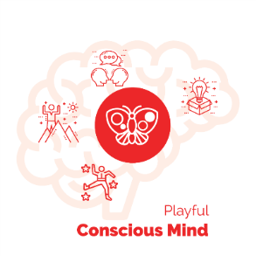
Playful Conscious Mind
Relate – Create – Explore – Experiment!
You play to become the next version of you.
When you FEEL SAFE, your conscious mind wants to play all the time.
Play includes awareness of risk and reward.
Your playfulness is social.
Super YOU
“A Superpower = A unique ability that you can practice
until it is capable of making a BIG IMPACT”
You have YOUnique abilities, perspectives, qualities – there many unique aspects of you that you can contribute to the world.
The Challenges of your dream will call for your Superpowers.
Now you know how to follow the treasure map of your Non-conscious mind to find your superpowers.
As you become aware of your powers and how you lost access to them, BE patient with re-learning how to use them.
Superpowers leave clues
You have many unique abilities!
Keep in mind that you lost access to your power:
- by getting “in trouble”; your belonging or social status was threatened.
- by having your power fail you; often when you were trying to help someone.
- by witnessing trouble; often someone that you cared about.

The Industrial Culture created a trifecta of soul-crushing experiences…
- Stressed out families
- Dehumanizing School
- Dehumanizing Jobs

Sounds harsh I know, but at some point we need to call it what it is.
Knowing what you are up against can help you.
And remember, all of these experiences left clues!
With persistence, the courage to play for your dreams, and a great coach by your side… you will reclaim your Human Nature and become Super YOU!
Then… pass it on. (and refer your coach ;-)))

Trust yourself to be wise with your power
As you gain power, be wise about how and when you use it. Sometimes it is better to stay safe and keep your powers under wraps. Sometimes it is better to express your power fully. The whole point of Inner Freedom is the freedom to choose when to use your playfulness and YOUnique power; And when you choose to use it, use is fully to impact the situation you are in.
It is very important to honor your YOUnique powers and give them a place and a voice in your life. If you don’t, often they will over compensate.
A great example comes from one of my players. She was complaining about being a worrier and ruminating. I said: “that is one of your superpowers!” She was quite surprised by this. I said: “the ability to project your energy into the future and foresee potential danger or trouble is an awesome power; every human tribe needs someone who can do that. If you make space in your week to do this intentionally and honor its wisdom, then it won’t feel the need to overcompensate and keep you up at night.” This was a life-changer for her.
You can use this example to gain a deeper understanding of almost every aspect of your YOUnique powers.
VERY often the qualities or quirks we have that seem bothersome are actually superpowers that are overcompensating in some way.
It is a HUGE opportunity within the human family to stop labeling our traits as abnormal or problems. The notion that there is some benchmark of normal that we can be compared to is a wholy nonsensical Industrial Age concept. There is no normal for humans; we are wildly diverse and the sooner we all approach our YOUniqueness with mutual respect and honor the sooner we will have a more joyful egalitarian world!

The fear of unintended consequences
I remember hearing about this idea called the fear of success and thinking that it was pretty crazy. Why would anyone be afraid of success?
Well. most people wouldn’t.
However there is something to be aware of: the fear of unintended consequences!
This is a real thing.
As you play for your dream and become the next version of you, there may be people, places, things and ideas that have been in your life but don’t want to come along for the ride.
It is the fear of losing the feeling of belonging with these people, groups and situations that can stop you in your tracks. This is amplified version of the Self-Preservation instinct that we have been exploring all throughout the program.
Often when you imagine playing for a new dream, you don’t realize what these unintended consequences will be; but they come to light along the way.
I have coached many people who gave up their dreams rather than let go of a person, group or situation. And you know what… it’s OK. The freedom to choose is an important aspect of life.
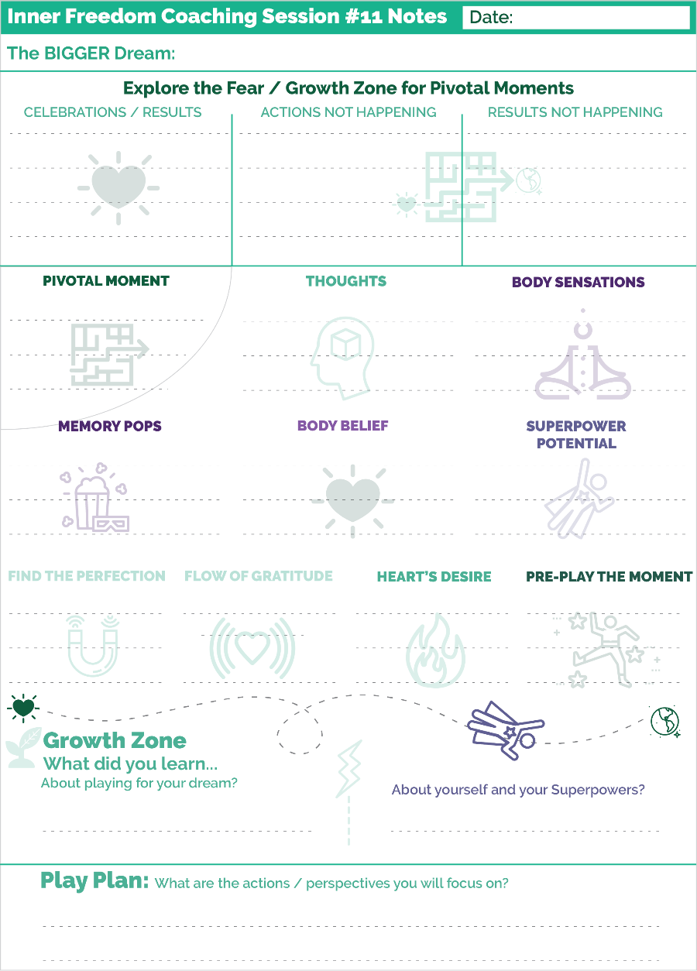
But at the same time I have also known people who just assumed that the person would never go along for the ride… and never actually talked with them to invite them to come along.
So if you ever run into this situation yourself, have the courage to ASK! And have the courage to use your growing influence!
If it ever comes down to a choice, trust your heart to know what to do!

Prepare for Session #11
It’s go time!
So identify of the biggest social opportunity in front of you and PLAY! Practicing with your coach will pave the way for you to make bold moves out in the social world.
Make plays out in the world that will make your Inner Freedom Experience a memorable one.
Let’s Play!

**!!** {End of Player Playbook} **!!**

Coaching Notes for Session #11
With your player this is a “standard” session where you choose a pivotal moment or a pivotal conversation and then play with it together and explore the social fear.
A regular pivotal moment: use Coaching Guide #11
A Role Play session: use Coaching Guide #10
An Intentional Co-Creation session: Use Coaching Guide #9
Speed Drill
In class however, we will do something a little different in our partner practice time: = Speed Drill.
This is an important practice where you aim to do the entire method in 22 minutes!
The Coaching Guide for #11 has the entire method; with minimal {Red Coaching Notes}
To do this you need be really familiar with all of the steps so that you can move quickly and avoid any deep dives on what your partner shares.
The point of this is to let the method do the magic AND so that you know in a regular coaching session you can do the Inner Freedom Method quickly when you have limited time.
Another point is that you will see that you can do the short version of the method – Steps 1,2,3,4,8,9 – in just 10-15 minutes if you need to.
Coaching Notes Playsheet
Write a few notes on the Coaching Notes Playsheet.

Fear of unintended (and unwanted) consequences of success (2010)
Often when we talk about the fear of success, what we are really talking about is the fear of unintended and unwanted consequences of success.

If you have listened to the sessions with Player Natasha you heard a great example of this. When she was a young girl her uncle offered her a prize of a new bicycle if she got the top grade in her class at school. She made a conscious decision NOT to win the prize because of the fear that she would be rejected by her sisters if she won the bicycle.

Let’s explore a few more examples.
You get a promotion within your company. Then your best friend who was your peer doesn’t feel comfortable connecting with you anymore.
Your business starts making a lot of money. Then your sibling who is always struggling financially expects that you will support him financially because you have so much. Whether you do or you don’t, this creates a ripple effect of discomfort throughout your extended family.
You are invited to speak at an event which is something you have been striving for. When you give your speech you share a few of your strong opinions. After the speech a few members of your community avoid you at meetings.
When you think about unintended consequences, it is powerful to really get creative about all of the possible negative things that could happen. This will do two things:
1) It will help you prepare emotionally for anything that might happen; this makes you mentally and emotionally stronger
2) It is a great way to exercise your imagination and embrace the idea that you can play with ANY social fear.

Quick review – When to use the Inner Freedom Method (2010)
There are several coaching situations where the Inner Freedom Method can be used to great effect.
Starting with the situations we have already discussed...
1) When your player is not doing something they intend to do
2) When your player is powering through their own inner resistance to do something important. It is a struggle; they have to FORCE themselves to do it.
3) When something is not happening even though your player is taking action -a desired result is NOT being created
And in addition when…
4) They have hesitation or fear about something they are about to do
It is very powerful to use an Inner Freedom “Pre-Play” to expand the capacity to feel BEFORE they do it.
5) They say "I don't know" or "I don't know what to do"
Remember: when someone says "I don't know" this means that they are not feeling their body. Thinking - logic and reason - are in the head / conscious mind; knowing is in the body.
So.. I don't know means:
a) I can't figure this out with logic AND
b) I can't access my intuition
c) I can't access my intuition means I can't access the wisdom in my body
6) If they say: "I am overwhelmed"
Overwhelm happens when a person is not able to feel.
Overwhelm is not caused by too much to do. You can only do what you can do. So overwhelm is caused by the energetic feelings about what you will NOT do.
In other words, what you FEEL in your body when you realize or think about what you can't do is what causes the experience of overwhelm.
So the key is to practice feeling the energy so that it flows through you. Then you can be fully present to what you ARE doing.

Inner Freedom – the capacity to choose
I have mentioned this idea a few times now but I just want to expand upon it a little bit here.
Having Inner Freedom gives you the capacity to choose when to play BIG – to embrace social risk- and when to play safe – to avoid social risk.
My experience is that most people who have a BIG Dream face a bunch of pivotal moments every single day; they just don’t notice them.
Now that they are more aware, they notice these moments a lot. If they choose to play BIG once per day – and choose to play safe all the other times - that will be amazing! That once per day will compound to amazing transformation over the course of just a few months.
So my point here is for you to help your players see that they can pick their spots for playing big. They can focus their energy toward just one Pivotal Moment per day.

Think BIG Now! Who can you coach?
Here is a quick note about your coaching business or your coach approach leadership or entrepreneurship.
With the Inner Freedom Method you can coach A LOT of people; including influencers who are doing BIG things in the world.
There is a common – and common sense – refrain in the field of coaching that it is best to coach players who are pursuing a dream that you know something about. YES! This is common sense. However, when you have confidence in your abilities with the this method, you can coach people way beyond what you have done yourself.
This is because social FEAR is in all of us. And everyone who has their sights on their next BIG Dream is going to be stopped by social fear at some point. Many of us are able to accomplish big things with raw talent that has been acceptable to the Industrial Culture and by powering through our social fears. But at some point we all hit a wall with that approach.
This is where YOU – the Inner Freedom Coach – come in!
My message for you here is to look for BIG players; befriend BIG Players. Make sure they know that you are a Life Coach with very special skills for guiding players who aim to do BIG things in the world AND are feeling doubt, frustration, resistance, overwhelm, isolation or FEAR. They might think: “oh that’s not me. I have the world by the tail. Nothing can stop me.” You just let them know that when they need you, they know where to find you!
Feel confident that every big player that knows you will want to hire you at some point; it is just a matter of time!
Voila! Life Coaching.

Class 11 Prep
We will explore a few of these questions in class.

Question: What have you learned about following the “Treasure Map”?

Question: Share about one or more activities that you were resisting but are now free to play with?

Question: What is an area of inner resistance that you have not yet gained freedom to play with?

Question: Think of a big challenge you are facing right now…
Who is your Dream ASKING you to become???
Question: Share an example of a self-expression or a Super Power that you have learned to FEAR.
And any insights you have gained by playing with that fear?

Question: Think of something BIG that you are playing for right now. Brainstorm several possible unintended or unwanted consequences of success. Include a few that feel real and close to your heart and a few that are further out in your imagination.

Chapter 12 – Celebration
& Becoming precedes results

"For me there is only the traveling on paths that have heart, on any path that may have heart, and there I travel. And the only worthwhile challenge is to traverse its full length---and there I travel looking, looking breathlessly."
-Carlos Castaneda,
The Teachings of Don Juan: A Yaqui Way of Knowledge

Chapter 12 Prep
Before Class
Read through the complete coaching guide for Session 12 (Page 89)
(this is a link to the PDF with the complete set of coaching guides)
Listen to this audio to prepare for Session 12.
(this is a link to the Player Prep SoundCloud audio)
Listen to Coaching Demo of Session 12
(Coach Dave and Player Leanne)
Playsheet Pack: Print 2 copies of page 19

{From the Player Playbook}

Session #12) Celebration
1) What Inner Freedom is… (one more time)
2) From Stressful Hierarchical Control to Joyful Co-Creation
3) The Human Journey with a Coach and a Treasure Map
4) Celebration!! Let’s look at your Play Sheets.
5) What’s next??
6) Prepare for Session #12

What Inner Freedom is…
Remember this idea about the Inner Freedom Experience?
Inner Freedom Coaching facilitates this transformation:
From: fear, emotions and “limiting” beliefs are something you "power through"; the non-conscious mind is dark and mysterious and must be avoided.
To: you can play with fear and emotions; you can uplevel your beliefs; and the non-conscious mind is a vast resource of wisdom and power.
How did we do??
We are playing together to maneuver your Heart’s Dream, through a maze of self-preservation beliefs in your Non-Conscious Mind, out into the world.
Hopefully you are beginning to see the “maze” as a fun adventure with a friend rather than an evil force lurking inside of you.

From Stressful Hierarchical Control To Joyful Co-Creation
This is an important idea that sets the stage for why I believe Life Coaching is a leading voice in the co-creation of an egalitarian world where every person is valued.
The shift from Hierarchical Control to Joyful Co-creation!
The Industrial Culture is completely immersed in the Command- Control – Compliance structure. Every human endeavor is organized like a military operation with top down command and rank and file workers.
People, at all levels of the chain of command, experience tremendous stress as they work to maintain control.
Why? Because Humans are not meant to live this way!
We are born to be FREE, joyful, fiercely egalitarian co-creators with each other and with life.
Life Coaching is a model for this lifestyle.
- Your Coach is with you while also not playing for you.
- Your Coach is guiding you while also following your lead.
- Your Coach is sharing observations with you while also not telling you what you must do.
- Your coach shares your dream while also not being attached to it so they maintain balance.
- Your Coach SEES your unique value while also not pressuring you to be a certain way.
- Your Coach sees you playing BIG while also not judging you in the gap of becoming.
It’s empowering.
It’s playful
It’s FUN!
Coach and player are egalitarian, co-creative partners.
YES!

Your Human Journey and the Treasure map (Reprise)
We have spoken about this quite a few times so I am not going to go into a big thing here.
I would love for you to look at this model again and recognize how much more awareness you have about yourself… about your Human Nature and about how to play for a dream.
Notice how much you have learned about your Social Safety Instincts.
Notice how much you have learned about your (Self) Preservation Zone.
Notice how much you have experienced the Fear / Growth Zone! (whew that’s an understatement!
Notice how much you have experienced your Human Nature Superpowers to Become – Believe and Belong!
Notice how much more awareness you have about the Superpower zone and how the challenges of your dream call out your Superpowers.
Notice how much clarity you have for your BIG Dream and how much more you can imagine yourself out in the world!
As far as the treasure map goes…
I wish I could make it a step by step process for you; but that is not what a treasure map is all about! Enjoy the adventure, the uncertainty, the unknown, the mystery… the surprises.
Have fun exploring WITH your coach as a companion.
Whenever you have a playful urge to do something… and then experience some doubt or fear… AWESOME! The next clue on the treasure map has revealed itself.

Energy Alignment Playsheets
In the Playsheet pack you will see 2 pages with questions about your experience of the Energy Alignment Game.
This is a valuable exercise to capture your growth and awareness.

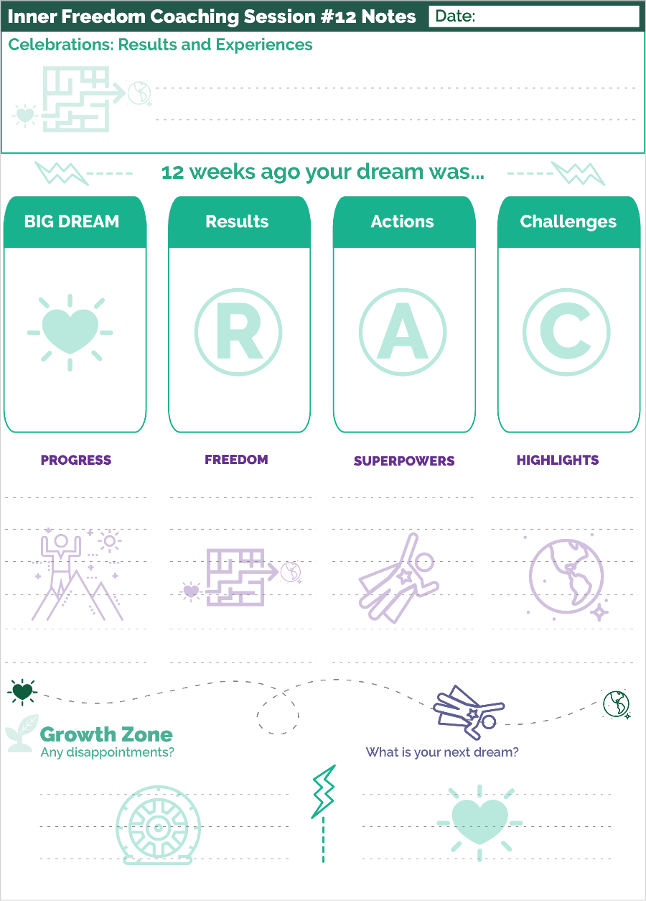
Celebration – Let’s look at your playsheets!
Next up…
Session12 with your Inner Freedom Life Coach is all about celebrating YOU and your adventure.
So take out all of your playsheets and read through them from the beginning through to now.
Look over both the Coaching Notes sheets as well as your weekly play plan sheets with journal notes about what happened during in between your coaching sessions.
Embrace what you see. Enjoy looking back. Expect your imagination to spark new desires!

Prepare for Session #12
Celebrations: Results and Experiences
Prepare to share your highlights and feel the glow.
We will walk through the four main elements that you shared with your coach in session 1; and notice what has happened on the adventure.
Look at your Coaching Notes Sheet from Session 1 and write in a few key words in each of the 4 sections.
Then you and your coach will talk through what happened. Some of it will be recapping what you know BUT also allow the Abera Ca Dabera effect to come through. You may describe it in a way that you haven’t said before.
BIG Dream ~ Progress
Notice how you described your BIG dream back in the beginning.
Notice your progress. Describe some of the experiences that you enjoyed.
Results ~ Freedom
What were some of the outcomes that you were trying to MAKE happen.
Then describe how you have cultivated the feeling of freedom to co-create.
Actions ~ Superpowers
What were some of the actions you were taking and some that you were avoiding.
Then describe how you have cultivated more skill with these actions. What Superpowers have you discovered and expressed.
Are you feeling more FREE to be yourself.
Challenges ~ Highlights
Take a step back and really embrace all of the challenges that you experienced.
What are your highlights from stepping into these challenges as a growth opportunity?
Disappointments
Disappointment is part of playing for a dream; it means you stretched for something better; it means you CARE about what happens.
The key is to embrace it and NOT judge it.
THEN… you can use it as fuel for your next imagination.
In a judgment free space, your disappointments can spark your desire AND imagination is a BIG WAY!

What’s Next?
That leads us to… what’s next for you?
You may have great clarity for your next adventure; or you may need a little space for the next dream to emerge.
Either way, a little retreat for rejuvenation before venturing back out into the world is a very good idea. Remember: you are NOT an Industrial Machine. You are a Human. And Humans play much better after rest!

**!!** {End of Player Playbook} **!!**

Coaching Notes for Session #12
You REALLY need to prepare for this session!
- Read through all of the coaching notes sheets that you have filled in during or after your sessions with your player. Aren’t you glad you have them now???
- Prepare some thoughts about the progress you have observed.
- Prepare some thoughts about the highlights you are excited about.
- Prepare some thoughts about the Superpowers you have helped them to discover.
- Prepare some thoughts about where their next dream can take them.
- IF you want to keep coaching them, BE prepared with an offer for a new engagement.
In this session you are going to guide your player through a celebration of the highlights from the 12 session engagement!
This is definitely a co-created experience. You want to give your player the first words for each segment, AND then be prepared to contribute.
Even though you have been celebrating with your player all along, this final celebration will hold a lot of meaning for both of you.
An important point is to engage in the conversation about disappointments. Disappointments are OK! When you talk about them in a judgment-free way they can be a source of fuel for the next adventure.
Speaking of the next adventure, that is another important part of this session. Encourage your player to dream bigger or to choose a new growth oriented adventure for the next part of their life.
Coaching Notes Playsheet
Write a few notes on the Coaching Notes Playsheet.
Another benefit of doing this is that it makes it much easier to write player success stories that you can use to share about your coaching! People love stories and you have the whole story written out!

Energy Alignment Celebration Playsheets
There are two playsheets in the playsheet pack called: BIG Dream Celebration.
These sheets guide you (and your player) through the elements of the Energy Alignment Game with an opportunity to write out your Celebrations and Experiences.
This is a valuable exercise which I recommend that you do AND I recommend you encourage your players to do it. Often with energy alignment, you don’t notice home much easier things have become unless you take a step back and think about it.
Another benefit of the exercise is that it sparks desire to go even deeper.

My certainty is greater than your doubt (2010)
To thrive as a coach it is essential that you OOZE certainty. This is because a player will not hire – or feel safe with – a coach who is oozing doubt. That is a truth about what people expect from a coach.
But it does bring up an important question: what is certainty?
The key distinction is between certainty and arrogance.
Arrogance is when you think that you know. And your self-worth is tied into proving what you know.
Certainty is when you know that you know AND you know that you don’t know.
You are confident and humble at the same time.
People feel confident and safe with a person who has this blend of energy.
- As a coach you have certainty in your Coaching Method
- As a coach you have certainty in your own ability to use the method
- As a coach you have certainty in your player and their abilities
- AND you know that there is a world of things that you don’t know; and that not knowing is OK!
The power of the Inner Freedom Method is that it gives you certainty in the area where people have the MOST doubts… in their ability to explore fear and take actions where they feel frustration.
People HAVE doubts!!
This is a good thing because if there were no doubts there would be no coaching.
With the Inner Freedom Method you can OOZE certainty; you have a method that can guide them on any personal growth adventure.
Voila! Life Coaching. (last time, I promise ;-)

{Keep Going!}

CoachVille Coaching Framework ~ With Inner Freedom Focus
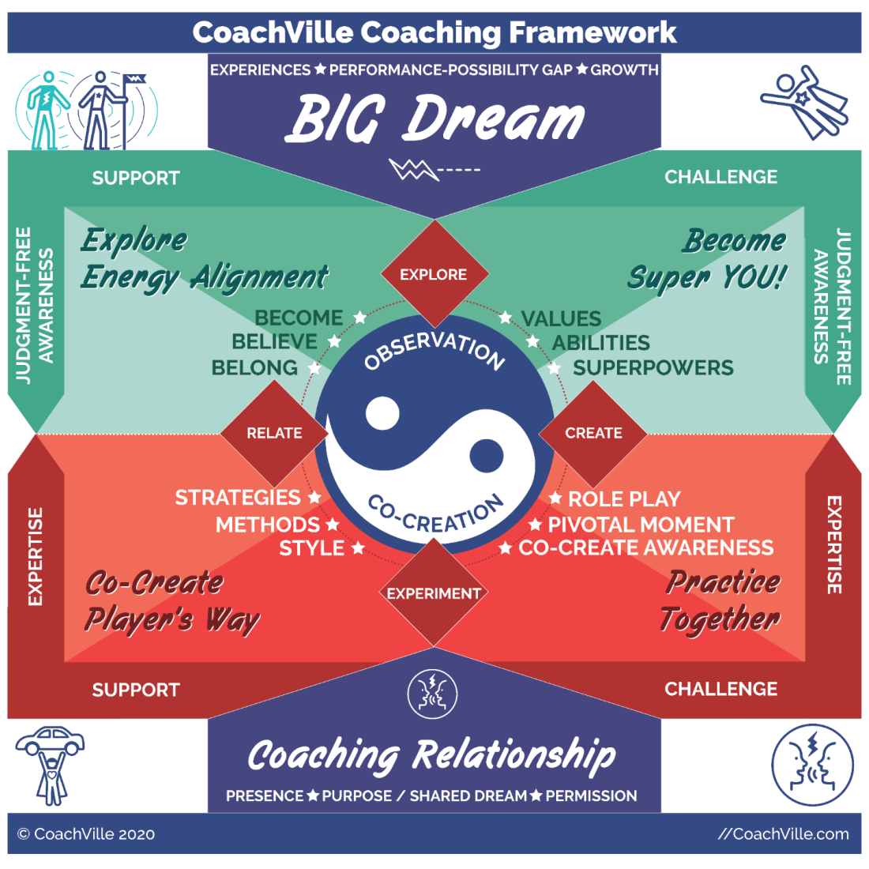
First let’s reconnect with our definition of Coaching:
Coaching is a profound personal relationship
Wherein the coach guides the player
In pursuit of playing better for their dreams
Through perceptive observations
And co-creative conversations
The field of Life Coaching is vast and dynamic. It needs to keep up with life which is moving fast and getting faster all the time.
As a result, is it pretty challenging to create a container that can both hold it all AND be something that you can get your mind around at the same time. Ideally you want a container that helps you understand what it is and how to do it at a high level.
We explore this Framework in different ways in each of our programs. So, you may have seen this already. Even if you haven’t, here is a brief walk through with a focus on what we have learned together in the Inner Freedom Method Program.
Observation ~ Co-Creation
The first thing to notice is the center which is the core of the coaching experience: the yin~yang type balance between observation and co-creation. This is the core of the coaching relationship!
Using the Inner Freedom Method you observed your player in several playful experiences: Co-Creating awareness, Pivotal Moments and Role Play.
I think the part where we explore the feeling energy and the memory pops looking for superpowers together is so profound. This feels like being on an Inner Adventure together where you are WITH the player on the adventure, and also observing your player and talking about what you see, at the same time. I think this so profound and so fun.
The key point in this is to create the feeling that you are doing this WITH them rather than FOR them; or TO them.
The other BIG point is that, with the Pivotal Moment Technique in the imagination and the role play technique for conversations, we absolutely CAN practice life! And anything we can practice we can coach to play better.
The coach and player practice together. The coach observes the player and shares what they see and can offer alternatives. And the player observes the coach to learn new ways of playing. Along with observation there are life-changing co-creative conversations that lead to new awareness and bigger possibilities. It is a powerful form of balanced partnership. It is a magical experience that can lead to transformation.
Play Life: Relate, Create, Explore, Experiment
Next notice the 4 Red Diamonds that display the ways that we play life in the Connected Age: Relate, Create, Explore and Experiment.
Playing with these brings up the Pivotal Moments because they can’t be controlled. This brings up all the frustration, overwhelm, resistance and fear that we explore in the Inner Freedom method. FUN.
The BIG DREAM
The players’ BIG Dream is the catalyst for the coaching experience.
We have certainly gotten into the BIG Dream all throughout the Inner Freedom Experience.
The compelling part about this is how we approach everything as a growth opportunity. This is what Life Coaching is all about.
The Coaching Relationship
The coaching relationship is unique in the world of human relating. It is a co-created experience where both individuals are equal partners with different roles; no one is “in charge”. The player is setting the destination with their Dream. The coach guides the pursuit using their coaching abilities and any relevant knowledge of the quest.
In the Inner Freedom Method you REALLY expand your coaching Presence! You hear so many intimate life experiences which calls upon you to grow you judgment-free capabilities.
Also being with someone who is FEELING energy and SEEING a memory pop is a profound Coaching Presence experience.
Permission is another big item here. I am sure you said something like: “Can I share an observation with you” so many times in the past 12 weeks!
The 2 Dynamics of the Framework
Support and Challenge
The coach is the ultimate supporter of the player providing encouragement and energy; we all need more support than we are getting! At the same time the coach must be able to challenge the player to grow in healthy ways. Most players are yearning for someone who can see them and show them places where they can grow. The true knack of coaching is being able to read the player and the situation and know which to provide – support or challenge - at any time.
In the Inner Freedom method you sure got a deep dive into support and challenge! In addition to providing both to your player, you also guide your player to explore this balance in the life experiences you explore with them.
When you get a deep understanding of this balance you start to ooze and “Elder” type of wisdom; at any age!
Judgment-Free Awareness (JFA) and Expertise
Well, you definitely got a boost to your Judgment-Free Awareness skills by practicing the Inner Freedom Method! Creating a safe space for practice and play is a big part of what we provide as life coaches.
The Expertise part is interesting. Your expertise in situations really comes through while doing Role Plays. The more you know about typical life scenarios, the better practice partner you will be. As you coach bigger players you will need to cultivate expertise in role playing intense leadership and business situations.
You also develop two new areas of expertise by coaching with the Inner Freedom Method. The first is expertise in body awareness. This is an awesome area of life and personal growth to know more about. This will open doors for you.
But the biggest new expertise is Treasure map reading!! I hope you do this a LOT more and make a claim for yourself that you are an expert at guiding personal growth Inner / Outer adventures and helping people reclaim their lost superpowers. People at all levels of success in life, from all walks of life will want a coach with this skillset!
The 4 Quadrants of the Framework
Explore Energy Alignment
Become ~ Believe ~ Belong
Energy alignment is the secret sauce of Life Coaching. And you certainly got a masterclass in Energy Alignment while coaching with Inner Freedom. How fun!
While the Inner Freedom Method hones in on beliefs and the Non-Conscious Mind part of Energy Alignment, there is also a healthy focus on restoring playfulness and the Urge to Become.
The real play in co-creating results in the world is Energy Play. Just like the bulk of the iceberg is unseen beneath the surface… the bulk of what makes things happen in the world is the unseen world of energy alignment.
You know more about that than most people at this point!
Become Super YOU!
Values ~ Abilities ~ Superpowers
This is the “unleash your unique power” portion of the coaching experience!
Whew! You have learned a lot about this in the past 12 sessions. And, like I said earlier I believe that this is a Coaching Superpower that can open a LOT of doors for you. There are a lot of people teaching information. But few can guide the INNER / OUTER adventure that helps people discover themselves!
And ultimately this is the thing people care about the most!
You can give it to them!!!
As I wrote several times in this book, the reality is that most people are not too aware of themselves because of the dehumanizing Industrial Culture.
Meanwhile, we are ALL yearning to be seen and known for who we really are.
Practice Together
Role Play ~ Pivotal Moment ~ Co-Create Awareness
This portion of the coaching framework is ALL about playing together while observing. These three coaching techniques, that allow you to co-create an experience of practicing life together, are fully embedded into the Inner Freedom Method.
You have learned so much about all three of these. You can now use them independently and also mix and match them into any coaching situation.
When you jump into these experiences as a coach you also get better as a player. As you play roles that your player needs to practice, you become more playful and resourceful as a coach and also as a player in life. In addition as you observe your players in both Role Play and Pivotal moment exercises you expand your observation abilities.
We didn’t get into this too much in this class, but doing a reverse role play is an awesome way to demonstrate a new way to do something. A reverse role play is when the coach plays the role of the player and the player plays the role of the person they want to approach. It can be really illuminating.
It can be SCARY to do this. You have to trust yourself to jump into the moment and play! For this, YOU need a healthy supply of Inner Freedom so that your playfulness is fully online!
The Co-Create Awareness Technique is a core technique of Life Coaching. We also call this the Abera Ca Dabera technique. Abera Ca Dabera translates to: I create as I speak.
This was built into the first section of every coaching session. You have this technique solid by now.
Co-Create Player’s Way
Strategies ~ Methods ~ Style
The bottom left of the coaching model refers to action; the “how” of playing better.
This is where you guide your player to create their own way of doing everything they want to do; and that their dream needs them to do.
This section was not a big focus of the Inner Freedom Method. However it probably started to happen naturally as your player expanded their playfulness and their confidence they started to experiment with doing things their own way.
If you continue to coach a player after 12 Inner Freedom Sessions, this quadrant will come into greater focus and importance.
You will guide your player to express themselves fully, find their voice and develop the style for who they want to become. All of this is in service of guiding your player to develop their own methods and unique way of playing better for their dream.
As you continue to coach you will develop your own coaching style and over time you will develop your own coaching methods as well.

Class 12 Prep
We will explore a few of these questions in class.
Question: How has this program increased your certainty as a coach?

Question: What have you learned about the shift from seeing your resistance as Self-‘sabotage to seeing your resistance as honorable social safety instincts and self-preservation?

Question: What have you learned about shifting from being a controller to a co-creator?

Question: What are your insights from listening to the Player Leanne Sessions?

Question: Share a Superpower that you have discovered and used while in this program?

Request: Please share your major insights and highlights from the Inner Freedom Program.

THANK YOU!
{From the Player Playbook}
Listen to this Thank YOU Audio.
The purpose of this 12 session coaching program was for you to:
- Experience playing for your dream WITH a Life Coach by your side.
- To experience yourself as a player… as a co-creator.
- You will gain influence. You will begin to see yourself as powerful and capable of having a profound positive impact in the lives of others and in the world!
- You will gain creativity. You will gain clarity on the YOUnique qualities that you have within you that you can use to co-create the results and experiences you desire.
- You will make changes. You will feel more confident in taking risks that can bring about positive rewards for your dream.
- You will gain Visibility. You will feel more courage in being seen and owning your value.
- You will develop the ability to tap into your body wisdom to make bold choices.
- You will develop the ability to tap into the Supermind for needed insights and possibilities… and then ACT on them.
- You will feel like your energy is flowing and aligned with your dream and greater purpose.
- Last but not least… you will stop the futile exercise of trying to conquer fear and you will learn how to EXPLORE fear – specifically social fear – which will lead to an extraordinary boost in your FREEDOM. INNER FREEDOM!
- As you practice exploring the FEAR you experience in social situations, you will rediscover your lost playfulness and YOUnique capabilities. AKA Your Superpowers!
I hope it was illuminating, enlivening and amazing.
I hope you and your coach have a plan to continue your adventure real soon! The world needs your dream and the YOUnique Superpowers you have to impact the world.
By the way… If you haven’t already, please send a note of thanks to your Coach. I know it would mean a lot to them.
And…
If you ever get the idea that you want to explore becoming a coach yourself…
We would love to have you with us at CoachVille.com.
Give us a call anytime.

Remember…
The world is a playground.
And we are going out to play… TOGETHER!
**!!** {End of Player Playbook} **!!**

Hey Coach!
A special note of thanks to YOU!
The Global Life Coaching Movement has a BIG Dream to
Uplift the Human Family one person at a time…
From: the tyranny of hierarchical control
To: the egalitarian joy of connected play.

While the dehumanizing Industrial Culture
- Squashes Dreams
- Silences Voices (and Superpowers)
- Shames Playfulness
As Life Coaches…
Together we are restoring the powers of Human Nature to our players!
Together we are RE-Humanizing the Human Family.
Thank you for everything you are becoming and everything you are doing.
FREE THE PEOPLE!
Coach Dave

