 | Quick Summary:  BIG Idea: Your pathway to success in business, career and life is to maximize the YOUnique Value that you contribute to the lives of others.  True wealth is the accumulation of value.  As you create YOUnique VALUE for others,  you ACCUMULATE commYOUnity WEALTH for yourself.  When you “own your wealth” and “FEEL your wealth” you are more attractive to people and opportunities in your community.  Capture Value Power: Quickly study the “YOUnique Value” descriptions and diagram. Make a quick assessment of your current YOUnique Value in each of the 9 areas.

Quick game plan to capture your YOUnique VALUE
- Find the Fun!
- Transformation from 20th Century Industrial Worker mindset to 21st Century Spirit of Play mindset.
- Assess your current YOUnique Value using key words and phrases that capture your experiences and ideas (Pattern Language)
- Optional: Plan your 21 Day YOUnique Value Challenge with creative ways to add YOUnique value to others while having FUN.

1) Find the Fun!
What is fun about capturing your YOUnique Value?
1) Collecting things is fun! – We love collecting things like stamps or cards; especially if each one is interesting or unique in some way. Look at all of the unique aspects of your value as a collection
2) Sharing is fun – Part of the joy of having anything is the opportunity to share it with others. This is what you are doing when you add value to the lives of others. Enjoy it!
3) Finding Unexpected Treasure! – A Treasure Hunt is a super fun activity! While you are finding YOUnique ways to add value to the lives of other people you may discover something of value from your life that you never knew had value! Any of your life experiences (or any of the 9 areas) could be a buried treasure that you discover when you get creative and playful about sharing your value with others! Pay attention to how other people respond to you, this will give you clues to find the treasure!

2) Transformations from worker to player
Industrial Work Mindset (the old way)… | Spirit of Play Mindset (the new way)…
My goal is to fit in and be like everyone else. | Each individual has YOUnique value based on the accumulation of wealth in 9 areas. The game is to boldy express
I just need to do my job by doing what I am told to do. It is the company’s job to figure out how to add value. | The game is to contribute my YOUnique value to the lives of others. As I add value I build wealth.
Money has value; Wealth is the accumulation of money. Save your money for retirement. | Wealth is the accumulation of value. Value is based on what is most important to the individual. There are MANY kinds of wealth to accumulate and share with others.
When I share what I have, I will have less | When I share my YOUnique Value, I create more Value AND accumulate Wealth!

3) Assess your current YOUnique Value
Building a business is one of the most effective ways to share your YOUnique value by using everything you have to create VALUE with and for others. Because business is personal and situational, when you share your YOUnique Value, your customer can immediately apply what you have shared to their own lives to then create value for others – value multiplies as it is shared! Every positive business experience expands your value so you gain by sharing.
Mantra: Your YOUnique value is the foundation of lasting CommYOUnity Wealth.  - You have enormous YOUnique value. However, you may not see yourself that way due to Industrial Work Mindset that had you try to fit in to a role or be like everyone else!  - With the spirit of play you can tap into your YOUnique value and express it in many fun ways.  - As you move deeper into your business, you will discover that you build CommYOUnity Wealth as you express more and more YOUnique value.  - It is possible to transform everything you have done and who you have become through life experiences into “YOUnique” Value that can be contributed to others | 9 Ares of YOUnique Value  - Knowledge – What you have studied  - Talent – Skills you have developed  - Experiences – What you have done, challenges you have overcome  - Energy – Natural character + WHO you have become + Your body  - Community – WHO you know; groups you are connected with  - Opportunity – A situation favorable for attaining a goal  - Financial – Money and things  - Relationships – Close connections (LOVE)  - Connected Space – Public spaces where you do things and meet people

“You contribute value to the lives of others and accumulate
commYOUnity wealth to boost your feeling of prosperity”
-Coach Dave Buck
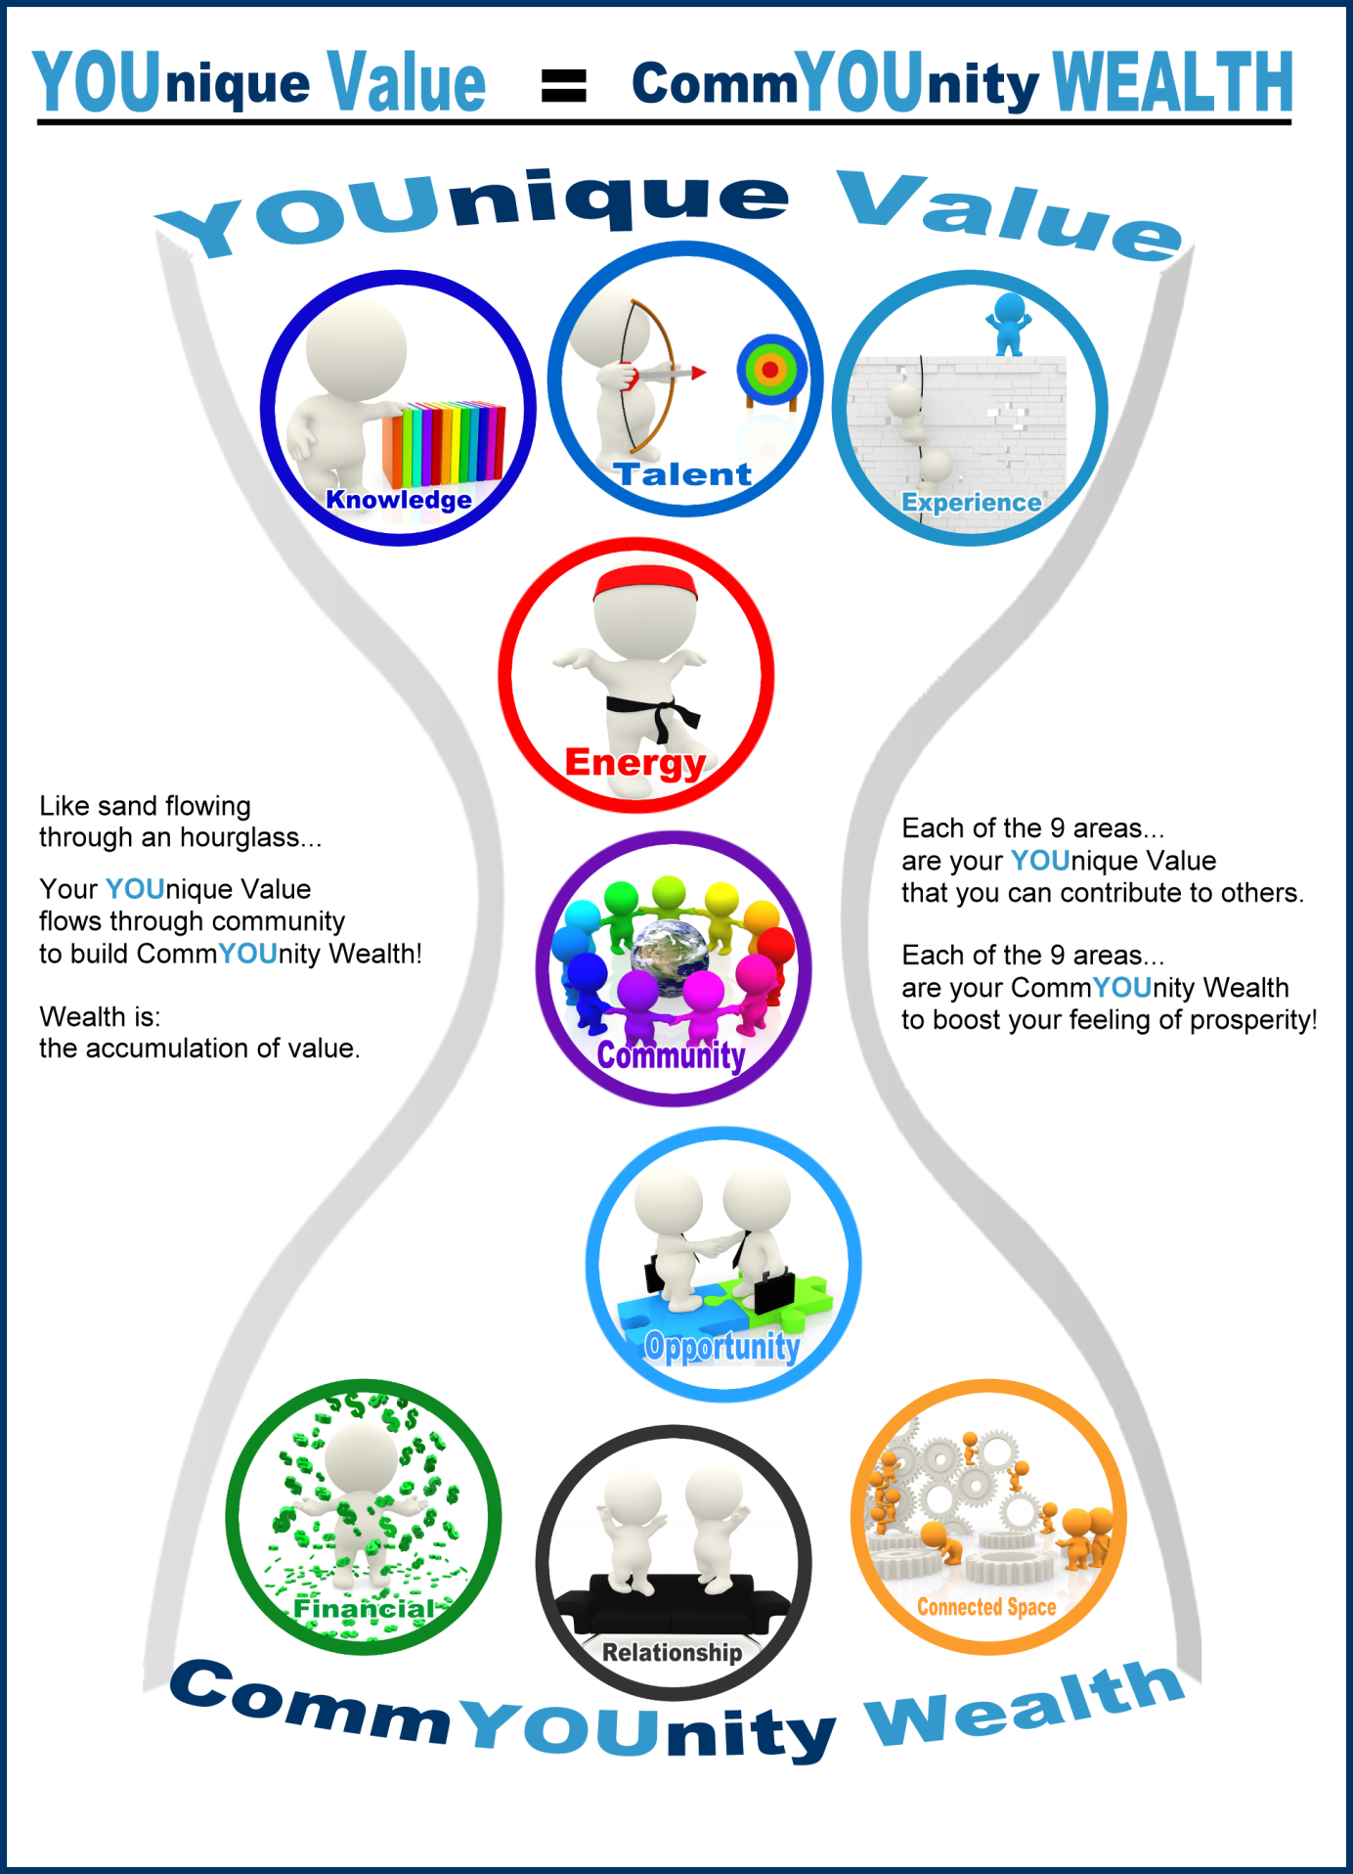

Wealth Area | Example | Add Value | New Wealth
Knowledge  what you have studied | Studied Hybrid Car Engines | Share the benefits of Hybrid cars with a friend buying a new car | New experience in helping someone choose a car
Talent  skills you have developed | Ability to fix cars | Fix the car of a friend | Understand a new type of car and the gratitude of the friend
Experience  what you have done, challenges you have overcome | Work as a mechanic | Teach a new car mechanic a few tricks | Rekindle your love for cars.
Energy  Natural character + WHO you have become + your body | Overcame the challenge of losing a job | Encourage a friend who is facing challenges | Renewed faith in life
Community  People you know; groups you are connected with | Member of the local chamber of commerce | Invite a colleague to join the Chamber | Appreciation within the chamber
Opportunity  a situation favorable for attaining a goal | I know someone who needs a Financial Planner | Connect them to a trusted colleague who delivers this service | Opportunity sharing is often reciprocated
Financial  Money and things | Positive cash flow from business operations | Pay team members & vendors! They like that. | Credit history of positive transactions
Relationships (Love)  Close connections (LOVE) | A close personal colleague | Attend a conference together | Deeper connection; a shared experience
Connected Space  Public spaces where you do things and meet people | A great coffee shop with friendly staff | Introduce a friend to the coffee shop | Now you both contribute to making it alive & successful

Notes to prepare for your YOUnique Value Assessment
1) Some things may fit in multiple categories, like something where you have knowledge, talent and experience. Just put it in the one most relevant category.
2) It is NOT a resume! Be creative in aspects of your life that could be shared to create value.
3) Use short phrases to capture the essence of what you want to share.
(don’t try to type in the whole story!)
4) As you play your Business game, you will expand what you see in yourself as VALUE!
5) It’s a good idea to update your YOUnique Value chart every year

Knowledge | Talent | Experience
 |  | 
Energy | Community | Opportunity
 |  | 
Financial | Relationship | Connected Space
 |  | 

4) 21-Day YOUnique Value Challenge (optional)
You are probably adding value to the lives of others many times every day already! The game is to be conscious and creative about doing it for 21 Days. Find a playful, YOUnique way to add value every day!
You can make a list or brainstorm with the “Purple FLASH!”; Keep looking for new ideas as you play!
A YOUnique Value you can share;  Do something FOR or WITH someone | How can you do it with the Spirit of PLAY?  Have fun while you are adding value!


