How to Create an Account at CoachVille

For Agency Coaches Creating an Account for a Player

Background
The simple steps someone takes to join as a member of CoachVille, simultaneously creates an account at CoachVille. The words: membership and account are used synonymously, and the word account is used for this tutorial. An account is necessary in order for a member to purchase classes or services.

Before an Agency coach can process a sale, the player must first have an account. If they do not, an Agency coach can create an account on behalf of their player. This tutorial outlines how to do this.

Step-By-Step
Follow these steps to create a membership account at CoachVille on behalf of a player:

- Open a browser window. Chrome or Mozilla Firefox are preferred.
- In the browser address bar type www.coachville.com.
- Click Join CV from the menu bar (Figure 1).

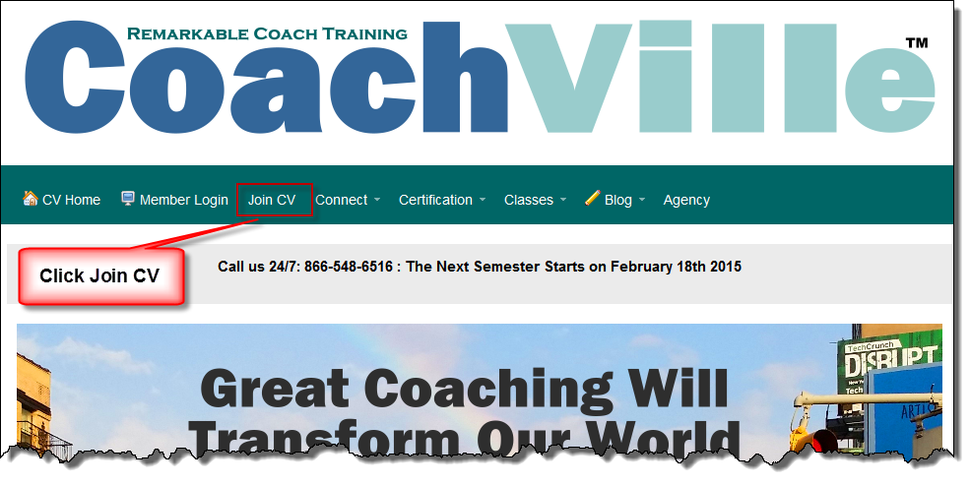
Figure 1 Click Join CV

- Skip the section that says CV Members Login Here. This is where you login to CoachVille after an account has been set up.
- In the Email field, enter the player’s email address.
- In the First name field, enter the player’s first name.
- In the Last name field, enter the player’s last name.
- In the Password field, enter an initial player password in all lower case letters in this format: lastnameyear Example: thomas2015
- If you are an Agency coach creating a player account, uncheck the box next to Subscribe to CoachVille Member News.
- Keep the box next to Coach Training Options blank.
- Enter Your Name (the Agency coach) in the Referral field.
- Review all of the information carefully to ensure it is correct.
- Click the Register as a CoachVille Member button when complete.

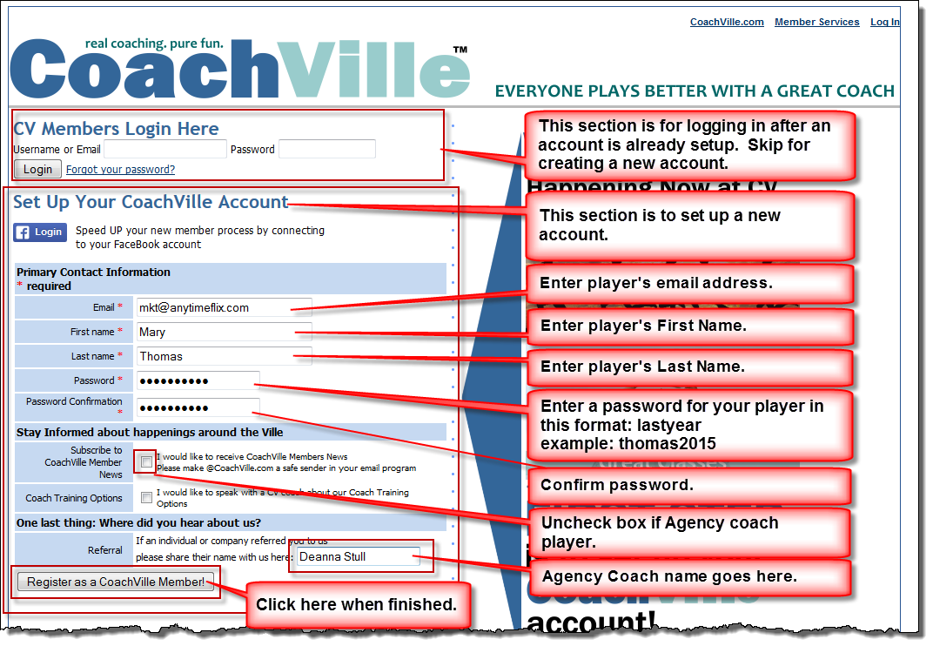
Figure 2 Set up your CoachVille Account

The CV Membership Home screen displays.

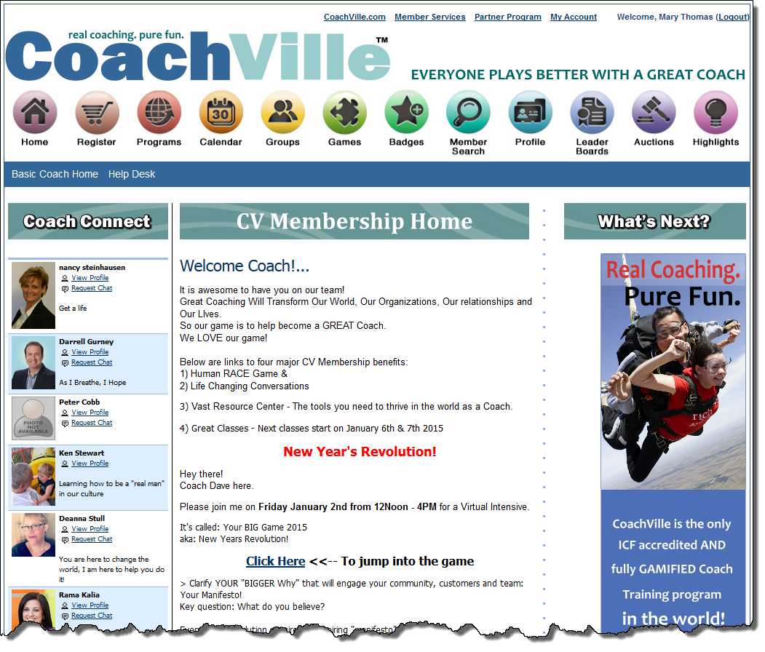
Figure 3 CV Membership Home.

You are finished! Click Logout in the upper right corner to log out.
150313 V1.01

