How to Process a Sale at CoachVille

Step-by-Step For Agency Coaches

Background
When an Agency Coach has a player that is ready to purchase services, the agency coach can send the player the purchase link to pay for the purchase themselves. In order for the link to work, the player must login to CoachVille first. Or, the Agency Coach can process the sale on behalf of the player.

There are two ways the Agency Coach can process the sale on behalf of the player.

1. Coach Already Created Account on Behalf of a Player: If the Agency Coach previously created an account on behalf of the player, they already have the player’s login and password. They can login as the player and process the sale assuming they have gathered the necessary billing and credit card information. They use the same steps as a player as outlined in “How to Pay with a Purchase Link” starting on page4.

2. Player Already Has an Existing Account: If the player already has an existing account, and the Agency Coach does not have the login and password, the Agency Coach can login as themselves and use their admin access to search for the player, and then login as the player using the steps that follow.

Step-by-Step: Agency Coach Processes Payment for Player
Follow these steps to process a sale on behalf of a player if they already have an existing account, and you do not have their login and password information.

Administrative access must be active, so you will first login as yourself. Next, you will login as your player. These steps assume that the player already has an account created at CoachVille, and the coach has been granted Administrative access.

- Open a browser window. Chrome or Mozilla Firefox are preferred.
- In the browser address bar type www.coachville.com.
- Click Member Login.

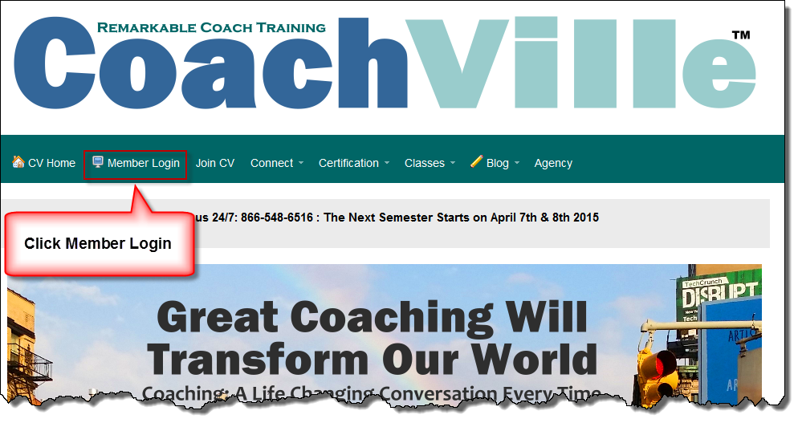
Figure 1 Click Member Login.

- Under CV Members Login Here, enter your email address and password.
- Click Login.

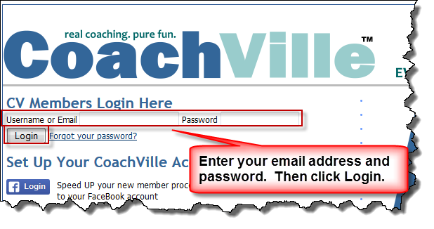
Figure 2 Enter your email address and password

After logging in, your administrative access is active, and enables you to use the CoachVille user lookup function to login as the player.

- Click the CoachVille User Lookup link below, or copy and paste the link in a new browser tab:

https://www.coachville.com/acs-admin/users/

- In the Quick search text box, enter the player’s email address, and then click Find User.

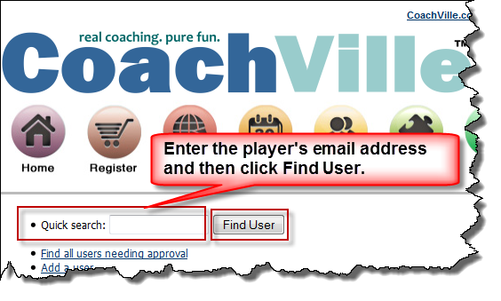
Figure 3 Quick Search

- Click the desired search result. In this example, we are logging in as Mary Thomas.

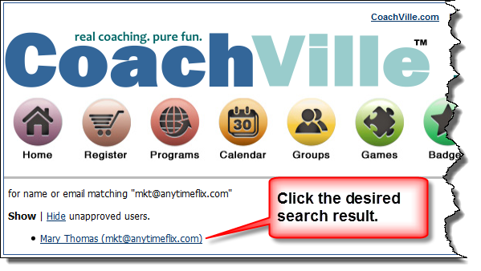
Figure 4 Search Results

- A user information page displays. Scroll to the very last item on the page under Administrative Actions and click login as this user.

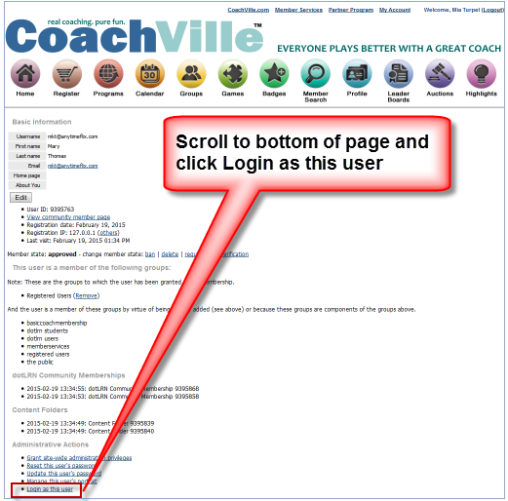
Figure 5 User information page

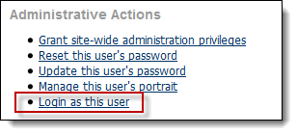
Figure 6 Login as this user link close-up

You are now logged in as this user (player), and you are viewing the player’s My Account page.

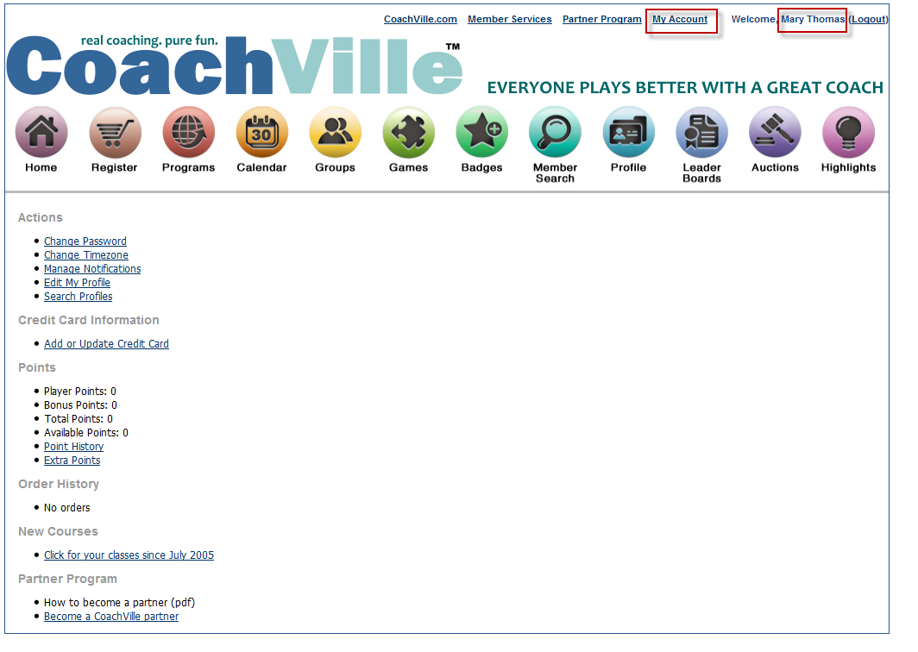
Figure 7 Player's My Account Page
- Copy and paste the product link into the browser address bar and either click the browser Go arrow (circled in Figure 8) or press ENTER on your computer keyboard.

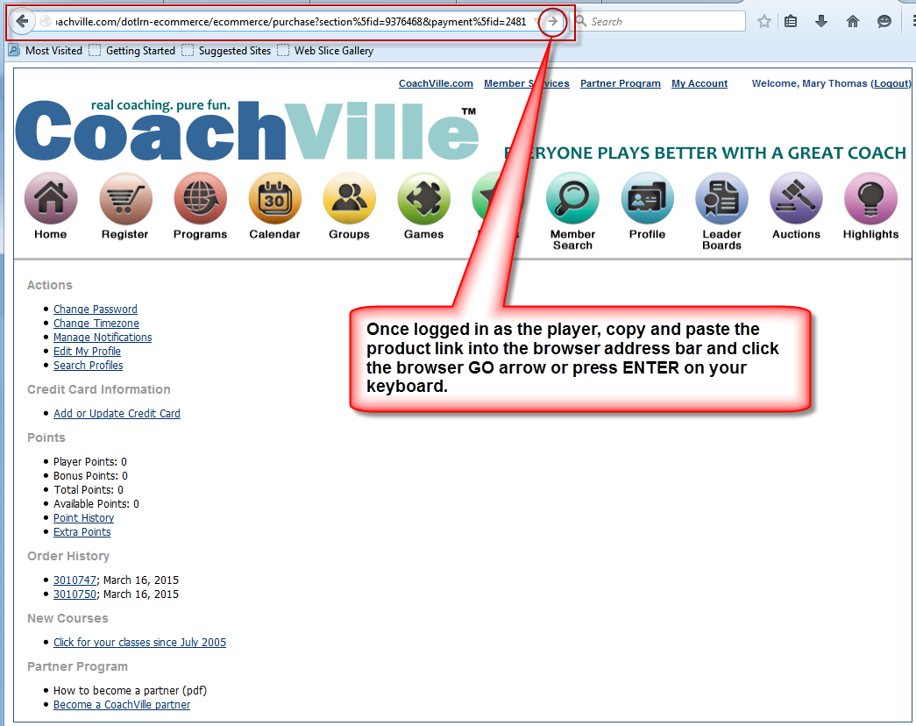
Figure 8 Copy product link into address bar

- An Item Description displays. Click Proceed to Checkout.

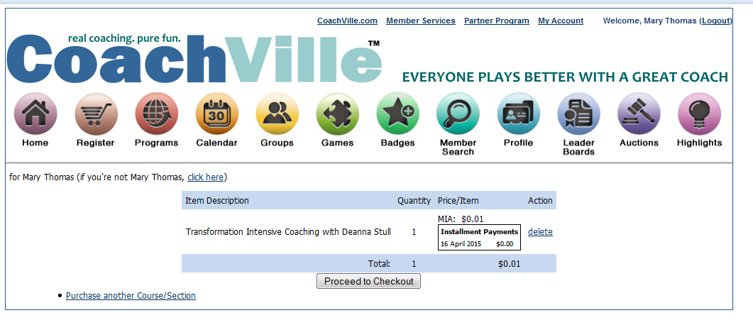
Figure 9 Item Description

- Enter the player’s Billing Information:
  - First Name
  - Last Name
  - Address
  - City
  - State/Province
  - Country
  - Check the box next to Refund Policy
- Enter the player’s Credit Card Information:
  - Credit Card Number
  - Type (Visa/MC/American Express/Discover/Novus)
  - Expires (Expiration Date)
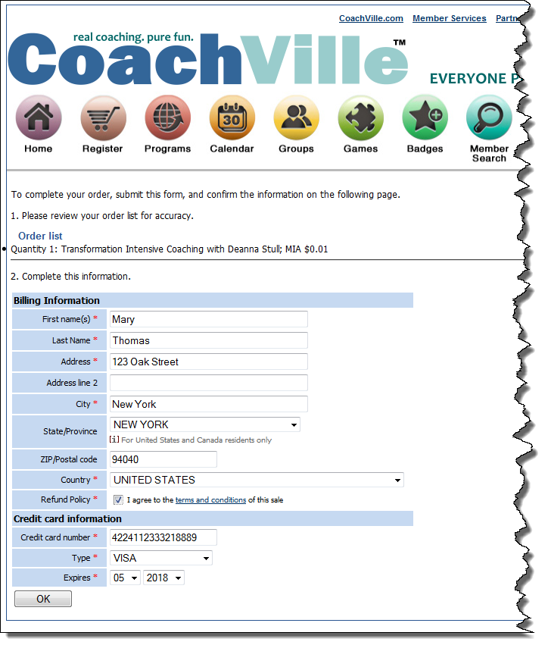
Figure 10 Billing and Credit Card Information
- Important: Double-check the accuracy of the information.
- If everything is accurate, click OK.
- An order confirmation displays (Figure 11).
- Confirm that that all information is correct. (If not, see What to do if anything is incorrect on page 4)
- If everything is correct, click the Submit button, and go to step 19.

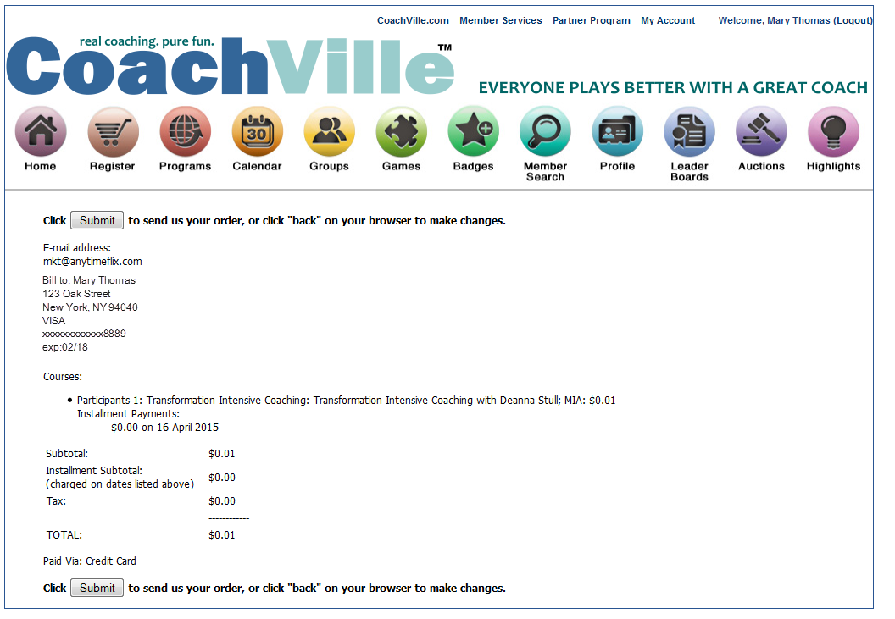
Figure 11 Order Confirmation Page

What to do if anything is incorrect
- Click the browser back arrow (Figure 12) on your browser window until you reach the Proceed to Checkout page (Figure 13).
- Click the delete link (Figure 13) to start over. This clears the cache in the shopping cart and prevents a duplicate order.
- A message displays “Your Shopping Cart is Empty” (Figure 14). Next re-paste the purchase link in the browser window and begin again with Step 10 on page 4.

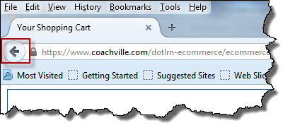
Figure 12 Browser Back Arrow

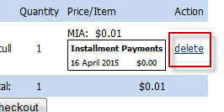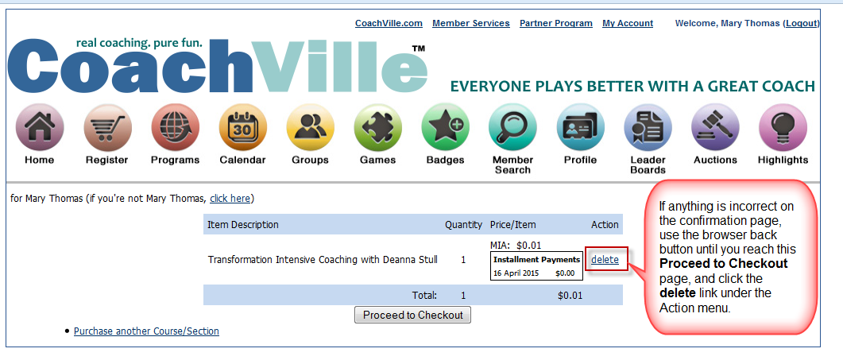
Figure 13 delete link on Proceed to Checkout page

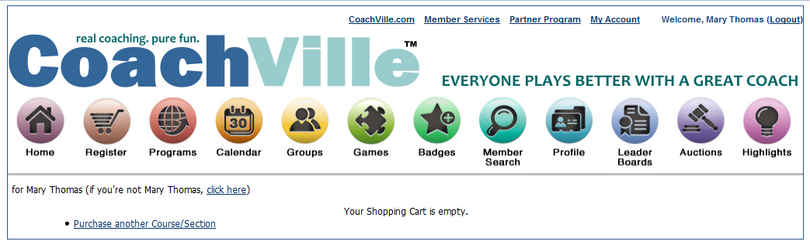
Figure 14 Your Shopping Cart is Empty message

- After clicking the Submit button, a Thank You for your registration page displays.

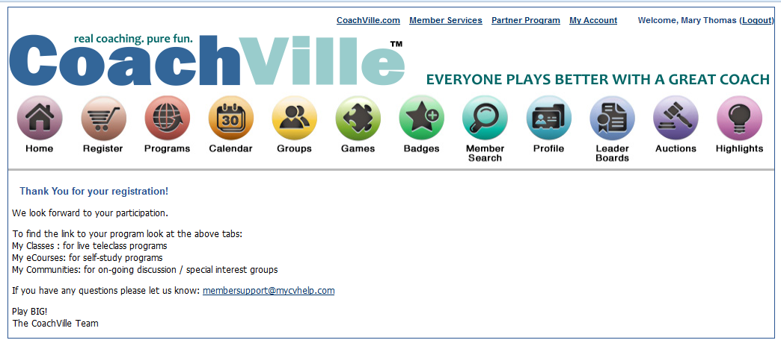
Figure 15 Thank You for your registration message.

- Click the Programs button to view newly purchased program.

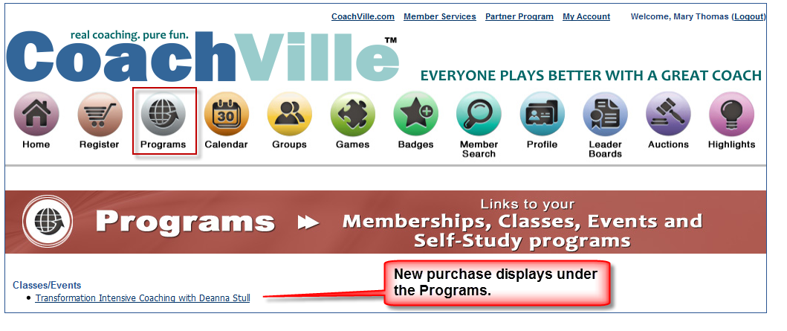
Figure 16 New purchase displays under Programs

How to Pay with a Purchase Link

The following steps walk you through how to pay for your purchase with a purchase link provided by your Agency Coach. It requires that you Login to CoachVille.

Login to CoachVille.com
- Open a browser window. Chrome or Mozilla Firefox are preferred.
- In the browser address bar type www.coachville.com.
- Click Member Login.

Figure 17 Click Member Login.

- Under CV Members Login Here, enter your email address and password (Figure 18).
- Click Login.

Figure 18 Enter email address and password
- Once logged in, copy and paste the purchase link provided by the Agency Coach into the browser address bar.

- Next either click the Go arrow or press ENTER on your computer keyboard (Figure 19).

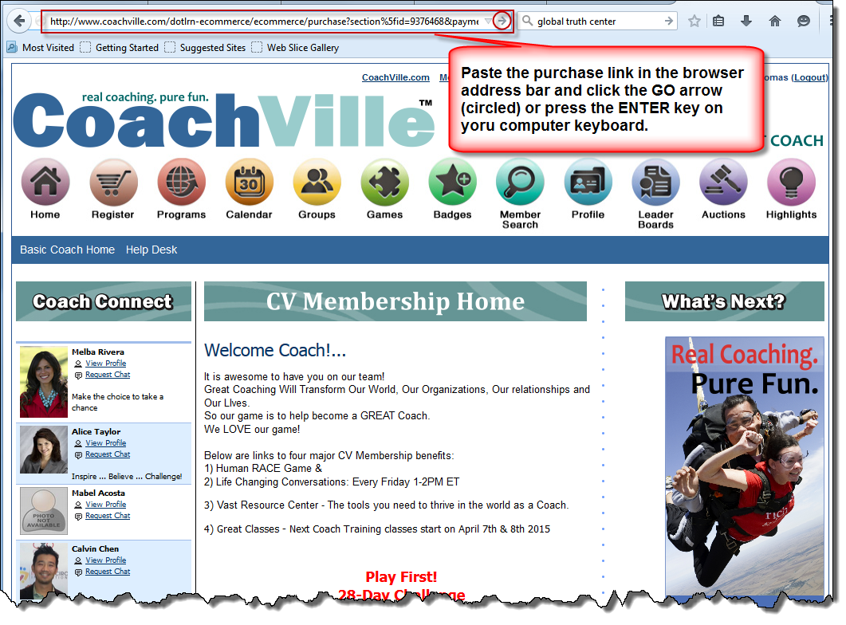
Figure 19 Paste the purchase link in the browser address bar and click the Go arrow or press ENTER

- An Item Description displays. Click Proceed to Checkout.

Figure 20 Item Description

- Enter your Billing Information:
  - First Name
  - Last Name
  - Address
  - City
  - State/Province
  - Country
  - Check the box next to Refund Policy
- Enter your Credit Card Information:
  - Credit Card Number
  - Type (Visa/MC/American Express/Discover/Novus)
  - Expires (Expiration Date)
Figure 21 Billing and Credit Card Information
- Important: Double check the accuracy of the information.
- If everything is accurate, click OK.
- An order confirmation displays (Figure 22).
- Confirm that that all information is correct. (If not, see What to do if anything is incorrect on page 4)
- If everything is correct, click the Submit button, and go to Step 16 on page 4.

Figure 22 Order Confirmation Page

What to do if anything is incorrect
- Click the browser back arrow (Figure 23) on your browser window until you reach the Proceed to Checkout page (Figure 24).
- Click the delete link (Figure 24) to start over. This clears the cache in the shopping cart and prevents a duplicate order.
- A message displays “Your Shopping Cart is Empty” (Figure 25). Next re-paste the purchase link in the browser window and begin again with Step 6 on page 13.

Figure 23 Browser Back Arrow

Figure 24 delete link on Proceed to Checkout page

Figure 25 Your Shopping Cart is Empty message

- After clicking the Submit button, a Thank You for your registration page displays.

Figure 26 Thank You for your registration message.

- Click the Programs button to view newly purchased program.

Figure 27 New purchase displays under Programs

150330 V1.01

