How to Pay with a Purchase Link

For New Players

The following steps walk you through how to pay for your coaching services or classes with a purchase link provided by your Agency Coach. It requires that you first Login to CoachVille.

Login to CoachVille.com
- Open a browser window. Chrome or Mozilla Firefox are preferred.
- In the browser address bar type www.coachville.com.
- Click Member Login.

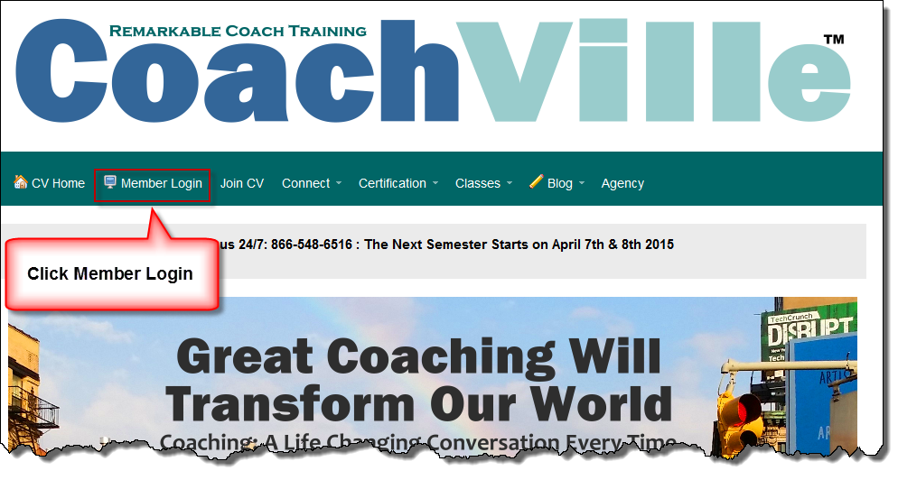
Figure 1 Click Member Login.

- Under CV Members Login Here, enter your email address and password (Figure 2).
- Click Login.

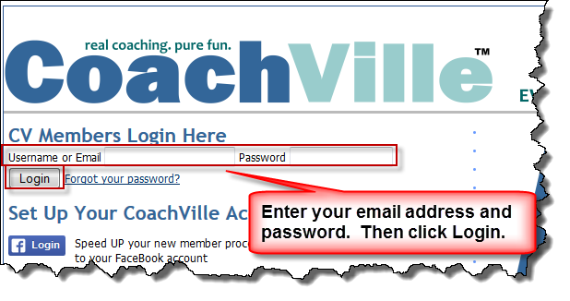
Figure 2 Enter email address and password
- Once logged in, copy and paste the purchase link provided by the Agency Coach into the browser address bar.

- Next either click the Go arrow or press ENTER on your computer keyboard (Figure 3).

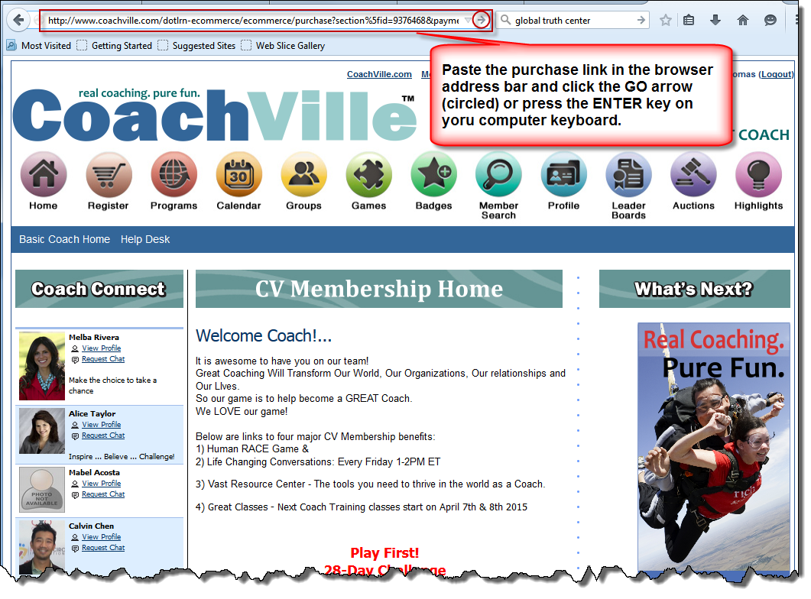
Figure 3 Paste the purchase link in the browser address bar and click the Go arrow or press ENTER

- An Item Description displays. Click Proceed to Checkout.

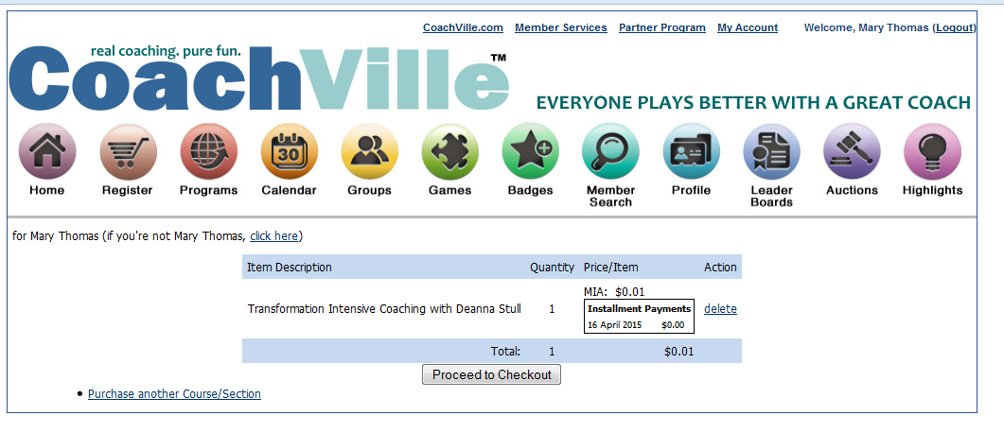
Figure 4 Item Description

- Enter your Billing Information:
  - First Name
  - Last Name
  - Address
  - City
  - State/Province
  - Country
  - Check the box next to Refund Policy
- Enter your Credit Card Information:
  - Credit Card Number
  - Type (Visa/MC/American Express/Discover/Novus)
  - Expires (Expiration Date)
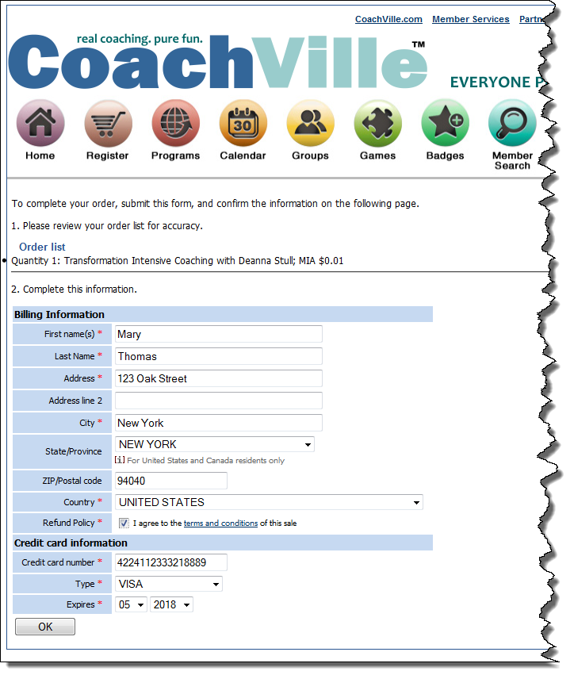
Figure 5 Billing and Credit Card Information
- Important: Double check the accuracy of the information.
- If everything is accurate, click OK.
- An order confirmation displays (Figure 6).
- Confirm that that all information is correct. (If not, see What to do if anything is incorrect on page 6)
- If everything is correct, click the Submit button, and go to Step 16 on page 7.

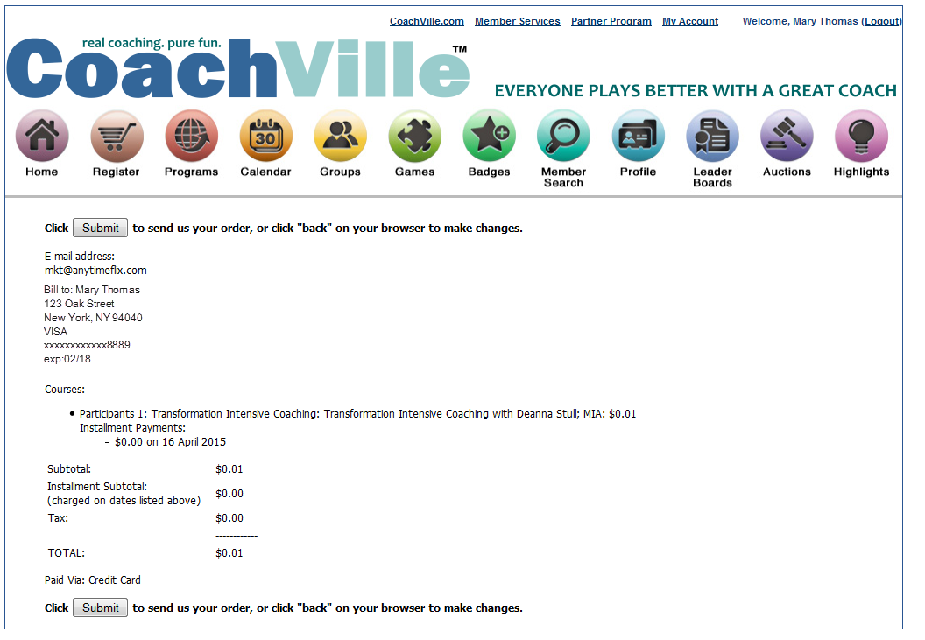
Figure 6 Order Confirmation Page

What to do if anything is incorrect
- Click the browser back arrow (Figure 7) on your browser window until you reach the Proceed to Checkout page (Figure 8).
- Click the delete link (Figure 8) to start over. This clears the cache in the shopping cart and prevents a duplicate order.
- A message displays “Your Shopping Cart is Empty” (Figure 9). Next re-paste the purchase link in the browser window and begin again with Step 6 on page 2.

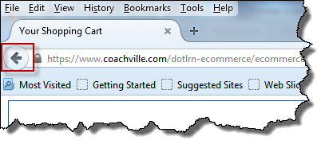
Figure 7 Browser Back Arrow

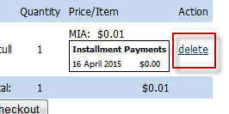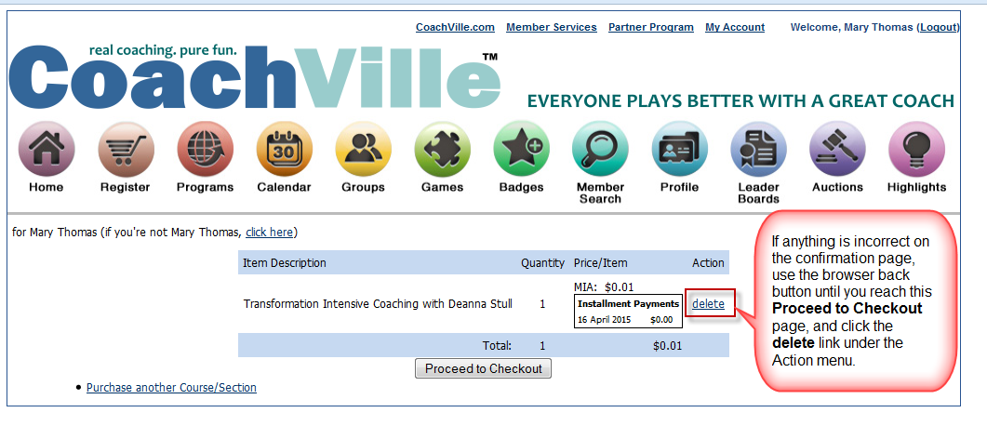
Figure 8 delete link on Proceed to Checkout page

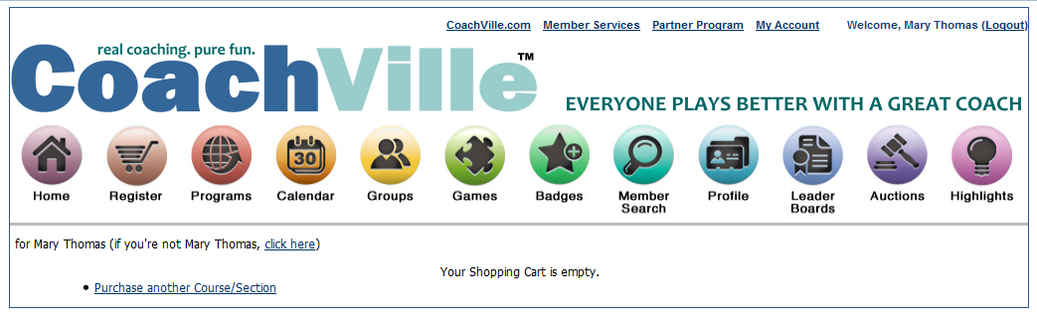
Figure 9 Your Shopping Cart is Empty message

- After clicking the Submit button, a Thank You for your registration page displays.

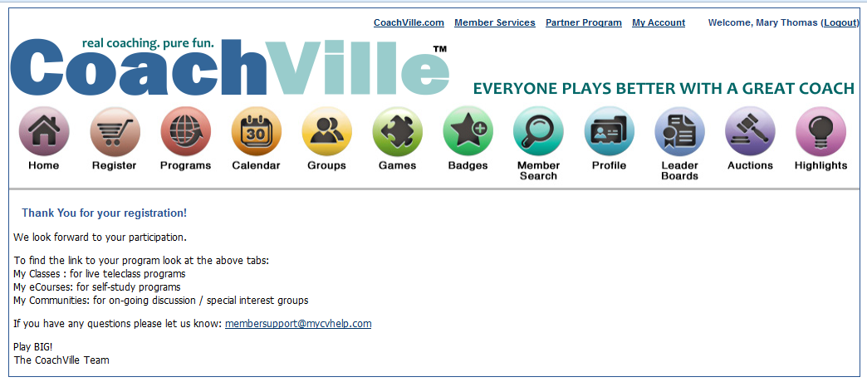
Figure 10 Thank You for your registration message.

- Click the Programs button to view newly purchased program.

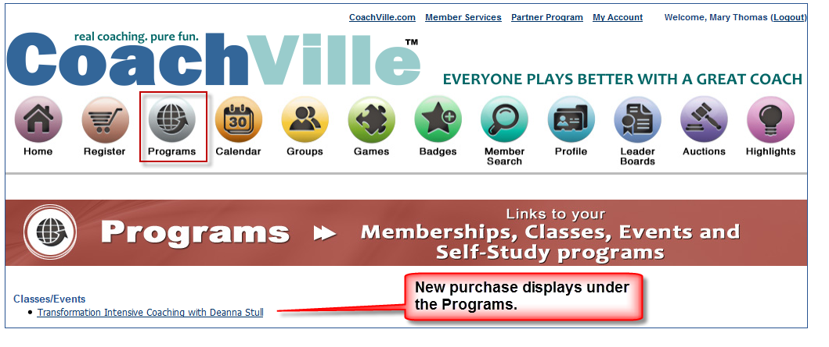
Figure 11 New purchase displays under Programs

150330 V1.00

