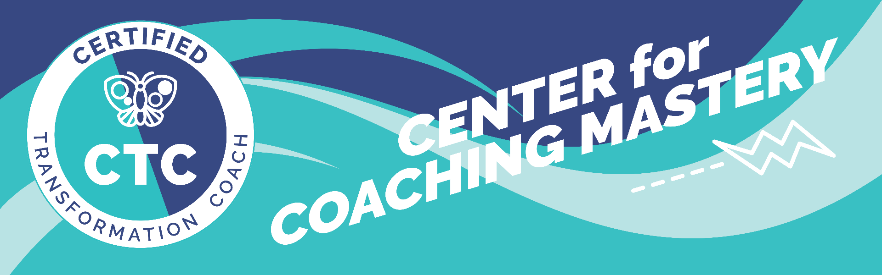

Coaching Markers FINAL Recording Scorecard
Coaches Name: | Date:
Live or Recorded: RECORDING | Assessor Coach Name:
*Ethics Breach(Yes or No): | Assessor Coach Credential:
*Disqualifiers: If there is an ethics breach as defined by the ICF Code of Ethics or by more than occasionally stepping into a role other than coach, as defined by the ICF, such as consultant, teacher, mentor or consultant you will not qualify for an ACC/PCC score.

Total Score: |  | Credential Level:

General Notes:
** Assessor, this is only if you want to add more that just competency-oriented notes, if you do not, just delete this and the above row..

Strengths:
- Core Competency # Choose an item.
include evidence from marker with comment using neutral language; if no competency use, "some ability" or "sometimes".
- Core Competency # Choose an item.
include evidence from marker with comment using neutral language; if no competency use, "some ability" or "sometimes".
- Core Competency # Choose an item.
include evidence from marker with comment using neutral language; if no competency use, "some ability" or "sometimes".

Growth Opportunities
- Core Competency # Choose an item.
include evidence from marker with comment using neutral language; if no competency use, "some ability" or "sometimes".
- Core Competency # Choose an item.
include evidence from marker with comment using neutral language; if no competency use, "some ability" or "sometimes".
- Core Competency # Choose an item.
include evidence from marker with comment using neutral language; if no competency use, "some ability" or "sometimes".

ICF Markers
ICF Markers: Your goal is to exhibit evidence of at least 26 markers with at least 2 markers in competency 2, 3 at least 3 markers in Competency 4, 5, 6 and at least 4 in competency 7. You must score 2 markers observed in Competency 1.
+ Indicates observed evidence of marker. Note some markers require two observations of evidence.

1 – Demonstrates Ethical Practice - Must score both to pass.
Observed? |  | Markers
☐ |  | Qualifier 1 – Coach demonstrates alignment with the ICF Code of Ethics
☐ |  | Qualifier 2 - Consistent alignment with role as Coach.

Competency 2 – Embodies a Coaching Mindset - Must score to pass.
Observed? |  | Markers
☐ |  | Demonstrated by Markers: 4.1, 4.3, 4.4, 5.1, 5.2, 5.3, 5.4, 6.1, 6.5, 7.1, and 7.5. [These markers are marked with asterisk for easy reference.

Competency 3 – Establishes and Maintains Agreement - Must score at least 3 to pass.

Observed? |  | Markers
☐ |  | 3.1 Coach partners with the client to identify or reconfirm what the client wants to accomplish in this session.
☐ |  | 3.2 Coach partners with the client to define or reconfirm measure(s) of success for what the client wants to accomplish in this session.
☐ |  | 3.3: Coach inquires about or explores what is important or meaningful to the client about what they want to accomplish in this session.
☐ |  | 3.4: Coach partners with the client to define what the client believes they need to address to achieve what they want to accomplish in this session.

Competency 4: Cultivates Trust and Safety - Must score at least 3 to pass. Requires two observed moments to mark as observed.
Observed? | Observed? | Markers
☐ | ☐ | *4.1: Coach acknowledges and respects the client’s unique talents, insights and work in the coaching process.
☐ | ☐ | 4.2: Coach shows support, empathy or concern for the client.
☐ | ☐ | *4.3: Coach acknowledges and supports the client’s expression of feelings, perceptions, concerns, beliefs or suggestions.
☐ | ☐ | *4.4: Coach partners with the client by inviting the client to respond in any way to the coach’s contributions and accepts the client’s response.

Competency 5: Maintains Presence - Must score at least 3 to pass. Requires two observed moments to mark as observed.
Observed? | Observed? | Markers
☐ | ☐ | *5.1: Coach acts in response to the whole person of the client (the who)
☐ | ☐ | *5.2: Coach acts in response to what the client wants to accomplish throughout this session (the what).
☐ | ☐ | *5.3: Coach partners with the client by supporting the client to choose what happens in this session.
☐ | ☐ | *5.4: Coach demonstrates curiosity to learn more about the client.
☐ | ☐ | 5.5: Coach allows for silence, pause or reflection.

Competency 6: Listens Actively - Must score at least 3 to pass. 6.1, 6.6 and 6.7 require two observed moments to mark observed.
Observed? | Observed? | Markers
☐ | ☐ | *6.1: Coach’s questions and observations are customized by using what the coach has learned about who the client is or the client’s situation.
☐ |  | 6.2: Coach inquires about or explores the words the client uses.
☐ |  | 6.3: Coach inquires about or explores the client’s emotions.
☐ |  | 6.4: Coach explores the client’s energy shifts, nonverbal cues or other behaviors.
☐ |  | *6.5: Coach inquires about or explores how the client currently perceives themself or their world.
☐ | ☐ | 6.6: Coach allows the client to complete speaking without interrupting unless there is a stated coaching purpose to do so.
☐ | ☐ | 6.7: Coach succinctly reflects or summarizes what the client communicated to ensure the client’s clarity and understanding.

Competency 7: Evokes Awareness - Must score at least 4 to pass. Requires two observed moments to mark as observed.
Observed? | Observed? | Markers
☐ | ☐ | *7.1: Coach asks questions about the client, such as their current way of thinking, feeling, values, needs, wants, beliefs or behavior.
☐ | ☐ | 7.2: Coach asks questions to help the client explore beyond the client’s current thinking or feeling to new or expanded ways of thinking or feeling about themself (the who).
☐ | ☐ | 7.3: Coach asks questions to help the client explore beyond the client’s current thinking or feeling to new or expanded ways of thinking or feeling about their situation (the what).
☐ | ☐ | 7.4: Coach asks questions to help the client explore beyond current thinking, feeling or behaving toward the outcome the client desires.
☐ | ☐ | *7.5: Coach shares — with no attachment — observations, intuitions, comments, thoughts or feelings, and invites the client’s exploration through verbal or tonal invitation.
☐ | ☐ | 7.6: Coach asks clear, direct, primarily open-ended questions, one at a time, at a pace that allows for thinking, feeling or reflection by the client.
☐ | ☐ | 7.7: Coach uses language that is generally clear and concise.
☐ | ☐ | 7.8: Coach allows the client to do most of the talking.

Competency 8: Facilitates Client Growth: Your goal is to exhibit at least 4 markers. - Must score at least 4 to pass.
***Note: The conversation about WHAT the client learned (i.e., Markers 8.2 and 8.3) must happen chronologically before the discussion about HOW the client will use their learning (Marker 8.4)

Observed? |  | Markers
☐ |  | 8.1: Coach invites or allows the client to explore progress toward what the client wanted to accomplish in this session.
☐ |  | 8.2: Coach invites the client to state or explore the client’s learning in this session about themself (the who).
☐ |  | 8.3: Coach invites the client to state or explore the client’s learning in this session about their situation (the what).
☐ |  | ***See Note: 8.4: Coach invites the client to consider how they will use new learning from this coaching session.
☐ |  | 8.5: Coach partners with the client to design post-session thinking, reflection or action.
☐ |  | 8.6: Coach partners with the client to consider how to move forward, including resources, support or potential barriers.
☐ |  | 8.7: Coach partners with the client to design the best methods of accountability for themself.
☐ |  | 8.8: Coach celebrates the client’s progress and learning.
☐ |  | 8.9: Coach partners with the client on how they want to complete this session.

Transcript:

